# Development Cooperation Factsheet

## Solomon Islands

MAY 2025



### Overview

Estimated Australian ODA: $170.9m (2025-26)

Gross National Income Per Capita: US$2,100 (2023)

Population: 0.8m (2023)

#### Table 1: Australian ODA to Solomon Islands, 2023-24 to 2025-26

| Australian ODA | 2023-24 Actual ($m)* | 2024-25 Budget Estimate ($m)* | 2025-26 Budget Estimate ($m)* |
| --- | --- | --- | --- |
| Country Programs | 103.3 | 103.6 | 103.6 |
| Regional | 26.0 | 34.5 | 30.6 |
| Global / Other | 11.9 | 11.8 | 11.2 |
| Other Government Departments | 18.7 | 21.3 | 25.4 |
| **Total ODA to Solomon Islands** | **159.9** | **171.2** | **170.9** |
| **Percentage total Australian ODA** | **3.3%** | **3.5%** | **3.4%** |

*Due to rounding, discrepancies may occur between sums of the component items in totals

#### Figure 1: Australian ODA to Solomon Islands by Sector Group, 2025-26 budget estimate

**Figure 1 presents the percentage of Australia’s Official Development Assistance (ODA) to Solomon Islands for the financial year 2025-26 attributable to seven sector groups.

This information is presented in a doughnut chart, where the seven primary Sector Groups take a portion of shading in the doughnut in direct proportion to the total percentage attributable to each Sector Group.

The percentages of total Australian ODA by Sector Groups are:
Agriculture, trade and other production services 10%
Economic infrastructure and services 37%
Education 10%
Governance 27%
Health 5%
Humanitarian 3%
Multisector and General Development Support 8%Sustainable Development Goals**

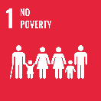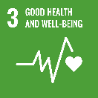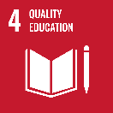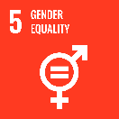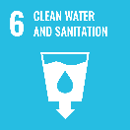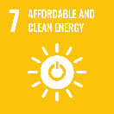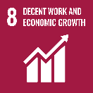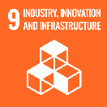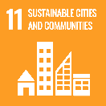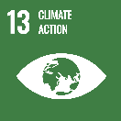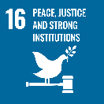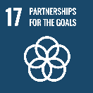

**Australia is proud to be Solomon Islands’ number one partner – with the largest economic, development and security cooperation programs in Solomon Islands. Our development cooperation program supports priority sectors including infrastructure, jobs and skills, private sector development, health, education, governance and elections, access to justice, and women’s leadership.**

Australia and Solomon Islands are family with interconnected futures – we share a region, an ocean, and a history of partnership. Our development program is our second largest in the Pacific, and third largest globally. Australia’s 2017 bilateral security treaty with Solomon Islands provides an enduring framework for security assistance. Two-way trade between Solomon Islands and Australia continues to grow. Australia and Solomon Islands also have substantial infrastructure cooperation, with close to AUD1.2 billion invested by Australia in high-quality, disaster-resilient infrastructure across Solomon Islands since 2019. Thousands of Solomon Islanders have participated in Australia’s labour mobility program, transforming the lives of many Solomon Islanders.

### Strategic direction

As one of Solomon Islands’ longest standing and most comprehensive development partners, Australia has a proud track record of supporting Solomon Islands across nearly every sector of the economy and society. Australia has refocused bilateral programs to better align with Solomon Islands Government priorities of infrastructure, economic growth and job creation, while maintaining support to human development investments in areas such as health, education, and gender equality.

The overarching goal for the Australia-Solomon Islands development partnership is supporting a stable and prosperous Solomon Islands through inclusive economic growth, infrastructure and job creation; investing in people, communities and links to Australia and the region; and improved stability, security and resilience.

### Program highlights

Australia supported:

* A record number of remittances to Solomon Islands by Pacific Australia Labour Mobility scheme workers in Australia, which directly benefits local Solomon Islands communities (2024).
* A significant uplift in delivery of small-scale community infrastructure projects across Solomon Islands through the Solomon Islands-Australia Community Partnerships program (2024).
* The new Solomon Islands Australia Health Partnership invests in essential health service delivery, targeted health infrastructure improvements, leadership and responding to emerging national health priorities (2025).
* The largest ever cohort of Solomon Islanders to undertake study through Australia Awards (2025).
* A major increase in the value of Solomon Islands exports to Australia, enabled by the duty free and quota free access provided under PACER Plus (2025).