# Development Cooperation Factsheet

## Social Protection

MAY 2025

### Overview

Estimated Australian ODA: $116.2m (2025-26)

#### Table 1: Australian Social Protection ODA by region

| Region | 2023-24 Actual ($m)* | 2024-25 Budget Estimate ($m)* | 2025-26 Budget Estimate ($m)* |
| --- | --- | --- | --- |
| Pacific | 10.1 | 13.0 | 25.3 |
| Southeast Asia | 20.3 | 48.1 | 35.3 |
| South and Central Asia | 10.8 | 13.6 | 10.8 |
| Middle East and Africa | 1.5 | 1.4 | 1.7 |
| Rest of the World^ | 37.6 | 35.3 | 43.1 |
| **Total Social Protection ODA** | **80.3** | **111.3** | **116.2** |

* Due to rounding, discrepancies may occur between sums of the component items in totals.

^Includes ODA that is not attributed to particular countries or regions.

In 2023-24, figures for social protection were calculated using a new Methodology based on investments in DAC Sector codes 12240, 16010, 16011-15.

#### Figure 1 presents the percentage of Australia’s Official Development Assistance (ODA) for health for the financial year 2023-24 across five regions. This information is presented in a doughnut chart, where the five regions take a portion of shading in the doughnut in direct proportion to the total percentage attributable to each region. The percentages of total Australian health assistance ODA by region are: Pacific 13% Southeast Asia 25% South and Central Asia 14% Middle East and Africa 2% Rest of the World* 47%Figure 1: Australian ODA for Social Protection by Region, 2023-24 actual

*\*Includes ODA that is not attributed to particular countries or regions.*

### Sustainable Development Goals

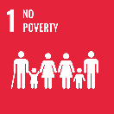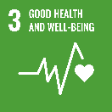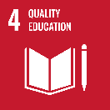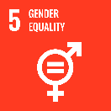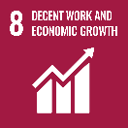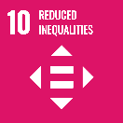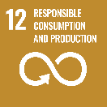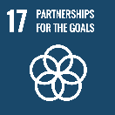

**Australia supports social protection programs to help safeguard people across their lifecycle from poverty and vulnerability. This assists people and communities build resilience to better manage daily stressors and unexpected shocks.**

### Social protection addresses risk, vulnerability, and poverty through a system of cash or in-kind transfers to people. Recent global shocks, ongoing social and economic pressures and the increasing impacts of climate change demonstrate the importance of strong, inclusive social protection (social security) systems.

### Strategic direction

### Australia continues as a leading development partner on social protection in the Indo-Pacific region. Our support assists countries alleviate poverty and inequality, helps households to manage day-to-day economic challenges, and mitigates points of vulnerability and risk – from pregnancy to old age. This support helps address barriers to gender equality, disability equity, and social inclusion. Social protection programs are also being strengthened to better respond to humanitarian, climate-related shocks and other disasters.

### Social protection plays an important role in building the Indo-Pacific region’s resilience to multiple and compounding challenges, contributing to effective, accountable and resilient states.

### Program highlights

* Australia’s support to the World Bank ($21 million) facilitated a US$80 million World Bank loan to the government of Papua New Guinea. This is supporting the introduction of Papua New Guinea’s first social assistance program, supporting pregnant women and early childhood (first 1000 days from conception).
* Australia is partnering with UNICEF for a program on Empowering Girls and Women through Social Protection in Southeast Asia ($4 million). The program aims to strengthen evidence and knowledge on social protection, gender equality, disability and social inclusion. Engagement with partner governments and civil society will better integrate inclusion and risk-informed approaches into social protection policy and practice.