# Development Cooperation Factsheet

## Samoa

MAY 2025



### Overview

Estimated Australian ODA: $51.8m (2025-26)

Gross National Income Per Capita: US$4,200 (2023)

Population: 0.2m (2023)

#### Table 1: Australian ODA to Samoa, 2023-24 to 2025-26

| Australian ODA | 2023-24 Actual ($m)* | 2024-25 Budget Estimate ($m)* | 2025-26 Budget Estimate ($m)* |
| --- | --- | --- | --- |
| Country Programs | 58.6 | 29.0 | 30.0 |
| Regional | 13.7 | 19.1 | 18.4 |
| Global / Other | 2.0 | 1.2 | 1.1 |
| Other Government Departments | 3.3 | 2.5 | 2.3 |
| **Total ODA to Samoa** | **77.7** | **51.8** | **51.8** |
| **Percentage total Australian ODA** | **1.6%** | **1.0%** | **1.0%** |

*Due to rounding, discrepancies may occur between sums of the component items in totals

#### Figure 1: Australian ODA to Samoa by Sector Group, 2025-26 budget estimate

Figure 1 presents the percentage of Australia’s Official Development Assistance (ODA) to Samoa for the financial year 2025-26 attributable to seven sector groups.

This information is presented in a doughnut chart, where the seven primary Sector Groups take a portion of shading in the doughnut in direct proportion to the total percentage attributable to each Sector Group.

The percentages of total Australian ODA by Sector Groups are:
Agriculture, trade and other production services 10%
Economic infrastructure and services 8%
Education 21%
Governance 48%
Health 8%
Humanitarian 0%
Multisector and General Development Support 5%

### Sustainable Development Goals

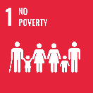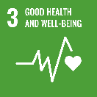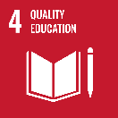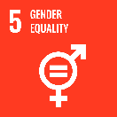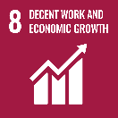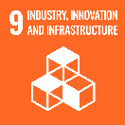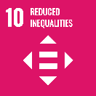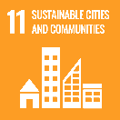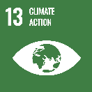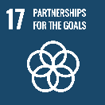

**Australia is Samoa’s largest bilateral development partner. Our development partnership is grounded in long-term, locally led programs, designed to directly respond to Samoan’s priorities.**

Our development partnership operationalises commitments in the Samoa-Australia Bilateral Partnership Arrangement (signed 2023), including on climate and disaster resilience; economic growth and partnerships; human and social development; and people to people links. The [Australian-Samoa Development Partnership Plan 2024-30](https://www.dfat.gov.au/publications/development/australia-samoa-development-partnership-plan-2024-30) translates into action the development priorities Australia shares with Samoa.

### Strategic direction

### Our development cooperation is centred on listening, respect and genuine partnership, and advances our shared vision in the 2050 Blue Pacific Strategy of a peaceful, prosperous, and resilient region. Australia is committed to supporting Samoa deliver on the [Pathway for the Development of Samoa](https://www.fao.org/faolex/results/details/en/c/LEX-FAOC219207/) and reach the Sustainable Development Goals. Locally-led development, Gender Equality, Disability and Social Inclusion (GEDSI), and climate considerations are mainstreamed across the breadth of our partnership.

### Program highlights

Key activities in our development partnership include:

* supporting Samoa’s development objectives through our long-term flagship partnerships: Tautua: Human Development for All ($40m, 2021-29), Tautai: Governance for Economic Growth ($45m 2022-30), and long-term budget support program ($105m 2023-31);
* construction of Samoa’s Legislative Assembly Office (expected completion May 2026), which follows our previous contribution to the construction of Samoa’s Parliament House (the Moata Fono);
* contributing ($6m, 2022-26) to the Health System Strengthening Program for Results, in partnership with Samoa’s Ministry of Health, the World Bank and New Zealand, to address non-communicable diseases;
* supporting activities in cricket, football, netball, rugby league and rugby union at elite and grassroots levels through PacificAus Sports and Team Up;
* celebrating the 15th anniversary of the Samoa-Australia Policing Partnership in 2024, and welcoming the Nafanua III Guardian Class Patrol Boat to Samoa – officially handed over in November 2023 as part of Australia’s Pacific Maritime Security Program;
* [Australia Awards](https://www.dfat.gov.au/people-to-people/australia-awards) - since 2007 more than 500 Samoan Australia awards alumni have graduated, helping to build a skilled Samoan workforce; and
* [New Colombo Plan](https://www.dfat.gov.au/people-to-people/new-colombo-plan) - since 2014, the New Colombo Plan has awarded eight scholarships and 802 mobility grants for Australian undergraduates to undertake study, language training and internships in Samoa, helping to build people-to-people links between Australia and Samoa.