# Development Cooperation Factsheet

## The Republic of Palau

MAY 2025



### Overview

Estimated Australian ODA: $7.5m (2025-26)

Gross National Income Per Capita: US$14,110 (2023)

Population: 17,727 (2023)

#### Table 1: Australian ODA to Palau, 2023-24 to 2025-26

| Australian ODA | 2023-24 Actual ($m)* | 2024-25 Budget Estimate ($m)* | 2025-26 Budget Estimate ($m)* |
| --- | --- | --- | --- |
| Country Programs | 2.6 | 2.1 | 2.6 |
| Regional | 0.7 | 9.7 | 4.7 |
| Global / Other | 0.2 | 0.1 | 0.2 |
| Other Government Departments | 0.0 | - | - |
| **Total ODA to Palau** | **3.5** | **11.9** | **7.5** |
| **Percentage total Australian ODA** | **0.1%** | **0.2%** | **0.1%** |

*Due to rounding, discrepancies may occur between sums of the component items in totals

#### Figure 1 presents the percentage of Australia’s Official Development Assistance (ODA) to Palau for the financial year 2025-26 attributable to seven sector groups. This information is presented in a doughnut chart, where the seven primary Sector Groups take a portion of shading in the doughnut in direct proportion to the total percentage attributable to each Sector Group. The percentages of total Australian ODA to Palau by Sector Groups are: Agriculture, trade and other production services 0% Economic infrastructure and services 0% Education 8% Governance 70% Health 18% Humanitarian 3% Multisector and General Development Support 1%Figure 1: Australian ODA to Palau by Sector Group, 2025-26 budget estimate

### Sustainable Development Goals

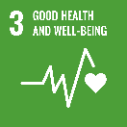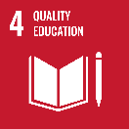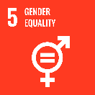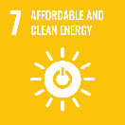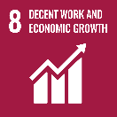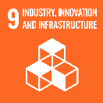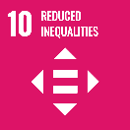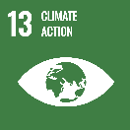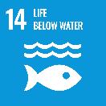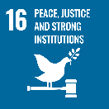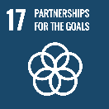

**The Republic of Palau is an independent country in a Compact of Free Association with the United States. It is a Micronesian country, comprising of 340 islands, eight of which are inhabited.**

The Government of Palau has outlined key national development priorities in its *Palau Development Plan 2023 – 2026* focusing on social support, Palauan culture and identity, environment and climate change, economic growth, and strengthening governance.

### Strategic direction

Australia works in genuine partnership with Palau to promote peace, prosperity and resilience across the region and help achieve Palau’s development objectives.

Our development program in Palau seeks to respond pragmatically to Palau’s priorities, including support for tax reform, digitisation of the health and agricultural sector, tertiary education and training, aviation connectivity and tourism, renewable energy, cyber security, gender equality, removal of UXOs, community, media and sports projects. Australia supports Palauan students to study at institutions in Australia through Australia Awards scholarships. Australia will continue to listen and consult with the Government of Palau to ensure the development program meets genuine needs.

### Program highlights

* Australia is partnering with Palau to expand connectivity in the Pacific with a non-stop flight service between Brisbane, Australia and Koror, Palau. The Palau Paradise Express commenced in May 2024 and is supported through the Australia-Pacific Partnerships for Aviation Program (SDG10; SDG8).
* Through the Australian Infrastructure Financing Facility for the Pacific (AIFFP), Australia has provided financing to Solar Pacific Pristine Power to construct and operate a grid connected solar power facility, which has the capacity to meet up to 20 per cent of Palau’s energy needs and reduce the Palauan Government’s dependency on diesel generation (SDG7).
* Co-financed with Japan and the United States, and through the AIFFP, Australia is supporting construction of an undersea cable to Palau that will provide greater system redundancy (SDG9).
* In partnership with Norwegian People’s Aid, Australia is supporting on-going clearance and removal efforts of explosive remnants of war in Palau and to build local capacity for future clearance work. This will mitigate harm to life and the environment and is expected to support land development and economic growth (SDG14).
* Australia is supporting Palau’s tax reform efforts, specifically the introduction of a GST. This is delivered through specialist tax advisers and access to Australian Tax Office support (SDG17).