# Development Cooperation Factsheet

## Philippines

MAY 2025



### Overview

Estimated Australian ODA: $94.4m (2025-26)

Gross National Income Per Capita: US$4,320 (2023)

Population: 114.9m (2023)

#### Table 1: Australian ODA to the Philippines, 2023-24 to 2025-26

| Australian ODA | 2023-24 Actual ($m)* | 2024-25 Budget Estimate ($m)* | 2025-26 Budget Estimate ($m)* |
| --- | --- | --- | --- |
| Country Programs | 69.2 | 70.4 | 71.4 |
| Regional | 10.2 | 13.5 | 11.9 |
| Global / Other | 4.8 | 4.8 | 7.2 |
| Other Government Departments | 4.1 | 5.5 | 4.0 |
| **Total ODA to the Philippines** | **88.4** | **94.2** | **94.4** |
| **Percentage total Australian ODA** | **1.8%** | **1.9%** | **1.9%** |

*Due to rounding, discrepancies may occur between sums of the component items in totals

#### Figure 1: Australian ODA to the Philippines by Sector Group, 2025-26 budget estimate

### Figure 1 presents the percentage of Australia’s Official Development Assistance (ODA) to the Philippines for the financial year 2025-26 attributable to seven sector groups. This information is presented in a doughnut chart, where the seven primary Sector Groups take a portion of shading in the doughnut in direct proportion to the total percentage attributable to each Sector Group. The percentages of total Australian ODA by Sector Groups are: Agriculture, trade and other production services 6% Economic infrastructure and services 8% Education 19% Governance 35% Health 5% Humanitarian 16% Multisector and General Development Support 11%Sustainable Development Goals

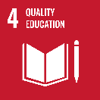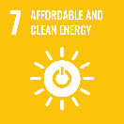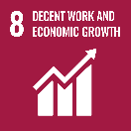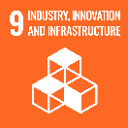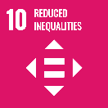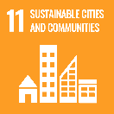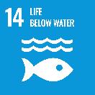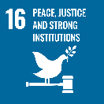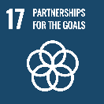

**The 50-year development partnership between Australia and the Philippines is a key pillar of our bilateral relationship. As articulated in the *Australia-Philippines Development Partnership Plan 2024-2029*, the overarching goal for the partnership is a stable, prosperous and resilient Philippines.**

Our development partnership objectives are to enhance the conditions for stability, bolster inclusive and sustainable economic growth, and increase institutional and community resilience to social, economic, and climate-related shocks. These objectives reflect the principles and priorities agreed in the Philippines-Australia Strategic Partnership and support the priorities presented in the *Philippine Development Plan 2023-2028*.

### Strategic direction

Our development program focuses on catalytic investments across a range of sectors strategic to the Philippines and Australia. Key areas of focus include peacebuilding, maritime cooperation, justice, economic growth and private sector development, education and skills, disaster and climate resilience, social protection and gender equality. We embed flexibility throughout our investments so that we can be response and adaptive.

We are prioritising locally-led development by supporting the Philippine Government’s own planning at national, subnational and local levels, and engaging with local civil society and development partners.

We will continue our innovative approach to technical assistance, which includes working with a mix of partners. We bring in Australian expertise from across the Australian Public Service, private sector, universities and civil society to build stronger institutional and whole-of-society linkages.

### Program highlights

In 2023-24, Australia supported:

* Mobilisation of $16 million in private investment in women’s economic empowerment in the Philippines (since 2016).
* Coral restoration projects to help coastal communities in Zambales, Palawan, Pangasinan and Cebu adapt to the economic and environmental impacts of climate change.
* Key economic policy reforms on public sector reform, digitalisation, climate resilience and energy transition, and women’s economic empowerment.
* Provision of life-saving relief items for 4,250 persons (including 250 pregnant/nursing mothers) severely affected by 2023 Typhoon Doksuri/Egay.
* Strengthened case management within the Philippines’ flagship social protection program, the Pantawid Pamilyang Pilipino Program (4Ps), which reaches 4.4 million Filipino families.
* The development of sector skills councils in data analytics and artificial intelligence, semiconductors and electronics, fruit and vegetables processing, healthcare, and green building construction, to help address the job-skills mismatch.