|  |  |
| --- | --- |
| **ESTIMATED AUSTRALIAN ODA 2021-22** | $587.8 million |
| **GROSS NATIONAL INCOME PER CAPITA** | US2,780 (2019) |
| **POPULATION** | 8.8 MILLION* (2019) |

|  |  |  |  |
| --- | --- | --- | --- |
| **Australian ODA** | **2019-20 Actual ($m)\*** | **2020-21 Budget Estimate ($m*)** | **2021-22 Budget Estimate ($m*)** |
| Country Programs | 508.7 | 491.1 | 479.2 |
| Regional | 46.4 | 63.2 | 53.2 |
| Global | 22.9 | 12.6 | 12.4 |
| Other Government Departments | 40.9 | 29.2 | 43.0 |
| **Total Australian ODA to PNG** | **618.9** | **596.0** | **587.8** |
| **% of Total Australian ODA** | **15.2%** | **14.9%** | **14.7%** |

**A stable, prosperous, peaceful and resilient PNG is critical to Australia’s interests. We are PNG’s largest development partner; its main partner on economic and security issues; and its most active supporter in helping it respond to the COVID-19 crisis.**

*\* Due to rounding, discrepancies may occur between sums of the component items and totals.*

PAPUA NEW GuinEA

Development Cooperation Factsheet: May 2021

*\*Due to rounding, discrepancies may occur between sums of the component items and totals.*

Strategic direction

The PNG COVID-19 Development Response Plan (CRP) sets out how Australia is helping PNG to respond to and recover from COVID-19 shocks over the next two years. Our support is framed around three pillars: **health security**; **stability**; and **economic recovery**, in line with *Partnerships for Recovery: Australia’s COVID-19 Development Response strategy*. The Comprehensive Strategic and Economic Partnership (CSEP) represents PNG and Australia’s shared priorities and provides the longer-term framework in which the CRP sits.

### Australia’s COVID-19 support focuses on working with PNG to help it respond to the epidemic, manage the related economic and social challenges, and ensure security and stability.

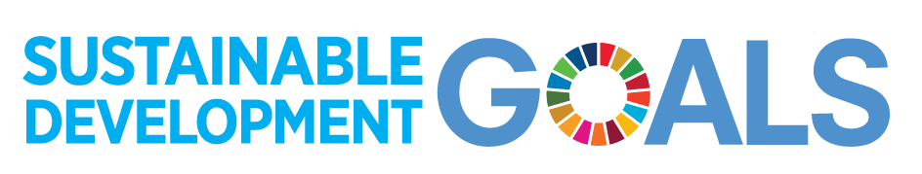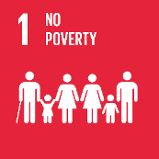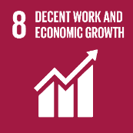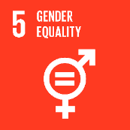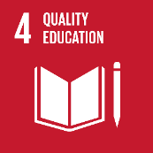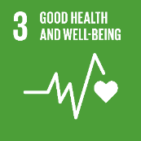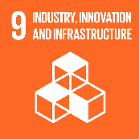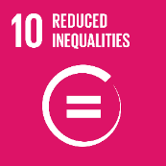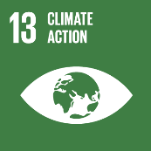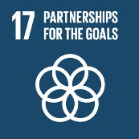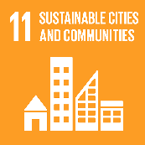

*Infrastructure Investments are made in all sectors, including health and governance*

### **Program highlights**

* Supported PNG’s COVID-19 response, including deployment of Australian Medical Assistance Teams; delivery of COVID-19 vaccines; support for COVID-19 testing, provision of PPE and information campaigns; and funding to help provinces implement their COVID-19 plans.
* Provided a loan of USD400 million to help the PNG Government to meet a financing shortfall and to help deliver economic reform.

**For more details**

* [PNG COVID-19 Development Response Plan](https://www.dfat.gov.au/publications/development/papua-new-guinea-covid-19-development-response-plan)
* [PNG-Australia Comprehensive Strategic and Economic Partnership](https://www.dfat.gov.au/geo/papua-new-guinea/papua-new-guinea-australia-comprehensive-strategic-and-economic-partnership)
* Completed the Coral Sea Cable providing better international telecommunications access.
* Maintained 1,700 kilometres of PNG’s 4,256 kilometres of national priority roads.
* Helped over 20,000 women and girls access crisis services.
* improved learning outcomes for 21,604 children (under the PNG Partnerships Fund).