# Development Cooperation Factsheet

## Palestine

MAY 2025

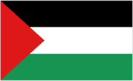

### Overview

Estimated Australian ODA: $31.6m (2025-26)

Gross National Income Per Capita: US$4,180 (2023)

Population: 5.2m (2023)

#### Table 1: Australian ODA to Palestine, 2023-24 to 2025-26

| Australian ODA | 2023-24 Actual ($m)* | 2024-25 Budget Estimate ($m)* | 2025-26 Budget Estimate ($m)* |
| --- | --- | --- | --- |
| Country Programs | 19.9 | 20.0 | 20.0 |
| Regional | 0.7 | 1.1 | 0.3 |
| Global / Other | 60.2 | 11.1 | 11.3 |
| Other Government Departments | - | - | - |
| **Total ODA to Palestine** | **80.7** | **32.2** | **31.6** |
| **Percentage total Australian ODA** | **1.7%** | **0.6%** | **0.6%** |

*Due to rounding, discrepancies may occur between sums of the component items in totals

#### Figure 1 presents the percentage of Australia’s Official Development Assistance (ODA) to Palestine for the 2025-26 budget estimate attributable to seven sector groups. This information is presented in a doughnut chart, where the seven primary Sector Groups take a portion of shading in the doughnut in direct proportion to the total percentage attributable to each Sector Group. The percentages of total Australian ODA by Sector Groups are: Agriculture, trade and other production services 9% Economic infrastructure and services 0% Education 21% Governance 27% Health 11% Humanitarian 32% Multisector and General Development Support 0%Figure 1: Australian ODA to Palestine by Sector Group, 2025-26 budget estimate

#### Sustainable Development Goals

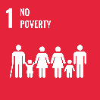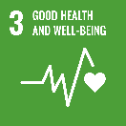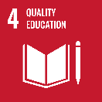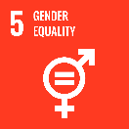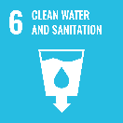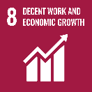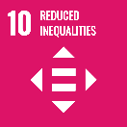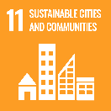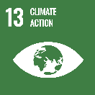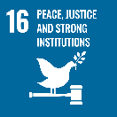

**The Palestinian is one of the poorest regions in the Middle East. Australia’s development cooperation and humanitarian assistance is a demonstration of our commitment to support enduring peace and a two-state solution where Israelis and Palestinians can live side by side in peace and security within internationally recognised borders.**

Australia has a long history of supporting Palestinians. Our annual $32 million bilateral development commitment focuses on inclusive economic growth and provision of basic services. Since 7 October 2023, Australia has also committed over $130 million in humanitarian assistance to conflict affected civilians in the Palestine and Lebanon. Australia continues to call for safe, unimpeded and sustained humanitarian access to and within Gaza for the delivery of lifesaving humanitarian assistance.

### Strategic direction

Australia’s development and humanitarian assistance to Palestine and to Palestinian refugees in Lebanon, Jordan and Syria, reflects and responds to urgent humanitarian needs, the protracted refugee crisis in the region and supports Australia’s interest in a stable and secure Middle East.

### Program highlights

Through a range of multilateral partners Australia supported:

* emergency food assistance to 428,750 severely food-insecure Palestinians affected by the ongoing conflict in Gaza;
* improved access to water, sanitation and hygiene services across Gaza and the West Bank through the provision of safe drinking water, wastewater infrastructure, sanitation services and dignity supplies to 1.5 million people;
* coordination of access and logistics support for humanitarian personnel and supplies into Gaza;
* improved access to essential services that protect sexual and reproductive health, prevent and respond to gender-based violence, and support the rights and well-being of women, girls and young people; and
* the protection of civilians and promotion of International Humanitarian Law throughout Palestine.