# Development Cooperation Factsheet

## Pakistan

MAY 2025



### Overview

Estimated Australian ODA: $11.5m (2025-26)

Gross National Income Per Capita: US$1,460 (2023)

Population: 247.5m (2023)

#### Table 1: Australian ODA to Pakistan, 2023-24 to 2025-26

| Australian ODA | 2023-24 Actual ($m)* | 2024-25 Budget Estimate ($m)* | 2025-26 Budget Estimate ($m)* |
| --- | --- | --- | --- |
| Country Programs | 0.2 | - | - |
| Regional | 7.2 | 6.9 | 5.0 |
| Global / Other | 1.8 | 1.8 | 2.7 |
| Other Government Departments | 2.0 | 3.9 | 3.8 |
| **Total ODA to Pakistan** | **11.1** | **12.6** | **11.5** |
| **Percentage total Australian ODA** | **0.2%** | **0.3%** | **0.2%** |

*Due to rounding, discrepancies may occur between sums of the component items in totals

**Figure 1 presents the percentage of Australia’s Official Development Assistance (ODA) to Pakistan for the financial year 2025-26 attributable to seven sector groups.

This information is presented in a doughnut chart, where the seven primary Sector Groups take a portion of shading in the doughnut in direct proportion to the total percentage attributable to each Sector Group.

The percentages of total Australian ODA by Sector Groups are:
Agriculture, trade and other production services 36%
Economic infrastructure and services 5%
Education 32%
Governance 3%
Health 22%
Humanitarian 0%
Multisector and General Development Support 2%**Figure 1: Australian ODA to Pakistan by Sector Group, 2025-26 budget estimate

### Sustainable Development Goals

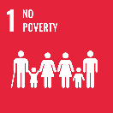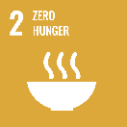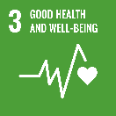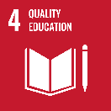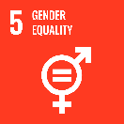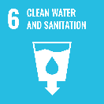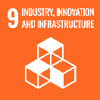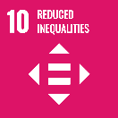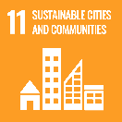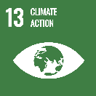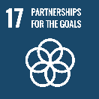

### Australia and Pakistan’s bilateral relationship is longstanding. It reflects genuine partnership through strong people-to-people links, cultural ties and shared interests in a peaceful, stable and prosperous region.

### Australia maintains targeted development assistance in Pakistan through ongoing global and regional programs. It aims to support people in Pakistan facing poverty, inequality, and climate-induced risk, emphasising locally-led delivery.

### Strategic direction

### Australia’s development cooperation in Pakistan aims to:

* address the impacts of climate change, by supporting adaptation and building community resilience;
* provide equitable access to essential health services, particularly for women and children;
* provide humanitarian assistance, including for those displaced; and
* connect and share Australian expertise to improve development outcomes.

### Program highlights

In 2024-25, Australia supported:

* enhanced water forecasting capabilities and reliable water allocation for Pakistan's farming communities, delivered by the Australian Centre for International Agricultural Research;
* improved access to clean and accessible water and sanitation facilities;
* improved food consumption and nutrition practices for people affected by the 2022 floods;
* family planning and reproductive health services for women and girls in underserviced communities; and
* Awarded 16 Australia Awards Scholarships to commence study in Australia and supported 20 awardees to undertake short courses.