# Development Cooperation Factsheet

## Pacific Regional

MAY 2025

  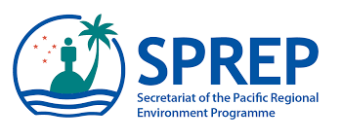

### Overview

Estimated Australian ODA: $790.4m (2025-26)

#### Table 1: Australian ODA to Pacific Regional, 2023-24 to 2025-26

| Australian ODA | 2023-24 Actual ($m)* | 2024-25 Budget Estimate ($m)* | 2025-26 Budget Estimate ($m)* |
| --- | --- | --- | --- |
| Country Programs | - | - | - |
| Regional | 322.9 | 567.4 | 629.1 |
| Global / Other | 179.8 | 166.2 | 155.0 |
| Other Government Departments | 7.2 | 4.7 | 6.3 |
| **Total ODA to Pacific Regional** | **509.9** | **738.3** | **790.4** |
| **Percentage total Australian ODA** | **10.6%** | **14.9%** | **15.5%** |

*Due to rounding, discrepancies may occur between sums of the component items in totals

#### Figure 1 presents the percentage of Australia’s Official Development Assistance (ODA) to Pacific Regional for the financial year 2025-26 attributable to seven sector groups. This information is presented in a doughnut chart, where the seven primary Sector Groups take a portion of shading in the doughnut in direct proportion to the total percentage attributable to each Sector Group. The percentages of total Australian ODA by Sector Groups are: Agriculture, trade and other production services 4% Economic infrastructure and services 9% Education 7% Governance 38% Health 11% Humanitarian 5% Multisector and General Development Support 26%Figure 1: Australian ODA to Pacific Regional by Sector Group, 2025-26 budget estimate

### Sustainable Development Goals

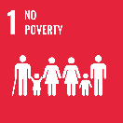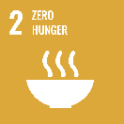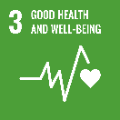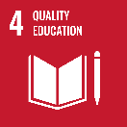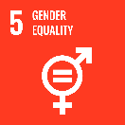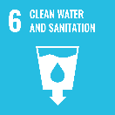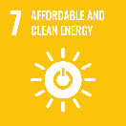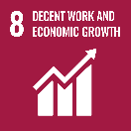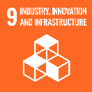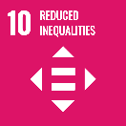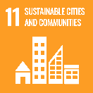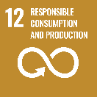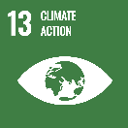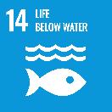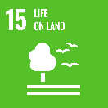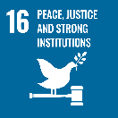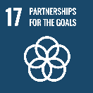

As the largest development partner in the Pacific, our relationships with Pacific countries are longstanding and enduring, based on respect and friendship and recognise our shared geography, history and culture. Listening to and respecting Pacific priorities and the needs of local communities is a fundamental priority for our partnership.

### Strategic direction

As a founding member of the Pacific Islands Forum (PIF) we will work through the Pacific’s regional architecture to meet shared challenges and safeguard our collective peace, stability and prosperity, guided by the PIF’s blueprint to meet these challenges: the 2050 Strategy for the Blue Pacific Continent. We will continue to support other regional institutions, including the Pacific Community (SPC), the Pacific Islands Forum Fisheries Agency, the Secretariat of the Pacific Regional Environment Programme and the University of the South Pacific.

Climate change impacts are an existential threat in the Pacific and Australia will invest in the region’s transition to renewable energy and support climate resilience. We will support economic growth and connectivity, including investments in transformative infrastructure such as highways, seaports, aviation links and telecommunications. Australia sees the Pacific as family and is focused on broadening and deepening personal and community connections through sport, culture and church linkages, including with Australian First Nations people and the Pacific diaspora in Australia. We will maintain our longstanding support for gender equality, disability and social inclusion (GEDSI).

### Program highlights

* The University of the South Pacific, the region’s premier tertiary education provider, produces approximately 4,000 graduates each year and helps to deliver on Pacific regional education priorities.
* Transformational infrastructure through the Australian Infrastructure Financing Facility for the Pacific (AIFFP) including a 15-megawatt privately-owned Palau solar farm financed by AIFFP, completed with the capacity to generate up to 23,000 megawatt hours per year or approximately 20 per cent of Palau’s electricity needs.
* Strong labour mobility outcomes with 34,230 Pacific Australia Labour Mobility (PALM) workers in Australia as of June 2024. PALM workers are estimated to send home an average of $1,500 each per month during their deployment in 2023-24 and take home to their communities new work experience and skills.
* Strengthened skills training systems and enhanced employment opportunities through the Australia Pacific Training Coalition. In 2023-24, 1,444 people graduated with full Australian qualifications (49 per cent female) and 6,011 people upskilled with short courses and micro credentials.
* *Team Up*, our flagship sports for development program in the Pacific, involves over 70 organisations transforming lives through sport. The Play for Equity Fund has provided small grants to 29 community initiatives using sport to advance gender and disability justice.
* PIF Leaders revitalised the Pacific Leaders Gender Equality Declaration which promotes an inclusive approach to gender equality and social inclusion, and recognises the responsibility and importance of both men and women in working towards achieving the PIF Leaders’ 2050 vision.