# Development Cooperation Factsheet

## Nepal

MAY 2025

### Overview

Estimated Australian ODA: $25.4m (2025-26)

Gross National Income Per Capita: US$1,430 (2023)

Population: 29.7m (2023)

#### Table 1: Australian ODA to Nepal, 2023-24 to 2025-26

| Australian ODA | 2023-24 Actual ($m)* | 2024-25 Budget Estimate ($m)* | 2025-26 Budget Estimate ($m)* |
| --- | --- | --- | --- |
| Country Programs | 9.1 | 9.1 | 9.1 |
| Regional | 14.5 | 5.9 | 5.6 |
| Global / Other | 11.2 | 10.1 | 9.7 |
| Other Government Departments | 0.8 | 1.0 | 1.0 |
| **Total ODA to Nepal** | **35.6** | **26.1** | **25.4** |
| **Percentage total Australian ODA** | **0.7%** | **0.5%** | **0.5%** |

*Due to rounding, discrepancies may occur between sums of the component items in totals

#### Figure 1: Australian ODA to Nepal by Sector Group, 2025-26 budget estimate

### Figure 1 presents the percentage of Australia’s Official Development Assistance (ODA) to Nepal for the financial year 2025-26 attributable to seven sector groups. This information is presented in a doughnut chart, where the seven primary Sector Groups take a portion of shading in the doughnut in direct proportion to the total percentage attributable to each Sector Group. The percentages of total Australian ODA by Sector Groups are: Agriculture, trade and other production services 13% Economic infrastructure and services 7% Education 24% Governance 37% Health 13% Humanitarian 4% Multisector and General Development Support 2%Sustainable Development Goals

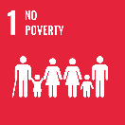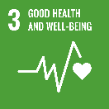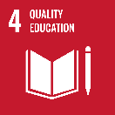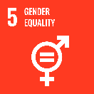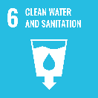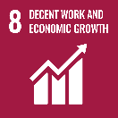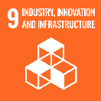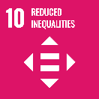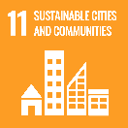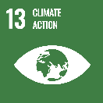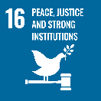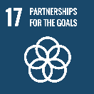

### Australia and Nepal celebrated 65 years of diplomatic relations in 2025. The relationship is built on a long-standing history of development partnership and close people-to-people links. We support Nepal’s transition to a middle-income country by 2026 and its contributions to a prosperous and stable Indo-Pacific region.

### Strategic direction

In line with the Sustainable Development Goals, Australia’s development cooperation program with Nepal aims to:

* support the roll-out of federalism, helping to improve intergovernmental coordination and clarify roles and responsibilities between the three spheres of government;
* build climate and disaster resilience, including through support to localise climate adaptation, promote green livelihoods and strengthen systems for early warning;
* promote gender, disability and social inclusion across all our programming and partnership; and
* support human development through the Australia Awards Scholarships program.

### Program highlights

In 2024-25, Australia has:

* Fostered improved coordination to strengthen intergovernmental relations between the three spheres of government; provided technical assistance to local and provincial governments to support stronger public financial management systems and service delivery; and improved understanding of, and response to the needs of women, marginalised groups and people with disabilities by engaging with over 12,000 local community members.
* Facilitated public consultations with over 6000 community members to identify and address climate risks and vulnerabilities; and continued to build the capacity of local governments on GEDSI responsive budgeting, inclusive disaster risk reduction plans, and early warning systems that supported the evacuation of over 74,000 people during monsoon floods in 2024.
* Supported 56 Australia Awards scholars to undertake master’s degrees, including six people with disability; facilitated eight study tours enabling participation by 30 professionals in Australian Professional Opportunities; and 11 activities that strengthened and maintained ongoing professional and people-to-people links for 296 alumni from Nepal.
* Partnered with eight organisations from the Australian Volunteers Program, to place 12 Australian volunteers in dedicated assignments contributing to areas such as natural resources and forest fire management, urban planning, tourism development and occupational therapy.