Development Cooperation Factsheet

Nauru
MAY 2026


Overview
Estimated Australian ODA: $46.0m (2026-27)0F
Gross National Income Per Capita: US$20,400 (2024)
Population: 11,947 (2024)

Table 1: Australian ODA to Nauru, 2024-25 to 2026-27
Australian ODA | 2024-25 Actual ($m)* | 2025-26 Budget Estimate ($m)* | 2026-27 Budget Estimate ($m)* ¹
Country Programs | 47.6 | 25.9 | 25.9
Regional | 31.4 | 18.4 | 19.6
Global / Other | 0.2 | 0.2 | 0.2
Other Government Departments | 0.6 | 1.5 | 0.3
Total ODA to Nauru | 79.8 | 46.0 | 46.0
Percentage total Australian ODA | 1.6% | 0.9% | 0.9%
*Due to rounding, discrepancies may occur between sums of the component items in totals

Figure 1: Australian ODA to Nauru by Sector Group, 2026-27 budget estimate
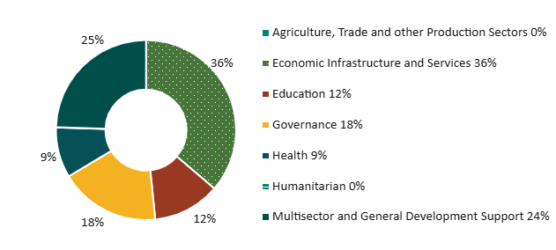

Sustainable Development Goals
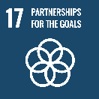
Australia is proud to be Nauru’s partner of choice with the largest economic, development and security cooperation program. Our partnership with Nauru builds on our extensive shared history, cultural affinity, and love of sport which binds our people.
Australia is committed to strengthening our development partnership and advancing our shared interests in a peaceful, stable and prosperous Pacific. We are supporting high-quality outcomes in priority sectors for Nauru across health, education, sport, infrastructure, economic governance, and advancing gender equality and disability inclusion.

Strategic direction
The Nauru-Australia Treaty signed on 9 December 2024 elevated the long-standing partnership between our two countries to an integrated economic, social and security partnership. The Treaty further strengthens our commitment to work with Nauru on its development challenges and shape our program to be responsive and best support emerging needs and priorities.
Our development program builds on Nauru’s priorities in the National Sustainable Development Strategy (NSDS) 2019-2030 for a stronger and more diversified economy underpinned by stable and responsible governance. To respond to this, we are refocusing bilateral programs to ensure our partnerships support Nauru’s prosperity and resilience. Australia’s support delivers investments in climate-sensitive infrastructure as well as economic governance reforms, education pathways, strengthened public health outcomes, and avenues for long-term fiscal sustainability post-2033.

Program highlights
In 2025-26, Australia supported:
- Economic resilience through reforms and improvements in expenditure control and fiscal transparency, improved budget processes, increased taxation and customs revenue capture, and risk-based audits.
- Uptake of the Queensland Certificate of Education and TVET opportunities in schools, as well as individual education plans to support students with learning disabilities.
- Removal and destruction of unexploded ordinances from the Nauru airport runway, and completion of the East Micronesia Cable connection to provide secure, reliable telecommunications, and connectivity to Nauru.
- Public health outcomes through mobilising health advisors to the Department of Health and Medical Services, and deploying an expert medical team to Nauru during a 2025 dengue fever outbreak.
- Improved transparency, inclusivity and accountability in key democratic institutions such as the Nauru Parliament, judiciary, Nauru Police Force, and Nauru Electoral Commission.

2026–27 ODA allocations and flows to Nauru may change pending Nauru’s scheduled graduation from ODA eligibility from 1 January 2027. DFAT would provide non-ODA development assistance following Nauru’s graduation.

