# Development Cooperation Factsheet

## Myanmar

MAY 2025

Myanmar flag

### Overview

Estimated Australian ODA: $124.8m (2025-26)

Gross National Income Per Capita: US$1,230 (2023)

Population: 54.1m (2023)

#### Table 1: Australian ODA to Myanmar, 2023-24 to 2025-26

| Australian ODA | 2023-24 Actual ($m)* | 2024-25 Budget Estimate ($m)* | 2025-26 Budget Estimate ($m)* |
| --- | --- | --- | --- |
| Country Programs | 41.8 | 42.1 | 45.1 |
| Regional | 4.4 | 9.5 | 9.4 |
| Global / Other | 63.8 | 69.5 | 70.2 |
| Other Government Departments | 0.4 | 0.3 | - |
| **Total ODA to Myanmar** | **110.4** | **121.4** | **124.8** |
| **Percentage total Australian ODA** | **2.3%** | **2.4%** | **2.4%** |

*Due to rounding, discrepancies may occur between sums of the component items in totals

#### Figure 1 presents the percentage of Australia’s Official Development Assistance (ODA) to Myanmar for the financial year 2025-26 attributable to seven sector groups. This information is presented in a doughnut chart, where the seven primary Sector Groups take a portion of shading in the doughnut in direct proportion to the total percentage attributable to each Sector Group. The percentages of total Australian ODA by Sector Groups are: Agriculture, trade and other production services 4% Economic infrastructure and services 1% Education 23% Governance 11% Health 6% Humanitarian 53% Multisector and General Development Support 2%Figure 1: Australian ODA to Myanmar by Sector Group, 2025-26 budget estimate

### Sustainable Development Goals

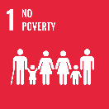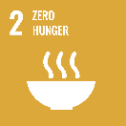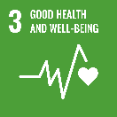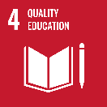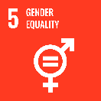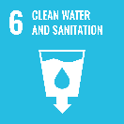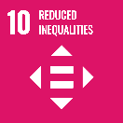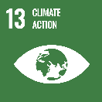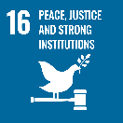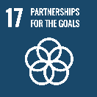

**The 2021 military coup in Myanmar reversed years of democratic, economic and development gains and plunged the country into a deep political, economic, humanitarian and security crisis. Despite the challenges, Australia’s assistance continues to reach communities in need throughout Myanmar.**

Australia is committed to supporting the people of Myanmar through our international advocacy and our development and humanitarian assistance. Australia does not provide any direct funding to the military regime, and we take proactive steps to ensure our assistance to Myanmar neither goes to the regime nor lends it credibility or legitimacy.

### Strategic direction

### Our work in Myanmar operates at the nexus of humanitarian, peace and development practice. Myanmar is subject to a protracted crisis, meaning many humanitarian operations are providing longer-term assistance that supports development goals while also working to alleviate acute suffering. Our humanitarian program addresses immediate needs and helps to improve communities' resilience to future shocks. The development program is focused on longer-term improvement and the provision of essential services, positioning us to provide greater support to specific sectors should there be substantial transformation of the situation. We continue to support the promotion of peace and democratic values and build the leadership and skills of the people of Myanmar. We work through trusted partners including the United Nations and non-government organisations.

### Program highlights

In 2024-25, Australia supported:

* Providing life-saving assistance, including distributing basic food and non-food items, emergency food, water and shelter.
* Delivering basic education services to children living in vulnerable and conflict affected communities.
* Improving the nutrition status and food security of populations in conflict affected areas through agricultural and livelihoods assistance.
* Delivering primary health care, essential health supplies and mental health services through local non-government organisations.
* A strong focus on gender equality by providing frontline services to improve women’s health and well-being including obstetrics and maternal and child health care, and access to gender-based violence support and counselling.
* Supporting efforts to mitigate conflict and its impacts and help protect space for longer-term progress on human rights, rule of law and democracy.