Development Cooperation Factsheet

Mongolia
MAY 2025


Overview
Estimated Australian ODA: $10.6m (2025-26)
Gross National Income Per Capita: US$4,870 (2023)
Population: 3.5m (2023)

Table 1: Australian ODA to Mongolia, 2023-24 to 2025-26
Australian ODA | 2023-24 Actual ($m)* | 2024-25 Budget Estimate ($m)* | 2025-26 Budget Estimate ($m)*
Country Programs | 5.6 | 5.6 | 5.6
Regional | 5.1 | 2.7 | 3.0
Global / Other | 2.2 | 1.7 | 2.0
Other Government Departments | - | - | -
Total ODA to Mongolia | 12.9 | 10.0 | 10.6
Percentage total Australian ODA | 0.3% | 0.2% | 0.2%
*Due to rounding, discrepancies may occur between sums of the component items in totals

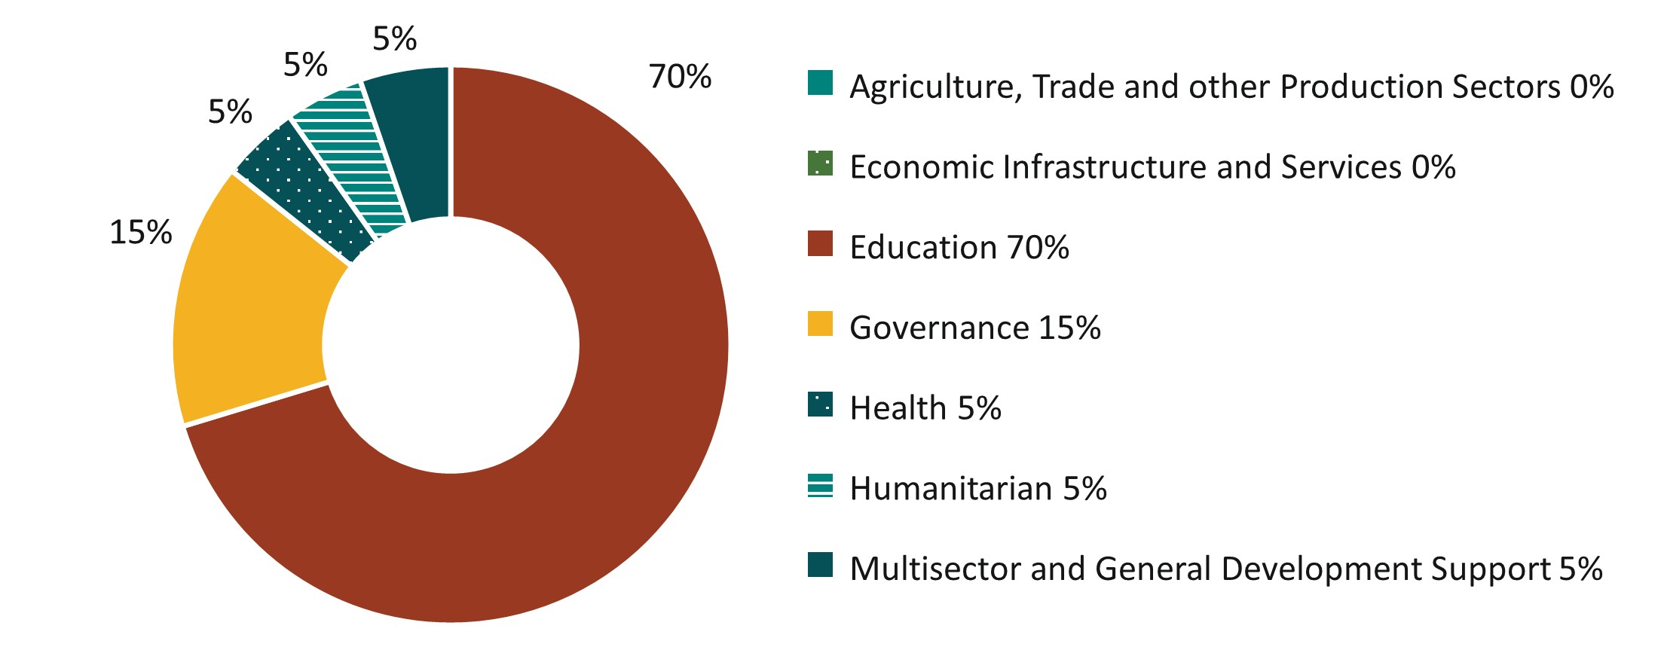
Figure 1: Australian ODA to Mongolia by Sector Group, 2025-26 budget estimate

Sustainable Development Goals
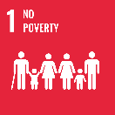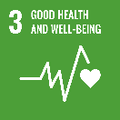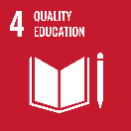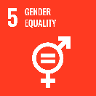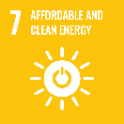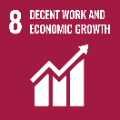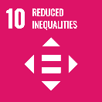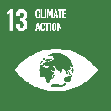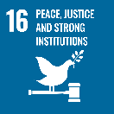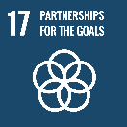
Australia’s relationship with Mongolia is longstanding and broad, spanning trade, investment, diplomatic and people-to-people links, defence and development cooperation.
The Australia Awards and Australian Volunteers program in Mongolia has supported knowledge transfer and people-to-people links between the two countries for over 30 years. Around 800 Mongolian alumni (‘Mozzies’) have benefited from Australian tertiary education and now support Mongolia’s development in almost all fields.
Australia continues to assist in Mongolia’s sustainable economic development through building human resource and organisational capacity in the public, private and civil society sectors, through the Women’s Climate Resilience Program, Technical and Vocational Education Projects, Direct Aid Program and Australian Volunteers Program. Australia supports Mongolia to have a robust democracy and an open, inclusive and well-managed economy.

Strategic direction

Australia’s development cooperation program in Mongolia aims to:
- build human capacity through the Australia Awards and Australian Volunteers Programs; and
- support gender equality and climate change action through the Women’s Climate Resilience Program, Technical and Vocational Education projects, Direct Aid and other programs.

Program highlights
- Australia provided $250,000 in humanitarian support in response to Mongolia’s 2024 “dzud” – an extreme cold weather event that resulted in 20 deaths including two children.
- In 2024-25, we awarded 17 Australia Awards Scholarships, ran four regional and in-country short courses and two Australian Professional Opportunity activities focused on energy reform and tax policy.
- Australian Volunteers Program in Mongolia continues to build a stronger partnership between Australia and Mongolia and most importantly, promote people to people links.
- The annual Women’s Leadership Program is improving the leadership skills of Australian Awards alumni from the public, private and civil society sectors.
- We support Mongolia to improve its professional education sector through a Cooperative Technical and Vocation Education and Training program.
- We are building women’s resilience to climate change through the Women’s Climate Resilience program.
- Through the Direct Aid Program, we are supporting Australian and local organisations to implement projects in the health, education, disability, gender, human rights and agriculture sectors of Mongolia to address local development challenges.

