# Development Cooperation Factsheet

## Maldives

MAY 2025

Maldives flag

### Overview

Estimated Australian ODA: $6.4m (2025-26)

Gross National Income Per Capita: US$11,070 (2023)

Population: 0.5m (2023)

#### Table 1: Australian ODA to Maldives, 2023-24 to 2025-26

| Australian ODA | 2023-24 Actual ($m)* | 2024-25 Budget Estimate ($m)* | 2025-26 Budget Estimate ($m)* |
| --- | --- | --- | --- |
| Country Programs | 2.4 | 3.0 | 3.0 |
| Regional | 1.6 | 1.8 | 3.4 |
| Global / Other | - | - | - |
| Other Government Departments | - | - | - |
| **Total ODA to Maldives** | **4.0** | **4.8** | **6.4** |
| **Percentage total Australian ODA** | **0.1%** | **0.1%** | **0.1%** |

*Due to rounding, discrepancies may occur between sums of the component items in totals

#### Figure 1: Australian ODA to Maldives by Sector Group, 2025-26 budget estimate

### Figure 1 presents the percentage of Australia’s Official Development Assistance (ODA) to Maldives for the financial year 2025-26 attributable to seven sector groups. This information is presented in a doughnut chart, where the seven primary Sector Groups take a portion of shading in the doughnut in direct proportion to the total percentage attributable to each Sector Group. The percentages of total Australian ODA by Sector Groups are: Agriculture, trade and other production services 4% Economic infrastructure and services 20% Education 56% Governance 5% Health 0% Humanitarian 0% Multisector and General Development Support 15%Sustainable Development Goals

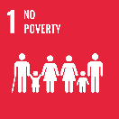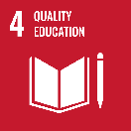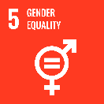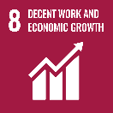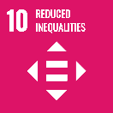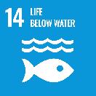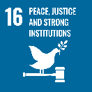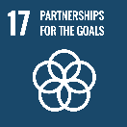

### Maldives is an emerging Indian Ocean democracy and a small island developing state vulnerable to the impact of climate change. Australia has an interest in a prosperous, peaceful and stable Maldives, underpinned by strong democratic institutions and a robust civil society.

### The increase in Australia’s development program demonstrates our commitment to deliver these outcomes and support Maldives’ democracy.

### Australia’s development activities respond to needs identified in consultation with Maldives and are delivered in partnership with national institutions and other development partners.

### Strategic direction

### In line with the Sustainable Development Goals, Australia’s development cooperation program in Maldives aims to:

* support capacity building through Australia Awards Scholarships and Fellowships
* strengthen governance and improve access to justice and
* build Maldivian capabilities to respond to the existential challenges of climate change.

### Program highlights

In 2024-25, Australia supported:

* 16 Australia Awards scholarships and ran short courses in response to identified needs in areas such as climate finance.
* democratic governance through practice parliaments that strengthened democracy and encouraged gender equality in political representation.
* Maldives’ blue economy capabilities by developing its ability to collect data on and rehabilitate its vital reef systems.