# Development Cooperation Factsheet

## Laos

MAY 2025



### Overview

Estimated Australian ODA: $55.1m (2025-26)

Gross National Income Per Capita: US$2,110 (2023)

Population: 7.7m (2023)

#### Table 1: Australian ODA to Laos, 2023-24 to 2025-26

| Australian ODA | 2023-24 Actual ($m)* | 2024-25 Budget Estimate ($m)* | 2025-26 Budget Estimate ($m)* |
| --- | --- | --- | --- |
| Country Programs | 28.0 | 24.1 | 26.1 |
| Regional | 22.7 | 23.7 | 16.8 |
| Global / Other | 5.2 | 5.4 | 5.8 |
| Other Government Departments | 5.0 | - | 6.4 |
| **Total ODA to Laos** | **60.9** | **53.2** | **55.1** |
| **Percentage total Australian ODA** | **1.3%** | **1.1%** | **1.1%** |

*Due to rounding, discrepancies may occur between sums of the component items in totals

#### Figure 1: Australian ODA to Laos by Sector Group, 2025-26 budget estimate

Figure 1 presents the percentage of Australia’s Official Development Assistance (ODA) to Laos for the financial year 2025-26 attributable to seven sector groups.

This information is presented in a doughnut chart, where the seven primary Sector Groups take a portion of shading in the doughnut in direct proportion to the total percentage attributable to each Sector Group.

The percentages of total Australian ODA by Sector Groups are:
Agriculture, trade and other production services 15%
Economic infrastructure and services 11%
Education 38%
Governance 11%
Health 8%
Humanitarian 1%
Multisector and General Development Support 16%

### Sustainable Development Goals

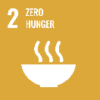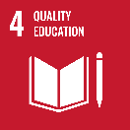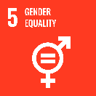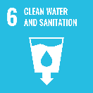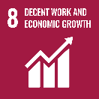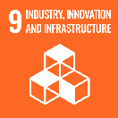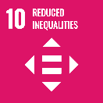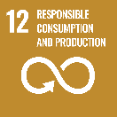

**Australia and Laos are longstanding bilateral and regional partners. The relationship is underpinned by development cooperation, business ties and people-to-people links.**

In 2024, Australia and Laos elevated our relationship to a Comprehensive Partnership, deepening and expanding our engagement. In addition to our bilateral development program, we provide substantial support through regional programs, including the Mekong-Australia Partnership and Partnerships for Infrastructure.

### Strategic direction

As outlined in the [*Australia-Laos Development Partnership Plan 2024-2029*](https://www.dfat.gov.au/publications/development/australia-laos-development-partnership-plan-2024-2029), Australia is supporting the following shared priorities with Laos: building human capital; supporting resilient, inclusive economic growth; and support for climate change resilience, adaptation and mitigation. Australia’s investments support the overarching Australia-Laos development partnership – a prosperous, resilient and stable Laos. The most vulnerable groups in Lao society, including women and girls, people with disabilities and ethnic minorities, are central to our engagement.

### Program highlights

In 2024-25, Australia:

* Awarded scholarships to 48 Lao nationals to study at world-class Australian higher education institutions – the highest number of Australia Awards Scholarships awarded per intake to date.
* Expanded a Lao language support program nationwide, increasing access to primary education for learners from non-Lao-speaking backgrounds.
* Delivered 36 tonnes of humanitarian supplies to strengthen the Government of Laos’ preparedness and emergency response capacity.
* ACIAR launched two new projects worth AUD7.4 million, to improve soil fertility for rice production restore forests. These are part of 19 ongoing ACIAR-funded research projects aimed at improving agricultural performance, strengthening research capacity and the resilience of Lao smallholder farmers.
* Provided an additional AUD4.5 million to help control the spread of dengue fever in hotspot cities in Laos.
* The Laos Australia Connectivity Partnership supported Laos in developing its first National Transport Strategy, which aims to create a connected, modernised transport system, attract investment, deliver economic and social benefits, and strengthen government capacity.
* Worked with the World Bank to provide support to the Ministry of Industry and Commerce to reduce the time to start a business to 23 days (from 173 days in 2018) and facilitated greater trade by cutting import, export, and transit times to 3.19 hours (from 9.4 hours in 2018).
* ACIAR and DFAT supported fish-friendly irrigation models in the Lower Mekong Basin through the construction of fish passages, which initial modelling showed were able to pass around 78 fish species ranging from 10-800mm in length.