# Development Cooperation Factsheet

## Kiribati

MAY 2025

Kiribati flag

### Overview

Estimated Australian ODA: $39.5m (2025-26)

Gross National Income Per Capita: US$3,740 (2023)

Population: 0.1m (2023)

#### Table 1: Australian ODA to Kiribati, 2023-24 to 2025-26

| Australian ODA | 2023-24 Actual ($m)* | 2024-25 Budget Estimate ($m)* | 2025-26 Budget Estimate ($m)* |
| --- | --- | --- | --- |
| Country Programs | 27.6 | 26.1 | 26.1 |
| Regional | 11.6 | 11.3 | 10.7 |
| Global / Other | 1.1 | 5.3 | 1.7 |
| Other Government Departments | 1.1 | 1.3 | 1.0 |
| **Total ODA to Kiribati** | **41.4** | **44.0** | **39.5** |
| **Percentage total Australian ODA** | **0.9%** | **0.9%** | **0.8%** |

*Due to rounding, discrepancies may occur between sums of the component items in totals

#### Figure 1 presents the percentage of Australia’s Official Development Assistance (ODA) to Kiribati for the financial year 2025-26 attributable to seven sector groups. This information is presented in a doughnut chart, where the seven primary Sector Groups take a portion of shading in the doughnut in direct proportion to the total percentage attributable to each Sector Group. The percentages of total Australian ODA by Sector Groups are: Agriculture, trade and other production services 7% Economic infrastructure and services 28% Education 23% Governance 24% Health 4% Humanitarian 9% Multisector and General Development Support 4%Figure 1: Australian ODA to Kiribati by Sector Group, 2025-26 budget estimate

### Sustainable Development Goals

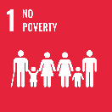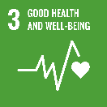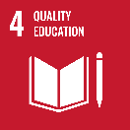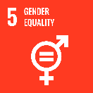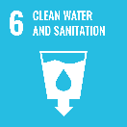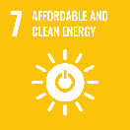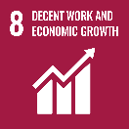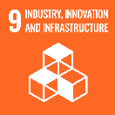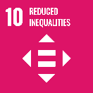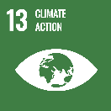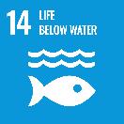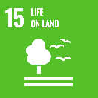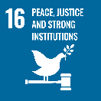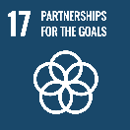

Australia is a long-standing partner of Kiribati. We work in partnership to deliver outcomes that align with Kiribati’s three core pillars of Te Mauri (Health), Te Raoi (Peace) and Te Tabomoa (Prosperity).

Australia is Kiribati’s largest bilateral development partner. Our development program in Kiribati is investing in health, education, economic growth, sustainable infrastructure, skills development, connectivity, gender equality, disability and social inclusion, climate resilience, and food security – to ensure prosperity for communities across Kiribati – and for generations to come.

### Strategic direction

Australia’s development cooperation aligns with the Government of Kiribati’s (GoK’s) development priorities, articulated in its ‘Kiribati Vision for 20 Years 2016-2036,’ and the Sustainable Development Goals (SDGs).

We will work with GoK to implement our International Development Policy and establish a Development Partnership Plan that will reflect how we will work together – in a genuine and respectful partnership – to address mutual interests and priorities and deliver positive outcomes for the people of Kiribati. Integral to this will be engaging with, and listening to, i-Kiribati partners to advance locally-led solutions.

Across all of our investments in Kiribati, Australia seeks to strengthen gender equality (SDG5) and disability inclusion (SDG10), as well as focus on climate resilience (SDG13).

### Program highlights

## We are working with the GoK to:

* Strengthen Kiribati’s health system and deliver essential health services, including mental health, rehabilitation and control of communicable diseases (SDG3).
* Improve education (SDG4), including by investing up to $50 million over the coming decade (2024-34) to deliver teacher training and improved learning environments for i-Kiribati children, including those with disabilities (SDG10).
* Develop workforce skills (SDG8) through our partnership with the Kiribati Institute of Technology and support i-Kiribati to access labour opportunities in Kiribati, the region and also Australia through our labour mobility (PALM) scheme.
* Invest in climate smart technology by delivering food-cubes, compost training and water tanks to improve food security (SDG2, SDG 3) for households and communities in Kiribati.
* Support the development of infrastructure (SDG 9), including:
* the East Micronesia Cable project, which will improve telecommunications connectivity across Kiribati, Nauru and the Federated States of Micronesia; and
* building schools, health and policing infrastructure.