# Development Cooperation Factsheet

## Indonesia

MAY 2025



### Overview

Estimated Australian ODA: $351.4 million (2025-26)

Gross National Income Per Capita: US$4,810 (2023)

Population: 281.2m (2023)

#### Table 1: Australian ODA to Indonesia, 2023-24 to 2025-26

| Australian ODA | 2023-24 Actual ($m)* | 2024-25 Budget Estimate ($m)* | 2025-26 Budget Estimate ($m)* |
| --- | --- | --- | --- |
| Country Programs | 293.2 | 312.1 | 319.3 |
| Regional | 17.5 | 23.4 | 12.7 |
| Global / Other | 10.4 | 11.2 | 11.8 |
| Other Government Departments | 7.9 | 6.9 | 7.7 |
| **Total ODA to Indonesia** | **329.1** | **353.7** | **351.4** |
| **Percentage total Australian ODA** | **6.8%** | **7.1%** | **6.9%** |

Figure 1 presents the percentage of Australia’s Official Development Assistance (ODA) to Indonesia for the financial year 2025-26 attributable to seven sector groups.

This information is presented in a doughnut chart, where the seven primary Sector Groups take a portion of shading in the doughnut in direct proportion to the total percentage attributable to each Sector Group.

The percentages of total Australian ODA by Sector Groups are:
Agriculture, trade and other production services 5%
Economic infrastructure and services 29%
Education 20%
Governance 36%
Health 3%
Humanitarian 4%
Multisector and General Development Support 3%*Due to rounding, discrepancies may occur between sums of the component items in totals

#### Figure 1: Australian ODA to Indonesia by Sector Group, 2025-26 budget estimate

### Sustainable Development Goals

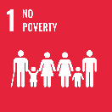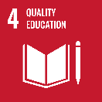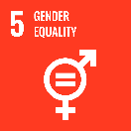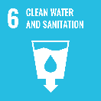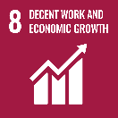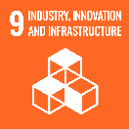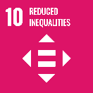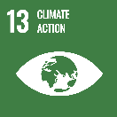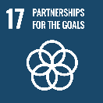

**Australia and Indonesia are close neighbours, strategic partners and friends.**

Australia and Indonesia have a long history of working together on shared priorities. We work in true partnership and have evolved the way we operate to keep pace with Indonesia’s rapid development and growing leadership role in the region. Our locally-led approach builds on Indonesia’s strengths and enables us to work together to address shared challenges.

### Strategic direction

**The overarching goal for the Australia-Indonesia development partnership is to promote Indonesia's prosperity, stability and resilience, and build strong links between our two countries.**

[The Australia–Indonesia Development Partnership Plan 2024–2028](https://www.dfat.gov.au/publications/development/australia-indonesia-development-partnership-plan-2024-2028) (DPP) translates into action shared development priorities. It sets out three overarching objectives (sustainable and equitable economic transformation, climate resilient communities, and strong institutions), how we will work together to deliver shared outcomes, and how progress will be monitored.

Development initiatives under the DPP are designed to flexibly respond to new opportunities for collaboration that are of mutual interest. Our initiatives provide a positive mechanism to engage with the Government of Indonesia and a range of other stakeholders, including civil society organisations, academia and private sector to promote a participatory approach to sustainable development.

### Program highlights

In 2023-24, Australia supported:

*Sustainable and equitable economic transformation*

* Indonesia’s accession to the Financial Action Task Force through PROSPERA [$259 million 2018-2026]
* 15 million children vaccinated against Polio through our Health Partnership [$72 million 2020-2025].

*Climate-resilient communities*

* climate change research partnerships worth $11.9 million through KONEKSI [$80 million 2021-2029]
* strengthened Indonesia’s climate disaster response capability through SIAP SIAGA [$64 million 2019-2024].

*Strong institutions and cross-cutting*

* improved access to justice for women and persons with disabilities through AIPJ [$74.5 million 2017-2025]
* 620 Indonesian students study in Australia through Australia Awards Indonesia [$128 million 2022-2030].