# Development Cooperation Factsheet

## Health

MAY 2025

### Overview

Estimated Australian ODA: $639.4m (2025-26)

#### Table 1: Australian Health ODA by region, 2023-24 to 2025-26

| Region | 2023-24 Actual ($m)* | 2024-25 Budget Estimate ($m)* | 2025-26 Budget Estimate ($m)* |
| --- | --- | --- | --- |
| Pacific | 220.3 | 225.2 | 255.7 |
| Southeast Asia | 113.6 | 100.0 | 116.5 |
| South and Central Asia | 22.8 | 22.9 | 19.9 |
| Middle East and Africa | 17.1 | 13.4 | 17.5 |
| Rest of the World^ | 316.2 | 294.4 | 229.7 |
| **Total Health ODA** | **689.9** | **655.9** | **639.4** |

* Due to rounding, discrepancies may occur between sums of the component items in totals.

^Includes ODA that is not attributed to particular countries or regions.

#### Figure 1 presents the percentage of Australia’s Official Development Assistance (ODA) for health for the financial year 2025-26 across five regions. This information is presented in a doughnut chart, where the five regions take a portion of shading in the doughnut in direct proportion to the total percentage attributable to each region. The percentages of total Australian health assistance ODA by region are: Pacific 40% Southeast Asia 18% South and Central Asia 3% Middle East and Africa 3% Rest of the World* 36% Figure 1: Australian Health ODA by Region, 2025-26 budget estimate

*\*Includes ODA that is not attributed to particular countries or regions.*

### Sustainable Development Goals

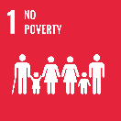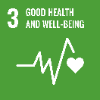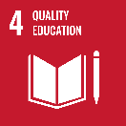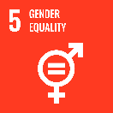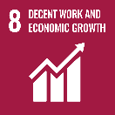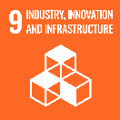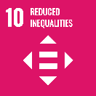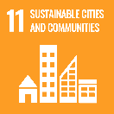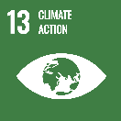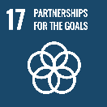

**Australia supports governments and communities, particularly in the Pacific and Southeast Asia, to build resilient, equitable and inclusive health systems.**

We are listening to the priorities of our region and supporting local leadership to respond to health challenges through responsive bilateral and regional programming. We also partner with global health organisations to extend our reach and impact, and advocate for our region in the global health system.

### Strategic direction

Our assistance for health is guided by Australia’s International Development Policy. We work at national, regional, and global levels to support partner countries to achieve their ambitions to deliver equitable access to quality, essential health services, help to prevent and respond to communicable and non-communicable diseases, and to advance sexual and reproductive health and rights.

We work with governments, civil society organisations and Australian, regional and multilateral partners to respond to our shared health challenges – including the risk of pandemics, antimicrobial resistance and the health impacts of climate change. Our health assistance supports inclusive health systems that aim to meet the needs of women and girls, people with disability and other groups experiencing marginalisation. We also seek to incorporate First Nations Australian perspectives in our investments.

### Program highlights

In 2023-24, Australia supported:

* 46 countries to improve the capacity of their health systems to provide quality, accessible and affordable health services through our bilateral and regional programs. The support we deliver through global health partnerships, including Gavi and the Global Fund, reaches many more.
* 30 countries to improve their ability to anticipate, prevent, detect, and control communicable disease threats. For example, our support helped enable the Solomon Islands to immunise an additional 71,447 children against measles and rubella in the lead up to hosting the 2023 Pacific Games, achieving 94.4% coverage.
* Over 3.3 million couple-years of contraceptive protection from unplanned pregnancies being made available for sexual and reproductive health.