Development Cooperation Factsheet

Gender Equality
MAY 2025

Overview
Estimated Australian ODA: $104.3 (2025-26)

Table 1: Total Australian Gender Equality ODA by Region, 2023-24
Australian ODA by Region | 2023-24 Actual ($m)* | 2023-24 Actual %
Pacific | 1,027.2 | 44%
Southeast Asia | 782.2 | 34%
South and Central Asia | 223.8 | 10%
Middle East and Africa | 175.3 | 8%
Rest of the World^ | 104.0 | 4%
Total Gender Equality ODA | 2,312.6 | 100%
*Due to rounding, discrepancies may occur between sums of the component items in totals
^Includes ODA that is not attributed to particular countries or regions.

Figure 1: Australian Gender Equality ODA by Sector Group, 2023-24 actual
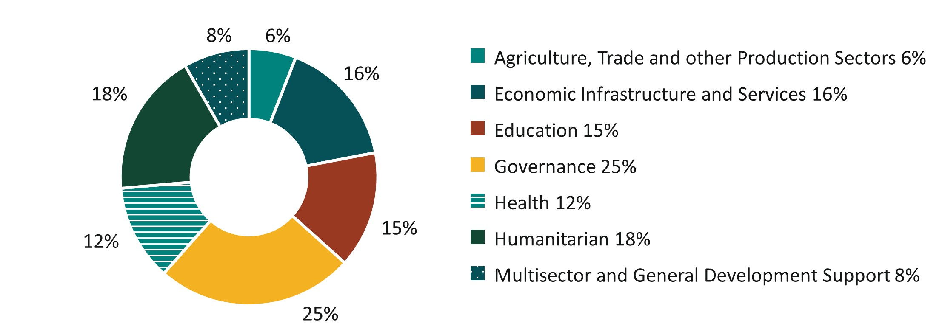

Sustainable Development Goals
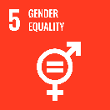
Australia is committed to advancing gender equality and the human rights of women and girls in all their diversity.
Gender equality is an essential precondition of stability, security, and prosperity, and benefits everyone. Gender inequality compounds the most pressing development challenges, preventing individuals, communities, and countries from meeting their full potential. More than 380 million women and girls worldwide are living in extreme poverty.

Strategic direction
Gender equality is a core issue for action of Australia’s International Development Policy.
Australia’s International Gender Equality Strategy reaffirms the centrality of our commitment to gender equality and advancing the human rights of women and girls. It outlines how we will use all tools of our foreign policy to drive gender equality, including through our bilateral and regional programs and relationships, our multilateral diplomacy, trade, development and humanitarian assistance.
We have reinstated a target for 80 per cent of all development investments to address gender equality effectively and require new investments of more than $3 million to include gender equality objectives.
In 2024-25, we will provide $65 million through the Indo-Pacific Gender Equality Fund to advance gender equality and the rights of women and girls in all their diversity.

Program highlights
- In 2024-25, Australia provided an additional $500,000 to Women’s Fund Asia to support refugee women-led organisations working for the human rights of refugee women, including to prevent and respond to sexual and gender-based violence (SGBV). This brings Australia’s support to regional women’s funds under the Amplify-Invest-Reach partnership to $13 million (2021-2026).
- Australia will expand support to the vital work of SGBV crisis centres in the Pacific through an additional $25 million over five years under Pacific Women Lead. This will enable SGBV crisis centres to extend the quality and reach of essential services to improve the safety, protection, and recovery of survivors of SGBV.
- Australian Development Investments made its first investment under the Investing in Women window – US $5 million in the Asia Business Builders Fund II, a Vietnam-based fund. Investing in Women aims to increase investment in businesses that benefit women, including companies that support women’s leadership, ownership and workforce participation.

