# Development Cooperation Factsheet

## The Federated States of Micronesia (FSM)

MAY 2025



### Overview

Estimated Australian ODA: $11.4m (2025-26)

Gross National Income Per Capita: US$4,250 (2023)

Population: 0.1m (2023)

#### Table 1: Australian ODA to Micronesia, 2023-24 to 2025-26

| Australian ODA | 2023-24 Actual ($m)* | 2024-25 Budget Estimate ($m)* | 2025-26 Budget Estimate ($m)* |
| --- | --- | --- | --- |
| Country Programs | 2.3 | 3.1 | 3.6 |
| Regional | 3.1 | 1.1 | 7.3 |
| Global / Other | 0.6 | 0.6 | 0.5 |
| Other Government Departments | 0.0 | - | - |
| **Total ODA to Micronesia** | **6.0** | **4.7** | **11.4** |
| **Percentage total Australian ODA** | **0.1%** | **0.1%** | **0.2%** |

*Due to rounding, discrepancies may occur between sums of the component items in totals

Figure 1 presents the percentage of Australia’s Official Development Assistance (ODA) to the Federated States of Micronesia for the financial year 2025-26 attributable to sector groups.

The percentages of total Australian ODA by Sector Groups are:
Agriculture, trade and other production services 1%
Economic infrastructure and services 67%
Education 16%
Governance 7%
Health 4%
Humanitarian 0%
Multisector and General Development Support 5%Figure 1: Australian ODA to Micronesia by Sector Group, 2025-26 budget estimate

### Sustainable Development Goals

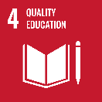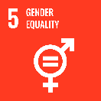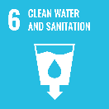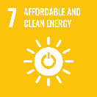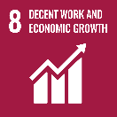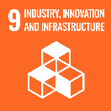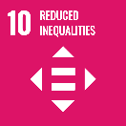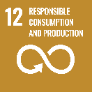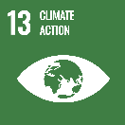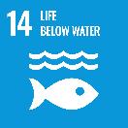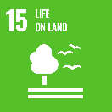

**Federated States of Micronesia (FSM) is an independent country in a Compact of Free Association with the United States. It comprises 607 islands, 65 of which are inhabited.**

The Government of the Federated States of Micronesia has outlined its national development priorities in its *FSM Strategic Development Plan 2024-2043*focusing on cultural heritage, education and human capital, health and wellbeing, gender equality and social inclusion, governance and institutional strengthening, peace and security, sustainable economic development, environmental sustainability and climate change, and infrastructure development and sustainability.

### Strategic direction

**Australia and the Federated States of Micronesia (FSM) share a close partnership, based on equality and respect.**

In cooperation with FSM, we are delivering important development outcomes in the areas of aviation and telecommunications connectivity, education and scholarships (Australia Awards), family protection and gender-based violence, climate change and disaster resilience.

Australia will continue to listen and consult with the Government of FSM to ensure our partnership meets genuine need and delivers long term benefits. Australia’s ability to respond to crises effectively will continue to be an important aspect of our partnership. Australia will continue to support Micronesian students to study at institutions in Australia and the region through Australia Awards Scholarships.

### Program highlights

In 2023-24:

* Through the Australian Infrastructure Financing Facility for the Pacific (AIFFP), Australia is supporting the East Micronesia Cable project that will improve internet connectivity and access to digital technologies across FSM, Nauru and Kiribati, including through delivery of the first submarine cable connection to Kosrae (SDG9).
* Supporting aviation connectivity between Australia, Palau, FSM, the Republic of the Marshall Islands, Kiribati and Nauru. P4A is partnering in the Pacific for a safer, more resilient and sustainable aviation sector (SDG10).
* Australia is supporting FSM’s efforts to increase electrification and reach renewable energy targets through investments in remote solar mini-grid systems. Through the Pacific Climate Infrastructure Financing Partnership, Australia is financing mini-grid systems on Woleai Atoll in Yap State, Pingelap Atoll in Pohnpei State and the islands of Piis Paneu and Etten in Chuuk State.
* Australia is supporting existing efforts by FSM and Japan to address the oil spill risks from World War II wrecks in Chuuk Lagoon (SDG14).

Progressing gender equality outcomes through Pacific Women Lead and our partnership with UNICEF by supporting a National Family Protection adviser and GBV counselling service.

* Australia, partnering with FSM and the Asian Development Bank, is co-financing the Improving Quality Basic Education Project to enhance the effectiveness and efficiency of FSM education systems to strengthen early grade learning in all schools (SDG4).