# Development Cooperation Factsheet

## FIJI

MAY 2025



### Overview

Estimated Australian ODA: $123.1m (2025-26)

Gross National Income Per Capita: US$5,680 (2023)

Population: 0.9m (2023)

#### Table 1: Australian ODA to Fiji, 2023-24 to 2025-26

| Australian ODA | 2023-24 Actual ($m)* | 2024-25 Budget Estimate ($m)* | 2025-26 Budget Estimate ($m)* |
| --- | --- | --- | --- |
| Country Programs | 127.6 | 54.0 | 64.0 |
| Regional | 32.3 | 57.3 | 48.4 |
| Global / Other | 6.9 | 7.1 | 7.2 |
| Other Government Departments | 4.3 | 4.8 | 3.5 |
| **Total ODA to Fiji** | **171.2** | **123.1** | **123.1** |
| **Percentage total Australian ODA** | **3.6%** | **2.5%** | **2.4%** |

*Due to rounding, discrepancies may occur between sums of the component items in totals

#### Figure 1: Australian ODA to Fiji by Sector Group, 2025-26 budget estimate

### Figure 1 presents the percentage of Australia’s Official Development Assistance (ODA) to Fiji for the financial year 2025-26 attributable to seven sector groups. This information is presented in a doughnut chart, where the seven primary Sector Groups take a portion of shading in the doughnut in direct proportion to the total percentage attributable to each Sector Group. The percentages of total Australian ODA by Sector Groups are: Agriculture, trade and other production services 8% Economic infrastructure and services 2% Education 12% Governance 32% Health 10% Humanitarian 19% Multisector and General Development Support 17%Sustainable Development Goals

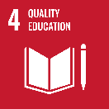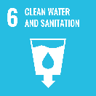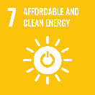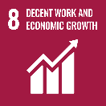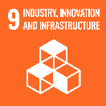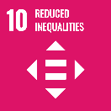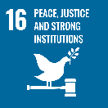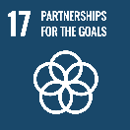

**Australia is Fiji’s largest bilateral development assistance partner. Our development cooperation program supports resilient, sustainable and equitable development in Fiji—a key hub for the Pacific region.**

The relationship between Fiji and Australia is underpinned by close and practical cooperation. Development Programs in Fiji contribute to the achievement of Fiji’s National Development Plan and Fiji’s implementation of the Sustainable Development Goals.

### Strategic direction

Australia and Fiji share a strong and enduring bilateral relationship. Therenewed and elevated *Fiji-Australia Vuvale Partnership* articulates our shared aspiration to enhance cooperation, consultation and friendship.

Australia’s development cooperation program in Fiji supports our ambition for a Pacific region that is peaceful, stable and prosperous.

We are committed to climate action and scaling up locally-led program delivery. We are supporting high-quality outcomes in priority sectors for Fiji including health, education and skills, as well as strengthening climate change action and advancing gender equality.

### Program highlights

* Our ODA for 2024-25 was supplemented by additional budget support of FJD 72million (AUD50million) to strengthen public financial management, drive economic reforms, and build climate and social resilience.
* Australia provided AUD10 million for a long term infrastructure master plan for Colonial War Memorial (CWM) Hospital and committed an additional AUD10 million for immediate infrastructure upgrades at CWM in line with the Priority Infrastructure Plan.
* Australian Infrastructure Financing Facility for the Pacific (AIFFP) is providing over AUD145.3 million in loan and grant finance to Fiji for infrastructure development. AIFFP’s first fully repaid loan was in Fiji. FJD$106 million (AUD68.4 million) in loan and guarantee financing alongside ANZ was provided to Airports Fiji to support capital works projects at Nadi International Airport and outer island airports.