# Development Cooperation Factsheet

## Bhutan

MAY 2025



### Overview

Estimated Australian ODA: $6.2m (2025-26)

Gross National Income Per Capita: US$3,600 (2022)

Population: 0.8m (2023)

#### Table 1: Australian ODA to Bhutan 2023-24 to 2025-26

| Australian ODA | 2023-24 Actual ($m)* | 2024-25 Budget Estimate ($m)* | 2025-26 Budget Estimate ($m)* |
| --- | --- | --- | --- |
| Country Programs | 2.1 | 2.1 | 2.1 |
| Regional | 7.5 | 2.5 | 3.6 |
| Global / Other | 0.4 | 0.1 | 0.5 |
| Other Government Departments | - | - | - |
| **Total ODA to Bhutan** | **10.0** | **4.7** | **6.2** |
| **Percentage total Australian ODA** | **0.2%** | **0.1%** | **0.1%** |

*Due to rounding, discrepancies may occur between sums of the component items in totals

#### Figure 1: Australian ODA to Bhutan by Sector Group, 2025-26 budget estimate

### Figure 1 presents the percentage of Australia’s Official Development Assistance (ODA) to Bhutan for the financial year 2025-26 attributable to seven sector groups. This information is presented in a doughnut chart, where the seven primary Sector Groups take a portion of shading in the doughnut in direct proportion to the total percentage attributable to each Sector Group. The percentages of total Australian ODA by Sector Groups are: Agriculture, trade and other production services 6% Economic infrastructure and services 32% Education 57% Governance 4% Health 1% Humanitarian 0% Multisector and General Development Support 0% Sustainable Development Goals

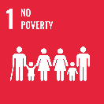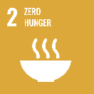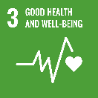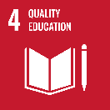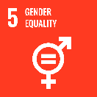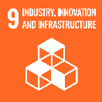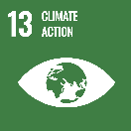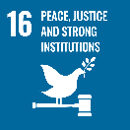

**Australia is supporting Bhutan to meet its sustainable development goals by helping build human capital and increase regional economic links and growth. Australia is considered a modest but highly regarded donor in Bhutan.**

Education and people-to-people links are key pillars of our bilateral relationship. Australia's Official Development Assistance to Bhutan is modest but it plays an important role in supporting Bhutan's sustainable development goals. Major forms of assistance include the provision of Australia Awards scholarships and fellowships, the South Asia Regional Infrastructure Connectivity program and the Australian Volunteers Program. Climate change and a focus on gender equality, disability and social inclusion remain important cross-cutting areas.

### Strategic direction

In line with the Sustainable Development Goals, Australia’s development cooperation program in Bhutan aims to:

* Build people to people links and human capacity through the provision of Australia Awards scholarships and fellowships.
* Increase regional economic links and growth through the South Asia Regional Infrastructure Connectivity (SARIC) Program.
* Support a resilient, inclusive and independent media through supporting activities under the Indo-Pacific Media Fund.

### Program highlights

In 2023-24, Australia supported:

* Bhutanese NGO ‘Respect, Educate, Nurture, Empower Women’ (RENEW, a member of the International Planned Parenthood Federation) to improve gender equality, strengthen sexual and reproductive health and rights, and address gender-based violence.
* Eight volunteer assignments through the Australian Volunteers Program to support partner organisations to progress their development objectives.
* Work with government and communities on water security and climate resilience through Water for Women partner SNV.
* Twelve long-term scholarships for study commencing in 2024 through the Australia Awards program in areas that contribute to Bhutan’s development priorities.