# Development Cooperation Factsheet

## Bangladesh

MAY 2025



### Overview

Estimated Australian ODA: $110.3m (2025-26)

Gross National Income Per Capita: US$2,880 (2023)

Population: 171.5m (2023)

#### Table 1: Australian ODA to Bangladesh, 2023-24 to 2025-26

| Australian ODA | 2023-24 Actual ($m)* | 2024-25 Budget Estimate ($m)* | 2025-26 Budget Estimate ($m)* |
| --- | --- | --- | --- |
| Country Programs | 30.8 | 30.8 | 31.8 |
| Regional | 4.7 | 5.5 | 7.7 |
| Global / Other | 72.4 | 66.8 | 67.0 |
| Other Government Departments | 3.3 | 3.8 | 3.8 |
| **Total ODA to Bangladesh** | **111.1** | **106.9** | **110.3** |
| **Percentage total Australian ODA** | **2.3%** | **2.2%** | **2.2%** |

*Due to rounding, discrepancies may occur between sums of the component items in totals

#### Figure 1: Australian ODA to Bangladesh by Sector Group, 2025-26 budget estimate

Figure 1 presents the percentage of Australia’s Official Development Assistance (ODA) to Bangladesh for the financial year 2025-26 attributable to seven sector groups.

This information is presented in a doughnut chart, where the seven primary Sector Groups take a portion of shading in the doughnut in direct proportion to the total percentage attributable to each Sector Group.

The percentages of total Australian ODA by Sector Groups are:
Agriculture, trade and other production services 5%
Economic infrastructure and services 1%
Education 22%
Governance 15%
Health 3%
Humanitarian 50%
Multisector and General Development Support 4%


### Sustainable Development Goals

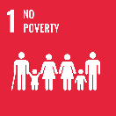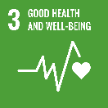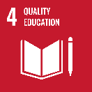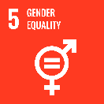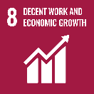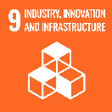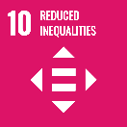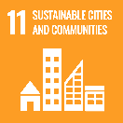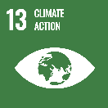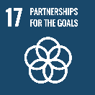

**Australia’s development cooperation program in Bangladesh aims to reduce inequality and support the drivers of inclusive growth: education, gender equality, skills development, and social protection.**

Our ongoing humanitarian assistance for Rohingya and host communities provides inclusive lifesaving assistance such as food, water, sanitation, protection services and shelter. This assistance builds resilience to shocks and aims to increase self-reliance through education and skills development.

### Strategic direction

### In line with the Sustainable Development Goals, we continue to support social protection reforms, skills development, and gender equality to drive inclusive growth. Australia will support Bangladesh’s economic development, including through economic reforms to assist Bangladesh’s transition to middle income status and realise its economic and trade potential.

### Program highlights

In 2024-25, Australia supported:

* Extremely poor children, especially girls and children with disabilities, to access quality basic education through our support to NGOs BRAC and UCEP.
* Humanitarian assistance to Rohingya and host communities in Bangladesh supporting the delivery of life-saving food, water and shelter as well as essential protection, education and health services to over one million people in need, including women, girls and people with disabilities.
* 68,266 young people (including 2,752 with disabilities) with technical/vocational training.
* Social protection reforms to enhance systems and governance, ensuring that support reaches the most vulnerable. We are also supporting the Government of Bangladesh in establishing governance processes to efficiently and effectively serve over 2000 NGOs.
* 130 scholarships awarded to Bangladeshi nationals. This included 60 Master's level scholars and 70 professionals attending short courses on governance, environment and climate change, and trade at Australian institutes.
* The Bangladesh Government with key economic and trade policy reforms in line with Bangladesh’s expected LDC status graduation in 2026.