# Development Cooperation Factsheet

## Agriculture

MAY 2025

### Overview

#### Agriculture, fisheries, and the broader food system are on the front line of climate change. Nearly half of households in the Indo-Pacific depend on agriculture or fisheries for their livelihoods, food and nutrition security. Climate change can impact on all dimensions of the food system, including production, processing, distribution and consumption. Australia’s agriculture investments in the Indo-Pacific are genuine partnerships, combining locally-led development solutions, with cutting edge research and expertise to support food system resilience.

#### Table 1: Australian ODA for Agriculture, 2023-24 to 2025-26

| Australian ODA | 2023-24 Actual ($m)* | 2024-25 Budget Estimate ($m)* | 2025-26 Budget Estimate ($m)* |
| --- | --- | --- | --- |
| Pacific | 43.5 | 36.7 | 43.7 |
| Southeast Asia | 70.7 | 55.4 | 61.9 |
| South and Central Asia | 17.2 | 20.3 | 17.0 |
| Middle East and Africa | 14.4 | 14.1 | 18.1 |
| Rest of the World^ | 84.2 | 95.3 | 104.4 |
| **Total ODA for Agriculture** | **229.9** | **221.8** | **245.1** |

*Due to rounding, discrepancies may occur between sums of the component items in totals.

^Includes ODA that is not attributed to particular countries or regions.

#### Figure 1: Australian ODA for Agriculture by Region, 2025-26 budget estimate

### Figure 1 presents the percentage of Australia’s Official Development Assistance (ODA) for Agriculture by Region for the financial year 2025-26 (budget estimate). This information is presented in a doughnut chart, where the five Regions take a portion of shading in the doughnut in direct proportion to the total percentage attributable to each Region. The percentages of total Australian ODA for Agriculture by Region are: Pacific 18% Southeast Asia 25% South and Central Asia 7% Middle East and Africa 7% Rest of the World 43%

### Sustainable Development Goals

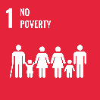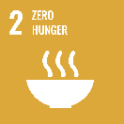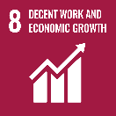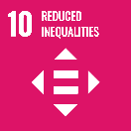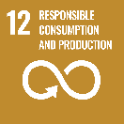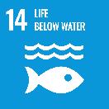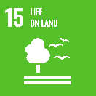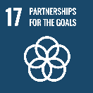

### Strategic direction

### Australia's agricultural development investments prioritise five key areas:

* Adapting agriculture and food systems to be more climate resilient.
* Increasing incomes and livelihood opportunities for smallholder farmers.
* Strengthening food and nutrition security.
* Promoting gender equality and inclusion in agriculture and food systems.
* Improving plant, animal and soil health and biodiversity.

### Program highlights

In 2023-24, Australia supported improved food security for 1,527,804 people, and assisted 612,932 people to use climate resilient agriculture practices on their farms. Highlights include:

* Working with rice seed producers In Indonesia to promote high-yielding rice seed varieties to smallholder farmers, resulting in 31% income increase for 40,011 men and 24,721 women farmers.
* Supporting the Centre for Pacific Crops and Trees (CePaCT) to conserve and distribute climate resilient food crops across the Pacific.
* Working with Pacific farmer organisations to help 16,800 farmers in Fiji, Papua New Guinea, Samoa, Solomon Islands, Timor-Leste, Tonga and Vanuatu to implement climate adaptation activities on their farms.
* Improving household incomes for Indigenous smallholder farmers in the southern Philippines through sustainable rubber-based intercropping and farm management systems.
* Supporting the Timor-Leste Animal Health Service with livestock disease surveillance, diagnosis and management to protect the valuable animal assets of smallholder farmers.
* Working with the private sector in Fiji to increase the availability of drought and flood resistant vegetable seeds for farmers.
* Supporting 473 communities across Vanuatu, Kiribati and Solomon Islands to develop and implement community management frameworks that support long term sustainability of coastal fisheries resources.
* Conducting cutting edge agricultural research in the Pacific, Asia and Africa through the Australian Centre for International Agricultural Research (ACIAR).