# Development Cooperation Factsheet

## Afghanistan

MAY 2025

### Overview

Estimated Australian ODA: $50.0m (2025-26)

Gross National Income Per Capita: US$380 (2023)

Population: 41.5m (2023)

#### Table 1: Australian ODA to Afghanistan, 2023-24 to 2025-26

| Australian ODA | 2023-24 Actual ($m)* | 2024-25 Budget Estimate ($m)* | 2025-26 Budget Estimate ($m)* |
| --- | --- | --- | --- |
| Country Programs | 49.8 | 50.0 | 50.0 |
| Regional | - | - | - |
| Global / Other | 21.0 | - | - |
| Other Government Departments | - | - | - |
| **Total ODA to Afghanistan** | **70.8** | **50.0** | **50.0** |
| **Percentage total Australian ODA** | **1.5%** | **1.0%** | **1.0%** |

*Due to rounding, discrepancies may occur between sums of the component items in totals

#### Figure 1 presents the percentage of Australia’s Official Development Assistance (ODA) to Afghanistan for the financial year 2025-26 attributable to seven sector groups. This information is presented in a doughnut chart, where the seven primary Sector Groups take a portion of shading in the doughnut in direct proportion to the total percentage attributable to each Sector Group. The percentages of total Australian ODA by Sector Groups are: Agriculture, trade and other production services 0% Economic infrastructure and services 0% Education 0% Governance 0% Health 0% Humanitarian 100% Multisector and General Development Support 0% Figure 1: Australian ODA to Afghanistan by Sector Group, 2025-26 budget estimate

### Sustainable Development Goals

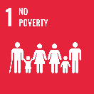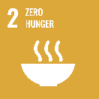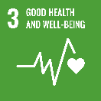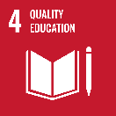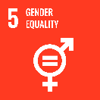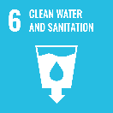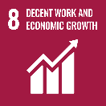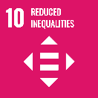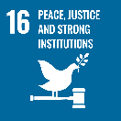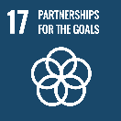

The humanitarian crisis in Afghanistan is one of the worst in the world. It is driven by protracted conflict and insecurity, drought, food insecurity, economic decline, price rises, rising poverty and high levels of displacement. In 2025, more than 22 million Afghans (over half the population) will require humanitarian assistance. The crisis is reversing many of the gains of the last 20 years. This deterioration since the Taliban’s takeover in 2021, has been characterised by rapid economic decline, hunger and malnutrition, rises in both urban and rural poverty, a near-collapse of the public health system and the almost-total exclusion of women and girls from public life.

### Strategic direction

### Since 2021, Australia has pivoted its development program to respond to the humanitarian crisis in Afghanistan and neighbouring countries. Australia has provided more than $260 million in emergency and basic needs assistance for Afghans, refugees, internally displaced people and their host communities. It includes food, water, shelter, health, education and protection services through UN and civil society partners, with a focus on women and girls. This recognises the acute needs facing the Afghan people and complexities of working in Afghanistan.

### Program highlights

In 2024,

* Australia supported 1.45 million vulnerable women, men, girls and boys with emergency assistance in conflict and crisis situations.