Delivering Aid for Trade: A Decade of Partnership in Action

ADB Trade and Supply Chain Finance Program (TSCFP) and Australian Department of Foreign Affairs and Trade (DFAT)
A contribution to 20 years of Aid for Trade and the 10th Global Review of Aid for Trade

Table of contents
Foreword 3
Partnership in action 6
Expanding Trade Finance in the Pacific 7
Supporting Trade Finance in Least Developed Countries 10
Building financial integrity and economic resilience 11
Promoting Gender Equality 14
The next 10 years 17

Foreword
Over the past decade, the partnership between the Australian Department of Foreign Affairs and Trade (DFAT) and the Asian Development Bank’s (ADB’s) Trade and Supply Chain Finance Program (TSCFP) has demonstrated how targeted Official Development Assistance (ODA) can strengthen financial systems and expand access to international trade.
This collaboration began with the notion that, when financial institutions have the capacity, safeguards and confidence to support cross-border trade, businesses are better able to seize the opportunities created by the open, rules-based global trading system, underpinned by the World Trade Organization. For many developing economies, access to trade finance is one of the most important enablers of economic growth and development.
Since 2015, Australia’s support has been instrumental in expanding trade finance partnerships in Asia and the Pacific. It is helping financial institutions in the ADB’s Developing Member Countries¹ (DMCs) build the knowledge and systems needed to manage risk and comply with international standards; enabling them to support businesses to take advantage of open trade settings and participate sustainably in international markets. The ADB-DFAT partnership has also helped catalyse support from Australian agencies, including AUSTRAC, Lighthouse (an Australian Border Force initiative), and Export Finance Australia, further strengthening the TSCFP’s impact.
The nature of the TSCFP’s work has evolved over the course of the partnership. Currently, Australia supports hands-on training for banks, workshops for women entrepreneurs, disability inclusion in financial institutions and activities across Asia and the Pacific to strengthen financial integrity. Australia and the ADB always work to ensure our activities are responsive to the needs of our development partners.
The ADB-DFAT TSCFP partnership is a strong foundation upon which to further promote inclusive access to trade finance and support for the open, rules-based multilateral trading system that underpins global commerce.
We look forward to this fruitful collaboration continuing to help economies, businesses and communities across Asia and the Pacific to grow, connect, and prosper.
Steven Beck
Director,
ADB Trade and Supply Chain Finance Program
Shannon White
Director, Multilateral Economic Cooperation Department of Foreign Affairs and Trade, Australia
¹ DMCs include Afghanistan, Armenia, Azerbaijan, Bangladesh, Bhutan, Brunei Darussalam, Cambodia, Cook Islands, People’s Republic of China, Georgia, India, Indonesia, Fiji, Hong Kong, China, Kazakhstan, Kiribati, the Republic of Korea, Kyrgyz Republic, Lao People’s Democratic Republic, Malaysia, Maldives, Marshall Islands, Federated States of Micronesia, Mongolia, Myanmar, Nauru, Nepal, Niue, Pakistan, Palau, Papua New Guinea, Philippines, Samoa, Singapore, Solomon Islands, Sri Lanka, Taipei, China, Tajikistan, Thailand, Timor-Leste, Tonga, Türkiye, Turkmenistan, Tuvalu, Uzbekistan, Vanuatu, Viet Nam
OFFICIAL

The DFAT-ADB partnership in numbers 2015-2025
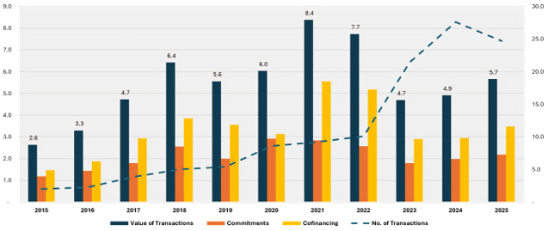
Trade has lifted millions out of poverty, but significant challenges remain. The TSCFP maximizes development impact through two core tracks: providing guarantees and loans, and delivering targeted projects that enhance inclusivity, resilience, and transparency in trade. Through its partnership with DFAT, TSCFP has delivered measurable results in narrowing the trade finance gap and addressing inequities—helping shape a more inclusive and effective trade and development landscape across Asia and the Pacific.

Funding figures
- DFAT funding: $8 million USD
- Trade and Supply Chain Finance supported: $60 billion USD
- Trade and Supply Chain deals enabled: 120,000+ transactions
- Australian Exports to DMCs supported: $1.1 billion USD

Banking figures
- 3,200+ Professionals in developing countries trained
- 85+ Developing country banks
- 19 Partner banks reviewed for inclusive HR policies
- 9 Pacific banks capacity building

TSCFP as a crisis tool
The TSCFP is an effective crisis management tool. During periods of global uncertainty, it has provided support through loans, guarantees, and other targeted interventions, like its supply chain mapping tool, which was launched in 2020 with DFAT support to help stakeholders address supply bottlenecks. This tool consolidated fragmented data on critical goods into a single platform, enabling stakeholders to trace production, components, and trade flows. By identifying bottlenecks and improving visibility, the tool supported faster crisis response and strengthened supply chain resilience, particularly in smaller and more vulnerable markets.

Effective Crisis Response Vehicle
- Food security
- COVID Knowledge Products
- COVID Support
- DMCs in Crisis

Why trade finance matters
- Trade supports jobs and economic growth
- Small businesses need access to finance to participate in international markets
- Trade finance gaps disproportionately affect women-owned businesses
- Strong financial systems help reduce financial crime
- More inclusive trade support resilient supply chains and economic development

Partnership in action
The DFAT-ADB TSCFP partnership is built on the shared goal of regional economic integration and resilience. It is focussed on supporting developing and Least Developed Countries (LDCs) across Asia and the Pacific to participate in and benefit from the global, rules-based multilateral trading system.
Due to their geographic isolation, many Small Island Developing States (SIDS) and Archipelagic developing economies in the Pacific and ASEAN must contend with higher trade costs and limited access to international finance networks. Local banks can struggle to maintain correspondent banking relationships or offer their clients the type of trade finance products needed to reach overseas buyers. This creates challenges for both new and established businesses.

Expanding Trade Finance in the Pacific
With the help of DFAT, the TSCFP is expanding its reach to Pacific financial institutions. The TSCFP is working directly with Pacific banks through targeted training and advisory support, helping to strengthen trade finance capacity and maintain access to global markets.
The TSCFP has delivered workshops and training programs across the region, encouraging knowledge sharing, discussion of practical solutions to common challenges, and the development of impactful networks.
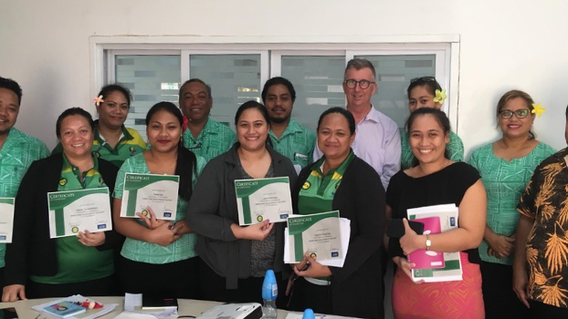
Since 2017, the TSCFP has provided capacity building opportunities for banks in the Pacific to enhance their processes and risk assessment capabilities.
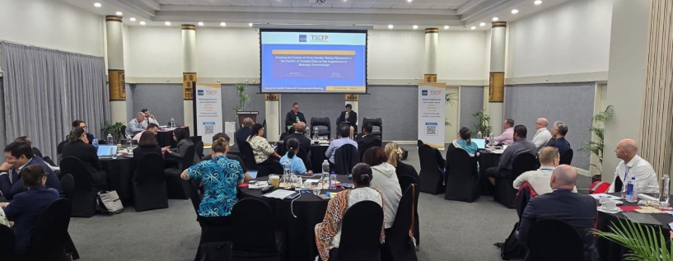
The TSCFP’s Enabling Trade Finance Forum (Fiji, September 2024) brought together 50 participants from regional banks, along with relevant international experts, to discuss the trade finance challenges facing the Pacific.
Formal arrangements are now in place with banks in Fiji, Papua New Guinea, Samoa and Vanuatu. In Samoa, TSCFP support enabled some of the country’s first modern export finance transactions, including dried cocoa exports to Japan, which are supporting exporters and creating reliable income for smallholder farmers.
“We have been able to establish connection with [another partner bank] and [are] working on the development of [a] remittance product similar to the one they have.” – 2024 Participant of the Enabling Trade Finance in the Pacific Forum.

The Derisking Challenge
In developing markets, like those in the Pacific, global banks have reduced or withdrawn correspondent banking relationships due to rising regulatory expectations and compliance costs, a trend widely referred to as “derisking”. This has constrained access to international payment and trade finance networks for smaller institutions.
In response, the ADB’s TSCFP has worked with partners like the International Monetary Fund, World Bank Group and Pacific central banks to raise awareness and develop practical solutions, including roundtables held in Sydney and Auckland.
In 2018, the TSCFP launched an anti-money-laundering and counter-financing of terrorism (AML/CFT) regulatory scorecard. Designed to align local regulatory frameworks with global standards, this initiative has helped improve transparency and consistency in compliance practices, reduce perceived risk, and support the continuation of critical correspondent banking relationships.
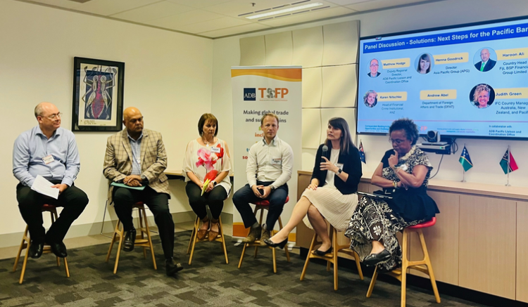
The TSCFP collaborates with commercial banks active in the Pacific. In 2020, a successful webinar series was conducted on AML issues in the Pacific.
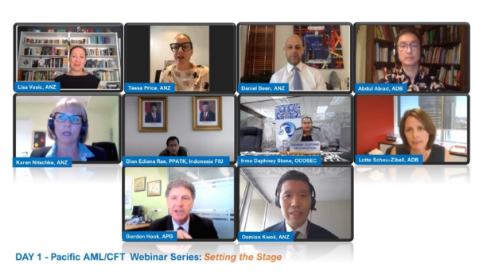
Day 1 – Pacific AML/CFT Webinar Series: Setting the Stage

Supporting Trade Finance in Least Developed Countries
DFAT-ADB TSCFP collaboration has also helped reduce barriers to trade in LDCs in Southeast Asia. In Cambodia, the TSCFP is helping strengthen banking channels, improve access to trade finance, and connect exporters and importers to regional and international markets.
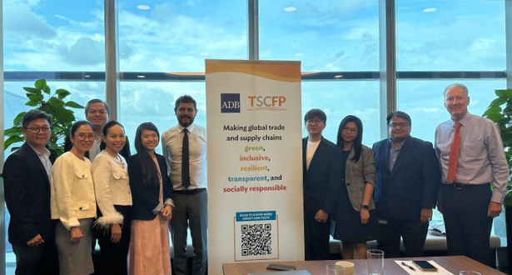

Connecting banks to scale trade finance
The ADB TSCFP’s twinning program (Singapore, February 2025), brought together the Foreign Trade Bank of Cambodia and Standard Chartered to discuss trade finance solutions, digital payments, and SME engagement.

Building financial integrity and economic resilience
Trade depends on trust, but the complexity of international trade transactions can create opportunities for financial crime. Having robust methods in place to stop bad-faith actors is essential for maintaining trust between legitimate parties. Without such methods, legitimate firms or their banks may refuse to work with each other, resulting in exclusion from the global financial system and making it difficult to pay for exports and imports.
The ADB Trade Finance Gaps, Growth and Jobs Study attributed the unintended consequences of AML/CFT as important contributors to market gaps. This led the TSCFP to engage with multiple partners to develop knowledge products, training, services, and solutions designed to address AML/CFT, which aim to strengthen safeguards in trade finance and stop illegal money flows. The TSCFP’s efforts, support by DFAT, have included
- a “Regulatory Scorecard,” which identifies problems in AML/CFT and creates a diagnostic framework to address them;
- a paper on the potential for greater transparency and closing financing gaps through global adoption of the Legal Entity Identifier (LEI);
- a study showing that SMEs in small countries can acquire an LEI easily and at low cost; and an on-line AML/CFT training program for partner banks with the Association of Certified Anti Money Laundering Specialists (ACAMS).
In 2020, TSCFP participated in the joint Financial Action Task Force-Egmont Group's Working Group on Trade-Based Money Laundering (TBML). The Group’s report cited the TSCFP’s anti-money-laundering initiatives as best practice.
TSCFP’s participation in Working Group led to a DFAT-funded pilot with the UN Office of Drugs and Crime (UNODC), which introduced the UNODC’s goAML system to Bangladesh, Mongolia, Nepal, Pakistan, and Sri Lanka, enabling reporting and tracking of suspicious financial transactions. GoAML is helping to counter TBML, thereby promoting trade transparency and building trust, confidence and predictability in global supply chains. The result is a more robust international trade system better equipped to deliver the economic growth and jobs required to achieve the Sustainable Development Goals.
DFAT continues to work with ADB to strengthen regional capabilities to detect and disrupt trade- based financial crimes, helping to build more transplant and trusted trading systems that underpin economic growth and regional prosperity. This includes the delivery of specialized training and regional workshops, such as last year’s TBML Masterclass (Thailand, February 2025), which brought together over 100 participants from banks, regulators, customs authorities, and law enforcement agencies to strengthen detection capabilities and inter-agency cooperation.
“[The training] helped me strengthen my understanding of Letter of Credit (LC) documentation requirements and risk mitigation practices… improving accuracy and turnaround time.” – 2025 Participant of the Trade Finance Refresher Training.


Building capacity to combat TBML
The TSCFP’s Countering Trade-Based Money Laundering (TBML) Master Class (Thailand, February 2025), supported by DFAT and held in partnership with UNODC and Thailand’s Anti-Money Laundering Office.
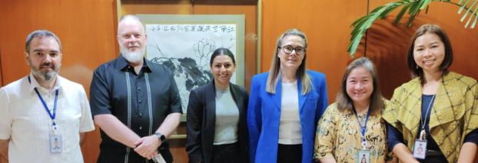

Strengthening regional Trade-Based Money Laundering cooperation
With DFAT’s support, the TSCFP joined the Australian Border Force Trade-Based Money Laundering (TBML) Lighthouse Project Workshop (the Philippines, November 2025). The Workshop included customs, law enforcement, and financial intelligence officers. It aimed to strengthen public-private cooperation and enhance regional capabilities for detecting and deterring financial crime in trade.

Promoting Gender Equality
Women’s economic equality and inclusive trade are priorities for DFAT and the ADB. Women’s participation in the workforce and equal opportunities for growth and advancement make for more profitable and sustainable institutions. When financial systems overlook women or small businesses, firms limit their ability to reach global markets, and supply chains are weakened.
In 2016, the TSCFP launched its Gender Initiative, supported by DFAT. The initiative aims to
- address gender inequalities within partner financial institutions; and
- enhance access to finance – and international trade – for women-owned businesses.
The 2021 ADB Trade Finance Gap Survey highlighted that women owned SME’s are disproportionately rejected from trade finance. Among the women-owned firms surveyed, about 70% of their applications were totally or partially rejected. The survey also showed that, once rejected, women business owners were less likely to return to seek financing.
One of the first Gender Initiative projects had gender experts review partner bank human resource policies to identify barriers affecting women in banking. The policies of 19 banks in 8 countries² were reviewed to identify enhancements to attract, retain, and promote women in banking. This was especially valuable for banks in developing countries where recruitment and promotion practices, professional development opportunities and family-friendly workplace measures had been overlooked or under-utilised. These reviews led to over two hundred recommendations to strengthen gender inclusion. Partner banks have since been adopting more gender-sensitive policies and practices.
The TSCFP’s Women Leaders in Trade (WLT) Program – made possible with DFAT support in 2025 – focuses on strengthening leadership pathways in financial institutions. It supports mid-career women bankers through targeted coaching and mentorship, helping participants build confidence, develop leadership skills and progress their careers.
“I have been elevated as Team Leader since the WLT program… gained practical skills in conflict resolution, team management, and influencing change. Learned to delegate work effectively to concentrate on more important tasks.” – Program Participant, Pakistan.
“This program provided a unique platform to engage with a diverse network of women professionals across the trade finance ecosystem, exchange ideas, and build meaningful connections that transcend borders. We, the participants, are still in touch and exchanging ideas and taking views in related areas which indeed is an opportunity to explore for good.” – Program Participant, MongoliaThe TSCFP Gender Initiative also encourages training and networking for women owned SMEs to help address knowledge gaps and access to trade finance. These activities have brought together banks and women entrepreneurs to discuss financing needs, share knowledge, and strengthen connections between financial institutions and women-led businesses. This learning program received the ADB’s internal recognition for best knowledge event at the Shereen Lateef awards in 2023.
“[I am now better] able to understand clear differences in trade financing when quoting for an export order” – 2025 Participant of the Workshop for Women Entrepreneurs on Trade Finance
By encouraging financial institutions to reform policies and rethink how financial services reach different groups of businesses, the DFAT-ADB TSCFP partnership is helping make inclusion a standard practice for trade finance in the region. These efforts support stronger supply chains and create more equitable opportunities for businesses to participate in global trade.

Gender equality figures
- 29 partner banks HR policies reviewed for gender inclusion
- 12 countries Covered by the gender initiative
- 231 recommendations Proposed to improve gender equality in banking
- 300+ women entrepreneurs Participated in trade finance forums The next 10 years
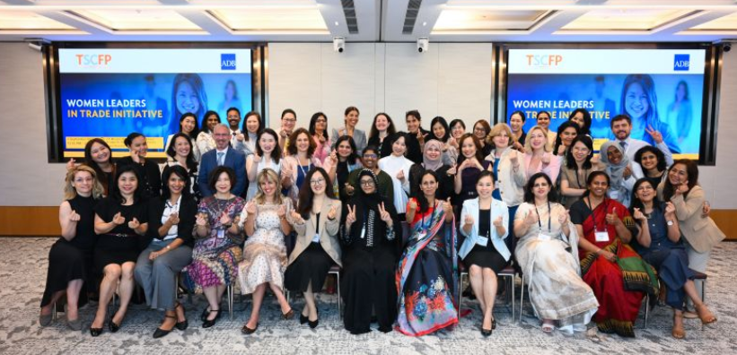

Advancing women into trade leadership
The TSCFP celebrated the graduation of participants in its Women Leaders in Trade initiative (Singapore, September 2025). The four-month executive coaching program helped 12 women bankers from nine markets (Bangladesh, Cambodia, Georgia, Mongolia, Nepal, Pakistan, Sri Lanka, Uzbekistan, and Viet Nam) to strengthen leadership skills and advance women’s participation in trade and supply chain finance.
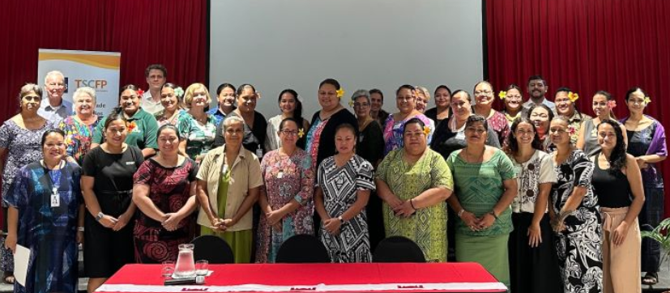

Strengthening trade in Samoa
The TSCFP delivered a women entrepreneur’s workshop (Samoa, March 2025) in partnership with the Samoa Chamber of Commerce, Women in Business Development Inc., and the Samoa Association of Manufacturers and Exporters. It was attended by 41 women entrepreneurs seeking to strengthen their export readiness and access to international trade.

The next 10 years
Over the past decade, the DFAT-ADB TSCFP partnership has successfully supported access to trade in Asia and the Pacific. It remains one of the only programs of its kind and is as relevant – if not more relevant – today than it was when it began.
Trade finance will continue to play an essential role in enabling economic growth across Asia and the Pacific. Many developing markets still face gaps in access to finance, particularly for small businesses and new exporters. When financial institutions have the confidence and tools to support cross-border trade, the businesses they serve gain the ability to invest, expand, and connect with global markets.
The DFAT-ADB TSCFP partnership will continue to work together to broaden its activities in Asia and deepen its engagement in the Pacific.
In the Pacific, access to trade finance remains a critical barrier to economic growth. Small island economies often face high transaction costs, limited banking relationships and restricted access to international financial networks.
The Australia-ADB TSCFP partnership is helping strengthen local financial capabilities and expand opportunities for Pacific businesses to participate in regional and global trade.
Digital connectivity and access to enabling technology will be crucial. Digital trade and e-commerce have the potential to be transformative in developing countries and LDCs, for SMEs, and for the expansion of inclusive trade. When implemented thoughtfully, these innovations can also help enhance access to trade finance and allow financial institutions to manage risk more effectively.
Together, DFAT and the ADB will work to strengthen gender equality and inclusion in financial institutions to ensure women entrepreneurs, small businesses, and persons with disabilities receive the same levels of service as anyone else.

A second phase of disability inclusion support
Building on the success of its first phase, the TSCFP Disability Inclusion Initiative, will be expanded with dedicated support from DFAT. The Initiative’s first phase reviewed relevant policies and procedures across financial institutions to understand how banking systems, workplace practices and financial services could be made more inclusive. Based on this review, the TSCFP developed recommendations and tools to help banks strengthen their disability inclusion policies and practices. Five disability inclusion tools and knowledge products were created and made available to all partner banks.
The next phase of the Initiative will focus on scaling advisory services and tools across Bangladesh, Pakistan and Sri Lanka. Working directly with partner banks, the initiative will help embed inclusive practices, such as conducting accessibility audits, inclusive user experience research, staff training, and integrating disability inclusion into ESG strategies and trade finance operations, from internal policies to client-facing services, with the aim of giving people with disabilities full access to international markets and the benefits of trade.
Over the past decade, Australia's partnership with the ADB has helped strengthen trade finance systems, expand opportunities for businesses, support women's economic participation, and build more resilient and transparent regional trading networks. As the developing economies across Asia and the Pacific continue to grow, ensuring businesses can access finance and participate in international trade will remain critical to sustainable economic development, job creation and regional prosperity.
DELIVERING AID FOR TRADE:
A DECADE OF PARTNERSHIP IN ACTION
ADB Trade and Supply Chain Finance Program (TSCFP) and Australian Department of Foreign Affairs and Trade (DFAT)

