# Can seasonal climate forecasts improve food security in Indian Ocean Rim countries in a variable and changing climate?

Funded by AusAID, CSIRO will partner with universities, government and non-government agencies in Australia, India and Sri Lanka in a new Indian Ocean Rim Association for Regional Co-operation (IOR-ARC) initiative that aims to enhance food security in the Indian Ocean Rim region by reducing agricultural production risks associated with a variable and changing climate.

## Food Security and Climate Change

Farmers in Indian Ocean Rim countries face a multitude of problems to sustain crop productivity with grain yields stagnant over the past decade and particularly rice production suffering unusually large variations.

Many of these problems are linked to climate variability with food shortages occurring due to delays in summer monsoons and heavy rains during harvest. This has contributed to price spikes for food and even changes in trade arrangements such as export bans.

Climate change is beginning to affect agricultural productivity through shifts in rainfall patterns, changing temperature regimes and increased climate variability as well as climatic extremes. Farmers in South Asia report they are observing these changes and that their historic weather knowledge and experience are progressively less useful in the agricultural planning process.

## Access to mid-range seasonal climate forecasts

In addition to the existing short-term (3-10 day) weather forecasts, access to reliable intra-seasonal to seasonal climate forecasts (month to multi-month timeframes) could provide farmers with a complementary set of response options which can further help reduce production risks.

Such mid-range forecasts could assist them to make more effective decisions such as which crops to plant and when, fertiliser application rates and timing of irrigation activity and harvest.

Effective intra-seasonal to seasonal management responses to short-term climate variability are a key means to progressively adapt to climate change

## Project Objectives

This project investigates how intra-seasonal to seasonal climate forecasts can support better agricultural decision-making. Such forecasts must account for climate variability and climate change.

The project will also address the delivery and use of seasonal climate information across different elements of society - from policy to agri-business to the farming community.

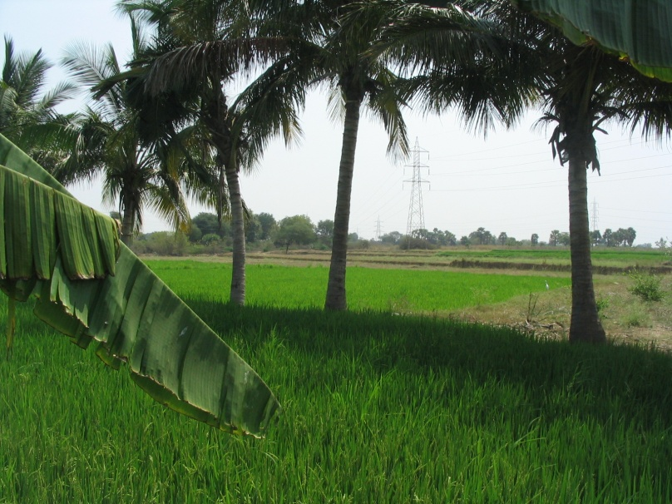Mixed tree cropping system, India

## Key Activities

The project will:

* Assess the existing climate information and delivery systems and policy settings.
* Enhance the understanding and capacity of agencies and decision-makers to jointly create climate knowledge systems that are relevant at farm and regional level.
* Review existing climate forecast products and explore how to combine these to make them more relevant and useable.
* Explore the potential to develop new forecast knowledge that accounts for climate trends and is focused on user-defined variables (e.g. start of monsoon or the Madden Julian Oscillation).
* Test seasonal forecasts for agricultural decision making across case study sites.

## Study Areas

Six case studies will ensure outcomes at the regional and at farm level. The case study areas will include the dry land agricultural systems in the Andhra Pradesh and Tamil Nadu states in India; and the mixed farming systems in several, diverse districts of Sri Lanka.

Study Regions in India and Sri Lanka

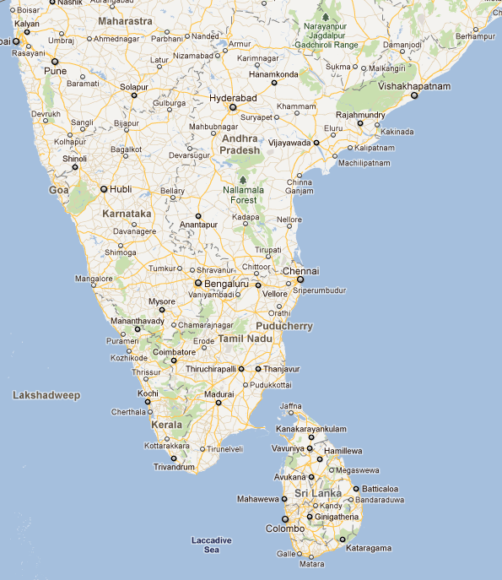

## Contribution to IOR-ARC

The project will contribute to the Indian Ocean Rim Association for Regional Co-operation more broadly through a knowledge sharing workshop for IOR-ARC member countries.

The workshop to be held in the third year of the project will share the outcomes on the use of seasonal climate forecasts.

### E:\uday\AUSAID_IOR\india pics sep 2011\DSC00612.JPG

The project commenced with a workshop of potential partners from Australia, India and Sri Lanka in Chennai, India in September 2011. There were 22 participants from four countries and 12 institutions.

## Project Partners

Key partners in the project include:

### Australia

* CSIRO
* University of Tasmania
* Australian National University
* South Australia Research and Development Institute

### India

* MS Swaminathan Research Foundation
* India Meteorological Department
* Acharya NG Ranga Agricultural University
* Tamil Nadu Agricultural University

### Sri Lanka

* University of Peradeniya,
* Sri Lankan Department of Agriculture
* Practical Action

Additional partnerships will be developed as the project progresses.

Climate Adaptation Flagship

Contact Dr Uday Nidumolu

Phone +61 8 8303 9410

Fax +61 8 8303 9717

Email uday.nidumolu@csiro.au