

New Civil Society WASH Fund
Industry Briefing to Sector
Thursday 28 June 2012
- Australia’s Prime Minister Julia Gillard announced the new $97 million competitive grants program at Rio +20
- The Fund will resource around 15 CSOs to deliver WASH activities in around 20 countries across Africa, Asia and the Pacific
- The Fund will run through to 2016-17 and is expected to deliver access to clean water and hygienic sanitation for 1.8 million people

Table of Contents
Building on a good model 3
The first Civil Society WASH Fund 3
A new Civil Society WASH Fund 4
Design objectives and areas of enquiry 4
AusAID sought clear guidance on: 4
Objectives and outcomes 5
Strategic goal: saving lives 5
Scope of countries included in the program 7
Focus 8
Sustainability 8
Innovation 9
Collaboration 10
Performance management arrangements 13
Performance assessment framework 13
Monitoring, Evaluation and Review Panel 14
Successful innovation from previous fund 14
Selection process 15
Inception phase 16
Questions 17

Building on a good model

The first Civil Society WASH Fund
- $32 million competitive grants program that ran from May 2010 to March 2012
- Resourced 11 civil society organisations (CSOs) to deliver 45 WASH activities in 24 countries across Africa, Asia and the Pacific
- International and Australian CSOs, including AusAID accredited and non-accredited CSOs
- Use of a performance assessment framework and panel of monitoring and evaluation advisors
- Delivered access to safe water for more than 560 000 people and access to sanitation for 780 000 people

A new Civil Society WASH Fund

Design objectives and areas of enquiry

AusAID sought clear guidance on:
- how partnerships CSOs can deliver sustainable outcomes in WASH
- the most appropriate management arrangements for the fund
- opportunities to contribute to the WASH evidence base
- A mid-term review was conducted in November 2010 by the Monitoring Review Panel. The purpose was to:
  - review the fund structure, management and partnership between AusAID and CSOs, with a view to informing future arrangements; and
  - report on how the fund expects to contribute to AusAID WASH objectives and provide a structured analysis of WASH approaches used in the fund.
- You can find a link to the report in the new fund’s guidelines and I encourage you to consider the recommendations. It raised several issues that caught our attention, including:
  - the apparent need for stronger engagement with the enabling environment for WASH;
  - the appropriate program management model for the fund;
  - how to better encourage collaboration between CSOs and tap into effective practice and innovation
- Design team assembled to look at how we could improve on the design of the first fund [composed of one AusAID representative and two consultants: Ms Michelle Whalen of Monanegra Consulting and Mr Paul Tyndale-Biscoe of FH Designs]. The final design report is available for download from the fund wesbsite.

A new Civil Society WASH Fund

Objectives and outcomes

Strategic goal: saving lives
Objective: To enhance the health and quality of life of the poor and vulnerable by improving sustainable access to safe water, sanitation and hygiene
- Outcomes framework adapted from previous fund but rearranged to:
      - Link outcomes with the Australian aid policy Effective Aid the three pillars of the AusAID WASH Thematic Strategy
      - Place a greater emphasis on sustainability

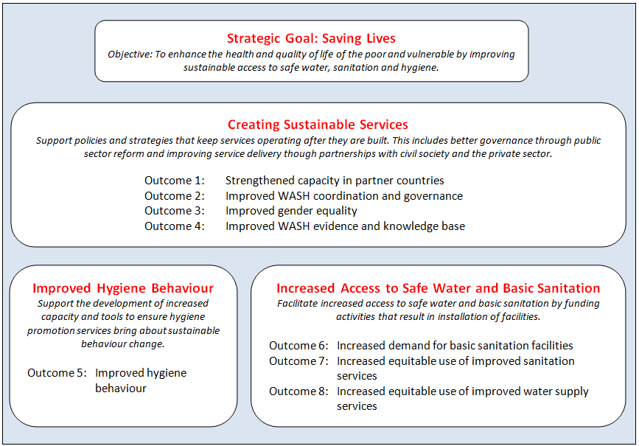
- This is the outcomes framework for the fund. Note that the fund objective has been adopted from the old fund however we have added the word ‘sustainable’.
- The three pillars of the AusAID WASH Thematic Strategy are highlighted in red. Outcomes have been clustered around each of the three pillars. They also form a hierarchy: any activities that relate to outcomes 5 to 8 will be expected to show progress against each of the outcomes under Creating Sustainable Services. For example, the design of a water supply project (outcomes 6 and 8) needs to include work on strengthening the capacity in partner countries to manage and maintain water supply (outcome 1).
- You will also note in the guidelines that the fund places an emphasis on sanitation, given the poor levels of access in all relevant regions.
  - Water supply projects will be expected to incorporate a sanitation component.
  - Both water and sanitation activities must have a hygiene element.

A new Civil Society WASH Fund

Scope of countries included in the program
Southern Africa | East Africa | South Asia | South-East Asia | Pacific
Angola  Botswana  Lesotho  Malawi  Mozambique  Namibia  South Africa  Swaziland  Zambia  Zimbabwe | DR Congo  Tanzania | Bangladesh  Bhutan  India  Nepal  Pakistan  Sri Lanka | Burma/Myanmar  Cambodia  Indonesia  Lao PDR  Philippines  Timor Leste  Vietnam | Fiji  Kiribati  Micronesia  Nauru  Papua New Guinea  Solomon Islands  Tonga  Tuvalu  Vanuatu
- This list has been developed based on a combination of AusAID presence and existing WASH strategies (ie where we work), as well as need as determined by the Joint Monitoring Program data on access to water and sanitation.
- The scope is quite broad and covers 34 countries. Note that AusAID does not expect an activity in every country – this is just a list of potential countries that CSOs could work in under the fund.
- Those CSOs proposing activities in countries where AusAID has an active WASH program will be encouraged to design activities that align and complement the AusAID WASH program. Send an email to WashFund@ausaid.gov.au if you would like assistance in reaching AusAID posts (AusAID offices in-country) during the call for proposals. AusAID will also try to create opportunities to talk to posts during the inception phase.
- We recognise that the degree of engagement with AusAID country and regional program areas depends on the available resources at post, which will vary. We therefore encourage partnerships with AusAID where possible.
- Example of a partnership: AusAID Southern Africa Delivery Strategy focuses on small towns and peri-urban areas in Malawi, Mozambique, Zambia and Zimbabwe. AusAID is keen to work with CSOs in Southern Africa to establish how CSO activities could complement the delivery strategy and extend the strategy’s geographic reach.
- Proposals in countries not captured by the scope of the program will be considered on a case by case basis. CSOs will be required to provide a clear justification as to why activities should be funded in a country that is not in the scope (ie a proven need in terms of number of people without access to water and/or sanitation) and must be able to show that the CSO has a history of delivering WASH activities in that country.

A new Civil Society WASH Fund

Focus

Sustainability
- Selection criteria that draw on current knowledge on supporting sustainability
- Outcomes framework that links water, sanitation and hygiene activities with current thinking on outcomes that relate to sustainability
- Performance assessment framework highlights key indicators that will assess the extent to which achievements will be sustained in the long term
- Longer time frame!!!
- There were three key drivers behind our work on the design. They were:
  - - sustainability
  - - innovation
  - - collaboration

A new Civil Society WASH Fund

Focus

Innovation
- An explicit outcome for improving the WASH evidence and knowledge base
- An Innovation and Impact Grants mechanism
- A linkage with the Australian Development Research Awards Scheme
- The Innovations and Impact Grants mechanism will provide grants to those CSOs that are successfully selected through the call for proposals. The grants are non-competitive and will be available for the lifetime of the fund (subject to resourcing constraints). AusAID has budgeted for up to 20 grants of up to $200,000 in value over two years. The grants will be rolled out to create a space for CSOs to take risks and trial new innovations or test successful innovations in new environments. CSOs must partner with research organisations to ensure the innovations are trialled under a robust framework.
- AusAID has also linked two Australian Development Research Awards Scheme grants to the fund. We will be encouraging researchers to partner with CSOs working within the fund and to look at the contemporary practice and approaches that CSOs are employing through their activities.

A new Civil Society WASH Fund

Focus

Collaboration
- Recruitment of a Knowledge and Learning Manager to help develop a community of practice within the fund
- Use of regional conferences will continue but will be complemented by use of online mediums, including webinars on common issues or innovations
- Intend to link with other AusAID CSO grants programs to encourage cross-fertilisation of ideas
- AusAID looking to support a formal community of practice within the fund. The Knowledge and Learning Manager will be recruited to support this objective.
- Two conferences will be held in Africa, Asia and the Pacific to bring together CSOs working in the fund. These will be an opportunity to discuss common issues that run across CSO activities, present on work funded by the Innovations and Impact Grants and generally discuss issues that CSOs believe require attention.
- Knowledge and Learning Manager will be responsible for organising the conferences and will also establish a dedicated website to provide webinars on topical issues.
- CSOs receiving funding through other AusAID competitive grants programs will be welcome to participate in the fund’s community of practice to help learn from and share ideas on what works on the ground.

CSO Activities
  - Delivery of WASH programs in Africa, Asia and the Pacific
  - Dedicated program manager in each CSO
  - Proven WASH capacity and track record in country
  - Detailed proposal
  - 10 to 15 agreements

Monitoring and Evaluation
  - Three members to form 'panel' (MERP)
  - Developmental evaluation approach
  - Develop Fund monitoring and evaluation framework
  - Provide assistance to CSOs for design documents
  - Monitor CSO activities, prepare learning reports, improve capacity of CSO monitoring and evaluation

Knowledge and Learning
  - Managed by Knowledge and Learning Manager
  - Regional learning events
  - Innovations grants: up to 20 two year grants valued at approximately $200,000 each
  - Online community of practice through Fund website, webinars and other electronic fora
  - Two research grants linked to Australian Development Research Awards Scheme
- Panel of three monitoring and evaluation experts will be employed to carry out ongoing monitoring and evaluation work during the lifetime of the fund.
- This was a function that has been carried over from the previous fund. Evaluations have concluded that the function worked very well. The Monitoring, Evaluation and Review Panel will work with the Knowledge and Learning Manager to raise cross-cutting issues across activities and facilitate discussions on solutions.

Project Management
  - Fund Manager responsible for day to day management of Fund, including communication between AusAID, Knowledge and Learning Manager, MERP and CSOs
  - Receives and collates CSO progress reports and prepares financial reports for AusAID approval

AusAID
  - Infrastructure Water and Sanitation Section responsible for overall Fund management and oversight, monitor and engage on policy issues and provide links to other relevant sections and programs
  - Posts given option to help align CSO activities with regional and country strategies (where possible/relevant), included in feedback loops concerning monitoring and results and facilitate coordination between fund activities and other AusAID in-country WASH sector activities (also optional)
- AusAID will be supported by a Fund Manager. This position has been created to better enable staff in AusAID’s Infrastructure and Water Policy Section to engage with CSOs on policy and practice issues that may arise through the fund. Will play a crucial role in coordinating the work of the various support roles (Knowledge and Learning Manager and the Monitoring and Evaluation Review Panel) with the work of CSOs and AusAID staff at post.

Performance management arrangements

Performance assessment framework
Based on AusAID WASH Performance Assessment Framework and WSI Civil Society Fund PAF developed by MRP with NGO partners
By providing some standard performance indicators and questions the Fund Performance assessment framework aims to:
- Support the articulation of changes expected as a result of the activity
- Support the refinement of common definitions for core indicators of improved water and sanitation
- Provide a platform for both CSOs and AusAID to report to stakeholders on the overall achievements of the Fund.
Will be reviewed during the Inception phase by MERP with the NGO partners
- Noted that the fund’s performance assessment framework is online but due to a glitch some CSOs have experienced difficulty in downloading the framework. The issue has now been resolved.
- Establishes common definitions to enable aggregate reporting of results across CSO activities, at both the country level and for the fund overall.
- CSOs will be able to share their views on indicators and approaches to performance management during the inception phase, during which time they will be working with the MERP to develop monitoring and evaluation frameworks for the activities

Performance management arrangements

Monitoring, Evaluation and Review Panel

Successful innovation from previous fund
- Developmental evaluation approach
- Ongoing support through lifetime of the fund
- Identify cross-cutting issues for AusAID, support discussions on how to resolve
- MERP will be working as a team with CSOs to improve program quality.
- An ongoing evaluative role allows for real-time improvement of fund activities.

Selection process
See separate PowerPoint available on the Fund website.
- The presentation on the selection process is included as a separate PowerPoint on the fund website.

Inception phase
A ‘funded step’ as recommended by the mid-term review of the previous fund
- Opportunity to further define and document activity designs and implementation plans
- MERP will provide templates
      - Will include specific plans for monitoring and evaluation, gender, disability and social inclusion, environment and climate change, institutional and knowledge management and a sustainability and exit strategy plan
- Opportunities to develop relationships with AusAID staff at Post (where relevant)
- CSOs successfully selected through the call for proposals will be invited to participate in the inception phase. This process is expected to take between three to six months. It is a funded step with CSOs receiving financial support to participate. The final products will effectively form the scope of services for the four year grant.

Questions
Responses to questions have been placed on the fund website.

