# Council for Australian-Arab Relations (CAAR) Strategic Framework 2025

## Overview

Over the past 40 years the Australian Government has established cultural councils to bolster people-to-people links and strengthen our bilateral and regional relationships. The Council for Australian-Arab Relations (CAAR) supports projects that enhance **Australia's economic, cultural** and **social relation**s with the **Middle East and North Africa Region (MENA).** CAAR seeks to empower people and organisations to connect and create partnerships in areas of mutual interest for Australian and Arab communities.

## Mission

To strengthen people-to-people links and cross-cultural understanding between Australia and the MENA region by encouraging collaboration and partnerships that support Australia’s foreign policy, trade, social and cultural interests.

The objectives of the CAAR are to:

* empower the peoples of Australia and the Arab world to develop a holistic and contemporary mutual understanding
* support positive and collaborative relationships between Australia's Arab diaspora communities and the broader Australian community
* support activities that encourage increased trade and investment between the two regions.

## Priorities

CAAR directs effort and resources towards priority sectors of mutual interest between Australia and the MENA region. Priorities are reviewed annually. Below are the 2025-26 CAAR priorities:

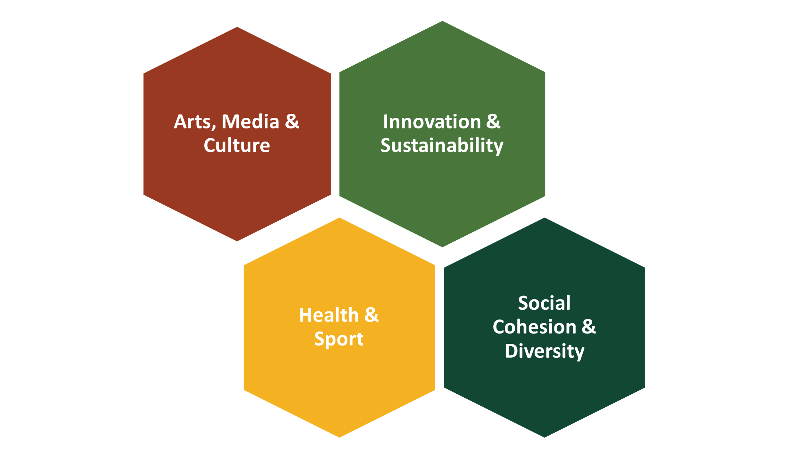

## Lines of Effort

The CAAR has four Lines of Effort to achieve its mission. These include:

1. an annual open, competitive **grant round**
2. promotion of priority interests at **cross-cultural events**
3. the ongoing **connecting** of **individuals and community groups** to likeminded entities for collaboration
4. highlighting successful projects to advance Australia’s **foreign policy interests** and **standing**.

### 1st Line of Effort: Grants

CAAR's annual grant cycle is the key mechanism for promoting CAAR’s priorities. Through the provision of monetary grants, CAAR supports community or institutional projects that promote the CAAR’s agreed priorities for that year. The intended outcomes of the grant opportunity are to:

* increase awareness in the Middle East and North Africa (MENA) region of shared interests with Australia
* increase awareness and understanding in Australia of the importance of the MENA region to Australia as an economic and strategic partner.
* maximise public diplomacy opportunities engaging DFAT Australian Embassies and State and Territory Offices when possible.
* build strong community and institutional relationships with MENA countries and promote social cohesion.
* grow relationships with many MENA countries through partnering with MENA institutes to establish economic opportunities.
* to increase recognition in the MENA region of Australia’s expertise.

The cycle involves three phases:

1. Project Phase:The main effort of the project phase is the promotion of the recently awarded grants and their respective projects. Promotion is conducted by individual Board members in their communities, the Secretariat through official social media, and DFAT overseas Posts and DFAT State and Territory Offices. Typically, a board meeting at the start of this phase considers priorities for the upcoming grant round and evaluates the ongoing CAAR strategy and governance processes.
2. Application Phase:The application phase commences with announcement of the new grant round. A key priority during this phase is community outreach to encourage applications.
3. Grant Phase:The main effort of the grant phase is the Secretariat’s management of Board recommendations for the approval of grant applications and awarding of funds to successful projects.

*Note: The cycle is displayed graphically at* ***Annex A****.*

### 2nd Line of Effort: Promotion Within Events

Events are an opportunity for CAAR to help promote its priorities and work through digital media. This line could also empower community events through networking and endorsement/promotion.

### 3rd Line of Effort: Community Building

CAAR Board members, DFAT Posts, DFAT State and Territory Offices, past grant recipients and other stakeholders form a network which can connect individuals and groups across the Australian and Arab community. This line of effort is un-resourced and not anchored to major events. It can involve facilitation of relationships between likeminded groups who are seeking to collaborate in an area of the CAAR’s priorities. It also includes the sharing of events and information between the Secretariat and the Board members. The Council will discuss successful community building activities and share ideas for future work in this line of effort.

### 4th Line of Effort: A Foreign Policy Tool

CAAR offers Australia a unique opportunity to promote a distinctive and positive image of Australia to the MENA region. CAAR also affords Australia an avenue to counter harmful narratives, by deepening the people-to-people links with the MENA region.

## Measures of Success

### 1st Tool – Grants

* + Grant round was conducted as specified in the CAAR Strategic Plan.
  + Grant recipients carried out their projects successfully as described in their applications.
  + Projects led to tangible outcomes or received public recognition with direct association to CAAR’s priorities.

### 2nd Tool – Promotion Within Events

* + Promotion through an event was linked to CAAR grant projects.
  + Promotion of events was linked to community building activities.
  + Activities led to tangible outcomes or public recognition in direct association to the CAAR’s priorities.

### 3rd Tool – Community Building

* + Stakeholders conducted un-resourced outreach, leading to a tangible outcome within CAAR’s priorities.

### 4th Tool – Foreign Policy

* + Increased awareness of Australia in the region supports our foreign policy and trade and investment interests.

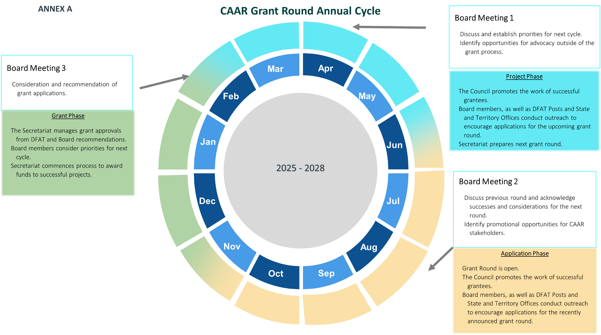

## Appendix A

### CAAR Grant Round Annual Cycle (2025-2028)

#### APRIL

**Board Meeting 1:**

* Discuss and establish priorities for next cycle.
* Identify opportunities for advocacy outside of the grant process.

**Project Phase:**

* The Council promotes the work of successful grantees.
* Board members, as well as DFAT Posts and State and Territory Offices conduct outreach to encourage applications for the upcoming grant round.

#### AUGUST

**Board Meeting 2:**

* Discuss previous round and acknowledge successes and considerations for the next round.
* Identify promotional opportunities for CAAR stakeholders.

**Application Phase:**

* Grant Round is open.
* The Council promotes the work of successful grantees.
* Board members, as well as DFAT Posts and State and Territory Offices conduct outreach to encourage applications for the recently announced grant round.

#### FEBRUARY

**Board Meeting 3:**

* Consideration and recommendation of grant applications.

**Grant Phase:**

* The Secretariat manages grant approvals from DFAT and Board recommendations.
* Board members consider priorities for next cycle.
* Secretariat commences process to award funds to successful projects.