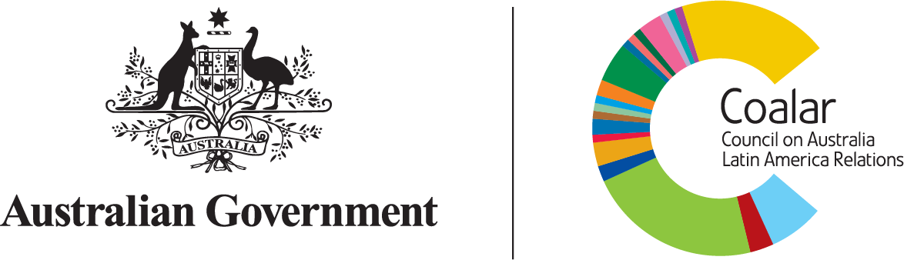

COUNCIL ON AUSTRALIA
LATIN AMERICA RELATIONS

HIGHLIGHTS REPORT
2 0 2 4 - 2 0 2 5

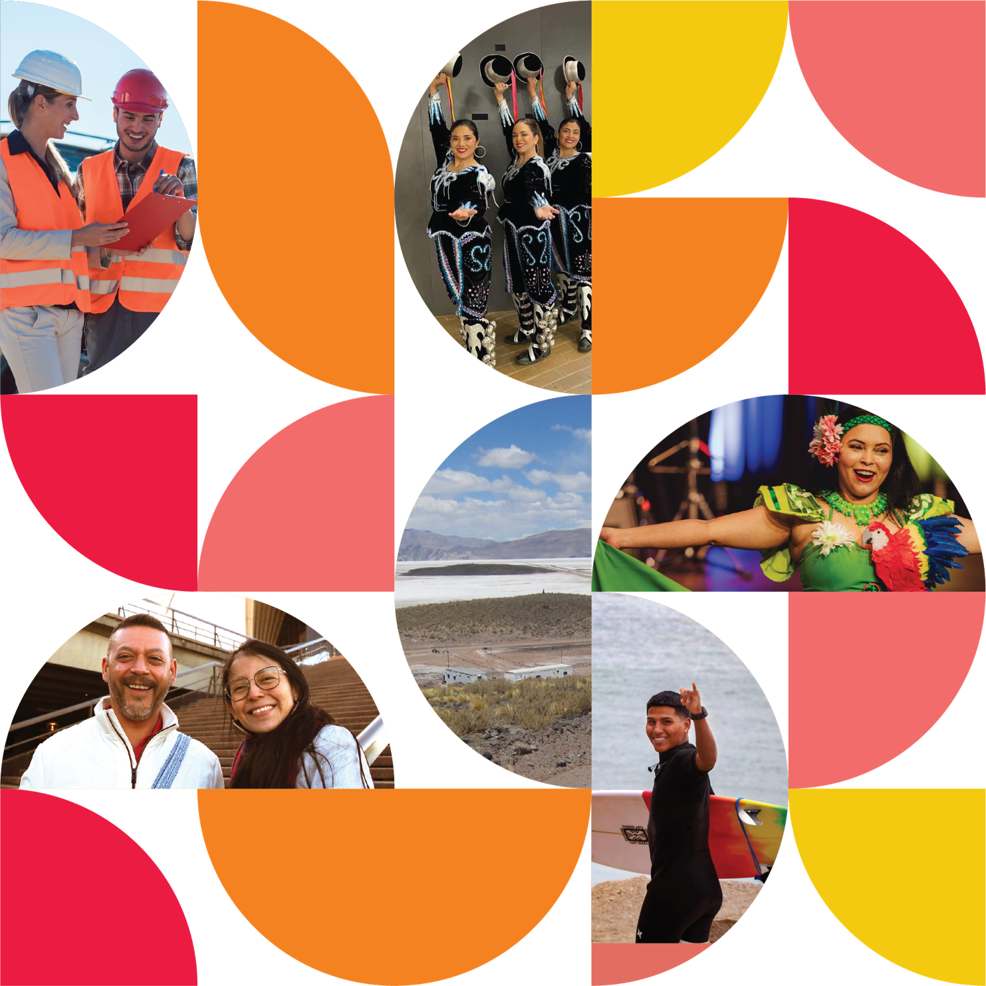

© Commonwealth of Australia 2025

Creative Commons
With the exception of the Commonwealth Coat of Arms, the COALAR logo, photographs and images and where otherwise stated, this publication is provided under a Creative Commons Attribution-NonCommercial NoDerivatives 4.0 International (CC BY-NC-ND 4.0) licence. The licence terms are available at creativecommons. org/licenses/by-nc-nd/4.0. To the extent that copyright subsists in a third party, permission will be required from the third party to reuse the material. Provided you have not modified or transformed the material in any way (including, for example, by changing the text, calculating percentage changes, graph/chart data, or deriving new statistics from published statistics), the Commonwealth’s preference is that you attribute this publication (and any material sourced from it) using the following: Department of Foreign Affairs and Trade Council on Australia Latin America Relations Highlights Report 2024. © Commonwealth of Australia 2025. Licensed from the Commonwealth of Australia under a Creative Commons Attribution-NonCommercial NoDerivatives 4.0 International licence.

Use of the Coat of Arms
The terms under which the Coat of Arms can be used are set out on the Department of the Prime Minister and Cabinet website at pmc.gov.au/honours-and-symbols/ commonwealth-coat-arms.

Accessing this report online
Further information about the Council on Australia Latin America Relations (COALAR) and an online version of this report are available on the DFAT website at Publications and links | Australian Government Department of Foreign Affairs and Trade

COALAR Secretariat
Department of Foreign Affairs and Trade RG Casey Building, John McEwen Crescent Barton ACT Australia 0221
Phone: 02 6261 1111
Email: coalar@dfat.gov.au
ISBN: 978-0-646-72455-3
Annual Report designed by The Brand Foundry

Table of Contents
Table of Contents 3
Foreword from the Minister 4
Message from the Chair 5
Overview of Key Achievements 7
Strategic Framework Implementation 7
Ministerial and Diplomatic Engagement 7
Board Renewal and Leadership Diversification 7
Sector Engagement 9
Digital Presence Enhancement 9
Project Portfolio Outcomes 9
Grant Program Optimisation 10
Regional Familiarisation Visit 10
COALAR Supported Activities 2024 11
COALAR Grant Projects 2024–25 12
Pillar 1 – Outreach and Advocacy 14
Board-Level Ministerial and Diplomatic Engagement 14
Regional Familiarisation Visit 14
Digital Presence Enhancement 15
Mexico Trade and Investment (Nearshoring) – Study and Seminars 15
Lithium Triangle Study 16
Pillar 2 – Collaboration, Communication and Education 19
Strategic Framework Implementation 19
Grant Program Optimisation 19
Safeguarding Our Coral Reefs, Honduras – Expert Visit 19
Women in Mining Leadership Program, Chile 20
Stakeholder Testimonials 21
Pillar 3 – Social and Cultural Connections 25
Board Renewal and Leadership Diversification 25
19th Latin American Film Festival 25
Australia-Latin America Young Leaders Dialogue 26
First Nations Diplomacy, Brazil – Art Exhibition 27
Pillar 4 – Shared Commercial Interests 31
Promoting Australia-Brazil Direct Flights – Study 31
Expanding Connectivity Mexico, Peru, Colombia – Study 32
Brazil Week 2024 33
The Way Forward 34
Council Member Profiles 36
COALAR Supported Activities 2024 40
COALAR Grant Projects 2024–25 42

Foreword from the Assistant Minister
The Australian Government values its political, economic and cultural engagement with the Latin American region; we share growing trade and investment ties, longstanding people-to-people and institutional links, and likeminded approaches on many key global issues.
It is critical that Australia seeks to broaden and strengthen our relationships to adapt to a changing world. Latin America is home to a wealth of opportunity for Australia. Much of Latin America is broadly likeminded on global issues, including our shared commitment to multilateralism, promoting gender equality, climate action, biodiversity and strengthening First Nations engagement. We have a mutual interest in growing our mining sector and deepening investment ties.
Latin America is a key multilateral partner, and the region is active and influential in the global trade and agricultural regimes. Latin Americans are now one of the fastest growing diasporas in Australia. Education is a success story – Colombia and Brazil are among our top ten markets for international students coming to Australia.
As with the other Foundations, Councils and Institutes (FCIs) supported by the Department of Foreign Affairs and Trade, the Council on Australia Latin America Relations (COALAR) plays an important role in the Australian Government’s foreign policy. COALAR makes an impact through its grant and other programs, and its board acts as a bridge between Australians and the people of Latin America – helping to strengthen political, economic and social ties beyond the reach of traditional diplomacy.
In 2024-25, COALAR funded key trade and investment, aviation and lithium mining studies, highlighting important Australia-Latin American investment and air-connectivity opportunities and catalysing stakeholder engagement. Through eight grant initiatives, COALAR helped foster Australia-Latin America business and First Nations cultural exchanges.
The experienced and diverse COALAR Board are well placed to continue to make a real impact.
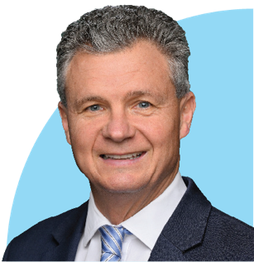

Matt Thistlethwaite
Assistant Minister for Foreign Affairs and Trade

Message from the Chair
I am delighted to introduce COALAR’s Annual Highlights Report, which describes a range of significant activities undertaken by COALAR from February 2024 to end June 2025.
Following a short hiatus in the Board's activity in 2023-24, this period began on 2 February 2024, with the Foreign Minister appointing me as COALAR’s first female Chair, along with five new board members. Two previously appointed members of the Council continued in their roles, alongside new and continuing ex-officio members supported by a secretariat within DFAT. The combination of ongoing and new members has ensured an invaluable breadth and depth of knowledge and experience has been brought to achieving the primary goal of COALAR – to improve relations between Australia and Latin America.
The Board began by developing two foundation documents to steer COALAR’s strategic direction and set its priorities for funding and other activity over the short to medium term. The approval of these documents on 30 June 2024 by the Foreign Minister, Penny Wong, was an important achievement. The COALAR Strategic Plan 2024-2027 and Business Plan 2024 have since guided our efforts in five key priority areas: Culture and Entrepreneurship, Education and Research, Environment and Energy Transition, First Nations, and Mining, METS and Resources.
The Board met four times in 2024, its first meeting taking place in Canberra on 27 March. While in Canberra, the Board met with the Ambassadors from the Group of Latin America and Caribbean (GRULAC) embassies, as well as then-Assistant Foreign Minister, Tim Watts, and then-Assistant Minister for Trade, Tim Ayres. On 12 June 2024, Board members also had the opportunity to meet with Foreign Minister Wong while in Adelaide. All of these meetings were invaluable. They not only affirmed the importance of the Board’s work, but also provided much food for thought on how we might achieve our goals by aligning with the Government’s strategic priorities for Latin America including, for example, growing trade and investment ties, particularly in mining, METS, energy and infrastructure.
Meeting with the Ambassadors provided opportunities for the Board to hear their perspectives on key themes and priorities for strengthening existing ties, and identifying new opportunities and possibilities for partnerships between the two regions. What was learned in these meetings informed many of the key decisions made in the coming months.
For me, the opportunity to meet and work with a range of stakeholders and colleagues in Latin America and Australia with a shared commitment to achieving one or more of COALAR’s goals was one of the most rewarding professional experiences of my career. A busy program in Chile, Colombia, Brazil and Peru included experiencing first-hand the benefits of a COALAR grant project (the ‘Surf for Good’ initiative in Peru and Brazil); speaking at the COALAR-supported Women in Mining Leadership Program in Chile, a project developed by the Sustainable Minerals Institute – International Centre of Excellence, Chile and the University of Queensland, in collaboration with DFAT’s Embassy in Santiago (refer to page 22); and exploring some of the opportunities and challenges associated with approaches to educational exchange between the regions that move beyond the recruitment of international students to a two-way sharing of knowledge and professional practice that ensures both Latin American and Australian students are equipped to thrive in an increasingly connected and unequal world.

Of course, one of the most significant pieces of work undertaken by the Board was the delivery of COALAR’s 2024-25 Grants Round which attracted a record number of 266 applications. This meant that the selection process was highly competitive and we were pleased to be able to fund eight high-quality projects which together touch on our four goals and five priority themes. We look forward to seeing the outcomes and impact of the successful projects (refer to page 44) in the coming months and years.
To round off a successful year, in February 2025, we welcomed a new member to the Board: Mr Carlos Colina. He fills the vacancy left by Ms Valeria Alvano Toloza, who completed her second three-year term on the Board in August 2024. The Foreign Minister also re-appointed Dr Erin Watson to serve her second three-year term.
It is clear that COALAR’s key activities over 2024 and 2025, highlighted in this report, have strengthened partnerships in the region within business, institutional and civil society sectors, while also identifying opportunities for further engagement, and raising the visibility and importance of Latin America within Australia, and Australia within Latin America. The last eighteen months have established the foundations for a productive year in 2025-26, with planning already in progress for an Australia-Latin America Future Forum in the first quarter of 2026. This is sure to be a highlight in next year’s report. In the meantime, I hope you enjoy reading about the highlights of the last year and feel inspired to support us in achieving our goals in 2025-26.


Professor Betty Leask
Chair

Overview of Key Achievements


Strategic Framework Implementation
The Council on Australia Latin America Relations (COALAR) has successfully implemented its COALAR Strategic Plan 2024-2027 and Annual Business Plan 2024, establishing four strategic pillars, four goals and five priority themes to guide Australia-Latin America relations. These foundational documents, approved by Foreign Minister Penny Wong on 30 June 2024, provide a structured roadmap for achieving COALAR's vision as the premier advocate for regional engagement.


Board Renewal and
Leadership Diversification On 2 February 2024, Minister Wong appointed Professor Betty Leask as COALAR's first female Chair since its 2001 establishment, alongside five new board members representing diverse sectors. This leadership renewal culminated in four strategic board meetings held in Canberra, Adelaide, virtually, and Sydney, enabling critical stakeholder engagement with parliamentary representatives and the Latin American diplomatic corps.


Ministerial and Diplomatic Engagement
COALAR's board has strengthened high-level governmental connections through strategic meetings with:
- Foreign Minister Penny Wong
- Assistant Minister for Foreign Affairs Tim Watts MP
- Assistant Minister for Trade Senator Tim Ayres
- Ambassadors from the Group of Latin America and Caribbean (GRULAC) embassies in Australia
- Australia's Heads of Mission in Latin America



Strategic Pillars

How coalar works
Pillar 1 | Pillar 2 | Pillar 3 | Pillar 4
Outreach and Advocacy | Collaboration, Communication  and Education | Social and Cultural Connections | Shared Commercial Interests



Goals

Why coalar works
Goal 1 | Goal 2 | Goal 3 | Goal 4
Raise Awareness of COALAR and Latin America-Australia relations | Strengthen Commercial Ties | Expand Social and Cultural Connections | Foster and promote gender equality and women's leadership



Priority Themes

What coalar works on
Theme 1 | Theme 2 | Theme 3 | Theme 4 | Theme 5
Culture and Entrepreneurship | Education and  Research | Environment and Energy Transition | First Nations | Mining, METS,  and Resources



Sector Engagement
COALAR's board members have strengthened connections across sectors through industry meetings including with:
- Australia Latin America
- Business Council (ALABC)
- Australia-Brazil Chamber of Commerce (ABCC)
- The Australian Museum
- Fundacion Santiago a Mil, Chile
- Austmine
- Austrade
- Carbon Market Institute
- World Wildlife Fund
- Australian Institute of Aboriginal and Torres Strait Islander Studies (AIATSIS)
- Museum and Art Gallery of the Northern Territory
- Australia Latam Emerging Leaders Dialogue



Project Portfolio Outcomes
Funded initiatives have delivered quantifiable benefits across multiple sectors:
- Mexico Trade and Investment (Nearshoring) – Study and Seminars
- Australia-Latin America Young Leaders Dialogue
- Promoting Australia-Brazil Direct Flights – Study
- Lithium Triangle Study
- First Nations Diplomacy, Brazil – Art Exhibition
- Expanding Connectivity Mexico, Peru, Colombia – Study
- Safeguarding Our Coral Reefs, Honduras – Expert Visit
- Women in Mining Leadership Program, Chile
- 19th Latin American Film Festival
- Brazil Week 2024



Digital Presence Enhancement
COALAR has revitalised its digital communication strategy, re-establishing its Facebook channel and increasing follower engagement by 10% (from 10,000 to 11,000) throughout 2024, expanding the Council's reach and influence across both regions.
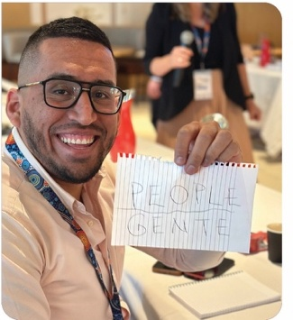
Mr Ben Poveda-Alfonso, COALAR Board member, at the Australia-Latin America Young Leaders Dialogue. Melbourne.



Grant Program Optimisation
The 2024-25 COALAR Grants Round achieved unprecedented engagement, attracting 266 applications – the highest in program history. Eight projects were successful in this grant round, collectively addressing all priority areas (refer to page 44):
- First Nations Voices of Empowerment: Strengthening Our Peoples, and Countries, Future Through Expert Cultural Exchange
- Creature/Criatura - An All-Ages, Immersive and Participatory Installation and Performance
- Pilot Implementation and Evaluation of the Spark Toolkit for Simulation and Analysis of Wildfires in Chile
- Australia-Brazil Symposium on Circular Innovation Ecosystems; Empowering Communities
- Empower HER Through Sport - Empoderarla a Través del Deporte
- The Antarctic Youth Coalition: From Punta Arenas to Hobart
- Driving Climate Innovation: Strengthening Australia-Brazil Partnerships in Cleantech, Sustainability, and Critical Minerals at United Nations COP30
- Voices from the South: Podcast Conversations Between Brazilian and Australian Scientists on Climate, Energy and Sustainability Challenges Facing the Global South



Regional Familiarisation Visit
The Chair conducted a comprehensive familiarisation visit across Chile, Colombia, Peru, and Brazil in May 2024, establishing direct connections with regional stakeholders and identifying emerging collaborative opportunities aligned with COALAR's strategic priorities.
During the 15-day visit, Professor Leask engaged with 55 diverse stakeholder groups and met with 226 individuals across the government, business, education, and cultural sectors. This extensive outreach created meaningful connections with organisations aligned with COALAR's five priority themes.
Key outcomes included potential partnerships with Fundación Santiago a Mil (Chile), the United Nations Economic Commission for Latin America and the Caribbean (ECLAC, or CEPAL in Spanish), the São Paulo Research Foundation (FAPESP, Brazil), and the Bogotá Museum of Modern Art (MAMBO, Colombia), creating pathways for future collaboration across cultural diplomacy, sport partnerships, education exchange, environmental initiatives, and Indigenous knowledge sharing. The visit revealed valuable cross-thematic opportunities, particularly through potential MOUs with organisations like Fundación Chilena del Pacífico.

COALAR Supported Activities 2024
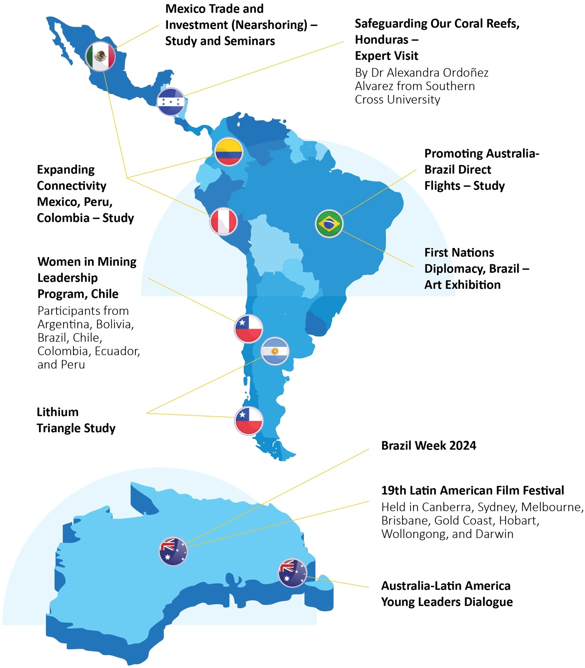

COALAR Grant Projects 2024–25
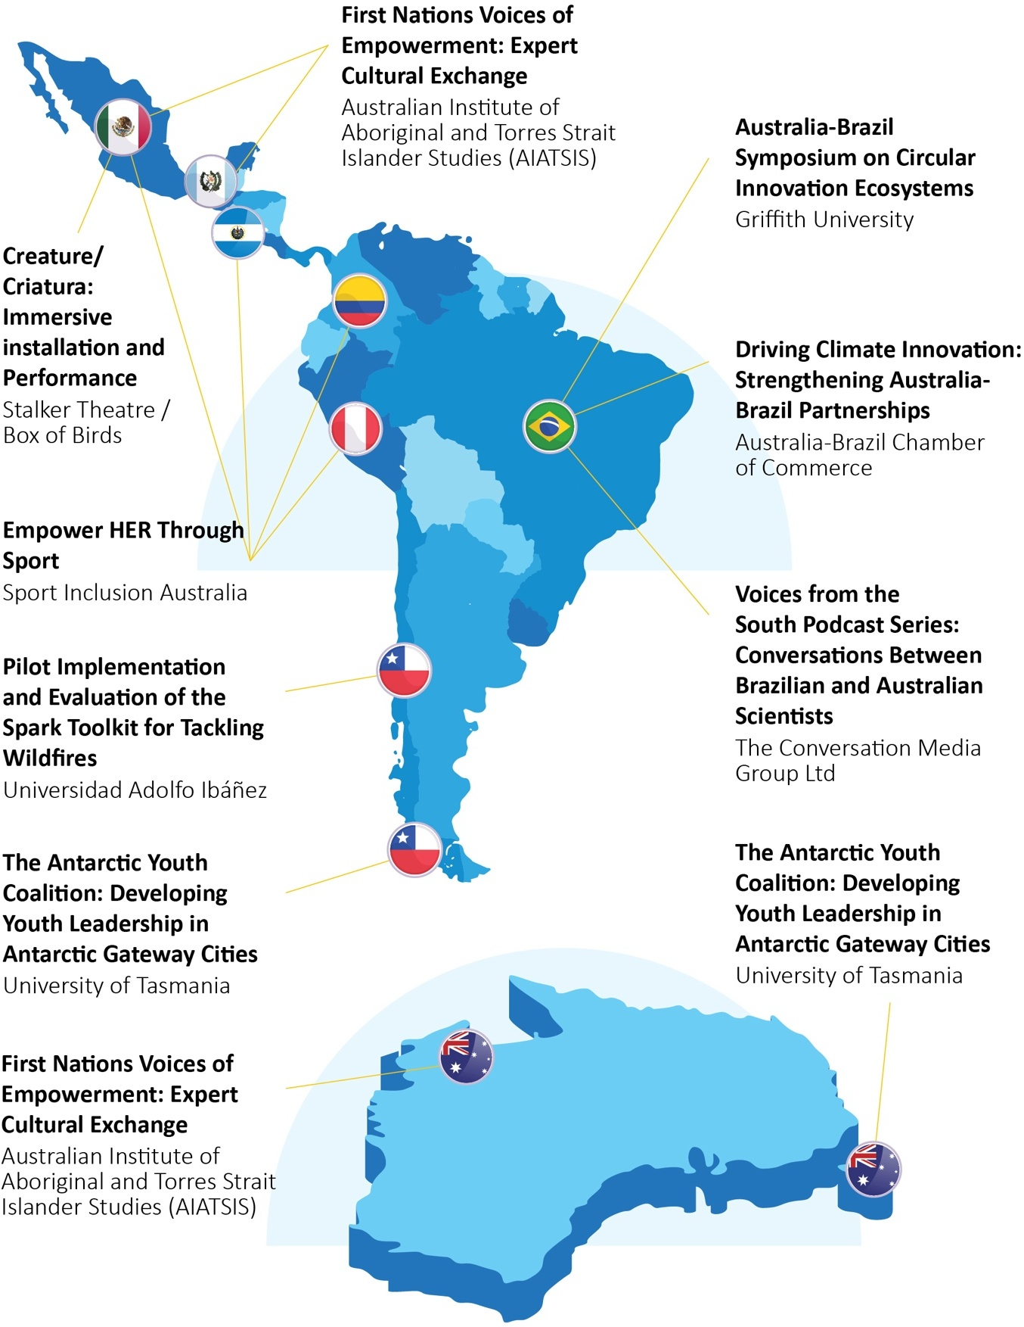

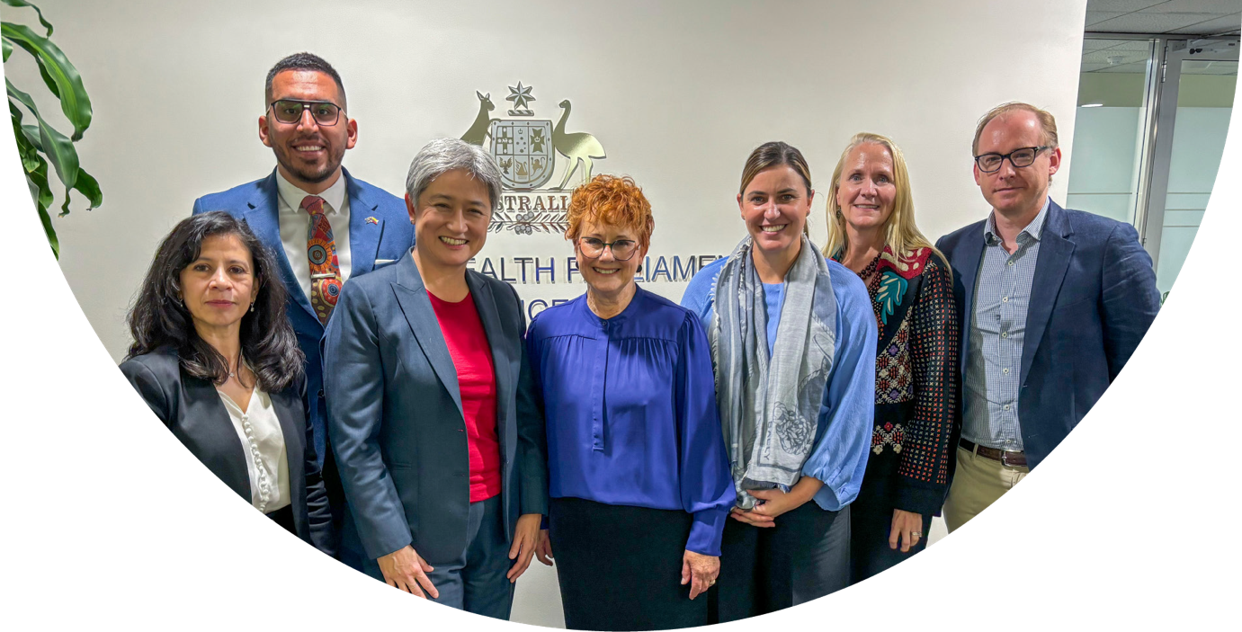

Key Impact Metrics

226 individuals engaged
across government, business, education, and cultural sectors during the regional familiarisation visit

55 stakeholder groups
met in four countries (Chile, Colombia, Peru, Brazil) during the regional familiarisation visit

+100% digital growth
Facebook followers increased from 10,000 to 11,000 throughout 2024

39,000 stakeholders reached
through information sharing about the Lithium Triangle report on multiple channels

6.81% LinkedIn engagement
rate on launch post of Lithium Triangle Study

160 attendees
at the Mexico Trade and Investment (Nearshoring) hybrid panel discussion, featuring senior
trade officials and business leaders

Senator the Hon Penny Wong Minister for Foreign Affairs with members of the COALAR Board.
(left to right) Ms Irma Enriquez Thompson; Mr Ben Poveda-Alfonso; Chair, Professor Betty Leask;
Dr Erin Watson; Ms Christine Gibbs Stewart; Mr Sam Guthrie, former Ex-Officio, Austrade.

1 Outreach and Advocacy
Showcasing contemporary Australian and Latin American business, culture, innovation, and entrepreneurship; advocating for greater Australian engagement in the region in priority areas of mutual interest; and acting as a conduit to the Australian government/ministers on Latin America.

Board-Level Ministerial and Diplomatic Engagement
COALAR's board has strengthened high-level governmental connections through strategic meetings with:
- Foreign Minister Penny Wong
- Assistant Minister for Foreign Affairs Tim Watts MP
- Assistant Minister for Trade Senator Tim Ayres
- Ambassadors from the Group of Latin America and Caribbean (GRULAC) embassies
- Australia's Heads of Mission in Latin America.

Regional Familiarisation Visit
The Chair, Professor Betty Leask, conducted a comprehensive familiarisation visit across Chile, Colombia, Peru, and Brazil in May 2024. The outstanding support of the Embassies in these countries was essential in establishing new connections with a diverse range of regional stakeholders, deepening existing connections and identifying emerging collaborative opportunities aligned with COALAR's strategic priorities.
During the 15-day visit, Professor Leask engaged with 55 stakeholder groups and met with over 200 individuals across government, business, education, and cultural sectors. Key discussions centred on opportunities in cultural diplomacy, sport/surf partnerships, education, climate and environment initiatives, and Indigenous knowledge sharing.
While in Santiago she opened and closed the 3-day Leadership Program for Women run by the University of Queensland, an event specifically designed for COALAR to support the development of a future generation of women leaders in mining. Possibilities for future collaboration across all COALAR priority themes were also explored with organisations such as Fundación Santiago a Mil (Chile), the United Nations Economic Commission for Latin America and the Caribbean (ECLAC, or CEPAL in Spanish), the São Paulo Research Foundation (FAPESP, Brazil), and the Bogotá Museum of Modern Art (MAMBO, Colombia).
These engagements revealed the importance and possibility of cross-thematic opportunities, particularly through potential MOUs with organisations such as the Fundación Chilena del Pacífico. The visit was particularly important, sending a strong signal to stakeholders about the importance of ongoing relationships and the desire to deepen those, while also establishing new connections in shared areas of interest concerning COALAR goals and priority areas.
The 2024 goals and priorities themes were well received and common areas of interest across LATAM and Australia were found to be connected to individual COALAR themes and also synchronously across multiple themes. There was strong interest in the 2024-25 grant round.
Key learnings from the visit included the importance of better publicising outcomes of previous and future projects, as well as the potential (and importance) of leveraging synergies across themes and countries, and of co-funding strategic projects in order to maximise value for money in expenditure of limited funds.

Digital Presence Enhancement
COALAR has revitalised its digital communication strategy, re-establishing its Facebook channel and increasing follower engagement by 10% (from 10,000 to 11,000) throughout 2024, expanding the Council's reach and influence across both regions.

Mexico Trade and Investment (Nearshoring) – Study and Seminars
This COALAR-funded report, of June 2024, delivers comprehensive analysis of investment opportunities for Australian enterprises in Mexico. Authored by Juan Carlos Baker, CEO of Ansley International Consultancy, this strategic assessment equips the Australian and Mexican governments, businesses and stakeholders with evidence-based insights into Mexico's market landscape within the nearshoring context.
The report serves as a crucial tool for the Australian Embassy in Mexico, as well as for COALAR Board members and business councils – the Australia, New Zealand, Mexico Business Council (ANZMEX) and the Australia- Latin America Business Council (ALABC) – in their promotion, advocacy, and sector stakeholder engagement. It has significantly facilitated dialogue with the Mexican Government, including the Ministry of Economy, in strengthening bilateral trade and investment relationships.
Key advantages identified for Mexico as a nearshoring destination include:
- Geographic proximity and logistics efficiency: Transporting merchandise to the US market from China or Vietnam takes 26-37 days and costs USD 2.36 per cubic foot, while shipping from Mexico takes just 2 days and costs USD 1.26 per cubic foot
- Extensive free trade network: Mexico's inclusion in the United States-Mexico-Canada Agreement (USMCA) facilitates access to 372 million potential consumers in the US and Canada
- Manufacturing excellence: Mexico's manufacturing industry combines cost-competitive labour with high- quality technology.
The report identified targeted investment opportunities for Australian businesses across five key sectors: agri- food, mining, healthcare, technology, and defence.

Measurable Impact
The Australian Embassy in Mexico supported three major engagement activities to amplify the report's findings:
- A strategic presentation to the COALAR Board
- An ALABC-hosted webinar on nearshoring opportunities (20 August 2024)
- A hybrid panel discussion moderated by Australia’s Head of Mission in Mexico, Ms Rachel Moseley, with approximately 160 attendees (24 November 2024).
The panel event featured high-level participation including Dr. Luis Rosendo Gutiérrez, Vice Minister for Foreign Trade, Simon Hanna, CEO of FIBRA Macquarie, Kate Brown, President of ANZMEX, Kim Prior, CEO of ALABC, representatives from Mexican states, and Mexico's Ambassador to Australia, Mr Ernesto Cespedes Oropeza.
Attendees included representatives from Australian businesses, such as Woodside and Macquarie, senior Mexican government officials and senators, representatives from Mexican states, and members of the diplomatic corps. Online participants included key Australian stakeholders from the private sector, industry bodies, and chambers of commerce.
By bringing together influential figures from both government and the private sector, the report has renewed dialogue on new areas of possible investment and reminded them that Australia is a reliable and willing trade and investment partner. The Australian Embassy will continue to engage in advocacy to further these efforts, aiming to capture the interest of specific Australian businesses with the potential to invest in Mexico.

Lithium Triangle Study
A COALAR supported study, Opportunities for Australian Businesses in the Lithium Triangle, comprised of a strategic analysis of the lithium-rich Andean region (holding 60% of global lithium resources) provides Australian Mining Equipment, Technology and Services (METS) companies with targeted market intelligence for diversifying into South American operations.
While Australia has a thriving lithium sector, hard rock mining extraction methods are vastly different to processes used in lithium-rich salt flats of Argentina and Chile. Therefore, Australian METS must develop new solutions and expertise for different operating conditions.
The report, prepared by Lindsay Rueda Services Pty Ltd, examines operators, explorers, extraction methods, processing techniques, operational challenges, supply needs, and ESG considerations across the Lithium Triangle region of Chile and Argentina.
Despite challenges including remote project locations, specialized technology requirements, and fragile ecosystems, the report identified significant opportunities for Australian METS businesses in:
- AI-driven exploration technologies
- Data-driven resource modelling
- Environmentally sound water and waste management
- Communications technology for remote locations
- Community engagement expertise.

Industry Engagement Metrics
COALAR’s webinar launch of the study on December 6 2024, co-hosted with Austmine, attracted 78 attendees from the Australian METS and government sectors. The webinar featured a high-profile panel including the (former) Australian Ambassador to Argentina, Simon Twisk, Valeria Ortiz, Business Development Director for Green Economy at the Australian Trade Commission, Santiago and Claudio Martinez, Vice President, Copper Sector, Growth, Worley.
Report information reached 39,000 stakeholders through multiple channels:
- Through direct emails: 19,000 recipients with 73.4% open rate and 18.3% click rate
- Events & webinars dissemination: 20,000 recipients with 33.9% open rate and 8.5% click rate.
Digital engagement metrics show:
- 159 on-demand views on YouTube
- 2,300+ impressions on YouTube
- LinkedIn engagement rate of 6.81% on the launch post, with 879 impressions
- 82% of webinar attendees represented Australian METS companies.

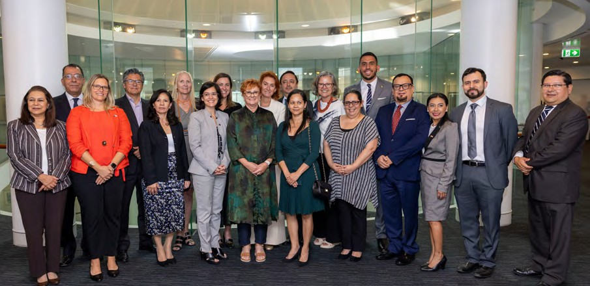
Latin American and Caribbean Heads of Mission in Canberra with the COALAR Board.
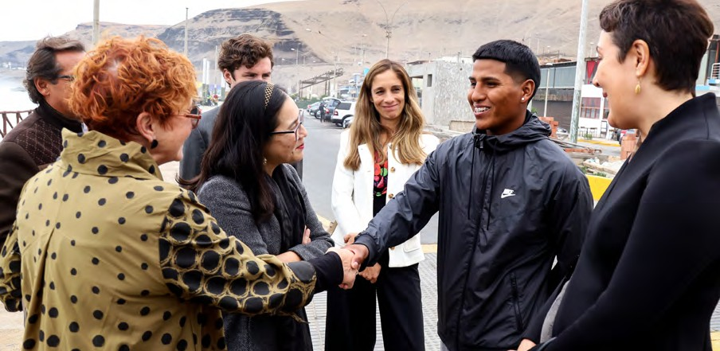
COALAR Chair Professor Betty Leask in Peru meeting with stakeholders from the ‘Surf for Good’ initiative.
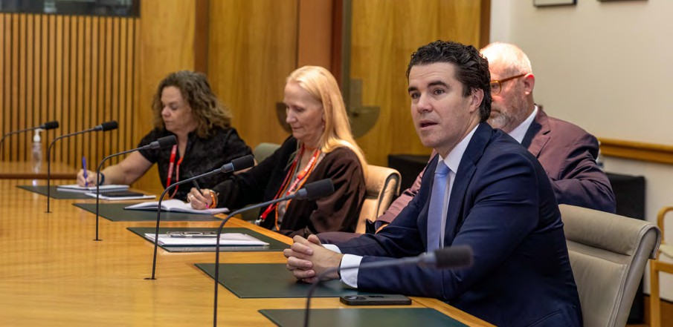
(left to right) Ms Diana Nelson, Director Latin America and Caribbean Section at DFAT; Ms Christine Gibbs Stewart, COALAR Board Member; Hon Tim Watts MP, former Assistant Minister for Foreign Affairs; Senator the Hon Tim Ayres, former Assistant Minister for Trade.

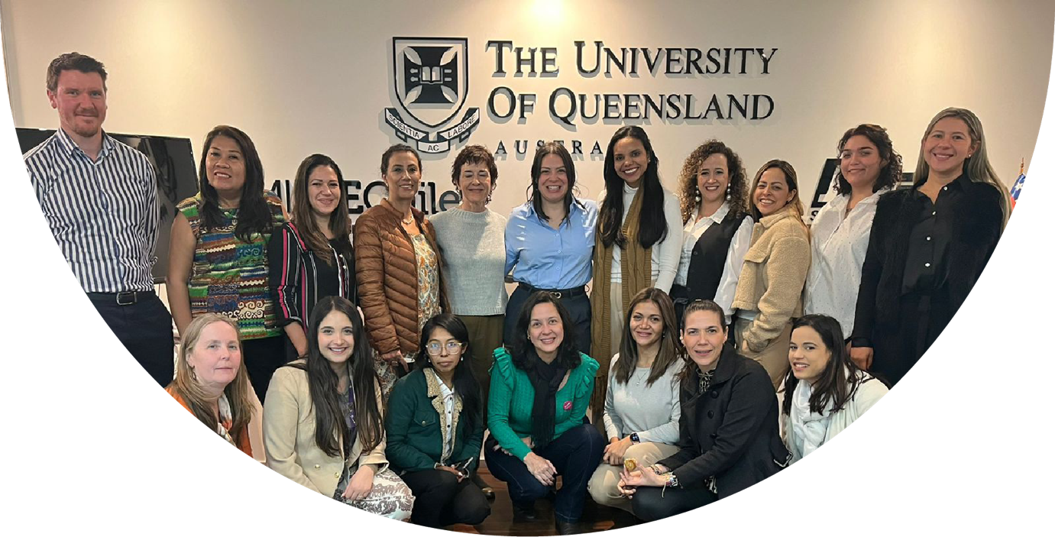

Key Impact Metrics

266 grant applications received
in 2024-25 – the highest in program history

8 strategic grant projects funded
addressing all five priority themes

226 views
on the Women in Mining Leadership Program Youtube video

14 female mining professionals from Latin America trained
in a regional leadership program

6 coral reef engagement events
held in Honduras across one week

1,000 views
on the National Autonomous University of Honduras-hosted coral presentation via Facebook

Dr Doug Aitken, Executive Director SMI-ICE-Chile, with the participants of the Women in Mining Leadership Program in Santiago, Chile.

2 Collaboration, Communication and Education
Shared knowledge and understanding of each other's cultures, economies and societies through cross-regional cooperation in key focus areas and dissemination of impact and outcomes of collaborations.

Strategic Framework Implementation
COALAR has successfully implemented its Strategic Plan 2024–2027 and Annual Business Plan 2024, establishing four strategic pillars and five priority themes to guide Australia-Latin America relations. These foundational documents, approved by Foreign Minister Penny Wong on 30 June 2024, provide a structured roadmap for achieving COALAR's vision as the premier advocate for regional engagement.

Grant Program Optimisation
The 2024-25 COALAR Grant Round achieved unprecedented engagement, attracting 266 applications – the highest in program history. Eight strategic projects received funding, collectively addressing all five of COALAR's priority areas (refer to page 44).

Safeguarding Our Coral Reefs, Honduras – Expert Visit
In 2024, COALAR seized on a unique opportunity to mark the 40-year anniversary of diplomatic relations between Australia and Honduras. The two nations are home to the two largest coral reefs in the world – the Great Barrier Reef and the Mesoamerican Reef – and share the objective of safeguarding these reefs toward a sustainable future.
COALAR supported a strategic collaboration between Australia’s Embassy in Mexico and Honduran partners to facilitate a one-week program in Roatan Island by Dr. Alexandra Ordoñez-Alvarez, a prominent Australian coral expert from Southern Cross University. The initiative enabled the knowledge transfer of Australia's innovative coral 'IVF' program to support conservation efforts for Honduras' section of the Mesoamerican reef. The program regenerates new corals in the face of the devastating loss of coral life due to bleaching.
The program included six engagement events over a one-week period:
- A presentation at the National Autonomous University of Honduras (UNAH), Tegucigalpa, reaching

approximately 100 students and faculty members
- A roundtable with the UNAH divers cohort and marine biology faculty (30 participants)
- A meeting with Mesoamerican Reef Fund representatives
- The Roatan Symposium (40 participants)
- Site visits to Roatan Marine Park research projects and facilities.
The program also included a virtual presentation by Southern Cross University Distinguished Professor, Peter Harrison, on his Coral IVF program being implemented in the Great Barrier Reef and internationally. This knowledge exchange addressed critical challenges facing the Mesoamerican reef system and established a framework for ongoing collaboration.

Stakeholder Impact
Bessy Aspra, Executive Director of Roatan Marine Park, said: "For Roatan Marine Park it has been an honour and a long-time dream to have had the opportunity to co-sponsor an event that has allowed us to strengthen the bonds of cooperation and friendship between Honduras and Australia for the conservation of coral ecosystems in the framework of World Oceans Day."
The initiative generated significant digital engagement:
- Over 1,000 views of the UNAH presentation and Dr. Ordoñez's interview on UNAH's Facebook channels
- Multiple publications on the UNAH website blog
- Substantial engagement on the Australian Embassy in Mexico's Ambassador X account
- Dedicated coverage on Roatan Marine Park's Instagram and Facebook platforms.
The project amplified COALAR in the region by strengthening links with Honduran government entities, local Non-Government Organisations, research institutes and tourism operators.
This project specifically strengthened Australia's diplomatic relationships with Honduras during the 40-year anniversary of diplomatic relations between the two nations.

Women in Mining Leadership Program, Chile
The Sustainable Minerals Institute – International Centre of Excellence (SMI-ICE-Chile) of the University of Queensland, in partnership with the Australian Embassy in Chile and supported by COALAR, delivered a transformative leadership program for female mining professionals from across Latin America.
The four-day program, held from 25 to 30 May 2024 in Santiago, Chile, brought together 14 female professionals from the mining sectors of Chile, Brazil, Argentina, Ecuador, Colombia, Peru, and Bolivia.
The curriculum addressed four key themes: leadership context and challenges, overcoming biases and leading change, communication and conflict resolution, and personal development.
COALAR Chair, Professor Leask, joined Todd Mercer (former Australian Ambassador to Chile), Dr Doug Aitken (Executive Director, SMI-ICE-Chile) and Antonia Ariztia (Head of Gender and Diversity, Chilean Ministry of Mining) to launch the program in Santiago.

Data-Driven Development
The program was informed by a comprehensive survey of 691 Women in Mining (WiM) members across seven Latin American countries, working in mining supply chains, companies of all sizes, academia, NGOs, and government organisations. This research ensured the training addressed region-specific needs and challenges.

Measurable Outcomes
- Enhanced leadership capabilities through a co-designed curriculum including courses, master classes, and collaborative activities.
- Establishment of a regional network of women leaders, providing a safe, collaborative space for knowledge sharing.
- Program evaluation framework developed to gather insights for future courses and build upcoming industry leadership experiences.

Stakeholder Testimonials
"This experience was enriching. I managed to connect with great women from Latin America. One of the things we did together was to strengthen our capacities as leaders." – Carolina Toro, Director, Metropolitan Region Nucleus, Women in Mining Chile
"I joined this course because I believe that women in Latin America have a lot of potential and I finished this program much more empowered and inspired than I imagined." – Barbara Jocew Schmitz, Change Management Specialist, RHI Magnesita

Industry Amplification
The program received substantial media coverage:
- Multiple articles on SMI-ICE-Chile website and LinkedIn
- YouTube video with 226 views and 11 likes
- LinkedIn posts generating 133 likes
- Coverage in industry publications including Reporte Minero, Revista Minería Chilena, and Salta Mining
- Presentation of survey results at the Mining Congress to 2050, organised by WiM Peru.

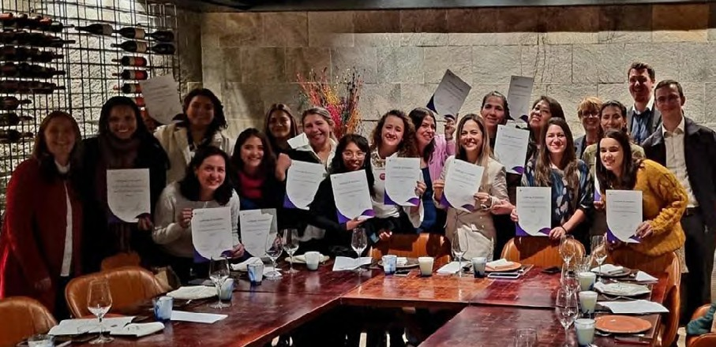
Participants of the Women in Mining Leadership Program in Santiago, Chile, after completing the program.
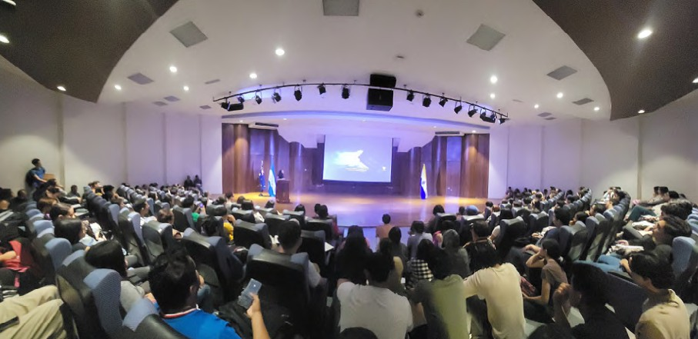
Coral expert Dr Alexandra Ordoñez-Alvarez presenting at the National Autonomous University of Honduras in Tegucigalpa, Honduras.
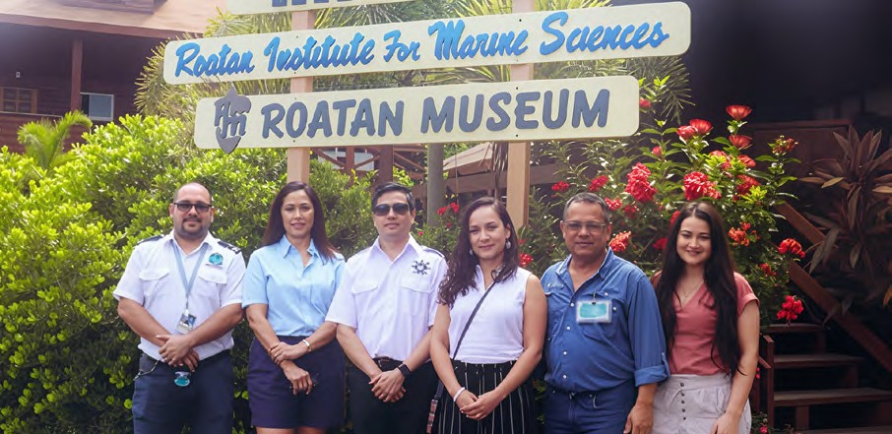
(left to right) Joel Doland McLaughlin Matute, Directorate General of the Merchant Navy; Bessy Aspra, Roatan Marine Park; Edgar Soriano Ortiz, Directorate General of the Merchant Navy; Dr Alexandra Ordoñez, Southern Cross University; Gael Gutierrez, Roatan Marine Park; Jasemine Altinkaya, DFAT. Photo Credit: Roatan Marine Park.


Coral reef, Roatan Island, Honduras.

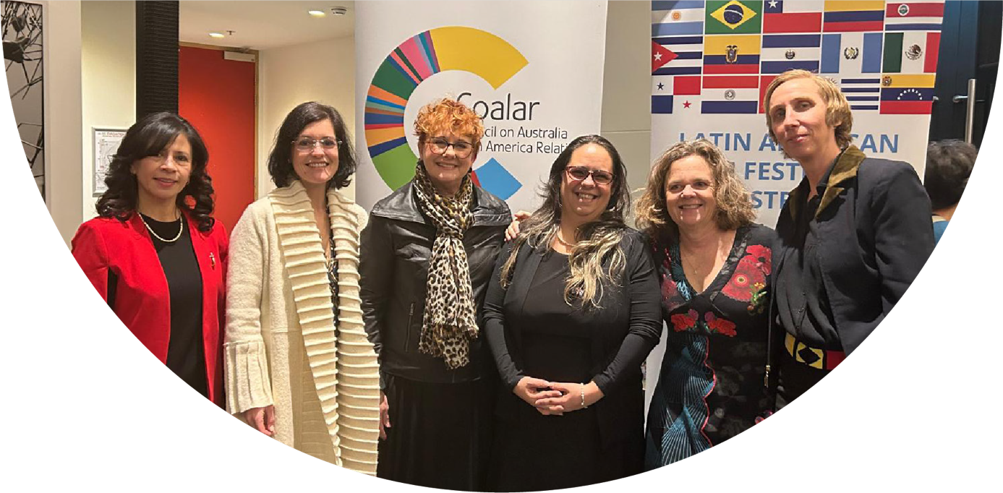

Key Impact Metrics

300 guests
attended the First Nations Diplomacy, Brazil – Art Exhibition

3,464 views
on the First Nations Diplomacy, Brazil – Art Exhibition event overview reel

40,000+ website visits
during the 19th Latin American Film Festival period

15 acclaimed films
were screened at the 19th Latin American Film Festival

31 participants
joined the Australia-Latin America Young Leaders Dialogue

102 film screenings
across 8 Australian cities reaching an audience of 7122 people during the 19th Latin American Film Fesitval

Opening of the 19th Latin American Film Festival, Canberra, 8 August 2024.
(left to right) Ms Irma Enriquez Thompson, COALAR Board Member; HE Mrs Dianela Pi, Ambassador of Uruguay and Dean of GRULAC; Professor Betty Leask, COALAR Chair; HE Mrs Tanieris Diéguez La O, Ambassador of Cuba; Ms Diana Nelson, Director Latin America and Caribbean Section at DFAT; Ms Robin Hooper, COALAR Secretariat Manager.

3 Social and Cultural Connections
Existing, emerging and new areas for engagement in bilateral and regional relationships.

Board Renewal and Leadership Diversification
On 2 February 2024, Minister Wong appointed Professor Betty Leask as COALAR's first female Chair since its 2001 establishment, alongside five new board members representing diverse sectors. This leadership renewal culminated in four strategic board meetings held in Canberra, Adelaide, virtually, and Sydney, enabling critical stakeholder engagement with parliamentary representatives and Latin American diplomatic corps.

19th Latin American Film Festival
In 2024, the Embassy of Cuba in Australia, on behalf of the Group of Latin America and Caribbean (GRULAC) embassies, coordinated the 19th Latin American Film Festival. The national festival, a significant event promoting cultural exchange and strengthening of ties between Latin America and Australia, has a longstanding relationship with COALAR which has sponsored the event since 2004. This cultural initiative strengthened Australia's engagement with Latin American diplomatic partners while showcasing Latin American cinema to Australian audiences.
The festival, held across multiple Australian cities, featured 15 films from 15 Latin American countries, creating a vibrant platform for cultural exchange and diplomatic engagement. The Festival, launched on the 8 August 2024 in Canberra by COALAR Chair Professor Betty Leask, was held in eight cities across Australia: Canberra, Sydney, Melbourne, Brisbane, Gold Coast, Hobart, Wollongong, with a return to Darwin for the first time since 2015.

Diplomatic Impact
The event strengthened Australia's diplomatic ties with the Group of Latin America and Caribbean (GRULAC) embassies, with ambassadors and representatives from the Latin American and Caribbean region participating in the festival activities. This enhanced engagement supports COALAR's mission to build stronger cultural and diplomatic connections between Australia and Latin America.

Cultural Exchange Outcomes
The festival attracted audiences of 7,122 people across the festival period. Post-event surveys indicated that 87% of attendees reported increased interest in Latin American culture following their festival experience, with 65% expressing their intention to learn more about Latin American business and tourism opportunities.

Media Engagement
The festival garnered substantial media coverage across traditional and digital platforms:
- 15 print and online articles in mainstream Australian media outlets
- 8 radio interviews featuring festival organisers and diplomatic representatives
- Social media reach of over 95,000 across dedicated festival channels
- 40,000+ website visits during the festival period.

Engagement & Participation
COALAR's sponsorship of the festival enabled broader promotion of the festival and facilitated participation of key diplomatic stakeholders, enhancing cultural exchange between Australia and Latin American nations. Through this support, COALAR directly contributed to increasing awareness of Latin American cultural expressions in Australia and strengthening people-to-people connections between the regions.

Australia-Latin America Young Leaders Dialogue
COALAR funded the inaugural Australia-Latin America Young Leaders Dialogue, bringing together 20 dynamic, young leaders and 11 inspiring experts to discuss enhancing political, economic, cultural and people-to-people links between Australia and Latin America. This investment supported next-generation capability development in Australian-Latin American relations.
Held at the Melbourne Cricket Ground on 27 June 2024, the event provided a structured forum for emerging leaders to engage with established experts across business, academia, diplomacy, and cultural sectors. The dialogue addressed key themes including renewable energy cooperation, educational exchanges, creative industries collaboration, and investment opportunities.

Participant Demographics
The 20 young leaders, selected from a competitive application pool, represented diverse professional backgrounds:
- 35% from business and finance sectors
- 25% from academic and research institutions
- 20% from government and diplomatic services
- 20% from creative industries and non-profit organisations.
Participants brought expertise and connections spanning eight Latin American countries, with particularly strong representation from Brazil, Chile, Colombia, and Mexico.

Knowledge Transfer Outcomes
The structured dialogue format facilitated both formal presentations and interactive workshop sessions, with concrete outcomes including:
- 4 new collaborative research initiatives established between Australian and Latin American participants
- 2 business partnership memoranda signed following connections made at the event
- 85% of participants reporting development of new professional networks they intend to maintain.

Long-term Impact Measurement
The program established a formal alumni network with tracking mechanisms to measure ongoing collaboration. Six months after the initial dialogue, metrics revealed:
- 12 follow-up meetings between Australian and Latin American participants
- 3 joint funding applications submitted for bilateral projects
- 1 trade delegation organised as a direct result of connections formed.

First Nations Diplomacy, Brazil – Art Exhibition
COALAR supported an Indigenous Australian art exhibition displayed at Australia's embassy in Brasília during signature events celebrating 80 years of diplomatic relations between Australia and Brazil in 2025.
Thirteen banner artworks by Indigenous Australian artists formed a central element of the embassy's 80th anniversary celebration on 30 January 2025, attended by approximately 300 guests including government authorities, diplomatic community members, Australian companies based in Brazil, and media representatives. The exhibition was enhanced with educational materials, texts, and videos accessible through QR codes, enabling attendees to gain deeper understanding of Australia's First Nations culture and history beyond the visual appreciation of the artwork.

Strategic Impact
The exhibition enhanced Australia's First Nations diplomatic engagement ahead of Brazil's hosting of the UN Climate Change Conference (COP30) in November 2025. Australia's Ambassador to Brazil, Sophie Davies, noted, "This Indigenous art exhibition has been particularly rewarding during this critical year leading up to the UN Climate Change Conference in Belém. The banners have enabled many of our partners to experience Australia's Indigenous art first-hand, and the educational component has sparked ongoing interest in Australia's Indigenous culture."

Stakeholder Response
Guests noted "it was great that Australia is showcasing its First Nations heritage here in Brazil." Many commented, "Not many people know about this incredible link between Australia and Brazil."

Digital Engagement
The exhibition generated substantial engagement on the social media platforms managed by Australia's embassy in Brazil (Facebook, Instagram and X):
- Event overview reel achieved 3,464 views and 192 interactions
- Ambassador's speech reel earned 2,117 views and 113 interactions

Future Amplification
The exhibition will continue to be displayed throughout 2025, including at Brasília's Supreme Court of Justice during the International Symposium on Indigenous Peoples Law in August 2025, where Mr. Kevin Smith, President of the Australian National Native Title Tribunal, has been invited to speak.

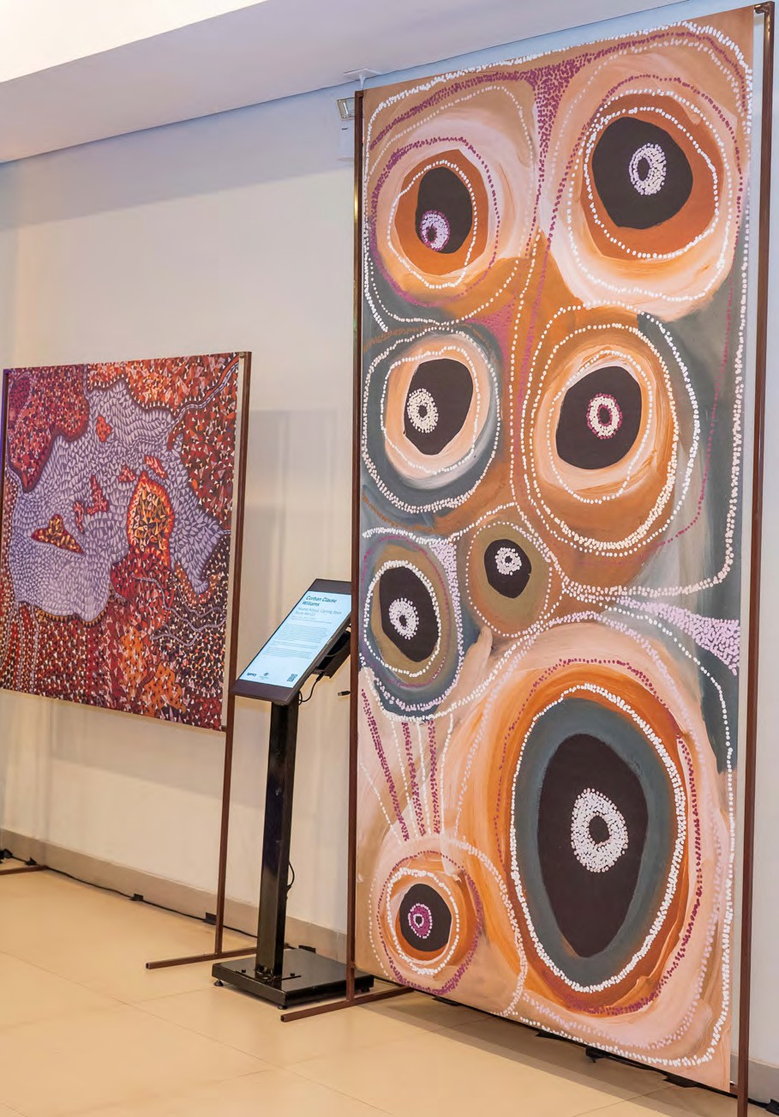
Artwork from the COALAR-supported First Nations Diplomacy, Brazil – Art Exhibition.

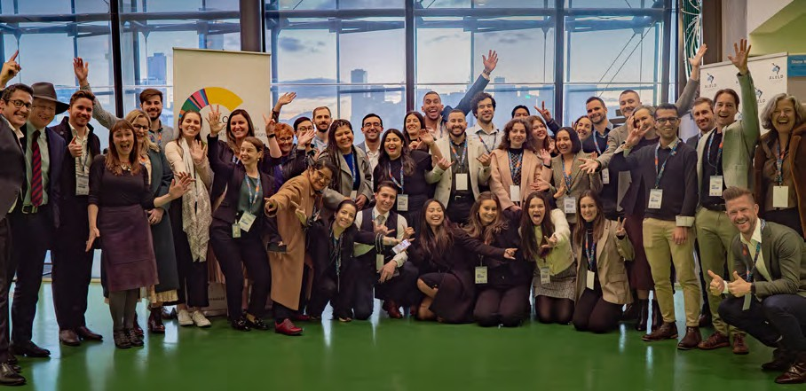
Attendees of the Australia-Latin America Young Leaders Dialogue.
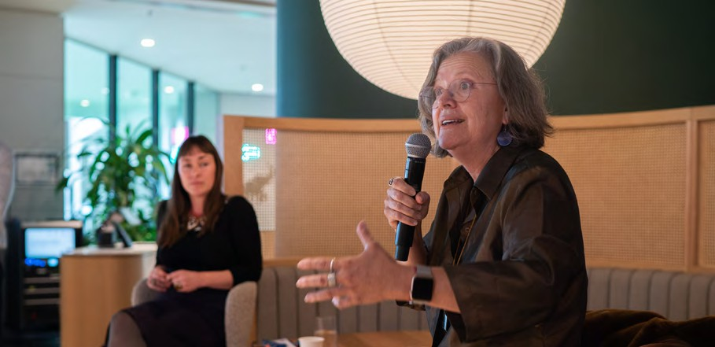
Ms Mara Bún, COALAR Board Member, at the Australia-Latin America Young Leaders Dialogue.
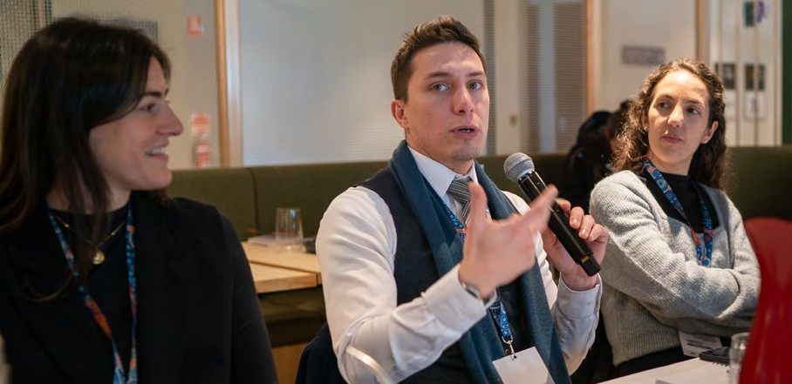
Australia-Latin America Young Leaders Dialogue delegate, Sebastian Alarcon Pinto, speaks with other delegates during workshop.

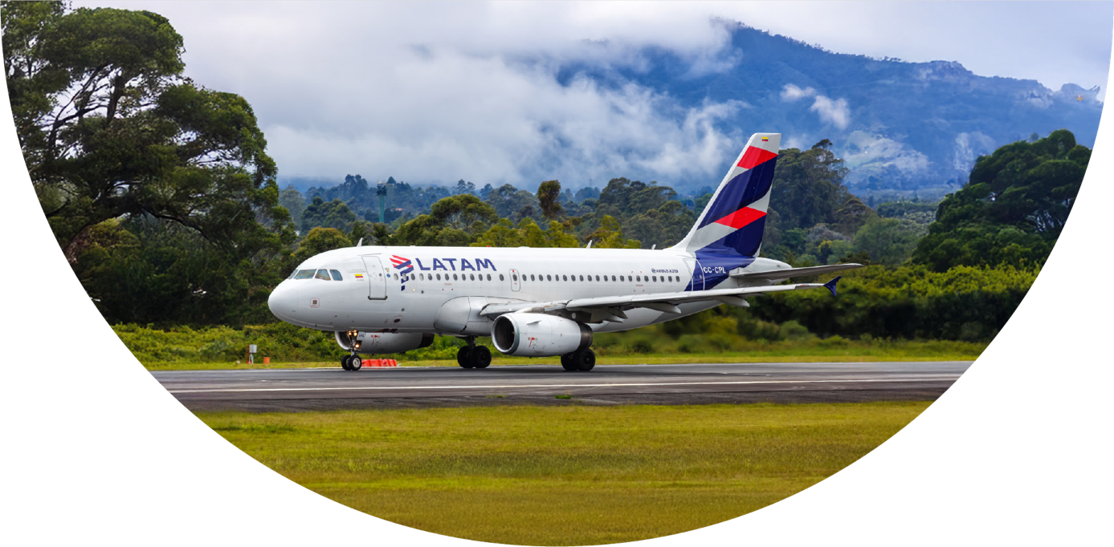

Key Impact Metrics

352,000 potential passengers
identified between Australia and Mexico/Peru/Colombia in 2023

6,500 Instagram followers
reached through Brazil Week exposure

21 stakeholder meetings
facilitated through the Direct Flights working group

4 high-level airline and tourism authority meetings
held to promote Australia-Brazil direct flights

46,000 website visitors
reached through Brazil Week 2024 exposure

2,500 annual event attendees
engaged through Brazil Week 2024 programming

LATAM Airbus A319 airplane Medellin airport, Colombia.

4 Shared Commercial Interests
Australia's good reputation and comparative advantages in the region, existing trade and investment links, and emerging opportunities to strengthen Australia's economic engagement in Latin America.

Promoting Australia-Brazil Direct Flights – Study
COALAR commissioned a comprehensive project delivering both a robust business case and actionable strategic recommendations aimed at enhancing travel and commercial connectivity between Australia and Brazil. This initiative addresses critical infrastructure gaps limiting bilateral economic exchange and provides quantifiable pathways toward improved air linkages.
Brazil is the only non-European country among Australia's top 25 trading partners that does not have direct flight connections. As Australia's largest export market in Latin America by a significant margin (including tourism, travel, and education-related services), and the recipient of half of Australia's direct investment in the region, improved connectivity represents a transformative opportunity.

Strategic Engagement
Australia's embassy in Brasília leveraged the report to conduct four high-level meetings with key stakeholders including:
- LATAM Airlines (20 August 2024)
- Embratur (Brazilian tourism authority, 23 October 2024)
- São Paulo Airport (4 November 2024)
- Qantas (30 January 2025).
Additionally, the Embassy facilitated strategic connections between Qantas, Embratur, and the Australia-Brazil Chamber of Commerce (ABCC) to maintain momentum for increased connectivity.

Key Outcomes
The study revealed that airports and tourism agencies in Brazil are eager to support direct flights, with airlines planning to improve connectivity from Australia to Brazil in 2025-26. A significant development emerged when Qantas began direct ticketing from Brazil on 1 April 2025, with enhanced regional capacity expected when new long-distance aircraft come online in 2026.

Stakeholder Testimonials
- ABCC: "It's fantastic to see the promise of greater connectivity between Brazil and Australia. There is so much potential waiting to be unlocked... The Brazilian business community will be very excited once this takes off."
- São Paulo Airport: "We are also very excited to see the possibilities of greater connectivity. Please stay in touch and keep us updated."
This project has strengthened relationships with key decision-makers across airlines, airports, and government agencies while raising COALAR's profile within important business sectors and the region.

Expanding Connectivity Mexico, Peru, Colombia – Study
COALAR funded a detailed viability assessment examining the potential for increased air connectivity between Australia and key Latin American markets: Colombia, Mexico and Peru. The project delivered both analytical findings and purpose-built advocacy materials, enabling stakeholders to effectively communicate and promote evidence-based recommendations.
The study, produced by Listen Consulting, provided comprehensive market intelligence and feasibility analysis for direct flights to these countries, enabling Australia's embassy in Mexico City to pitch the benefits of improved connectivity options.

Market Analysis Highlights
The study revealed strong and growing demand for improved connectivity between Australia and key Latin American markets. Key insights include:
- Trade between Australia and Mexico grew 62% from 2019 to 2023, reaching AUD $5.3 billion
- In 2023, there were 176,000 visitors traveling between Australia and Colombia/Mexico/Peru, creating 352,000 potential passengers
- The Mexican market alone represents 78,000 visitors (156,000 passengers)
- The proposed most viable route (Sydney-Mexico City with a technical stop in Los Cabos) requires only 124,000 passengers annually to support six weekly flights on a 250-seat aircraft.

Stakeholder Engagement
The project facilitated 21 meetings of the Direct Flights Working Group comprised of Australia's embassy in Mexico City and Australia-New Zealand-Mexico Business Council representatives. Key engagements included discussions with:
- Airlines: Aeromexico, Virgin, COPA Airlines, QANTAS, and Air New Zealand
- Airports: Sydney, Melbourne, Brisbane, Cancun, and Auckland
- Government/NGO stakeholders: Tourism Australia, Global Victoria, DFAT State Offices, Mexican Ministry of Foreign Affairs, Australian Freight Association.
This initiative has significantly expanded Australia's relationships in the aviation sector, creating new pathways for ongoing dialogue with decision-makers across the industry.

Brazil Week 2024
COALAR provided a $5,000 'Innovator' tier sponsorship to the Australia-Brazil Chamber of Commerce's 'Brazil Week 2024', showcasing business opportunities in Brazil ahead of the G20 Summit (2024) and COP30 (2025).
The sponsorship delivered significant exposure through ABCC's digital platforms, reaching 6,500+ Instagram followers, 46,000+ website visitors, and 15,000+ mailing list members. Benefits included ABCC annual membership, a dedicated newsletter article, and tickets to events that historically attract 2,500+ attendees.
Brazil Week 2024 showcased business opportunities ahead of Brazil's hosting of major international events, creating strategic positioning for Australian businesses interested in expanding their presence in the Brazilian market.

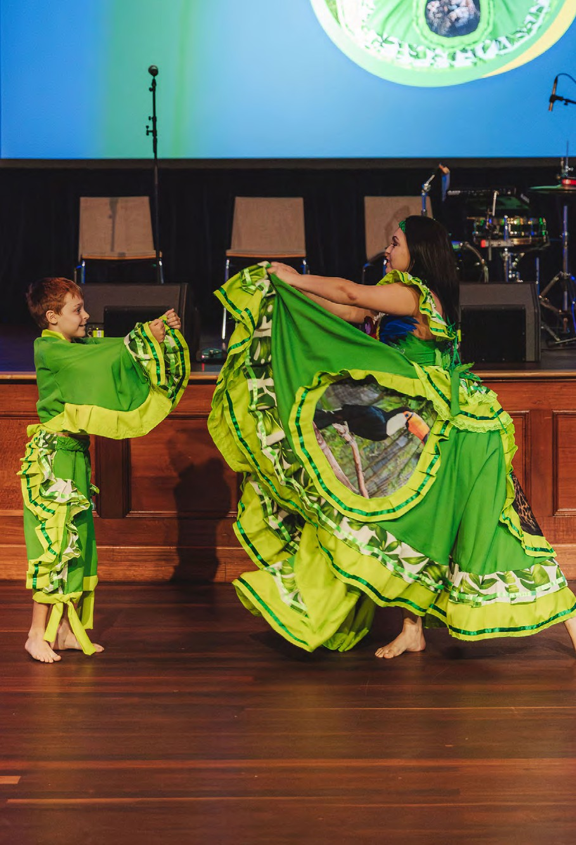
Brazil Week 2024 activities.

The Way Forward
COALAR’s key activities over 2024 and 2025, as highlighted in this report, have strengthened partnerships in the region across industry, institutions and civil society; identified opportunities for further engagement; and raised the visibility and importance of Latin America to Australia.
COALAR’s efforts in 2024 have set the stage for a productive year ahead, with the delivery of much activity in both Latin America and Australia. This year marks the 20th anniversary of the Latin American Film Festival, and we are excited to be working with the Group of Latin America and Caribbean (GRULAC) embassies and this year’s coordinator, the Embassy of the Republic of El Salvador, to make it a success.
A signature event for the first quarter of 2026 will be an Australia-Latin America Future Forum. The Forum will be a catalyst to raise the strategic importance of Latin America to Australia, highlight mutually shared interests aligned to COALAR’s goals and strengthen the profile of COALAR itself.
2025 will also see the opening of the 2025-2026 COALAR grant round and the implementation of the eight grant projects approved through COALAR’s 2024-2025 grant round. The eight projects are well-aligned to priority areas, as outlined in the COALAR Strategic Plan 2024-2027, provide benefits to both Australia and Latin America, and involve a wide range of countries in Latin America.
The grant-funded projects include a First Nations cultural exchange between Mexico, Guatemala and Australia to share expertise and best practices in areas such as language preservation and revitalisation, and cultural heritage; trialling an Australian model of technological innovation in wildfire management in Chile; advancing the inclusion of women with disability in sports leadership in Latin America; collaboration between industry leaders, policymakers and researchers in Australia and Brazil to drive small business engagement in ‘circular resource recovery’ solutions, to address plastic pollution in the marine environment in regional Brazil; and development of youth leadership in Antarctic Gateway Cities (Punta Arenas and Hobart) to strengthen linkages between Australian and Chilean youth on Antarctic interests and issues (refer to page 44).
The year ahead is set to be a busy and exciting time for COALAR, as we continue to seek out opportunities to grow our network and build on existing links, to strengthen our partnerships and ties with the region.

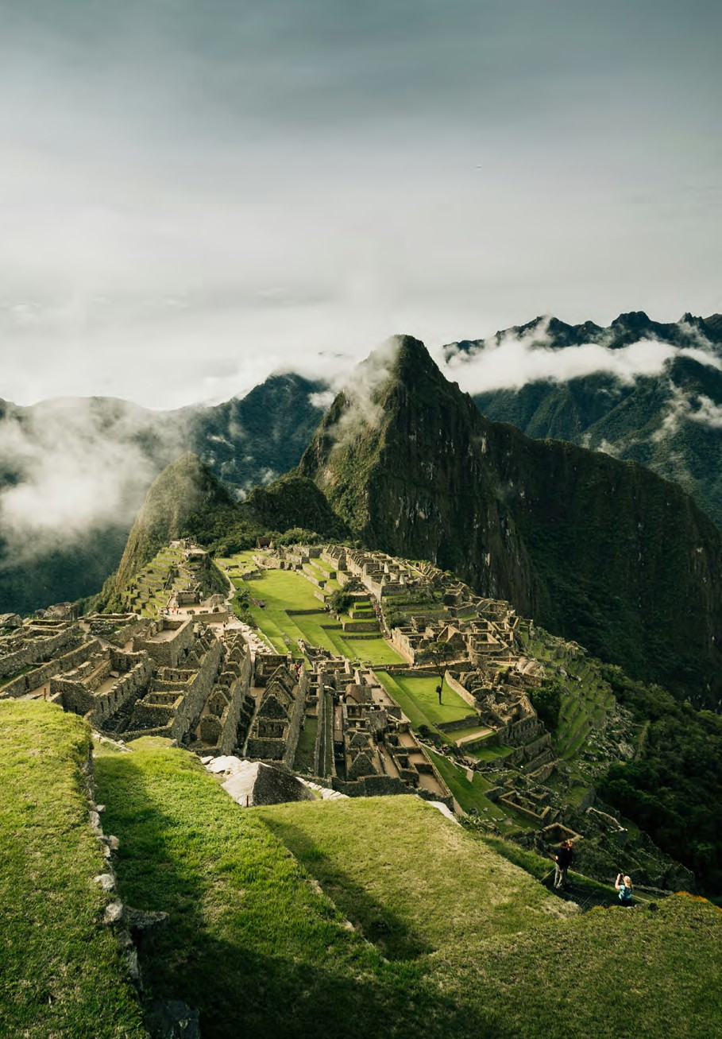
Machu Picchu, Peru.

Council Member Profiles


Professor Betty Leask

Chair | Education | South Australia
Professor Emeritus at La Trobe University and Visiting Professor at Boston College Centre for International Higher Education, Betty Leask, is an internationally renowned researcher, educator and thought leader on internationalisation of the curriculum and higher education. Professor Leask has led multiple national research projects on teaching and learning, and has recently worked on projects in Brazil, Chile and Mexico.


Mr Ignacio Hernandez

Finance/Energy Transition | New South Wales
Mr Ignacio Hernandez has more than thirty years' experience in the banking, finance and energy sectors in Australia, Asia and Latin America. Mr Hernandez is CEO of Asia Pacific for HIF Global, the world's leading e-fuels company, which is developing large scale, green hydrogen-based plants located in Australia, Latin America and the US. Before HIF, Mr Hernandez spent over 18 years as an investment banker in Australia and Chile, with a focus on the infrastructure and energy sectors. He holds a Bachelor of Science and Economics from The London School of Economics and Political Science.



Ms Mara Bún

Environment/Ethical Investment | Queensland
Ms Mara Bún specialises in sustainable finance and innovation to drive decarbonisation and nature restoration. Following a high-profile executive career across the finance, non-profit and R&D sectors, Ms Bún now serves as a Company Director and advisor in the civil society, sustainable business and research sectors to drive lasting commercial, social and environmental impact. Throughout her career, Ms Bún has fostered Australia-Brazil collaboration, including at the CSIRO, where she facilitated biofuel R&D with Brazilian R&D agency Embrapa. Ms Bún is a dual Brazilian/Australian citizen.


Mr Benjamin Poveda-Alfonso

Not-for-Profit/Youth/ Community Engagement | Education | Northern Territory
Mr Ben Poveda-Alfonso is an award-winning public servant and advocate for youth leadership and multicultural inclusion. He manages the Northern Territory Government’s Office of Youth Affairs, leading policies and programs that empower young people across urban, regional, and remote communities. He has represented his community on national and state forums, including the NT Ministerial Advisory Council on Multicultural Affairs. Originally from Colombia, Ben co-founded the international student-led organisation, Kindness Shake, and is the founding president of the Colombian-Australian Association of the NT. A 2024 Australian of the Year Local Hero finalist, he champions stronger Australia–Latin America ties through inclusive, grassroots engagement.



Ms Irma Enriquez Thompson

Cultural Promoter/Arts/Music | New South Wales
Ms Irma Enriquez is a Mexican-Australian pianist and awarded cultural promoter with over 30 years' experience in the industry. Ms Enriquez has performed across the globe and has been a guest speaker at conferences including Contemporary Latin American Music, International Women’s Day, Women in the Arts, and Hispanic Culture Heritage. Ms Enriquez holds accreditations earned in both Mexico and Germany in Governance, Cultural Diplomacy and International Relations. Ms Enriquez is a Board Director of the Music Teachers Association of NSW and was previously Associate-Professor at the Australian National University’s Centre for Latin American Studies.


Ms Christine Gibbs Stewart

Mining/METS | New South Wales
Ms Christine Gibbs Stewart is a business and community leader with over 35 years of experience in senior management, industry development, and international business. Ms Gibbs Stewart is currently CEO of Austmine, the leading industry association representing Australia’s Mining Equipment, Technology and Services (METS) sector. Ms Gibbs Stewart brings deep expertise in international markets, with a strong focus on Latin America, where she has worked extensively across diverse industries. In addition to her role at Austmine, Ms Gibbs Stewart holds board positions with two other organisations and is a former director of the Australia–Latin America Business Council (ALABC).


Mr George Mina
Department of Foreign Affairs and Trade | Ex Officio – Deputy Secretary, Trade and Investment Group



Dr Erin Watson

Public Policy | Victoria
Dr Erin Watson PhD is Managing Director of Baker & York, an international public policy consulting firm where she advises companies, governments, and international organisations on emerging political and economic trends across the Indo-Pacific. Dr Watson is Founder and Chair of the Australia Latam Emerging Leaders Dialogue, Australia's preeminent youth organisation to strengthen relations between the regions. Dr Watson has represented Australia at eight G20 summits, including in Argentina.


Mr Carlos Colina

Media/Arts | Victoria
Mr Carlos Colina is a seasoned journalist and radio broadcaster. Mr Colina currently serves as the Executive Producer of SBS Spanish, overseeing a diverse range of programs covering news, current affairs, sports, health, community issues, and migration. Mr Colina is renowned for in-depth interviews with high-profile guests, including presidents, government ministers, leading scientists, celebrated artists, and prominent athletes.
Mr Colina holds a Master’s Degree in Communication, alongside Diplomas in Radio Broadcasting and War Journalism, reflecting a commitment to excellence and versatility in media.


Ms Vanessa Lapthorne
Department of Education | Ex Officio – Assistant Secretary, Engagement Branch, International Division


Ms Elizabeth Fells
Austrade | Ex Officio – General Manager, Government and Policy Division

COALAR Supported Activities 2024

Recipient | Country Locations | Coalar Strategic Pillars & Priority Areas | Project Summary | Funding amount
Ansley Consultores Internacionales | Mexico | Pillar 4 – Shared Commercial Interests  Education and Research | Mexico Trade and Investment (Nearshoring) – Study and Seminars: An in-depth study of the opportunities that exist for Australian businesses in Mexico, focusing on advantages as a nearshoring hub and looking at the benefits of diversification of export markets. | $36,231.84
Australia Latam Emerging Leaders Dialogue | Australia | Pillar 3 – Social and Cultural Connection  Culture and Entrepreneurship | Australia-Latin America Young Leaders Dialogue: An Australia-Latin America Young Leaders Dialogue event on the 27 June, at the Melbourne Cricket Ground. It brought together a cohort of identified future young leaders and experts on Latin America from within Australia. | $44,709.00
Seventy Two Consulting | Brazil | Pillar 4 – Shared Commercial Interests  Education and Research | Promoting Australia-Brazil Direct Flights – Study: A business case and strategic recommendations for promoting enhanced travel and commercial connectivity between Australia and Brazil. | $20,520.00
Lindsay Rueda Pty Ltd | Argentina Chile | Pillar 4 – Shared Commercial Interests  Environment and Energy Transition  Mining, METS and Resources | Lithium Triangle Study: A study that identifies export and investment opportunities for Australian METS companies in the Lithium Triangle region of South America. | $26,000.00
Agency Project Pty Ltd | Brazil | Pillar 2 – Collaboration, Community and Education  First Nations | First Nations Diplomacy, Brazil – Art Exhibition: Australia's embassy in Brasília, in collaboration with the Indigenous not-for-profit organisation Agency, produced an Indigenous art exhibition to showcase in Brazil. | $20,000.00
Listen Consulting | Colombia Mexico Peru | Pillar 4 – Shared Commercial Interests  Education and Research | Expanding Connectivity Mexico, Peru, Colombia – Study: A study that provides strategic recommendations to pitch Australia as an important partner for increased global connectivity with Latin America with a focus on connecting people and markets in Colombia, Mexico, and Peru. | $41,000.00
Dr Alexandra Ordoñez Alvarez, Southern Cross University | Honduras | Pillar 2 – Collaboration, Community and Education  Environment and Energy Transition | Safeguarding Our Coral Reefs, Honduras – Expert Visit: Dr. Alexandra Ordoñez Alvarez of Southern Cross University, undertook a one-week program in Roatan Island, Honduras, showcasing an Australian expert’s ‘Coral IVF’ model. | $15,547.04
University of Queensland SMI-ICE Chile | Chile | Pillar 2 – Collaboration, Community and Education  Mining, METS and Resources  Education and Research | Women in Mining Leadership Program, Chile: The Australian Embassy in Santiago partnered with the University of Queensland’s Sustainable Minerals Institute (SMI) Centre of Excellence, to present a four-day ‘Women in Mining Leadership Program’ in Santiago, Chile. | $60,000.00
Group of Latin America and Caribbean (GRULAC) embassies in Australia | Australia | Pillar 3 – Social and Cultural Connection  Culture and Entrepreneurship | 19th Latin American Film Festival: Support for the 19th Latin American Film Festival. | $10,000.00
Australia-Brazil Chamber of Commerce | Brazil | Pillar 3 – Social and Cultural Connection  Culture and Entrepreneurship | Brazil Week 2024: Support for the national Brazil Week 2024 activity. | $5,000.00

COALAR Grant Projects 2024–25

Grantee | Country Locations | Coalar Strategic Pillars & Priority Areas | Project Summary | Funding amount
Australian Institute of Aboriginal and Torres Strait Islander Studies (AIATSIS) | Australia Guatemala Mexico | Pillar 2 – Collaboration, Community and Education  First Nations  Education and research Culture and Entrepreneurship | First Nations Voices of Empowerment: Strengthening Our Peoples, and Countries, Future Through Expert Cultural Exchange: bringing First Nations representatives from Mexico and Guatemala to Australia to experience cultural immersion, participate in diplomatic engagements, and exchange First Nations expertise and best practice in areas including language preservation and revitalisation, cultural heritage, and archival and collection management. | $40,000.00
Stalker Theatre / Box of Birds | Mexico | Pillar 3 – Social and Cultural Connection  Culture and Entrepreneurship  Education and Research  Environment and Energy Transition  First Nations | Creature/Criatura - An All-Ages, Immersive and Participatory Installation and Performance:  a collaboration with the Cultural Centre of the University of Guadalajara and Cervantino Festival in Guanajuato, Mexico, in a cross-cultural production focused on Australia’s bush habitat and its First Nations peoples. | $25,800.00
Universidad Adolfo Ibáñez | Chile | Pillar 2 – Collaboration, Community and Education  Education and Research  Environment and Energy Transition | Pilot Implementation and Evaluation of the Spark Toolkit for Simulation and Analysis of Wildfires in Chile: CSIRO’s Spark toolkit provides a solution for tackling wildfires. The project addresses data availability, suitability, and integration; integration of fire science knowledge; and implementation of an enhanced pilot of Spark in Chile to demonstrate the potential of this tool for territorial planning, landscape-scale prevention management, and operational wildfire response. | $50,000.00
Griffith University | Brazil | Pillar 2 – Collaboration, Community and Education  Environment and Energy Transition  First Nations  Culture and Entrepreneurship Education and Research | Australia-Brazil Symposium on Circular Innovation Ecosystems; Empowering Communities: Australian and Brazilian experts, researchers, innovators, local government officials and community leaders will collaborate to develop decentralized ‘circular resource recovery’ solutions to address plastic pollution in the marine environment in regional Brazil. This project will culminate in a three-day symposium and participatory co-design workshop, at the University of Sao Paulo, Brazil. Australian innovation and excellence, including in the field of Local Plastic Microfactory technology, will be showcased during the symposium, with marginalised communities and community-based enterprises/emerging micro-businesses being a specific area of focus. | $48,000.00
Sport Inclusion Australia | Colombia El Salvador  Mexico Peru | Pillar 2 - Collaboration, Community and Education  Culture and Entrepreneurship  Education and Research | Empower HER Through Sport - Empoderarla a Través del Deporte: This project on women's leadership focuses on empowering and promoting the inclusion of women with a disability, in particular those with an intellectual impairment, in seven Latin American countries. Activities include training for women administrators, coaches and athletes, and fostering leadership across all roles in sport though a series of professional workshops, masterclasses, ‘Yarning Circles’ and leadership exchanges. The project will also cultivate partnerships with national paralympic committees in Latin America to drive engagement and participation in Virtus international events, with a focus on events in Australia leading up to the Paralympic Games in Brisbane 2032. | $48,000.00
University of Tasmania | Chile | Pillar 2 – Collaboration, Community and Education  Education and Research  Mining, METS, and Resources Culture and Entrepreneurship | The Antarctic Youth Coalition: From Punta Arenas to Hobart: The University of Tasmania will partner with the Punta Arenas-based Antarctic Youth Coalition (AYC) and the City of Hobart to develop youth leadership in the Antarctic Gateway Cities of Punta Arenas and Hobart. The project will establish a Hobart Chapter of the AYC, develop Spanish language skills of local youth participating in AYC Hobart and strengthen linkages between Australian and Chilean youth on Antarctic interests and issues. |  | $39,848.72
Australia-Brazil Chamber of Commerce | Brazil | Pillar 4 – Shared Commercial Interests  Mining, METS and Resources  Environment and Energy Transition  Culture and entrepreneurship | Driving Climate Innovation: Strengthening Australia-Brazil Partnerships in Cleantech, Sustainability, and Critical Minerals at United Nations COP30: This project will boost collaboration in cleantech, sustainability and critical minerals between Australia and Brazil during COP30. The project’s activities also coincide with Australia and Brazil marking 80 years of diplomatic relations. The project’s activities include showcasing leadership in clean energy and advancing strategic partnerships on sustainable development and net-zero initiatives. | $48,000.00
The Conversation Media Group Ltd | Brazil | Pillar 2 – Collaboration, Community and Education  Environment and Energy Transition  Education and Research First Nations | Voices from the South: Podcast Conversations Between Brazilian and Australian Scientists on Climate, Energy and Sustainability Challenges Facing the Global South: The Conversation Media Group, in collaboration with The Conversation Brasil, will produce a  5-episode podcast exploring how science is shaping responses to climate change, focusing on collaboration that is underway to adapt economic activities to environmental challenges. The series, produced in English, Spanish and Portuguese, will highlight high-quality academic research from Brazil and Australia. | $40,000.00

Annex A COALAR Supported Activities 2024

Mexico
- Trade & Investment (Nearshoring) – Study and Seminars
- Expanding Connectivity

Peru
Expanding Connectivity

Colombia
Expanding Connectivity

Honduras
afeguarding Our Coral Reefs – Expert Visit By Dr Alexandra Ordoñez Alvarez, Southern Cross University

Chile
- Women in Mining Leadership Program Participants: Argentina, Bolivia, Brazil, Chile, Colombia, Ecuador, Peru
- Lithium Triangle Study

Argentina
Lithium Triangle Study

Brazil
- Promoting Australia–Brazil Direct Flights – Study
- First Nations Diplomacy – Art Exhibition

Australia
- Brazil Week 2024
- 19th Latin American Film Festival
- Cities: Canberra, Sydney, Melbourne, Brisbane, Gold Coast, Hobart, Wollongong, Darwin
- Australia–Latin America Young Leaders Dialogue

Annex B COALAR Grant Projects 2024–25
Projects | Grantee | Countries
First Nations Voices of Empowerment: Expert Cultural Exchange | Australian Institute of Aboriginal and Torres Strait Islander Studies (AIATSIS) | Australia
The Antarctic Youth Coalition: Developing Youth Leadership in Antarctic Gateway Cities | University of Tasmania | Australia  Chile
Australia-Brazil Symposium on Circular Innovation Ecosystems | Griffith University | Brazil
Driving Climate Innovation: Strengthening Australia-Brazil Partnerships | Australia-Brazil Chamber of Commerce | Brazil
Voices from the South Podcast Series: Conversations Between Brazilian and Australian Scientists | The Conversation Media Group Ltd | Brazil
Creature/Criatura: Immersive Installation and Performance | Stalker Theatre / Box of Birds | Mexico
Pilot Implementation and Evaluation of the Spark Toolkit for Tackling Wildfires | Universidad Adolfo Ibáñez | Chile
Empower HER Through Sport | Sport Inclusion Australia | Colombia  El Salvador  Guatemala  Mexico  Peru

