Project Design Document
Cocoa Livelihoods Improvement Project
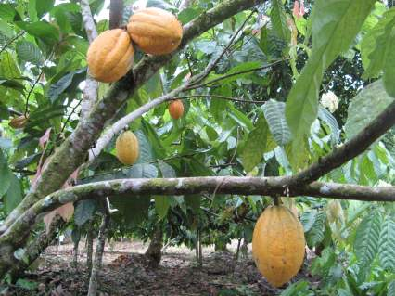
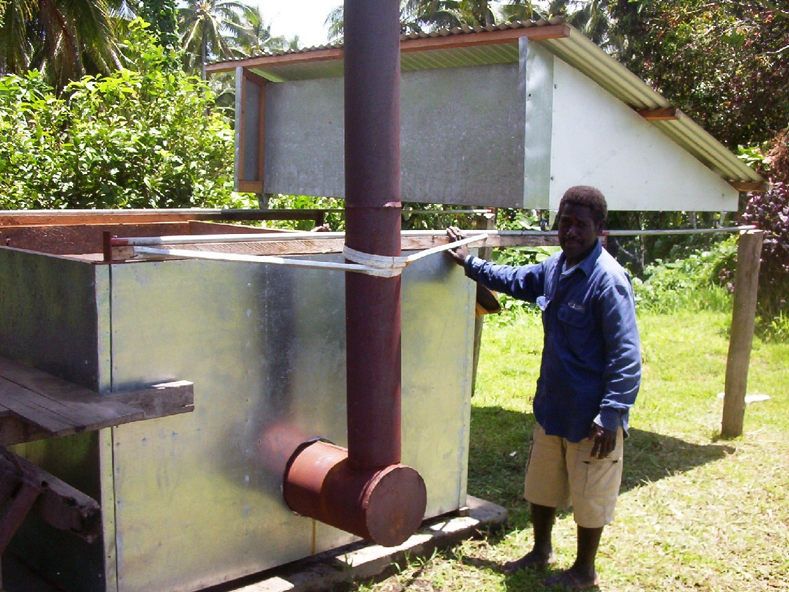
Solomon Islands
Broadly based Rural Income Generation through Cocoa Development (BRIGCD) Project

18 September 2010
Table of Contents
ACRONYMS iv
Design Team vi
EXECUTIVE SUMMARY vii
Cocoa Value Chain vii
CLIP Project vii
Conclusion viii
Introduction 1
A value chain approach 1
Selection 2
Rapid assessment of bulk cocoa value chain 3
Markets 5
Product Differentiation Techniques 7
Constraints in the Marketing System 10
Lack of competition in export marketing 10
Large price discounts 10
Production 11
Varieties 11
State of seed gardens 11
Nurseries 12
Crop husbandry 12
Extension services 13
Cocoa Bean Quality Is Low 13
Post Harvest Issues 14
Inadequate number of fermentaries resulting in less returns to growers 14
Infrastructure 14
Storage Facilities 14
Environmental Issues 15
Organisation/Management 15
Players in the Value Chain 16
General management at the enterprise level 16
Finance 18
Policy and Regulations 18
Policy Environment for Cocoa Development 19
Identification of Constraints and Opportunities 19
SWOT Analysis 19
Constraints and Matrix 20
Determine Clear Constraints in the Value Chain 21
Design of Market Solutions (interventions) 21
CLIP Achievements to Date 21
Rationale for Providing Further Support to the Cocoa Value Chain 24
Investing in rigorous analysis and proven best practice 24
Opportunities for Accessing Niche Markets 25
Enhanced Productivity through Growing Healthy Cocoa 25
Opportunities for Women and Youth 25
Project Design of CLIP 26
Intervention 3.1.1: A Better Organised, Trained and Committed Cocoa Extension Service for Farmers 26
Intervention 3.1.2: Farmers Using Improved Planting Materials 28
Intervention 3.1.3: Aged Cocoa Stands Rehabilitated 29
Intervention 3.1.4: Piloted Integrated Pest and Disease Management (IPDM) Strategy 29
Intervention 3.2.1: Improved Quality of Solomon Islands Cocoa 29
Intervention 3.2.2: Improved Efficiency of the Cocoa Marketing System 30
Intervention 3.2.3: Certification of Cocoa Exports Facilitated 30
Program Budget and Timing 30
Implementation Framework: Management and Governance Arrangements and Structure 31
Project Organisation and Coordination 31
Program of Work and Budget 31
Performance Measurement 32
Monitoring and Evaluation (M&E) 32
Results Chain Methodology Framework 33
Annex 1: Project Results Chain 35
Annex 2: Implementation Plan 36
Annex 3: Results Assessment 37
Key Performance Indicators 37
Reporting Requirements 38
Annex 4: Risks and Risk Management Strategies 39
Cocoa Pod Borer 39
Institutional Rivalries 39
Policy Reforms not Adopted by SIG 39
RDP Supplemental Grant Funds Not Made Available to Cocoa Enterprises 39
Payment for Planting Materials 39
Environmental Risk 40
Women and Their Food Gardens 40

ACRONYMS
ACIAR Australian Centre for International Agricultural Research
ANZ Australia and New Zealand Banking Corporation
APC Assistant Project Coordinators
ARDS Agriculture and Rural Development Strategy
AUD Australian Dollar
AusAID Australian Agency for International Development
BCCDRP Bougainville Cocoa and Copra Dryer Rehabilitation Project
CLIP Cocoa Livelihoods Improvement Project
CPB Cocoa Pod Borer
CCI Cocoa Coconut Institute of PNG
CEMA Commodities Export Marketing Authority
CEPA Cocoa Exporters and Producers Association
CIRAD Centre de coopération internationale en recherche agronomique pour le développement
COE Cocoa of Excellence Celebration
CPRF Community Peace and Restoration Fund
CSP Community Sector Program
CTA Chief Technical Adviser
DML Direct Marketing Limited
DME Direct Micro-Expelling
DML Direct Marketing Limited
DRC Domestic Resource Cost (ratio)
EU European Union
FAO Food and Agriculture Organization of the United Nations
FLO Fair Trade Labelling Organizations International
GAP Good Agricultural Practices
ICCO International Cocoa Organisation
IPDM Integrated Pest and Disease Management
IRR Internal Rate of Return
KGA Kastom Gaden Association
KPSI Kokonut Pacific Solomon Islands (SI) Ltd.
LPC Land Purchase Cooperative Societies
M&E Monitoring and Evaluation
MAL Ministry of Agriculture and Livestock
MFE Metal Fabricating Enterprises
MRD&IA Ministry of Rural Development and Indigenous Affairs
NATI National Agricultural Training Institute
NGO Non-government Organisation
NPM National Project Manager
NPV Net Present Value
NTO National Training Officer
PSC Project Steering Committee
QA Quality Assurance
RAMSI Regional Assistance Mission to Solomon Islands
RCDF Rural Constituency Development Fund
RDP Rural Development Project
RIPEL Russell Islands Plantation Estates Ltd
ROC Republic of China (Taiwan)
RTC Rural Training Centres
SAS Smallholder Agriculture Study
SBD Solomon Islands Dollar
SC Screening Committee
SIG Solomon Islands Government
SIPL Solomon Islands Plantations Limited
SIPPO Swiss Import Promotion Program
SPC Secretariat of Pacific Communities
STABEX EU price stabilization funds
TA Technical Assistance
TARDP Transitional Agriculture and Rural Development Project
TCP Technical Cooperation Program (of FAO)
TSAP Transitional Support to Agricultural Program
TSP Triple Superphosphate
VSD Vascular Streak Dieback

Design Team
Members of the Design Team were:
• Trevor Clarke, Design Mission Team Leader, Cocoa Extension Specialist, and former Project Manager, AusAID Bougainville Cocoa/Copra Drier Rehabilitation Project
• Owen Hughes, Manager, CSP Agricultural Livelihoods
• Dr John Konam, Plant Pathologist and Cocoa Research Specialist, SPC (and Team Leader, ACIAR Cocoa Scoping Study)
• Dr Andrew McGregor, Agricultural Economist and AusAID Rural Development Adviser (also involved with the ACIAR Scoping Study), Cocoa Marketing Specialist
• Moses Pelomo, General Manager, CEMA, Cocoa Development Specialist
• Dr Smilja Lambert, Cocoa Sustainability Research Manager (Asia Pacific) Mars Inc. (ACIAR Cocoa Scoping Study)
• Colin Dwyer, General Manager, Kokonut Pacific (SI) Ltd., Organic Agriculture Specialist

EXECUTIVE SUMMARY

Cocoa Value Chain
Cocoa is the third most important export earner for Solomon Islands and, after copra, is the most important source of income for about 13,000 (20 percent) rural households.
Round log exports, which currently provide 60-70 percent of export revenue, will end within a few years. Furthermore, the international market for copra has all but recently disappeared, and greater investment in coconut oil production has not yet been forthcoming. Cocoa is one commodity that can fill the gap and make a substantial contribution to the Solomon Islands economy. The crop is agronomically suited to a wide geographic coverage, and has provided smallholders with relatively good returns on their inputs over the last few decades. There are realistic prospects for increased yields and improved quality that could significantly raise the level of these returns. The medium-term international market prospects for cocoa remain good, with particularly strong demand for good quality fermented cocoa from the Asia/Pacific region.
Current levels of cocoa exports (about 4,000 tonnes per annum) are well below the realistic potential of the industry, assessed by the Cocoa Design Mission to be in the order of 10,000-15,000 tonnes. Old plantings have not been rehabilitated and new plantings have been limited by a lack of appropriate planting material. Cocoa farmers are poorly informed about good cocoa management and processing practices, a situation compounded by the lack of information and training because of inefficiencies in extension delivery by the Ministry of Agriculture and Livestock (MAL). Furthermore, current marketing arrangements provide little incentive to improve quality, or offer opportunities for adding value through emerging production-based marketing certification schemes. Without addressing these broader dimensions of cocoa management, programs that focus on single interventions (rather than taking a value chain approach) will not to be beneficial to the overall development of the sector.

CLIP Project
The Cocoa Livelihoods Improvement Project (CLIP) is guided by an MMW/Value Chain approach which emphasises market solutions, addresses needs of total value chain, focuses on services provided by private sector, and considers the sustainability of the value chain with all activities. The CLIP will act as facilitator in providing support through service providers.
Based on recent experiences in East New Britain and Bougainville, Papua New Guinea (PNG), a significant increase in smallholder cocoa production can be obtained by providing targeted support to rural households. Following a similar approach, cocoa production in Solomon Islands could realistically double in five years, with a significant improvement in dried bean quality and returns to smallholder producers. The CLIP is designed to:
- Increase cocoa exports to 10,000 tonnes in five years and 15,000 tonnes in ten years
- Reduce the differential between Solomon Islands and PNG Free-on-Board (FOB) bulk cocoa prices to 25 percent in five years, and 75 percent in ten years
Realization of these targets would mean that export earnings from cocoa, at current prices, could reach SBD145 million in five years, increasing to SBD220 million in ten years. This would represent one-third of the current value of log exports. Unlike logging, however, this income would be widely distributed amongst smallholder households. Design of the CLIP was guided by four main considerations:
- Findings and recommendations of the Smallholder Agriculture Study (SAS)
- Economic challenges facing Solomon Islands, with the imminent demise of log exports, and the likely loss of coconut export earnings
- The need to achieve a widespread distribution of increased benefits throughout the cocoa value chain
- The need to cover a major gap in the Rural Development Project (RDP)
CLIP’s goal is to facilitate substantial increase in livelihoods for all players in the value chain by addressing identified constraints. This is to be achieved through:
- improving extension services to farmers, and training of extension staff
- introducing an innovative extension methodology - Integrated Pest and Disease Management (IPDM), which should achieve at least a 75 percent increase in cocoa production for 1350 farming families
- provision of information to farmers and extension personnel on good cocoa management practices
- improving quality and availability of planting material
- rehabilitating at least 75 percent of old cocoa blocks by radical pruning, shade thinning and maintenance
- improved cocoa quality by upgrading processing facilities
- introduction of at least 800 prefabricated mini-driers suitable for cocoa smallholders, particularly those living in more isolated locations
- facilitate the access to a number of emerging production-based marketing certification schemes
- improving the efficiency of the marketing system through support to traders and exporters
Geographically, CLIP will focus on Guadalcanal (40 percent of the proposed funding), Malaita (30 percent), Makira (20 percent), Western Province (5 percent) and other areas (5 percent). A Trust Fund will be established by CLIP to provide AUD2.5 million in support of services provided to those in the cocoa value chain. It is estimated that at least AUD600,000 will be paid back into the Trust Fund from beneficiary contributions for further development efforts.
There will be a strong synergy between CLIP and Component 2 of the Rural Development Program (RDP). CLIP and RDP will cooperate closely in resourcing MAL extension officers with information and training in the latest cocoa husbandry and processing techniques. CLIP will be hosted by the Commodity Export Market Authority (CEMA), with field extension activities implemented through the MAL Provincial Extension Service. Project Officers will be located in key regions (Guadalcanal, Malaita, Makira and Western Provinces) and work with MAL extension staff to implement the Project. A Project Steering Committee will be established comprising key stakeholders, including AusAid, CSP, CEMA, MAL, MRD&IA, RDP and grower, buyer and exporter representatives. The Project will be serviced by CSP’s management and implementation systems and its installed capacity to manage project funds, signifying the need for both CSP and CLIP to cooperate closely in implementation and performance management. The Project will also work closely with relevant groups and private sector entities when providing services to those in the value chain.
A Stage 1 Project of four to five years duration is proposed, with a Stage 2 expected to follow. The estimated cost of Stage 1 is AUD9 million, plus an expected MAL counterpart contribution. The estimated contribution by cocoa smallholders to the Trust Fund is AUD600,000.

Conclusion
CLIP represents a major long-term initiative to revive the Solomon Islands cocoa industry and substantially raise farm productivity and quality, incomes and export levels. The size and duration of AusAID’s commitment to rural development in Solomon Islands is highly warranted and will leverage a great opportunity for the people of the Solomon Islands.
CLIP contributes to the goal of the Solomon Islands Australia Support to Agricultural Livelihoods initiative (2009-2014) “... for rural smallholders to achieve sustained improvement in their agricultural livelihoods as a result of enhanced production and marketing”. Specifically, the activities of CLIP will ensure the realisation of Objective 2 of this initiate, which states: “Family incomes benefit from the improved operation of key agricultural markets”.

Introduction
The cocoa value chain development design is being led by a thorough understanding of all market activities and is in keeping with the considerations promoted by proponents of the Making Markets Work (MMW) concept. A development coming out of the BDS era of the late 1990’s, MMW takes on a wider view of markets beyond merely those for Business Services. MMW is not a novel concept and is, in fact, re-iterating the manner in which markets have been operating since day one. MMW looks to systematically understand the market structure related to a given product. A useful tool in accomplishing this is the Value Chain methodology. This approach considers all markets, both business services and final product goods or service for all levels of the value chain.

A value chain approach
The value chain illustrates the full range of activities that firms and workers undertake to bring a product from its conception to its end use and beyond. This includes activities such as design, production, processing, marketing, distribution and support to the final consumer. The activities that comprise a value chain can be contained within a single firm or divided among different firms. Value chain activities can produce goods or services, and can be contained within a single geographical location or spread over wider areas.
The competitiveness of firms not only depends on the functioning of suppliers and buyers within a chain, but also and often most importantly, on the entire chain at the national and global level. The value chain approach helps to identify all the enterprises that contribute to the production of a good or service within and beyond a chain and also identifies actions needed, by business service providers to support the enterprises of the given chain A value chain encompasses the full range of actors, activities, and services required to bring a product (or service) from its conception to its end use by consumers. A value chain assessment seeks to understand the various factors that drive the incentives, growth, and competitiveness within a particular industry; and to identify the opportunities and constraints to increasing the benefits for businesses throughout the industry. Major elements of a value chain framework are provided below:
Figure 1 - Value Chain Framework
End Markets - End markets determine the characteristics of the final product or service produced. The demands and specifications of the end market or final buyer drive quality and standards
Inter-firm Cooperation (vertical and horizontal linkages) – Vertical linkages are the necessary relationships and functions to get a product from inception to the end market, including: input/raw material supply, production, processing, distribution, wholesaling, and retailing
Supporting Products or Services – Supporting products or services (old BDS) support the main functions or vertical linkages in a value chain.
Business Enabling Environment (Local, National, and Global): Trade agreements, product standards, specifications, and policy or regulatory issues greatly influence the environment for business growth and competitiveness.

Selection
A value chain framework promotes an overall approach to intervention design and implementation, and uses the following steps:
- Selection
- Assessment
- Identification of constraints and Opportunities
- Design of Market Solutions (Interventions)
- Performance measurement utilizing Results Chain methodology
In selecting the value chain to support it is necessary for the value chain to have, at the minimum, 1) unmet market demand for the associated product(s) or service(s), and 2) that there is good potential to impact on many beneficiaries. In addition, other appropriate criteria will be considered. The following provides criteria (and rankings) derived from documents, discussions with key informants, and experiences of CLIP staff members.

Criteria
- Potential for Value Added: Adding value to a product is an important aspect of any value chain. The value added activities provided for greater profits from the initial raw material.
- High Productivity: Choosing a value chain with high productivity normally means that there will be a great impact at the production level. In general, agricultural activities are high in productivity and usually a good choice for involving many people.
- High Unmet Market Demand: It is extremely important that the chosen value chain is one that has a solid market with good potential for growth. There should be good evidence to substantiate the demand. The market may be local, regional, national, or export.
- Potential for Meeting Standards for Certification: Certification of consumable products is becoming increasingly important throughout the world. Buyers are adamant in purchasing hygienic and high quality products.
- Strength of Export Potential: As with value added, exporting of products could result in broader markets and higher incomes. As the global economy shrinks, there is an increased opportunity for exportation to many parts of the world.
- Potential for Income Generation: This criterion is linked to the need to keep focused of poverty alleviation as an important aim of any intervention proposed by CLIP. This is also linked with the idea of large impact due to high numbers of producers and others in the value chain. The end result should be greater incomes for large numbers of persons and their families.
- Potential for Employment: The chosen value chain should allow for growth in employment through new entries in related businesses, and also hiring of new employees to existing concerns. The value chain should show potential for overall growth that provides for significant job opportunities.
- Gender Participation: As earlier stated women play an important role in the economy of the Solomon Islands, especially at the rural agriculture level. Chosen value chains should have potential to include women. Interventions should provide for the consideration of the specific needs of the women involved at various levels of the chain.
- Environmental/Social Impact: Ecological impact should be strongly considered in choosing a value chain to support. It should be clear that the activities of the value chain not have negative effects on the environment
Value Chain Ranking by Qualitative Criteria (1 to 10 – 10 being highest, as having most potential/positive)
Criteria | Cocoa value chain
1. Potential for Value Added | 7
2. High Productivity | 8
3. High Unmet Market Demand | 7
4. Potential for Meeting Certifications | 7
5. Strength of Export Potential | 8
6, Potential for Income Generation | 6
7. Potential for Employment | 5
8.Gender Participation | 6
9. Lack of Environmental/Social Impact Concerns | 6
Total | 60
Ranking of qualitative criteria are subjective and based on understanding of current conditions and forecasts for the future. Rankings were on 10 being the highest score while 1 represents the lowest. Quite often various product/services are ranked against one another to determine the highest scoring and, therefore, the products/services with best potential to benefit from support. In this current case, the ranking is undertaken to illustrate the potential that the cocoa value chain has based on the established criteria.

Rapid assessment of bulk cocoa value chain
Extensive cocoa planting began in the late-1960s after in-country research had identified varieties resistant or tolerant to Solomon Islands pests and diseases. Plantings at that time used two strains of Amelonado seed from Keravat (PNG) and Fiji, and, later, Sabah hybrids from Malaysia. A major expansion of the cocoa industry occurred in the mid-1980s. At that time, Lever Brothers and Solomon Islands Plantation Limited (SIPL) undertook substantial plantings, predominantly, of two Sabah hybrids (NA33 and PA7 crosses with Amelonado).
The Solomon Islands cocoa industry is almost entirely smallholder based. Cocoa is grown in all provinces except Rennell/Bellona. According to the 1997 Village Resources Survey (Ministry of Finance) cocoa was grown in 1626 villages (about 13,000 households, or 20 percent of total households), which made it the second most important cash crop after copra in terms of geographical coverage. Cocoa production is now concentrated in Guadalcanal, Malaita and Makira (Figure 1). Before 2000, Western and Choiseul provinces were also significant producers, a situation that could now be restored given appropriate interventions outlined by the Cocoa Design Mission. Census data on the area planted with cocoa is not available. Estimates from the amount of cocoa exported suggest that 10,000-15,000 ha of cocoa exist in Solomon Islands.
Figure 1: Share of 2007 Cocoa Production by Province (%)
Over the last decade, cocoa has maintained its position as the third most important export commodity in value terms, behind logging and fishing, and has only recently been surpassed by oil palm. Cocoa was the export crop least affected by the “social unrest” between 1999 and 2003.
Average cocoa exports during the 1990s were approximately 3,500 tonnes per annum. Production fell to a little below 2,000 tonnes in 2002. This was at a time when coconut product exports all but disappeared and palm oil production ceased. In 2003, cocoa exports rebounded to above 4,000 tonnes, peaking at a record high 4,900 tonnes in 2005. Exports have since retreated to about 4,000 tonnes per annum in the last two years; contributing around SBD60 million annually in export earnings (see Figure 2).
The Smallholder Agriculture Study (SAS) analysed the cocoa industry in 2004, and concluded that the sector’s robustness was attributed to a number of factors:
- The years 2002 and 2003 were a period of relatively favourable world market prices
- Cocoa is usually grown as part of a mixed cropping system, giving reasonable returns to labour, even when prices are relatively low (Enoka, 2005)
- A competitive domestic marketing system existed, in which buyers actively competed for beans
Figure 2: Solomon Islands cocoa exports 1998 – 2007 (tonnes)
The following provides information on the cocoa value chain in the Solomon Islands. Some of the 7b categories are more complex than others (e.g., Markets and Production) and require more explanation.

Inputs
Inputs utilized in the farming of cocoa are few and not very sophisticated. Many farmers are accustomed to using very rudimentary tools and other inputs. Over the years those supporting the cocoa value chain have encouraged farmers to take on more advanced choices of inputs.
Tools (for cutting. pruning, digging, etc.) are available from local shops in Honiara but reportedly the cost are high and the needed tool is not always available. In the past tools were inferior Chinese made that are now being replaced by Australian designed tools (still made in China). Tools are only available in Honiara in limited stocks, making it difficult for those in other islands to secure. In many cases farmers still resort to using handmade implements such as bamboo for digging.
There is a trend toward using polybags for growing seedlings as they have been encouraged by CLIP and the MAL. Yet, many still prefer to use leaves from the bush not understanding that the time consumed in collecting the leaves can be equated to money lost. Nylon shed coverings are being recommended but many still use coconut leaves which is considered acceptable.
All in all there are no serious constraints related to inputs for the cocoa value chain in the Solomon Islands. There seems to be a gradual shift from using crude handmade implements to using more updated manufactured goods.

Markets

General Market Conditions
Cocoa is a ‘prescribed’ commodity under the CEMA Act, meaning that CEMA is empowered to enforce regulations and standards for cocoa beans (fermented and dried), and products (manufactured and value added) in Solomon Islands.
CEMA has been involved in cocoa marketing, but never had a monopoly as was the case with copra. Consequently, domestic cocoa marketing has always been competitive. The cocoa industry, as with that for coconut, was severely affected by the near collapse of inter-island shipping services and the marketing system during the early-2000s, especially in Choiseul and Western Provinces. In these locations, private cocoa traders are yet to fill the gap left by the collapse of CEMA’s buying network.
The current marketing system can be characterized as highly competitive at the trader/dry bean buyer level, and as a monopoly at the importer level. As a consequence of the competition amongst traders, growers have benefited from relatively low marketing margins (farm gate prices as a percentage of the Free-on-Board (FOB) price). CEMA estimates that cocoa growers receive 78 percent of the FOB price. In contrast, past cocoa marketing monopolies in Fiji, Vanuatu and Samoa, contributed to large marketing margins ranging from 30 percent to 45 percent (McGregor, 2006). While growers have benefited from competition between local buyers for purchase of dry and wet beans, the same is not true among exporters.
Currently there are 25 “exporters” licensed by CEMA – though it is reported that only 6 are active. These so-called “exporters” are in effect buying agents for the single importer of Solomon Islands cocoa, the Sydney-based broker Holland Commodities Ltd. Holland Commodities provides working capital to the local buying agents in exchange for exclusive rights to the dried beans they purchase. One local exporter, C-Corp, is directly exporting to Asian countries.

Recent Market Developments
During 2008, world cocoa prices were at their highest level in real terms for two decades (Figure 1). Over the period January to October 2008 the International Cocoa Organisation (ICCO) daily New York price averaged USD2.65/kg, which was 40 per cent higher than for the corresponding period in 2007. The world monthly average price peaked at USD3.02/kg in June 2008, falling back to USD2.07/kg in November 2008.
The surge and subsequent decline in cocoa prices in 2008 is consistent with the movement of most commodity prices over the period driven by investment and hedge fund activity in the exchanges of London and New York. There have also been market fundamentals that have been driving cocoa prices to relatively higher levels than most other commodities. Ongoing political problems in Cote d’Ivoire (the world largest cocoa exporter) have caused downward pressure on supply (Table 1).
Table 1: World cocoa exports and imports *
In the last 4 to 6 years, global cocoa demand has been growing at around 4 percent per annum. Over the period 2003/04 to 2006/07 there was only a 1.7 percent increase in world cocoa exports, compared to a 13.3 percent increase in cocoa imports.
Consequently, there has been a world cocoa deficit over the last few years, with grindings (demand) exceeding production (Table 2).
Over the last decade cocoa stocks as a percentage of grindings (demand) have been falling (54.5 percent in 1988/99 to 40.4 percent in 2007/08), putting upward pressure on prices.
* Source: World Bank, Development Prospects Group, Nov 10, 2008
During this period there has been a particularly sharp increase in Asian demand compared with Asia/Pacific supply (Figure 2). This reflects the sharp increase in the consumption of cocoa products in China and India.
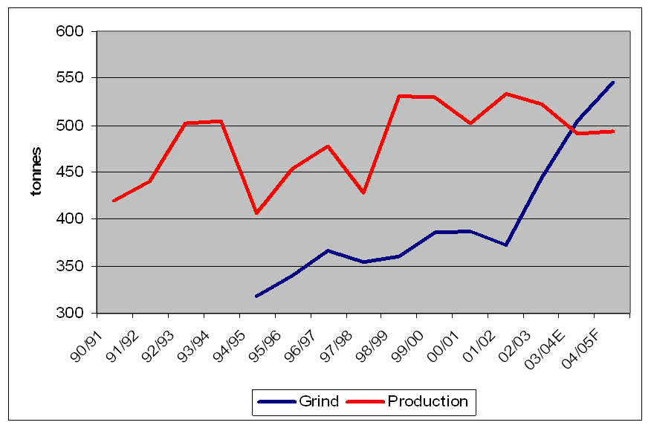
Figure 3: Asian cocoa bean grinding capacity compared with supply*
These market fundamentals continue to drive the world cocoa prices despite a world recession that is generally depressing world commodity prices. This is reflected in a recent BBC feature on cocoa prices titled: Cocoa prices hit a 23-year-high.
* Source: Dr S. Lambert, Cocoa Stakeholder Workshop, Nov-08

Medium Term Price Prospects
Cocoa, as with all commodities, cannot escape the depressing impact of the global financial crisis and a world recession on consumer demand. However, chocolate is an affordable luxury in developed and emerging markets, the demand for which can be expected to withstand the downturn reasonably intact.
Global grindings, a measure of demand, are expected to reach 3.77 million tons in 2008/09, 2 per cent higher than last season's total (The World Bank, Development Prospects Group, Nov 10, 2008). However, this is well below the 4 per cent growth in demand of recent years. The World Bank is projecting cocoa prices to decline to USD2.00/kg in 2009 and USD 1.90/kg in 2010, down from $2.60/kg in 2008 (Figure 1).

Long-term Price Prospects
Longer-term, real prices are projected to decline slightly as supplies in some key producing countries are expected to increase more rapidly than demand. However, prices are expected to remain higher in real terms compared to those of the 1990s. Actual prices will depend on political developments in Côte d’Ivoire and the growth in demand in emerging markets – particularly China, India and Russia. Côte d’Ivoire has been the key driving force behind cocoa's price variability.

Product Differentiation Techniques
Based on observation made of other products, the cocoa industry in Solomon Islands has the capacity to benefit from a large number of product differentiation techniques that result in increased returns to producers. Some more prominent techniques are briefly noted.

Markets for Single Origin Cocoa
Figure 6: Example of Fair Trade and Organic labelling
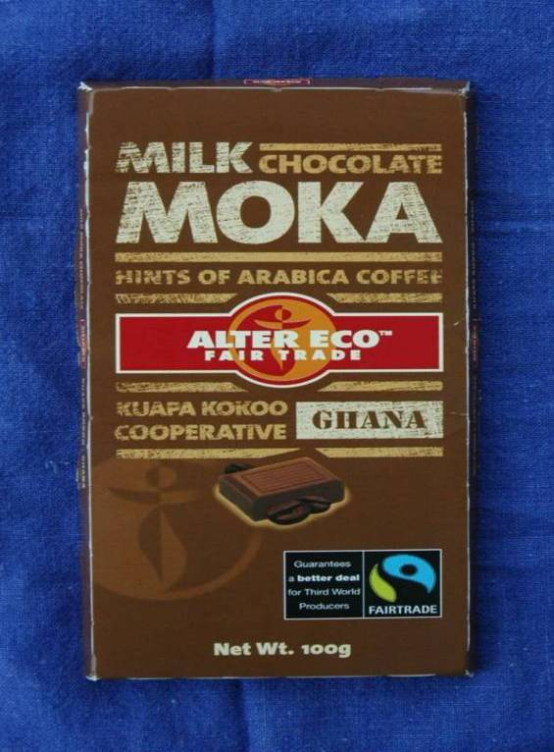
The concept of single origin is long established for products such as premium quality wines, scotch whiskey and coffee. Single origin chocolates are now becoming an important part of the European and American markets, which are willing to pay premium prices for quality beans that meet the required specifications. Single origin chocolate is made from cocoa beans from one region. Chocolate connoisseurs argue that chocolate has varied tastes and such tastes depend upon where it is grown and how it is grown. The source location of single origin chocolate and cocoas are an important part of labelling and marketing. The actual marketing is often undertaken in conjunction with some of the other product differentiation techniques such as organic and fair trade certification. Figure 3 shows two generic forms of single origin chocolate as well as producer-specific chocolate.
A cocoa producer in Papua New Guinea (PNG) is already marketing his product to a French grinder as single plantation cocoa. A sample from Solomon Islands is being sent to “Cocoa of Excellence Celebration (COE) 2009”. The main organising institutions of the COE are Biodiversity International, CIRAD and “Salon du Chocolat”, with the support of several chocolate manufacturers. The goal of the COE is to promote the consumption of high quality cocoa origins, with the objective of creating awareness among producers and other operators in the national and international cocoa supply chain for the opportunities that can be gained from high quality cocoa differentiation.
Participation in the COE event will provide a detailed assessment of cocoas from the Pacific Islands region and their suitability for niche, single origin markets. It will also introduce speciality cocoa buyers to Pacific Island cocoas.

Fair Trade
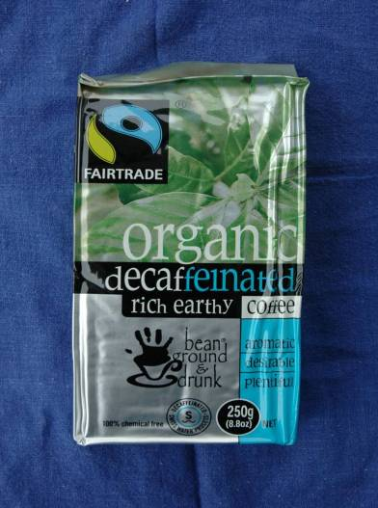
Fair-trade markets are somewhat similar to organic markets in that they are often complementary. Figure 4 shows a coffee example.
Organisations operating under Fair Trade principles are expected to:
- pay a price to producers that covers the costs of sustainable production and living, plus, pay a premium that producers can invest in development
- partially pay in advance to pre-finance the purchase of inputs by producers
- sign contracts that allow for long-term planning and sustainable production practices
- Fair Trade cocoa prices are calculated on the basis of world market prices, plus fair trade premiums. The fair trade premium for standard quality cocoa is US$150 per tonne. For Fair Trade cocoa which is also certified organic, there is an additional organic premium of US$200 per tonne. For Fair Trade cocoa that is certified organic, an organic premium of USD 200 per tonne is paid.

Chocolate Content
Chocolate is increasingly being sold on the basis of the cocoa content of the chocolate (see Figure 6).
As noted, cocoa from Solomon Islands has already been sent to COE to establish, amongst other things, the suitability for the cocoa to be blended to produce chocolates of different cocoa content. The results from this will help direct future marketing efforts.

Good Agricultural Practices
Europe has taken the lead in developing farm-based practices called Good Agricultural Practices (GAP). Initially intended for the retailer trade, GAPs are now being expanded to a whole raft of agricultural products that enter the European food industry in either the raw or processed form. With the increased attention being paid to food safety and its associated production techniques, more and more food handlers are requiring that their suppliers provide evidence of their GAP.
The initial GAP concept has been expanded. At the highest level there is now a certification scheme based on GLOBALGAP. There are specific regional schemes such as ASEAN GAP. There are GAP schemes for specific countries such as VIETGAP. Even more specific are schemes such as BRC – British Retail Consortium that sets standards for the production of foods that are marketed through British retailers who are members of the consortium.
Having some form of GAP certification is not necessarily a guarantee of achieving a higher price. However it does mean that the producer can at least enter that market because without it they must sell into less demanding and thus lower paying markets. As an example, Vietnamese exporters of dragonfruit with EUROGAP certification can export their products to the higher paying Western European countries whereas those without such certification can only export to the lower paying Eastern European markets.
The development of a Solomon Islands–based GAP certification scheme specific to cocoa will enable this cocoa to be differentiated from other cocoas and thus enhance the capacity to achieve a higher price. Potentially, future cocoa production coming from the 1350 farmers adopting IPDM practices being promoted by the CLIP, may qualify for GAP certification.

Other Product Differentiating Schemes
The Solomon Islands cocoa industry can look at a large number of certification schemes that can help differentiate their product. These schemes are based on appealing to the socially conscious consumer. An example of social consciousness marketing is the labelling of canned tuna as “caught with dolphin / turtle friendly nets”.
Figure 7: Rain Forest Alliance
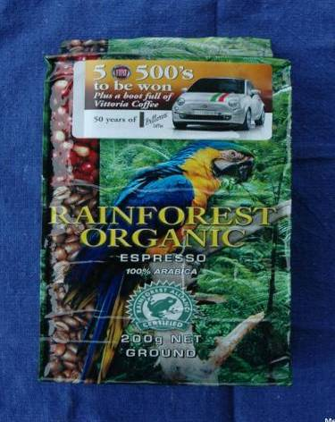
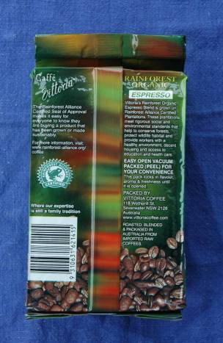
In PNG, one coffee exporter is marketing his coffee with the German-based Utz Certification scheme that basically advocates that farmers are professionals implementing good practices that lead to better businesses. The Utz organisation is expanding its scheme to cocoa.
Another scheme is the Rain Forest Alliance (see Figure 7), also being used by a PNG coffee exporter to enhance his product’s marketability in a non-price manner. Another certification scheme relates to the product being produced in a bird friendly manner.
These schemes and other emerging production-based marketing certification schemes need to be examined. Lessons learned from such schemes should be applied to the marketing of Solomon Islands cocoa, as a means of enhancing product differentiation that means that the cocoa is sold not just on price parameters. The examples from other industries in other parts of the world are that such product differentiation enhances the potential to increase producer incomes.

Constraints in the Marketing System
There are several areas of inefficiency in the cocoa marketing system, which reduce grower income.

Lack of competition in export marketing
Section 1.1.2 examined competition in the cocoa marketing system and noted the highly uncompetitive marketing conditions which prevail at the export level. The lack of price premiums paid to growers producing better quality dried beans means that there is no incentive for them to improve.
Farmers would benefit from the entry of additional cocoa exporters. However, the present policy of restricting cocoa export licenses to indigenous Solomon Islanders creates a significant barrier to entry, given the large working capital needed to become a successful cocoa exporter. While there have been attempts by the Cocoa Exporters and Producers Association (CEPA) to lobby SIG to guarantee commercial bank loans to indigenous cocoa exporters, members remain beholden to Holland Commodities as the primary source of finance required for cocoa purchases. This policy will need to be amended if growers are to receive the full benefit of the CLIP.

Large price discounts
In the past, Solomon Islands cocoa enjoyed a small price premium. However, since 2000, the export of sub-standard grades has resulted in large price discounts compared to neighbouring countries (referred to in Section 1.1.2). There is a large deficit of good quality fermented beans in the Asia/Pacific region (for more details see Annexes 9 and 11). Given this situation, Solomon Islands cocoa producers are failing to capitalise on the full market potential of their product.
Solomon Islands should be obtaining premium prices from this secure market, yet producers often fail to meet the quality standards required for export. Field inspections by the Cocoa Design Mission confirmed the main reasons to be poor fermentation, poor drying, and poor hygiene. These factors reduce quality and lower returns to the industry. For example, under-fermented cocoa beans results in cocoa that lacks flavour and, therefore, requires blending to produce an acceptable product, while over-fermented cocoa contains excessive free fatty acids and bad odour. Under-drying cocoa beans will prolong fermentation, dilute natural flavours and create mould, and result in discounted market prices due to excessive moisture content. Significant price discounts also apply to cocoa contaminated by smoke.
There is a knowledge and willingness amongst smallholders in Solomon Islands to ferment cocoa, which presents a potential quality advantage compared to many South East Asian smallholders, who do not ferment their own beans. However, Solomon Islands smallholders need access to appropriate technology and training (e.g., on how to ferment cocoa correctly) to realize such advantages. This interest has been confirmed more recently by grower responsiveness to the series of cocoa processing training activities conducted by CEMA.

Production
Despite the encouraging resurgence in cocoa production following the ethnic tension, block maintenance has been neglected. Cocoa does not tolerate neglect as well as coconut, and smallholder yields have been very poor as a result, generally below 250 kg/ha/yr dry bean. The average yield for smallholders globally is about 350 kg/ha (Kotecha, et. al., 2003). Some smallholders in East New Britain, PNG have been able to maintain yields approaching 2000 kg/ha/yr. Low cocoa yields in Solomon Islands are attributed to the age of trees and poor farm management practices.

Varieties
According to the SAS, the lack of better planting material poses a major constraint to reversing yield decline in run-down plantations, expanding cocoa production, or even maintaining existing production in the medium term. This Cocoa Design Mission concurred with this important finding.
While Amelonado cocoa is suitable for smallholders, and will be used in the initial replanting program, there is a need to identify other varieties, which have disease resistance and yield well under good management. A hybrid clone selection and propagation program is needed in Solomon Islands, which would produce varieties capable of yielding 2000 kg/ha/yr or more under good management. Similar yield levels have been demonstrated by smallholders in PNG using new hybrid materials.

State of seed gardens
The Ministry of Agriculture and Livestock (MAL) cocoa seed garden at Dodo Creek Research Station (Black Post) was abandoned during the ethnic tension. It contained 25 hybrids, mainly ICS ex-Sabah, and two strains of Amelonado (from PNG and Fiji). The seed garden contained two recommended hybrids (NA 33 and PA7), which resulted from screening and agronomic trials on the 25 Sabah hybrids introduced in the 1970s.
Black Post has now reverted to customary ownership. Negotiations with MAL on lease arrangements and payment arrears remain pending. Cocoa from the seed garden is currently harvested by the landowners and sold to exporters (rather than used for seedlings). Meanwhile, the research station near Dodo Creek is substantially neglected and overgrown. MAL regards the seed garden as being of little use, since planting materials have been contaminated and are no longer “true-to-type” genetically. This view is not shared by the Cocoa Design Mission, which is discussed further in Annex 11.
Discussions with a landowner spokesperson indicated they had been waiting for assistance from Solomon Islands Government (SIG) to rehabilitate the research plots. To date, this assistance has not been forthcoming. The landowners also indicated to the Cocoa Design Mission that they would be interested in cooperating with CLIP on an Amelonado Seed Garden, through selection of hybrid clones from good trees (identified by counting the number of pods produced per year) and observing pest and disease resistance. Follow up observation and selection of these clones would be required. Landowners would be paid for any material used in this varietal research program (described under Output 3.1.2).

Nurseries
There are an insufficient number of nurseries to cater for a large replanting program. Currently, two central nurseries supply seedlings free-of-charge to farmers, using funds advanced from the major buyer of Solomon Islands cocoa (Holland Commodities).
Direct Marketing Limited (DML) operates a central nursery at Lungga, Guadalcanal, and has supplied about 375,000 seedlings over the last four years. Another provider of cocoa seedlings, John Kwaita, who is also a large buyer, has distributed about 50,000 seedlings on Malaita. There are other, smaller on-farm nurseries. The Cocoa Design Mission had reservations about the quality of mixed seed, being planted by the central nurseries, i.e. hybrid and Amelonado crosses. Furthermore, the polybags supplied to the nurseries by Holland Commodities are 250 mm in length. These polybags are too short to allow for good tap root development – the standard polybag used in PNG is 350 mm.
Natural bush shade is used in the central nurseries. Nursery beds containing the planted polybags are too wide-spaced. The result is variable shading with those seedlings in the centre being crowded out from insufficient sunlight to produce a strong seedling. A heavy canopy of dry fronds and branches are used in the on-farm nurseries, which means spindly or low quality seedlings are generally being produced and distributed to farmers for planting out.
The free distribution to farmers of cocoa seedlings raised in these nurseries is a potential risk to the success of the CLIP. According to the DML proprietor at Lungga, seedlings cost about SBD3.70. The farmer collecting seedlings must pay for transport. However, it may be difficult for the Project to charge even a subsidized price when farmers are used to obtaining planting material at no cost. Farmers will need to be convinced of the financial benefits from planting superior quality cocoa seedlings.

Crop husbandry
The main agronomic constraints to cocoa production in Solomon Islands are: old trees (25-35 years), over shading, lack of adequate pruning, and the variability of planting material. Poor farm sanitation (pruning, shade management, weeding) is evident in most of the cocoa growing areas. Lack of sound management creates an environment conducive to pests and diseases, which result in major crop losses.
Black pod (Phytophthora palmivora) is thought to account for up to 40 percent loss in production. There are less significant losses caused by Amblypelta (a pod sucking coreid bug), rats, pink disease, white thread blight, brown root rot, and the insects Pantorhytes (a weevil), Longicorn (a beetle), and Pansepta (web worm). Cocoa Pod Borer (CPB) is a potential significant threat - the risk is detailed in Section 9.1.
Improvements in crop management would achieve the greatest immediate yield increases for smallholders. For example, the rehabilitation of an overgrown and unproductive plantation requires radical pruning and cleaning of undergrowth. Within 9–12 months of the block being cleaned, flowering will recommence. It is through these rapid rehabilitation efforts that the CLIP will contribute towards achieving the high economic rates of return envisaged in the SAS (see Section 2.1).

Extension services
Deficiencies in technical information, skills and information dissemination hamper the delivery of improved technologies to the cocoa sector. A farmer-focused approach to good crop management based on participatory action learning methods is a clear priority, if cocoa productivity in Solomon Islands is to improve.
Institutional weaknesses in the cocoa sector do not promote communication between actors along the cocoa value chain, or help in the exchange of knowledge and technologies. Participatory approaches that build the knowledge and skills of farmers, and other intermediaries, are also lacking.
Cocoa extension activities in the past focused on blanket technical messages and demonstrations, without much emphasis on ensuring that farmers and extension officers understood the interactions within the cocoa agro-ecology, and factors contributing to outbreaks of diseases and pests. Farmers and extension officers were passive recipients of information, and seldom learned to “think for themselves”. Cocoa manuals and extension materials, where available, are commonly written for a broad audience, and the demand expressed to the Cocoa Design Mission for such information emphasises the importance for field workers to access appropriate content.
Many research technologies and extension messages promoted by NGOs and public agencies in Solomon Islands do not offer sufficient demonstrable potential for improvement over established practices. For example, crop technologies which offer only a 10 percent increase in income per day of labour are unlikely to be adopted. Messages that are understood and within people’s means to apply offer substantial improvements in locally important key performance indicators (e.g. better returns to labour, higher family incomes, good market prospects, easy access to transport) are much more likely to be adopted by smallholders. This lesson is backed by successful regional experiences on the adoption of farmer-validated crop technologies, for example: semi-commercial cattle smallholders (Vanuatu), smallholder cocoa farmers (East New Britain, PNG), and smallholder peanut production (Markham Valley, PNG).
CEMA has been involved in training fermentary owners on quality issues, but this training does not cover crop husbandry. Provincial MAL extension officers conduct limited farm visits and provide advice to farmers on how to improve cocoa husbandry. Morale amongst MAL staff appears to be low, with complaints of being office-bound from lack of transport or fuel. There is no training of MAL staff on cocoa husbandry and processing.
There is a perception in MAL that young field assistant recruits require training, while the older officers already know everything there is to know about cocoa. The reality is that all extension officers need to update their knowledge regularly, and be introduced to concepts such as improved nursery management, radical shade thinning and pruning, block replanting and processing.
Training is also required in the innovative extension methodology of Integrated Pest and Disease Management (IPDM), based on the “Farmer Field School” approach that is being introduced under the CLIP. Farmers also speak of the need for training in financial management and record- and book-keeping.

Cocoa Bean Quality Is Low
Key factors that have led to the decline in Solomon Islands cocoa quality in recent years include:
- Cocoa growers, processors, buyers/traders, and exporters have received minimal support since 2000
- The inability of CEMA to monitor cocoa quality regulation compliance led to a proliferation of low-grade cocoa during, and following, the tensions
- New entrants to the industry have not received training in cocoa processing and quality control, relying instead on incorrect information provided by some traders and buyers’ agents
- Underpinning the determination of cocoa quality is a marketing system that does not provide financial incentives to improve quality, or penalise poor quality. In the principal production areas there is frantic competition amongst an excessive number of buying agents for a limited supply - these agents are driven by an emphasis on quantity and are faced with a “take it or leave it” situation regarding quality.

Post Harvest Issues
Several post-harvest factors account for the poor quality of cocoa produced by Solomon Islands smallholders. These include harvesting pods while still unripe, inclusion of foreign matter with wet beans and poor fermentation and drying methods. Farmers harvest cocoa pods at the wrong time for many reasons, including the desire to get income quickly, lack of knowledge about the quantity of wet beans needed for fermentation, and the relationship between pod maturity, harvesting time and quality.
Poorly maintained kiln pipes made from discarded 200 litre fuel drums often last only 3-6 months, and develop rust and holes in the pipe. Their use is a cheap (at least SBD50 per drum), but short-term technique, given that alternative options (e.g., steel flues) are more expensive. Damaged drums and pipes allow smoke to permeate the beans on the drying beds. Furthermore, lack of flue pipes means that smoke often drifts back over the cocoa from the fire place and the end of the kiln pipe. This gives smoky flavour to the cocoa, which is unacceptable to chocolate manufacturers. Often, farmers use the same driers for drying copra and cocoa, which also adversely affects the flavour and quality of the beans.

Inadequate number of fermentaries resulting in less returns to growers
Many cocoa processing facilities are owned and controlled by the central buyers. This means some cocoa households have to transport/carry wet bean long distances to road heads, because buyers do not collect at farm gate.
In isolated areas, the lack of processing and storage facilities is a serious problem. Carrying of wet bean to the buying points is an inefficient use of labour and provides a low return on effort. Access to more small fermentaries is needed to open up these areas for increasing cocoa production.
The distribution of income is also inequitable. The household production unit generates the bulk of value in the cocoa value chain, but fails to capture a significant proportion of this value when selling wet bean. As was the case in Bougainville prior to the BCCDRP, larger buyers and processors received 25-60 percent of the value of cocoa depending on whether they were in a monopoly buying situation. Such conditions are a significant disincentive to cocoa production and result in lower family incomes. They also encourage wet bean sellers to contaminate their beans to add weight and value (such as adding unripe bean clumps, stones and wood). For this reason, the CLIP will introduce mini-driers based on the Bougainville model.

Infrastructure

Storage Facilities
Several strategically located storage sheds are required to securely stockpile beans in close proximity to cocoa growing areas, before trans-shipment to larger centres. In many instances, cocoa is stored in relatively exposed conditions, causing further losses to farmers through spoilage and theft (a situation compounded by inconsistent and unpredictable transportation arrangements).
The Community Sector Program (CSP) has supported a marketing facilities program since 2006. This has included the construction of produce storage sheds through preparation of building plans, materials lists, budgets and work plans. Assistance is provided with procurement and transportation of commercial building materials to the nearest port of local trans-shipment, and payments to building supervisors and timber millers where necessary.
While these projects were based on community-driven requests for assistance, the approach used could easily be modified for the CLIP program, with potential sites identified on the basis of key cocoa growing areas, transportation networks, marketing nodes, and needs/benefits assessments. Given that storage facilities would usually be located on traditional lands, and would financially benefit the surrounding population, the community(s) involved would need to contribute land, sand and gravel, round logs and labour. CSP also provides assistance to working committees regarding their roles and responsibilities (during planning and construction phases), and to management committees responsible for running completed facilities on issues such as sustainability, space apportionment, access, fund raising, financial management and maintenance requirements.

Environmental Issues
There is a risk that new cocoa plantings will encroach into garden land, and/or primary or secondary forest. This has occurred previously with the promotion of cattle development and also the establishment of a large number of exotic tree plots, particularly teak, resulting in relatively less horticultural lands land near villages.
Although there is a potential environmental risk, it should not be large as the Project’s emphasis, at least initially, will be on rehabilitation and replanting of pre-existing cocoa plots, rather than expansion into new areas. On the positive side, there is potential for the large areas of forest that have recently been logged to be utilised for cocoa expansion using multiple land use models - cocoa is relatively efficient at sequestering carbon, up to 80% of primary forest cover levels on a per area basis.
To mitigate the impact of any new cocoa plantings/expansion, the Project will promote two key strategies:
- Inter-cropping cocoa under existing coconut stands (or, if appropriate, teak) as a more efficient land use model, and income diversification plan
- Inter-planting cocoa with suitable food crops. The Project will investigate the feasibility of distributing planting materials for shade-resistant banana varieties and root crops such Xanthosoma, possibly through the cocoa nurseries

Organisation/Management
The following page presents the Value Chain Map for bulk cocoa in the Solomon Islands. The map illustrates the interrelationships between players at the various levels. The map only includes those activities that take place in the Solomon Islands related to bulk cocoa and does not include activities further up the chain for value addition to bulk cocoa such as grinding, manufacturing of chocolate, related drinks, cosmetics, etc.
Channels (from left to right) on the map below:
1. This channel represents the majority of the smallholder cocoa farmers who are growing the beans, drying and fermenting and selling the processed beans to the “exporters” for sorting, grading and packaging and arranging for export.
2. This represents those smallholder farmers that do not do their own processing. The process beans continue up the chain as with channel 1.
3. This is an integrated channel that grows (approx. 300-400 hectares), processes, sorts, grades, packages, prepares for shipping and exports. This channel also buys from smallholders to augment its own supply. In this channel only differentiated bulk cocoa is exported. Inferior beans are sold to other “Exporters”. (C-Corp)
4. This channel shows “collectors” who buy form various locations and may sell to exporters or may hold an export license.
5. These are groups of farmers working together to farm and process in readiness for selling to exporters. There are about 10 groups that farm approximately 300 hectares. Another 20 groups farm a small area of about 30-50 hectares.
6. The final horizontal channel represents the remnants of what was once the RIPEL scheme (farming area of about 1000 hectares). There is talk that RIPEL may be revived, but currently it is being, partially, farmed by squatting farmers (mostly former RIPEL employees).
7. The hexagon at the top right shows the second true exporter in the chain. Most of those holding export licenses are merely collecting, sorting, packaging and preparing for exporting via an Australian owned export company.

Players in the Value Chain
Input suppliers: Inputs are supplied by private sector retailers that may sell directly to farmers or through NGOs, associations, CEMA, or the MAL.
Producers (farmers): Producers are characteristically the majority of smallholders have an average of 1 to 2 Hectares of cocoa trees. Cocoa farming is quite often a family affair with most family members sharing the responsibilities. The land is traditional family land that is handed down from one generation to the next. There are also groups of farmers (as noted above Channel 5), and one medium sized commercial farm (channel 3 above)
Fermentaries/Dryers: Fermenting and drying is very often done by smallholder farmers for their own crop. Some smallholders pass on wet beans to be processed by another farmer who has the required equipment. In the case of the integrated farmer, they also undertake this processing.
Collectors: Collectors can be farmers who, in addition to their, own crop collect processed beans from others and deliver to the “exporter”. There are some members of the chain who only collect from various sources and then sell to the “exporters. The integrated channel collects as part of the overall process.
Sorters/graders/packagers: There are 25 holders of export licenses from CEMA. Of these, only 6 are currently active. Of those 6, only one is actually exporting. The other “exporters” are merely collecting, sorting and packaging and preparing for shipping. They are essentially agents for an Australian exporting company.
Shipping Preparers: In the case of the integrated channel shipping is another of the tasks they undertake. For other bulk cocoa, shipping preparation is done by the “licensed exporters”.
Exporters: True exporting is done only by those in the integrated chain (#3 above) and by the Australian firm that exports bulk cocoa prepared by the CEMA licensed exporters.
Others
Associations/Cooperatives: There are formal and informal farmer groups. The formal groups are registered as commercial groups. The advantage of formalizing the group is that they can then be eligible for support from the government, donors and possibly banks.
Cocoa Export and Producers Association: although not currently very active, this body main mandate is to be the mouthpiece for cocoa value chain and provide for policy lobbying activities.
CEMA: Is a parastatal that was established by an act of parliament and given responsibility to promote cocoa, coconut product, etc. It is a regulatory body – especially export inspection.
MAL: For cocoa, MAL mandate is to focus on production, training, information and new plant material. Overall, they are reported to be weak in providing the needed services.
NGOs: NGO’s working with cocoa are few in number and where funding is available for cocoa, it is directed into “income generation” activities. Some provide training through CEMA or other donors and some provide direct services such as training and processing equipment.
MCILI: This government body provides support to co-operations, business advisory service covering a range of general topics.

General management at the enterprise level
At the farm level it has become clear that farmers have little knowledge of recordkeeping, much less in undertaking the actual practice of keeping records and other management practices. Some farmers have started keeping records and are beginning to see the benefits involved in maintaining an on-going recordkeeping regimen.

INTERNATIONAL BUYERS
Exporting of differentiated bulk cocoa
Exporting of undifferentiated bulk cocoa
EXPORTING
Shipping
preparation
SHIPPING PREP
Shipping
preparation

SORTING/GRADING
PACKAGING
Sorting
Grading
Packaging
Sorting
Packaging
Collection
Collection

Processing
Collection

Processing
Collection
Collection

Processing
Collection
Processing
Collection
Processing
Ferm/drying
Processing
Production
Ind. Small
Production
Ind. Small

Production Medium
Production
Groups - Small
Production
Old RIPEL
Premises
PRODUCTION
PRIVATE
GOVERNMENT
DONORS
INPUTS

Finance
Adequate access to appropriate credit and other financial services by cocoa growers is crucial to the cocoa sector. Since completion of the SAS, there have been two important developments:
- Arrival of Farmset, a specialist farm supply company from PNG
- Expansion of ANZ Bank’s rural finance services network.

Farm Level
Farmers require financial assistance for investment in cocoa rehabilitation and processing facilities. It has been difficult for farmers to mobilize sufficient finance to hire the substantial labour required to prune, thin shade and purchase cocoa seedlings. Finance is also needed to purchase improved drier parts or to replace rusted kiln pipes and cocoa wire. Money is also needed for inputs such as seedlings, tools, tagging supplies, etc.

Agent/trader Level
“Exporters” (traders and agents) require sufficient cash to pay farmers immediately on delivery of wet or dry beans. Currently, the source of this funding is advanced by Holland Commodities. However, in 2008 SIG cabinet approved SBD1-2 million to be used as a loan guarantee to the commercial banks for the purchase of cocoa by members of CEPA. It is unclear whether a similar arrangement will be in place for 2009. Overall, the lack of independent financing inhibits competition and reduces the incentive to pay price premiums for quality beans.

Exporter Level
The Solomon Islands cocoa industry suffers from a lack of real, independent exporters. Although CEMA has provided export licenses to about 25 individuals, only one is actually exporting. The others are either acting as agents or not active. To fill a single container for export requires 15 tonnes of dried beans, costing around SBD150,000. A relatively modest shipment of five containers, or 75 tonnes, would cost the exporter SBD750,000 for the cocoa content alone. When shipping and handling costs are added, the total cost of a shipment to Singapore would approach SBD1 million. As several months would lapse before the exporter received payment for the consignment, it is little wonder that independent exporters have not emerged, given the high working capital required and the current policy that reserves cocoa export licenses for Solomon Islanders. Finance needs to be made available to stimulate more exporting of bulk cocoa from the Solomon Islands.

ARDS and Rural Finance
The 2007 ARDS identified rural finance as a major development constraint. To address this constraint, rural enterprises can now access much needed liquidity through a “Supplemental Equity Fund” of RDP. This fund is managed through the three commercial banks of Westpac, ANZ and Bank of South Pacific. The RDP provides a matching grant of 20 percent of the total cost of approved loans, to supplement a 20 percent deposit paid by small enterprises. These grants range from SBD25,000 to SBD750,000. Discussions between the Cocoa Design Mission and RDP confirmed a willingness on the part of RDP to consider an arrangement under which the CLIP would assist cocoa enterprises access this source of grant financing.

Policy and Regulations
The Solomon Island government regards cocoa as a “key cash-crop” along with coconuts with an emphasis on exportation. Production of cocoa is open to all with considerations for suitability of soil, and concerns that the cocoa will not displace home gardens. Related assessments are undertaken by the MAL.
Licensing is required for traders (collectors) and for exporters. The trader licences are done at the provincial level, while export licensing is done through CEMA. This provides for a complex system – as one person may need multiple licenses for trading in different places and also exporting.

Policy Environment for Cocoa Development
AusAID’s Rural Development Strategy focuses on reducing rural poverty by increasing opportunities to generate income. The rehabilitation and expansion of the Solomon Islands’ cocoa sector is in line with this Strategy.
The long-term objective of CLIP is that of CSP: Build capacity for self-reliance within communities, civil society organisations and service providers. CLIP’s intermediate outcome is Agricultural livelihoods strategically improved through targeted activities. These statements are aligned with the longer-term ARDS conceptual framework for rural-based programs, and the major expressed policy of the SIG on producing early and tangible impacts to rural smallholders and their families.
The draft Medium Term Development Strategy: 2008–2010 outlines thirteen national objectives, of which four are of particular relevance to rural livelihoods.
- Objective 5 recognises that the future of the country depends largely upon private sector development, and aims to shift resources toward private sector driven economic growth
- Objective 6 aims to raise the standard of living by addressing the basic needs of the people in rural villages where the majority of the population lives
- Objective 7 emphasises the need to work towards national food security
- Objective 11 aims to generate employment opportunities for the growing population in order to achieve high economic growth, wealth and social well-being for all Solomon Islanders
Furthermore, CLIP will contribute to the goal of the Solomon Islands Australia Support to Agricultural Livelihoods initiative (2009-2014) “... for rural smallholders to achieve sustained improvement in their agricultural livelihoods as a result of enhanced production and marketing”. Specifically, the activities of CLIP will ensure the realisation of Objective 2 of this initiate, which states: “Family incomes benefit from the improved operation of key agricultural markets”.

Identification of Constraints and Opportunities
General overview related to the assessment above (Section V) provided a clear understanding of the workings of the cocoa value chain at all levels. An important part of this understanding is the identification of constraints and opportunities faced by those active in the chain. The following provides a summary of identified constraints and opportunities in two forms, 1) a SWOT analysis, and 2) a constraints and opportunities matrix.

SWOT Analysis
One way to graphically illustrate conditions facing those in the value chains is through the use of the SWOT Analysis. This analysis summarizes internal Strengths and Weaknesses, and external Opportunities and Threats. From the Rapid Assessment, documentation, and views from others the following provides a SWOT Analysis for the cocoa value chain.
STRENGTHS  - Large areas for cultivation  - Basic farming methods understood by many  - Value chain becoming more organized  - Farmers’ increased interest  - CEMA heavily involved in promoting cocoa  - Contributions from MAL | WEAKNESSES  - Stagnant production levels  - Neglected older trees  - Poor quality bringing lower prices  - Lack of basic farm management  - General lack of processing facilities  - Lack of maintenance for dryers  - Lack of competition by exporters  - Lack of financing for all in the value chain  - Lack of adequate support services
OPPORTUNITIES  - Potential for market demand to absorb greater production  - Potential for certification  - Potential to meet global quality standards  - Women and youth involvement  - Growing global demand  - Potential to learn from cocoa experiences of nearby countries | THREATS  - Pricing can be dictated by few people  - High import tax for packaging (jute bags)  - Cocoa Pod Borer  - Moisture content of dried beans  - Variability of global prices  - There is a market for poor quality  - As population increases – cocoa land decreases  - Cocoa land encroaching on home horticultural plots
The above chart provides a graphic look at the current situation of the cocoa sector in the Solomon Islands. As one can see, there are some important Strengths and Opportunities that can be capitalized on. Also, there are some weaknesses and threats that will be the basis for interventions at various levels of the value chain. Although, internal Weaknesses will usually be easier to intervene with than external Threats - which can be more complex and more costly.

Constraints and Matrix
The following constraints matrix provides a more detailed view of issues facing various players in the value chain. Details are presented using the 7 categories used in the assessment above. For each, constraints, target players and possible solutions are identified. Current or potential partners are also listed.
Value Chain Component | Constraint | Target Value Chain Player | Market Solution | Potential Partners for Related Service
Inputs | 1. Costly tools  2. Lack of seedlings  3. Costly bags for packing bulk cocoa | Producers  Producer  Traders, Exporters | Facilitate the availability of affordable tools  Provision of quality seedlings  Source options for buying bags | Gov’t., CEMA  C. Corp  Holland  Bangladesh jute  options
Markets | 1. Lack of true local exporters  2. Lack of pricing information | Local trader/exporters  All | Support the development of local exporters to do direct exporting  Access to information that provides regular global prices | C. Corp  Holland  CEMA  CEMA  Exporters
Production/Technology | 1. Low quality of bulk cocoa  2. Lack of sufficient varieties  3. Bad condition of seed gardens  4. Insufficient nurseries  5. Mounting levels of cocoa waste products | All  All  All  Farmers  Farmers, other processors | Upgrading of production skills – quality seedlings  Provision of varieties through nurseries  Support to rehabilitate Dodo Creek Res. Sta.  Support the establishment of more nurseries  Promote local value added such as use of pods for animal feed and fertilizer | CEMA, MAL  Ext. Service  Farm groups  MAL, CEMA  Ext. Svc.  Gov’t, MAL  Farm groups  CEMA, MAL  Farm groups  Farm groups,  entrepreneurs
Infrastructure/Ecology | 1. Poor quality of feeder roads  2. Inadequate number of drying/fermenting facilities  3. Lack of storage for processed bulk cocoa  4. Fermenting may produce unhealthy toxins  5. Overuse of land for cocoa growing | Farmers, collectors  Farmers, processors  All  Farmers, processors  Farmers, communities | Develop road maintenance schemes  Support the provision of more F/D facilities  Support to develop storage in strategic locations  Determine extent of toxicity and provide information  Support related research and information | Gov’t., donors  Gov’t.  CEMA  Farm groups  Gov’t.  CEMA  Farm groups  Gov’t.  CEMA  Farm groups  Gov’t., CEMA  Farm groups
Management/Organisation | 1. Lack of positive structure value chain  2. Lack of recordkeeping re: production activities and finances | Farmers  Farmers | Continue development of farm groups and build relationships between producers and traders  Promote recordkeeping | Farmers,  Traders, MAL  Farmers  CEMA, MAL  Ext. Services
Finance | 1. Farmer lacks capital to expand/upgrade  2. Local trader/exporters lack funds to pay farmers for bulk cocoa Traders/exporters  3. High cost to export | Farmers  ALL  Exporters | Develop credit schemes with lending institutions  Provision of funding – CEPA  Secure finances to cover shipping cost, collaborate with others | Gov’t., CEMA  Financial institutions  Gov’t.  Banks  CEMA, Banks
Policy/Regulations | 1. High export levys | Exporters | Lobby for acceptable price | Exporter group, CEMA
The SWOT analysis and the Constraints Matrix above will provide the fodder for developing CLIP’s array of interventions. Interventions will be targeted at all relevant levels of the value chain so as to capture the overall needs of the vertical chain. In this case, the main gaps in the chain are constraints related to production and marketing. These, therefore, will be the main foci of a comprehensive set of interventions.

Determine Clear Constraints in the Value Chain
As we have identified a variety of constraints facing those in the cocoa value chain, the next step is to take what we have learned and develop corresponding interventions. In dealing with the design of interventions we must be certain that we fully understand the issues and can distinguish between symptoms and actual causes of a condition.

Design of Market Solutions (interventions)

CLIP Achievements to Date
As CLIP has been in operation and undertaking support activities to the cocoa value chain, it is important to note the lessons learned in preparation for a more substantial support effort. The following presents some major findings:

High Returns Can Be Realised From Cocoa Rehabilitation
The Cocoa Design Mission concurred with the SAS recommendation to focus initially on rehabilitating existing smallholder cocoa blocks, rather than encouraging new plantings. Analyses by the SAS suggest that overall cocoa production loss from black pod disease on overgrown and neglected blocks is 30-40 percent, representing an annual loss of 1,200 to 1,600 tonnes of cocoa valued at US$3-4 million annually. The potential losses due to pods that never develop on these blocks would be many times this amount.
Rehabilitation of an overgrown and unproductive cocoa plot requires major pruning and cleaning of re-growth. Within 9–12 months of being cleaned, flowering will recommence. According to financial modelling by McGregor (2006), one hectare of severely overgrown cocoa could be adequately cleaned with an initial input of 15–20 days of labour, plus an additional 5–10 days of normal maintenance in the first year. In the following year, the farm might be expected to yield 400–500 kg of wet beans, valued at around SBD800–1,000 (at a wet bean price of SBD2 per kg). The return to labour would be SBD35–40 per person per day.
Also modelled were the returns of typical cocoa smallholders in north Malaita, growing 0.5 ha of widely spaced cocoa inter-planted with food crops, and selling wet beans to larger cocoa farmers who operate fermentaries. In this case, the household labour used to clear the land and weed the plantation was shared (50 percent) with subsistence food production. Despite a lower level of cocoa production, a reasonable return to household labour was achieved (SBD29 per person per day at a wet bean price of SBD2 per kg). Even if the wet bean price fell to SBD1.50 per kg, the return to labour was still reasonable at SBD20 per day.

Importance of Extension in Rehabilitation
Increasing smallholder production requires an improved extension service, with regular on-farm visits to teach farmers improved techniques, and provide periodic mentoring and encouragement. Effectiveness of extension staff can be achieved through training, organisation and prioritisation of work programs, provision of extension information, and support for mobility (both transport and fuel). The CLIP will facilitate the provision of such inputs to enhance extension effectiveness.

Farmers Require Physical Assistance in Rehabilitation
Major rehabilitation programs, such as that implemented in East New Britain (PNG) in the 1980’s, required assistance to farmers for radical pruning and shade thinning. Youth groups can be trained to carry out this work, and be paid to rehabilitate blocks.

Suitability of Amelonado to Initiate Planting Programs
Planting material needs to have the potential to yield well under village farm conditions. Amelonado can perform well on smallholder blocks, with good production and black pod tolerance. Amelonado trees are vigorous, which enables them to last and produce longer under less than ideal smallholder management. Furthermore, Amelonado is a homozygous variety (self-pollinating) that develops into a uniform stand compared to hybrid varieties Trials at Black Post before the ethnic tension indicated that Amelonado yielded better than the available hybrids (Na33 and Pa7). New seed gardens should be pure stands of Amelonado, in locations that are accessible to farmers.
Central cocoa nurseries need to be strategically located. Nurseries which are near cocoa growing areas are preferable as they would save on transportation and labour costs. Only the selected Amelonado seed should be used to obtain high yielding uniform plantations.

Bougainville and East New Britain Smallholder Cocoa Rehabilitation Experience
Cocoa production in Bougainville increased from 4,500 tonnes in 2000/01 (similar to current levels in Solomon Islands) to a present level of 15,000 tonnes per annum. Bougainville cocoa production is now projected to reach 21,000 tonnes per annum by 2010/11. Similar rates of expansion were achieved with smallholder cocoa programs in East New Britain in the 1980s.
Most of the lessons learned from Bougainville in rehabilitation of the cocoa sector are directly applicable to Solomon Islands. Both regions share similar agro-ecological characteristics of climate, soils and terrain. The rural households of Bougainville and Solomon Islands have similar livelihood assets and vulnerabilities. They operate in post-conflict environments, are isolated from major marketing nodes, face transportation difficulties and have constrained access to finance. The relevant features of the Bougainville experience have been incorporated into the design of the CLIP.
The AusAID-funded BCCDRP illustrated that a substantial response from smallholders can be obtained if economic incentives are conducive, and that appropriate technology is available. In the period 2001 to 2005, over 2,500 cocoa mini-driers (8’x6’) were distributed on a cost-sharing basis (recipients paid between 25-35 percent of the drier cost). Bougainville farmers demonstrated their ability to raise significant equity for investments they saw as worthwhile.
A key finding of the Independent Completion Report of the BCCDRP was the more equitable distribution of wealth amongst households who used mini-driers, which led to increased competition in the marketing chain, without compromising product quality. As a result, small wet bean sellers also benefited, with the larger fermentaries having to pay higher prices to attract supplies – wet bean price increases of up to 30 percent were reported (AusAID, 2006). The Project also increased linkages between the cocoa industry and the rest of the Bougainville economy, and provided the basis for a nascent manufacturing sector. This approach contributed to longer-term sustainability of the cocoa industry through enhanced local linkages with the private sector, facilitating the development of metal fabricating enterprises from the beginning.
The Bougainville cocoa experience provides an excellent example of what can be achieved, and study tours to the island for lead farmers, traders and extension officers from Solomon Islands will be an important part of the CLIP.

Distribution of Free Inputs to Beneficiaries
Experience suggests that considerable care should be exercised in developing programs that distribute free materials and services (see Section 1.1.3). BCCDRP demonstrated the value of farmers making upfront cash contributions for materials they received under the Project. While raising equity is a challenge, it is an effective filtering device to determine which farmers are really committed to the Project’s objectives. The value of beneficiaries making upfront cash contributions mirrors the experience of Kokonut Pacific Solomon Islands (KPSI) Ltd., with its network of Direct Micro-Expelling (DME) virgin coconut oil processing mills.

Gender and Youth
As noted in Section 1.3.5, the CLIP has incorporated lessons learned from the cocoa development programs in East New Britain and Bougainville, PNG, where women and youth demonstrated a successful active participation in all aspects of the cocoa value chain. Aside from being the major labour force in cocoa production, women and youth also played active roles in value-added activities, such as processing, buying wet/dry bean, bulking, transporting and warehousing cocoa. Crucially, access to loan financing had enabled women and youth to graduate from labouring roles to management and ownership positions.

Previous Cocoa Development Schemes in Solomon Islands
Pitakia Moses Pelomo, General Manager of CEMA, provides detailed recollections of the cocoa sector (Annex 2), and indicates that substantial interventions came in waves, usually a decade apart. A number of important lessons can be drawn from these past efforts:
- Schemes that are better organized in terms of implementation, and are comprehensive in their coverage of the industry, tend to succeed
- Recipients of assistance who contribute their own resources (e.g., labour and finance) will have more sustainable results
- Identify beneficiaries through face-to-face field investigations, rather than desk-based plans and modelling
- Politicised programs end in failure
- Functioning farm support services such as extension, training, agro-input supplies, and equity contribution, are essential ingredients to success

Rationale for Providing Further Support to the Cocoa Value Chain
The Solomon Islands is on the brink of a major economic crisis in the face of two looming developments:
- Log exports are expected to finish by 2012 (Ministry of Forests, Natural Forests: Resource Assessment Update, 2008). Currently 60-70 percent of foreign earnings and government revenue come from log exports
- The export market for copra has all but disappeared. Unless there is urgent investment in oil milling capacity, the coconut industry faces the prospect of collapse
If measures are not taken to counter these developments, then progress made over the last few years in the areas of governance and security could be compromised. Cocoa is one commodity that can make a substantial contribution towards reversing the expected shortfall in export revenues. Cocoa:
- provides good returns to household labour compared to available alternatives
- offers realistic prospects for higher household income through increasing yield and improving quality
- is agronomically suited to a wide geographic area
- has good market prospects

Investing in rigorous analysis and proven best practice
In recent years, AusAID has had successful involvement with cocoa development in Bougainville and is ideally placed to apply this experience in Solomon Islands. There are also excellent opportunities to collaborate with ACIAR, which is currently undertaking a Scoping Study on the potential for substantially increasing the value of cocoa industries in Solomon Islands, Vanuatu, Fiji and Samoa.
The ACIAR Scoping Study concluded that Solomon Islands have considerable potential to become a significant cocoa producer, based on the following considerations:
- good agronomic conditions
- cocoa is already well established amongst smallholders
- there are large areas that can be readily rehabilitated
- a quick production response can be achieved by appropriate rehabilitation techniques
- there is fermentation tradition amongst cocoa farmers, unlike much of Asia
- good quality fermented cocoa is in very high demand in the Asian Region
- cocoa farmers are responsive to incentives and willing to learn
- reasonable planting materials are already available within the country
- there are good market prospects – the price of cocoa is still reasonably high and relatively unaffected by the global financial crisis
- global experience has shown that cocoa can be a driver of rural development
Increasing the production of quality cocoa was identified by the SAS as a high priority for improving rural livelihoods and promoting economic recovery in a post conflict environment. However, any potential development assistance for the cocoa sector was put on hold at the time (2006), pending development of the ARDS. With the ARDS and the resulting RDP in place, AusAID is now in a position to action the SAS recommendations with respect to cocoa.
Component 4 of the SAS outlined a program for increasing the production of quality cocoa, including:
- training cocoa growers in the rehabilitation of village and plantation cocoa plots
- producing booklets and other printed material on the production and processing of cocoa
- introducing improved planting material
- increasing land use efficiency by demonstrating multi-species cropping involving cocoa and other economic crops
- upgrading fermentaries through the provision of steel flues
The proposed CLIP represents a major long-term initiative to revive the Solomon Islands cocoa industry, and substantially raise farm productivity and export levels. The size and duration of AusAID’s commitment to rural development in Solomon Islands means that it is in a unique position to take on such a commitment.

Opportunities for Accessing Niche Markets
While there appears to be little prospect for Solomon Islands to add value through manufacture of cocoa products, there is considerable scope to access a series of environmental and social marketing parameters, which can result in higher incomes for smallholder producers. Examples of these would be certification, Fair Trade, Good Agricultural Practice (GAP) schemes, Rainforest Alliance, and the use of Bird Friendly practices. KPSI Ltd. plans to enter the organic trade in 2009, exporting cocoa sourced from land already certified as organic under the company’s DME virgin coconut oil operations.
Reliable quality, effective marketing and increasing volumes are vital for servicing these niches. The CLIP design makes provision for product and market diversification through these market-based certification interventions.

Enhanced Productivity through Growing Healthy Cocoa
Solomon Islands cocoa smallholders can achieve significant yield increases. Current yields are low by international standards. In order to improve yields a package of measures need to be introduced, including those to control weeds and major pests and diseases, and to improve plant nutrition.
New smallholder cocoa management strategies, based on sound agronomic practices and integrated pest and disease management, have been developed for smallholder cocoa, with outstanding success (e.g., in PNG and West Africa). Such strategies use farmer participatory approaches to facilitate an action learning process aimed at building farmers’ ability to make sound crop management decisions, based on a better understanding of the crop cycle and agro-ecology of cocoa plots.
Farmers participating in CLIP can expect significantly higher yields (e.g., 100% increases, or at least 60 pods/tree/yr as shown on Bougainville) if these options are implemented correctly.

Opportunities for Women and Youth
Women and youth play a major role in cocoa production in Solomon Islands. In some more isolated communities, they appear to be the main labour force. Often, girls who leave school with minimal education are recruited as labourers in cocoa plantations. Women’s participation in the cocoa value chain is generally restricted to tending the plantations and carrying wet bean to buying points. A more equitable spread of family income derived from cocoa will be a desired outcome of the Project, consistent with the higher level objectives of CSP’s Agricultural Livelihoods component.
The CLIP will encourage the involvement of women and youth, and specific mechanisms will be developed to increase their participation. In particular, there will be opportunities to apply for loans from the Trust Fund to purchase mini-driers, as well as involvement in marketing and enterprise development along the value chain. Women representatives will be appointed to the Screening Committee of the Trust Fund to appraise loan applications.
Women and youth need to be skilled in cocoa husbandry, including fermentation, to improve production and bean quality. Training programs will need to be monitored closely for quality and content, a responsibility of the Project’s Training Officer. The Project will assist this group with planting materials, and design specific training programs on nursery management, and rehabilitation of old blocks (through employment of youth groups). Women and youth will be actively engaged in piloting a new cocoa extension model (IPDM) based on adult learning principles.
Youth groups with potential to be trainers will be identified, and trained in the villages under contract to the Project. When competency is reached, a work program for each group will be devised to train cocoa growers in their community. Each trainer is expected to train a sufficient number of groups based on the area to be rehabilitated.

Project Design of CLIP
The goal of CLIP is to substantially raise rural incomes through increasing cocoa production and improving quality. The Project has two specific targets:
- Increase cocoa exports to 10,000 tonnes in 5 years and to 15,000 tonnes in 10 years
- Reduce the differential between Solomon Islands and PNG FOB prices by 25 percent in 5 years and 75 percent in 10 years
It is expected that these targets will be achieved through:
- Improving delivery of extension services to farmers, and provision of appropriate information
- Training of extension staff and farmers
- Provision of better quality planting materials to farmers
- Rehabilitating old cocoa blocks by pruning, shade thinning and maintenance
- Improving quality by upgrading processing facilities, and training in cocoa processing and quality control
- Facilitating organic cocoa exports
- Improving the efficiency of the marketing system
- Piloting of an innovative IPDM approach, modelled on proven FFS methodology
- Provision of appropriate information and extension aids.

Intervention 3.1.1: A Better Organised, Trained and Committed Cocoa Extension Service for Farmers
MAL Provincial extension staff will need to be well trained and motivated. Systems will be put in place to plan cocoa development activities, and staff trained in their use. Staff will also receive regular training in cocoa husbandry and quality improvement. Extension officers will be provided with transport so that they can visit farmers more often. They will be given motorbikes and running costs will be borne by the Project; and they will be given funds to hire canoes.
There will be a strong synergy between CLIP and Component 2 of the Rural Development Program (RDP). CLIP and RDP will cooperate closely in resourcing MAL extension officers with information and training in the latest cocoa husbandry and processing techniques. To date, participatory rural appraisals conducted by RDP Component 2 have identified cocoa improvement as a priority of farmers in a number of communities.
Figure 4 – CLIP major interventions
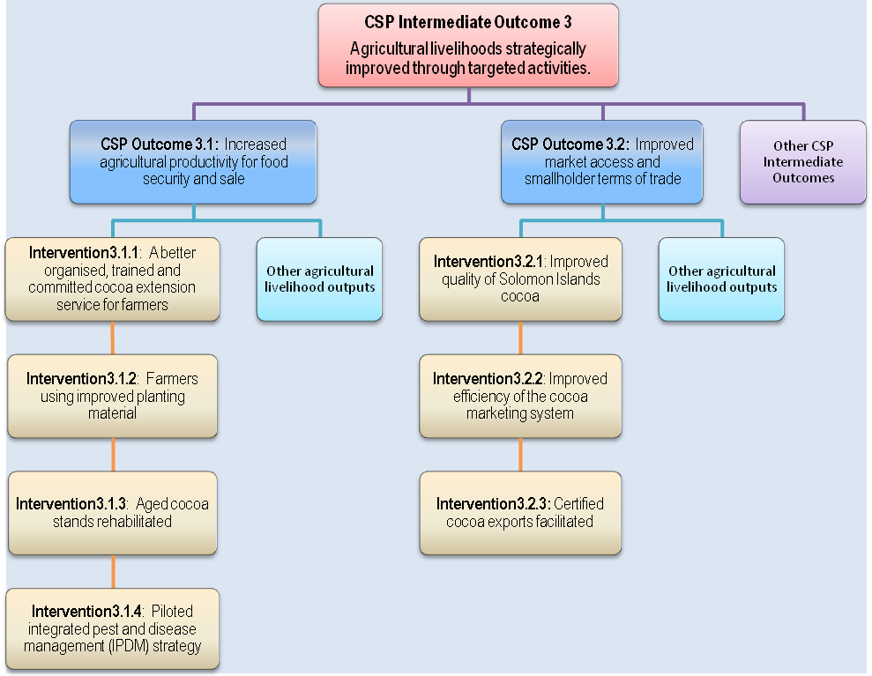
A “Cocoa Book” for extension staff and farmers will be produced, published and distributed. Illustrated leaflets on key topics will be published in Solomons pidgin. Awareness posters will also be published and distributed on the need for rehabilitation, pruning and shade thinning, cocoa processing quality, pests and diseases, and cocoa pod borer identification (to facilitate a timely emergency response should the need arise).
Regular field days will be conducted on successful farmers’ blocks in provinces, where farmers will learn good cocoa husbandry and quality processing practices. Field days will be theme-oriented, covering such topics as:
- on-farm nurseries
- planting out seedlings and their field management
- shade management
- cocoa rehabilitation with major pruning, shade thinning and replanting
- cocoa husbandry, including understanding and managing pest and diseases
- processing including timely harvesting, fermenting, drying and storage
- bookkeeping and financial management.

Intervention 3.1.2: Farmers Using Improved Planting Materials
Good stands of pure Amelonado cocoa will be identified on private farmers’ blocks in key cocoa areas that can be used as seed for the planting program. Contamination of Amelonado seed from other varieties (Trinitario, Upper Amazon) will be dealt with by providing adequate incentives for block owners to remove such trees.
Nurseries for propagating healthy cocoa seedlings will be established to enable farmers to obtain material for planting, and replanting blocks. Nursery management practices will be improved with technical advice and assistance. Central nurseries will be set up in key areas and run by selected farmers, assisted with advice, seeds, polybags and shade cloth. Seedlings will be sold at a subsidized price to neighbouring growers. Transport costs will be shared equally by farmers and the Project.
On-farm nurseries will be established where there is poor access. Farmers will be provided with management advice, seeds, polybags and shade cloth. Pods for at-stake plantings (direct seeding into planting holes for bud-grafting) will be provided to lead farmers.

Applied cocoa varietal research program
An applied varietal research program will also be established as a foundation for the longer-term expansion of cocoa in Solomon Islands, with high yielding germplasm. Since the demise of Dodo Creek Research Station, the services of lead farmers and Rural Training Centres (RTCs) will be utilized.
A block of Upper Amazon x Amelonado hybrids at Black Post will be rehabilitated and best trees observed for number of pods, and pest and disease resistance. Farmers participating in the pilot IPDM initiative will be assisted to select outstanding performers. The best trees will then be cloned by bud-grafting onto suitable root stock.
Clones of material from the Quarantine Facility of Reading University (UK), and SG2 hybrids from Fiji, will also be introduced and evaluated. An initial selection of 100 clones will be planted (plots of 10 trees each), and monitored using Amelonado as a control. The best 15 of these clones, selected for their yield and pest and disease resistance, will be distributed to farmers demonstrating high levels of management. High yields can be an expected outcome of a bud-grafting program producing the best hybrid clones. It is anticipated that ACIAR will participate in this applied research component longer-term.
During this establishment phase, locations for research blocks of high yielding germplasm will be identified in consultation and coordination with the Provincial Coordination Committees and MAL, to ensure that coverage is strategically aligned with industry needs and the sector development policies, plans and programs of SIG.
Cocoa farmers often are not aware of what effects chemical fertilizers have on different parts of the cocoa tree in terms of utilising nutrients in the soil to grow and to produce beans, leaves, roots etc., or on providing for tree vigour and improved health, leading to increased pod production in well-managed mature cocoa. IPDM’s participatory action research approach advocates balanced tree nutrition in order to achieve the levels of productivity gains anticipated. Farmer groups interested in maximising their cocoa yield potential will participate in on-farm fertiliser demonstrations (fertilised vs. unfertilised) that will allow them to observe these effects and to draw conclusions on any relationship between chemical fertilizer and cocoa yield. Moreover, by participating in IPDM activities farmers will routinely monitor the on-farm demonstrations and will learn to evaluate the economics of fertiliser use (i.e. net profit) for farm management decision-making.
The project will provide simple field diagnostic kits to enable rapid soil and plant analyses necessary for diagnosing nutrient disorders and for developing balanced fertilizer recommendations in areas where cocoa is already established. Where cocoa expansion is to occur on a larger scale, more detailed soil testing could be supported by the project to evaluate soil suitability for growing cocoa. Soil samples would be examined by (certified) soil testing laboratories in either Fiji or Papua New Guinea. The need for testing will be determined by project management, after taking into consideration comprehensive land evaluation work undertaken by Hansell and Wall in the 1970s.

Intervention 3.1.3: Aged Cocoa Stands Rehabilitated
Rehabilitation will be the initial priority of the Project, since it provides quick and assured benefits for cocoa households. Youth groups will be utilised to undertake rehabilitation tasks on a fee basis. Much of the cocoa in Solomon Islands is more than 30 years and over-shaded. To increase production, these trees need heavy pruning and the shade thinned. Some blocks require complete clearing and replanting. Improved peanut seed, through another CSP Agricultural Livelihood activity, will become available for sale in 2009 to improve ground cover and soil fertility on rehabilitated blocks, and to provide early cash flow for households. The Project targets 75 percent of aged cocoa stands that need rehabilitation.
The rehabilitation component will commence with an awareness campaign. Farmers needing assistance will be identified by extension staff. A cash contribution for redevelopment costs (25 percent) will be made by farmers and deposited into a Trust Fund. The Project will utilize youth and community groups trained in pruning and shade thinning techniques. There will be provision of planting materials, where required, to fill gaps in the rehabilitated cocoa blocks. Farmers and their families on the rehabilitated blocks will be trained on good cocoa husbandry practices and block sanitation to ensure that the benefits of any rehabilitation are maintained.

Intervention 3.1.4: Piloted Integrated Pest and Disease Management (IPDM) Strategy
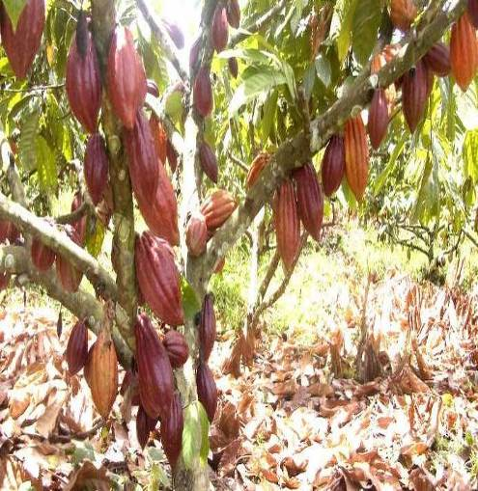
The participatory IPDM pilot strategy is based on the adoption of a successful extension model from East New Britain, PNG, which itself has been adapted from FFS approaches in many Asian and African countries. The pilot IPDM initiative will commence with awareness creation amongst rural farmer associations growing cocoa, and a number of groups of cocoa farmers aligned with the main buyers; mostly located on Malaita, Guadalcanal and Makira. The target is for at least 1350 farming families (25 groups) to adopt the IPDM package. If this is achieved, it should result in at least a 75 percent increase in their cocoa production.
An on-farm demonstration plot will be created for the introduction of IPDM workshops. Farmer representatives will be trained in IPDM at the demonstration plot and then commissioned to establish their own demonstration plot (one plot per group of 50 farming families). These farmer representatives will conduct a tree and production census for farm management planning. The participating families will then establish IPDM learning plots via participatory action learning techniques.
When farmers have established their learning plots, they will receive further rounds of IPDM training utilizing the services of a cocoa IPDM specialist, and IPDM technicians sourced periodically from PNG. These technicians and farmers will facilitate agro-ecosystems analysis (AESA) and decision-making based on field observations across the IPDM groups. There will be weekly “look and learn” exchanges among the IPDM farmer groups. Through this participatory process farmers will select superior germplasm for planting material improvement. At the end of the process the farmer groups will organize annual field days to show the benefits of IPDM to a wider farming community.
The photo (opposite) depicts a vigorous, high yielding cocoa tree from a Bougainville smallholder plot, showing what can be achieved by adopting IPDM practices (note number of healthy pods per tree). Cocoa smallholders in Solomon Islands can achieve similar performance levels.

Intervention 3.2.1: Improved Quality of Solomon Islands Cocoa
Cocoa quality needs to be improved to increase grower incomes. To address quality issues such as poorly fermented, under-dried and smoky cocoa beans, the CLIP will support CEMA and MAL to train growers and fermentary owners. The Project will also promote the use of appropriate sun-drying systems, where feasible.
Cocoa fermentaries requiring repair will be identified with the help of MAL extension staff and CEMA. A priority will be to assist fermentary owners to replace decrepit 200 litre drums with 3mm gauge steel pipes and flues. Cocoa wire mesh will also be sourced and made available. Steel kiln pipes and flues will be manufactured by, and purchased from, local metal fabricators willing to participate in the program. The Project will introduce locally manufactured, prefabricated, mini-driers. These will be transported to farm sites. The beneficiaries must be successful farmers, with at least two hectares of cocoa and who have undergone processing and management training. Participating farmers will contribute 25 percent towards the cost of driers, and 50 percent of the transportation cost.

Intervention 3.2.2: Improved Efficiency of the Cocoa Marketing System
The Project will encourage the development of a more efficient marketing system, which in turn provides incentives to improve cocoa quality and maximizes returns to growers. Improving marketing efficiency will be achieved through:
- Identifying buyer(s) who can provide funding to undertake direct marketing from Solomon Island exporters.
- Providing market and marketing information to the industry and government, explore creative marketing options.
- Providing policy advice. An example of an inappropriate policy is reserving export licenses for indigenous Solomon Islanders
- Encouraging the development of financially independent exporters through the utilization of the RDP Supplemental Equity Fund
- Assistance with cocoa storage facilities will be provided in remote areas, in conjunction with CSP’s market infrastructure activities
- As per the Bougainville BCCDRP model, farm families with 2 hectares or more of well managed cocoa will be identified and become eligible to apply for assistance to purchase an appropriately sized, prefabricated, cocoa fermentation box and mini-drier.

Intervention 3.2.3: Certification of Cocoa Exports Facilitated
Niche markets for high quality organically grown cocoa are available. These markets provide opportunities for small volumes of cocoa that would not otherwise comply with minimum volume requirements for shipment of bulk cocoa exports. A successful certified cocoa venture could be expected to lead to an improvement in the overall reputation of Solomon Islands cocoa, as has been the case in Vanuatu.
A specific component to improve market access and smallholder terms of trade has been included as a part of CLIP to promote the export of certified organic cocoa. Technical advice for this pilot operation will be provided on cocoa husbandry, pest and disease control, fermentation, drying and marketing. To be successful in this venture the cocoa not only has to be organically certified, but must be of premium quality.

Program Budget and Timing
CLIP entails a long term commitment to Solomon Islands cocoa industry development. A Stage 1 of 4 to 5 years is proposed, with a Stage 2 expected to follow. The estimated cost of Stage 1 is AUD9 million plus an expected MAL counterpart contribution. It is estimated that at least AUD600,000 will be paid back into the Project’s Trust Fund from beneficiary contributions towards rehabilitation costs and better processing equipment.

Implementation Framework: Management and Governance Arrangements and Structure

Project Organisation and Coordination
As explained in Section 3.2, CLIP is located within the logical hierarchy of Agricultural Livelihoods under CSP, with planned activities and outputs extending across two major interventions (3.1 and 3.2). The Project will be serviced by CSP’s management and implementation systems and its installed capacity to manage project funds, signifying the need for both CSP and CLIP to cooperate closely in implementation and performance management. This structure reduces the risk of creating loosely managed coordination mechanisms by working through alternative management systems of other programs, whose scope of activities may indeed change or be re-examined. It avoids pursuing a traditional delivery mechanism on a project by project basis.
CLIP’s activities extend along the entire cocoa value chain; an important criteria used in appraising institutional options for servicing this large Project. The Cocoa Design Mission considered the respective mandates of different organisations to provide the leadership necessary for effective engagement, coordination and management of the Project. Important criteria for this assessment were an organisation’s functionality, capacity and compatibility with the activities of industry stakeholders. Given these requirements and the imperative of coordinating time-bound work programs through a diverse number of value chain participants, stakeholders at the Design Workshop recommended the Project be hosted through CEMA, with field extension activities implemented through the respective MAL Provincial extension services.
Management support is included as a specific component of the Project. It is acknowledged that CSP does not possess adequate human resources to support project-specific services to be delivered under the Project. For this reason, management support has been built into the Project to assist with coordination and implementation, reporting, monitoring and evaluation, and annual planning.
CLIP will be managed by a National Project Manager (NPM), with the support of a full-time Chief Technical Adviser (CTA) and an Administration Assistant (AA). There is budget provision for a National Training Officer (NTO) to coordinate all training events in the Provinces for staff and farmers, including preparation of training aids. An IPDM Specialist will provide advisory technical services for the introduction of an IPDM component and coordination of field campaigns in the Provinces. Assistant Project Coordinators (APC) will be co-located in MAL Provincial offices (Guadalcanal, Malaita, Makira and Western Province) to work with extension staff to implement the Project.

Program of Work and Budget
Financial accountability and resource allocation will be the responsibility of the PM and CTA. Work planning will be undertaken during the inception phase (Months 1-3) and, thereafter, on an annual basis. Planning will be conducted through a workshop process involving key stakeholders, including MAL officers. The workshops will be required to review and validate the detailed activity schedules for project implementation. Planning will be the primary responsibility of the NPM and APC, assisted by the CTA.
Project oversight will be provided at two levels:
- Project Steering Committee (PSC). The PSC will be made up of key stakeholders, including AusAid, CSP, CEMA, MAL, RDP, and representatives of growers, buyers and exporters. The PSC would meet annually to monitor implementation performance through progress reports and field visits, and to endorse annual plans before their submission to AusAID for approval.
- Provincial Coordination Committee (PCC): A PCC will be established in each of the four major cocoa growing Provinces, comprising members of the Provincial Government, cocoa industry, grower representatives, MAL Chief Field Officer, and CLIP management. The PCC will meet six-monthly to review progress against work plans in the Province, assist with activity scheduling and coverage of covering project components, and facilitate the implementation of project activities in the field. The Chairman of the PCC will represent the Province on the PSC.
CLIP is a comprehensive, four-year program of support to the cocoa sector of Solomon Islands. Subsequent to the design of CLIP, the Solomon Islands Government (SIG) requested assistance to accelerate cocoa development in the Province, and to condense CLIP implementation schedules and timelines into three years in line with stated priorities of employment creation through cocoa development (see Table 1). The commitment to cocoa development by SIG and the Malaita Provincial Government (MPG) will help ensure the achievement of accelerated program targets within three years.
For example, the range of activities envisaged under CLIP, in particular those described for IPDM under Section 3.2.4, are deliverable under an accelerated program with strong commitment from MPG. IPDM farmer groups should become self-sustaining within three years of gaining the skills and competencies required to practice good cocoa management to raise block productivity and sustain yield increases of 75 per cent.
Malaita Province should reach this level of productivity by mid-2012, followed by Guadalcanal (end-2012), Makira (early-2013) and Western (mid-2013).
The Project’s organisation framework is given in Figure 5.
Table 1: CLIP start-up phase
Pipes, chimneys, prefabricated mini-driers and boxes will be produced locally. Initial indications are that local manufacturers exist and are willing to be involved in the fabrication of driers and their components. If lack of competition means uncompetitive prices, consideration will be given to import from overseas, possibly from Bougainville, where manufacturers exist and freight charges are not expected to be excessive.

Performance Measurement

Monitoring and Evaluation (M&E)
The Project’s interim M&E plan is designed to meet the information requirements of stakeholders. It will be reviewed and updated by stakeholders at an Inception Workshop within 3-4 months of Project start-up. The Participatory M&E Specialist from the Agricultural Livelihoods Unit of CSP will facilitate the Inception Workshop, and assist the PM and CTA to finalise the Project’s M&E plan, and ensure its compliance with CSP’s performance hierarchy.
Methods of M&E employed at Project level will include achievements against the annual plan, assessed and reported 6-monthly to the PSC. Regular field visits by Project Staff and Program Officers from the CSP Agricultural Livelihoods Unit will verify achievements made, and jointly troubleshoot operational issues with the APCs based in the provinces.
Near the end of Stage 1, a survey of beneficiaries will be undertaken to evaluate and report on achievements and impacts over the life of the Project. The survey will cover blocks planted, blocks rehabilitated, fermentaries repaired, mini- and solar-driers supplied, exporters, marketing and prices received. The Agricultural Livelihoods Unit of CSP has developed a methodology for participatory impact assessment work across its range of activities. The methodology specifies procedures and processes for baseline data analysis (qualitative, quantitative), methods and tools for analysing change (using a combination of the results chain model, Bennett’s Hierarchy, modified domains of change), and reporting formats based on the Sustainable Livelihoods framework (5 asset classes). The survey work to be undertaken by the Project will need to be harmonized with the ongoing impact assessment of other agricultural livelihood activities under CSP.
CLIP has clear, quantifiable performance targets:
- Increased cocoa exports (10,000 tonnes in 5 years and 15,000 tonnes in 10 years)
- Reduced differential between Solomon Islands and PNG FOB prices (differential reduced by 25 percent in 5 years and 75 percent in 10 years)
The hypothesis is that agriculturally derived incomes will be boosted through better production, processing and marketing of higher quality cocoa, enhancing the livelihoods of participating households. Project achievements, in terms of production and price, will be translated into their impact on rural income and its distribution.
The project’s M&E Plan will dovetail with the CSP Agricultural Livelihoods M&E / Impact Assessment Plan to test this hypothesis. In terms of impact on the broader objectives of developing sustainable cocoa production and quality assurance systems, a number of questions need to be considered to test the hypothesis and provide guidance for the design of future agricultural livelihoods programs in Solomon Islands.
- Does market development stimulate adoption of improved crop management and increase investment in cocoa production, leading to higher productivity?
- What are the major “drivers” for market development and competitiveness in smallholder environments?
- How do cash receipts (e.g., sale of wet/dry beans) translate into demand for additional services from rural, non-farm enterprises, ranging from construction, transport, trade-store goods, agro-processing, other goods and services, etc.?
- What are optimal strategies for sectoral expansion that are sustainable and not exploitive?
- The extent of women and youth participation is important. Data collection must be disaggregated to highlight gender issues associated with Project implementation. There will be need to verify whether training and extension activities are effectively targeting women and youth among the cocoa growing households.

Results Chain Methodology Framework
The following diagram provides a simplistic view of the Results Chain format. The chain is in two distinct parts, 1) the Process and, 2) the Results. The Process illustrates the inputs and activities that are targeted to the value chain and the results show the
Inputs => Activities => Outputs => Use of Outputs => Outputs => Outcomes => Impact
- Inputs are from CLIP and are merely Facilitation, Expertise, and Money.
- Activities are the planned interventions
- Outputs explain “what will actually happen” and may be short-term, medium term and/or long-term
- Use of Outputs explains results by way of use. May not always be relevant for all chains
- Outcome explains the desired benefit. There may also be indirect benefits as a result of inputs and outputs.
- The Impact is the long term benefit and should correspond with Project mandates related to Goals.
The following are suggestions to be used in developing results chains:
- Results Chains are results (achievement) oriented as opposed to activity (implementation) oriented.
- The Chain must be results oriented - boxes contain desired results as opposed to activities such as “training”, providing inputs, etc
- There must be a causal connection, e.g. – clear connection of “if…then” between successive boxes.
- The Chain should demonstrate change, e.g., improvement, increase, decrease, etc.
- There should be sufficient boxes to illustrate logical connections but not so meant so as to be overly complex
- Show one result per box
Annex 1 provides an illustrative view of the results chains for the cocoa value chain based on the interventions presented in this document. The details of the chains may change as the true direction of the CLIP is determined. As the CLIP’s re-developed the results chain will need to be altered to reflect any new goals, interventions and expected outcomes.

Annex 1: Project Results Chain
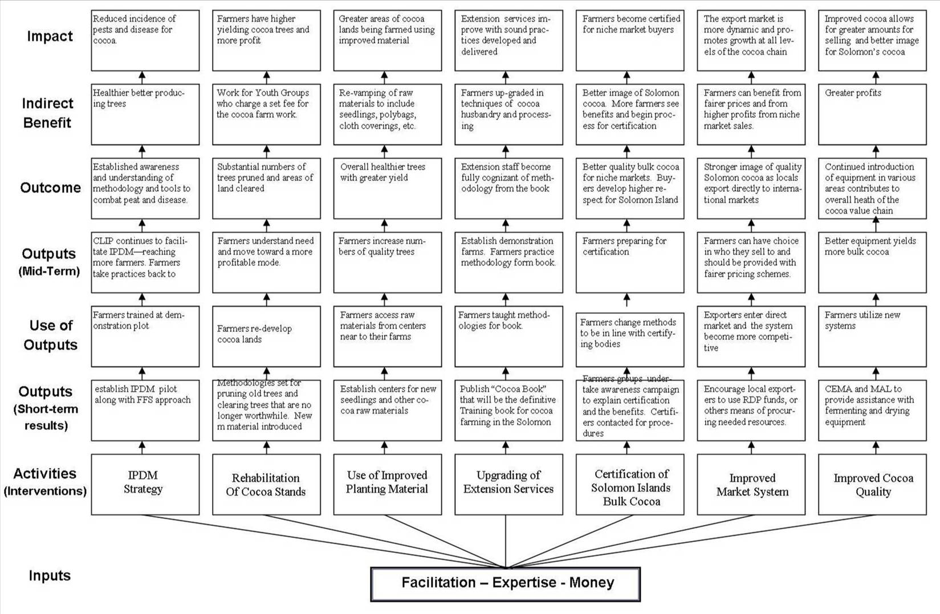

Annex 2: Implementation Plan

BLANK ON PURPOSE (EXCEL FILE)

Annex 3: Results Assessment
Annex 6 presents the Project’s interim M&E plan, which is designed to meet the information requirements of stakeholders. It will be reviewed and updated by stakeholders at an Inception Workshop within 3-4 months of Project start-up. The Participatory M&E Specialist from the Agricultural Livelihoods Unit of CSP will facilitate the Inception Workshop, and assist the PM and CTA to finalise the Project’s M&E plan, and ensure its compliance with CSP’s performance hierarchy.
Methods of M&E employed at Project level will include achievements against the annual plan, assessed and reported 6-monthly to the PSC. Regular field visits by Project Staff and Program Officers from the CSP Agricultural Livelihoods Unit will verify achievements made, and jointly troubleshoot operational issues with the APCs based in the provinces.
Near the end of Stage 1, a survey of beneficiaries will be undertaken to evaluate and report on achievements and impacts over the life of the Project. The survey will cover blocks planted, blocks rehabilitated, fermentaries repaired, mini- and solar-driers supplied, exporters, marketing and prices received. The Agricultural Livelihoods Unit of CSP has developed a methodology for participatory impact assessment work across its range of activities. The methodology specifies procedures and processes for baseline data analysis (qualitative, quantitative), methods and tools for analysing change (using a combination of the results chain model, Bennett’s Hierarchy, modified domains of change), and reporting formats based on the Sustainable Livelihoods framework (5 asset classes). The survey work to be undertaken by the Project will need to be harmonized with the ongoing impact assessment of other agricultural livelihood activities under CSP.

Key Performance Indicators
CLIP has clear, quantifiable performance targets:
- Increased cocoa exports (10,000 tonnes in 5 years and 15,000 tonnes in 10 years)
- Reduced differential between Solomon Islands and PNG FOB prices (differential reduced by 25 percent in 5 years and 75 percent in 10 years)
The hypothesis is that agriculturally derived incomes will be boosted through better production, processing and marketing of higher quality cocoa, enhancing the livelihoods of participating households. Project achievements, in terms of production and price, will be translated into their impact on rural income and its distribution.
The project’s M&E Plan will dovetail with the CSP Agricultural Livelihoods M&E / Impact Assessment Plan to test this hypothesis. In terms of impact on the broader objectives of developing sustainable cocoa production and quality assurance systems, a number of questions need to be considered to test the hypothesis and provide guidance for the design of future agricultural livelihoods programs in Solomon Islands.
- Does market development stimulate adoption of improved crop management and increase investment in cocoa production, leading to higher productivity?
- What are the major “drivers” for market development and competitiveness in smallholder environments?
- How do cash receipts (e.g., sale of wet/dry beans) translate into demand for additional services from rural, non-farm enterprises, ranging from construction, transport, trade-store goods, agro-processing, other goods and services, etc.?
- What are optimal strategies for sectoral expansion that are sustainable and not exploitive?
- The extent of women and youth participation is important. Data collection must be disaggregated to highlight gender issues associated with Project implementation. There will be need to verify whether training and extension activities are effectively targeting women and youth among the cocoa growing households.

Reporting Requirements
The Project will be required to submit the following reports:
- Inception Report by the end of the third month after start-up. This will update the PDD and include a detailed work plan for the remainder of Year 1
- Brief 6-monthly project progress reports highlighting achievements, implementation issues and their management, and a work plan and budget for the ensuing period. This report will consolidate achievements from quarterly reporting by the APCs. The reporting format will be determined jointly with the CSP Agricultural Livelihoods team
- Annual reports covering the same points as for the 6-monthly reports, but including a detailed plan developed at the annual planning workshop
- A terminal report to be prepared according to AusAID guidelines for final reports

Annex 4: Risks and Risk Management Strategies

Cocoa Pod Borer
The CPB poses a major industry threat and, thus, Project risk. CPB is a moth whose larvae bore into the cocoa pod preventing further pod development and ruining the beans. It is common in Sulawesi and Indonesia. In 2004, CPB spread to East New Britain, PNG’s major producing area. It is rumoured to have entered Bougainville. Losses from CPB could ruin Solomon Islands’ cocoa industry.
An important risk management strategy is to avoid obtaining any planting material, either as seeds, pods or budwood from East New Britain or Bougainville, even though the hybrid clones are high yielding (under good management). Instead, the Project will use locally sourced Amelonado. Under CLIP’s applied varietal research program, Upper Amazon materials from Black Post, together with introductions of PNG SG2 hybrids from Fiji, and clonal material from Reading University’s quarantine facility, will be obtained. These sources present no risk of CPB introduction.
The presence of CLIP will, in itself, reduce the risk of a CPB incursion and its impact. CPB identification will be an important part of the extension program. Training will create awareness and increase the likelihood of early detection, enabling the initiation of a timely emergency response, such as quarantining infected islands or areas.

Institutional Rivalries
There is a risk that institutional rivalry will result in lack of cooperation in implementation. The roles of each organization need to be clearly defined from the outset so there is no confusion and maximum cooperation achieved. MAL extension staff will need clear instructions to cooperate with CLIP and CEMA staff, and to treat cocoa development as a national priority in their work programs.

Policy Reforms not Adopted by SIG
A continuation of current policy of restricting cocoa export licenses to indigenous Solomon Islanders would severely reduce the prospect of achieving CLIP’s goals. Through dialogue, policy makers will need to be convinced of the benefits to growers from increased competition, and that increased competition could be achieved through a combination of measures:
- the entry of a substantial new independent exporter
- the entry of an experienced organic cocoa exporter
- one or more of the existing cocoa traders/buyers becoming an exporter through the availability of working capital.

RDP Supplemental Grant Funds Not Made Available to Cocoa Enterprises
The RDP equity grant facility has been identified as a potential source of working capital to finance the graduation of existing cocoa buyers into independent exporters. If such funding was not forthcoming it would be a constraint to achieving the goals of CLIP. A role of the Project is to identify suitable candidates and to facilitate the preparation of working capital loan proposals for submission to commercial banks. This will be achieved through creating awareness of the RDP facility, and through the provision of quality market information to aspiring exporters

Payment for Planting Materials
There is a risk that farmers will not pay (or at least, will be reluctant to pay) for cocoa seedlings under CLIP, particularly given SIG and Holland Commodities’ support to the free distribution of planting materials. Three keys factors should ameliorate this situation:
- Smallholders are willing to pay for good quality seed, which is potentially high yielding (evidence from Cocoa Design Mission)
- It was also important to farmers that the Project addressed all aspects of the value chain, as opposed to previous cocoa projects which were too narrowly focused
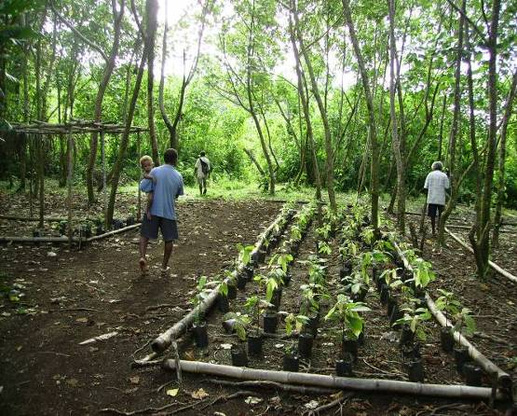
- Discussions with Holland Commodities during October 2008 indicated that their interest in continuing to support the free distribution of seedlings is waning. The nurseries on Malaita (near Auki and Malu’u) were no longer operating and in poor condition when visited by the Cocoa Design Mission in November 2008, with many farmers reporting concerns about the quality of seedlings distributed previously from both sites. The operator of the third and principal nursery at Lungga, near Honiara, died in January 2009, leaving its future status uncertain.

Environmental Risk
There is a risk that new cocoa plantings will encroach into garden land, and/or primary or secondary forest. This has occurred previously with the promotion of cattle development and also the establishment of a large number of exotic tree plots, particularly teak, resulting in relatively less garden land near villages.
Although there is an environmental risk, it should not be large as the Project’s emphasis, at least initially, will be on rehabilitation and replanting of pre-existing cocoa plots, rather than expansion into new areas. However, the large areas of forest that have recently been logged in Solomon Islands could be suitable for cocoa expansion under multiple land use models - cocoa is relatively efficient at sequestering carbon, up to 80% of primary forest cover levels on a per area basis.
To mitigate the impact of any new cocoa plantings/expansion, the Project will promote two key strategies:
- Inter-cropping cocoa under existing coconut stands (or, if appropriate, teak) as a more efficient land use model, and income diversification plan
- Inter-planting cocoa with suitable food crops. The Project will investigate the feasibility of distributing planting materials for shade-resistant banana varieties and root crops such Xanthosoma, possibly through the cocoa nurseries.

Women and Their Food Gardens
There is a preference in Solomon Islands for cocoa to be planted closer to settlements, on flatter land, and in areas that are more accessible. This is because of: the crop’s higher (and generally male-oriented) status; the fact that men seek to reduce their own effort associated with cocoa maintenance, harvesting and cartage activities; and for security reasons (particularly in regions of high population/production pressure). Consequently, food gardens are usually relegated to peripheral sites, increasing the burden on women and children responsible for their regular maintenance (given the greater distances involved).
To alleviate the impact of any cocoa expansion on food garden locations and women, the Project will encourage two main strategies:
- Increased awareness of (and support for) the planning and implementation of mixed land use approaches amongst cocoa smallholders
- Increased awareness of (and support for) house gardening options amongst cocoa smallholders, including appropriate crops and husbandry techniques

In recent years, Solomon Islands has received around SBD 900 per tonne less for cocoa exports than PNG.
By comparison, rice imports in 2007 were valued at SBD167.7 million (Statistics Office, Department of Finance and Treasury).
The structure of this document follows the above five steps
Subsequent to the SAS, current perceived weakness is export marketing, which is detailed in Sections 1.2.3.1, 1.2.4.2, and 1.2.4.3 of this design document.
In the first four months of 2008, China's imports of cocoa beans rose 13 per cent to 15,543 metric tons, while imports of cocoa powder gained 22 percent to 6,342 tons (Beijing Orient Agribusiness Consultant Ltd.). Cadbury (India) report the growth in cocoa demand in recent years has been 15 per cent annually and will reach 30,000 tonnes over the next 5-years (www.confectionarynews.com).
To quote: London cocoa futures have hit a 23-year-high as cocoa turned out to be the most lucrative commodity in 2008. Cocoa for delivery in May peaked at £1,820 per tonne in London, which was its highest price since October 1985. Cocoa traded in the US has also been rising, although not as strongly because of the strength of the dollar. Most commodities are priced in dollars, even in London trading, but London cocoa is priced in sterling, so traders can benefit from the weaker currency. "Cocoa is on fire," said Sterling Smith from FuturesOne in Chicago. "We have supply concerns continuing. The market is plenty bullish and we have plenty of room to go on the upside," he added. There are concerns about falling cocoa production in Africa, while demand for cocoa is holding up much better than other commodities in the downturn. Published: 2008/12/24 08:06:42 GMT (http://news.bbc.co.uk/go/pr/fr/-/2/hi/business/7798696.stm)
Fair Trade Labelling Organizations International (FLO) (2004). Fair Trade Standards in General. www.fairtrade.net/sites/standards/general.html.
ICCO (2004). Fair Trade Cocoa and Chocolate. www.icco.org/questions/fairtrade.htm
op. cit. SIPPO (2002).
op. cit. SIPPO (2002).
An important GAP principle applicable to agriculture in Solomon Islands is Integrated Pest Management (IPM), owing to the indiscriminate use of plant protection chemicals by fresh produce enterprises, who market their produce to retailers and consumers. The present use of inorganic fertilizers by these enterprises is of minor consequence.
Vinning, G. and Chinh, N Q. 2008. Dragon fruit: the case for market pull certification. Marketing Component Working Paper No. 4. Investment Options for the Proposed Loan Project: Quality and Safety Improvement of Agricultural Products MARD. Asian Development Bank. Project Number: PPTA 4927-VIE. Hanoi, July.
Dried cocoa beans should be shipped at 6 to 7 percent moisture – Solomon Islands cocoa is often exported at 8 to 9 percent moisture (pers. comm. Trevor Clarke).
Lambert reports that the price differential between under-fermented cocoa and good fermented cocoa is around US$250/tonne (see Annex 11).
As expressed in a MAL project document National Cocoa Seed Gardens, submitted to the Department of National Planning and Aid Coordination, seeking funds from the 2007 development budget to establish new cocoa seed gardens across Solomon Islands.
It is also anticipated that the Australian Centre for International Agricultural Research (ACIAR) will support this work, f ollowing recommendations of the ACIAR Scoping Study.
Both pink disease and white thread blight are serious only where there is poor management and should be pruned out when seen and taken out of the plantation.
These three insects have grubs which bore into trunk and branches, weakening and eventually killing the tree.
SBD 20-28 million equivalent
Members of the Cocoa Design Mission (John Konam, Smilja Lambert and Andrew McGregor) were concurrently involved with the ACIAR Cocoa Scoping Study.
Presentation to a stakeholder design meeting on CLIP by Dr Smilja Lambert, Cocoa Sustainability Research Manager, Asia Pacific, Mars Inc. Dr Lambert’s detailed report is presented in Annex 11.
The three other high priority recommendations were: improving food security for rural villages, enhancing domestically marketed food, and increasing the production of quality copra (Bourke, et. al., 2006).
This will be similar to the farmer-friendly pictorial “Torabut i wokim bisnis long kakau” produced for East New Britain and Samoa, but modified to the situation in Solomon Islands.
For example: nurseries and planting out, cocoa rehabilitation, cocoa husbandry, pruning and shade thinning, pests and diseases and processing.
A number of other product differentiation techniques and the opportunities they present for exporting cocoa to niche markets are described in Annex 9.

