

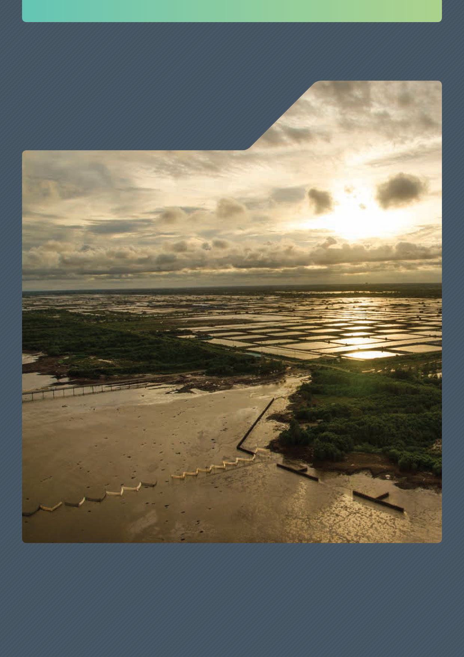

Climate Change Action Strategy

Tackling climate change through Australia’s Development Assistance Program 2020–2025



This booklet should be attributed as Department of Foreign Affairs and Trade - Climate Change Action Strategy, November 2019.

ISBN - 978-1-74322-480-9 (Book)

ISBN - 978-1-74322-479-3 (PDF)

ISBN - 978-1-74322-481-6 (Word doc)

ISBN - 978-1-74322-482-3 (Online)

Cover image: Integrated Coastal Management Program

T- Fence in Bac Lieu Province, Mekong Delta Vietnam. An innovative breakwater fence system supported by Australia to protect communities from storms and floods.

Creative Commons



The Commonwealth of Australia’s, Department of Foreign Affairs and Trade - Climate Change Action Strategy, October 2019 (this publication) is protected by copyright. The material in this publication is licensed under a Creative Commons Attribution 4.0 International Licence (https://creativecommons.org/licenses/by/4.0/), with the exception of:

* the Commonwealth Coat of Arms;
* the Department of Foreign Affairs and Trade logo;
* any material protected by a trademark; and
* all images (images are licensed individually as set out below in the image credits).

Creative Commons Attribution 4.0 International Licence is a standard form license agreement that allows you to copy, distribute, transmit and adapt this publication provided that you attribute the work. The full legal code for the licence (which includes any relevant licence conditions) is available on the Creative Commons website accessible by using this link: https://creativecommons.org/licenses/by/4.0/legalcode.

The Commonwealth’s preference is that you attribute this publication (and any material sourced from it) using the following wording: Source: Licensed from the Commonwealth of Australia under a Creative Commons Attribution 4.0 International Licence. The Commonwealth of Australia does not necessarily endorse the content of this publication.

Image credits

**Cover page image**  
Credit: Lisa Steuer/GIZ

**Chapter 2 image 1 (Pacific-Australia Climate Change Science and Adaptation Planning Program)**  
Credit: Pacific-Australia Climate Change Science and Adaptation Planning Program

**Chapter 2 image 2 (Womens UNFCCC Negotiation Training)**  
Credit: Women’s Environment and Development Organisation

**Chapter 3 image 1 (Integrated Coastal Management Program)**Credit: GIZ/Harald Franzen

**Chapter 3 image 2 (Gizo Market Solomon Islands)**Credit: GIZ/Harald Franzen

**Chapter 3 image 3 (Disaster Preparedness Capacity Building)**Credit: Rapid-CCC/Kris Guiço

**Chapter 4 image 1 (Tina River Hydropower Project)**Credit: Tina River Hydro Project Office, DFAT

**Chapter 4 image 2 (Surveying mangroves in Fiji)**Credit: Lucy Wallington/Department of Environment and Energy

**Chapter 4 image 3 (Kiribati Education Improvement Program)**Credit: Nicholas Harding/Coffey International

**Chapter 4 image 4 (Savanna Fire Management)**Credit: Tim Alewood/International Savanna Fire Management Initiative

**Chapter 5 image (Partnership for Cleaner Textile Program)**Credit: International Finance Corporation

**Chapter 6 image (Solar Farm in Tonga)**  
Credit: Mr Johnny Lillis and Vilami Ongosia (OIREP Program)

Contact

Telephone: +61 2 6261 1111  
Email: resilience@dfat.gov.au

Published in November 2019  
Editing by Morris Walker Pty Ltd  
Typesetting and internal designs by Swell Design Group Pty Ltd

# Message from the Secretary



Australia’s Foreign Policy White Paper outlines the deepening challenge climate change will pose over the next ten years and into the future. It notes that all countries will need to factor climate change into long term planning and investment, including its implication for national and regional security.

In Australia’s neighbourhood, Pacific island countries are highly vulnerable to the adverse consequences of climate change. The Pacific islands Forum Boe Declaration acknowledges climate change as the greatest threat to the livelihoods, security and wellbeing of peoples of the Pacific. Australia has expertise in many areas that will underpin effective responses to climate change in the region, including in climate science and meteorology, energy, water, agriculture, infrastructure, adaptation, disaster preparedness and response. We have a long history of sharing this expertise with country partners, including through our development assistance program, in support of their efforts to tackle climate change, enhance development outcomes, and meet the Sustainable Development Goals.

Tackling climate change across our development assistance program demands comprehensive analysis and early consideration of climate risks, impacts and opportunities for low emissions, and climate resilient development. This is vital to an effective development assistance program that promotes prosperity and social inclusion, reduces poverty and enhances stability in our region.

This Climate Change Action Strategy outlines the Department of Foreign Affairs and Trade’s approach to responding to climate change in the development assistance program. Its focus is on working directly with countries in our region, particularly in the Pacific.

This Strategy complements our aid investment and sectoral priorities. It takes forward work the Department has implemented over the past number of years; informing development assistance policy, updating the Department’s systems, increasing targeted climate investments and integrating climate considerations in existing and planned investments.

This Strategy also sets out how we will maintain our internal capacity and harness the expertise of our aid implementation partners, enhance our partnerships and promote innovative approaches to addressing climate change.

Implementing the Strategy will help us work with our partners to realise the goals of the Paris Agreement, and provides a framework for us to support climate action into the future.



**Frances Adamson**

# Executive summary

Climate change is a major risk to sustainable development and is threatening global efforts to eradicate poverty. It will increasingly affect all australian development assistance policy and investment decisions, and influence long-term planning and risk management.

The world’s climate is changing faster than most scientists expected even five years ago.

The impacts of climate change are magnifying a range of challenges for developing countries. For some, including Pacific atoll nations, climate change impacts present an existential threat.

Disasters and extreme weather events such as drought, floods and cyclones are adversely impacting livelihoods, critical infrastructure and productive industries. The impacts are magnified by long-term effects from climate change, such as threats to ecosystems, ocean acidification and sea-level rise.

The Paris Agreement, now ratified by 187 parties, underlines the strength of global commitment to addressing the threats of climate change, including commitments by donor countries to provide support to developing countries in need to address climate change.

Australia has long supported climate change action through its development assistance program. There is already substantial investment in climate change and disaster resilience, particularly in the Pacific. Informed by climate change science, Australia will continue to support activities to reduce greenhouse gas emissions, and invest in ways to build resilience and adapt to the adverse impacts of climate change.

Addressing the risks of climate change, as well as taking advantage of the opportunities from climate action – such as more climate-resilient economic growth, jobs and technologies – reinforces sustainable development and supports poverty reduction.

The Climate Change Action Strategy will underpin our climate investments and assist the Department of Foreign Affairs and Trade (DFAT) to meet Australia’s commitments, building on our $1 billion climate development assistance from 2015-2020.

In this context, the Government has pledged to spend $500 million from 2020-2025 to build Pacific climate change and disaster resilience. This is a step up on Australia’s previous pledge to the Pacific to spend $300 million over four years (2016-2020) which we are on track to exceed.

We aim to support the goals of the Paris Agreement to address climate change and strengthen socially inclusive, gender-responsive sustainable development in our region, and beyond.

We will build on our track record and current efforts in the Pacific. Australia has provided climate support through our development assistance program for more than 25 years. We use a partnership approach, respecting the needs and priorities of our development partners, to help our region reduce emissions and adapt to climate change.

The Strategy is informed by, and implements, the Foreign Policy White Paper and Australia’s aid policy, Australian aid: promoting prosperity, reducing poverty, enhancing stability, as well as the Sustainable Development Goals.

Harnessing capabilities through whole-of-government approaches will continue to be important, as will working with experts outside of government including our capable Non-government organisation (NGO) community.

Consistent with the Foreign Policy White Paper, the Strategy has a focus on the Indo-Pacific, notably Pacific island countries, Southeast Asia and South Asia. In supporting the goals of the Paris Agreement, the Strategy will also help Australia build capacity in developing countries to enable them to meet their Paris Agreement obligations. It recognises the need for further integration of climate change adaptation and disaster resilience and for stronger engagement with the private sector in finding solutions.

The Strategy promotes social inclusion and gender equality, with a clear focus on the most vulnerable communities, especially women and girls, people with disability and indigenous peoples.

The Strategy sets three key objectives to make the best use of our development assistance:

* support partner countries to adapt to climate change, and to plan, prepare for and respond to climate related impacts
* promote the shift to lower-emissions development in the Indo-Pacific region
* support innovative solutions to climate change, including those that engage private sector investment.

Australia will provide specific and targeted climate change programs that support transition to lower-emissions, more climate resilient communities with better sustainable development outcomes. As part of this approach the Government’s new $140 million Private Sector Mobilisation Climate Fund will accelerate climate action in the Indo-Pacific by increasing the pace and scale of private sector climate investments.

DFAT will also integrate climate change action across Australia’s development assistance program. Climate change will increasingly affect development assistance policy and investment decisions and influence long-term planning and risk management. Development assistance investments should be sensitive to lower-emissions options, and also to addressing the adverse impacts of climate change, such as ensuring infrastructure or agricultural investments are climate resilient.

The Government is committed to ensuring that DFAT maintains the mix of capabilities for successful implementation of the Strategy, including by working across government and with external parties with the expertise and capacity to deliver effective, measurable outcomes for people in need, now and into the future.

1. Overview: Departmental Strategy for Climate Change Action in Australia’s Development Assistance

AIM
Australian development assistance supports the goals of the Paris Agreement to address climate change and strengthens socially inclusive, gender-responsive sustainable development in our region.
OBJECTIVES
Promote the shift to lower emissions development in the Indo-Pacific region.
Support partner countries to adapt to climate change, and to plan, prepare for and respond to climate-related impacts.
Support innovative solutions to climate change, including those that encourage private sector investment.
LONG-TERM OUTCOMES
Lower-emissions growth pathways in the Indo-Pacific.
Increased adaptation and resilience to climate change for partner country communities and economies.
Innovative climate change solutions extending the boundaries of mitigation and adaptation action.
Stronger sustainable development impacts and more effective development assistance.
IMPLEMENTATION
Integrate climate change across the development assistance program while reinforcing social inclusion and gender equality.
Increase targeted climate change investments to achieve outcomes
at scale.
Strengthen Departmental capabilities for climate change development.
Improve risk management and safeguards frameworks to address climate change in Australia’s development assistance investments.

Contents

Message from the Secretary 4

Executive summary 5

01. Climate change and development 9

1.1 Climate change science and impacts 9

1.2 The nexus between climate change and development 10

1.3 The international architecture on climate change 12

02. Building on our track record for climate change action 15

2.1 Australia’s climate change development assistance commitments 16

2.2 Where does our climate change development assistance go? 19

03. A new climate change action strategy 23

3.1 Indo-Pacific: a focus for the new Strategy 24

3.2 Supporting the goals of the Paris Agreement 25

3.3 Integrating climate change adaptation and disaster resilience 25

3.4 Engaging the private sector 26

3.5 Social Inclusion and Gender Equality 27

3.6 Stronger and innovative partnerships 28

04. Climate change action strategy: objectives 30

4.1 Promote the shift to lower-emissions development in the Indo-Pacific region 30

4.2 Support partner countries to adapt to climate change, and to plan, prepare for and respond to climate-related impacts 34

4.3 Support innovative solutions to climate change, including those that encourage private sector investment 36

05. Implementing the change 38

5.1 Integrating Climate Change Action Across Australia’s Development Assistance Policy and Program 38

5.2 Targeted Climate Change Action to Achieve Outcomes 40

5.3 Maintaining Departmental Capacity for Climate Change Action 42

06. Strategy performance and review 45

6.1 Performance Assessment Framework 45

6.2 Review 45

List of acronyms 47

# 01. Climate change and development

## 1.1 Climate change science and impacts

The world’s climate is changing faster than most scientists expected even five years ago. The impacts of climate change are increasingly evident and felt by communities around the world.

The 2018 Intergovernmental Panel on Climate Change (IPCC) Special Report, ‘Global warming of 1.5°C’ assessed the impacts of global warming on natural and human systems.[1] The report presents global risks and impacts from climate change, including those likely to affect the Indo-Pacific region such as sea-level rise, coastal inundation, mass coral bleaching and mortality, heat and rainfall extremes and socio-economic impacts on health, food and water resources, livelihoods and migration.

Climate change science informs the Department’s approach to addressing climate change in the development assistance program. We also work collaboratively with other government agencies like the Department of Environment and Energy, Bureau of Meteorology, Geoscience Australia and the Commonwealth Scientific and Industrial Research Organisation (CSIRO) to develop better and more relevant climate information to support our country partners with their climate change action.

The Paris Agreement, adopted in 2015 and to be implemented from 2020, recognises the need for an effective response to the threat of climate change. The international community has shown its support for action on climate change with high levels of commitment to the Paris Agreement, which more than 187 Parties[2] have now ratified. At the United Nations Framework Convention on Climate Change (UNFCCC) Conference of the parties (COP24) in Poland 2018, all Parties agreed to the implementation rule-book for the Paris Agreement.

Successful global action will be necessary to limit the severity of climate change impacts.

Understanding climate change projections in the Pacific

Under the Australia Pacific Climate Partnership, DFAT is funding CSIRO to update the long-term climate projections for the Pacific. The “Next Gen” project will focus on bringing science into practice in key development sectors to support good decision making – working closely with the Secretariat of the Pacific Regional Environment Programme (SPREP), CSIRO is engaging with regional science agencies and country representatives to ensure the information produced is meaningful, useful and timely.

Australia’s climate change commitments

Australia ratified the Paris Agreement in 2016. Our target of reducing emissions by 26 to 28 per cent below 2005 levels by 2030 is achievable, reasonable and responsible, and in step with the efforts of other developed countries. Achieving the Paris Agreement goals requires a long-term transition to a low-emissions, climate resilient economy. Australia has committed to develop a long-term strategy by 2020. On 25 February 2019, the Australian Government announced the [Climate Solutions Package](https://www.environment.gov.au/climate-change/publications/climate-solutions-package), a $3.5 billion investment to deliver on Australia’s 2030 Paris climate change commitments. The Government’s plan builds on existing policies and success in meeting Australia’s Kyoto Protocol commitments.

As the Prime Minster said “Australia is doing our part to cut global emissions and our Climate Solutions Package sets out to the last tonne how we will meet our 2030 target that will see us halve emissions per person and reduce the emissions intensity of our economy by two-thirds. The fact Australia leads the world in per capita investment in clean energy, we have the world’s most successful green bank in the Clean Energy Finance Corporation and that we’re on track to have around a quarter of our electricity needs met by renewables by 2020 all underscores the work underway to reduce our global emissions”. 13 August 2019

## 1.2 The nexus between climate change and development

The United Nations identifies climate change as a threat to development.[3] The World Bank estimates that without a global response to climate change, an additional 100 million people could be living in extreme poverty (that is, living on less than US$1.90 a day) by 2030.[4]

The Foreign Policy White Paper highlights that climate change, environmental degradation, and demand for sustainable sources of food, water and energy will be political, economic and security disrupters over the longer term. These challenges could undermine stability in fragile states and create conflict, irregular migration and disaster displacement.

People living in coastal regions in the Indo–Pacific are at risk of flooding and potential displacement. Food, water and health security will become more pressing. The Pacific is particularly at risk of rising sea-levels, especially low-lying atolls.

The Kainaki II Declaration for Urgent Climate Change Action Now, endorsed by Pacific Islands Forum leaders in August 2019, articulates the multi-faceted risks experienced by the region.

The Intergovernmental Panel on Climate Change (IPCC) highlights that climate change will amplify existing risks and create new risks for natural and human systems. These risks are unevenly distributed and are generally greater for disadvantaged people and communities in countries at all levels of development. Climate change will negatively impact biodiversity, ecosystem services and economic development and amplify risks for livelihoods and for food and human security.[5]

While all countries will feel the effects of climate change, developing countries are both more exposed and more vulnerable, and have fewer support systems and less capacity and resources to withstand shocks.[6] They are at greater risk because of a lack of access to climate data, research and technology.

Climate change disproportionately affects vulnerable and socially marginalised groups, who often do not control the resources to respond and are underrepresented in key decision-making groups. Understanding and addressing the differentiated impacts of climate change is crucial.

The livelihoods of women and girls, particularly in the Pacific, are often dependant on sectors such as agriculture and water resources, where climate change impacts are acute. Many indigenous peoples are dependent on natural resources for their livelihoods, and hence face greater difficulties recovering from extreme weather events. People with disabilities are also particularly vulnerable, for example during heatwaves, flooding or other extreme weather events exacerbated by climate change.

While climate change has pronounced impacts on these groups, they are also active and valuable contributors to climate change responses at the international, national, and community levels. Their participation and knowledge is important in the development of effective solutions.

Recognising these significant and pervasive challenges, in recent decades, donor countries have committed financial, technological and capacity building support to help countries address climate change. This includes support for activities to reduce greenhouse gas emissions, for adaptation to the adverse impacts of climate change, and to build resilience.

While significant international effort is focused on the risks of climate change, climate action also presents opportunities through lower emissions, more climate-resilient economic growth, jobs and new technologies.

Opportunities include reinforcing sustainable development approaches across key sectors such as agriculture, reducing atmospheric, land and water pollution, and bolstering eco-systems and biodiversity. Access to renewable energy and off grid technology can promote economic growth and human development, especially in remote and vulnerable areas.

Many new approaches bring long-term cost savings through energy or water efficiency. Longer-term outcomes can encompass inclusive economic growth and better governance, as well as increased energy access, cleaner, more resilient cities, and health, gender equality and education benefits.

The International Finance Corporation (2019) estimates that [the Nationally Determined Contributions of 21 emerging market economies alone represent US$23 trillion in investment opportunities by 2030.](http://www.ifc.org/wps/wcm/connect/news_ext_content/ifc_external_corporate_site/news+and+events/news/new+ifc+report+points+to+%2423+trillion+of+climate-smart+investment+opportunities+in+emerging+markets+by+2030)[7]

The world is expected to invest about US$90 trillion on infrastructure in the period up to 2030, more than the entire current stock today. Investing the US$90 trillion to build the right infrastructure now will deliver a new era of economic growth. Investing it wisely will help drive innovation, deliver public health benefits, create a host of new jobs and go a long way to tackling the risks of runaway climate change. Ambitious climate action could generate over 65 million new low-carbon jobs by 2030, as well as avoid over 700,000 premature deaths from air pollution compared with business-as-usual.[8]

Key Climate Change Terms

Mitigation: the reduction of greenhouse gasses released into the atmosphere, including through activities that remove or reduce emissions—either through natural systems such as forests which absorb carbon emissions, or through technologies such as carbon capture usage and storage, where carbon dioxide can be sequestered. The main source of greenhouse emissions is from burning fossil fuels for energy, but emissions also arise from other sources such as land use, transport, waste, building materials and industrial processes.

Adaptation: the ability to adjust to climate change to minimise potential impacts, take advantage of opportunities or to cope with the consequences. This means anticipating and planning for the impacts across areas affected by climate change. Indications are that $1 invested in disaster risk reduction activities saves up to $15 on response and recovery in the aftermath of a disaster.[9]

Resilience: the capacity to tolerate shocks or disturbance, and to recover and rebuild a better ‘new normal’. Resilience has economic, social and ecological dimensions. It requires diversity and the ability to adapt when external conditions change, and to respond to new opportunities.

## 1.3 The international architecture on climate change

Australia looks to, and engages with, the rules-based international order to address complex global challenges such as climate change. In the region, the Pacific Islands Forum is the preeminent regional body that discusses climate change.

A strong international framework to address climate change has been established over the past three decades. Central to this is the Paris Agreement, which builds on the work of the UNFCCC and the Kyoto Protocol.

The Paris Agreement aims to hold the increase in global average temperature to well below 2°C above pre-industrial levels, and to pursue efforts to limit the temperature increase to 1.5°C to reduce the risks and impacts of climate change. It also sets goals to:

* increase countries’ ability to adapt to the adverse impacts of climate change
* make finance flows consistent with a pathway towards low greenhouse gas emissions and climate-resilient development.

As part of the Paris Agreement, countries must submit Nationally Determined Contributions (NDCs) for emissions reductions. Countries may also provide adaptation communications setting out priorities and support needs. The Agreement establishes a transparency system to build confidence that countries are meeting commitments.

A key element of the Agreement is commitment by donor countries to provide support for climate action to developing countries in need. One hundred and thirty two countries have sought such support toward meeting their NDCs.

In support of the Agreement, in 2015, developed countries reaffirmed their commitment to scaling up their collective support to provide US$100 billion a year in climate finance by 2020, including from private and public sources. Estimates by the OECD in 2019 found donors were on track to meet this goal.[10] A new collective goal will be set from 2025 onwards.

The UNFCCC’s Financial Mechanism, including the Global Environment Facility and the Green Climate Fund, receive and disperse funds to developing countries. There are a number of specialised funds, including the Special Climate Change Fund, the Least Developed Countries Fund and the Adaptation Fund, which are administered and accounted through UNFCCC processes.

Financial support for developing countries to take action on climate change comes from more than just developed country development assistance. Support is flowing from new donors, including new country donors (such as China), philanthropic organisations, private sector investment, and from development and humanitarian funding sources. These funds will support developing country efforts to build capacity and local expertise, and ensure sustainability.

Another key piece of the international architecture is the Sendai Framework for Disaster Risk Reduction. The Sendai Framework recognises climate change and natural disasters require an integrated response. It emphasises strengthening governance to manage risk, investing in risk reduction and bolstering disaster preparedness and response.

There are a wide range of other associated organisations and initiatives undertaking action on climate change. These include the International Civil Aviation Organization, the International Maritime Organization and the Montreal Protocol Kigali Amendment, which are working to reduce emissions from global aviation, shipping and hydrofluorocarbons respectively.

A critical feature in this broader landscape is the United Nations 2030 Agenda for Sustainable Development, which includes 17 Sustainable Development Goals (SDGs) to guide global development efforts. These include Goal 13 dedicated to climate action, and other climate relevant goals such as affordable and clean energy, marine and land ecosystems, health, gender equality and sustainable cities.

The central role of climate change in the SDGs is driving national development strategies and donor support. This includes influencing finance flows from the Multilateral Development Banks (MDBs), such as the World Bank Group, which announced in 2018 that over 32 per cent of its financing had climate change benefits, and committed to double its climate action investments to around US$200 billion by 2025.[11] Significantly, between 2013 and 2017, public finance from developed countries delivered through MDBs increased from US$15.4 billion to US$27.5 billion.[12]

Leader-level architecture such as the G20, G7, Asia–Pacific Economic Cooperation (APEC), the Pacific Islands Forum (PIF) and other regional organisations also drives momentum and action.

The Sustainable Development Goals and responding to climate change

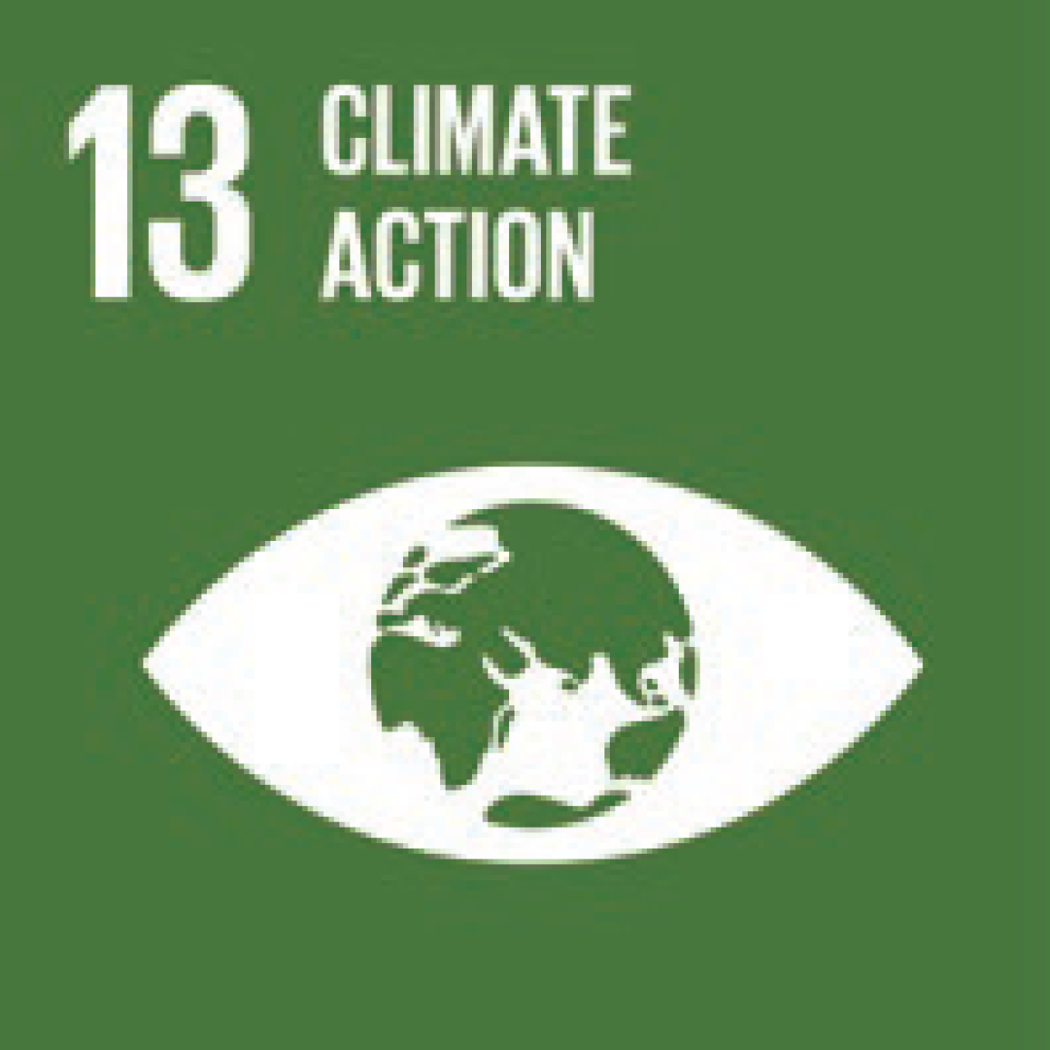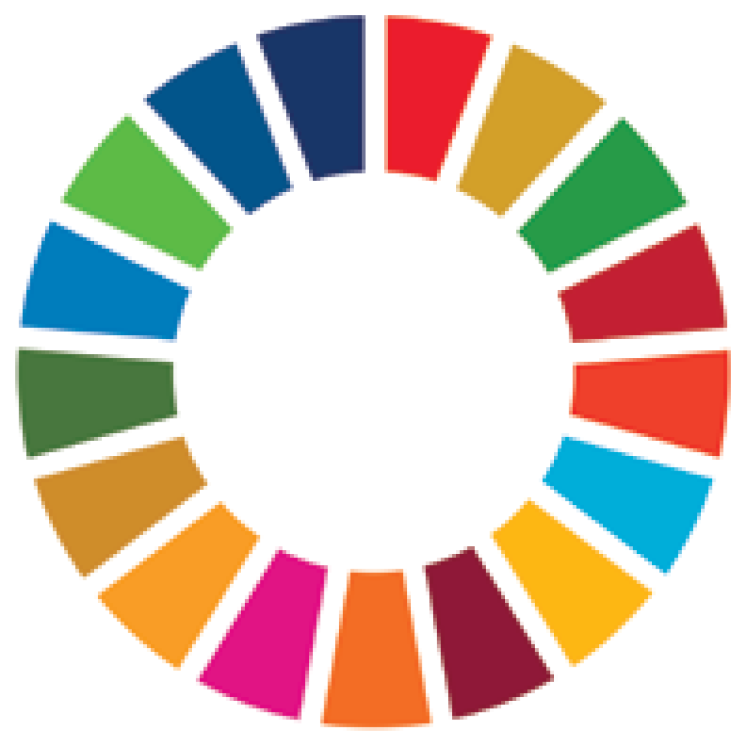

Through SDG 13 – Climate Action, governments will target the following objectives (among others):

* Strengthen resilience and adaptive capacity to climate-related hazards and natural disasters in all countries
* Integrate climate change measures into national policies, strategies and planning
* Improve education, awareness-raising and human and institutional capacity on climate change mitigation, adaptation, impact reduction and early warning

This Strategy will support us to continue taking a socially inclusive approach that recognises intersecting vulnerabilities and helps achieve multiple SDGs and the Paris Agreement. For example, Australia recognises the role of affordable and clean energy in supporting sustainable and inclusive economic growth, including through increasing trade and export opportunities. Similarly, Australia’s support for more sustainable cities and resilient agricultural practices can contribute towards low-emission pathways. Limiting global temperature increase would ease the path for other SDGs, such as those related to poverty, hunger, access to water, health and gender equality. In turn, achieving many of the SDGs will help countries adapt to climate change impacts.[13]

# 02. Building on our track record for climate change action

Australia has provided climate change finance through our development assistance program for more than 25 years. We use a partnership approach in the Indo-Pacific to help our region reduce emissions and adapt to climate change.

Climate change is already a key consideration for Australia’s development assistance in the Pacific. We have forged strong and enduring partnerships with Pacific island countries and regional organisations. We are supporting responses to climate change for sustainable development.

The Pacific is increasingly tackling climate change through a regional lens that Australia supports. For example, we support the Framework for Resilient Development in the Pacific and the Pacific Resilience Partnership, both important for regional coordination on resilient development.

We also support scientific, policy and institutional capacity-building in the Pacific, such as early warning systems and disaster preparedness.

Australia supports community adaptation for food and water security, including sustainable agricultural and fishing systems in the Pacific and in developing countries in Africa, South and Southeast Asia.

For over a decade, we have helped reduce emissions by promoting better forest management in Indonesia. We’ve also improved monitoring, reporting and verification for emissions, including in China, Thailand, Indonesia and Kenya.

In these endeavours, Australia is committed to socially inclusive and gender-responsive approaches. We work in the UNFCCC to strengthen the perspectives and representation of women in international climate change bodies. This has included Australia’s support to training women UNFCCC negotiators, particularly from Pacific island countries.

Australia has also drawn on capabilities across government to maximise our effectiveness. This includes expertise in agencies such as the CSIRO, the Bureau of Meteorology, the Australian Centre for International Agricultural Research (ACIAR), Geoscience Australia and the Department of the Environment and Energy.

These collaborations have been complemented by work with non-government experts, including Australia’s business, education and non-government organisations (NGOs).

For over two decades, the Department has adopted a practice of continuous improvement, frequently informed by lessons learnt in implementing investments. In 2018, the Office of Development Effectiveness undertook an independent evaluation of Australia’s climate change assistance, and the findings have informed this Strategy.

Investing in the Future: Office of Development Effectiveness (ODE) Evaluation of Australia’s Climate Change Assistance

The ODE evaluation of Australia’s climate change assistance published in 2018[14] identified key characteristics of stronger performing climate change investments as having:

* longer investment timeframes (five years or longer)
* climate change risks framed within the broader development goals of partner countries
* scientific and technical partners with strong on-the-ground service delivery experience
* an appropriate level of technical input in design and implementation.

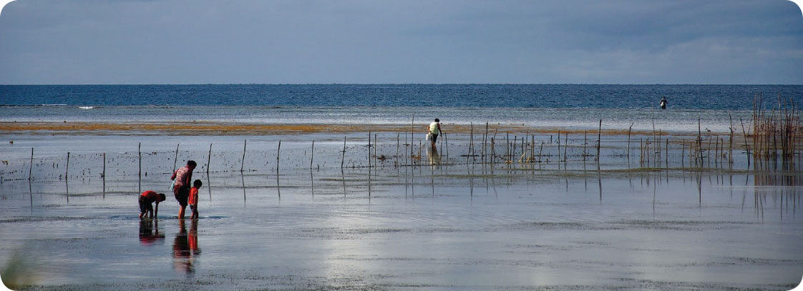

Credit: Pacific-Australia Climate Change Science and Adaptation Planning Program

Pacific-Australia Climate Change Science and Adaptation Planning Program.

Gathering seafood at low tide in Nuku’alofa, Tonga.

## 2.1 Australia’s climate change development assistance commitments

Building on Australia’s track record, in 2015, the Australian Government announced it would invest at least $1 billion from our development assistance program over five years to 2020 to strengthen climate resilience and reduce emissions. This was central to assisting developing countries as per our commitment to the Paris Agreement.

As part of this global figure, the Australian Government announced in Pohnpei in September 2016 that it would provide $300 million to address climate change and disaster resilience in Pacific island countries.

We expect to exceed this pledge. Our investments to date have contributed to projects as diverse as:

* ensuring roads and bridges we help build are more resilient to extreme weather in Papua New Guinea so that its people have continued access to markets and can visit their families during times of disaster
* the Tina River Hydropower project which will provide power to most of Honiara in Solomon Islands for years to come, and
* building climate change resilient schools in Kiribati.

Going forward, our focus is to provide assistance directly to our partner governments rather than through the Green Climate Fund (GCF).

In line with this approach, at the Pacific Islands Forum in Tuvalu in 2019, the Prime Minister announced a new pledge to spend $500 million over five years from 2020 to help Pacific nations invest in renewable energy and climate and disaster resilience. Australia will continue to invest in renewable energy, ensure new infrastructure can withstand disasters and ensure health services are well positioned to respond to changing needs.

The Prime Minister also announced a new climate change infrastructure window in the Australian Infrastructure Financing Facility for the Pacific to advance the region’s energy ambitions, as well as new bilateral climate change dialogues with Pacific Island countries to better understand their needs and ambitions.

The Government has also set aside $140 million from the development assistance budget for the Australian Private Sector Mobilisation Climate Fund to mobilise significant private sector investments in low emissions, climate-resilient solutions for the Pacific and Southeast Asia. The fund will ultimately develop a significant portfolio of projects with contributions from the private sector and other agencies.

This Strategy will guide these investments and inform our climate change development assistance commitments and climate action into the future.

Snapshot: Australia’s current climate change development assistance action

Australia stands by its commitments.

The Australian Government is on track to exceed the initial $1 billion commitment by 2020.

Our climate change development assistance is balanced between mitigation and adaptation (based on partner country priorities) and focused on countries in our region that are most vulnerable to climate change, as they work towards sustainable development and poverty reduction. (Figure 4 refers)

To track and account for our climate change development assistance, the Department has developed a robust and transparent methodology based on the Organisation for Economic Co-operation and Development’s (OECD) Development Assistance Committee guidelines.[15] It is also consistent with agreed UNFCCC principles and is regularly reviewed in detail by OECD and UNFCCC officials.[16]

Every two years, Australia submits a biennial report to the UNFCCC, which summarises financial, technical and capacity building support to developing countries that addresses climate change.[17]

1. Australia’s Total International Climate Change Development Assistance Expenditure by Financial Year

Australia’s total international climate change development assistance expenditure by financial year based on Australia’s international development assistance official sector statistical summaries for 2014-15 to 2017-18.
The figures comprise five columns reflecting the respective amounts expended on climate related activities in respective annual periods as follows:
Column 1: $222 million was spent in 2014-15
Column 2: $249 million was spent in 2015-16
Column 3: $249 million was spent in 2016-17
Column 4: $268 million was spent in 2017-18
Column 5: $300 million was estimated to have been spent in 2018-19

Based on Australia’s International Development Assistance Official Sector Statistical Summaries for 2014–15 to 2017–18

1. Australia’s International Climate Development Assistance by Region and Type

Figure 3: Australia’s international climate development assistance by region and type based on financial years 2015-16, 2016-17 and 2017-18 climate development assistance expenditure. This data excludes core contributions to multilateral organisations, which cannot be disaggregated by region. 

The figure comprises five donut graphs, one large showing the relative proportion of expenditure on Southeast Asia programs (15%), Pacific programs (62%), South and South West Asia programs (8%) and Global programs (15%). 

The four smaller donuts each show the relative expenditure on mitigation, adaptation and cross-cutting activities in each of Southeast Asia programs, Pacific programs, South and South West Asia programs and Global programs. 

• In the climate development assistance delivered to Southeast Asia programs, 34 per cent was spent on mitigation, 53 per cent on adaptation and 13 per cent on cross-cutting activities. 
• In the climate development assistance delivered to Pacific programs, 10 per cent was spent on mitigation, 78 per cent on adaptation and 12 per cent on cross-cutting activities.
• In the climate development assistance delivered to South and South West Asia programs, 17 per cent was spent on mitigation, 71 per cent on adaptation and 12 per cent on cross-cutting activities.
• In the climate development assistance delivered to Global programs, 14 per cent was spent on mitigation, 54 per cent on adaptation and 32 per cent on cross-cutting activities.

Based on 2015-16, 2016-17 and 2017-18 climate development assistance expenditure. This data excludes core contributions to multilateral organisations, which cannot be disaggregated by region.

## 2.2 Where does our climate change development assistance go?

Australia’s climate change development assistance is focused on the Pacific, with more modest support to Southeast Asia, South and South West Asia, and Africa.

For example, since 2012 Australia has been supporting the 14 Pacific island Meteorological Services to monitor, analyse and communicate information about climate and oceans, including seasonal forecasts and sea level rise, to support climate informed planning and decision making across the Pacific.

In Southeast Asia, our climate change development assistance is a mix of investments that target climate change adaptation and mitigation, and investments that embed climate change considerations in key sectors such as infrastructure, water, agriculture and governance.

For example, through the Integrated Coastal Management Program Australia supported Vietnam to strengthen planning, technical and financial capacities for climate-resilient development of the Mekong Delta.

In South and South West Asia, our climate change development assistance focuses on climate change action in the energy, water and agriculture sectors.

For example, through the Sustainable Development Investment Portfolio Australia is assisting an integrated approach to water, energy and food management in three major Himalayan river basins, with a focus on climate change risks.

Through the 2015-2020 commitment period, about half of Australia’s climate change development assistance comprises core contributions to multilateral organisations, such as the Global Environment Facility, the Global Green Growth Institute, and UNFCCC funds as well as climate change related activities undertaken by the World Bank and Asian Development Bank.

Australia’s climate change development assistance across the world also includes scholarships, non-government organisation programs, and multi-donor trust funds.

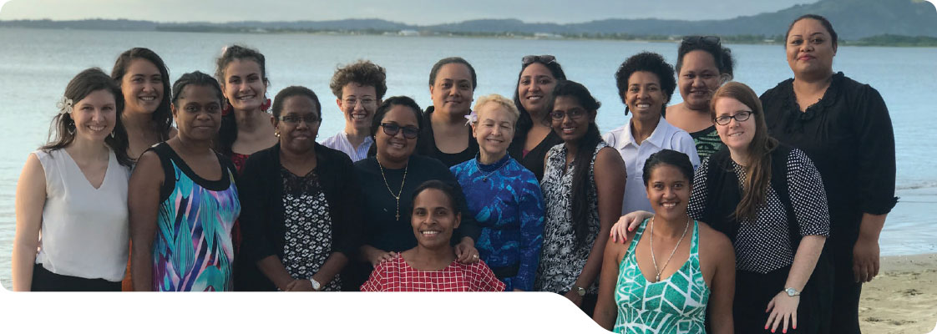

Credit: Women’s Environment and Development Organisation.

Pacific Women Climate Change Negotiators Program

Women remain under-represented across the UNFCCC, including in country delegations. Since 2016, Australia has supported women from across the Pacific in negotiation, communication and leadership training to raise their voices in creating international climate change policy.

1. Distribution of Australia’s International Climate Change Development Assistance

Figure 4: Distribution of Australia’s International Climate Change Development Assistance based on the average annual climate development assistance expenditure for financial years 2015-16, 2016-17 and 2017-18.
The figure comprises a map of the Indo-Pacific with markers placed over the relevant country to symbolise the amount of climate expenditure Australia spent per country, ranging from 0-$1 million; $1 million-$5 million; $5 million-$10 million; $10 million-$20 million and $20 million-$40 million.

Countries, regional and global programs shown against each amount are as follows:
$0-$1 million: Myanmar, Philippines, Republic of Marshall Islands, Samoa, Sri Lanka, Timor-Leste, Tuvalu and Southeast Asia & Pacific Regional programs.
$1 million-$5 million: Afghanistan, Bangladesh, Cambodia, Kiribati, Nauru, Pakistan, Tonga, Vanuatu, Vietnam and Southeast Asia Regional Programs. 
$5 million-$10 million: Fiji, South and South West Asia Regional Programs
$10 million-$20 million: Indonesia, Solomon Islands, Global Programs and Pacific Regional Programs.
$20 million-$40 million: Papua New Guinea.

Figure 4 continued: Distribution of Australia’s International Climate Change Development Assistance based on the average annual climate development assistance expenditure for financial years 2015-16, 2016-17 and 2017-18.
The figure comprises a map of the Indo-Pacific with markers placed over the relevant country to symbolise the amount of climate expenditure Australia spent per country, ranging from 0-$1 million; $1 million-$5 million; $5 million-$10 million; $10 million-$20 million and $20 million-$40 million.

Countries, regional and global programs shown against each amount are as follows:
$0-$1 million: Myanmar, Philippines, Republic of Marshall Islands, Samoa, Sri Lanka, Timor-Leste, Tuvalu and Southeast Asia & Pacific Regional programs.
$1 million-$5 million: Afghanistan, Bangladesh, Cambodia, Kiribati, Nauru, Pakistan, Tonga, Vanuatu, Vietnam and Southeast Asia Regional Programs. 
$5 million-$10 million: Fiji, South and South West Asia Regional Programs
$10 million-$20 million: Indonesia, Solomon Islands, Global Programs and Pacific Regional Programs.
$20 million-$40 million: Papua New Guinea.

Based on the average annual climate development assistance expenditure for 2015-16, 2016-17 and 2017-18.

# 03. A new climate change action strategy

The climate change action strategy is informed by the foreign policy white paper, Australia’s aid policy and the sustainable development goals. Addressing climate change is a priority for Australia’s development assistance. It is consistent with our emphasis on global action to address the impacts of climate change, provide support to those that need it, help vulnerable communities and strengthen our development assistance investments.

To drive this priority, Australia will better integrate climate change into development assistance programming and operations, step-up targeted climate change development assistance, manage climate change risks to our investments, strengthen climate and environment safeguards, and build organisational and partner climate change knowledge and capacity. Harnessing capabilities through whole-of government approaches will continue to be important, as will working with experts outside government.

We will continue to encourage partner countries to contribute to global efforts against climate change and to build their resilience to the impacts of climate change. This includes a strong focus on governance and participation, and targeting support to vulnerable, often marginalised, communities to influence decisions affecting their wellbeing.

Supporting partner countries to mitigate emissions and adapt to the impacts of climate change—particularly in our region—will not only help maximise and protect our investments, but will also protect against the threat of climate change impacts eroding development outcomes.

Australia’s development assistance for climate change can also present many opportunities for our region in benefiting sustainable development such as: reduced emissions and pollutants; new industries, practices and technologies; more sustainable management of resources; better integrated and more inclusive government policy development; and stronger risk and disaster management. Like elsewhere, our region can take advantage of the economic opportunities arising from the transition to a lower emissions, more resilient global economy.

Australia is working with other donors and partner countries on solutions to ensure that climate change, economic development and poverty reduction policies are mutually reinforcing.

In genuine partnership, the Department aims to ensure our development assistance aligns with partner countries’ national development priorities, National Adaptation Plans, and their Nationally Determined Contributions (NDC’s) under the Paris Agreement.

Success requires these partnerships endure over decades.

The Strategy is underpinned by common principles more broadly reflected in Australia’s Aid Policy, including:

* fostering genuine and long term partnerships
* ensuring sensitivity to partner country development needs, priorities and climate change commitments
* promoting social inclusion and gender equality, with a clear focus on the most vulnerable communities, especially women and girls, people with disability, and indigenous peoples, encouraging their participation and harnessing their expertise
* building and supporting local capacity and ownership
* making and prioritising science and knowledge based decisions, with a focus on access and user needs
* promoting effective governance
* maximising impact of investments
* strengthening private sector engagement and investment
* strengthening environmental protection and biodiversity
* promoting transparency and accountability for outcomes.

1. Strategy Implementation

Guided by Common Principles in Australia’s Aid Policy:
• Focus on the Indo-Pacific
• Support the goals of the Paris Agreement
• Integrate adaptation and resilience
• Engage the private sector
• Social inclusion and gender equality
• Stronger and innovative partnerships
Act to:
• Integrate climate change action across Australia’s aid policy and program
• Target climate change action to achieve outcomes
• Maintain departmental capacity for climate change action
Supported by sound governance:
• Establish a DFAT Climate Change Policy Committee
• Integrate into DFAT’s aid and policy governance arrangements
• Lead a high level interdepartmental committee
• Engage with the National Disaster and Climate Resilience Reference Group
Drive continual improvement through:
• A Performance Assessment Framework
• Periodic review

## 3.1 Indo-Pacific: a focus for the new Strategy

Consistent with the Foreign Policy White Paper, the Climate Change Action Strategy recognises the particular vulnerabilities of developing countries and has a strong focus on the Pacific, consistent with Australia’s Step-up in this region.

The Strategy also strengthens Australia’s engagement with Southeast Asian countries, such as Indonesia, Vietnam and the Philippines – and in South Asia; where climate change risks and opportunities are increasing and there is growing interest in partnering with Australia to address these challenges.

Stronger growth, prosperity and stability in the region – including resilience – directly benefits Australia and the citizens of our neighbouring countries. It is also where Australia’s development assistance can make the most difference.

While the focus of the development assistance program will be on the Indo–Pacific, Australia will also work with others at a global level to strengthen the rules-based system for international climate action, help countries meet their Paris Agreement commitments, and address the humanitarian needs of Least Developed Countries and Small Island Developing States.

## 3.2 Supporting the goals of the Paris Agreement

As the framework for global climate change action, the Strategy supports the mitigation, adaptation and finance goals of the Paris Agreement. Our partners’ Nationally Determined Contributions (NDCs) for climate change action under the Paris Agreement and associated National Adaptation Plans provide clear blueprints for climate change action and will help inform Australia’s investments.

The Paris Agreement involves commitments and accountability for all countries, developed and developing, for the first time. Many developing countries need capacity building to fulfil implementation requirements of the Paris Agreement. For example, support for emissions inventory, accounting and reporting systems, for development of capabilities and pathways to trade in international carbon units and for review processes associated with the transparency system of the Paris Agreement. The Strategy will support such capacity building to help ensure that the Paris Agreement becomes a strong driver of global climate change action from commencement in 2020.

## 3.3 Integrating climate change adaptation and disaster resilience

The Strategy recognises that DFAT will need to further integrate climate change adaptation, disaster risk and resilience building into Australia’s development assistance.

Many disaster events in the world are climate-related. Vulnerable community members, including women and girls, are particularly disadvantaged.[18] Those with a disability are least able to access emergency support during disasters, and the most likely to sustain morbidity or mortality. Climate change will exacerbate the severity and frequency of some disasters and could affect countries’ ability to respond.

Development assistance focused on climate change resilience can support disaster risk reduction, preparedness and preventative action, build resilience, facilitate humanitarian responses and help communities recover more quickly. This integrated approach is outlined in the Department’s Humanitarian Strategy and supported by the Australian Humanitarian Partnership, which has a focus on strengthening the ability of local communities and organisations in the Pacific to prepare and respond to crises.[19]

Disaster risk reduction

Since 2005 in the Philippines, through the Disaster and Climate Risks Management Initiative, Australia has supported the Philippines government to build the disaster resilience of its systems, communities and people. Australian agencies have been working with the Philippines Government to help improve disaster forecasting and early warning alerts to communities about hazards such as approaching typhoons, to allow people to prepare and stay safe.

Australia’s work with Vietnam on an Integrated Coastal Management Program has helped strengthen climate resilient development in the Mekong Delta. The project enhanced planning, technical and financial capacities of Vietnam to withstand climate pressures and extreme weather events. This included bolstering water management systems against flooding as well as supporting cost-effective natural protection systems, such as mangrove rehabilitation and coastal forest protection. Community resilience-building has been further supported by promoting alternative farming practices, providing income opportunities and enabling access to data and financial instruments.

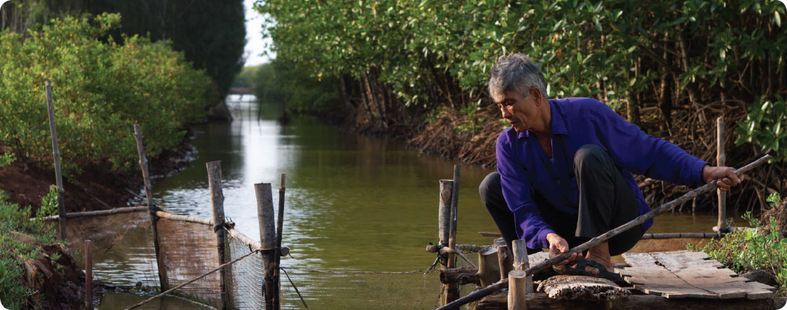

Credit: GIZ/Harald Franzen

Integrated Coastal Management Program, Vietnam

Bac Lieu Province, Vietnam - farmer pulls a fish trap from the water at his sustainable shrimp farm. Shrimps are raised among mangroves, meaning they can be bred without the use of antibiotics or chemicals, making both the shrimps and environment less polluted.

## 3.4 Engaging the private sector

The private sector has an essential role in tackling climate change. Australia’s private sector has a comparative advantage and well-recognised capabilities and technologies in climate change action. We will harness Australian capabilities and promote trade and investment opportunities that support climate change action through our development program.

Eliminating trade barriers on environmental goods and services can support positive outcomes for trade, the environment and development. Reduction or elimination of tariff and non-tariff barriers to environmental goods and services can facilitate technology transfer leading to energy efficiency gains.[20]

Aid for trade

Australia’s aid for trade program is supporting renewable energy in developing countries. For example, we are partnering with the Australian National University to address barriers to clean energy investment and to facilitate the take up and use of clean energy technology. This project will deliver clean energy investment roadmaps addressing government policy, market pricing, engagement, participation and capacity building, and will focus on institutional investors and other market and non-state actors.

## 3.5 Social Inclusion and Gender Equality

Australia’s development program supports climate action investments that are socially inclusive and gender-responsive, recognising that the impacts of climate change on people are influenced by social pressures including discrimination on the basis of gender, class, ethnicity, age and disability.[21] Responding to these intersecting issues involves identifying biases, discrimination or other forms of social marginalisation, pro-actively engaging participants in an inclusive way, and aiming for the investment to deliver benefits and opportunities equally.

Gender-responsive investments seek to integrate women’s knowledge, experience and concerns into all stages of an investment design and delivery. They also recognise the powerful role of women’s action and leadership at all levels, particularly in their local communities, in building resilience and enabling an integrated response to climate change and disasters.

Gender-responsive climate change policy

Australia’s development program supports climate action investments that are socially inclusive and gender-responsive. Gender-responsive investments identify gender biases up front, pro-actively foster women’s and girls’ engagement, and aim for women and men to derive equal benefit and opportunity. Women’s concerns and experiences are integrated into each of the design, implementation, monitoring and evaluation phases of an investment.

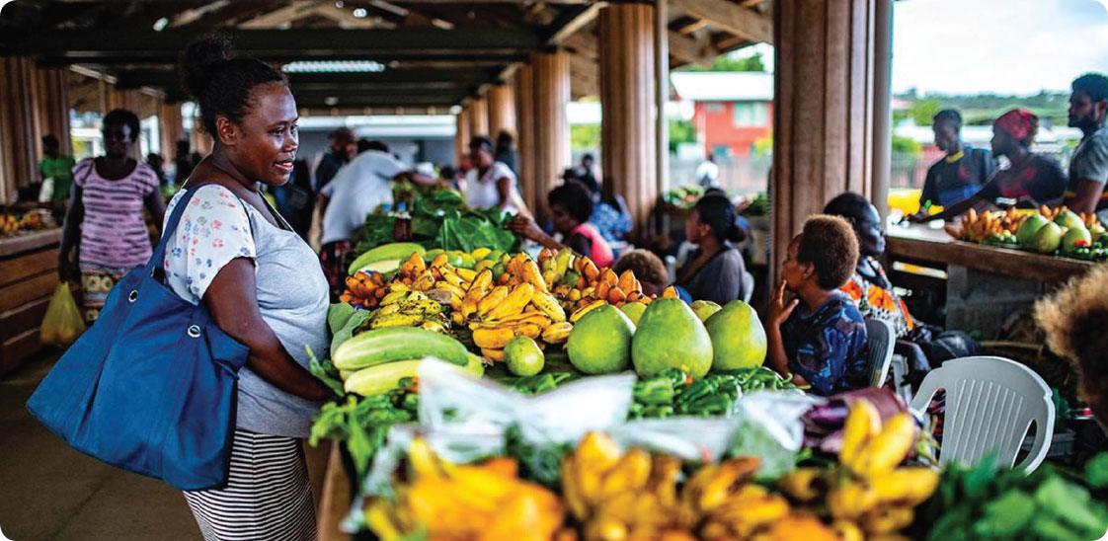

Credit: GIZ/Harald Franzen

Australia provided $3.5 million for the redevelopment of the Gizo Market. The new market includes climate resilient features, such as reinforced beams, which will help the structure withstand wind speeds of a Category 5 cyclone. The site has also been raised above 2055 sea level rise projections.

Working closely with the women producers, the architects were provided specifications to meet women’s needs and disability access, as well as current climate change projections developed under Australia’s Pacific climate science and information services. Providing secure facilities for women to sell their market produce helps to empower women, enabling them to engage in the formal economy and improve the livelihoods and health of their families.

Taking a holistic approach, the design also includes a sustainable water supply and sanitation facilities, ramps for disability access and an affordable, secure clean energy supply. Even in the face of a disaster, Gizo Market is equipped to enable women producers to get back on their feet quickly and re-engage in their livelihoods. Gizo Market is a good practice example of the way design and construction of facilities in the Pacific can transform resilience in the face of increasing climate change threats and disasters.

## 3.6 Stronger and innovative partnerships

The challenge of climate change requires strong action at all levels of society: national and sub-national governments, business, institutions, non-government organisations, academia, community groups and individuals.

The years following the Paris Agreement have seen closer collaboration between these actors. Australia has considerable strengths beyond the government sector.

The Department will continue to work with new and established partners to help developing countries respond to climate change and harness opportunities for cooperation.

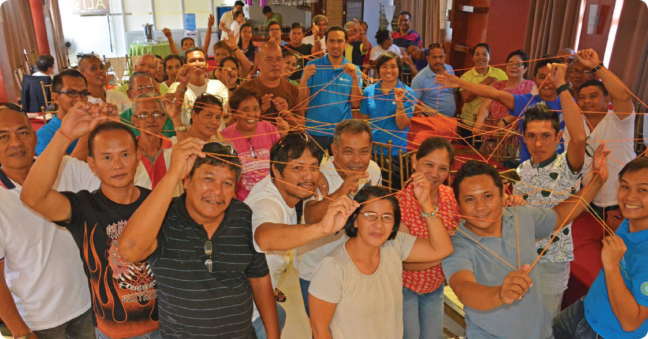

Credit: Rapid-CCC/Kris Guico

Australian supported Resilience and Preparedness toward Inclusive Development (RAPID) workshop with Filipino community leaders on developing simple DRR-related interventions in their local areas.

The Pacific Resilience Partnership – Stronger Together

Australia is an active participant and financial supporter of the Pacific Resilience Partnership which was established by the Pacific Islands Forum in 2016. The partnership brings together countries, territories, development partners and non-state actors to drive implementation of the *Framework for Resilient Development in the Pacific*. For more information see www.resilientpacific.org

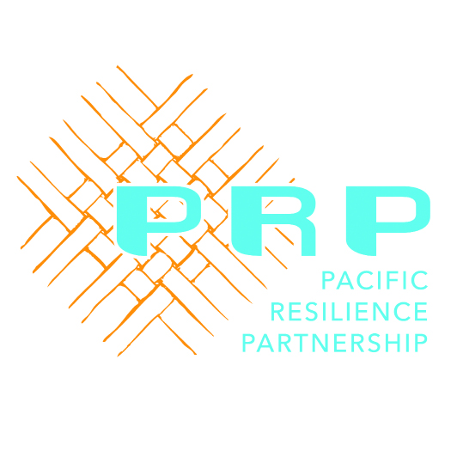

# 04. Climate change action strategy: objectives

The strategy sets three key objectives to make best use of our development assistance:

* promote the shift to lower-emissions development in the Indo-Pacific region
* support partner countries to adapt to climate change, and to plan, prepare for and respond to climate-related impacts
* support innovative solutions to climate change, including those that encourage private sector investment.

## 4.1 Promote the shift to lower-emissions development in the Indo-Pacific region

Through the Paris Agreement, countries aim collectively to reduce greenhouse gas emissions as soon as possible, recognising that this will take longer for developing countries.

Many developing countries, especially in the Pacific, have very ambitious NDCs and will need technical and financial support to reach their goals.

Lower economy-wide emissions must be part of successful and sustainable economic development. Inadequate global emissions reductions will require more adaptation measures and increase development challenges.

Reflecting the needs and priorities identified by developing country partners, as well as Australian priorities and strengths, the Strategy prioritises the following areas for transition   
to lower emissions in the region:

### i) Investing in low emissions energy technologies

* Developing countries in the Indo-Pacific seek support for increasing renewable technologies in their energy mix, including solar, wind, hydro, biomass, wave and geothermal. Australia has experience in these areas, including for smaller scale, off grid hybrid systems and in transmission technologies and IT solutions for grid integration.
* Many countries in our region seek improvements in energy efficiency to reduce emissions and meet their NDCs. Drawing from experience through our own target of improving Australia’s energy efficiency by 40 per cent by 2030, Australia has strong capabilities in this area related to energy production, industry, buildings, standards and appliances, and grid design.
* Clean technologies for fossil fuels remain an important objective in the region. Australia has significant capabilities to contribute to regional action and cooperation to reduce emissions from fossil fuel use, such as Carbon Capture and Storage and reducing “fugitive emissions” such as caused by leaks from pipes and flaring in the gas, coal and oil industry.
* Australia’s development assistance investment priority on infrastructure is to tackle bottlenecks in the region, help create the right conditions for the private sector, and expand trade and advance development, while providing opportunities for low emissions investments.

Tina River hydropower project

Australia’s Aid Program is supporting low emissions technologies in the Pacific, including solar grids in Kiribati, power management systems in Samoa, and energy efficiency measures in Tuvalu. In Solomon Islands, Australia is supporting the Tina River Hydropower Project, which is co-funded with partners including the World Bank and the Green Climate Fund. Ninety-seven per cent of the Solomon Islands’ electrical grid is generated through high-cost diesel and its electricity prices are among the highest in the world.

The Tina River Hydro, which is due to open in 2022, will help meet Honiara’s forecast energy demand, shifting its energy sector towards more affordable, efficient and cleaner energy, which will reduce emissions beyond its commitments under the Paris Agreement.

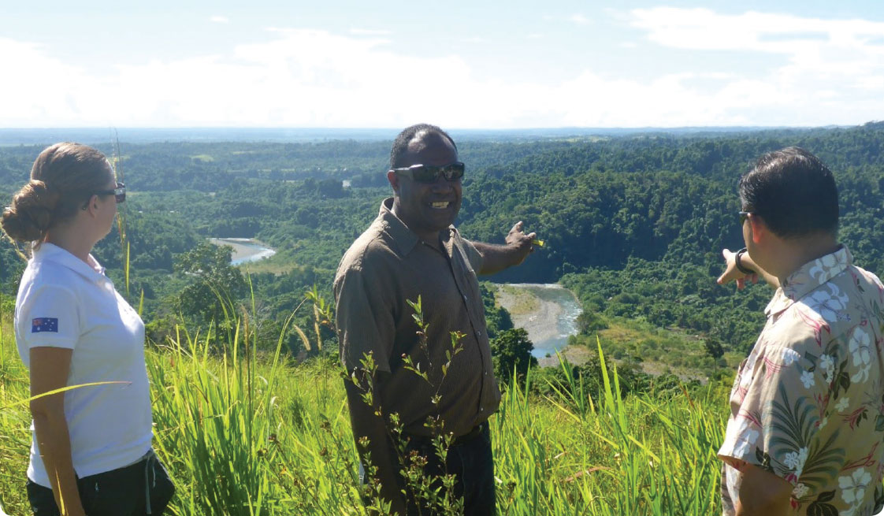

Credit: Tina River Hydro Project Office

The Tina River Hydropower Development Project, Solomon Islands

(L-R) Counsellor, Jasmine Cernovs and Project Office Manager, Fred Conning, from the Honiara Australian High Commission together with Pablo Kang, DFAT’s Assistant Secretary, pointing towards the proposed dam site.

### ii) Investing in the land sector and oceans

More than 100 countries’ Nationally Determined Contributions (NDC’s) list the land sector and agriculture as a priority for mitigation and adaptation. This includes many developing countries, given their predominantly agrarian economies.

Best practice is expanding from a focus on sequestering carbon through forests, to a stronger whole-of- landscape approach. This recognises that threats to forests are frequently related to unsustainable agricultural practices that encroach on forests, and that significant sequestration occurs in non-forest landscapes such as grasslands, wetlands, peatlands and agricultural lands.

* Australia has experience in managing the land sector and using agriculture technologies. This includes approaches and models for estimating emissions reductions from agriculture, building on the work of specialist agencies such as ACIAR and CSIRO.
* We have over a decade’s experience in measurement reporting and verification systems (MRV) for emissions reductions and management. MRV systems are an essential foundation of developing countries’ climate change mitigation, enabling them to identify and track sources of emissions and develop pathways for international transfers of units.
* Coastal blue carbon ecosystems such as mangroves, sea-grasses and salt-marshes can sequester up to four times more carbon per area than land-based forests.[22] We are helping developing countries protect and restore these ecosystems, including through blue-carbon measurement reporting and verification systems. This also has significant adaptation co-benefits to enhance food security, secure livelihoods, conserve biodiversity and for coastal protection.

Oceans and Blue Pacific

The ocean is home to more than half of all life on Earth. It shapes our climate and weather, and is essential to our future wellbeing. The ocean also provides food for half the world’s population, and is an economic powerhouse that supports entire industries, generates millions of jobs, and helps to drive the global economy.

However, the health of the world’s oceans are being affected by a series of global, regional and national challenges. Their health is under pressure from overfishing, plastic and other pollution, coastal development, and the impacts of climate change that include warming, acidification and sea level rise. Australia supports action to address these pressures through a range of initiatives and commitments internationally and in particular in the Indo-Pacific region.

Pacific peoples have a deep and long connection to the ocean, which is at the heart of the Blue Pacific narrative – it connects and feeds communities, drives economies and is central to the culture of Pacific peoples. As signatories to the Boe Declaration on Regional Security and the Kainaki II Declaration, Australia and our Pacific partners collectively share the responsibility to sustainably manage the Pacific Ocean and its resources. As a member of the Pacific Island family, Australia is committed to a secure, prosperous and sustainable Blue Pacific. This means working with Pacific Island countries to secure and sustainably manage fisheries, take action to reduce ocean plastics, and protect coral reefs and biodiversity.

Forests

Australia leads the Asia-Pacific Rainforest Partnership, which brings together governments, the private sector and civil society to promote greater action to reduce emissions from deforestation and forest degradation in the Asia-Pacific region.

Land management

Forest and land fires in Indonesia are a significant contributor to greenhouse gas emissions. They threaten biodiversity, impact on the national economy and cause transnational health issues by spreading smoke haze. Australia’s Indo–Pacific Land Action Package is helping Indonesia prevent and control fire, improve land management and strengthen law enforcement.

Mangroves

Australia’s International Partnership for Blue Carbon (IPBC) aims to build awareness, share knowledge and accelerate practical action to protect and restore mangroves, tidal marshes and seagrass systems for climate action. Since 2015, it has grown to include almost 40 formal members. Beyond sequestering carbon, coastal blue carbon systems can enhance biodiversity, food security, secure livelihoods, increase resilience and contribute to climate adaptation. Australia is working with Germany and Pacific island countries for stronger management of Blue Carbon systems.

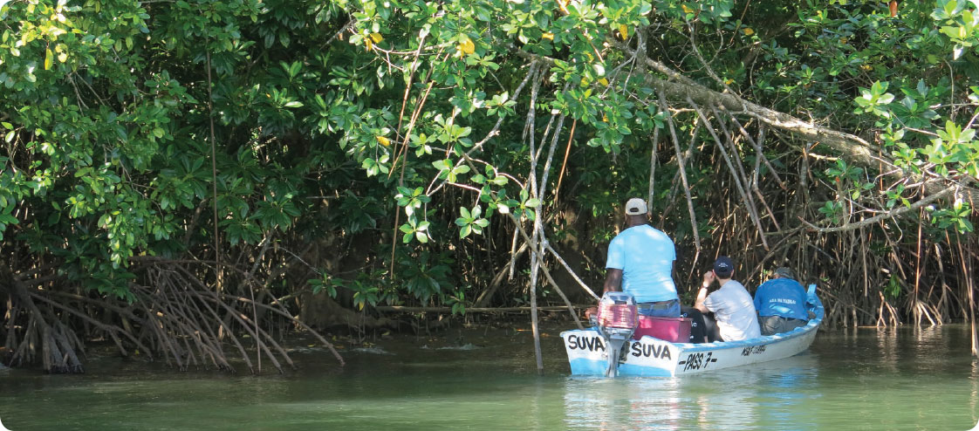

Credit: Department of Environment and Energy/Lucy Wallington

Blue Carbon Partnership and Coral Reef Innovation Facility, Pacific Regional

Surveying mangroves in Fiji. The IPBC is working to raise awareness of the importance of blue carbon ecosystems and to accelerate practical action for increased protection and restoration.

### iii) Investing in sustainable cities and transport

According to the World Bank (2019), over 4 billion people around the world – more than half the global population – currently live in cities.[23], and more than half of the world’s population lives in urban areas today. By 2050, two-thirds of all humanity – 6.5 billion people- will be urban.[24] [By 2100, some 85 per cent of the population will live in cities](http://www.oecd.org/regional/regional-policy/The-Metropolitan-Century-Policy-Highlights%20.pdf), with urban population increasing from under 1 billion in 1950 to 9 billion by 2100. By 2025, China will have more than 220 cities with populations over 1 million and 8 megacities with over 10 million[25].

Urban areas are projected to produce the majority of future emissions growth, presenting further challenges for climate change action.

As countries grapple with this increasing urbanisation, there is mutual interest in strengthening partnerships for innovative solutions, while recognising vulnerable groups are at heightened risk in times of change.

Australia has:

* global branding of our cities for liveability and sustainability and is well positioned to support next generation cities in the region with positive mitigation outcomes
* relevant planning, policy, regulatory and other governance capabilities, including socioeconomic approaches to build community participation, resilience and welfare
* significant skills and technologies for mitigation, including low emissions building materials, energy efficiencies for buildings, smart and sustainable traffic and transport systems and sustainable water and waste management infrastructure and systems.

## 4.2 Support partner countries to adapt to climate change, and to plan, prepare for and respond to climate-related impacts

Under the Paris Agreement, countries committed to enhance adaptive capacity, strengthen resilience and reduce vulnerability to climate change. This is essential to ensure sustainable development, and to protect people, livelihoods and ecosystems, including from disasters.

The commitment recognises the importance of support for, and international cooperation on, adaptation efforts.

The Paris Agreement encourages action to follow country-driven, gender-responsive, participatory and fully transparent approaches. These must take into consideration vulnerable groups—including women, children, indigenous people, and people with a disability— communities and ecosystems.

Approaches should be guided by the best available science, technology and innovation and, as appropriate, local knowledge; within the context of national priorities set by our development partners.

Inadequate adaptation in the face of climate change and disaster will erode development gains made in many countries - including affecting investments, economic security - and potentially exacerbate loss of species and biodiversity.

For more than two decades, Australia has supported adaptation and disaster planning and response through our development initiatives, especially in the Pacific. We will continue to prioritise investments in these areas.

The range and scale of adaptation challenges in the Indo-Pacific mean there is a particular need for targeted and tailored approaches informed by countries’ specific circumstances and priorities. In this context, our adaptation investments will focus on three key areas:

* governance and adaptive planning, and help to prepare for and respond to the adverse impacts of climate change, including through our partners’ National Adaptation Plans
* effective adaptation programs that strengthen community resilience in partner countries, especially for the most vulnerable and will work to reduce the adverse impacts of climate change
* investments that strengthen adaptation efforts in areas of mutual priority. These include infrastructure; science, research and meteorological support; and agriculture, fisheries and water.

Integrating adaptation considerations across the Australian development assistance program’s other sectoral areas will help maximise development outcomes.

There will be synergies with the investment priorities for lower emissions outlined above (4.1), given frequent mitigation and adaptation co-benefits, and the significant adaptation challenges associated with the energy and land sectors, forests, oceans, and cities.

Building community resilience is important in all these areas, particularly to reduce the risk of disasters and other impacts from climate change.

Adapting and building resilience in the Pacific

Pacific island countries are particularly vulnerable to climate change. Australia has a strong focus on practical support to help the region adapt, including integrating climate and disaster risks into infrastructure such as bridges, schools and health facilities.

As well as integrating climate change action into Pacific development programs, these efforts aim to reduce the adverse impacts of climate change on these countries.

An example of this is the new Australia–Pacific Climate Partnership. This initiative is ensuring that development assistance investments are climate informed, and that climate change data and information is relevant and influential in government and community decision making.

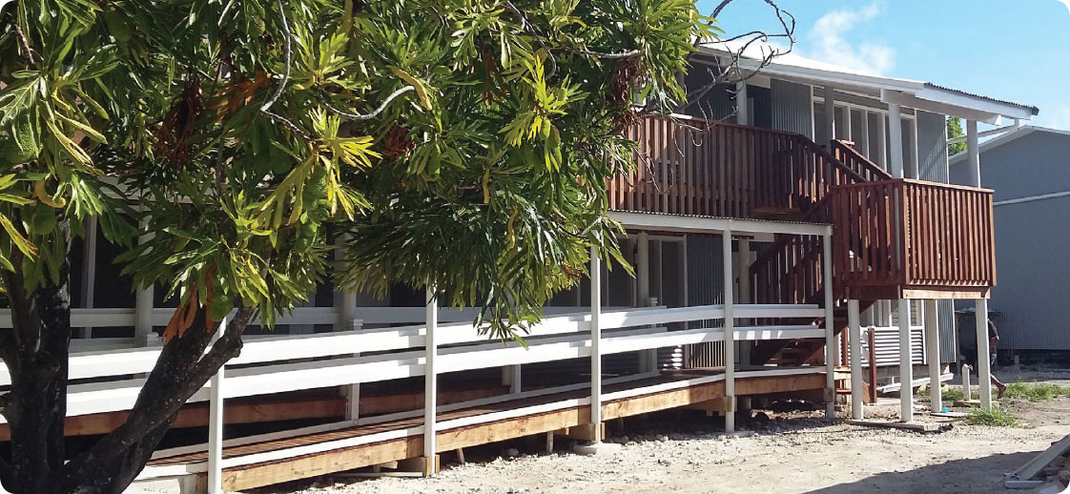

Credit: Coffey International/Nicholas Harding

Kiribati Education Improvement Program

An Australian funded school on South Tarawa, Kiribati. Through the Kiribati Education Improvement Program, Australia is working with the Ministry of Education to ensure school facilities have raised floors and optional protective seawalls to reduce future coastal flooding. The facilities provide a light and naturally ventilated learning environment, with disability access, and are built with regionally sourced sustainable materials.

## 4.3 Support innovative solutions to climate change, including those that encourage private sector investment

This Climate Change Action Strategy supports innovation in Australia’s climate change development assistance, including to encourage private sector investment, entrepreneurialism and multisector partnerships to achieve outcomes.

Innovative approaches will help us meet the climate change challenge. Solutions will require creative thinking at all levels, from national policy-making to community responses. We will need to extend the current boundaries of mitigation and adaptation action, while ensuring well established practices for sound decision-making, effective investment implementation and accountability are maintained.

The Strategy will guide the Department in three ways:

* developing innovative approaches and projects that provide new, transformative and scalable initiatives for our investments, including piloting new ideas
* emphasising innovative financing models to unlock new sources of funds for sustainable investments, particularly the mobilisation of private sector capital
* building on existing efforts and, where required, developing new partnerships and working models within and outside the traditional donor community to maximise investments and outcomes

Innovation for reefs

We share our world-leading domestic coral reef expertise with developing countries to build reef resilience and marine biodiversity. This will help mitigate the impacts of climate change and other risks. Since July 2018, Australia has co-chaired the International Coral Reef Initiative with Monaco and Indonesia. Through this, we share knowledge, experience and innovation with a growing membership.

Australia co-champions the Commonwealth Blue Charter Coral Reef Protection and Restoration Action Group with Belize and Mauritius. The Action Group’s purpose is to catalyse action for the protection, conservation and restoration of coral reefs.  Our inaugural meeting and workshop held 9 to 11 July 2019 in Townsville attracted policymakers and technical experts from Belize, Jamaica, Kenya, Kiribati, Mauritius, Tanzania, the UK, Vanuatu and the Commonwealth Secretariat.

Combining indigenous and space age technologies

Australia is sharing innovative, world-leading savannah fire management practices developed by Indigenous Australians. The approach harnesses traditional knowledge combined with satellite technology to reduce greenhouse emissions, improve land management, and also provide economic benefits through international carbon markets revenue. We are exporting this technology, initially through a pilot for Botswana’s Okavango-Zambezi region as it is among the most affected areas in the world by savannah fires.

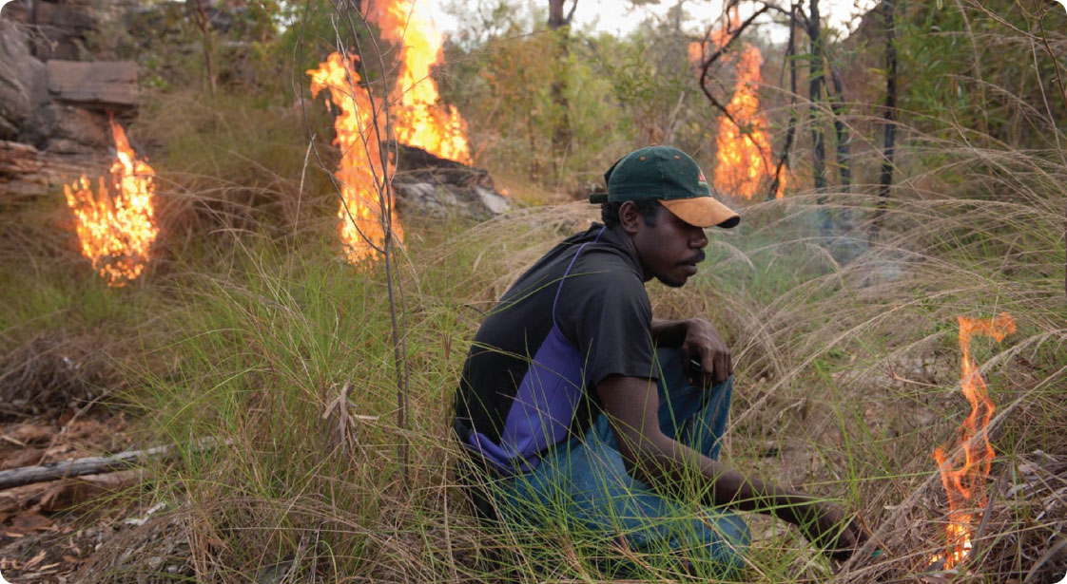

Credit: Tim Alewood / ISFMI

International Savanna Fire Management Initiative: Botswana Pilot Study, Botswana

Ranger Ray Nadjamerrek demonstrates early dry season burning techniques in the Warddeken Land Management area, Arnhem Land, Australia.

# 05. Implementing the change

## 5.1 Integrating Climate Change Action Across Australia’s Development Assistance Policy and Program

Responding to climate change as a cross-sectoral issue is integral to planning, design and decision-making across Australia’s development assistance policy and program. It will increasingly affect all development assistance policy and investment decisions, and influence long-term planning and risk management.

Integration of climate change across the broader development assistance program is important to enhancing development outcomes and addressing climate change directly: for example, we may switch to lower emissions energy in building schools. It also helps address the adverse impacts of climate change, such as ensuring those same school buildings are climate resilient.

Climate change is not a recent or additional sectoral priority, but continues to be integral to design and decision-making. Early consideration of climate change mitigation and adaptation opportunities when planning our investments will increase chances of success and improve development outcomes.

Ignoring our changing climate and the potential impact on communities will result in suboptimal outcomes for our development assistance interventions. Integrating climate change action in Australia’s development assistance program is:

* best practice aid policy
* important for implementing the Sustainable Development Goals
* integral to the overall effectiveness and risk management of Australia’s development assistance program.

Integrating climate change into our broader development assistance policy and program not only produces more effective programs, it can often produce efficiency gains. For example, in the case of the Pacific, we can also help communities achieve lower energy costs by switching to cheaper renewable energy. Investing in agricultural productivity can deliver water conservation.

Integration of climate change can also achieve other environmental outcomes, such as sustainable forest management contributing to biodiversity conservation.

Further examples of integrated climate change development assistance include:

* supporting the preparation of a country’s low-carbon, climate resilient development plans
* integrating climate adaptation skills, health and environment education into school curricula
* designing wastewater management systems to account for climate change pressures
* promoting climate resilient agriculture and food security in vulnerable areas
* strengthening regulatory capabilities in sectors to deal with climate change impacts (such as energy).

We aim to ensure all new major investments consider and respond to climate change risks, impacts (especially for vulnerable communities), and opportunities for low emissions, climate resilient development. This approach will bolster the Department’s planning and design process. It will identify opportunities for climate change specific programs now and in the long term. This will help our regional partners make the transition to a low-emissions, climate resilient, economic future. It builds on our current work to establish stronger skills and tools for integration.

At the same time, we are aligning our development assistance with the Sustainable Development Goals, which emphasise climate change action. We have also introduced a new accounting framework for climate change development assistance based on the OECD Development Assistance Committee methodology, and developed a new environmental and social safeguard policy with stronger screening for climate change and disaster risk.

As climate change exacerbates existing development challenges, the Department’s sectoral and cross-cutting development assistance policies and investments—from governance, humanitarian, economic and social policy, gender and disability, to agriculture, water, forestry and infrastructure—will take into account climate change impacts and opportunities.

Integration in practice: Australian Infrastructure Financing Facility for the Pacific

In 2019, the Government launched a $2 billion Australian Infrastructure Financing Facility for the Pacific (AIFFP). The Facility will provide loans to fund priority infrastructure projects in the Pacific region and will have the capacity to lend to Pacific island countries (and Timor Leste) and the private sector. The Facility will provide non-concessional loans worth up to $1.5 billion, supported by ODA grants of up to $500 million.

Climate change will be a key consideration for the new Facility. Australia will work closely with Pacific states on issues of aligned concern, including climate and disaster resilience. The AIFFP also has a dedicated Climate Infrastructure Window to advance the region’s energy transition and climate ambitions. Priorities of the financing facility include the energy, water and transport sectors, which are key areas in meeting the challenges of climate change. Achieving best practice means development assistance investments are climate resilient – for example when building a new port we must factor in the impact of rising seas or storm surge from extreme weather events.

Integration in practice: South Asia

The Sustainable Development Investment Portfolio is strengthening regional cooperation in South Asia. This includes the interdependencies between climate, water, energy and food security. Climate change features as an explicit investment objective. Specialist climate data, technical support and assessment in the program cycle has strengthened decision-making and program impacts.

For example, in 2017, our work in partnership with other bilateral donors and the private sector improved energy efficiency in Bangladesh’s textiles industry. Australian development assistance contributed to reducing water usage by 3.1 billion litres, energy use by 606,000 megawatt hours, and greenhouse gas emissions by the equivalent of 185,000 tons of CO2.

It provided electricity to further microbusiness opportunities in India, Bangladesh, Pakistan, Nepal and Bhutan, and gave eight million people access to off-grid lighting systems. It also improved food security by helping more than 50,000 farmers—15,000 of whom are women—to adopt climate smart agricultural practices.

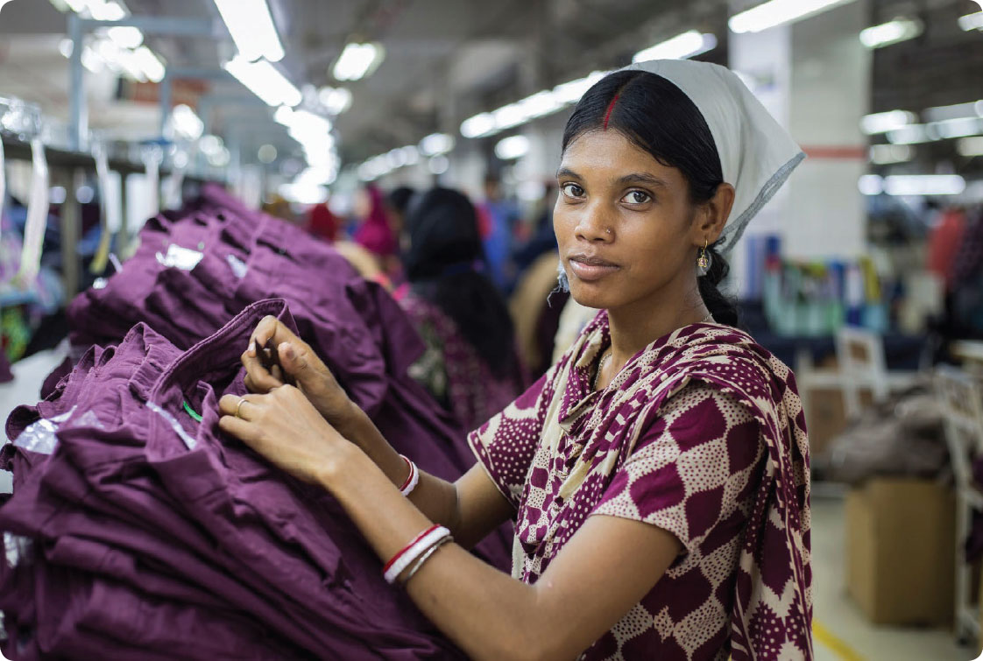

Credit: International Finance Corporation’s (IFC)

The Partnership for Cleaner Textile (PaCT) program

IFC’s Partnership for Cleaner Textile (PaCT) program in Bangladesh advised 200 textile factories to adopt best practices to reduce water, energy, and chemical use in order to make the sector environmentally sustainable and competitive.

## 5.2 Targeted Climate Change Action to Achieve Outcomes

Meeting the Paris Agreement goals requires investments to reduce greenhouse gasses and adapt to build resilience. A key component of Australia’s climate change development assistance will be targeted action primarily focused on achieving climate change outcomes.

According to the Asian Development Bank, developing Asia will need an investment of US$26 trillion from 2016 to 2030 (or US$1.7 trillion a year) if the region is to maintain its growth momentum, eradicate poverty and respond to climate change. Climate mitigation and adaptation costs alone are estimated at US$200 billion a year.[26]

Beyond addressing the impacts of climate change by supporting mitigation or adaptation activities, dedicated climate change development assistance can help investments achieve economies of scale and specialised capacity. Early support for mitigation efforts could reduce the need for adaptation efforts in the future.

Dedicated climate change development assistance also demonstrates the value the Department attaches to addressing the issue and to meeting the priorities of developing countries for support, especially Pacific island countries.

Examples of dedicated climate change development assistance include:

* urban infrastructure or sustainable transport programs designed to reduce greenhouse gas emissions or adapt to climate change
* land, ocean use and agribusiness to reduce or remove emissions, adapt to a changing climate or strengthen carbon sinks through sustainable forest management, afforestation and reforestation, and ocean and blue carbon efforts
* health programs to support adaptation, such as measures to control heat stress or malaria in areas where climate change is increasing health risks
* mitigation activities in the energy, industrial or mining sectors designed to reduce greenhouse gas emissions either through clean energy, energy efficiency or both.

The Department will also explore innovative partnerships with others active in climate finance, such as multilateral banks, private sector climate financing mechanisms, NGOs, philanthropic foundations, and other institutions.

New programming approach to climate change in Papua New Guinea

On 28 October 2019, Australia participated in the inaugural PNG-Australia Climate Change Annual Dialogue in Port Moresby. This annual dialogue is important to ensure Australian funding responds to PNG’s own resilience goals, targets and ambitions. The dialogue also provides an opportunity to review our activities under the PNG-Australia Climate Change Action Plan, which was jointly signed in May 2018 by the then Ministers for Environment.

Mobilising the Private Sector

Australia partners with the Private Financing Advisory Network (PFAN)[27], a multi-donor initiative that identifies promising clean energy and climate businesses in developing countries and provides mentoring, network and technical assistance to help them secure private finance. Australia provides financial support to PFAN (US$3 million between 2016-2019) along with other international donors, and is the vice-chair of its steering committee. In 2017, PFAN leveraged US$69 million of private finance to help mitigate emissions at scale.

Australia also supports renewable energy deployment in Asia through its US$43.5 million investment in InfraCo Asia Development (IAsD).[28] This initiative develops and funds early stage, high-risk infrastructure, taking an equity stake in socially-responsible and commercially-sustainable projects. It leverages donor funds to attract private finance for infrastructure projects in emerging markets and developing economies. This innovative model provides a financial return, which can be reinvested in future projects and support increased outcomes from donor funds.

### Dedicated development assistance to promote climate change action

Announced by the Prime Minister in August 2019, the Australian Government is developing a new $140 million Private Sector Mobilisation Climate Fund to mobilise significant private sector investments in low emissions, climate-resilient solutions for the Pacific and Southeast Asia.  The fund will develop a significant portfolio of projects with contributions from the private sector and other agencies.

The fund will strengthen Australia’s climate change support to the region, by tapping the creativity and capital of the private sector, and leveraging Australia’s development assistance budget to maximise climate change action. The fund is aligned with the Department’s Private Sector Development Strategy, and is an example of supporting innovation to meet the challenges of climate change.

Using a range of financial instruments, the fund will support innovative climate change mitigation and adaptation investments in target countries, focusing on areas where there   
are gaps in private sector investment. Areas of focus include the energy, agriculture, infrastructure and transport sectors.

Barriers to private sector climate investment the fund will address include:

* Limited access to affordable finance
* Limited commercial appetite for greenfield construction and early stage development
* Knowledge gaps including lack of standardised models and limited experience and capacity
* Regulatory risk and challenging investment environments

## 5.3 Maintaining Departmental Capacity for Climate Change Action

Implementing this Strategy requires the capability to support climate change outcomes and integrate climate change across Australia’s development assistance program. Our approach to implementation will respond to the recommendations of both the:

* 2018 OECD DAC review of Australian aid[29]
* 2018 Office of Development Effectiveness’ evaluation of Australia’s climate change assistance.[30]

These documents support ongoing development of guidance and technical capability, and stronger emphasis on integrating climate change considerations into Australian development assistance investment plans and country analysis.

Implementing the Strategy requires sound climate change knowledge and capacity among the Department’s staff and implementing partners. Improving collaboration with science expertise located in other government agencies will provide climate science advice and projections to assist the Department’s climate change analysis.

### Overseeing the Climate Change Action Strategy

This Strategy articulates a vision for our climate change action across all relevant areas of the Department to 2025. To lead this work, a new Climate Change Policy Committee will be established, bringing together Senior Executive Officers including sectoral and development assistance management divisions to provide strategic oversight and coordinate the Strategy’s implementation across the Department.

The Department will also use existing governance arrangements for the development assistance program, such as the Departmental Executive’s Strategic Policy Committee, the Aid Governance Board, and Development Policy Forum to guide the Department’s implementation of the Strategy, drawing on advice from independent expertise as relevant and appropriate.

To reinforce whole-of-government coordination in implementing the Strategy and to integrate climate change across the government’s development assistance program, the Department will lead a high-level interdepartmental committee for this purpose.

The Department will also continue to engage in the Australian Government’s National Disaster and Climate Resilience Reference Group. This group meets at Senior Executive level throughout the year to consider risks and opportunities arising from climate change and extreme weather events, and to facilitate cross-government climate change and disaster policy collaboration.

### Maintaining capacity for the Department’s climate change development assistance policy and programming

We will implement the Strategy by building on our existing work and maintaining the Department’s capacity to deliver its objectives.

We will integrate the Strategy and its objectives into existing development assistance policy and processes by:

* ensuring the consideration of climate change in broader Australian development assistance polices. This includes our approach to the Sustainable Development Goals, and to the humanitarian, disaster risk reduction, governance, human rights, health, disability, gender, water, food, security, and education sectors
* incorporating climate change in key Departmental mechanisms to establish, drive and report development assistance, including in aid investment plans, the Department’s aid management system (Aidworks), and development assistance quality, monitoring and evaluation systems
* consolidating Departmental approaches to climate finance accounting based on the OECD DAC guidelines.

We will maintain internal capacity by providing guidance, upskilling and training by:

* developing Strategy implementation tools to guide staff in implementing the Strategy and to harness best practice guidance, training, specialist advice and support, knowledge and leadership
* providing formal guidance on climate change alongside the Aid Programming Guide, evaluation of programs, and incorporating climate change into other key sectoral policy guidance
* providing climate change specific training – including e-learning and face to face – for staff who are developing or managing development assistance policy strategies or investments
* harnessing and developing internal and external capabilities and skills, and drawing on the best expertise within and outside government to deliver the strongest possible outcomes.

### Establish knowledge and implementation partnerships

We will strengthen knowledge and implementation partnerships with other government departments, external agencies, private sector and NGOs, which have practical Australian and international climate change expertise.

Australian technical, research, NGO, business, academic and policy bodies have highly regarded skills and strong regional relationships, which can support effective climate change action in the region. Knowledge partnerships improve access to the latest thinking, technology and approaches to climate and disaster risk management as well as emissions reduction. Implementation partnerships can draw on our diverse network of expertise on climate change investments to maximise implementation on the ground.

The Department will work with other government departments to help them share their expertise, scientific and technical advice with their government counterparts in the region. An officer-level cross-departmental working group and knowledge hub will be established to facilitate this work and inform the leadership focused interdepartmental committee.

We will work with our development assistance implementing partners, including NGOs, academia, and private development assistance contractors, to harness and reinforce their climate change capability, increase their investment in climate change action, and strengthen connections. For example, we will work with the Australian Council for International Development on its Climate Change Community of Practice network. The Department is committed to further strengthening cooperation with the NGO community to deliver results.

# 06. Strategy performance and review

## 6.1 Performance Assessment Framework

Aligning closely with the Department’s existing review processes including Making Performance Count, a Performance Assessment Framework will be developed to create a robust evaluation mechanism for assessing Strategy progress to 2025 against its three core objectives:

* promoting the shift to lower emissions development;
* supporting partner countries adapt to climate change, and to plan, prepare for, and respond to climate related impacts; and
* supporting innovative solutions to climate change, including those that engage private sector investment.

To achieve this, DFAT will annually review and assess progress in implementing the Strategy, the outcomes of which will be reported in the Performance of Australian Aid report. This will include data collected through the Department’s annual performance and quality processes, case studies of good practice, and reviews and analysis of emerging trends and opportunities. This information will be used to determine:

* how well climate action is being integrated across Australia’s development policies and programs;
* increases in targeted climate change investments to achieve outcomes at scale;
* increased strengthening of Departmental capabilities for climate change development; and
* the nature and extent of improvements in risk management and safeguard frameworks to address climate change in Australia’s aid investments.

A performance assessment note will also be provided to country programs to:

* suggest qualitative and quantitative indicators for program areas to draw from in integrating climate change;
* reflect international best practice in monitoring and evaluation and include lessons learnt from our own experience; and
* include recommendations to improve implementation against the Strategy’s core objectives.

## 6.2 Review

This Climate Change Action Strategy will guide the Department’s efforts through to 2025.

The Strategy is designed for periodic review and continuous improvement, acknowledging that knowledge, behaviour, scientific understanding and technical advances on climate change evolve over time. Risks and opportunities from climate change and disasters will continue to evolve and interact with the broader development context in ways that are difficult to predict. Ongoing analysis, research and policy development will be required to inform policy development and implementation of the Strategy.

The Department will undertake regular reviews and report on Strategy implementation. The reviews will consider lessons learnt from each implementation stage of the Strategy. The reviews will be guided by best practice climate change and development assistance principles, and informed by the July 2018 Office of Development Effectiveness Evaluation of Australia’s Climate Change Assistance, and the Department’s management response to the Evaluation.

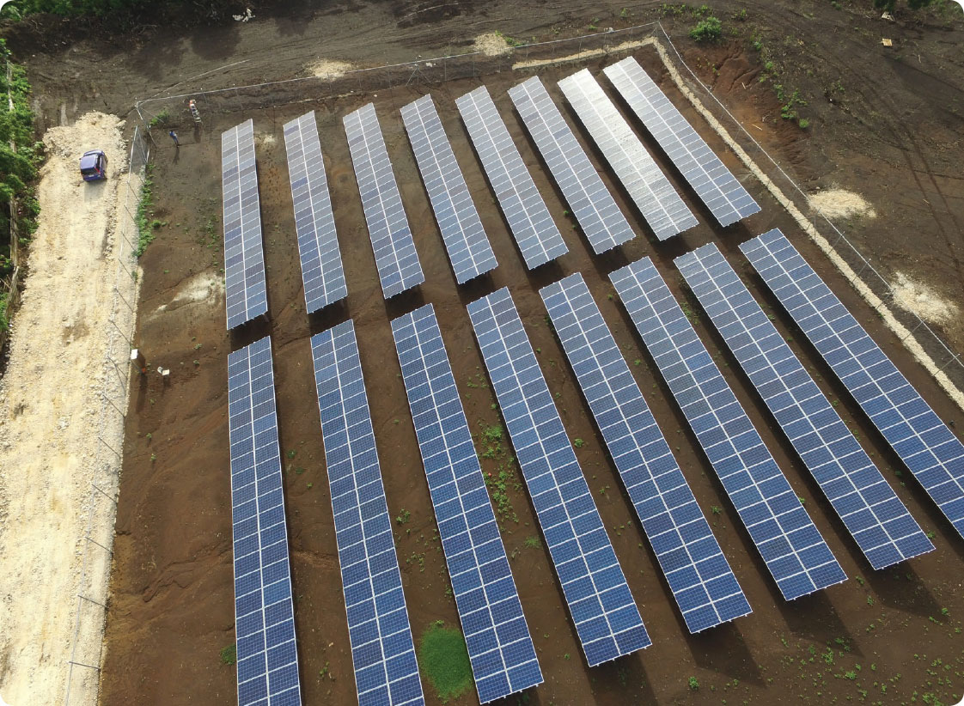

Mr Johnny Lillis and Vilami Ongosia (OIREP Program)

A solar farm on ‘Eua helps ensure local communities have consistent access to reliable clean energy.

# List of acronyms

ACIAR Australian Centre for International Agricultural Research

AIFFP Australian Infrastructure Financing Facility for the Pacific

APCCAP Australian Infrastructure Financing Facility for the Pacific

APEC Asia-Pacific Economic Cooperation

BOM Bureau of Meteorology

COP24 24th Conference of the Parties to the United Nations Framework Convention on Climate Change

CSIRO Commonwealth Scientific and Industrial Research Organisation

DFAT The Department of Foreign Affairs and Trade

FRDP Framework for Resilient Development in the Pacific

GCF Green Climate Fund

GEF Global Environment Facility

ICAO International Civil Aviation Organization

IMO International Maritime Organization

IPCC Intergovernmental Panel on Climate Change

LDC Least Developed Countries

LDCF Least Developed Countries Fund

MDB Multilateral Development Banks

MRV Measurement reporting and verification

NDC Nationally Determined Contribution

ODE Office of Development Effectiveness

OECD Organisation for Economic Co-operation and Development

PIF Pacific Islands Forum

PRP Pacific Resilience Partnership (PRP)

SCCF Special Climate Change Fund

SDG Sustainable Development Goal

SIDS Small Island Developing States

SPREP South Pacific Regional Environment Programme

**[WWW.DFAT.GOV.AU](http://www.DFAT.GOV.AU)**

1. Intergovernmental Panel on Climate Change (IPCC), “Special Report on Global Warming of 1.5 Degrees” (2018),   
   <https://www.ipcc.ch/sr15/>
2. <https://treaties.un.org/Pages/ViewDetails.aspx?src=IND&mtdsg_no=XXVII-7-d&chapter=27&clang=_en>
3. United Nations, “UN Sustainable Development Goals” (2015), <https://www.un.org/sustainabledevelopment/>
4. World Bank, “Climate Change Overview” (2019), <https://www.worldbank.org/en/topic/climatechange/overview>
5. <https://www.ipcc.ch/report/ar5/syr/>
6. World Bank Group, “Shock Waves: Managing the Impacts of Climate Change on Poverty” (2016),   
   <https://openknowledge.worldbank.org/bitstream/handle/10986/22787/9781464806735.pdf?sequence=13&isAllowed=y>
7. <https://www.worldbank.org/en/topic/climatefinance> April, 2019
8. <https://newclimateeconomy.report/2018/> - Unlocking the inclusive growth story of the 21st Century: Accelerating Climate Action in urgent times, New Climate Economy, The Global Commission on the Economy and Climate, Aug 2018
9. The Department of Foreign Affairs and Trade, “Humanitarian Strategy” (2016), <https://dfat.gov.au/about-us/publications/Documents/dfat-humanitarian-strategy.pdf> and UNISDR, “Global Assessment Report on Disaster Risk Reduction” (2019), <https://www.unisdr.org/>
10. OECD, “Climate finance from developed to developing countries public flows in 2013-17” (2018),   
    <http://www.oecd.org>
11. World Bank, “World Bank Group Announces US$200 billion over Five Years for Climate Action” (2018), <https://www.worldbank.org/en/news>
12. OECD, “Climate finance from developed to developing countries public flows in 2013-17” (2019),   
    <http://www.oecd.org> and <https://doi.org/10.1787/39faf4a7-en>.
13. DFAT, “Report on the Implementation of the Sustainable Development Goals” (2018), <https://dfat.gov.au/aid/topics/development-issues/2030-agenda/Documents/sdg-voluntary-national-review.pdf> and United Nations, “UN Sustainable Development Goals” (2015), <https://www.un.org/sustainabledevelopment/>
14. The Department of Foreign Affairs and Trade, “Investing in the Future: Evaluation of Australia’s Climate Change Assistance” (2018), <https://dfat.gov.au>
15. OECD, “Climate Change: OECD DAC External Development Finance Statistics” (2018), [www.oecd.org/dac](http://www.oecd.org/dac)
16. UNFCCC, “Report on the Technical Review of the Third biennial Report of Australia” (2018), <https://unfccc.int/sites/default/files/resource/TRR.3_AUS.pdf>
17. UNFCCC, “Australia’s 7th National Communication and 3rd Biennial Report” (2017), <http://unfccc.int/files/national_reports/national_communications_and_biennial_reports/application/pdf/024851_australia-nc7-br3-1-aus_natcom_7_br_3_final.pdf>
18. Neumayer and Pluemper, “The Gendered Nature of Natural Disasters: The Impact of Catastrophic Events on the Gender Gap in Life Expectancy, 1981–2002” (2007), [https://www.tandfonline.com/doi/full/10.1111/j.1467-8306.2007.00563](https://www.tandfonline.com/doi/full/10.1111/j.1467-8306.2007.00563.x).x
19. DFAT, “Humanitarian Strategy” (2016), <https://dfat.gov.au/about-us/publications/Documents/dfat-humanitarian-strategy.pdf>
20. World Trade Organisation – <https://www.wto.org/english/tratop_e/envir_e/envir_neg_serv_e.htm>
21. IPCC “Climate Change 2014: Synthesis Report. Contribution of Working Groups I, II and II to the Fifth Assessment Report of the Intergovernmental Panel on Climate change” (2014), <https://www.ipcc.ch/site/assets/uploads/2018/02/SYR_AR5_FINAL_full.pdf>
22. International Partnership for Blue Carbon, “Factsheet” (2016), Source: <https://bluecarbonpartnership.org>
23. World Bank, “Urban Development Overview” (2019), <https://www.worldbank.org/en/topic/urbandevelopment/overview>
24. <https://www.undp.org/content/undp/en/home/sustainable-development-goals/goal-11-sustainable-cities-and-communities.html> United Nations Development Programme 2019
25. European Commission 2018. <https://ec.europa.eu/knowledge4policy/foresight/topic/continuing-urbanisation/worldwide-urban-population-growth_en>
26. Asian Development Bank, “Asia Infrastructure Needs Exceed US$1.7 trillion per year, double previous estimates” (2017), <https://www.adb.org>
27. UNIDO, “Private Advisory Financing Network”, (no date), <https://www.unido.org/our-focus/safeguarding-environment/clean-energy-access-productive-use/climate-policies-and-networks/private-financing-advisory-network-pfan>
28. 28 InfraCo Asia, webpage (2018), <https://infracoasia.com/>
29. OECD, “Extract from the OECD Development Co-operation Peer Reviews Australia” (2018), <https://www.oecd.org/>
30. The Department of Foreign Affairs and Trade, “Investing in the Future: Evaluation of Australia’s Climate Change Assistance” (2018), <https://dfat.gov.au>