Australia Awards Global Tracer Facility
Case Study in China -
environment and public health fields
April 2018

Table of contents
Acronyms and Abbreviations 2
1. Executive Summary 2
1.1 Findings 2
2. Background of the Study 2
2.1 Objectives 2
2.2 Scope 2
2.3 Case Studies 2
2.4 Country context 2
2.5 Fellowships context 2
3. Methodology 2
3.1 Overall Case Study design 2
3.2 Methods 2
3.3 Sample 2
3.4 Exclusions 2
3.5 Data collection 2
3.6 Process 2
3.7 Data management and reporting 2
3.8 Limitations 2
4. Development Outcomes 2
Summary findings 2
4.1 Introduction 2
4.2 Background 2
4.3 Alumni contributions 2
4.4 Enabling Factors 2
4.5 Challenges 2
5. Economic and Public Diplomacy Outcomes 2
Summary findings 2
5.1 Introduction 2
5.2 Background 2
5.3 Examples of cooperation and partnership 2
5.4 Enabling factors 2
5.5 Challenging factors 2
6. Views about Australia and Australian Expertise 2
Summary findings 2
6.1 Introduction 2
6.2 Examples of positive views of Australia and Australian expertise 2
6.3 Challenge to positive views of Australian institutions 2
7. Impact of Australia Awards on Addressing Equity Issues 2
Summary findings 2
7.1 Introduction 2
7.2 Background 2
7.3 Access to Australia Awards 2
7.4 Social equity impact of alumni 2
8. Conclusion 2
9. Alumni Profiles 2
10. References 2
Annex 1: Case Study Propositions 2
Annex 2: Key Participant Questions 2
Annex 3: China Case Study Participants 2
Tables
Table 1 China Case Study alumni participants 2
Table 2 Key stakeholders, host organisations and employer/colleague interviews 2

Acronyms and Abbreviations
ALA | Australian Leadership Awards
CAMS | Chinese Academy of Preventive Medicine
CEPH | Centre for Environment and Population Health
ChAFTA | China-Australia Free Trade Agreement
China CDC /CDC | Chinese Centre for Disease Control and Prevention
DFAT | Australian Government Department of Foreign Affairs and Trade
GIS | Geographic Information Systems
ICE WaRM | International Centre of Excellence in Water Resources
IELTS | International English Language Testing System
IWC | International Water Centre
NCD | non-communicable diseases
NGOs | Non-governmental organisation
SARS | severe acute respiratory syndrome
SCB | Scholarships and Alumni Branch (DFAT)
WHO | World Health Organisation
YRCC | Yellow River Conservancy Commission

Executive Summary
This report explores the long-term outcomes of Australian Government fellowship alumni from the People’s Republic of China during the period 2006 to 2010. Alumni in this Case Study undertook Australian Leadership Awards (now known as Australia Awards Fellowships) in the fields of environment and public health.
These fellowships were hosted by Australian institutions in collaboration with Chinese organisations. The objective of these fellowships was to build leadership capacity and expertise of emerging Chinese leaders and enhance skills in areas of bilateral interest. Alumni now work in the fields of sustainable water management, public health, and food and water security.
This research was conducted by the Department of Foreign Affairs and Trade’s (DFAT) Australia Awards Global Tracer Facility (the Facility).

Findings

Development contributions
Alumni have made significant contributions to the development and improvement of environment and health policy and practice in China, indicating Australia Awards long-term Outcome 1 is being achieved. Alumni developed a broad range of skills on-award which they have utilised in their work. These skills include integrated approaches to water management and environmental sustainability; multi-disciplinary approaches to public health; and broader skills such as communication, critical thinking, and leadership. Examples of contributions to development include:
- leadership in environment and public health
- capacity building of professionals in environment and public health
- application of multi-sectoral approaches to public health and environmental sustainability
- improving public awareness of health and environmental issues
- policy contribution at the national and global level.
Alumni identified the following factors which enabled them to make contributions following their fellowship:
- critical thinking learnt and applied during their fellowship
- improved English proficiency
- new approaches to project management
- fellowship training tailored to Chinese organisation’s needs.

Alumni highlight that challenges they have faced in making further contributions include:
- English language barriers
- difficulties integrating new skills into Chinese workplaces
- changes in Australia aid policy, resulting in changes to the availability of funding for fellowships for China in some years
- the latent impact of their award – on return, some alumni were not yet in positions to implement change or innovation.

Economic and public diplomacy outcomes
Alumni and the organisations involved in this Case Study have strong and enduring ties to Australia. Relationships have been fostered strongly through the Australia Awards fellowships and are embedded via various Memorandum of Understanding (MoU) between Chinese and Australian organisations. Partnerships and cooperation were identified in this Case Study in the areas of:
- ongoing capacity development programs with Australian institutions
- research collaborations in environment, water management and public health
- contributions of Chinese and Australian partners to global cooperation in fields including hydrology, climate change, communicable disease control and disaster management.
The strong examples of sustained partnerships with Australian organisations demonstrate that the Australia Awards long-term Outcomes 2 and 3 are being achieved in the cohort for this Case Study.
Alumni identified a number of factors which supported them and their organisations to develop these relationships such as:
- the development of intercultural competence and English language enabling Chinese alumni to remain connected with Australia following the award
- fellowship funding as a mechanism for ‘fertilising’ relationships that are now ongoing
- the flexibility of the fellowships in their early years to tailor courses to meet the needs of partner organisations
- Australian hosts’ cultural understanding of how to work with Chinese organisations.
Alumni and stakeholders identified a number of challenges to the development of relationships. These include changes to Australian aid policy and fellowship funding. As China ceased to be an Australian aid recipient, host organisations and employers had to redefine their relationships and find new ways to fund their capacity development programs.

Views of Australia and Australian expertise
Alumni in the China Case Study hold enduring positive views about Australia, Australians and Australian expertise, indicating achievement of Australia Awards long-term Outcome 4. In particular, alumni emphasised:
- that Australia is a global leader in their fields of expertise
- the high quality of teaching and learning received in Australia
- positive cultural experiences.
Alumni indicated that this positivity was also a result of the support they received on-award including tailored English language classes, language partners, industry visits, study tours and cultural activities.
The English proficiency of some alumni caused some challenges for them while on-award, including limiting the chance to obtain a formal qualification. However, this did not impact on their positive views of Australia and Australian expertise.

Impact on addressing equity issues
China has undergone significant economic transformation in recent decades and while this has positively influenced many aspects of life, there remain some populations vulnerable to poverty and disadvantage. Most of the alumni in this Case Study are working in areas of policy or research that specifically focus on improving health and environmental issues that benefit the most vulnerable groups in China – women and children in rural areas.
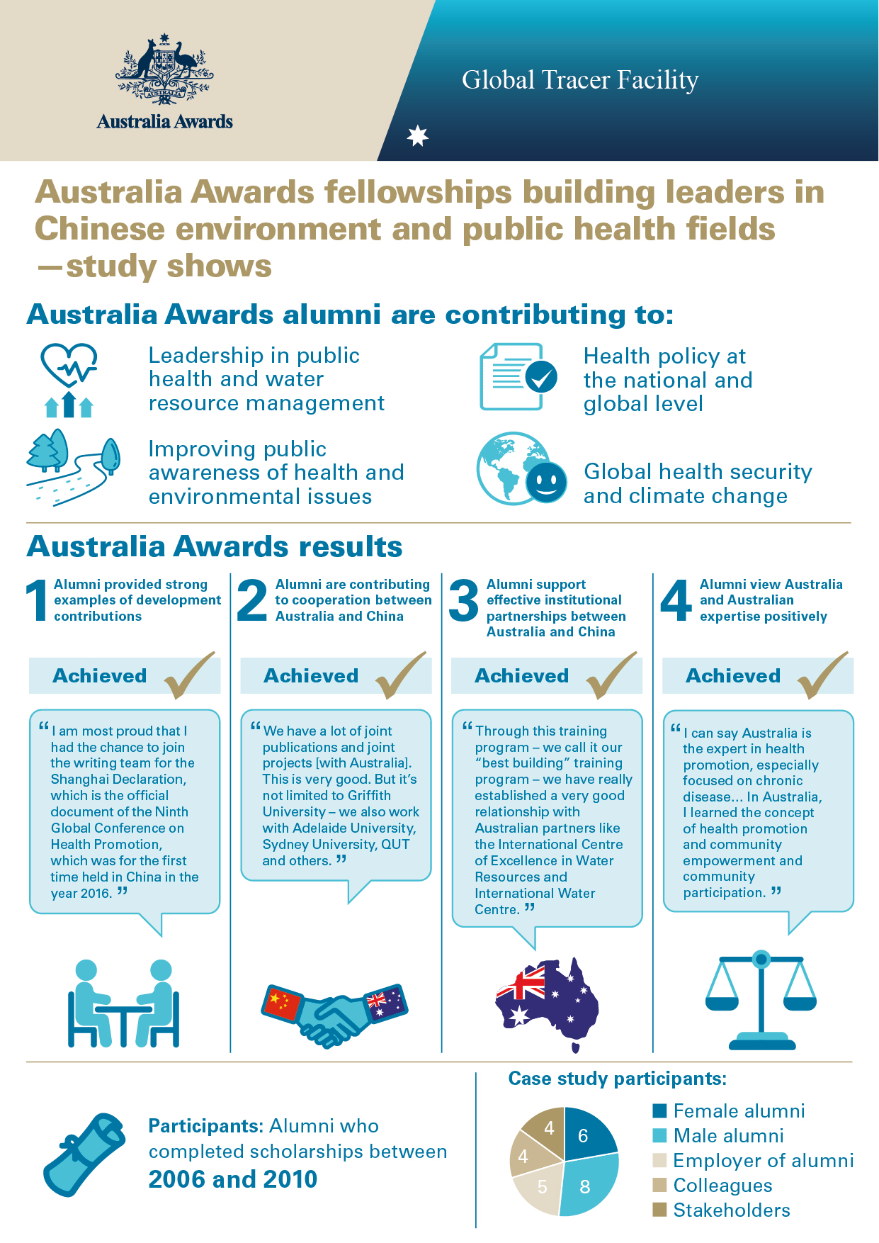

Background of the Study
The Facility is a four-year project funded by DFAT. Through this project, DFAT assesses the development contributions and public and economic diplomacy outcomes of Australia’s investment in the Australia Awards. The key research and reporting activities being undertaken are a quantitative Tracer Survey and qualitative Case Studies, which are prepared concurrently throughout the four years of the project.
This report gives the key findings of the China Case Study which was undertaken by the Facility in April 2018.

Objectives
The Facility seeks to generate high-quality information on former scholarship and fellowship holders, with a focus on less recent alumni. This information provides a strong evidence base for country programs and the Scholarships and Alumni Branch (SCB) of DFAT to evaluate the impact of Australia Awards on alumni and, by implication, on their home institutions and countries.

Scope
The scope of the Facility is limited to alumni of DFAT’s Australia Awards and previous DFAT-funded scholarships programs, awards (both long and short duration) and fellowships (managed by SCB).

Case Studies
The Case Studies are being conducted via an iterative approach whereby the qualitative phase can be designed based on what is learned from the initial quantitative phase.
The Facility Case Study methodology is explanatory and multiple in design. That is, cases are selected based on findings from the quantitative (survey) research, and the ‘how’ and ‘why’ of alumni experiences is explained in detail. Multiple Case Studies enable the researchers to explore differences within and between cases. Case Studies contribute to the evidence base for country programs, providing useful comparison across cases and Case Studies to build a robust understanding of diverse alumni experience.

Year 1 of the Facility
In this first year of the Facility, however, Case Study countries and themes were based on criteria such as availability and range of alumni details in the Global Alumni database; previous country or thematic research undertaken; investment priorities, and partner-country priorities. The cohort for Year 1 Case Studies were alumni who graduated between 1952 and 1995. In Year 1, the selected Case Study countries are Fiji, Sri Lanka, Nepal, and Kenya. Field research took place between late October 2016 and March 2017.

Years 2 through 4
Subsequent Case Studies in Years 2 through 4 will be determined through the annual planning process. Case Studies will not be limited to geographic foci, and may be sectoral or regional as determined through findings of the annual Tracer Survey and planning and consultation process. Case Studies will also align with the priorities of the Australia Awards Global Strategy: Investing in the next generation of global leaders for development 2016-2018 (the Global Strategy) and any other areas of importance as identified by SCB.
In Year 2, the selected Case Study countries and sectoral focus were Vanuatu – Law and Justice, Mongolia – Finance, Solomon Islands – Health, Indonesia – Education, and China – Environment and Public Health fields. Field research occurred between mid-October 2017 and April 2018.

Country context
The People’s Republic of China was founded in 1949 and has since undergone great social and economic change moving from a feudalist society to the second largest market based economy in the world. With the world’s largest population of 1.4 billion people, and 8 out of the top 20 megacities (populations of 10 million plus), China has experienced ‘the fastest sustained growth of any major economy in history’ (World Bank, 2018).
The rapid industrialisation and urbanisation of China has lifted millions of people out of poverty, however, there remain many challenges. Poverty is high in rural areas, with at least 43 million people living below the poverty line (Chow 2018). There are also issues of gender and regional disparities, environmental pollution, and increasing demographic pressures on infrastructure due to an aging population and the movement of poor migrant workers to urban areas (United Nations Development Program 2015).
In 2016, the Chinese Government announced major policy initiatives including action plans to achieve the UN Sustainable Development Goals (SDGs) and the Healthy China 2030 blueprint. These policies put health and development at the centre of all Chinese Government policy with President Xi Jinping calling for a multi-sectoral approach to improving the health of all Chinese to ensure long-term economic growth and social stability (WHO, 2016a).

Australia-China bilateral relationship
The Australian Government established diplomatic relations with the People's Republic of China in 1972 and set up an embassy in Beijing the following year. In 1981, Australia was the first bilateral aid donor to China. Over the course of 30 years of Australian aid in China, the Australian Government focused on improving governance, health, education, and rural resource development.
By the early 2000’s, China was seen as a regional leader and Australian aid was used strategically to support Australia’s interest in the region (AusAID 2006). The Australian Leadership Awards were introduced in 2006 with the aim to develop emerging leaders from all sections of the Asia-Pacific, including China. The scheme allowed a broad range of Australian educational institutions to receive aid-funded students to help build leadership and expertise capacity, and enhance people-to-people links (AusAID 2006) in areas such as environmental issues and clean energy, trade, HIV/ AIDS and disease eradication.
With China’s rapid economic growth, in 2011 the Australian Government announced it would largely phase out bilateral aid to China by June 2013.This caused a shift in the relationship between the two countries. In 2013 Australia and China signed a Memorandum of Understanding (MOU) for a Development Cooperation Partnership to work together on a number of aid projects in the Pacific region to improve health outcomes and regional security. The first project began in 2016 to eradicate drug resistant malaria in Papua New Guinea. The MOU was renewed in 2017(DFAT 2018). China has now also become an active aid donor in Africa and the Asia Pacific region.
The Australia-China bilateral relationship has strengthened and evolved over the years. At its core is strong economic trade bonds, with China being Australia’s largest trading partner (Lowy Institute 2018). The relationship has been described the as a ‘comprehensive strategic partnership’, signified by the China-Australia Free Trade Agreement (ChAFTA) signed in 2015.

Fellowships context
China’s rapid industrialisation and economic growth over the last 40 years has caused large scale environmental damage. Long-term environmental sustainability and public health have become part of the Chinese government’s top priorities and seen as interconnected to the longevity of China’s economic success and prosperity. China defines public health as ‘for the health of all, involving various sectors such as health, agriculture, environmental protection, education and technology’ (Li and Jiang 2017).
In the last 10 years the Chinese government has begun to set up environmental protection laws, tackle air, water and soil pollution, and promote environmental sustainability. In addition, the Chinese government embarked on the world’s largest health system reform process in order to supply universal health care. The aim is to tackle disparities between urban and rural, rich and poor citizens and to provide for an aging population.
The Australian Government provided aid to support the training and capacity building of emerging leaders areas of water resource management, climate change and public health. From 2006 to 2010, the Australian Government provided Australian Leadership Awards to support the upskilling of essential staff.
This Case Study focusses on alumni from these fellowships. The alumni in this Case Study can be divided into three cohorts: water resource management, water and food security, and public health. Personnel from two large Chinese organisations were the main beneficiaries of the fellowships. In the boxes that follow, background and insight into these organisations and the relationships they have with Australia is provided. This background is intended to complement the specific detail and findings provided in the analysis chapters of the report.
Box 1 Fellowship partner – China Centre for Disease Control and Prevention
The China Centre for Disease Control and Prevention (China CDC) is China’s leading health agency. It was established in 2002 by the Ministry of Health after an extended period of economic and healthcare reform in China. It is divided into four levels: national, provincial, municipal and county (local), and has 22 departments with over 200,000 staff. China CDC is responsible for:
- scientific research, into disease control and prevention
- policy advice, planning and implementation of prevention plans to combat different diseases
- public health management of food safety, environmental health, occupational health, and universal healthcare
- providing systematic public health education and training
- health security, disaster relief and emergency response.
China CDC has had a long, collaborative relationship with the Centre for Environment and Population Health (CEPH) at Australia’s Griffith University and its Director, Professor Cordia Chu AM.
The relationship can be traced back to the mid-1990’s, when Professor Chu published a book called ‘Ecological Public Health’ (Chu 1994) which was well received in China due to its focus on environment determinants of health and its multi-sectoral approach. It was translated into Chinese and Professor Chu began working on Healthy Cities and maternal and child health projects with senior leaders within the reforming Chinese health sector. This included working with Professor Liming Li from Peking University and the Chinese Academy of Preventive Medicine (CAMS) (the predecessor of China CDC).
Professor Li became the Director of the newly established China CDC in 2002, and began working on improving the public health knowledge and leadership capacity of his staff. Using his existing connections with Professor Chu and Griffith University he set up an international training program for China CDC staff. His plan was to empower 100 top level public health leaders to guide China into the future.
The outbreak of severe acute respiratory (SARS) in China in 2003, saw the need for a coordinated response from across all levels of the new organisation to address the pandemic. The Chinese government responded to the crisis by mobilising China CDC and investing in public health education campaigns, health surveillance and emergency response infrastructure. SARS redefined public health policy and practice in China, strengthening the role of China CDC and highlighting the urgent need to build capacity of staff to deal with the ongoing health security of China.
In 2006, Griffith University and China CDC established a dual Master of Science Public Health Program and began training emerging leaders. The program was tailored to China CDC’s needs and focused on multi-disciplinary approaches to public health. Key areas included leadership, research methodology, health promotion and risk communication, strategic planning and project management, policy design and delivery. In 2007, Professor Chu successfully applied for funding through the Australian Leadership Awards to facilitate the training.
Griffith University has hosted 11 rounds of Australia Awards fellowships since 2007, providing professional development training for over 38 staff from across the 22 departments of China CDC. Many of these staff have taken on senior roles within CDC on their return, building capacity within their departments and becoming agents for change.
Over the years the program has adapted to meet changes in policy of the Australia Awards fellowships. In subsequent rounds, China CDC staff joined other emerging leaders from the Asia-Pacific region for short term public health programs. This has been influential in helping Griffith’s CEPH develop a substantial partnership network in China.
In May 2018, Griffith University and China CDC renewed their MOU and continue to work closely together on research projects and training programs. A number of alumni have gone to complete further studies at Griffith University including PhD’s in Public Health and Epidemiology.

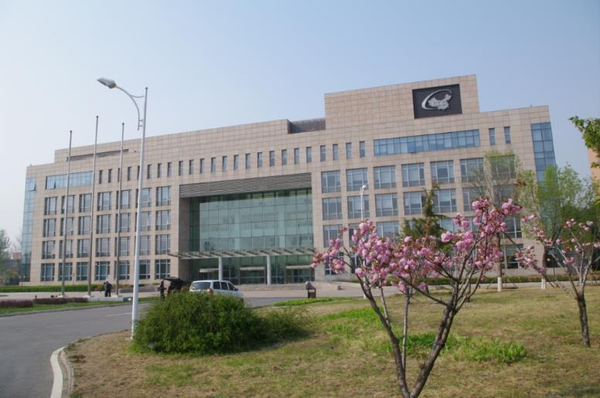
Image 1 China CDC Headquarters, Changping Campus (near Beijing)
Box 2 Fellowship partner – The Yellow River Conservancy Commission (YRCC)
The Yellow River Conservancy Commission (YRCC) is an agency of the Ministry of Water Resources, People's Republic of China. YRCC is responsible for the water management of the Yellow River basin including: water quality, water allocation, environmental protection, flood management and hydroelectricity generation. YRCC has over 40,000 staff, in branch offices along the 5,000 kilometres of river.
The Yellow River is the second longest river in China and originates in Tibet, flowing through eight provinces before it reaches the Yellow Sea. It is known as the Mother River and over 400 million people live in the Yellow River basin. It is an essential element of the Chinese economy, supplying over 15 per cent of China’s agricultural land and providing water to 12 per cent of the Chinese population.
Since the late 1990’s the Yellow River has developed the reputation as being one of the world’s most polluted rivers. Growing awareness of environmental issues led to a change in Chinese government policies and YRCC begin to focus on improving water quality, environment protection and water management.
In 2002, YRCC began a capacity building initiative targeting young professionals across the organisation aged 30-45, who had been employed at the company for more than five years. The aim of the professional development program was to upskill mid-level staff, providing leadership skills and international training in trans-disciplinary approaches to the water cycle, and water management. YRCC developed relationships with the International Centre of Excellence in Water Resources in Adelaide (ICE WaRM) and the International Water Centre (IWC) in Brisbane. YRCC also has a relationship with the Delft Institute for Water Education in the Netherlands. Between 2002 and 2006, YRCC sent three self-funded groups to the Netherlands and two groups to Australia.
With the introduction of the Australia Awards fellowships, YRCC were able to expand their training collaborations with ICE WaRM and IWC. In 2007 and 2009 ICE WaRM ran two Australia Awards funded fellowship projects in conjunction with University of South Australia. The eight month YRCC Professional Development Programme for agencies of the Ministry of Water Resources was tailored to YRCC staff needs and included English language training, industry placements, industry and field visits. Fellows who met the IELTS requirements of the University of South Australia also had the opportunity to be recognised with a Graduate Certificate of Integrated Water Management.
The IWC hosted YRCC staff in 2007, 2008 and 2009 with funding support through Australia Awards fellowships. The IWC courses provided YRCC fellows with English language training and a strong focus on environmental sustainability, water leadership, change management, ecosystem health and river restoration. The courses included industry placements and industry and field visits across Queensland and the Murray Darling Basin, and two alumni were awarded a Graduate Certificate in Water Management from the University of Queensland.
Both IWC and ICE WaRM have an ongoing relationship with YRCC through training programs (now solely funded by YRCC) and through research projects, conferences and newsletters.

Image 2 China’s Yellow River

Methodology
This chapter includes an overview of the Case Study design, development and implementation. This is the ninth Case Study of the Facility. China was one of five Case Study countries proposed in the Year 2 Facility Annual Plan. As stated, China was selected as a Case Study country on the basis of having a sufficiently large number of alumni participants in the Facility’s Tracer Survey, Year 1 who completed a fellowship in the areas of environment and public health fields.
Australia has largely phased out bilateral aid to China. A small number of ongoing projects provide targeted Assistance. Prior to 2011, the Australia-China aid program was valued at approximately AUD40m per annum. The final bilateral aid investment strategy, the China-Australia Country Program Strategy 2006 – 2010 (CPS) consisted of three key objectives: (1) build capacity in selected sectors in China, in particular governance, environment and health, (2) enhance the Australia–China relationship by building institutional linkages, and (3) work collaboratively with China to strengthen the region.
As China is Australia’s largest trading partner. Possible sector foci considered for this country included: health; and agriculture, environment and related studies. While the number of alumni respondents in agriculture, environment and related studies was slightly lower than these other fields, the benefit of choosing this sector is the inclusion of an almost even gender split. In addition, despite the lower numbers, alumni surveyed provided good examples of how their environmental and public health studies in Australia were applicable in China.

Overall Case Study design
The purpose of the Facility Case Studies is to collect detailed qualitative data on the impact and benefits of the Australia Awards. The Case Study methodology proposed is based on the Facility Case Study Approach, which was developed in the inception phase of the Facility and reported in the Annual Plan for Year 1.
The Global Strategy and Australia Awards Global Monitoring and Evaluation Framework form the basis for the Case Study design. The research questions, propositions, data collection instruments, and report template are built around these frameworks. Findings reported by alumni are triangulated with relevant stakeholders such as employers and colleagues, and industry bodies thereby strengthening findings by providing further evidence to support or refute propositions. This methodology was developed by the Facility and SCB.
The overarching theory that has guided the design of this Case Study methodology is based upon the goal of the Australia Awards that ‘… partner countries progress their development goals and have positive relationships with Australia that advance mutual interests’.

The Case Study research questions are framed by the intended long-term outcomes of the Australia Awards as guided by the Framework:
1 How do alumni use the skills, knowledge and networks gained on-award to contribute to achieving partner-country development goals?
2 How are Australia Awards contributing to Australia’s economic and public diplomacy outcomes?
3 How has being an Australia Award alumni impacted alumni?
4 Are the benefits of receiving a scholarship experienced equally by all groups who have received them?
The primary unit of analysis for this Case Study is the alumnus or alumna. Case Studies seek to explore how alumni of Australia Awards have acted to contribute to the achievement of the goal and objectives of the Australia Awards.

Methods
The data collection method used for this Case Study was through interviews. A set of questions were developed for each key participant group, namely alumni, colleagues and employers (both of alumni and generally), alumni associations, host institutions and the DFAT staff and managing contractors working on the Australia Awards in partner countries. Questions for each key participant group (see Annex 2) align with the research propositions (located at Annex 1) and long-term outcomes of the Australia Awards. This ensures that data collected directly relate to the key questions the Case Studies are seeking to answer and that there is consistency across each Case Study.

Sample
Data from the Global Alumni database for China at the time of planning this Case Study revealed 61 alumni who completed their fellowship between 2006 and 2010 (the focus period for the Facility in Year 2). From this group, a total of 23 studied or are working in the field of environment, agriculture and public health. Interviews and focus groups were conducted in China as part of the Case Study field work. These involved 14 alumni, six women and eight men (see Table 1).
Table 1 China Case Study alumni participants
Name* | Gender | Australian Government fellowship | Year of fellowship | Institution | Current position
Zheng Dai | M | Asia-Pacific Public Health Leadership Program (APPHLP) | 2007 | Griffith University | Deputy Director , Associate Professor Department of Education and Training, China Centre for Disease Control and Prevention, Beijing
Xi Jingjing | F | Asia-Pacific Public Health Leadership Program (APPHLP), | 2008 | Griffith University | Director of General Office, Associate Researcher, China Centre for Disease Control and Prevention
Hou Xiaohui | M | The China Disease Control and Prevention Leadership Program (CDCLP) | 2007 | Griffith University | Head of International Collaboration, Office of Science, Technology, and International Cooperation, Chinese Centre for Health Education.
Jiang Yingying | F | Asia-Pacific Public Health Leadership Program (APPHLP) | 2008 | Griffith University | Researcher, National Centre for Chronic and Non- communicable Disease Control and Prevention, China Centre for Disease Control and Prevention
Guo Haijun | M | Asia-Pacific Public Health Leadership Program (APPHLP), | 2008 | Griffith University | PhD Candidate, Griffith University, Associate Professor and Senior Researcher, National Institute for Nutrition and Health, China Centre for Disease Control and Prevention
Yu Haihong | M | Professional Development Programme (PDP) for agencies of the Ministry of Water Resources, PR China | 2009 | International Centre of Excellence in Water Resources Management (ICE WaRM) | Officer, Department of Personnel and Labour, Yellow River Conservancy Commission
Wang Zhongmei | F | YRCC Professional Development Programme | 2007 | International Centre of Excellence in Water Resources Management (ICE WaRM) | Project Manager, Yellow River Institute of Hydraulic Research, Yellow River Conservancy Commission
Jin Shuangyan | F | Integrated River Basin Management Fellowship | 2008 | International Water Centre  (IWC) | Section Head, Water Resources Research, Yellow River Institute of Hydraulic Research, Yellow River Conservancy Commission
Liu Wei | M | Professional Development Programme (PDP) for agencies of the Ministry of Water Resources, PR China | 2009 | International Centre of Excellence in Water Resources Management (ICE WaRM) | Researcher, Bureau of Hydrology, Yellow River Conservancy Commission
Pang Hui | F | Professional Development Programme (PDP) for agencies of the Ministry of Water Resources, PR China | 2009 | International Centre of Excellence in Water Resources Management (ICE WaRM) | Project Officer, Department of International Cooperation, Science and Technology, Yellow River Conservancy Commission
Song Ruipeng | M | Integrated River Basin Management Fellowship | 2008 | International Water Centre (IWC) | Senior Engineer and Researcher, Bureau of Hydrology Yellow River Conservancy Commission
Fan Jie | F | Integrated River Basin Management Fellowship | 2008 | International Water Centre (IWC) | Project Officer, Press & Publications Centre, Yellow River Conservancy Commission
Bao Changjun | M | Asia-Pacific Public Health Leadership Program (APPHLP) | 2008 | Griffith University | Director of Department of Incurable Infectious Disease Control and Prevention, Jiangsu Provincial Centre for Disease Control and Prevention
Wang Wen | M | Knowledge Sharing For Food Security and Water in Asia | 2010 | International Centre of Water for Food Security, Charles Stuart University | Professor at the College of Hydrology and Water Resources, Hohai University, Nanjing
*Names in the table (and subsequent sections of the report) are ordered as per Chinese convention: Family name, First name.
In addition to the alumni who participated in the Case Study, 13 other people were interviewed in order to provide context, triangulate alumni perspectives and better understand the impact of the fellowships on this particular cohort. These additional interviews included current stakeholders such as the staff from the Australian Embassy in China, and four representatives from the host organisations who hosted the fellows during their time in Australia and were involved in the development of the fellowships.
Key staff from the two main Chinese organisations involved in the Case Study were also interviewed to gain an understanding of the aims of the fellowships from the employer’s perspective and the impact of the alumni on their return to their organisation. Table 2 lists these participants. In total 27 people were interviewed for the China Case Study.

Table 2 Key stakeholders, host organisations and employer/colleague interviews
Name | Position | Reason for interview
Professor Lui Qiyong | Chief Scientist for Climate Change, Director, WHO Collaborating Centre for Vector Surveillance and Management, China Centre for Disease Control and Prevention | Colleague and employer of China CDC alumni
Ms Wang Linhong | Professor and Director, National Centre for Chronic and Non- communicable Disease Control and Prevention, China Centre for Disease Control and Prevention | Employer and colleague of China CDC alumni
Professor Liming Li | Vice President of Disease Prevention and Control Committee of the Ministry of Health, and President of Chronic Disease Prevention and Control; Vice President of National Patriotic Health Campaign Committee, Adjunct Professor Centre for Environment and Population Health, Griffith University and Professor of Epidemiology at Peking University | Founder of China CDC and cofounder of the fellowship program with Griffith University
Ms Sun Feng | Deputy, Director General International Cooperation, Science and Technology, Yellow River Conservancy Commission | International representative for YRCC and colleague of alumni
Ms Jiang Zhen | Director, Department of Personnel and Labour, Yellow River Conservancy Commission | Personnel and selection officer of fellows for the YRCC programs
Professor Cordia Chu, AM | Director, Centre for Environment and Population Health, Griffith University | Key host representative and cofounder of China CDC fellowships
Dr Ian Reid | Chief Academic Officer, International Centre of Excellence in Water Resources Management (ICE WaRM) | Key host representative for ICE WaRM
Mr Mark Pascoe | CEO, International Water Centre (IWC), Griffith University | Key host representative for IWC
Mr Pablo Orams | Project Officer, Masters of Integrated Water Management | IWC representative
Ms Maree Ringland | Counsellor, Public Affairs and Culture, Australian Embassy, Beijing | Australian Embassy representative
Mr Tony Fu | China Alumni Engagement Manager, Australian Embassy Beijing | Australian Embassy representative, alumni engagement in China
Ms Felicia Cui (Haipei) | Office Manager, Education and Research Section (Endeavour Scholarships and Fellowships), Australian Embassy Beijing | Australian Embassy representative, Educational opportunities for alumni
Ms Ella Kinnear | First Secretary, Head of Development Cooperation, Australian Embassy, Beijing | Australian Embassy representative, Environment, Health, Gender Equity and Social Inclusion (GESI)

Exclusions
This Case Study focussed on alumni who had studied in the areas of environment and public health and completed a fellowship between 2006 and 2010. Alumni fitting the defined focus population came predominantly from two large organisations. Within these organisations were many alumni who have benefited from Australia Awards fellowships. The interviews and focus groups were conducted with those alumni available at the time of fieldwork and as such the views and stories in these Case Studies are based on those who participated in the research. They may not necessarily be indicative of all alumni from these organisations, and are not representative of fellowship alumni from other fields in China.

Data collection
The Facility piloted all Case Study instruments with Australia Awards alumni who resided in Australia. This process validated the instruments and adaptions to questions were made. In addition, an interview guide template for researchers to record all data collected was developed and utilised. Following a review of Year 1 Case Study data, questions were adjusted for clarity.
This Case Study was conducted by Ms Jo Doyle and Dr Daniel Edwards, core Facility staff who bring relevant expertise in qualitative research and international development. Case Study researchers worked together to undertake data collection and report writing: one conducted the interview and the other recorded and took notes. This enabled high-quality reliable data to be gathered. At the conclusion of interviews, the researchers discussed and verified the data to ensure completeness and accuracy.

Process
The Case Study field research was undertaken in China from 16 to 23 April 2018. Prior to going into the field the researchers interviewed Australian host organisations involved in the fellowships to gain an overview of the history of each fellowship, an understanding of the relationship between the institutions involved, and the key elements of the training undertaken by the participants. This was done via teleconference as the host organisations are in a number of locations in Australia including Adelaide and Brisbane. In late May 2018, researchers also interviewed the founder and former employer (Prof Li) of a number of alumni over the phone as he was unavailable during the field research.
Alumni were requested to provide their resume to researchers where available for further background information. Participants were provided with background information relating to the research and the Facility, and all provided written informed consent to their participation.

Data management and reporting
All interviews were voice recorded (with approval granted to do so). In addition, the Case Study researchers annotated responses during the interview. A transcription specialist transcribed all interview recordings. After the completion of the interview and transcription process, the Case Study researchers consolidated the written and oral recordings into a single near-verbatim transcript (with restarting of sentences and fillers excluded).
Interview scripts were subsequently coded using computer assisted qualitative data analysis software, NVivo. This enabled emerging themes to be identified and links to be made between participants that supported or refuted the research propositions, as aligned with the long-term outcomes of the Australia Awards.
Analysis of the Case Study data involved a strategy that was guided by the theoretical proposition developed under the conceptual framework for the Case Study and by the techniques identified in the Facility’s Case Study Approach document.

Limitations
There were a number of limitations of this research that were inherent to both the nature of the research and the research process, as discussed below.

Positive response bias
It is probable that alumni who felt that they had a positive experience as an Australian Government scholarship recipient and/or had success in their career following their award are more likely to agree to participate in Case Studies. In a study by the Commonwealth Scholarship Commission in the UK, ‘A study of research methodology used in evaluations of international scholarship schemes for higher education’ (Mawer, 2014) recognition of positive response bias is highlighted:
…there is widespread recognition that a more pressing problem is nonresponse bias in which those who reply to sample surveys are likely to be engaged with alumni associations or tracing (e.g. Day, Stackhouse and Geddes, 2009) and disproportionately represent the ‘successful’ outcomes of scholarship programmes.
Accordingly, it is likely that the alumni in the China Case Study had a positive bias towards their experience, outcomes and views of Australia. The Facility has developed interview questions and analyses approaches to reduce the impact of this bias – these are applied consistently across all Case Studies. Through this approach, leading questions are avoided and alumni are offered opportunities to reflect on their outcomes at the beginning and at the end of the interview without specific questions to guide their answers.

Nature of the research
Outcome 1 of the Global Strategy is that ‘alumni are using the skills, knowledge and networks gained on-award to contribute to achieving partner-country development goals’. However, some alumni have shaped development goals rather than contributed to them, and while it may be outside the purview of partner-country development goals that this research is being evaluated against, such contributions are still significant.
The Case Study researchers experienced difficulty in evaluating Outcome 2 ‘alumni are contributing to cooperation between Australia and partner countries’, and Outcome 3 ‘effective, mutually advantageous partnerships between institutions and business [have been developed] in Australia and partner countries’. These two outcomes are aligned with the second research question for the Case Study ‘How are Australia Awards contributing to Australia’s economic and public diplomacy outcomes?’ There is an overlap and difficulty in differentiating ‘cooperation’ and ‘partnerships’. The research team delineated them by determining that Outcome 2 relates to people-to-people links including informal relationships; whereas Outcome 3 specifically relates to institutional links between the partner-country and Australia, which alumni have contributed to establishing.
No issues were encountered by the research team in collecting, collating, coding or analysing data related to Outcome 4 of the Australia Awards - ‘Alumni view Australia, Australians and Australian expertise positively’.

Research process
The ability to code the interview transcripts effectively was dependent on understanding the partner-country development goals. Researchers involved in the Case Study made concerted attempts to identify relevant secondary data such as policy documents, papers, books and digital resources to provide background and insight into development plans, policies and changes over the time span of 2006 to 2010, the years of focus for Year 2 when these alumni completed their scholarship.

Development Outcomes

Summary findings
Alumni have made significant contributions to the development and improvement of environment and health policy and practice in China. Alumni developed a broad range of skills on-award which they have utilised on return. These skills include integrated approaches to water management and environmental sustainability; multi-disciplinary approaches to public health; and broader skills such as communication, critical thinking, and leadership.
Examples of contributions to development include:
- leadership in environment and public health
- capacity building of professionals in environment and public health
- application of multi-sectoral approaches to public health and environmental sustainability
- improving public awareness of health and environmental issues
- policy contribution at the national and global level.
Key enabling factors
Alumni identified the following factors which enabled them to make contributions following their fellowship:
- learning and applying critical thinking during their fellowship
- improved English proficiency
- improved project management techniques
- fellowship training tailored to Chinese organisation’s needs.
Key challenging factors
Alumni highlight that challenges they have faced in making further contributions include:
- English language barriers
- difficulties integrating new skills into Chinese workplaces
- changes to Australian aid funding for fellowships, meant that host organisations in Australia were unable to continue to offer this opportunity to Chinese organisations for a number of years
- the latent impact of their award – on return, some alumni were not yet in positions to implement change or innovation.

Introduction
This chapter details the development impact of alumni and explores the Australia Awards long-term Outcome 1: ‘Alumni are using their skills, knowledge and networks to contribute to sustainable development’. The analysis and discussion explores the following Case Study propositions:
- alumni use their skills, knowledge and networks to contribute to achieving partner-country development goals
- alumni develop skills, knowledge and networks on-award that enable and are used to contribute to achieving partner-country development goals
- alumni understand, value and want to contribute to partner-country development goals.
This Case Study shows that alumni have made strong contributions to environment and public health in China, with impact at the local, national and global level.

Background
China has undergone immense industrialisation and urbanisation over the past 60 years. With a population of over 1.4 billion, the environment and public health have become priority areas of the Chinese government policy agenda.
Over the last decade China has embarked on the world’s largest health system reform process in order to supply universal health care. The aim is to address the disparities between urban and rural, rich and poor citizens and provide for an aging population. In 2016, ‘President Xi Jinping put health at the centre of the country’s entire policy making machinery, making the need to include health in all policies an official government policy’ (WHO, 2016a). In current Chinese policies, population health is regarded as essential to the economic success, social advancement and stability of China. President Xi lists China’s ‘three tough battles’ as controlling risks, reducing poverty and addressing pollution, and in President Xi’s new era of Chinese socialism, the health of the environment and the health of the people are interconnected. The Healthy China 2030 blueprint, designed by over 20 different government departments in 2016, outlines multi-sectoral approaches to public health and environmental governance to create future prosperity and health for all (WHO 2016a).


Image 3 Haze and traffic jams in Beijing

Health challenges in China
With the largest population in the world, China has a number of significant health challenges. The risks of infectious diseases and pandemics such as avian flu and severe acute respiratory syndrome (SARS) mean that it is important for China to engage health literacy and immunisation programs, and set up emergency response infrastructure and planning.
Rapid industrialisation and urbanisation has caused widespread air, water and soil pollution causing a range of non-communicable diseases (NCDs) and cancers (Li & Jiang, 2017). Improving the environment and tackling air pollution and has become part of the government’s top priorities. The health of the waterways and the river restoration is seen as an integral aspect of this.
Chronic NCDs such as heart disease and respiratory diseases account for over 86 per cent of all deaths in China. These diseases usually have a long duration, causing disability and a long-term reliance on the health care system. Factors like poor nutrition due to poverty, inferior occupational health and safety laws, lifestyle choices like smoking (over 300,000 million smokers), and an ageing population place pressure on healthcare services and impacts the economy (Li, et al, 2017).

Meeting the challenges
In 2002, the Chinese Centre for Disease Control and Prevention (China CDC) was established by the Ministry of Health to provide a coordinated, multi-sectoral approach to public health. Its focus is in providing scientific research and strategic management to the prevention and control of diseases (see Box 1 for further details about China CDC). Likewise, large government authorities responsible for agricultural and environmental issues, such as the Yellow River Conservancy Commission (YRCC), have begun to shift focus from exploiting natural resources for economic gain to recognising environmental protection is pivotal to economic sustainability (see Box 2 for further details about YRCC).
A key shift in Chinese public policy over the last decade has been the acceptance of the interconnectedness of environmental health and the health of the population. Education has become an essential element in addressing health and environmental issues in China. The Chinese government is investing in extensive public literacy campaigns to inform and empower citizens of the risks of infectious diseases, environmental pollution and lifestyle risks such as smoking. China is also investing in large-scale preventative public health campaigns to promote healthy lifestyles and physical fitness and embracing international movements such as Healthy Cities as part of the Healthy China 2030 blueprint.
In addition, in 2018 the Chinese government announced the formation of the Ministry of Natural Resources to coordinate the protection of and use of forests, wetlands, grasslands and resources to tackle pollution. As China is the world’s largest emitter of greenhouses gases, it is currently implementing a national emission trading scheme and investing in renewables, gas and nuclear power to reduce emissions.

Skills developed on-award
Within this chapter are examples of a range of skills that alumni developed while on their fellowship that they have been able to utilise on their return from Australia. While these skills are implicit throughout the analysis that follows, a list of skills identified by the alumni, their colleagues and/or employers is provided here to highlight the breadth in knowledge gained by alumni on-award.
Generic/broad/soft skills developed include:
- communication
- leadership skills
- critical thinking
- teamwork
- intercultural competence
- problem-solving
- networking.
Areas in which practical/technical/’hard’ skills were developed include:
- evidence-based research techniques
- technical writing
- English: reading/writing/listening and oral skills
- presentation skills
- policy development
- strategic planning
- project management
- health promotion and risk communication
- trans-disciplinary approaches to water management
- multi-sectoral approaches to public health policy and practice
- global health security.

Alumni contributions
Alumni in this Case Study have made a number of significant contributions in their fields of expertise. These impacts are highlighted below in five key areas: leadership in environment and public health; capacity building; application of multi-disciplinary approaches; improving public awareness of health and environmental issues; and contribution to national and global policy.

Leadership in environment and public health
Fellowship alumni are now leaders and change agents in multiple fields, often leading teams on national, or nationally important projects such as the reform of the Chinese health system and the management of the Yellow River basin.
According to the founder of China CDC Professor Li, more than 90 per cent of the Australia Awards alumni were promoted on their return, and joined the ‘leadership level in the national or provincial CDC levels’. These senior managers are using skills and expertise acquired in Australia to manage large national projects.
Professor Chu from Griffith University also highlighted the strong leadership outcome for the China CDC alumni who studied a dual Master of Public Health:
When you’re looking at 2008, that cohort is now a leader. Most of them are leaders in their own field. A few of them are CDC provincial heads. They also do a lot of really important decision making. And are now the think tank about Healthy China.
Professor Chu refers to a number of prominent alumni from that group who include the Deputy Director of China CDC, the Director for the NCD Institute, the Deputy Director of Education and Training, the Director of Health Promotion Institute and the Director of China CDC General Office.
One such alumna from the 2008 fellowship cohort is Ms Xi Jingjing, the Director of China CDC’s General Office. After completing her fellowship her career rapidly developed. Ms Xi was able to utilise her experiences of leadership training and presentation skills and applied for a promotion and move from the Human Relations Department to the General (central) Office. In 2016, she became the youngest woman in China CDC history to be promoted to Director. She noted in her interview:
When I started at Griffith University, I learnt much about the art of leadership, especially what is the art of leadership. We learnt from many courses, including how to design a project and how to communicate with others and their stakeholders and how to evaluate the project. I think the courses taught me a lot of methodology and theories about administration and how to practise and how to realise all the theories in my work. So I think I gained a lot and benefitted a lot from the courses, the one-year study experience at Griffith University.
YRCC staff returned to China with increased knowledge of the importance of environment in the management of the water cycle, explaining that the approaches learnt in Australia put them at least 10 years ahead of their colleagues. Many of them were promoted to leadership positions in their bureaus on their return to help build the capacity of their units. Mr Song Ruipeng, a Senior Hydrology Engineer and Researcher at YRCC spoke of this from his experience:
Before I went to Australia for professional training, I was an engineer but now I’m a senior engineer, and my work today is not only limited to research but is more about management, and has also expanded to carry out more international cooperation in hydrology research.
Mr Song is now a key person within his research team, sharing information with colleagues and often acts as a department liaison with international researchers and partner organisations in his field: ‘I’m the person in my bureau who can contact the latest global water information’.
Research leadership was further exemplified by a number of other alumni featured in this Case Study. For example, Mr Bao Changjun, who is the Deputy Head of the Jiangsu Province CDC and leads a team of more than 30 researchers, highlighted how his experience in Australia helped his research career and led to the leadership position he now has.
On his return from Australia, Mr Bao felt more confident and began publishing in English. As a senior leader and researcher in infectious diseases, he has since published more than 20 papers internationally. His academic papers have appeared in some of the world’s leading journals including the New England Journal of Medicine and the British Medical Journal. He has also been able to apply for and lead significant national-level research projects:
For example, last year I got a major project from our provincial level. The project is about avian influenza, like the H7 N9. It’s a big issue for the past several years. In our province, we have had cases since 2013 to now. We have had more than 200 cases. So that project is focused on the epidemiological features of the cases, how to forecast an early warning of the epidemic and how the virus evolves.
Ms Jin Shuangyan, now a senior hydrology expert at YRCC also equates her English language training and improved research skills as opening the door to the latest global hydrology research and collaborations with global experts in her field. According to her colleague Mr Song, she has ‘become the technical leader in our organisation after coming back from Australia and the professional training, maybe because her English has improved and she could get more listed information from the global side.’ Ms Jin encourages all her staff to read English publications to keep up-to-date with the latest data or techniques and to collaborate with global experts.
In addition to sharing knowledge with colleagues, alumni have used their research skills and influence as leaders to solve significant problems in their fields. Mr Liu Wei was able to apply the technical modelling skills he learned in Australia to recalculate an error in a Yellow River reservoir, identifying a major error in previous calculations. ‘[I] applied GIS (Geographic Information Systems) to our traditional data analysis. I built a model on one of our most important reservoir in 2010, and corrected a 200 million cubic meter error in our former reservoir volume data’. As a result, further flood mitigation strategies could be developed for this province.

Capacity building
Two alumni interviewed in this Case Study are now in senior personnel training roles, designing capacity building programs for staff within their organisations using similar content and techniques employed by their institutions in Australia.
Mr Zheng Dai is currently the Deputy Director of the Education and Training Department for China CDC and is responsible for the development and delivering postgraduate programs across the organisation. Mr Zheng attributes his studies at Griffith University in 2008 as having an impact on his thinking, giving him a broader understanding of the many determinants involved in health policy and provision. He stated that he now uses this knowledge to build the capacity of others within the organisation through effective program design and training.
I have used my learned knowledge and skills to give my efforts in these public health professional standard training programs…[When planning for this] you need to do an assessment and find the budget…and you must evaluate your training results and effectiveness. All this I just learned from our course at Griffith University.
In 2014, Mr Zheng was instrumental in gaining national funding to support the postgraduate education programs, and he now works closely with leaders throughout the organisation to tailor programs to build the capacity of China CDC staff.
Ms Pang Hui is employed in the Department of International Cooperation at YRCC and works closely with international partners like Australia’s ICE WaRM and IWC to facilitate training programs and international projects. She sees the value of international training on her colleagues. ‘I’ve realised some training has had an important impact on them’. She feels it has given them a deeper understanding of environmental issues and the whole water cycle, improving their capacity to run large water management projects along the Yellow River Basin.

Applications of multi-disciplinary approaches to the environment and public health
Following their time on-award, alumni began applying multi-disciplinary approaches to their fields in environment and public health. The fellowship courses focused on building leadership skills and provided them with a broad overview of their industries, opening their thinking to new innovative practices.
An example of this is the work of Ms Jiang Yingying, a researcher at the National Centre for Chronic and Non-communicable Disease (NCD) Control and Prevention. In a recent project, she employed a multi-disciplinary approach engaging stakeholders across a number of organisations to deliver a NCD project.
There’s a nationwide program in Non-communicable Disease Control and Prevention...In this program, we try to raise the awareness of NCD control at the government level. We don’t want the government to only focus on economic development. We want them to invest more in the health field, so we want to make a collaboration among different sectors of the government: education sector, transportation sector, sports sector, not only focused on health sectors…That project focused on multi-cooperation and promotion.
To develop this program, Ms Jiang worked closely with her former Australian lecturer, Professor Chu. Together they trained staff prior to the rollout of the project and provide tailored training to staff across departments, highlighting the role of multi-disciplinary approaches and raising awareness of the importance of health promotion in their work.

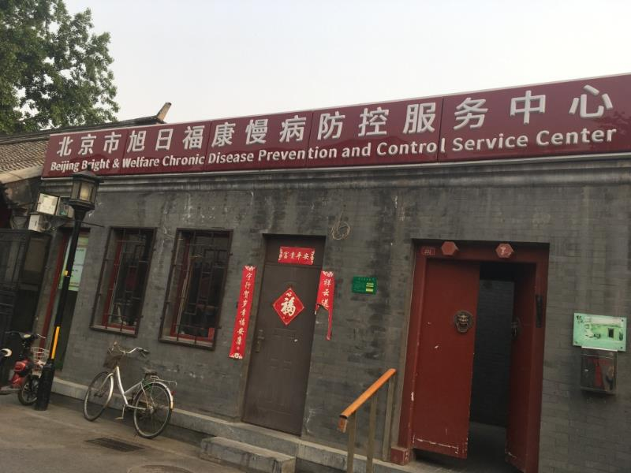
Image 4 China CDC local level Chronic Disease and Control Service Center, Beijing
Professor Wen Wang from Hohai University undertook a six-week course through Charles Stuart University on ‘Knowledge Sharing for Food Security and Water in Asia’. He found it broadened his ‘view on agriculture water management, how they monitor water management in the countryside and how they use some meteorological observations, use the stream flow and the canal gauging systems’. As a result, he is able to use this in his work as a Professor at the College of Hydrology and Water Resource at Hohai University in Nanjing.
The ICE WaRM and IWC fellowships – which involved the YRCC alumni from this Case Study – were also designed to provide trans-disciplinary approaches to water management. The fellowships called for participants to think beyond their defined roles and look more holistically at the water cycle and the management of water as a natural resource. These ideas were relatively new in China at the time and provided alumni with expertise ahead of the peers.
Ms Wang Zhongmei is a Senior Hydrology Researcher and project manager at the Yellow River Institute of Hydraulic Research. Prior to studying at the University of South Australia with ICE WaRM, her role was predominantly focused on engineering. With the shift in government policies and public attitudes to environmental protection and water management, she has found her knowledge of trans-disciplinary approaches have benefited her team and her ability to lead others.
When I studied in Australia, I gained knowledge about water recycling and wastewater. At that moment, I didn’t think that [it was] closely related to the professional work. However, after coming back, in recent years, the ecosystem problems and some deterioration occurred, and the situation of environmental protection became more and more important. The Chinese government changed the policy to encourage environmental protection, especially putting forward the protection of mountain water, forest, farming land and the lakes as an integral part to build that in total, so that we can transfer the focus from not only engineering structures to environmental provision.
Another key theme within this Case Study is the new thinking gained by alumni during their fellowships relating to the interconnectedness of population health with environmental health. One example of this is the involvement of alumni in the Healthy Cities initiative, which aims to improve urban environments and promote healthy lifestyles. With 57 per cent of Chinese now living in urban areas (World Bank, 2018), and predictions of 70 per cent by 2030 (Meyers, 2017), the government sees that it is essential to educate and empower citizens to improve their living and working environments.
For China, this initiative links closely with national policy relating to the environment. According to Professor Chu:
Healthy China is the main strategic goal, but Healthy Cities is one of their pathways, which is very smart because at the city level you can integrate programs and then develop just big enough to have the power to change things but really local enough to address just the people’s developmental needs.
Dr Hou Xiaohui, Head of International Collaboration in the Chinese Centre for Health Education, is now working on the Healthy Cities initiative. He also recently completed a project on the ‘vulnerability assessment of climate change in Jiangxi Province’ with a multidisciplinary team of researchers from South Korea, and Japan. Dr Hou attributes his Masters studies at Griffith University to his keen interest in multi-sectoral approaches to public health and big-picture planning, also noting that Professor Chu from Griffith is a key international figure in the Healthy Cities initiative.
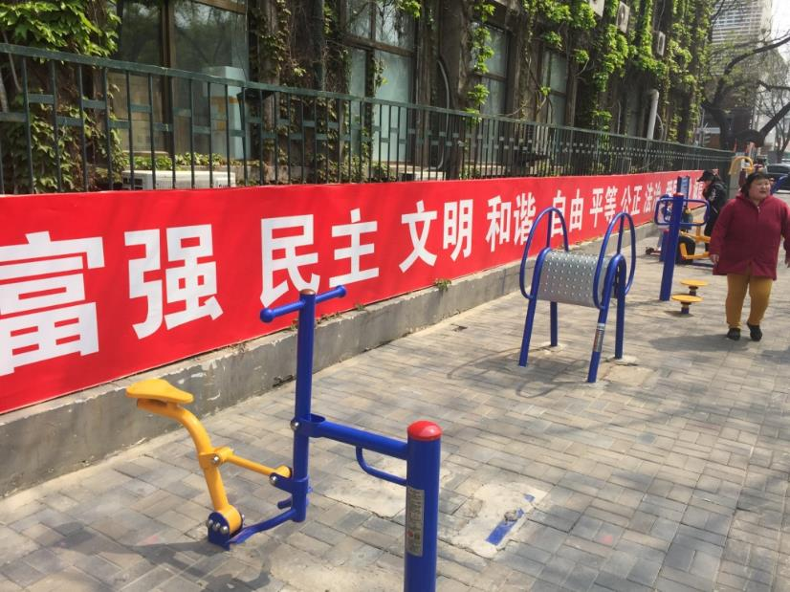
Image 5 Public exercise installations in Beijing – part of the Healthy Cities initiative

Improving public awareness of health and environmental issues
A strong theme throughout this Case Study was the use and implementation of environment and public health education campaigns to empower citizens to protect their health and local environment. This interweaves throughout the work alumni do and is embedded in multi-disciplinary responses to disease prevention and environmental issues. For Dr Hou ‘Health promotion, risk communication and climate change, [how] they connect to health. I think it’s these three main powers or powerful weapons I got from Australia’. He has used these in his international work in climate change and the Healthy Cities initiative detailed above.
During her time at Griffith University, Ms Jiang ‘learned very useful health promotion strategies’ which inspired her to work in NCD’s on her return to China. ‘I think the experience in Australia made me feel clearer about my future research interest, that is, health promotion focused on chronic disease.’
Ms Fan Jie works in media and publications at the YRCC. She is involved in spreading information about the work being done to protect and restore the Yellow River through social media, TV and tailored brochures and publications. As in the examples above, Ms Fan’s experience in Australia helped in building the messages of respect for the environment:
Yellow River management is very important for China, and it’s the mother river...So our mission is to let the public know the details. Now in China, the government pays much more attention to the environment and water saving, so the publication job is quite important for the organisation.

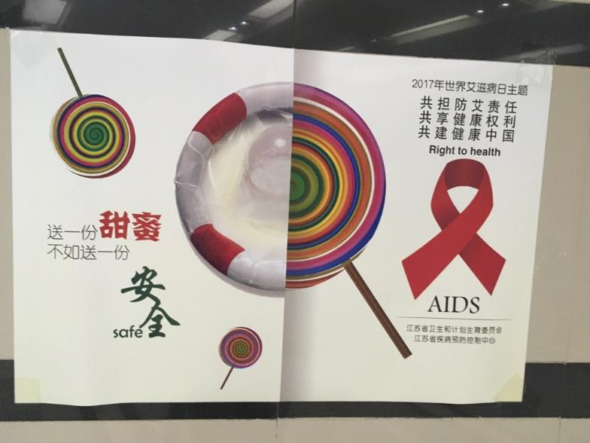
Image 6 Public health education campaign poster relating to HIV AIDS, Jaingsu CDC

Contribution to national and global policy
A number of China CDC alumni are contributing to national health policy design and the implementation of these initiatives throughout China. Key areas of policy contribution include health promotion and risk communication (Mr Guo Haijun, Ms Jiang, Dr Hou), climate change (Dr Hou), non-communicable diseases (Ms Jiang), Healthy Cities (Dr Hou), health security and infectious diseases (Mr Bao).
Other fellowship alumni not represented in this Case Study are also involved in the My Mental Health program, maternal and child health, food security, occupational health, global health security. According to Professor Chu, ‘alumni were also involved in the think tank for the 2030 Healthy China blueprint’ – the key national policy document relating to health and the environment for China.
In addition to the work at the national level, fellowship alumni are also contributing to global health policy. For example, Dr Hou was a key member of the international team tasked with drafting the Shanghai Declaration promoting health in the 2030 Agenda for Sustainable Development for the World Health Organisation in 2016. He was able to use his expertise in public health literacy and health promotion in the design of the document. He highlighted this as an important career achievement:
I am most proud that I had the chance to join the writing team for the Shanghai Declaration, which is the official document of the Ninth Global Conference on Health Promotion, which was for the first time held in China in the year 2016. We finished the draft in Geneva.
Prof Chu believes this global leadership in policy is one of the most significant impacts that the fellowships have had. In this respect, she emphasised:
I think this is the Australia Awards contribution: making the region safer. Then globally, ensuring global health is addressing those really in need and addressing the parity issue we face commonly. That’s bound to have an impact on Australia too.

Enabling Factors
As highlighted in this chapter, alumni have been able to make a range of significant contributions to the areas of environment and public health in China in the years following their fellowship. Throughout the interviews, a number of key enabling factors were identified that help facilitate these contributions. They are discussed here and relate to the fact that these courses provided alumni with critical thinking skills, the development of English language proficiency and research skills, and strong project management expertise.

Development of critical thinking
Fellowship alumni spoke about a ‘change in thinking’ during their studies in Australia as contributing to the development of their careers. Mr Zheng saw a change in his thinking about the ‘social, cultural and biological determinates [of] human health’. This provided him with a greater understanding of the public health sector in China and more able to design effective training programs for China CDC staff. Dr Hou found he expanded his critical thinking skills while in Australia which changed his career focus from the micro level (laboratory research into polio) to the macro level (national public health campaigns).
Learning about the interconnection of the health of the environment and the population was also instrumental in changing alumni perceptions and work practices on their return to China. Mr Liu from YRCC states he ‘gained a broader vision both academically and culturally’ of water management and environmental sustainability which influenced his future work.
The change in thinking also had an impact on the alumni’s intercultural competencies making them more accepting of different cultures and religions. Ms Jiang found it broaden her horizons:
I studied in Australia for a year. I know something about Australia and about other countries that opens my way of thinking, opens my horizons. That makes my life more colourful and I can tolerate more things, accept more, and that makes my personality more peaceful. I think that’s very important.

English proficiency and access to global research
Those alumni who studied for a period of time in Australia stated that their English language skills improved while on fellowship. Many cite their increased language proficiency as allowing them greater access to global research and opening opportunities to connect with researchers outside of China. This access has offered opportunities through joint projects, conferences, professional partnerships and promotion within their organisations.
According to Ms Jiang the ‘most important skills I learnt in Australia were the communication skills, and also the team cooperation [which] is very important during research.’ She highlights presentation skills and group discussions as really helping her to build her confidence.
In Australia, we had plenty of group discussion work, and we shared the duty of the same task, which was different from what I had experienced in China. Also, communication is very important. We seldom practised our presentations in China at the Chinese campus, but in Australia, every week we had a presentation task.
Another key aspect noted by alumni is that increased English proficiency has vastly improved their ability to access global information through scientific publications. English is seen as the universal scientific language and the majority of the world’s scientific research published in English. Therefore, this ‘places non-native speakers at a disadvantage’ (Huttner-Koros, 2015).
Mr Guo cites his improved English language skills as giving him evidence to support his research at the National Institute of Nutrition and Health and for motivating him to study a post-doctoral degree in Australia:
I heard that 80 per cent of the outcomes of research on this planet has been published in English. So, after my graduation, I was able to find the evidence from the internet directly. I think this is a kind of an advantage, that I can have access to the front information, very concrete, very solid information from the internet. Secondly, I also tried to publish our research outcomes internationally, and maybe this will improve the relationship between China and the other countries.

Project management skills
Most alumni interviewed in this Case Study attributed the project management skills they learnt during their fellowships as really helping their work to plan and implement large scale, national projects on their return to China.
For example, Ms Fan felt that her course gave her more than just an insight into integrated water management but also project management skills. She now runs large communications projects for the YRCC and notes, ‘The project management methods in Australia is quite different from that in China. So it’s very important for me’.

Fellowships tailored to suit needs
A key element of the success of the fellowships explored in this Case Study were the strong relationships developed between the host institutions and the Chinese organisations. The fellowships were tailored to the needs of the Chinese organisations and focused on building emerging leaders and international networks.
To facilitate this, YRCC and China CDC fellows were provided with English language support, placements, industry visits, and study tours while in Australia. Alumni all mentioned the practical elements of their courses which provided them with an insight to new ways of doing things and linked them to additional organisations such as Queensland Health (China CDC) or the Murray Darling Basin Authority (YRCC). Alumni also learnt about new cultures while living and studying with students from diverse backgrounds such as Vietnam, Bangladesh and Indonesia. These relationships are ongoing through the networks which developed between the organisations.

Challenges
Alumni in this Case Study identified the following challenges which affected their studies while in Australia and their ability to use the skills and knowledge acquired on their return.

English language skills critical for fellowship training
English language proficiency challenged a number of the alumni while in Australia. Many alumni stated that they had trouble listening and speaking when they first arrived. Mr Bao discussed this in his interview:
I came to class and listened to the talk, and it was difficult for me, so most of the time I tried to improve my spoken and listening capability. I found a language partner in the first year. She was very kind.
International English Language Testing System (IELTS) requirements became a hurdle for YRCC alumni in their achievement of postgraduate qualifications. Only two of the alumni interviewed were awarded a Graduate Certificate in Integrated Water Management due to the inability of many in the group to meet the required IELTS score of 6.5. This affected the relationship between the host organisation and YRCC and was also a source of disappointment for the unsuccessful fellows who returned home without the postgraduate qualification.
Dr Reid, the Chief Academic Officer, at ICE WaRM reflects on the issues:
‘There was a lot of argy-bargy, basically, between YRCC, us and DFAT and the university about the English language requirement. So the intention was for them to do the English language training and to get up to the appropriate IELTS level so that then they could get their grad cert through the university. The unfortunate aspect was: despite lots of effort, not all of them succeeded in getting to that IELTS level. I think from memory... only four or five of the group actually passed the IELTS test at the 6.5 level which was required, so then they could get the grad cert [graduate certificate]. So the others did not get a grad cert. They only got a professional certificate. So, whilst the participants did the academic requirements without any trouble, because they didn’t get the IELTS test score, they didn’t get the graduate certificate.

Cultural factors
Returning home to China, a number of alumni encountered barriers to change within their organisation. According to Mr Zheng, ‘when I went back to China there were not many people to consult with this critical thinking, this mind style’. Dr Hou also noted:
Because every one of us, when we came back from Australia, we wanted to use what we had learned to serve our country. Our friends and families in some cases made this difficult. Of course, the political system is a little bit different, as is the research environment and cooperation style and [there are some] cultural barriers. We have very good ideas, but we want to complete it very quickly, but no way. So I think it’s a kind of challenge, but we need to think a lot about how to combine both sides’ advantages and try to find a very practical way to get our goals. So I think it’s also a kind of chance for us.’
A common experience for alumni was the difficultly of readjusting to Chinese work culture and traditional ways of doing things on their return. Alumni cited the difficulty of enacting change due to hierarchical barriers and a resistance to thinking critically within their organisations. Acting autonomously, and sharing your ideas with others was not a common business practice and it meant that alumni faced challenges of getting innovative ideas and practices through.
Others suggested that it is easier in Australia to influence change and talk directly to the government or industry. One alum noted:
In Australia, I think it’s a little easier to communicate with the government, with other experts from different fields like agriculture or the veterinary field. But now in China, there are barriers in different departments, and sometimes we have difficulty communicating with officers from the government because they have a different perspective, different opinions.
This alum spoke about an outbreak of influenza which occurred some time ago and the difficulties in getting support to inform people of the risks because other departments thought it might cause widespread panic.

Changes in aid funding affecting regional development programs
Prior to 2011, the Australia-China aid program was valued at approximately AUD41m per annum and Australia Awards fellowships were part of the Australian Government’s official development assistance (ODA) to China aimed to build leadership capacity in key areas such as: governance, environment and health (AusAID 2010).
As discussed earlier, Australia has largely phased out bilateral aid to China. Rapid economic growth experienced over the last 30 years, has dramatically reduced poverty and saw China become one of the largest economies in the world.
Changes to eligibility of Australian Awards fellowships impacted the ability of host organisations and recipient organisations to continue to build capacity at a broader level.
Dr Reid explained how ICE WaRM was affected by these changes:
When China ceased to be an aid recipient country, and for a number of our programs, we actually couldn’t include China due to the rules. For example, in our Mekong program, we were really keen to get China involved in the Mekong programs because they’re the upstream country, and if you’re looking at trans-boundary water management, you really need to get China and their dam engaged with the lower countries. But unfortunately China was taken out of the list of countries who were eligible, so we couldn’t do that anymore.
According to Mr Mark Pascoe the current CEO of the IWC, it was a surprise to the YRCC leadership that this change in aid policy affected Australian Government support for fellowships. As a result, both YRCC and IWC revaluated their working relationship and sought alternative ways to fund their successful programs.
Initially, the removal of the fellowships did impact on the relationships between hosts and recipients like YRCC, as it was seen as a bureaucratic end to a program that was working well. However, over time the relationship has continued, with IWC running YRCC funded bespoke training projects in water management.

Latent impact
Three alumni, in particular, spoke about how it took time for them to digest the knowledge that they learnt and for the right role or situation to come along for them to use the skills and knowledge they learned while on-award. Especially for those studying water management, links to environmental sustainability and conservation were yet to make an impact on their industry in China when they arrived back from their fellowships (between 2007 and 2009). Mr Song felt ‘we just got too much information and we needed some years to digest it, and just to come back to our real work’.
Ms Xi stated ‘I think when I was in Australia, I was too young to understand all the teacher taught us because at that time I was just a staff member in the human resource department. After I returned to my organisation, I think something is very useful but I could not make sense of it when I was there. It was a challenge. When I became a leader, I could make sense of all that they taught us.’

Economic and Public Diplomacy Outcomes

Summary findings
Alumni and the organisations involved in this Case Study have strong and enduring ties to Australia. Relationships have been fostered strongly through the Australia Awards fellowships and are embedded via various MoUs between Chinese and Australian organisations. Partnerships and cooperation were identified in this Case Study in the areas of:
- ongoing capacity development programs
- multiple research collaborations in environment, water management and public health
- contributions of Chinese and Australian partners to global cooperation in fields including hydrology, climate change, communicable disease control and disaster management.
The strong examples of sustained partnerships between alumni and their organisations demonstrate that the Australia Awards long-term Outcomes 2 and 3 are being achieved in this Case Study.
Factors enabling alumni and their organisations to develop these relationships include:
- the development of intercultural competence and English language in facilitating Chinese alumni to remain linked with Australia following the award
- fellowship funding as a mechanism for ‘fertilising’ relationships that are now ongoing
- the flexibility of the fellowships in the early years to tailor courses to meet the needs of partner organisations
- Australian hosts’ pre-existing relationships with organisations in China and the cultural understanding of how to work with China.
Alumni and stakeholders identified a few challenges to the further development of relationships, including:
- the loss of connections in the time between learning new skills and being able to apply them
- consistency and continuity of funding for fellowships.

Introduction
This chapter describes how alumni and their organisations are contributing to Australia Awards long-term Outcome 2 ‘cooperation between Australia and China’, and long-term Outcome 3 ‘establish effective, mutually advantageous partnerships between institutions and/or businesses in China and institutions and/or businesses in Australia’. The Australia Awards Global Monitoring and Evaluation Framework Global MEF) describes activities under these outcomes as facilitating business or trade links, participating in international or regional bodies, or advocating the relationship (e.g. promoting study in Australia).
Australia Awards fellowships are specifically intended to support connections between governments, businesses, and non-governmental organisations (NGOs) in partner countries and Australia. As noted in the Global MEF, this is due to their ‘tailored approach to skills development’ which may include opportunities to network, or undertake internships or work placements. As a result, there are two types of outcome in terms of networks and cooperation between Australia and China identified in this Case Study. One relates to the links developed by alumni individually as a result of their on-award experience, and the other is the relationship developed between the participating organisations (i.e. the host in Australia and the recipient organisation in China) as a result of the fellowship partnership.
The examples in this chapter demonstrate ongoing cooperation between alumni and Australia, as well as the strong and enduring relationships between Chinese and Australian organisations. In addition, the outcomes point to a further benefit of global collaboration and cooperation developed by alumni often as a result of their connections or experiences in Australia. These examples suggest achievement of Australia Awards long-term Outcomes 2 and 3 for this group of fellowship alumni and their organisations.

Background
Australia and China have strong economic and diplomatic ties; a relationship described in a 2014 joint country agreement as a: ‘comprehensive strategic partnership’ (DFAT, 2018). China is Australia’s largest export market and Australia’s largest source of imports. The trade value of the Australia-China relationship exceeded $155 billion in 2016 (DFAT, 2018).
Australian education is one of the significant contributors to exports to China, enjoying steady growth over the past few decades. In 2018 more than 165,000 Chinese international students were studying in Australia, representing 31 per cent of all international students (DET, 2018). As a result, the presence of alumni from Australian education institutions in China is substantial. It is estimated that over the past 20 years approximately 500,000 students from China have completed a higher education qualification in Australia. These links through education have been the foundation of numerous alumni associations, particularly the Australia China Alumni Association, as well as notable alumni networking by individual Australian universities.
In terms of partnerships and cooperation, Australia’s bilateral aid commitment to China has changed over the past decade, as China assumes an increasing role as an aid donor. An MOU in 2013 (and renewed in 2017) ‘facilitates Australia and China cooperating on shared development objectives on issues of regional or global importance’ (DFAT, 2018) and represents a formal turning point in the aid relationship of the two countries. The commitment to cooperation on this front is exemplified in one of the many examples discussed below.

Examples of cooperation and partnership
A multitude of examples linking the alumni and their organisations in China with Australia and Australians were collated through this Case Study. Across these examples, three core themes emerged: partnership through capacity development programs run by Australian institutions; collaborative research projects involving alumni and Australian partners; and contributions to global cooperative programs where skills developed in Australia and with Australia institutions have helped broaden networks.

Australia-China capacity development programs
The Australia Awards fellowships have been the foundation of a number of strong, ongoing networks between China and Australia in two particular fields relating to environment: public health and management. In the area of public health, a long-lasting partnership has been built between China CDC and Griffith University’s Centre for Environment and Population Health (CEPH) (see Box 1 for further background). In water management and environment, YRCC has established relationships with the South Australia-based ICE WaRM and the Queensland-based IWC (see Box 2 for further background).
At the core of each of these partnerships has been capacity building in fields in which Australian institutions are able to contribute significantly. For China CDC, the decades-long collaboration with Griffith University was notably strengthened when the fellowships were established. Since the first round of fellowships in 2007, the CEPH has secured funding in 11 Australia Awards fellowship rounds, during which 58 China CDC professionals have participated.
The former head and founder of China CDC, Professor Liming Li, notes that the long-term nature of the capacity building partnership with Griffith University has consolidated relationships for the future in all levels of China CDC. Professor Li highlighted that alumni: ‘take a very important role as the new bridge in China at different levels of the CDC system so we can develop some international or nation-wide cooperation programs.’
For the YRCC, Ms Sun Feng, who is a central figure in the relationships with Australian institutions noted the importance of the capacity building aspect of the partnerships: ‘Through this training program – we call it our “best building” training program – we have really established a very good relationship with Australian partners like ICE WaRM and IWC.’
The success of these partnerships has been in the impact that alumni have been able to make in cooperation and skill development on return. Ms Sun shared that while the number of alumni from the fellowships (approximately 100) is small in comparison to the overall size of YRCC (40,000 employees), ‘from the international cooperation point of view, the fellowships really influenced [YRCC]’.
The capacity building aspect of the relationships noted above has extended beyond the fellowship training itself. Since the funding to China for Australia Awards ceased, both YRCC and China CDC have continued jointly-funded training programs with Australian partners. This has included delivery of programs similar to the fellowships in Australia as well as Australian’s travelling to China to run workshops and lectures.
Australia Awards alumni from Griffith University have also returned to Australia on other scholarships to complete higher degree programs. Dr Hou and Mr Guo are two alumni specific to this Case Study who have followed this path. Dr Hou received a Griffith University Vice Chancellor’s scholarship to undertake his doctorate with Professor Chu, while Mr Guo has just begun his doctorate at Griffith University on an Australia Awards Endeavour scholarship. Prof Chu notes ‘we have a very good success rate of people returning to do a PhD, completing that, and now a few of them want to come back to do a postdoc [post doctorate].’
In a formal sense, alumni and stakeholders in China and Australia mentioned various MoU documents that have been established to consolidate partnerships over the past decade. Such MoUs have been established within and across each of the key organisations involved in the fellowships discussed in this Case Study.
In addition to these direct MoUs, the relationships have also expanded into other Australian and Chinese organisations. Professor Chu from Griffith University highlighted that ‘we’ve developed so many MoUs because of the [fellowship] program…and one of the outcomes is that the actual function of the MoU was developed through the alumni link.’ For example, when alumnus Dr Hou moved jobs from China CDC to the Chinese Centre for Health Education, he helped his new organisation instigate an MoU with Griffith University. It was this organisation’s ‘first MoU with a foreign organisation’ and involves the Australian and Chinese partners working towards ‘cooperation in health promotion and risk communication.’
The YRCC’s MoUs with Australian institutions also extend beyond fellowship hosts ICE WaRM and IWC. Ms Sun highlighted an MoU her organisation has had with the Murray-Darling Basin Commission for the past decade, organised around water events and based on the ‘similar challenges’ that the river systems in these countries face.

Research partnership
While training and capacity development has been the foundation of the relationships identified in this Case Study, the ‘offshoots’ of these relationships have included a number of research projects and partnerships. Mr Zheng highlighted the importance of this during his interview, noting the expansion of focus for China CDC in their relationship with Griffith University: ‘We signed the second round MoU to not just focus on the professional training program but also to have research cooperation with each other.’ In many ways, the move towards research partnerships exemplifies the maturing of the relationships between the organisations highlighted in this Case Study.
In the area of water and environmental management, YRCC alumni spoke of collaborative projects with both IWC and ICE WaRM over the past decade. These included a three-year project relating to environmental water flows, environmental law and cooperation on projects in environmental protection. As mentioned by Ms Pang, these projects expanded on the new approaches and thinking that were gained while on-award in Australia and applied them to the Chinese context: ‘Now environmental protection gets more and more focus. Years ago it was not the focus of YRCC, but now it is different; it’s one of the important tasks now.’
Collaborative research between China CDC and Australian institutions is also strong, with alumni mentioning involvement in projects in the areas of climate change, environmental health, communicable disease control, health promotion and prevention-based projects in women and children’s health. Many of these joint projects involve Griffith University, where these alumni studied. However, alumni did offer examples showing collaboration beyond Griffith University, as Professor Liu noted:
We have a lot of joint publications and joint projects [with Australia]. This is very good. But it’s not limited to Griffith University – we also work with Adelaide University, Sydney University, QUT and others.
In addition to these examples, China CDC is involved in the first research project to come from the Australia-China Development Cooperation Partnership Memorandum of Understanding. The project involves a trilateral partnership between Australia, China and Papua New Guinea, (PNG) and aims to ‘increase the quality of malaria diagnosis in PNG health services’ as well as ‘pilot effective cooperation between Australia, China and PNG’ (Australian Pacific Loan Market Association (APLMA, 2016). This is a significant project in the context of bilateral relationships between Australia and China.

Contributions to global cooperation
Importantly, fellowship alumni and their organisations spoke about the way in which they are making collaborative partnerships across the globe in their areas of expertise. Often these collaborations also include Australians, and in many cases, the interest and confidence to take a global outlook have been inspired by the experiences in Australia.
An important example of this is the International Yellow River Forum organised by YRCC. According to Ms Sun: ‘In Australia, you have the International River Symposium and then in China with the YRCC, we have our International Yellow River Forum. So we send our delegates to join, to take part in their festivals, and also they send theirs to come to us.’
As highlighted by Ms Pang, the YRCC Forum is truly global and relies on alumni from the Australia Awards fellowships for its success:
I feel proud of one international activity we have organised, and that’s the International Yellow River Forum…It gathers the water experts and the water managers from dozens of countries…I think for this International Yellow River Forum, all of us, those trainees who have received overseas training have contributed a lot…I think the training program helped to organise such a grand event.
Another alumna, Ms Fan spoke about directly drawing on links she had made in Australia during her fellowship in order to help in organising the Forum. Ms Fan had undertaken a placement while in Australia with the company that organises the internationally renowned Riversymposium. When back in China and helping to organise their Yellow River Forum, Ms Fan made contact with her Australian hosts to assist with some of the queries she had.
International collaborations in research and in the practical implementation of expertise were also among the key achievements highlighted by alumni in this Case Study. Among the alumni interviewed were examples of collaboration through international organisations and groups such as:
- the World Health Organisation – which funds the China CDC WHO Collaborating Centre for Vector Surveillance and Management
- membership of international advisory committees on climate change (Dr Hou)
- multinational collaborations focused on emerging infectious diseases (Mr Bao)
- international leadership hydrology research (Ms Jin and Mr Song).

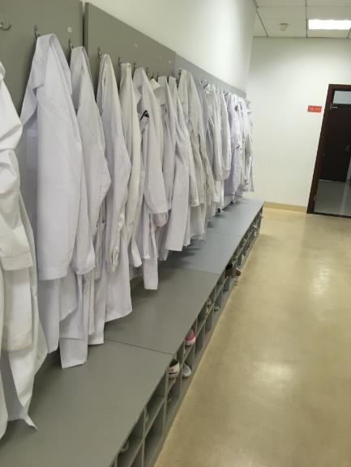
Image 7 Lab coats at the China CDC's WHO Collaborating Centre for Vector Surveillance and Management

Enabling factors

Fellowships help ‘fertilise’ relationships
The Australia Awards fellowships are themselves an important factor in facilitating relationship building between host institutions in Australia and organisations in China.
A consistent theme in the interviews for this Case Study related to the way in which the funding for the Australia Awards fellowships was the mechanism by which the now long-term relationships were able to be consolidated. For both China CDC and YRCC, the first round of Australia Awards fellowship funding came at a time during which they were beginning to look abroad for opportunities to build capacity. The access to funding was a central piece that helped to ensure that the training was able to develop with Australian institutions.
In both the organisations in China that feature in this Case Study, the slight pause in funding for Australia Awards fellowships to China did not mean that the relationship ended. But without the initial funding to establish a partnership, it is less likely these relationships would be continuing today.
The fellowships have also fostered relationships that have pushed into research collaborations for both the Chinese alumni and the host institutions. Ms Pang highlighted that the fellowships have enabled her and her YRCC colleagues ‘to understand cooperation with Australian partners.’ She noted that as a result of the long-term relationship through the fellowships, when they are looking for international partners, Australians will be the ‘first’ choice ‘because we have cooperated for a long time and we know we can rely on each other’.
These long-term relationships, consolidated through the Australia Awards funding also benefit Australian hosts. The vast network of partnerships with China of Professor Chu’s Centre for Environment and Public Health at Griffith University is indicative of this. As Professor Chu notes ‘we’ve progressed to now become a regional hub for health security because we are so closely working with different countries’.

Flexibility of the fellowships
The host partners saw the early years of the Australia Awards fellowships as successful because of their flexibility. As noted by Mr Pascoe of IWC, developing the initial Australia Awards fellowships was ‘literally an iterative process…We say [to the organisation being supported] “How about this?” They say “How about this?”, so there’s a bit of argy-bargy to get to rest on the final program’.
In the examples explored for this Case Study, this flexibility has enabled both the hosts and the fellows greater opportunities for collaborative outcomes and innovation in program design. In the IWC example, there was an opportunity to drive participants in a bus down to the Murray-Darling basin from Brisbane to Adelaide to learn about management of water across the whole system: ‘They had an incredible experience, an experience that most of the rest of us don’t get to have, actually.’
The flexibility of the fellowships regarding the selection of participants was also an important feature of the early success, according to ICE WaRM’s Dr Ian Reid. This particular aspect no-doubt also assisted in equipping participants with some of the cross-disciplinary aspects highlighted in Chapter 4:
There was a lot of discussion with management at YRCC about choosing mid-level people, people who weren’t at the end of their career but had least five years’ experience, looking for gender balance as much as possible, and also looking for people across discipline areas, so we get some cross-fertilisation of ideas.

Pre-existing relationships
Each of the Australian host organisations featured in this Case Study had spent a number of years fostering relationships in China before the Australia Awards fellowship funding opportunity eventuated. The pre-existing relationships enabled the successful building of applications for fellowship funding, and also acted as a foundation for maintaining connections once this funding source ended.
For example, ICE WaRM had a long association with Chinese water organisations, including an MoU with YRCC prior to the fellowship funding. Dr Ian Reid of ICE WaRM noted that the Australia Awards fellowships were ‘a useful vehicle to provide the resources and framework to carry out the remit [of our MoU]’. For Griffith University, the founder of China CDC Professor Li highlighted the role Professor Chu had on his organisation: ‘Cordia Chu took a very important role as the bridge and the country builder for international health cooperation and capacity building...I am deeply thankful for Griffith University and especially Cordia Chu for their role in supporting the fledgling China CDC in the mid-2000’s.’
Relationship building and networking are very important in Chinese culture. Each of the host institutions effectively used ‘guanxi’ – the Chinese style of networking and relationship building – to create and sustain multifaceted academic partnerships with their Chinese partners.
In her interview, Professor Chu noted that although many organisations try to develop relations in China, they don’t succeed as they treat relationships as ‘business transactions’. Likewise, Dr Reid of ICE WaRM highlights that:
In China everything goes through the central ministry, so you have to have good linkages, a good understanding of the central ministry to get your foot in the door...We were in the fortunate situation that we’d had people who’d worked with them in the past and had a good experience there.

English language and global view through training
The benefit to alumni and their organisations through the improved English language skills were highlighted in detail in the previous chapter, especially in relation to access to scientific information and knowledge. Proficiency in English has also been notable in providing alumni with a key means of communication for developing partnerships with Australia and more broadly across the globe. Ms Pang clearly articulated this benefit:
We learned professional language, how to express some professional concepts accurately. That helped me to understand some professional knowledge and also to realise what kind of areas are suitable for YRCC to develop cooperation.
Alumni were also exposed to a broader world view through the fellowships. Culturally, alumni spoke about the significant benefits of ‘going abroad’. Dr Hou noted that when ‘we share our cultural experience’ it ‘enhances our connection’. Likewise, Ms Pang highlighted ‘when you have stayed in a foreign country…you get closer with that country and with people there, so after that, if there is work you need to develop it is helpful to connect with some familiar partners…older friends.’
In tandem, the language proficiency, and cultural competency played an integral role in building the confidence of alumni and their organisations. Their time in Australia equipped them with skills to locate appropriate partners and develop the kinds of collaborations discussed earlier in this chapter – and this has often been to the benefit of relationships with Australian organisations.

Challenging factors

Funding for fellowships
As noted earlier, in 2013 the signing of an MoU between Australia and China, officially altered the bilateral relationship from one in which Australia provided donor funding, to a more cooperative outlook focussed on contributing to ‘shared development objectives on issues of regional or global importance’ (DFAT, 2018).
This change in funding presented a challenge for the host institutions in Australia and participating organisations in China because the generosity of the Australia Awards had been a significant factor in sustaining relationships. One of the Australian hosts noted that the change came as a bit of a surprise, especially to the Chinese partners.
In the course of the Case Study, the issue of funding became a notable question from leaders of Chinese organisations. The research team was asked ‘Why are you interested in us if your government is no longer funding this program in China?’ So, while relationships continue, the change in funding does remain a point of contention.

Losing connections over time
Another factor impeding the ability of some of the alumni involved in this Case Study relates to the ‘latency’ factor discussed in the previous chapter. Some alumni indicated that by the time they had a project or opportunity to utilise their Australian connections, they had lost contact. As noted by Mr Song, ‘maybe at that time [immediately after fellowship] we don’t have our own project…But later, if we want to carry out a similar project, it’s harder to just connect again after a long time.’ Similar issues were highlighted by Ms Wang, ‘now I feel that [waste water treatment] knowledge is useful, but I have lost many connections.’

Views about Australia and Australian Expertise

Summary findings
Alumni in the China Case Study hold enduring positive views about Australia, Australians and Australian expertise especially in the areas of public health and water resource management.
The Australia Awards long-term Outcome 4, that ‘Alumni view Australia, Australians and Australian expertise’ has been achieved based on the evidence provided by alumni in this Case Study.
Alumni shared examples of positive views of Australia and Australian expertise as a result of their positive experiences of life and study in Australia and the support they received on-award. This included tailored English language classes, language partners, industry visits, study tours and cultural activities. In particular, alumni emphasised:
- that Australia is a global leader in their fields
- the high quality of teaching and learning received in Australia
- positive cultural experiences.
English proficiency did cause some challenges for alumni while on-award, however, this did not impact their positive views of Australia and Australian expertise. Expectations regarding postgraduate qualifications did impact those YRCC alumni who were unable to receive formal acknowledgement for their studies in Australia due to IELTS proficiency requirements.

Introduction
The Australia Awards aims to develop positive views of Australia, Australians and Australian expertise (DFAT, 2016). One element of the ‘theory of change’ that underpins the Australia Awards is that undertaking an Australia Award will result in outputs that include:
- awardees/fellows and their families have a positive experience of life in Australia
- awardees/fellows complete good quality, relevant education, training, other professional development and research activities.
It is assumed that these factors will translate to the long-term outcome of alumni viewing Australia, Australians and Australian expertise positively. This outcome, in tandem with those relating to the development of skills, networks, cooperation and partnerships, will contribute to the overall goal of the Australia Awards: that ‘partner countries progress their development goals and have positive relationships with Australia that advance mutual interests’ (DFAT, 2016).
This chapter includes evidence of Australia Awards fellowship alumni’s views about Australia, Australians and Australian expertise based on their experiences in Australia and at Australian institutions. Their views relate to receiving effective support, having positive experiences of life in Australia, and perception of the fellowships.
These perceptions shared by alumni and stakeholders demonstrate that the Australia Awards long-term Outcome 4, ‘Alumni view Australia, Australians, and Australian expertise positively’, has been achieved.

Examples of positive views of Australia and Australian expertise
All alumni in this Case Study shared positive views as a result of their time in Australia and spoke warmly of their experiences living and studying in a foreign country. Many found the chance to study in Australia as transformational. The fellowships in this Case Study ranged from six weeks to a year, with alumni having a range of study experiences, including interaction with Australian organisations through industry visits, work placements and study tours.
In this section, the positive views and experiences of alumni are discussed in three broad areas: respect for Australia as a global leader in fields of expertise relevant to these alumni, the quality of teaching and learning experienced in Australian institutions, and the positive experiences of culture and lifestyle gained while in Australia.

Australia is seen as a global leader in water resource management and public health
Australian expertise in the fields of public health and water management are highly respected in China.
Both ICE WaRM and IWC have a global reputation for innovative, professional development courses on integrated approaches to water management. These Australian organisations worked closely with YRCC to customise their fellowships and help shift the focus from engineering to a whole-of water-cycle approach to water management. Mr Liu sums up the feelings of other YRCC alumni: ‘I do think the quality of Australian expertise is in a very good level. Especially those relating to water resource management and water treatment.’
Ms Fan recalls her course was at least 10 years ahead of what was happening in China at the time and this had a large impact on alumni:
The most precious achievement from the course in Australia, for example, the concept of water saving and water governance, especially the sustainability of water development.

Griffith University is seen by senior leaders and alumni from China CDC as a world leader in environment and public health practice and promotion. Professor Li, the founder of China CDC, chose to partner with Griffith University as part of the initial capacity building phase of the fledgling organisation because it was:
‘Strong in environment health and population health, and that part is very important for China’s new CDC to establish the service system and the capacity building. It’s very experienced research, training, and practice in Australia, so we needed this kind of idea because in the United States its [CDC] is very strong only in basic research side, not the population-based practice. So this is why we selected Australia.
For alumna Ms Jiang, Griffith University’s socio-ecological model of public health was essential to her development as a researcher because it emphasised the different interactions between the social, biological, environmental and economic determinants of health. She became interested in chronic NCD’s and on her return to China joined the division of Non-communicable Disease Control and Community Health to work in health promotion.
I can say Australia is the expert in health promotion, especially focused on chronic disease, because you know in China we have strengths in infectious disease, but we have little experience in how to control chronic disease successfully. In Australia, I learned the concept of health promotion and community empowerment and community participation. That was very interesting and a very fresh concept for me that I didn’t learn in China. Also in 2008, when I finished the Masters degree, my project was focused on the Australia nationwide physical activity promotion program named the 10,000 Steps. That’s a very interesting project. And now in China, about three years ago, we also have our own 10,000 Steps program.
Mr Gou, an alumnus who will be returning to Australia to undertake his doctorate, maintains a high regard for Australian expertise in his field:
Australia is located at a very high level of health promotion and policy-making, and we draw upon the methodology framework of the research from Australia, and that is really valuable. For example, when we did our Chinese National Dietary Guidelines Review, and we needed some evidence to support the solutions, some conclusions, we did the evidence assessment and we drew upon the methodology and the framework from Australia.

Quality of teaching and learning
Alumni and their employers have positive views about the quality of teaching and learning in Australia. Each fellowship was uniquely designed by Australian experts to build capacity and leadership in Water Management, Public Health and Food and Water Security. Fellows were provided with a unique insight into Australian culture through industry visits, work placements, study tours and social activities.
Ms Fan noted that she was “impressed” by the learning and teaching style in Australia which was very different to China at that time. She enjoyed studying with other international students and sharing ideas and experiences:
I attended the Master course at UQ, so many classmates from different countries like Vietnam, Ecuador, Pakistan and even Africa. So we many international communications. I got many different modes of thinking, and also learned many different habits and things from different countries.
My Bao recalls the teachers as being very supportive, and approachable. He also found the facilities at Griffith University’s Nathan campus were of a very high standard:
The teachers’ pay much attention to the students to improve their capabilities and provide very good resources. The libraries are open to search for everything they want, so it’s really good for them. The teachers are very kind. If you have any questions, you can talk to them directly or write an email. They give you an answer very quickly. If you have any problems, you can talk to your teachers, not just study, maybe living or other things.
A number of alumni emphasised the focus on building critical thinking skills and examining problems through a variety of lenses. Mr Gou remembers working in groups as being very different from Chinese classroom experiences:
We did some product research together in a group and we discussed with our group members, we learnt from each other and we got ideas from each other, so we finally have a good report for our product. It was a very happy and enjoyable time.
Alumni in this Case Study all received specialist English language support and strong pastoral care while in Australia. This support ranged from language partners and tailored English language classes for public health at Griffith University to additional English language support for YRCC alumni at the University of South Australia and the University of Queensland. Ms Jiang positively recalls the support she received while in Australia.
In 2008 when I was studying at Griffith University, there was an activity called Language Partners at the school campus. So I had an Australian girl – she was studying at Griffith too – and she and I were language partners. We met each other once a week at the Griffith University campus.
Griffith University [also] arranged a teacher focused on English communication and that really, really helped us to improve our communication skills. That’s very helpful.
Alumni returned to China and shared their positive experiences with their colleagues, encouraging others to study in Australia. Two of the Case Study alumni returned to Australia to undertake doctoral studies at Griffith University, and Mr Bao is planning to send his son to the University of Queensland in Brisbane after his own positive experience.
I am sending my son, my only son, to study in Australia in Brisbane. Maybe from July this year, he will go to the University of Queensland. He wants to study the subject of biological and chemical engineering. I think that Brisbane is a very, very beautiful city. He wanted to go to study in Sydney or Melbourne but I recommended he go to Brisbane. He likes Australia very much because he has the experience to travel to the United States and to Australia but he compared the two countries and he chose Australia.

Lifestyle and cultural experiences
Alumni in the Case Study had positive experiences of Australia and Australians, highlighting the beauty of the landscape and the richness of cultural diversity. Ms Pang remembers Australia as ‘quite beautiful with large areas, small population and an advanced economy’. Alumni all recall Australia as a multicultural country, and Ms Jiang’s reflection sums up many of the alumni comments.
I think Australia is a multicultural country, people from all diverse countries and they live together and they share a different culture, different opinions.
Many alumni recalled positive memories of their teachers providing them with an insight into Australian culture through opening their homes and engaging with alumni socially. Ms Fan remembers ‘they organised barbeques, maybe in the house of different staff or a park’ which was a ‘great experience’. Her colleague, Mr Song, fondly recalls learning and about football. ‘It was a good way for us to know about Australian culture’. Mr Zheng recalls that Professor Chu ‘look[ed] after us like we are her children’. She was ‘very good because she designs the course…she gives us the opportunity to contact the culture of Australia, to see shows or go to church and have many parties’.
Those alumni who studied in Australia for seven months to a year, felt their time in Australia changed their perceptions of other cultures, lifestyles and religions, and provided them with a new way of seeing the world. Mr Bao fondly remembers his experience studying with students from other nationalities as building a broader understanding of different religions and cultural norms:
So we had guys from different countries. They had a different culture, like the guys from Indonesia, most of them were Muslims. So they had a very different traditional culture from ours. So throughout our study in Australia, I have learned how to collaborate with different backgrounds. We all got along very well. In the same hall, we had eight people: four guys from Indonesia and four from China. So we studied and lived together.
The YRCC fellowship alumni also visited a number of different regions during their studies, meeting people from a range of industries related to water management and experiencing both rural and urban communities across Australia. These alumni have a strong impression of Australia and Australians as being very environmentally aware, especially in regards to water conservation and management of pollution. For example, when Ms Fan arrived in Australia, she discovered that she wasn’t just going to learn about water management but she was going to have to practice water conservation too. She remembers that during her time in Australia there was a drought and the government had a public campaign to limit water use:
The government asked people to limit their bath time to four minutes. When I arrived at the apartment, the manager told us: you should pay attention to that because of the shortage of water, and the concept of water saving impressed me very much.

Challenge to positive views of Australian institutions
Although the majority of the alumni had very positive experiences of Australia and Australians, a number of YRCC alumni found their level of English proficiency did impact on their experiences in Australia, and on the achievement of an Australian qualification. For a number of alumni, the inability to achieve the required IELTS result had a negative impact on their views of Australia’s strict IELTS regulations and the shortness of their stay.
Dr Reid from ICE WaRM points out that the inability of some alumni to meet the IELTS requirements caused some problems. Alumni had ‘all passed the subjects for the graduate certificate. If it wasn’t for the English language requirement, they would all have a graduate certificate’. According to Dr Reid, this impacted the relationship, as YRCC felt they were promised something that wasn’t delivered due to what was seen by YRCC as a technicality. Mr Liu sums up the mixed feelings of those YRCC staff affected ‘we are thought to have overseas training, but most people like our classmates have only got an uncompleted degree.’

Impact of Australia Awards on Addressing Equity Issues

Summary findings
China has undergone a significant economic transformation in recent decades. A contribution to and result of this change has been a population movement from rural to urban areas. This massive internal migration has exposed a number of inequities in terms of wealth distribution and access to services.
Alumni and stakeholders interviewed in this Case Study highlighted that the opportunities for women and people with disability were very different depending on whether they lived in an urban or a rural area. Substantial improvement in opportunity was spoken about for those living in cities, but there remains a significant disadvantage among these groups in rural areas.
Alumni themselves are contributing to the reduction in inequality through their policy and research work. In particular, many of the initiatives by alumni in the area of public health are particularly focussed on improving outcomes for those who are most vulnerable to disease and natural disasters – women, children and people with disability.

Introduction
This chapter explores the impact of the Australia Awards in addressing equity and disadvantage in China. It explores how interventions to ‘address barriers to participation and provide on-award/post-award support where participation by women, people with disability and other disadvantaged members of society is low’ (DFAT, 2016a, p. 12).
This chapter offers some context to equity issues in China, exploring the views of alumni and stakeholders who participated in the Case Study as well as highlighting some key statistics relating to gender and disability. It then discusses the experiences of alumni in terms of access to the fellowships and concludes by outlining the impact of the alumni from this Case Study in addressing equity issues.
It is important to re-state that China is no longer a recipient country for the Australia Awards, and as such the extent to which this chapter is able to closely examine the role of the Australia Awards in promoting equity at present is restricted.
The China Case Study involved six female and eight male alumni. None of the alumni identified as having disability and all were currently located in an urban area of the country.

Background
As a country of 1.4 billion people spread across a vast expanse spanning coastal, mountain, desert and grassland areas, China is a large and complex nation. A central issue to equity in China is the substantially unequal distribution of wealth between urban and rural populations. On this measure, China has one of the largest disparities in the world (UN Women, 2012). This disparity is linked to the massive changes in China’s economy over the past few decades and the pursuit of growing opportunities in urban areas. Within a generation, this shift in China has been tremendous – in 1960 only 16 per cent of China’s population lived in urban areas, by 2016 this figure had risen to 57 per cent (World Bank, 2018). This inequity manifests in different ways, especially in relation to opportunities for women and for people with disability.

Gender
National legislation in China emphasises that women and men are equal before the law. China has a nation-wide gender equality plan and framework, encapsulated in its Program for Chinese Women’s Development (2011-2020). The implementation of this plan and other gender-related policies are the responsibility of China’s All China Women’s Federation (UN Women, 2012).
In terms of national leadership, while 24 per cent of seats in national parliament were held by women in 2017, among ministerial positions in government, women comprise 10 per cent (World Bank, 2018).
Significant gains have been made by women in China’s growing cities, where ‘increasing numbers of women [are] pursuing higher education, are in waged employment, or have started small businesses’ (UN Women, 2010, p.1).
The alumni involved in the Case Study, who live in urban areas, reflected these outcomes through their interviews, highlighting that they saw strong gender equality in China. For example, Ms Pang noted, ‘It’s easy to find we [women] are equal…especially in cities’ and Mr Liu said ‘China is a country where gender equality is not a problem, especially in the professional workplace’.
However, as highlighted by UN Women, ‘In rural China, although women make up 65 per cent of the rural labour force, they occupy only 1-2 per cent of local decision-making processes’ (2012, p.1). This disparity was also picked-up by alumna Professor Wang, who linked this outcome to the policies of the past in China, such as the ‘One Child’ policy: ‘In China, many farmers want to have a boy, but if they find the born baby is a girl, sometimes they just send it to someone else. That’s a big problem in the rural areas.’
Regardless of locality, one area noted by some stakeholders and highlighted by UN Women is the disparity in retirement ages for women and men in China. Women’s retirement age is five years younger than men. This policy restricts women’s capacity to maximise lifetime earnings and to receive pensions equal to those of men.

Disability
Estimates suggest that approximately 6 per cent of the Chinese population have a disability (World Bank, 2013). The International Labour Organisation (ILO) notes that over the past few decades, a range of legislative and regulatory measures have been made in China to recognise people with disability, outlaw discrimination and mandate quotas for employment of people with disability in public sector organisations.
In addition, the Chinese government has introduced free 12 years of education for children with disabilities and is promoting the development of a quality, special education system as part of their commitment to meeting the SDGs. The Program for Promoting Special Education: Phase II (2017-2020) aims to achieve 95 per cent enrolment rate of disabled children in compulsory education (Ministry of Education, China 2017)
Alumnus Dr Hou, discussed the attitudes he has witnessed in recent years to illustrate this change:
this issue has more attention paid to it…for example, in the bus or subway [they have messages such as] “Please give this seat to disabled people”…so there is this kind of example from the government because we know the disabled population should be paid more attention here for their health, for their equality.
However, challenges in reducing stereotypes, and improving educational outcomes for people with disability persist. The ILO highlights that ‘people with disabilities remain a vulnerable group and many still encounter specific difficulties in a society whose economy is experiencing a tremendous market-oriented transition.’ One element of this impact is the mobilisation of the Chinese population from rural areas to urban cities – as with other vulnerable groups, people with disability are disproportionately located in rural areas, where poverty is high. Data from the Chinese Second National Sampling Survey on Disability suggests that three-quarters of all people with disability in China live in rural areas (ILO, 2008), a significantly higher representation than the general population, of which fewer than half live in a rural area.

Access to Australia Awards
Among alumni, there was an emphasis that they felt gender was not a particular issue when it came to selection for their fellowships. In relation to this, Mr Bao noted that ‘my classmates at Griffith in 2008 were maybe half and half male and female’. Likewise, Professor Li emphasised that the China CDC policy was that ‘women workers get the same alternatives as men for the international training’ and Dr Reid from ICE WaRM mentioned that the YRCC selection process included ‘looking for gender balance as much as possible’.
The Australian Embassy and Consulates in China and Australian alumni groups in China also continue to support a range of activities among Australian alumni in China promoting women as strong participants in all facets of society. Of particular note is the Women in Leadership Award presented annually by the Australia-China Alumni Association, and there is also increasing emphasis in building the numbers of women nominated for other categories of these alumni awards.
The Australian Embassy in Beijing emphasis in promoting people with disability has also been highlighted in recent years. Once such example is the support for Australian model Madeline Stuart, one of the world’s first professional models with Down Syndrome, to take to the runway at Fashion Week China in 2016.

Social equity impact of alumni
Among the alumni interviewed for this Case Study, there was one consistent theme that emerged relating to their collective impact on social equity in China. This impact has not necessarily come from an active social equity ‘agenda’ among the alumni and other stakeholders in the Case Study. For many of the alumni, the work in which they are undertaking helps to protect and minimise harm to vulnerable groups in the population such as women, children and people with disability.
The work of alumni within the China CDC is a particular example in this regard. The alumni interviewed are professionals combatting communicable and non-communicable disease, designing approaches to disaster recovery, addressing health policy, and developing public education campaigns to increase health literacy. Invariably, the populations that most benefit from the advances being made by these alumni are vulnerable groups. Women, children, people living in rural areas, and migrants who have come from rural areas into the cities are the most likely people within the population to be disadvantaged in their access to health services, fresh water, immunisation programs and health education (Li & Jiang, 2017). The advances being made by these alumni are specifically contributing to increasing the livelihoods and life chances of these vulnerable groups in China.

Conclusion
This Case Study has demonstrated the positive, long-term impact that Australia Awards fellowships can have on individuals and their organisations. The examples provided in this report suggest that all of the long-term outcomes of the Australia Awards have been achieved for this cohort of alumni.
Alumni returned from their fellowship with new skills, knowledge and ways of thinking that they have been able to implement in their work over the decade since returning home. The expertise and leadership of alumni in various areas of public health and water management has contributed to national and international policy, been used in public awareness campaigns and resulted in high-impact research outputs. Alumni featured in this Case Study are now the leaders in public health and the environment in China, an area which is among the top three priorities of the Chinese Government.
Importantly, the Australian host institutions and the Chinese organisations involved in the Case Study have been able to use the fellowships to fertilise and grow strong, ongoing partnerships. The examples provided have shown how these partnerships are occurring across all levels. At the organisation level, partnerships have been consolidated through MoUs and ongoing dialogue between senior leaders. At the individual level, alumni have formed relationships with colleagues in Australia and continue to exchange knowledge and research. Importantly, although aid funding from Australia to China has ceased, the spirit of collaboration between the organisations has remained and adapted to changes in policy and funding priorities.
The positive views of Australia forged through the fellowships, and the ongoing relationships with Australia indicate that Australian expertise is highly valued in these important policy and research areas. On the basis of this, there is cause to be optimistic about the opportunities for joint Australia-China leadership in public and environmental health in our region into the future.

Alumni Profiles
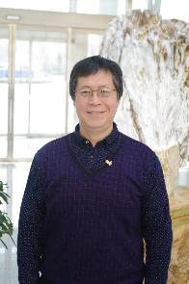
Mr Zheng Dai (John)
The knowledge and skills we learned at Griffith University [helped] me to improve the core competencies and focus on many different jobs or other programs [within China CDC]. In my training management position now, I suggest assessment or evaluation skills to ensure the training quality. It is very important for the training quality and effectiveness [in my organisation].
Fellowship | Asia-Pacific Public Health Leadership Program (APPHLP),
Years | 2007 - 2008
Degree | Master of Science Public Health (Joint Master of Public Heath CDC)
Institution | Griffith University
Current position | Deputy Director , Associate Professor Department of Education and Training, Chinese Centre of Disease Control and Prevention (Beijing) (China CDC)
Brief biography | As the Deputy Director of the Department of Education and Training, Mr Zheng Dai is responsible for the development and delivery of the Chinese Centre of Disease Control and Prevention’s postgraduate and professional development training system.  Mr Zheng studied a Master of Science Public Health at Griffith University where he focused on health program planning and evaluation, health policy and management. Returning to China he was promoted in 2011 and has been actively involved in designing training content, standards and evaluation index systems for China CDC professional development programs.  In 2014, Mr Zheng led an expert group to develop the China-wide clinical preventive medicine residential training programs and was involved in the establishment of a graduate school for China CDC staff. He lobbied senior management and was instrumental in attracting funding for postgraduate education management programs.  In his role as Deputy Director, Mr Zheng works closely with Griffith University’s Centre for Environment and Population Health (CEPH) to facilitate international training opportunities for China CDC staff.
Location at the time of field research: Beijing, China
Date of interview: 16 April 2018

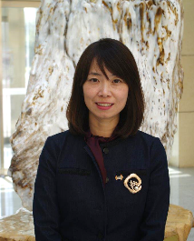
Ms Xi Jingjing (Crystal)
My dream and my expectation was not to be a leader but I applied for the opportunity to the round two leadership program. I just wanted to have an overseas experience and to feel the different culture and study some new things. But when I came back, the overseas experience was very useful for my career, and all the things I studied in Griffith University also could help me to solve many problems in my work. So it was beyond my expectations.
Fellowship | Asia Pacific Public Health Leadership Program (APPHLP),
Years | 2008
Degree | Master of Science Public Health (Joint Master of Public Heath CDC)
Institution | Griffith University
Current position | Director of General Office, Associate Researcher, Chinese Centre of Disease Control and Prevention (Beijing) (CDC)
Brief biography | Ms Xi Jingjing is the Director of the General Office at the Chinese Centre of Disease Control and Prevention headquarters in Beijing. She works closely with the Ministry of Health and the Director of China CDC, coordinating 11 institutions and 31 departments, with over 2,000 full-time staff.  Prior to be being selected to study the dual Master of Public Health at China CDC and Griffith University, Ms Xi worked in the Human Resources Department at China CDC and had studied a Bachelor of Medicine Administration at Beijing University of Chinese Medicine.  Studying at Griffith University in 2008, Ms Xi was able to build her understanding of public health services management. In 2011, she applied for a position in the General Office and was able to use the presentation skills she developed while in Australia to gain her new role. Her career began to develop rapidly and she was promoted to Deputy Director of the General Office and received the 2013 Young Australia China Alumni of the Year Award.  In 2016, Ms Xi was appointed Director of the General Office, becoming the youngest women in China CDC history to be appointed to Director level. She is active in building leadership and management capacity of China CDC staff at the National and Provincial level.
Location at the time of field research: Beijing, China
Date of interview: 16 April 2018

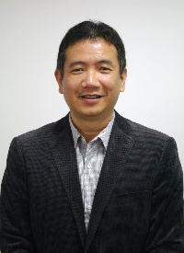
Dr Hou Xiaohui (Sean)
I am most proud that I had the chance to join the writing team for the Shanghai Declaration, which is the official document of the Ninth Global Conference on Health Promotion, which was for the first time held in China in the year 2016. We finished the draft in Geneva and we were one of the teams. I am very proud of that.
Fellowship | The China Disease Control and Prevention Leadership Program (CDCLP)
Years | 2007
Degree | Master of Science Public Health (Joint Master of Public Heath CDC)
Institution | Griffith University
Current position | Head of International Cooperation, Office of Science, Technology and International Cooperation, Chinese Centre for Health Education
Brief biography | Dr Hou Xiaohui (Sean) is the Head of International Cooperation, Office of Science, Technology and International Cooperation at the Chinese Centre for Health Education, Chinese Ministry of Health. His key research areas include: health education and promotion, community needs assessment and policy development, risk communication and decision-making, and environmental health.  Graduating in 1992 from Wuhan University, Dr Hou worked for a number of years on China’s national poliovirus eradication program for China CDC. In 2007, he was selected to participate in the first fellowship program and joint Master of Science Program at Griffith University. While in Australia he developed a deep interest in population health and health promotion and was awarded a Vice Chancellor Scholarship to study a Doctorate at Griffith University.  After completing his doctoral degree in 2015, he returned to China and started working for the Chinese Centre for Health Education where he was instrumental in setting up a Memorandum of Understanding with Griffith University’s Centre for Environment and Population Health.  In his current role, Dr Hou works on a range of research at the national and global level. He is involved in a number of international research groups in climate change in health and was a key contributor to the Shanghai Declaration on promoting health in the 2030 Agenda for Sustainable Development.
Location at the time of field research: Beijing, China
Date of interview: 17 April 2018

Ms Jiang Yingying (Nina)

[In the ten years since my fellowship] I have undertaken many, many projects or programs that make up my research career. This makes me feel very joyful. And I publish many papers in journals and I undertake many projects with the World Health Organisation and I am undertaking an important project led by the Ministry of Health in China. It’s a nationwide project. I think all these years of experience make my career more interesting. And I wish to continue my research in chronic disease control and prevention. That makes me enjoy my career.
Fellowship | Australian Leadership Award Fellowship  Asia Pacific Public Health Leadership Program (2008)
Years | 2008
Degree | Master of Science Public Health (Joint Master of Public Heath CDC)
Institution | Griffith University
Current position | Researcher, National Centre for Chronic Non- Communicable Disease Control and Prevention, Chinese Centre of Disease Control and Prevention (Beijing) (CDC)
Brief biography | Ms Jiang Yingying (Nina) is a Researcher at the Non-communicable Disease Control (NCD) and Prevention Centre of China CDC and specialises in NCD control, through health promotion and community-based programs.  Prior to studying in Australia, Ms Jiang worked in the Communications Centre of China CDC. She was awarded a fellowship to study a Master of Science, Public Health at Griffith University in 2008.  While studying in Australia she became passionate about public health promotion and risk communication and decided to pursue a career in research. On her return to China, she transferred to the National Centre for Chronic Disease Control and Prevention where she began working on largescale public health campaigns.  In her current role, Ms Jiang is involved in a range of national health promotional initiatives aimed at educating and empowering communities to reduce chronic disease. Her role sees her work with a range of stakeholders and global agencies like the World Health Organisation.
Location at the time of field research: Beijing, China
Date of interview: 17 April 2018


Mr Guo Haijun (Jason)
I took part in the National Nutrition Survey which covers all of the country. We have a very comprehensive surveillance system and we collect data from all over the country. During the survey, I do this job as a supervisor. I sometimes answer teachers at the community levels to teach the interviewers, to tell them how to do these things, and also the method is designed by my research group. I am able to be a researcher, to be a supervisor, to be an expert at the national level. So it’s given me a feeling of achievement.
Fellowship | Australian Leadership Award Fellowship  Asia Pacific Public Health Leadership Program (2008)
Years | 2008
Degree | Master of Science Public Health (Joint Master of Public Heath CDC)
Institution | Griffith University
Current position | Doctorate Candidate, Griffith University  Associate Researcher, National Institute for Nutritional and Health, Chinese Centre of Disease Control and Prevention (CDC), Beijing
Brief biography | Mr Guo Haijun is an Associate Researcher, at the National Institute for Nutritional and Health in China CDC. He is currently undertaking a Doctorate at Griffith University investigating the health and nutritional impact of sugar-sweetened, carbonated drinks on children and young people as part of an Australia Awards Endeavour Scholarship.  In 2008, Mr Guo was given the opportunity to undertake a joint Master of Science in Public Health program with China CDC and the University of Griffith. As part of this program he spent eight months in Brisbane, studying with a range of health professionals.  Before going to Australia, he worked at the local level within CDC. After completing his dual Masters In Public Health, he was promoted to a senior researcher and moved to the national divisional level. He began working on national programs such as the National Nutrition Survey where he provided supervision and support to China CDC staff in the field at the local level.  After the completion of his Doctorate, Mr Guo hopes to use his research to provide evidence to inform future policy within China and reduce the impact of fizzy drinks on the health and nutrition of young people.
Location at the time of field research: Beijing, China
Date of interview: 17 April 2018

Ms Wang Zhongmei

When I studied in Australia, I gained knowledge about water recycling and waste water… I didn’t think that closely related to the professional work. However, after coming back, in recent years, the ecosystem problems and some deterioration occurred and the situation of environmental protection became more and more important. The Chinese Government changed the policy to encourage environmental protection, especially putting forward the protection of mountain water, forest, farming land and the lakes as an integral part to build that in total, so that we can transfer the focus from not only engineering structures to environmental provision... So I realised that my education and training is, in fact, in front of my professional work.
Fellowship | Australian Leadership Award Fellowship  YRCC Professional Development Programme,
Years | 2007
Institution | International Centre of Excellence in Water Resources Management (ICE WaRM) and University of South Australia and the University of South Australia
Current position | Project Manager, Yellow River Institute of Hydraulic Research, Yellow River Conservancy Commission
Brief biography | Ms Wang Zhongmei is a Project Manager in the Yellow River Institute of Hydraulic Research and is involved with dams and sluices.  In 2007, Ms Wang was selected as an emerging leader within her department and undertook the YRCC Professional Development Program in Adelaide with ICE WaRM and the University of South Australia. With a background in hydrology water research and sediment separation, Ms Wang was unclear how she would utilise the environmental elements of her training at ICE WaRM on her return to China, as at the time her department was very engineering focused.  However, over the last 10 years, her Australian expertise and understanding of the whole-of-water-cycle, water recycling and water waste have helped Ms Wang support the shift in focus within her department towards environmental provision.
Location at the time of field research: Zhengzhou, China
Date of interview (YRCC Focus Group): 20 April 2018

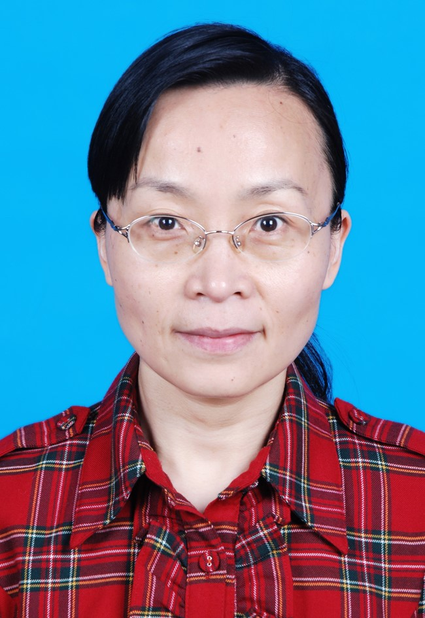

Ms Jin Shuangyan
I think I’m an example for my colleagues, especially for young colleagues. From the English learning, my oral English is poor, but I think my reading is better than my oral English.
Fellowship | Australian Leadership Award Fellowship  Integrated River Basin Management Fellowship
Years | 2008
Institution | IWC and the University of Queensland
Current position | Section Head Water Resources Research, Hydrology Bureau, Yellow River Institute of Hydrology and Water Resources
Brief biography | Ms Jin Shuangyan is the section head of water resources research within the Hydrology Bureau, at the Yellow River Institute of Hydrology and Water Resources. She is mainly responsible for the analysis, investigation and evaluation of hydrology and water resources, sediment and water soil cultivation.  In 2008, Ms Jin undertook the Integrated River Basin Management Fellowship for emerging leaders from YRCC and studied at the International Water Centre and the University of Queensland.  Since returning from her fellowship Ms Jin has developed in-depth research skills and has become a technical leader within the Hydrology Bureau often researching the latest data and trends in English. She encourages her staff to read widely and access the latest hydrology information in English and is involved in a number of international projects.
Location at the time of field research: Zhengzhou, China
Date of interview (YRCC Focus Group): 20 April 2018

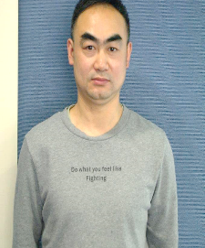
Mr Liu Wei (Leo)
I [focus my research] in one field and constantly improve the process, the technology, like applying new technology and new methods to it, continuing to inform the ways and patterns of working.
Fellowship | Australian Leadership Award Fellowship  Professional Development for Agencies of the Ministry of Water Resources, PR China
Years | 2009
Institution | ICE WaRM and the University of South Australia
Current position | Researcher, Bureau of Hydrology, Yellow River Conservancy Commission
Brief biography | Mr Liu Wei has been a researcher in the Bureau of Hydrology for the last 20 years and specialises in riverbed topography monitoring.  As part of the fellowship, Mr Liu studied with ICE WaRM and the University of South Australia in Adelaide from January to August 2009. During that time he developed a range of skills and received professional training in geographic information systems (GIS) which he found extremely useful on his return to China.  Mr Liu returned to his former role after he completed his fellowship but found that he had expanded his professional and technical knowledge and became more outgoing. In 2010, he used his new technical skills to recalculate an error in YRCC data using GIS and corrected a 200 million cubic metre error in the reservoir data.  Over the last 10 years, Mr Liu has contributed to the development of procedures to improve data processing of flood control and water resource utilisation data in the Yellow River Basin.
Location at the time of field research: Zhengzhou, China
Date of interview: 20 April 2018

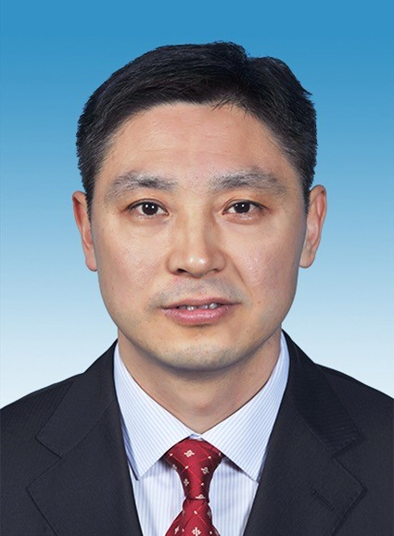
Mr Yu Haihong
When I studied the experience widened my mind. To connect with other alumni I found IWC has established an alumni group…I can get information about the IWC, about the Australian water field and also some global news on water. I think that’s a good forum for us to keep in contact and also get some global information
Fellowship | Australian Leadership Award Fellowship  Professional Development for Agencies of the Ministry of Water Resources, PR China
Years | 2009
Institution | ICE WaRM and the University of South Australia
Current position | Officer, Department of Personnel and Labour, Yellow River Conservancy Commission
Brief biography | Mr Yu Haihong works for the Yellow River Conservancy Commission in the area of human resource management. He works with a team of YRCC staff tasked with identifying the professional development needs of the 40,000 personnel in his organisation.  Mr Yu undertook an Australia Award fellowship in 2009 with a number of colleagues from YRCC with ICE WaRM. His fellowship also involved study at the University of South Australia where he established a number of long-term friendships.
Location at the time of field research: Zhengzhou, China
Date of interview (YRCC Focus Group): 20 April 2018

Ms Pang Hui
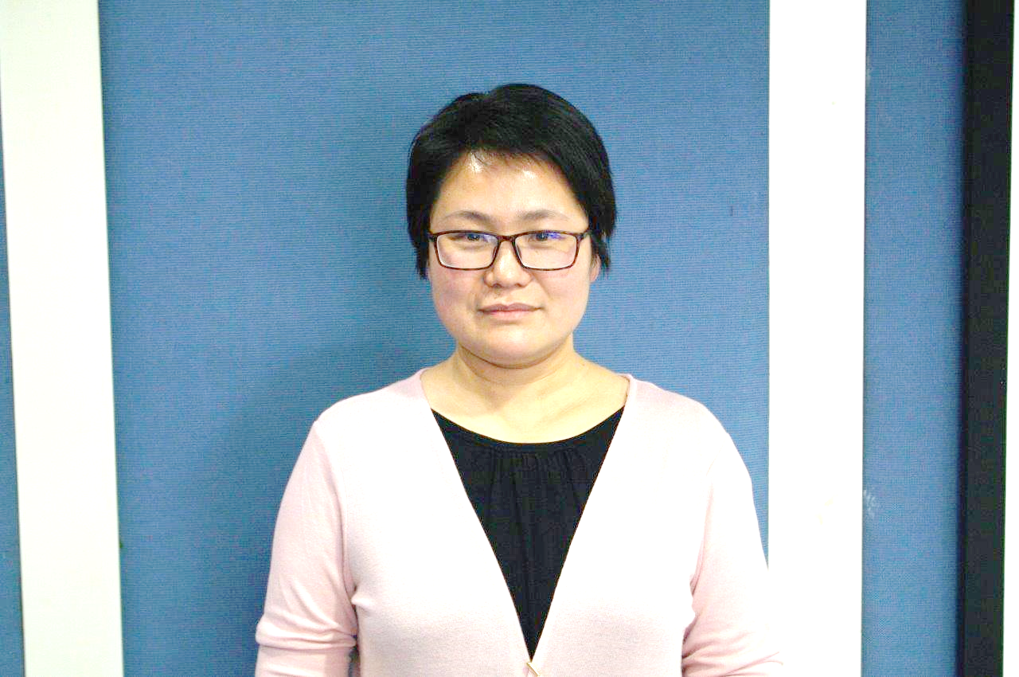
I feel proud for one international activity we have organised, and that’s the International Yellow River Forum… It gathers the water experts and the water managers from dozens of countries. The Ministry of Water Resources, the ministers have come to join this event and, give very high recommendation and praise to this event. I think for this International Yellow River Forum, all of us, those trainees who have received overseas training have contributed a lot to this forum. If we had not had training programs for these alumni, maybe it’s quite difficult for us to organise such an event. So I think the training program helped to organise such a grand event.
Fellowship | Australian Leadership Award Fellowship  Professional Development for Agencies of the Ministry of Water Resources, PR China
Years | 2009
Degree | Graduate Certificate of integrated Water Management
Institution | ICE WaRM and the University of South Australia
Current position | Project Officer, Department of International Cooperation, Yellow River Conservancy Commission
Brief biography | Ms Pang Hui is a Project Officer within the Department of International Cooperation at the Yellow River Conservancy Commission headquarters in Zhengzhou, China. Her role is to work closely with international partners and stakeholders, managing international capacity building opportunities and programs for YRCC staff.  Before studying in Australia, Ms Pang worked for the Bureau Of Hydrology and would occasionally be involved in international projects due to her high-level language English skills. She was invited to participate in the professional development program and went to study in Adelaide in 2009 at ICE WaRM and the University of South Australia. Ms Pang was one of the few YRCC participants to achieve a Graduate Certificate of Integrated Water Management at the completion of her fellowship.  Returning to China, she transferred to the Department of International Cooperation and began working closely with international partners, facilitating capacity building programs, project collaboration and research.
Location at the time of field research: Zhengzhou, China
Date of interview: 20 April 2018


Mr Song Ruipeng
I got not only the knowledge on integrated water management, but many aspects about water management - water recycling and also planning. I got too much information and it’s just over my expectations! I also established friendships with my Australian friends. So that’s a very great experience for myself.
Fellowship | Australian Leadership Award Fellowship  Integrated River Basin Management Program
Years | 2008
Degree | Graduate Certificate of Integrated Water Management
Institution | IWC and the University of Queensland
Current position | Senior Engineer, Bureau of Hydrology, Yellow River Conservancy Commission
Brief biography | Mr Song Ruipeng is a Senior Engineer and Manager from the Science and Technology Department within the Bureau of Hydrology, at the Yellow River Conservancy Commission (YRCC) headquarters in Zhengzhou, China.  In 2008, as part of capacity building initiative for YRCC staff, Mr Song was awarded an Australian Leadership Award Fellowship to undertake a Graduate Certificate of Integrated Water Management as part of the Integrated River Basin Management Program in Brisbane, Australia. The program was hosted by the International Water Centre (IWC) and the University of Queensland.  Returning to the Hydrology Bureau after completing his studies in Australia, Mr Song began to use Australian modelling expertise in his work. He was promoted to a senior role in his bureau and attributes his time in Australia to developing his critical thinking skills and providing him with a more holistic view of water management.  Now a Senior Engineer, Mr Song uses his research skills developed in Australia to share global expertise in Hydrology and build the capacity of his junior staff.
Location at the time of field research: Zhengzhou, China
Date of interview: 20 April 2018

Ms Fan Jie
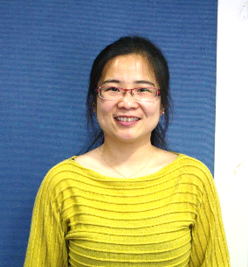
I’m proud of my job, especially proud of the work 2012 with the forum organisation. The International Yellow River Forum is the first international meeting in the Chinese water field and it’s also had a good influence in the international water field, And in total for the five forums, there are more than maybe 6,000 overseas delegates from almost 80 countries and areas, and especially in the fifth forum, there were several delegates at minister level attending the forum, and the Minister of the Chinese Ministry of Water Resources came here and [achieved] international cooperation
Fellowship | Australian Leadership Award Fellowship  Integrated River Basin Management Program
Years | 2008
Degree | Graduate Certificate of Integrated Water Management,
Institution | IWC and the University of Queensland
Current position | Officer, Press & Publication Centre, Yellow River Conservancy Commission
Brief biography | Ms Fan Jie is responsible for the development of educational, communication materials and social media content relating to the preservation of the Yellow River, and is employed in the Press & Publication Centre, at YRCC.  Prior to going to Australia, Ms Fan worked for the Department of International Cooperation. In her role, she worked closely with global partners and participated in the organisation of the Triannual Yellow River Forum. As part of her work in international relations, she visited Canada in 2003 and the Netherlands and Germany in 2006.  In 2008, Ms Fan was selected to go to Brisbane as part of the Integrated River Basin Management Program where she undertook a Graduate Certificate of Integrated Water Management at the University of Queensland and International Water Centre.  On her return to China, Ms Fan returned to her department with improved technical knowledge of water governance and environmental sustainability. In 2012, she moved to the Press & Publication Centre and began working on project managing education publications relating to the YRCC Mother River protection initiatives.
Location at the time of field research: Zhengzhou, China
Date of interview: 20 April 2018
Mr Bao Changjun
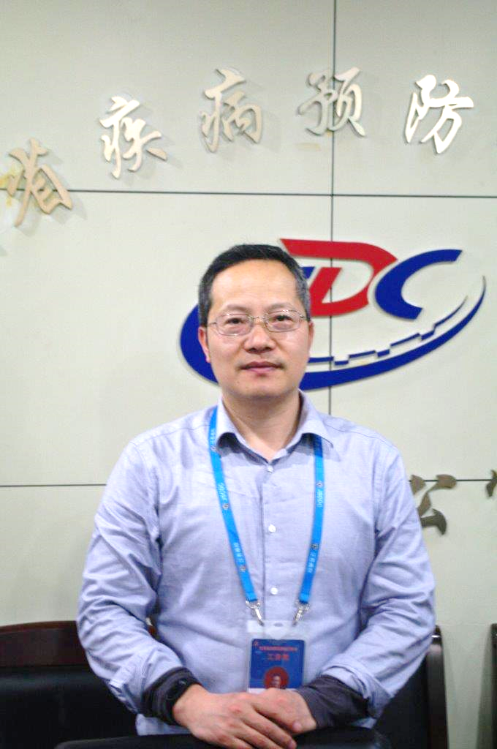
Just for my personal experience, I think [the fellowship] gave me a very, very good chance to improve my research level, my English language level and to deal with guys with different cultural backgrounds. I worked in infectious diseases, but through the study in Australia, I have very, very strong impression of climate change and environment protection. The environment in Australia is better than China, but they have so many measures to protect the environment. About 10 years ago in China, the protection measures for the environment were not so good and now we realise the serious outcomes of environmental pollution
Fellowship | Asia Pacific Public Health Leadership Program (APPHLP),
Years | 2008
Degree | Master of Science Public Health (Joint Master of Public Heath CDC)
Institution | Griffith University
Current position | Director/Chief of the Department of Incurable Infectious Disease Control and Prevention, Jiangsu Provincial Centre for Disease Control and Prevention
Brief biography | Mr Bao Changjun is the Director of the Department of Incurable Infectious Disease Control and Prevention, at the Jiangsu Provincial CDC where he has worked for the last 20 years. He specialises in the epidemiological features of infectious diseases.  Graduating from the South East University in 1997 with a Master of Medicine, Mr Bao majored in biostatistics and began working for the CDC in infectious diseases. In 2008, he was awarded an Asia Pacific Public Health Leadership Program Fellowship to study a Master of Science in Public Health at Griffith University where he specialised in epidemiology and biostatistics.  During his studies in Australia, Mr Bao researched Influenza B and Hepatitis B. He developed a range of skills while on-award including technical writing skills in English which he has since employed in his work. Mr Bao has published over 20 articles in global publications since returning to China, including papers in the prestigious New England Journal of Medicine and the British Medical Journal.  At present, Mr Bao is working on a range of projects including research into the H7 N9 influenza virus, and the serve fever associated with thrombocytopenia syndrome, which is an emerging infectious disease.
Location at the time of field research: Nanjing China
Date of interview: 23 April 2018

Professor Wang Wen
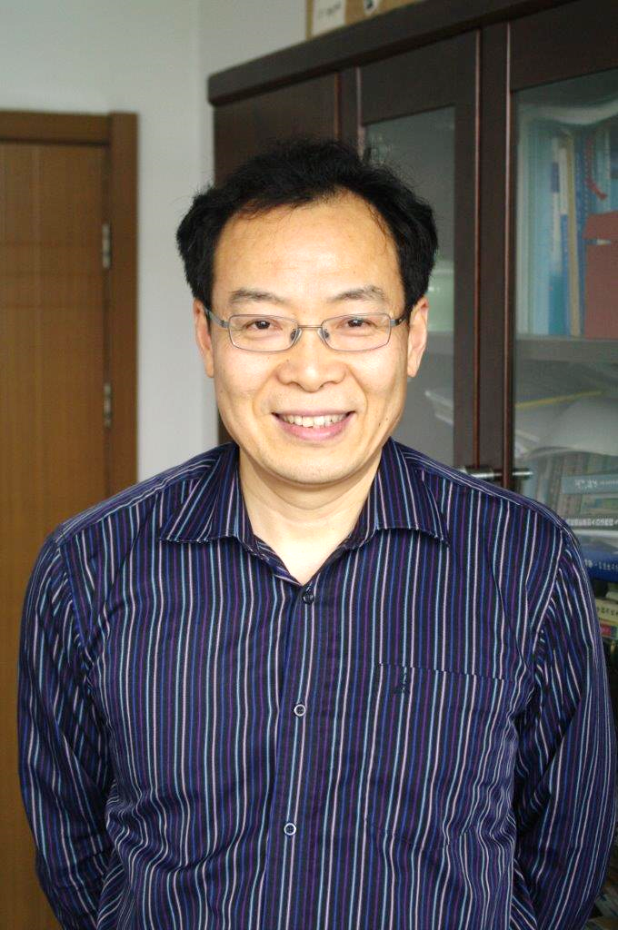
I think it just broadened my view on agriculture water management, how they monitor water management in the countryside and how they use some meteorological observations, use the stream flow and the canal gauging systems... That’s something that really impressed me, because in China that’s maybe too costly and we have too much labour. In the future, in China we really want to improve our water management, more precisely. That’s something that the top government really wants to do. Water use efficiency is very important, so what I saw in Australia really kept reminding me how to make it better, to improve water management.
Fellowship | Knowledge Sharing For Food Security and Water in Asia
Years | 2010 (6 weeks)
Institution | Charles Sturt University’s International Centre of Water for Food Security, Wagga Wagga
Current position | Professor at the College of Hydrology and Water Resources, Hohai University, Nanjing
Brief biography | Professor Wen Wang works for the College of Hydrology and Water Resources at Hohai University in Nanjing; his research is in the field of remote sensing technology for hydrological modelling and water resources management.  Completing both his undergraduate and postgraduate studies at Nanjing University, Professor Wang studied a doctoral degree in the Netherlands. He works at Hohai University as a Professor, teaching and conducting research in the College of Hydrology and Water Resources.  In 2010, he was given an opportunity to join a six week course on Knowledge Sharing For Food Security and Water in Asia at Charles Sturt University’s International Centre of Water for Food Security in Wagga Wagga. The course had approximately 15 participants from a range of fields from China and Pakistan and included field and industry visits and a tour of regional Australia.  Although the duration of his time in Australia was short, Professor Wang attributes his course as providing him with a deeper insight into water management and irrigation.
Location at the time of field research: Nanjing China
Date of interview: 23 April 2018

References
APLMA (2016), Australia China Papua New Guinea Pilot Cooperation on Malaria Control: Project Summary, Asia Pacific Leaders Malaria Alliance. Accessed at: http://aplma.org/upload/resource/Papers/Aus-Papua-China_Coopertation.pdf June 8, 2018.
Associate Press (AP) 2018, More than 55 percent of Chinese now live in urban areas available at https://www.apnews.com/7238b70e4e7f48a0bdf8a5fb11fcb244, accessed 15 June, 2018
AusAID 2010, Australian Agency for International Development Annual Report 09/10, https://dfat.gov.au/about-us/publications/corporate/annual-reports/australian-agency-for-international-development-annual-report-09-10/index.html accessed 25 June 2018
AusAID 2006, A White Paper on the Australian Government’s Overseas Aid Program Australian Aid: Promoting Growth and Stability, http://dfat.gov.au/about-us/publications/Documents/whitepaper.pdf accessed 29th June 2018
Chow. E 2018, China’s War on Poverty Could Hurt the Poor, https://foreignpolicy.com/2018/01/08/chinas-war-on-poverty-could-hurt-the-poor-most/ accessed 29 June 2018
DET (2018), Australia International Education International Student Data 2018, Australian Government Department of Education. Accessed at: https://internationaleducation.gov.au/research/International-Student-Data/Pages/InternationalStudentData2018.aspx June 8, 2018.
DFAT (2016a), Australia Awards Global Strategy, Department of Foreign Affairs and Trade, Canberra. http://dfat.gov.au/about-us/publications/Documents/australia-awards-global-strategy.pdf
DFAT (2016). ‘Public Diplomacy Strategy 2014-16’. http://dfat.gov.au/people-to-people/public-diplomacy/Documents/public-diplomacy-strategy-2014-16.pdf.
DFAT (2018), China country brief, Australian Government Department of Foreign Affairs and Trade. Accessed at: http://dfat.gov.au/geo/china/Pages/china-country-brief.aspx June 8, 2018.
Huttner-Koros. A 2015, ‘The Hidden Bias of Science’s Universal Language’, available at: https://www.theatlantic.com/science/archive/2015/08/english-universal-language-science-research/400919/ accessed 1 June 2018
ILO (2008), Facts on people with disabilities in China, International Labour Organization. http://www.ilo.org/wcmsp5/groups/public/---asia/---ro-bangkok/---ilo-beijing/documents/publication/wcms_142315.pdf
Li, L., & Jiang, Q (2017), Introduction to Public Health in China, Public Health in China Series, People’s Medical Publishing House, Beijing.
Lowy Institute 2018, ’China-Australia relations’, https://www.lowyinstitute.org/issues/china-australia-relations accessed 2 July 2018
Ministry of Education People’s Republic of China 2017, Review of China’s education reform in 2017, http://en.moe.gov.cn/News/Top_News/201801/t20180130_326023.html accessed 2 July 2018
Myers. J, 2016, ‘You knew China's cities were growing. But the real numbers are stunning’, available at https://www.weforum.org/agenda/2016/06/china-cities-growing-numbers-are-stunning accessed on 15 June 2018
Paul. D 2017, China Releases National Plan to Implement SDGs http://sdg.iisd.org/news/china-releases-national-plan-to-implement-sdgs/, accessed 29 June 2018
UN Women (2012), China Fact Sheet, United Nations Entity for Gender Equality and Empowerment for Women. https://sgp.undp.org/images/02%20CHINA%20factsheet.pdf
World Bank (2013) World Report on Disability. https://datacatalog.worldbank.org/dataset/world-report-disability
World Bank 2016, Deeping Health Reform in China: Building High Quality and Valued-Based Service Delivery, https://openknowledge.worldbank.org/bitstream/handle/10986/24720/HealthReformInChina.pdf accessed 29th June 2018
World Bank (2018) World Bank Open Data, accessible at: https://data.worldbank.org
World Bank 2018, China overview, http://www.worldbank.org/en/country/china/overview , accessed 29 June 2018
WHO (2016a), Healthy China 2030 (From Vision to Action), World Health Organisation available at: http://www.who.int/healthpromotion/conferences/9gchp/healthy-china/en/
WHO (2016b), ‘Shanghai Declaration on promoting health in the 2030 Agenda for Sustainable Development’, World Health Organisation, available at http://www.who.int/healthpromotion/conferences/9gchp/shanghai-declaration.pdf?ua=1 , accessed on 17 April, 2018

Annex 1: Case Study Propositions
Explanatory Case Studies require the development of propositions that are intricately linked to the original research questions. A proposition is a statement that helps direct attention to something that should be examined in a Case Study. The researcher has to make a speculation, on the basis of the literature and any other earlier evidence, as to what they expect the findings of the research to be. When a Case Study proposal includes specific propositions, it increases the likelihood that the researcher can limit the scope of study and complete the project. The researcher can have several propositions to guide the study, but each must have a distinct focus and purpose. The data collection and analysis can then be structured in order to support or refute the research propositions.
For the Facility, propositions were formed using the Global Strategy outcomes as the basis. Sub-propositions were formulated by speculating on the underlying assumption or enabling factors that realise the proposition. In alignment with the methodology, instruments will be designed to collect data that both support and refute the propositions.
- Alumni use their skills knowledge and networks to contribute to achieving partner-country development goals.
  - alumni develop skills, knowledge and networks on-award that enable and are used to contribute to achieving partner-country development goals
  - alumni understand, value and want to contribute to partner-country development goals.
- Alumni are contributing to cooperation between Australia and partner countries
  - alumni possess and are able to leverage their useful networks and relationships.
- Effective, mutually advantageous partnerships between institutions and business [have been developed] in Australia and partner countries
  - alumni possess and are able to leverage their useful networks and relationships
  - partnerships that are developed are effective and mutually advantageous to participating countries.
- Alumni view Australia and Australian expertise positively
  - alumni’s views are underpinned by their experiences in Australia.
- The benefits of receiving an Australia Awards or scholarship are experienced equally by all recipients.
  - receiving an Australia Awards or scholarship positively addresses, rather than reinforces, imbalances that are associated with gender and disability.

Annex 2: Key Participant Questions
Alumni
[Validation question]
We understand you received an Australian Government Scholarship to study [level, field, years], is this correct?
Could you please confirm your current role and organisation?
- Can you please tell us why you applied? What was your motivation?
- Were there any barriers to accepting a scholarships and coming to Australia? [e.g. employer support, family responsibilities]
- Can you tell me about your time in Australia experience as a student?
a Did you make any professional networks?
b Thinking about the networks that you might have developed during your scholarship, were there any that were long lasting; that resulted in working together or connecting other people?
3. After you returned, what was your job?
a What skills and knowledge gained during your time in Australia have been applicable in your work?
b What are some of the things that made it possible for you to apply your skills and knowledge after you returned home?
c What were some of the things that made it difficult to apply the skills and knowledge you gained after you returned home?
d What do you think is needed to assist alumni to use their skills and knowledge when they return home?
- What do you believe are the greatest benefits of the Australian Government scholarship program?
- Throughout your career, in what ways have you used Australian expertise in your work?
a Can you give an example of this, such as Australian-developed practices, equipment, ways of working, processes, theory/theorists, consultants, journals, models, etc.?
6. Are you currently or have been a member of an alumni association? (University/Australian Government scholarship recipient/ADS)
a What was the name of the association?
b What do you get out of it?
c What more could alumni associations do for alumni?
d If not (a member of an association) why not?
7. Can you describe an achievement that you are most proud of, in your work or community?
8. Compared with the males/females who have received a scholarship from (country x), how has your career progressed since returning home?
9. Have there been any barriers you have had to overcome to progress in your career?
10. Compared to peers similar to you but did not receive an opportunity to study overseas, do you believe there are any differences in how your careers have progressed?
11. (Supporting Interviewer) did you have any questions you would like to ask of (alumni X)?
Employers/colleagues – For interviews regarding an individual alumni
[Validation question]
Could you please confirm your role and organisation?
- Could you please tell us how long have you known [Alumni X] and in what capacity?
a Did you know [Alumni X] before s/he received the scholarship?
b Were you his/her manager?
2. To your knowledge, what new skills and knowledge did [Alumni X] use [in the workplace following their studies in Australia]?
a Could you provide examples of how this was applied?
3. How did the organisation support X to use his/her new skills and knowledge after returning from Australia?
a Did you have a role in supporting [alumni X] to reintegrate following their scholarship?
i If so why? What did this involve?
ii If not, why?
iii Developing a reintegration/return to work plan?
b Did X return to the same role following their scholarship?
c Did they receive additional responsibilities after their scholarship?
4. In your view, how did studying in Australia impact [Alumni X’s] career?
5. Have you or your organisation benefited from any networks or friendships between [country X] and Australia created by the [Alumni X] as a result of receiving an Australian Government scholarship?
a Please explain further; who and what?
b What about any other countries?
6. Are you aware of any other links [Alumni X] has created between people in [country X] and Australia as a result of receiving an Australian Government scholarship?
a Please explain further; who, what why?
b What about between people in [country X] and any other countries?
7. What more could be done to increase opportunities to create institutional links between Australia and your country?
8. How has having an Australian Government scholarship recipient in your organisation impacted how you view Australia and Australian expertise?
9. Do you draw on Australian expertise for your work?
Employers/stakeholders – For interviews regarding alumni generally
[Validation question]
Could you please confirm your role in (X organisation)?
- How familiar are you with the Australia Awards?
[If YES; a suggested probe if needed]
a Estimated, how many Australian scholarship recipients have worked for your [ministry/organisation/sector/field]?
[If NO; probe further with]
b Do you know of anyone who has received an Australian Government scholarship in your [ministry/organisation/sector/field]?
- Has your (ministry/organisation/sector/field) benefitted from any links or networks developed by Australian Government scholarship alumni?
a Do you have any examples?
b What have been the results of this?
- Has having Australian Government scholarship recipients in your (ministry/organisation/sector/field) influenced the way you view Australia and Australian expertise?
- Have Australian Government scholarship recipients established any links between your [ministry/organisation/sector/field] and organisations in Australia?
a If yes what has been the result of these links?
b Benefits to you?
c Benefits to your workplace?
d Benefits to your country?
e If no, why not?
5. Are you aware if alumni have presented any opportunities on return to link your workplace or any other organisation in your country with an organisation in another country?
a If yes what has been the result of these links?
b Benefits to you?
c Benefits to your workplace?
d Benefits to your country?
e If no, why not?
- What more do you think could be done to support links with Australian organisations?
- In your view, what has been the overall long-term impact of having Australian Government scholarship recipients in your [ministry/organisation/sector/field]?
a How has having a number of Australian Government scholarship recipients over a number of years influenced your department’s ability to achieve its goals and /or objectives?
b With regards to skills and knowledge; i.e. changed practices, processes or systems?
8. What are some of the things that make it easy or difficult for women to progress in their careers in your country?
9. What are some of the things that make it easy or difficult for those with a disability to progress in their careers in your country?
10.Comparing Australian Government scholarship recipients to their peers who did not receive an opportunity to study overseas, do you believe there are any differences in how their careers have progressed?
DFAT
[Validation question]
Could you please tell us about yourself and your role with the Australia Awards Program?
- In your own words, what is the purpose of the Australia Awards Program?
a In your own words how does the Program achieve [points stated in the previous response]?
2. Based on your experience what would you say are the strengths of the Australia Awards Program?
3. How do you think alumni participation in the Australia Awards Program contributes to [Country X’s] development goals?
a What evidence have you seen of this either personally or professionally?
b How do you think the program lead to benefits for both Australia and [Country X]?
4. In your opinion, how do you think an alumni’s participation in the Australia Awards Program contributes to a positive relationships between [Country X] and Australia?
a What factors/events have informed this opinion?
5. How do you think the Australia Awards contributes to gender equality and disability inclusiveness?
6. What other barriers do you think Australia Awards alumni have to overcome to progress in their careers in [Country X]?
7. What do you think are the barriers to achieving gender equality and disability inclusiveness?
a Do you feel [barriers stated in the previous response] have changed over time?
b In what way?
c Any other barriers?
8. If you had the power to change things about the Australia Awards what would you make different?
9. That covers the things I wanted to ask. Anything you would like to add?
Alumni Association
[Validation question]
Could you please tell us about yourself and your role with the alumni association?
- In your own words, what is the purpose of the alumni association?
a What sort of services does the association provide?
2. What is the most valuable contribution the association provides for alumni?
3. What are some of the challenges involved in running an alumni association for alumni who have studied in Australia?
4. What activities does the alumni association provide to support women to progress in their careers in your country?
a What have been the outcomes of the program/s?
5. What activities does the alumni association provide to support those with a disability to progress in their careers in your country?
a What have been the outcomes of the program/s?
6. In what ways does the alumni association enable alumni to form new professional and personal networks?
7. What activities does the alumni association provide to help alumni remain connected to each other through face-to-face activities and social media?
8. How does the alumni association support alumni to remain connected to Australia?
9. What role does the alumni association play in fostering cooperation between your country and Australia?
10. What do you think should be done to assist your alumni association to contribute to greater cooperation between Australia and [Country X]?
11. Is the alumni association partnered with any institutions and businesses in Australia?
a If yes, what has been the result of these links?
i Benefits to you/association?
ii Benefits to alumni?
b If no, why not?
12. What more could be done to increase opportunities to create institutional links between Australia and your country?
13. How does the alumni association promote Australia and Australian expertise?
Gender Equality and Disability Inclusiveness Experts
Gender Equality
1. How does gender impact career?
2. What barriers are there to achieving gender equality?
3. What could or should be done to improve gender equality?
4. Compared with males who receive a scholarship to study overseas, how do you feel women’s careers progress? [for DFAT or those with knowledge of scholarships]
Disability Inclusion
- How does disability impact career?
- What barriers are there to achieving disability inclusion?
- What could or should be done to improve disability inclusion?
- Compared with others who receive a scholarship to study overseas, how do you feel people with disability career’s progress? [for DFAT or those with knowledge of scholarships]

Host Institutions
[Validation question]
Could you please tell us about yourself and your role within this Australia Award host institution?
- What is your role and your relationship to the Australia Awards fellowships program?
- Could you please tell us about the fellowships program?
- What support does your organisation provide to prepare fellows for their time in Australia?
- How does the fellowship program/course achieve its aims?
- How do you ensure the course is relevant to participants?
- How do you ensure participants foster networks and links with Australia and Australians?
- How do you ensure participants develop relevant and useful networks?
- How does the fellowship program assist your organisation to build relationships with China/Partner Country?
  - Are you still engaged with the organisation or fellows?
- Second researcher – any questions?
- Do you have anything you would like to add?

Annex 3: China Case Study Participants
Type | Date (2018) | Name | Position or Degree
Alumni | 16/04 | Zheng Dai  (John) | Deputy Director , Associate Professor Department of Education and Training, China Centre for Disease Control and Prevention, Beijing
 | 16/04 | Jingjing Xi  (Crystal) | Director of General Office, Associate Researcher, China Centre for Disease Control and Prevention,
 | 17/04 | Hou Xiaohui (Sean) | Head of International Collaboration, Office of Science, Technology, and International Cooperation, Chinese Centre for Health Education.
 | 17/04 | Yingying Jiang  (Nina) | Researcher, National Centre for Chronic and Non- communicable Disease Control and Prevention, China Centre for Disease Control and Prevention
 | 17/04 | Haijun Guo  (Jason) | PhD Candidate, Griffith University, Associate Professor and Senior Researcher, National Institute for Nutrition and Health, China Centre for Disease Control and Prevention
 | 20/04 | Yu Haihong | Officer Department of Personnel and Labour, Yellow River Conservancy Commission
 | 20/04 | Wang Zhongmei | Yellow River Institute of Hydraulic Research, Yellow River Conservancy Commission
 | 20/04 | Jin Shuangyan | Researcher, Bureau of Hydrology, Yellow River Conservancy Commission
 | 20/04 | Liu Wei  (Leo) | Researcher, Bureau of Hydrology, Yellow River Conservancy Commission
 | 20/04 | Pang Hui | Project Officer, Department of International Cooperation, Science and Technology, Yellow River Conservancy Commission
 | 20/04 | Song Ruipeng | Senior Engineer and Researcher, Bureau of Hydrology Yellow River Conservancy Commission
 | 20/04 | Fan Jie | Marketing, Press & Publications Centre, Yellow River Conservancy Commission
Alumni employers or colleagues | 16/04 | Professor Qiyong Lui | Chief Scientist for Climate Change, Director, WHO Collaborating Centre for Vector Surveillance and Management, China Centre for Disease Control and Prevention
 | 17/04 | Wang Linhong | Professor Director, National Centre for Chronic and Non- communicable Disease Control and Prevention, China Centre for Disease Control and Prevention
 | 20/04 | Sun Feng | Deputy, Director General International Cooperation, Science and Technology, Yellow River Conservancy Commission
 | 20/4 | Jiang Zhen | Director, Department of Personnel and Labour, Yellow River Conservancy Commission
 | 25/05 | Professor Liming Li | Prof. Li, Vice President of Disease Prevention and Control Committee  of the Ministry of Health, and President of Chronic Disease Prevention  and Control ; Vice President of National Patriotic Health Campaign Committee, Adjunct Professor Centre for Environment and Population Health,  Griffith University and Professor of Epidemiology at Peking University
Australian Embassy, Beijing | 18/04 | Maree Ringland | Counsellor, Public Affairs and Culture, Australian Embassy, Beijing
 | 18/04 | Tony Fu | China Alumni Engagement Manager, Australian Embassy Beijing
 | 18/04 | Felicia Cui (Haipei) | Office Manager, Education and Research Section, (Endeavour Scholarships and Fellowships)
 | 18/04 | Ella Kinnear | First Secretary, Head of Development Cooperation, Australian Embassy, Beijing
Host Organisations | 26/03 | Dr Ian Reid | Chief Academic Officer, International Centre of Excellence in Water Resources Management (ICE WaRM)
 | 29/03 | Professor Cordia Chu AM | Director, Centre for Environment and Population Health, Griffith University
 | 10/04 | Mark Pascoe | CEO, International Water Centre (IWC), Griffith University
 | 10/04 | Pablo Orams | Project Officer Masters of Integrated Water Management

.

See http://dfat.gov.au/people-to-people/public-diplomacy/Documents/public-diplomacy-strategy-2014-16.pdf and http://dfat.gov.au/trade/economic-diplomacy/pages/economic-diplomacy.aspx
Image © Maksym Deliyergiyev, used under license from Shutterstock.com
Estimate based on calculations using the Department of Education Higher Education Statistics student data time series: https://www.education.gov.au/selected-higher-education-statistics-2016-student-data
See: https://foreignminister.gov.au/releases/Pages/2015/jb_mr_151108.aspx
Other Case Studies by the Facility have examined this aspect in more detail due to the ongoing role of Australia Awards in the aid programs of the countries involved.
This proposition differs from the Australia Awards Program Logic long-term Outcome 1 in order to link this proposition to the Goal of the Australia Awards Program. The use of the term ‘partner-country development goals instead of ‘sustainable development’ makes the proposition and ensuing questions more relevant and relatable to alumni.

