DFAT Child Protection Guidance Note Establishing Child Protection Risk Context

November 2021

DFAT Child Protection Guidance Note

Establishing Child Protection Risk Context

## Purpose

This guide will assist DFAT staff and partners or recipients undertaking a program, activity or grant (activity) funded by DFAT in establishing the **child protection risk context**. This will then determine if an assessment of child protection risk at the activity level is required and/or whether the organisation must apply the nine minimum child protection standards at Attachment A of the [DFAT Child Protection Policy 2017](http://www.dfat.gov.au/childprotection) (CPP). This guidance supports the CPP and is consistent with DFAT’s approach to risk management.

## Background

Establishing the context of risk is the **first step** in the risk management process and is circled in the diagram below.

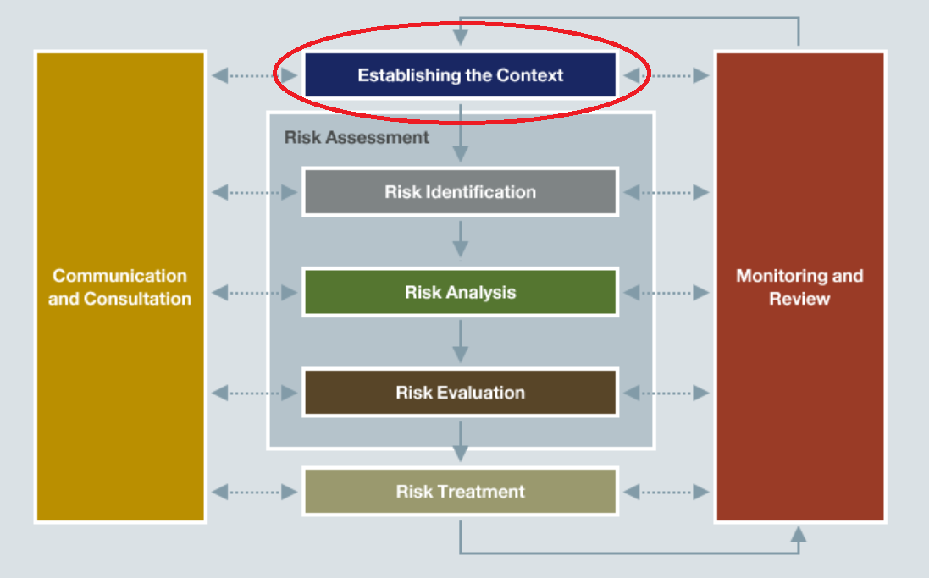

DFAT staff and partners or recipients must ensure child protection risk is considered, and is managed in accordance with [DFAT’s risk management practices](http://dfat.gov.au/about-us/publications/Pages/aid-programming-guide.aspx). Child protection risks must be assessed as part of standard risk management processes at design, implementation, monitoring and evaluation – and managed throughout the lifecycle of the activity.

There are common **child protection risk context** areas that DFAT staff and DFAT funded partners or recipients can review to determine the likely risk level of an organisation and the level of contact between staff and children that will take place under the activity.

Risk levels included in this document are modelled on the DFAT Risk Matrix and follow the principles of the [International Standard on Risk Management (AS/NZ 31000:2009)](http://www.finance.gov.au/sites/default/files/COV_216905_Risk_Management_Fact_Sheet_FA3_23082010_0.pdf).

### ‘High’ Risk Activities and Organisations

Activities can be ‘high’ risk for a number of reasons. This can be due their nature, their location, political or cultural sensitivities and/or the organisation/s involved etc.

In addition, DFAT may be engaging in a low risk activity with an organisation, however, if that organisation is deemed ‘high’ risk (e.g. they undertake other programs that work directly with children so are considered child focused), then a child protection risk assessment must be conducted before an agreement or contract is entered into. The DFAT minimum child protection standards at Attachment A and B of the CPP are applied to manage the risk. Risk monitoring must be conducted throughout the engagement for ‘high risk’ organisations.

## Establishing the child protection risk context

There are three steps summarised below that are used to establish the **child protection risk context.** Once you have completed the three steps you can establish the overall potential **child protection risk context** and determine whether a child protection risk assessment is required and whether DFAT’s nine minimum child protection standards need to be applied. Below is an overview of the steps.

**Step 1:** Does the activity involve **working with** children or **contact with** children?

**Step 2:** Is the organisation **child-focused** and what child protection controls[1] are currently in place?

**Step 3:** Based on the outcomes of the first two steps, determine the Child Protection Risk Context. Is an assessment of child protection risk required? Does the organisation need to apply all or some of DFAT’s nine minimum child protection standards?

**Note: All three steps must be undertaken. Details of these steps follow.**

### Step 1: Does the activity involve working with children or contact with children?

There are two parts to this step:

Part A – Determine the level of contact with children (e.g. nil, contact or working)

Part B – Assess the Activity Risk

The definitions at the end of the document can assist with answering Part A and B.

|  |  |  |
| --- | --- | --- |
| **Step 1: Part A** – What is the level of ‘working with’ or ‘contact with’ children at the activity level? Complete the worksheet by adding a Yes or No response. | | |
| 1. **Contact with Children - Assessment (No = nil contact)** | | |
| **Inherent risk** | Personnel will be deployed internationally (outside their usual country of residence)? |  |
| Personnel will be working in a remote and/or rural location? |  |
| **Degree of Isolation** | Involves being alone with children?  (not frequently enough to be working with children) |  |
| Involves activities that are away from organisation location |  |
| Involves meeting one-on-one with children?  (not frequently enough to be working with children) |  |
| Involves unpredictable or remote settings? |  |
| **Online contact or access to personal details** | Involves direct one-on-one or group access to children online? |  |
| Involves supervising child-to-child online contact? |  |
| Involves online access to a child’s or children’s personal and/or confidential information? |  |
| Inadequate/missing safe options for children to report unwanted attention or inappropriate behaviour by others? |  |
| Involves educating children and supporting adults on cyber safety? |  |
| 1. **Working with Children - Assessment** | | |

|  |  |  |
| --- | --- | --- |
| **Child/children less able to protect themselves or report situations of harm** | Engages with children who more likely to be in situations of vulnerability which would increase their exposure to protection risks?  *For example: Children with disabilities (in particular girls with disabilities and those with intellectual and communication impairments), homelessness, child sex workers or parents who are sex workers, children and families impacted by disasters, displaced, migrants, refugees and asylum seekers, children in contact with the law, children that have been subject to trafficking, orphans, unaccompanied minors and the very young, children with parents with disabilities, child headed households* |  |

|  |  |  |
| --- | --- | --- |
|  | Engages with children who may find it more difficult to protect themselves? *For example: children with physical impairments may not be able to physically distance themselves from a perpetrator, children with sensory impairments may not be able to hear or see a perpetrator approach, and some children (including children with intellectual disabilities) may not have received accessible education and information which would enable them to understand what is inappropriate* |  |
| Engages with children who may be less likely or less able to report situations of harm? For example, due to communication barriers or not being believed, lack of accessible information about reporting, inaccessible justice and accountability systems and stigma and shame? |  |
| Engages with children who may experience isolation and exclusion, and do not have many support systems? |  |
| **Degree of physical contact** | Involves demonstrating a skill to children? |  |
| Position involves need for physical contact/touching children? |  |
| Involves providing personal care? (e.g. washing, dressing, toileting) |  |
| **Degree of monopoly** | Monopoly on provision of goods and/or services   * Medical? * Food distribution? * Career training (sports/musical)? * Rehabilitation and/or assistive devices? |  |
| **Degree of supervision** | Involves personnel having unsupervised contact with children? |  |
| Activities/engagement with children is not observed or monitored? |  |
| Insufficient number of trained staff to supervise activities/engagement with children? |  |
| **Degree of trust** | Involves developing close, personal, long term relationships with children? |  |
| Involves transporting youth? |  |
| Involves one or more of the following:  One-on-one supervision, overnight supervision, out of town activities, advising or offering guidance to youth or spending extended periods of time with youth (e.g. camps), provision of disability support services (for example, sign language interpretation, mobility and orientation support, personal assistance)? |  |
| Contributes to important decisions regarding the future of children? |  |
| **Access to Property** | Has access to personal/confidential information? |  |
| Adult has a perceived or actual level of authority? (from child perspective) |  |
| **Skills and knowledge required** | Requires specific skills, knowledge, qualifications or service eligibility requirements to undertake a child related position? |  |
| **Child labour** | Possibility that activity will lead to the employment of children? |  |
| Possibility that activity will lead to the removal of children from school? |  |
| Possibility that activity will lead to children being employed in hazardous work? |  |
| **Parent/caregiver more likely to be in situations of vulnerability** | Engages with parents who do not have access to services they need to improve their parenting capacity which would support them to meet the needs of and protect their children? |  |
| Engages with parents who experience challenges that contribute to their ability to provide care? (e.g., situational) |  |
| Engages with parents who are experience isolation and exclusion and do not have access to support systems? |  |

|  |
| --- |
| **Step 1: Part B** – Assess the Activity Risk |

|  |  |  |  |
| --- | --- | --- | --- |
| Based on your responses in Part 1, identify the inherent risk of the activity using the table below. Activity Risk is the level of potential risks to children due to the nature of the activity (working with children) or the design of the activity (design of the activity introduces risks to children). | | | |
| **LOW** | **Nil contact** | **🞎** | The activity does not involve any individuals working in-country (**you answered No to all questions in Step 1 Part A**) |
| **MODERATE** | **Contact with Children** | **🞎** | The activity involves or may involve contact with children – this includes any work in‑country, remote or rural area. **(you answered Yes to any questions in ‘Contact with Children - Assessment’ but ‘No’ for all questions in ‘Working with Children - Assessment’ in Step 1 Part A)** |
| **HIGH** | **Working with Children** | **🞎** | The activity involves working with children **(you answered YES to any questions under ‘Working with Children - Assessment’ in Step 1 Part A)** |

|  |
| --- |
| Note: If the activity is determined to be ‘**working with children’** then an **assessment of child protection risk** is required and the organisation must apply the **nine minimum child protection standards** (at Attachment A and B of the DFAT Child Protection Policy 2017. DFAT requires its funded partners to build on these minimum standards as appropriate to their activity or organisation.  An individual contractor engaged in a ‘working with children’ activity is not required to have a child protection policy. However, they are required to have a current criminal history check, to sign a code of conduct that applies and builds on (where appropriate) DFAT’s Child Protection Professional Behaviours and provide evidence of their commitment to child protection. This would include an assessment of child protection risks and attending child protection training. |

### Step 2: Is the organisation child-focused and what child protection controls are in place?

There are three parts to this step:

Part A – Assess the organisation’s focus on children

Part B – Assess the strength of the organisation’s child protection systems

Part C – Assess the overall organisation risk

|  |  |  |
| --- | --- | --- |
| **Step 2: Part A** – Assessment of Organisation’s Focus on Children Complete the worksheets below and add a Yes/No response against each question under ‘Focus’ | | |
| **Focus -** A child-focused organisation is an organisation that answers ‘yes’ to any of the questions below**[2]**. | | |
| **Types of activities** | Does the organisation across all of its operations provide any direct activities/services for children? |  |
| Does the organisation provide any humanitarian relief? |  |
| **Business model/services provided by organisation** | Organisation provides Residential/Orphanage/Shelter services to children with and/or without disability? |  |
| Organisation uses a child sponsorship model? |  |
| Organisation allows sponsors to visit with children? |  |
| Organisation is part of a ‘voluntourism’[3] program? |  |
| Organisation requires technical experience/expertise to implement child related services? |  |
| Organisation uses children and/or images of children as a ‘product’ for fundraising activities? |  |

|  |
| --- |
| Note: If an organisation is ‘**child-focused’** then an **assessment of child protection risk** is required and the organisation must apply or build on the **nine minimum child protection standards** at Attachment A and B of the DFAT Child Protection Policy 2017. This is regardless of whether the level of contact with children is ‘working’, ‘contact’ or ‘nil’. This is due to the increased risk of child abuse and exploitation within a child-focused organisation. |

|  |  |  |
| --- | --- | --- |
| **Step 2: Part B**  Complete the worksheets below and add a Yes/No response against each question  **Systems and Controls -** Strength of systems and controls scaled by number of ‘yes’ responses.  Use the scale 0 x Yes answers = poor systems, 9 x Yes answers = strong systems | | |
| **Child protection policy and procedures [4]** | Child Protection Policy in place that includes a commitment to preventing a person from working with children if they pose an unacceptable risk to children? |  |
| Risk management practices in place and include risks to children |  |
| Recruitment practices, screening completed for all staff, before commencing work? |  |
| Notifications/Incident reporting procedures in place? |  |
| Staff and downstream partners receive child protection training? |  |
| Boundaries for appropriate behaviour/code of conduct are implemented? |  |
| The organisation’s employment contracts contain provisions for suspension or transfer to other duties of any employee who is under investigation and provisions to dismiss any employee after an investigation? |  |
| Record keeping procedures are in place (meetings, activities, incidents, reports, logs, record of complaints, staff performance)? |  |
| The organisation ensures their downstream partners (organisations or individuals) comply with the relevant minimum child protection standards? |  |

|  |  |  |  |
| --- | --- | --- | --- |
| **Step 2: Part C** – Organisational Risk | | | |
| Organisational risk is the level of potential risk posed by the organisation due to their ability to address child protection risks through their policies, procedures and systems and the type of work the organisation engages in (e.g. if they are a child focussed organisation, their risks will be higher). | | | |
| **LOW** | **NO FOCUS** | **🞎** | Organisation is not a child-focused organisation **(you answered No to all questions in Step 1 – Focus)** |
| **MODERATE** | **FOCUS & STRONG SYSTEMS** | **🞎** | Organisation is a child-focused organisation and has good child protection systems in place (**You answered Yes to any question in Step 1 Focus and had a majority of Yes answers to the questions under systems and controls)** |
| **HIGH** | **FOCUS & POOR SYSTEMS** | **🞎** | Organisation is a child-focused organisation and has poor or nil child protection systems in place **(You answered Yes to any question in Step 1 Focus and had a majority of No answers to the questions under systems and controls)** |

Step 3: Establish the overall child protection risk context

Establish the overall child protection risk context to determine whether an assessment of child protection risk and the application of the minimum child protection standards are required.

Once you have completed steps 1 and 2 you can establish the overall risk context by placing the results of each activity in the appropriate field below:

|  |  |  |  |
| --- | --- | --- | --- |
| **Organisation level of contact with children and systems in place**  (organisation risk from Step 2) | **Activity Level of Contact with Children** (activity inherent risk from Step 1) | | |
| **NIL**  **(LOW)** | **CONTACT**  **(MODERATE)** | **WORKING**  **(HIGH/VERY HIGH)** |
| **NO FOCUS**  **(LOW)** | 🞎 No further assessment required (low risk) | 🞎 Assessment of child protection risk required  Apply the appropriate minimum child protection standards to manage the risk* (moderate risk) | **🞎 Assessment of child protection risk required**  **Apply and build on all nine DFAT minimum child protection standards**  **Consider the need for technical expertise (very high risk)** |
| **FOCUS & STRONG SYSTEMS**  **(MODERATE)** | 🞎 Assessment of child protection risk required.  Apply the appropriate minimum child protection standards to manage the risk*  (moderate risk) | 🞎 Assessment of child protection risk required  Apply the appropriate minimum child protection standards to manage the risk* (moderate risk) | 🞎 Assessment of child protection risk required  Apply and build on all nine DFAT minimum child protection standards (high risk) |
| **FOCUS & POOR SYSTEMS**  **(HIGH/VERY HIGH)** | 🞎 Assessment of child protection risk required.  Apply and build on all nine DFAT minimum child protection standards (high risk) | 🞎 Assessment of child protection risk required  Apply and build on all nine DFAT minimum child protection standards (high risk) | **🞎 Assessment of child protection risk required -**  **Apply and build on all nine DFAT minimum child protection standards**  **Consider the need for technical expertise (very high risk)** |

|  |  |  |  |
| --- | --- | --- | --- |
| **Low Risk** | **Moderate Risk** | **High Risk** | **Very High Risk** |

#### If the matrix indicates an assessment of child protection risk is required

**Implementing Partners:**

* Conduct an assessment of the child protection risks within the organisation and activity using the organisation’s own risk management processes and documentation. A child protection risk assessment requires the partner to assess all possible child protection risks within the activity.[5]
* Show evidence to DFAT that the assessment has been completed and documented.
* For high or very high-risk contexts, consider whether you should get someone with child protection expertise to assist with the risk assessment and policy and procedure development.

**DFAT Staff:**

* Conduct an assessment of child protection risks at design, tender, contract negotiation, implementation, monitoring and evaluation for the lifecycle of the activity, in accordance with the *Aid Programming Guide* and the *Risk Management for Aid Investments Better Practice Guide*.
* For high or very high-risk contexts, consider the need for child protection expertise to assist with the risk assessment.

#### *If the matrix indicates a requirement to apply the appropriate minimum child protection standards to manage the risk

* The minimum child protection standards put in place will depend on the risks identified in the risk assessment. DFAT would expect at a minimum that implementing partners:
  + Undertake a risk assessment
  + Have appropriate recruitment and screening practices in place
  + Have clear reporting procedures and a requirement to immediately report any suspected or alleged instances of child abuse, exploitation, harm or child protection policy non-compliance to the DFAT Conduct and Ethics Unit via [childwelfare@dfat.gov.au](mailto:childwelfare@dfat.gov.au)
  + Training for personnel in child protection awareness and their obligations to protect children and report concerns.

Identify and record who completed the steps above and when the child protection risk assessment (if required) will be completed.

## Definitions

|  |  |
| --- | --- |
| Term | Definition |
| Working with children | Working with children means being engaged in an activity with a child where the contact would reasonably be expected as a normal part of the activity and the contact is not incidental to the activity. Working includes volunteering or other unpaid work.  *The risks of child exploitation and abuse generally increase with the frequency of contact, meaning that working with children is a higher risk than contact with children*. |
| *Example*s | Activities or services for children:   * Disability service * Cultural youth exchange * Residential care * Child protection services * Justice facilities for children * Childcare services * Child education services, Children in sports * Child accommodation services * Health services, Access to Sexual & Reproductive Health * Counselling and support services for children * Emergency response, Humanitarian assistance to children and families |
| Contact with children | Contact with children means being engaged in an activity or in a position that involves or may involve contact with children, either under the position description or due to the nature of the work environment. This means physical contact, face-to-face contact, oral communication, written communication or electronic communication.  *Contact covers contact with children in the community not associated with the work being performed*. |
| *Examples* | * Any international work, in particular working in remote/rural locations * Oral and written communication (including electronic communication) relating to a child * Access to data relating to a person under 18 * Public diplomacy, official functions, visits or other communication activity involving photography, filming, videoing or social media activity where children are present * Visiting premises e.g. schools, health or residential facilities, that provide services to children * Any community consultation (data collection, surveying, training) * Women and Gender focussed activities * Health Sector Programs |

1. Child protection controls may include but are not limited to, organisations undertaking child safe recruitment practices such as criminal record checks, ensuring all staff sign a Child Protection Code of Conduct etc. Controls are applied to reduce the likelihood of a risk taking place.
2. A yes would indicate that an organisation would need to apply and build on the minimum child protection standards at Attachments A and B in the DFAT Child Protection Policy.
3. Voluntourism is “Volunteer travel, volunteer vacations or voluntourism is travel which includes volunteering for a charitable cause” Voluntourism is a business model that has been shown to be very high risk to children.
4. A no response to all or most questions would indicate a high-risk organisation due to poor systems. A yes response to all or most questions would indicate strong systems
5. See DFAT’s Child Protection Guidance Notes for guidance on risks and mitigation measures within certain sectors <http://dfat.gov.au/childprotection> or contact the Child Protection Compliance Section on [child.protection@dfat.gov.au](mailto:child.protection@dfat.gov.au).