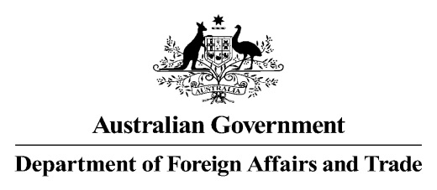

**Child Incident Notification (CIN)**

Case Number (*To be allocated by EES: Year\CIN No.*)

________________________________________

Where this document is not completed by EES, it is to be provided to the Employee Conduct and Ethics Section at [childwelfare@dfat.gov.au](mailto:childwelfare@dfat.gov.au) as soon as possible.

EES will assess the notification and direct it to the proper area of inquiry and investigation within the Department. The person reporting and\or sender of the document may be contacted if further information is required.

|  |  |
| --- | --- |
| 1. If this report was received initially by CPC or Consular Operations, please complete the following (*All others go to Section 2*) | |
| Circle: CPC or Conops  Name:  Position: | Date received and case number:  Cable No. (if applicable):  Email date: (Print and attach) |
| 1. Names(s) of person reporting and contact details | |
| Name:  Position: | Telephone:  Email: |
| 1. Reporting Post or Agency | |
| Post or Agency: | Country: |

|  |  |  |  |  |  |  |  |
| --- | --- | --- | --- | --- | --- | --- | --- |
| 1. Type of Allegation | | | | | | | |
| Please circle most appropriate description of alleged incident:  Sexual Abuse\Sexual Misconduct  Physical Abuse  Psychological Abuse  Neglect  Other | | | | Further details if known (Date\location\when report was received):  Other relevant details: (For example implements used, vulnerability, or disability factors): | | | |
| 1. Details of Person(s) against whom the allegation has been made | | | | | | | |
| Family Name: |  | | | | | | |
| Given Name: |  | | | | | | |
| Sex: |  | | | | | | |
| Date of birth: |  | | | | | | |
| Nationality: |  | | | | | | |
| Contact details: |  | | | | | | |
| Employer\Program:  (Please circle most appropriate descriptor. You can circle more than one) |  | | | | | | |
| DFAT Employee  including LES | Australian Citizen or Permanent Resident | | | NGO Employee | Contractor including sub-contractor | Volunteer |
| Position:  (If applicable) |  | | | | | | |
| 1. Details of Victim(s) | | | | | | | |
| Family Name: |  | | | | | | |
| Given Name: |  | | | | | | |
| Sex: |  | | | | | | |
| Date of birth: |  | | | | | | |
| Nationality: |  | | | | | | |
| Contact details: |  | | | | | | |
| Age of child at time of alleged incident: | | |  | | | | |
| Have any injuries been observed or reported? *(If more space is needed, please utilise Section 8)* | | | | | | | |
| 1. Further Details | | | | | | | |
| Is the victim still in danger of abuse or neglect? | | | |  | | | |
| Are local police or other local authority aware of the incident\allegation? | | | |  | | | |
| What other authorities have been informed? | | | |  | | | |
| Has the AFP at post (where relevant) been advised or consulted? If so, what is their response or proposed action? | | | |  | | | |
| 1. Any other pertinent information for initial assessment | | | | | | | |
|  | | | | | | | |

|  |  |  |
| --- | --- | --- |
| **CEU use only** | | |
| Case Number (Year\ CIN No.) |  | |
| Recorded on CIN\EES database: | Date: | |
| Received via (Post\Agency\original source) |  | |
| Responsible Section (Circle): | Employee Conduct & Ethics  Child Protection Compliance Section  Consular Operations | Responsible Section Case No. |
| Referral to responsible section | Date: | |
| EES advised of case outcome\closure | Date | |
| EES database updated and cross referenced with Section case No. |  | |