# Statement on International Public Support for the Clean Energy Transition

IMPLEMENTATION GUIDELINES

December 2024

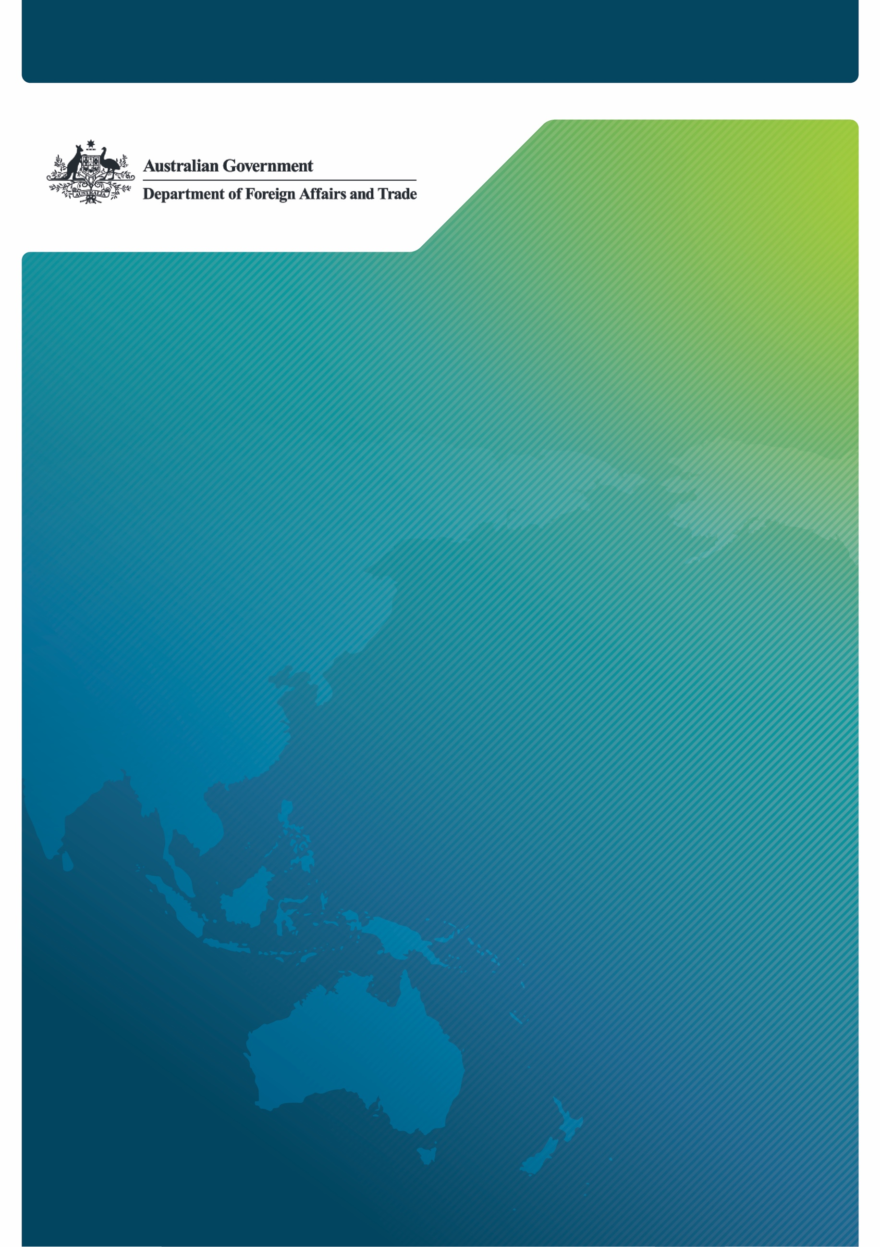

## Overview

On 4 November 2021 at the 26th United Nations Framework Convention on Climate Change (UNFCCC) Conference of Parties (COP26) in Glasgow, the [Statement on International Public Support for the Clean Energy Transition](https://webarchive.nationalarchives.gov.uk/ukgwa/20230401054904/https:/ukcop26.org/statement-on-international-public-support-for-the-clean-energy-transition/) (known as the Glasgow Statement or Clean Energy Transition Partnership (CETP)) was signed by 39 countries and institutions.

On 5 December 2023 at COP28 in Dubai, the Australian Government joined the Glasgow Statement as announced in a [joint media release](https://minister.dcceew.gov.au/bowen/media-releases/joint-media-release-australia-joins-clean-energy-transition-partnership) by Australia’s Minister for Foreign Affairs, Senator the Hon Penny Wong, Minister for Climate Change and Energy, the Hon Chris Bowen MP, and then Assistant Minister for Climate Change and Energy, Senator the Hon Jenny McAllister.

### Implementation of the Glasgow Statement

The Australian Government recognises the urgency of addressing the climate crisis. Australia's commitment to the Glasgow Statement reinforces its commitment to build a global net zero economy, which will contribute to the Government’s full and effective implementation of the Paris Agreement.

The Australian Government has taken strong action to restrict direct Government support for the fossil fuel energy sector, including:

* Legislating to prohibit direct financing for the extraction of coal and gas and the construction of pipeline infrastructure primarily for the extraction of natural gas in the *National Reconstruction Fund Act*;
* Legislating to prohibit the prescription of funding programs where they would subsidise the extraction of coal and gas in the *Industry Research and Development Act*;
* Legislating that Export Finance Australia must have regard to Australia’s obligations under international agreements, including Australia’s emissions reduction targets and the Glasgow Statement; and
* Restricting Export Finance Australia’s commercial account and new Future Made in Australia financing in relation to a range of defined coal, natural gas or crude oil investments; and
* Amending over a dozen acts of Parliament to incorporate Australia’s international climate change commitments, including Australia’s emissions reduction targets.

The Glasgow Statement further supports Australia’s implementation of domestic and global climate commitments, including agreement by parties to the Paris Agreement under the COP28 Global Stocktake to *transition away from fossil fuels in energy systems, in a just, orderly and equitable manner, accelerating action in this critical decade, so as to achieve net zero by 2050* (see UAE Consensus). Joining also complements Australia’s and other G20 members commitment to phase-out inefficient fossil fuel subsidies that encourage wasteful consumption.

These Guidelines outline the scope and application of this commitment and are intended to assist Australian federal departments and agencies, including providers of direct Australian public support, on how to incorporate and faithfully comply with our commitments under the Glasgow Statement.

The Glasgow Statement is a voluntary,non-binding commitment that does not generate any obligations under international law. Changes to domestic legislation are **not** required to implement commitments under the Glasgow Statement.

The Government will update these Guidelines as necessary, to ensure coherence with Australia's evolving climate obligations, commitments and policies.

### The Glasgow Statement – Full Text

We the [undersigned] commit to the following actions to align our international public support towards the clean energy transition and out of unabated fossil fuels. Our joint action is necessary to ensure the world is on an ambitious, clearly defined pathway towards net zero emissions, that is consistent with the 1.5°C warming limit and goals of the Paris Agreement, as well as the best available science and technology. These measures will help stimulate sustainable, resilient and inclusive economic development globally, and support a just transition for affected communities:

1. We will prioritise our support fully towards the clean energy transition, using our resources to enhance what can be delivered by the private sector. This support should strive to “do no significant harm” to the goals of the Paris Agreement, local communities and local environments.
2. Further, we will end new direct public support for the international unabated fossil fuel energy sector within one year of signing this statement, except in limited and clearly defined circumstances that are consistent with the 1.5°C warming limit and the goals of the Paris Agreement.
3. We will encourage further governments, their official export credit agencies and public finance institutions to implement similar commitments into COP27 and beyond. This includes driving multilateral negotiations in international bodies, in particular in the OECD, to review, update and strengthen their governance frameworks to align with the Paris Agreement goals. For government signatories, this will also guide our approach on the boards of multilateral development banks.

In committing to the above, we furthermore recognise:

1. the findings of the Intergovernmental Panel on Climate Change (IPCC) and IEA net-zero analysis show that in the pathways consistent with a 1.5°C warming limit and the goals of the Paris Agreement, the global production and use of unabated fossil fuels must decrease significantly by 2030;
2. that the accelerated alignment of international public and private sector financial flows is critical to driving energy transitions, energy access and supporting the development of both emerging and existing clean technologies, improving livelihoods and employment prospects worldwide;
3. the progress, driven in part by enabling public finance investments, in reducing the costs of clean energy alternatives such as solar and wind power to become cheaper than unabated fossil fuels in almost every region of the world, revolutionising and transforming energy options and access;
4. that investing in unabated fossil-related energy projects increasingly entails both social and economic risks, especially through the form of stranded assets, and has ensuing negative impacts on government revenue, local employment, taxpayers, utility ratepayers and public health;
5. the devastating impacts of the COVID-19 pandemic and the need to recover better and greener for a sustainable economic recovery that saves lives and improves livelihoods.

### Australia’s Commitment to the Goals of the Paris Agreement

Signing the Glasgow Statement forms part of Australia’s wider action to ensure full and effective implementation of the[Paris Agreement](https://unfccc.int/files/meetings/paris_nov_2015/application/pdf/paris_agreement_english_.pdf)[1] and is an important step in accelerating the global transition to clean energy.

The Paris Agreement is a legally binding international treaty on climate change. Australia is one of 195 Parties to the Paris Agreement, which entered into force for Australia on 10 November 2016. Australia's [*Climate Change Act 2022*](https://www.legislation.gov.au/C2022A00037/latest/text) implements our obligations under the Paris Agreement, including by legislating our 2030 emissions reduction target of 43 per cent below 2005 levels and our net zero 2050 target.

The Australian Government is committed to building a net zero economy and ambitious action to address climate change and its impacts. The Glasgow Statement further enables Australia, and all signatories, to better align international investments with the goals of the Paris Agreement.

## Policy Scope

As a signatory to the Glasgow Statement, Australia will not finance new international unabated fossil fuel energy sector projects from 5 December 2024 (12 months from the date of signing this statement), **except in limited and clearly defined circumstances** (limited circumstances) outlined in the next section of these Guidelines.

### Ending New Direct Support for International Unabated Fossil Fuel Energy Sector

A core commitment the Australian Government has made under **paragraph two** of the Glasgow Statement, is to:

**End new direct public support for the international unabated fossil fuel energy sector** [within one year of signing this statement], **except in limited and clearly defined circumstances** that are consistent with the 1.5°C warming limit and the goals of the Paris Agreement.

Australia’s decision to join the Glasgow commitment builds on a substantive and existing framework already in place to ensure its public financing does not support international unabated fossil fuel projects and to align spending with Paris Agreement goals. Climate action is integrated across Australian Government operations, including through the introduction of disclosure requirements under the [Commonwealth Climate Disclosure Policy](https://www.finance.gov.au/government/climate-action-government-operations/commonwealth-climate-disclosure-policy), and release of the [Climate Risk and Opportunity Management Program](https://www.dcceew.gov.au/climate-change/publications/climate-risk-opportunity-management-program-resources) (2024 – 2026), which aims to improve public sector management of climate risks.

The **Application** section of these Guidelines detail climate actions Australian federal departments and agencies impacted by the Glasgow Statement, are already taking.

To determine whether a project is in scope of the Glasgow Statement, and whether a limited circumstance exception applies:

**Part A** of these Guidelines establishes the parameters in which the commitment applies. Projects within these parameters cannot be supported by Australian federal departments and agencies, unless a limited circumstance applies under **Part B**.

**Part B** of the Guidelines provides criteria for the limited circumstances whereby a project that falls in scope of the Glasgow Statement could be supported by Australian federal departments and agencies.

## PART A: Definitions

The Australian Government will end support for projects that meet **all** (five)definitions below, with limited exceptions (**Part B** refers):

### New

Any **new** direct public support for an international unabated fossil fuel energy project, provided on or after 5 December 2024.[2] New support for existing projects (including greenfield and brownfield projects), is within scope.

Delivery of support to fulfil existing project commitments is **not** within scope, as the Glasgow Statement does not apply retrospectively.

### Direct Public Support

Providing **direct** **public support** includes any form of public finance provided by the Australian Government (including loans, guarantees, insurance and equity) for an international unabated energy sector project,[3] regardless of the project proponent.

### International

**International** unabated fossil fuel energy sector refers to projects wholly outside of Australia’s jurisdiction in the fossil fuel energy sector, regardless of owner domicile.

### Unabated

**Unabated** refers to a project that does not or cannot demonstrate a high level of emissions reductions through operational carbon capture (e.g., CCS or CCUS), or other effective technologies.Furthermore, to be considered abated a project will need to demonstrate significant emissions reductions over the lifetime of the asset, support transition pathways to net zero, and not create lock-in effects that delay or diminish the transition to renewable energy. Offsets or credits are not considered a form of abatement.

### Fossil Fuel Energy Sector

**Fossil fuel energy sector** refers to the exploration, production, transportation, storage related to distribution infrastructure, refining, distribution and power generation of coal, crude oil and natural gas.

**PART B: Limited Circumstances**

The limited circumstances in which the Australian Government may provide support within scope of the commitment are where there are compelling reasons of national interest or urgent humanitarian need.

**National Interest Exception**

The Government may decide, on an exceptional basis, to support an international unabated fossil fuel energy sector project on national interest grounds. In such cases, as part of its decision, the Government should also take into account:

1. whether the country has a credible **low-carbon transition strategy[4]** or **nationally determined contribution (NDC)[5]** covering the energy sector;
2. if the transaction is consistent with the goals of the Paris Agreement (including the 1.5 degrees warming limit); and
3. situations in which there are no viable renewable alternatives, or, if the project is time-bound and has a point-in-time for transition to or integration of renewables.

Any decision to exercise the national interest exception will be made by relevant portfolio ministers. For example, to assess whether Australian Infrastructure Financing Facility for the Pacific (AIFFP) can support projects in scope of the Glasgow Statement on national interest grounds, DFAT Ministers (Minister for Foreign Affairs, Minister for International Development and the Pacific and where required Minister for Trade and Tourism), and other relevant Ministers, are part of the decision-making process.

**Humanitarian Response Exception**

The Government may decide, on a case-by-case basis, to provide support for emergency power generation supply for the purposes of humanitarian response. In such cases, depending on suitability and availability, the Government will ensure support is limited to:

1. standard portable diesel generators with power generation up to 1MW;
2. the time-bounds of the humanitarian response; and
3. situations in which there are no viable renewable alternatives.

Australia has signed the global [Climate and Environment Charter for Humanitarian Organizations](https://aus01.safelinks.protection.outlook.com/?url=https%3A%2F%2Fwww.icrc.org%2Fen%2Fdocument%2Ficrc-ifrc-climate-environment-charter&data=05%7C02%7CMonique.Andreatta%40dfat.gov.au%7C9d3a38779c4749b6258708dc964c370a%7C9b7f23b30e8347a58a40ffa8a6fea536%7C0%7C0%7C638550501544126306%7CUnknown%7CTWFpbGZsb3d8eyJWIjoiMC4wLjAwMDAiLCJQIjoiV2luMzIiLCJBTiI6Ik1haWwiLCJXVCI6Mn0%3D%7C0%7C%7C%7C&sdata=g2HsFJrGZI3%2FgMiaEfI01Xe%2Br2Xs3Fa%2FFpQwr%2Bi2SP4%3D&reserved=0) and should pursue its best efforts under the circumstances of a humanitarian response, to *maximize the environmental sustainability of humanitarian programmes and operations and to reduce greenhouse gas emissions, while maintaining the ability to provide timely and principled assistance* (paragraph 2).

## Application

These Guidelines will assist Australian federal departments and agencies that currently fall in scope of the Glasgow Statement, including:

* EFA (including finance provided on behalf of the AIFFP); and
* Australia's official development assistance (ODA), including that provided by the AIFFP.

This is not an exhaustive list, and the Government will update the Guidelines as necessary, to ensure consistency with Australia's evolving climate obligations, commitments and policies.

### Export Finance Australia (EFA)

[EFA](https://www.exportfinance.gov.au/) is a corporate Commonwealth entity governed by the provisions of the [*Export Finance and Insurance Corporation Act 1991* (Cth)](https://www.exportfinance.gov.au/our-organisation/our-governance/export-finance-and-insurance-corporation-act/)(EFIC Act) and the [*Public Governance, Performance and Accountability Act 2013* (Cth)](https://www.exportfinance.gov.au/our-organisation/our-governance/pgpa-act/) (PGPA Act). EFA is part of the DFAT Portfolio, with the responsible ministers being the Minister for Trade and Tourism, and the Minister for Finance. EFA’s purpose is to support Australian export trade and overseas infrastructure development that benefits Australia.

#### Climate action

EFA supports the Government’s climate agenda. EFA is required under the [*Climate Change (Consequential Amendments) Act 2022*](https://www.legislation.gov.au/C2022A00038/asmade/text), to have regard to Australia’s obligations under the Paris Agreement and emissions reduction targets. In 2024 this was further amended by the Future Made in Australia (Omnibus Amendments No. 1) Bill 2024 to include the Glasgow Statement and restrict EFA’s financing of a range of defined coal, natural gas or crude oil projects. EFA’s [policy for environmental and social review of transactions](https://www.exportfinance.gov.au/our-organisation/our-corporate-responsibility/transactions/environmental-and-social-review/policy/) applies globally recognised approaches to ensure consistency with best-practice environmental and social standards. EFA is bound to the Organisation of Economic Co-operation and Development (OECD) Common Approaches and is a signatory to the Equator Principles. EFA is also expected to comply with the [OECD Arrangement](https://www.oecd.org/en/topics/sub-issues/arrangement-and-sector-understandings.html) for Officially Supported Export Credits, including the prohibition on the financing of unabated coal power plants.

Environmental and Social Impact Assessments (ESIA) are a distinct element within EFA’s decision-making, undertaken by specialist staff. EFA provides details of its potential involvement in transactions associated with a project that has potential for significant adverse environmental and/or social impacts ([Category A project](https://www.exportfinance.gov.au/our-organisation/our-corporate-responsibility/transactions/transaction-disclosure/)), including access to the project’s environmental and social impact assessment. When a transaction is associated with a Category A project located outside Australia, approval from EFA’s Board is required in all circumstances. EFA publishes transactions supported each financial year on its [Transaction Register](https://www.exportfinance.gov.au/our-organisation/about-us/transaction-register/). The Register includes a wide range of information on transactions, including key transaction details (Customer, Industry, Goods/Services, Destination, Product, Finance amount and the outcome of the environmental/social impact assessment).

Category A transactions are subject to [additional disclosure requirements](https://www.exportfinance.gov.au/our-organisation/our-corporate-responsibility/transactions/transaction-disclosure/). EFA outlines on its website all Category A transactions it is considering. This disclosure outlines the project, type of finance being considered, the reason for classification as a Category A project and, for overseas projects, links to the relevant ESIA. For overseas projects public submissions are accepted by EFA.

### Australian Infrastructure Financing Facility for the Pacific (AIFFP)

[AIFFP](https://www.aiffp.gov.au/about) was established in 2019 and is operated by the DFAT Portfolio, within the Office of the Pacific, with the responsible ministers being the Minister for Foreign Affairs, the Minister for International Development and the Pacific, and the Minister for Finance. EFA issues loans on behalf of AIFFP under the [*Export Finance and Insurance Corporation Act 1991*](https://www.legislation.gov.au/C2004A04223/latest/text)*.* AIFFP’s purpose is to enable quality infrastructure across the region. This is achieved through partnering with Pacific governments and the private sector to provide grant and loan financing for high quality, transformational energy, water, transport, telecommunications and other infrastructure.

#### Climate action

As EFA issues loans on behalf of AIFFP, the EFA’s climate action detailed above applies to AIFFP. In addition, the [Pacific Climate Infrastructure Financing Partnership](https://www.aiffp.gov.au/climate-change#aiffp%E2%80%99s-climate-change-focus) expands on the already strong climate focus of AIFFP investments.

### Australia's Official Development Assistance (ODA)

[Australia's ODA](https://www.dfat.gov.au/development/australias-development-program#:~:text=2023%2D24%20Budget%20highlights,the%20October%202022%2D23%20Budget.) is part of the DFAT Portfolio, with the responsible ministers being the Minister for Foreign Affairs and the Minister for International Development and the Pacific. The [International Development Programming Guide](https://www.dfat.gov.au/about-us/publications/international-development-programming-guide) is an operational resource for DFAT staff with international development program management responsibilities, which includes annual investments of over $4 billion in ODA. The purpose of ODA is to promote sustainable economic growth and poverty reduction in developing countries, primarily in the Indo-Pacific region. This is delivered through a series of country, regional, global, and thematic development programs. More information is available in the [ODA Budget Summary](https://www.dfat.gov.au/development/australias-development-budget-and-statistical-information).

#### Climate action

Climate change is prioritised in Australia’s [International Development Policy](https://www.dfat.gov.au/publications/development/australias-international-development-policy), which guides Australia’s development program. Specifically, the Development Policy commits to increasing climate investments and better addressing climate risks. ODA decision-makers also integrate climate considerations (risks and opportunities) into investments, through applying the [Good Practice Note on Integrating Climate Change into Development Assistance](https://www.dfat.gov.au/international-relations/good-practice-note-integrating-climate-change-development-assistance-implementing-partners). All ODA funded blended finance mechanisms screen out fossil fuel assets and focus entirely on clean energy investments or net zero emission assets.

1. [Paris Agreement English (unfccc.int)](https://unfccc.int/files/meetings/paris_nov_2015/application/pdf/paris_agreement_english_.pdf)
2. Or for Export Finance Australia (EFA), valid from the date of receipt of a Ministerial direction, including a Statement of Expectations.
3. ‘Energy sector project’ excludes the secondary use of fossil fuels, for example businesses using petrochemicals as feedstock in production processes for products such as fertiliser; or businesses in the mining, technology and services sector participating in the supply chain where these companies operate across sectors. 
4. A country's **low-carbon transition strategy** is a roadmap that includes technical details on plans for reducing greenhouse gas emissions. Credible strategies should include documented guidelines to enable a country's transition to a low carbon economy (e.g., carbon budgets, emissions caps, CCS, CCUS or other equivalent abatement technologies that significantly reduce emissions or achieve decarbonisation).
5. An [**NDC**](https://unfccc.int/process-and-meetings/the-paris-agreement/nationally-determined-contributions-ndcs#:~:text=Nationally%20determined%20contributions%20(NDCs)%20are,the%20impacts%20of%20climate%20change.) is a climate action plan to cut emissions and adapt to climate impacts. Countries set targets for mitigating the greenhouse gas emissions that cause climate change and for adapting to climate impacts – they include but are not limited to the energy sector.

   There are obligations under the Paris Agreement for parties to establish an NDC and to update it every five years (Articles 4(2) – (3)). All [195 Parties to the Paris Agreement](https://unfccc.int/NDCREG) have issued at least a first NDC. National ministries generally lead NDC development.