UEA INTERNATIONAL DEVELOPMENT

CLIMATE CHANGE AND COASTAL ECOSYSTEMS PROGRAMME
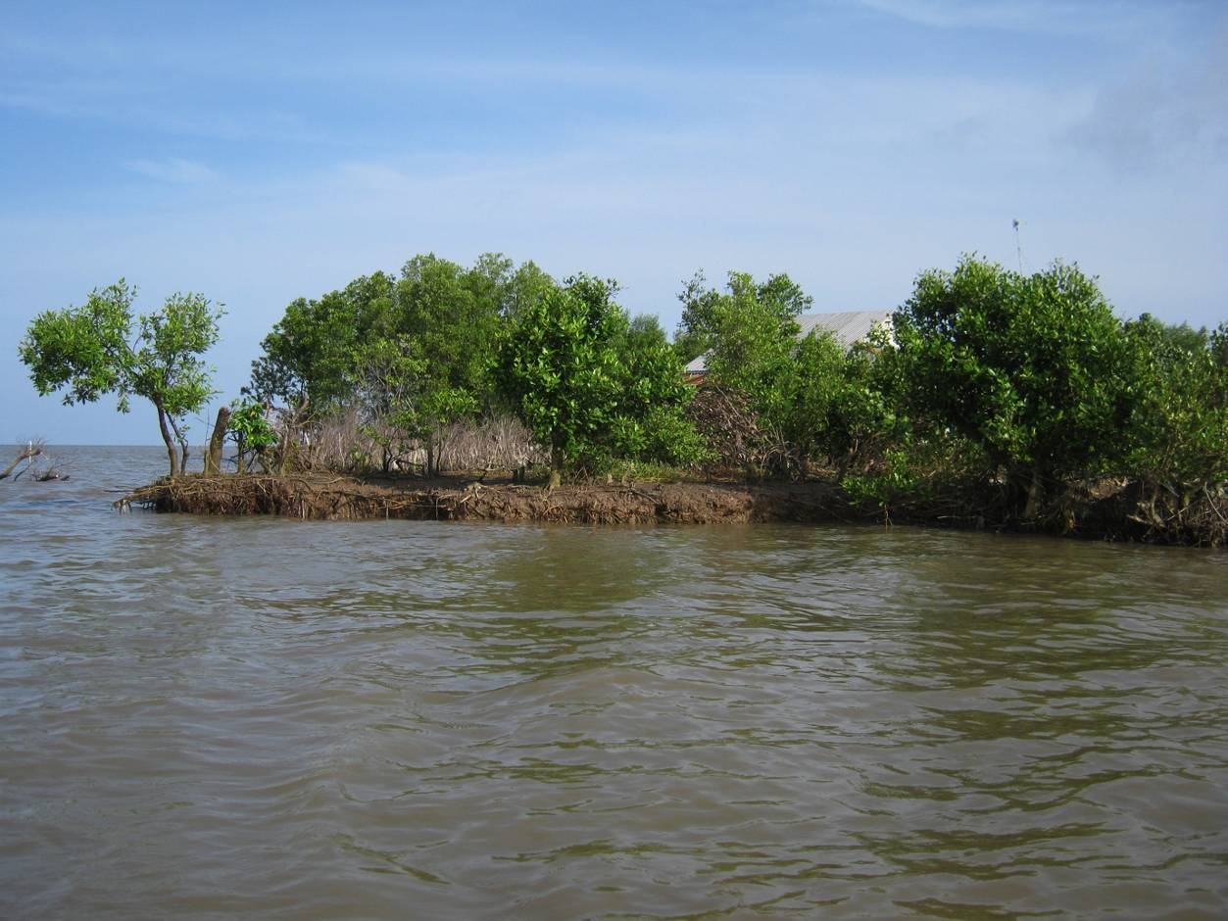
Gender Analysis

November 2010
GTZ and AusAID

ACKNOWLEDGEMENT

This study is conducted by a team of two international experts based at the School of International Development, University of East Anglia, United Kingdom. These include Nguyễn Thị Nguyệt Minh as Gender Expert and John Sawdon as Climate Change Adaptation specialist. We would like to express sincere thanks to the following people whose organisational support and discussions were essential for the execution of the fieldwork for this study:
In Hanoi, Ms Le Ngoc Ha was instrumental in putting together working schedules for us under tight time constraint and Ms Hoang Thi Lua provided translation and logistical support during the field mission and Hanoi meetings.
In Soc Trang: Mr Trịnh Văn Hiệp
Ms Triệu Thy Thanh Thảo
Ms Nguyễn Thị Vân Kiều
In Bac Lieu: Mr Lê Thành Lập
In Ca Mau: Ms Trần Ngọc Ẩn
In Kien Giang: Mr Nguyễn Hữu Nghĩa
Mr Nguyễn Thanh Linh
In An Giang: Mr Võ Thanh Minh
We would also like to thank various people at the district and commune level in the five provinces we visited who accompanied us to village, commune and household meetings. The local Women’s Union in those places are particularly helpful and enthusiastic in offering the support. We are impressed by their devotion and hard work in carrying out their mandate. Special thanks are extended to the Chief Technical Advisors of the three existing GTZ projects - Mr Klaus Schmidt, Mr Joachim Hof, and Ms Sharon Brown who provided us with expert understandings of ecological and livelihoods issues in the region.

Executive summary

The Climate Change and Coastal Ecosystem Program is a tripartite initiative between the Government of Vietnam, the German Technical Cooperation Agency and the Australian Development Agency. The program aims to develop and improve the management of coastal natural resources in the Mekong Delta as part of responses to climate change impacts in the region. The integration of management approaches with local livelihood strategies is essential to the success and sustainability of this programme. Meanwhile, the differing gender roles in local livelihoods in the program area means that men and women are likely to be differently affected by climate change as well as policy responses to climate change. This gender analysis aims to better understand these potentially differential impacts with a view to ensuring that project interventions are gender sensitive.

This is primarily a qualitative study which also draws on secondary statistical data where available. Corresponding to the structure of the program, the study focuses on two levels of analysis, namely policy-making processes and local level issues and responses. Consultation through household interviews, group discussions and meetings with local and higher level authorities and agencies has taken place in all project provinces, including Soc Trang, Bac Lieu, Ca Mau, An Giang and Kien Giang.

KEY FINDINGS

Gender and livelihoods
Despite impressive poverty reduction and economic growth, specific gendered vulnerabilities in the region have been compounded by recent changes in land and natural resource use as well as other socio-economic developments. High levels of vulnerability are present amongst the landless and the poor, who are predominantly Khmer, as well as recent in-migrants. These include female and male access to local employment, access to natural resources, legal status as well as mobility and employment restrictions.

Gender roles are segregated in the program region. Women tend to be confined to the home due to their primary involvement in home-based care and housework while men are more associated with tasks outside the home, including income-earning activities and participation in community events and decision-making. This division of roles extends into livelihood activities. Men tend to be involved in tasks requiring physical strength, technical skills, and travelling greater distances from home. In contrast women are more associated with tasks that are perceived as lighter and less technically demanding. They are also less likely to travel far from home while engaging more in activities around the home such as livestock keeping and gardening.

While most regional livelihoods activities such as rice or crop farming are gender sequential, industrial shrimp farming is extremely segregated involving almost only male labour. Local employment opportunities for women have been thus significantly reduced due to the conversion of land use from rice production to shrimp production. The mechanisation of rice farming, which provides technical jobs for men, has also acted to limit employment opportunities for women. Moreover, persisting wage differentials reflect deep-seated perceptions about the relative value of women’s and men’s work.

The poor, particularly poor and landless women, are dependent on various natural resources for their livelihoods, including those taken from coastal forests, inland forests, river banks and mudflat areas. Access to these areas is being affected by conservation and protection measures as well as the effective privatisation of the resources in some areas. For example, the mudflats have been recently leased out in Kien Giang for household production, potentially excluding poor users. Household based forest allocations also have implications for the access of landless people to forest resources. Meanwhile, community based management options such as the clam cooperatives are being tested in the region but thus far have proved problematic due to management and sustainability issues.

Forest protection contracts (or ‘Green Books’) for coastal protection forest allow farmers in many coastal areas to farm shrimp within 30-40% of the land area while requiring them to protect the remaining forest as a condition of their tenure. These contracts represent significant household assets as they frequently extend for 20-50 years. In Ca Mau they can also be used as collateral for bank loans. However, as was formerly the case with land use rights certificates, the title is in the name of the household head, who is typically a man. This has implications for women’s ability to exercise control over the important household asset.

Labour migration takes place predominantly amongst the young, both men and women. Married women tend to be more restricted than men due to their domestic responsibilities. Migration levels are increasing, but were regarded with ambivalence by many people in the areas visited. This is due to low wage levels, high living costs in urban areas, and anxiety regarding ‘moral risks’ facing young female migrants. Migration of mothers also places an increased burden on older rural women who have to look after the grandchildren left behind. Simultaneously, the restricted female mobility and their heavy care duties are aggravated by a total lack of early age childcare options, particularly in remoter parts of the region.

Climate change and gender
We found that the existing gendered vulnerabilities are exacerbated by the likely effects of climate change. Differences in livelihood roles between men and women result in differential exposure to those effects. For instance, women’s workload increases with the need to transplant rice as a result of late rainfall, whereas men have more problems when the shrimp ponds are affected. Meanwhile, women’s subsistence activities are severely hampered through negative impacts on livestock e.g. increased disease incidence and reduced availability of natural resources. Further, poor and landless women are doubly affected by shrinking natural resources and diminished wage labour opportunities resulting from climate induced failures in agriculture and aquaculture. This adds to their existing vulnerabilities.

In terms of general well-being, we found that women are facing greater insecurity and domestic burdens as a result of climate change effects. Erosion for instance is wiping out homes and shrimp ponds in certain areas, forcing households to look for alternative residence and employment where women will face greater strain in both providing and caring for their family. Meanwhile, increased health problems, sanitation needs as well as a lack of clean fresh water as a result of those effects are compounding their existing domestic burdens. These will have an impact on their social well-being as well as their ability to participate in community decision making.
Due to the gender roles in the household, the community and the labour market, women and men from different ethnic minorities and wealth groups have varying adaptation capacities. This is not only due to their existing vulnerabilities, but also on account of differential access outside support and resources, which is highly gendered and uneven in the region. For example, in all the project provinces, 70-80% of extension events are targeted at men, including those focusing on typically female roles such as pig rearing.
Gender awareness and capacity of the implementation and policy-making bodies is limited. As a consequence, their activities tend to take existing gender inequalities for granted rather than making an effort to address them. Adaptation and mitigation thinking generally seems technically oriented while current measures such as forest protection do not consider the likely exclusion of poor and landless women. Meanwhile, the Women’s Union is active at the grassroots level but remains constrained by lack of resources and under-staffing, which limit their outreach activities, particularly in remoter protection areas.
Finally, gender considerations remain superficial in policy-making processes regarding climate change. As yet there has been little effort to translate stated gender equality objectives into concrete action and plans. There is a general lack of clarify at national and provincial levels in terms of how best to address linkages between gender and climate change.

RECOMMENDATIONS

Following are recommendations for the program. The recommendations target three different levels, including its programming and organisation, its implementation and the policy level, which the program may wish to influence.
1. Programming and organisational recommendations
- Priority should be especially given to supporting communities living in or close to critical protection areas, which are currently disadvantaged on account of their location and resulting unequal access to infrastructure and services.
- The program should pay greater attention to involving the landless poor, including those belonging to the Khmer and Cham ethnic groups as well as recent migrants, in the implementation and as beneficiaries of the project activities, particularly women in these groups. Sustainable improvements in their livelihoods and status are essential to the achievement of both resource management and sustainable livelihoods objectives of the program. We recommend that all project provinces should make poor women an explicit focus while considering them in all project activities
- In the development of REDD or/and PES schemes landlessness issues must be carefully considered so that the poor, the landless and women are not excluded. We strongly recommend that these are seen as opportunities to create local employment rather than simply focus on compensation. More specifically, the following considerations should be made: i) Women and women’s organisations should be enabled to participate in decision-making, designing and monitoring the implementation these initiatives at all levels; ii) The problem of reduced female access to subsistence natural resources through protection measures should be addressed; iii) Female tenure rights regarding forest protection contracts should be clarified; iv) There should be proactive measures to include the landless, women in particular, in the benefit sharing through REDD financing.
- A provincial Focal Point for Gender and Social Development from an appropriate provincial line agency should be appointed by each program province to be charge of coordinating and monitoring gender related activities in the provincial project. Also, a national Gender and Social Development Advisor should be appointed to be charge of developing and overseeing the implementation of a Gender and Social Development Strategy for the program.
- Cooperation and information sharing with interested national agencies and organisations such as Women Union, UNIFEM and the Gender Equality Department under MoLISA should be strengthened through joint activities and information sharing.
2. Recommendation for implementation of the program
- Awareness raising and capacity building should be carried out to improve understanding in both gender and climate change issues. This could be done through providing women and gender agencies with information and knowledge on climate change adaptation while improving the gender capacity of agencies responsible for climate change policy implementation. Alternatively, training courses/workshops on Gender and Climate Change designed based on the local conditions could target both kinds of agencies.
- Khmer language skills development of staff working in Khmer areas should be supported and encouraged.
- Separate consultations with local women and men should be a standard approach in project planning. The women and the men should discuss their priorities and concerns in separate meetings before any joint planning exercise.
- Project meetings should consider appropriate timing and locations that are convenient to local women. There should always be explicit encouragement of female participation in such events.
- Local women should be encouraged and supported to take over leadership roles in community based groups and organisations facilitated by the projects.
- Technical interventions which support aquaculture and agriculture farmers should be carried out alongside with livelihoods support for the landless poor, particularly poor women. This could be done through developing locally specific strategies in income generation and local employment.
- Other uses of Melaleuca timber in An Giang and non-timber forest products in all provinces should be investigated and promoted in close consultation with both local women and men.
- Extension services should be made more gender sensitive in a number of ways including: i) Support should be given to improve extension’s capacity in marketing and business development, which is important for women, particularly Khmer women, who have limited access to market information and linkages; ii) It is recommended that value-chain experts brought in to develop a strategy for developing higher added value products from farming in the protection area and women should be strongly encouraged to be involved in this; iii) Training courses should always be organised with explicit encouragement and incentives for women to attend.
- A coherent strategy in supporting the development of biogas in the project region should be developed with adequate access to credit and market as well as effective veterinary services.
- Introduction of other household fuel solutions such as fuel-efficient stoves and improved charcoal processing should take into account local conditions and preferences both in terms of design and utility.
- Other energy efficiency and mitigation technologies that could have gender impacts should also be pursued including solar water filters for households without access to potable water; solar photovoltaic and battery type systems for locations with limited access to public grids.
3. Policy level recommendations
- It should be explored how protection farmers in other provinces than Ca Mau could access credits through the forest protection contract (Green Book). This, however, should ensure that women and men are equally represented in the contract.
- Support should be given to the development of provincial strategies and capacity in creating rural non-farm employment. This should be done in parallel with fostering linkages between local areas and industrial employers in major urban centres.
- Options should be explored to ensure that the poor and vulnerable groups, especially women and children, are not excluded from the use of common pool resources. There should be an investigation into the existing common pool resource management options.
- A strategy for providing low-cost early-age childcare, i.e. for children below 4, particularly in the remoter parts of the delta should be developed.
- Support should be given to the development of viable water supply schemes in locations where no/limited underground water exists.
- Current support in terms of environmental sanitation such as credits for building toilets, communication programs should have wider coverage in the delta.
- There should be better support and incentives for ethnic minority women to attend literacy or job skill training courses.
- Migrants should be to be enabled to access services and support available to local residents.
- Support should be given to MoNRE and the national Women Union in developing a joint climate change adaptation programme. Meanwhile, MoLISA and DoLISAs should be supported in developing gender policies and advocacy roles, particularly through addressing the cross-cutting themes of gender and climate change.
- Support should be given to the development of gender indicators for regular data collection exercises at ministerial and provincial levels regarding climate change impacts.

List of acronyms

AusAID | Australian Agency for International Development
CCCEP | Climate Change and Coastal Eco-systems Programme
DARD | Department of Agriculture and Rural Development
DoLISA | Department of Labour, Invalids and Social Affairs
DoNRE | Department of Natural Resources and Environment
FPD | Forest Protection Department
FU | Farmers Union
GSO | General Statistical Office
GTZ | German Agency for Technical Cooperation
MARD | Ministry of Agriculture and Rural Development
MoLISA | Ministry of labour, Invalids and Social Affairs
MoNRE | Ministry of Natrual Resources and Environment
REDD | Reduced Emission from Deforestation and Forest Degradation
PES | Payment for Environmental Services
NTP | National Target Programme
UNFCCC | United Nations Framework Convention on Climate Change
UNIFEM | UN Development Fund for Women
VHLSS | Vietnam Household Living Standards Survey
VND | Vietnamese Dong
WU | Women's Union

Table of contents
Executive summary 1
List of acronyms 6
Table of contents 7
1 Introducton 10
1.1 Project background 10
1.2 Rationale for gender analysis 10
1.3 Approach and methodology 11
1.3.1 Analytical approach 11
1.3.2 Scope 12
1.4 Structure of this report 12
2 Gender and climate change policy in Vietnam 13
2.1 Gender Policy and implementation 13
2.2 Climate change policy and Implementation 14
2.3 Gender in climate change policy and planning 14
3 Climate change and livelihoods 16
3.1 Development context in the Mekong Delta 16
3.1.1 Climate change and environment 16
3.1.2 Population 19
3.1.3 Economy 19
3.1.4 Employment and livelihoods 20
4 Gender context 26
4.1.1 Division of labour, decision making and participation 26
4.1.2 Male and female involvement in livelihoods activities 28
4.2 Gender issues in livelihoods 29
4.2.1 Local Employment Opportunities 29
4.2.2 Access to natural resources 31
4.2.3 Legal status 34
4.2.4 Labour mobility 36
4.3 Climate change effects, adaptation and gender issues 37
4.3.1 Gender and climate change effects 37
4.3.2 Adaptation, mItigation and gender issues 42
5 Conclusions and reccomendations 46
5.1 Conclusions 46
5.2 Reccomendations 50
5.2.1 Programming and organisational recommendations 50
5.2.2 Recommendations for program implementation 2
5.2.3 Policy level recommendations 4
5.3 Process reflection 5
6 Annexes 6
6.1 Programme areas by province 7
6.2 Data collection methods 7
6.3 Population growth 2000-2009 8
6.4 Income data in the Mekong Delta 8
6.5 Mekong river delta district poverty rate 2008 9
6.6 Individuals citing their main job as fishing 10

List of tables
Table 1: Main land-uses by province 2009 (GSO statistics on-line) 16
Table 2: Mekong Delta GDP by sector 2000 - 2007 constant 1994 prices (MPI figures) 20
Table 3: Mekong Delta employment over last 12 months percentage (GSO VHLSS figures various years) 20
Table 4: Water surface area for aquaculture 1995-2009, 1,000 ha (GSO statistics on-line) 22
Table 5: Observed linkages between effects likely to be associated with climate change and gender 41
Table 6: Project impacts, activities and importance of gender considerations 1
Table 7: Gender indicators 1

- iNTRODUCTION

project background
Vietnam has been identified as one of the countries likely to be most affected by climate change, and the Mekong delta is the most vulnerable area in the country. This is due its low-lying topography, which is subject to above average sea level rise and tropical storms. The delta is expected to see an increase in extreme weather events such as floods, storms and droughts as well as slow on-set changes, including increased temperatures and variability in rainfall, increases in saline intrusion, and increased erosion. This is all in the context of a natural system that is already under pressure from unsustainable development trends both within the delta and throughout the Mekong River Basin.
The Vietnamese government and Mekong Delta provinces are increasingly aware of the potential impacts of climate change in the delta and have been actively seeking cooperation with donors in developing responses to the threats posed by climate change. To this end the Government of Vietnam, AusAID and the German Federal Ministry for Economic Cooperation and Development through the German Agency for Technical Cooperation are planning to scale up existing cooperation in coastal zone management in a “Climate change and coastal ecosystem management programme” (CCCEMP). The program will encompass five vulnerable delta provinces, including An Giang, Kien Giang, Soc Trang, Bac Lieu and Ca Mau.
The core problem of the program is formulated as “Economic pressure, poverty, incoherent responses to the new challenges related to climate change (mitigation and adaptation) and weak advisory capacities result in non sustainable resource use in the coastal and riverine wetlands, forests and protected areas. This has negative impacts on the protective functions and adaptation to climate change of mangrove forests, riverside vegetation and income generating opportunities for the local population.” To address this, the program plans interventions at the local, provincial and national levels, including:
- Support to legal and institutional framework;
- Planning and management of coastal zone ecosystems for climate change adaptation;
- Biodiversity conservation;
- Promotion of sustainable income opportunities;
- Piloting of protection and rehabilitation measures;
- Cooperation between Provinces and National Government; and,
- Participatory community development.
These components will be pursued to differing degrees in the five project provinces reflecting the key issues they face (see Annex 5.1).

Rationale for gender analysis
It is increasingly understood that the impacts of climate change are likely to have differential impacts on women and men. Likewise, the impacts of project interventions targeting climate change mitigation and adaptation are likely to have gender implications. More broadly, it is now recognised that gendered development interventions tend to be more successful than interventions that do not take account of gender differences. Meanwhile, gender equality and women’s empowerment are central to meeting the Millennium Development Goals. The programme therefore seeks not only to address climate change issues but also to develop gendered strategies for adaptation and mitigation. It is the purpose of this study therefore to ensure that gender can be mainstreamed into the programme operations. The study has three main objectives:
- Analysis on the impacts of climate change on gender equality within the five program provinces and identification of opportunities for the programme to minimise the climate change impacts on and to improve gender equality;
- Identification of opportunities for an equal involvement of women in decision making, policy development and policy design; and,
- Analysis of the integration of gender considerations in relevant strategies, policies and official documents and how these are implemented.

Approach and methodology

Analytical approach
Assessing the impacts of climate change poses a number of methodological problems. Firstly, impacts are highly uncertain, with knowledge of the magnitude of climate change effects, at best, still speculative. Secondly, the long time horizon associated with climate change poses difficulties in terms of identifying social and economic impacts. In a rapidly industrializing country like Vietnam, population distributions, direct employment in agriculture, or poverty levels and characteristics are highly dynamic. Predicting how these factors will change as a basis for identifying impacts is fraught with difficulties. Thirdly, the impacts of, and responses to slow onset effects of climate change are likely to be very different from responses to extreme events. With slow onset change systems, people may move their place of dwelling in response to more frequent low-level floods or change cropping patterns. More frequent extreme events tend to cause more damage and find people less well prepared. The interventions implied by these different sorts of climatic effects could be quite different.
In order to circumvent these issues this analysis adopts a vulnerability-based approach in assessing the likely impacts of climate change. This approach first establishes the broader social, economic and environmental context and how different livelihood strategies fit into this. We then seek to establish current areas of vulnerability, including reliance on vulnerable assets/resources, limited ability to diversity sources of income, and limited access to services and infrastructure, as well as structural equalities related to gender and ethnicity. We then look at how the likely climate change effects relate to the vulnerability context, identifying causal pathways leading from these changes to livelihood strategies. Meanwhile, we also examine how policy and programme interventions in response to climate change reflect considerations of gender issues.
The research methods used for the study are elaborated in Annex 5.2.

Scope
Foremost, this is not an impact assessment. It is currently not possible to attribute weather and other climatic events to climate change in general. Nevertheless, many of the effects of climate change on the Mekong Delta are likely to be an intensification of current trends such as saline intrusion, flooding, droughts, or storms. This assessment thus can identify the causal pathways through which effects are currently being felt as a basis to elaborate the likely connection between gender and climate change.
Given the resources available, an in-depth analysis of the issues across all five provinces has not been possible. Rather the approach has been to identify general mechanisms linking climate change risks and responses to gender. Where possible the team has tried to develop some idea of the magnitude and significance of particular issues. However, this has not always been possible and the hope is that important issues identified in this study will be picked up by further research. The important topic of climate change related health impacts in particular could not be investigated in great details in the study. However, there are recent works looking into those issues, including research done in the Mekong Delta.

structure of this report
The first section of this report looks at the policy context for gender and climate change in Vietnam and the five programme provinces. The following section looks at the overall development context in the Mekong Delta and how climate change and gender issues fit into this context, drawing on the fieldwork to identify ways in which climate change associated impacts are likely to have differential gender impacts. The final section of the report gives conclusions and recommendations.

- Gender and Climate change policy in Vietnam

Gender Policy and implementation
Gender equality in Vietnam has always been an important part of policy, with equal rights of women and men enshrined in the first constitution adopted in 1946. In 1982 Vietnam ratified the Convention on the Elimination of all forms of Discrimination against Women. Vietnam’s Plan of Action developed in the wake of the Beijing Women’s Conference in 1995 also stressed the need to promote women’s role in social and economic development. In recent socio-economic development programs and strategies, the promotion of gender equality is a priority. There is also a National Strategy for the Advancement of Women (2001 – 2010), which addresses equal rights in employment and education; health status of women; women’s role in leadership and decision-making; women’s rights and benefits in socio-economic activities and capacity building for women. Meanwhile, the revised Land Law in 2003 provides for joint titling in land use rights as well as the consent of both husband and wife to formal land transactions.
The 2006 Law on Gender Equality suggests measures to promote gender equality, including i) The promotion of gender equality through the adoption of special measures; ii) Mainstreaming gender equality in the legislative process; iii) Information, education and communication; iv) Responsibilities of state agencies; v) Prohibited acts; and, vi) Further definition of ways of enhancing gender equality. Legislation supporting and elaborating this law contains specific instructions for ministries and agencies relating to gender equality. Since 2007 the Ministry of Labour, Invalids and Social Affairs (MoLISA) has been responsible for the implementation of the Law on Gender Equality. Since 2010, provincial Departments of Labour, Invalids and Social Affairs (DoLISAs) have been given the remit for gender mainstreaming, which was previously managed by Departments of Planning and Investment (DPIs). MoLISA has also taken over the chairing of the National Committee for the Advancement of Women from the Women’s Union. Key problems associated with the change are the low gender capacity and limited resources of the ministry and provincial departments, as recognised by the director of the ministry’s Gender Equality Department. In the fieldwork, DoLISAs showed little gender awareness and how gender considerations should be incorporated into provincial planning.
Another key organisation working on gender issues is the Vietnam Women’s Union (WU). It has played an active role in the advancement of women’s issues at all levels. The Union was instrumental in driving the adoption of the Law on Gender Equality. At the local level the WU is very active with programmes for micro-finance, livelihoods, public health and environmental sanitation, anti-trafficking and business development to name a few. Despite its experience and capacity in addressing gender issues, especially at the grassroots level, the organisation has a limited role in policy formation. This is particularly the case since the reorganisation placed greater responsibility for gender issues under MoLISA.
In general, women are underrepresented in policy making and implementation at all levels. In the five project provinces, with the exception of the Women Union, only around a third of staff at departments interviewed (DARD, DoNRE and DoLISA) are women. In addition, a number of vice directors of provincial agencies interviewed were female (see Annexes). Even though women are represented in provincial administration, it is not clear that gender is considered in policy making or implementation. At district and commune level administrations there are generally few women. Local staff in agriculture, forestry, natural resource management offices are likewise predominantly male with women mostly in secretarial and administrative functions. In Ngoc Hien district of Ca Mau for instance, the only woman in the Agriculture Section with 22 staff is the accountant.

climate change policy and Implementation
The Government of Vietnam ratified the United Nations Framework Convention on Climate Change (UNFCCC) in 1994 and the Kyoto Protocol in 2002. However, climate change was not addressed in development planning and sectoral policy until recently with the adoption of the National Target Program to Respond to Climate Change (NTP). Subsequently climate change considerations must be integrated into all new policies and strategies including all sectoral and provincial level plans. The Ministry of Planning and Investment is currently developing a strategy for mainstreaming climate change into national development planning, and climate change is likely to be an important part of the national 2010-2020 Socio-economic Development Strategy. Ministries, provinces and sectoral agencies are required to develop action plans for addressing climate change. However, most of these are being developed and are not yet available. The NTP also identifies projects to be implemented but these are similarly still in the pipeline. The Ministry of Natural Resources and Environment (MONRE) is responsible for the NTP, whose Steering Committee include representatives from all other line ministries and the Women’s Union.

gender in climate change policy and planning
There has been little research on the linkage between gender issues and climate change. Despite the Women Union’s formal role in the NTP, few gender considerations have been incorporated into climate change policy, and there is limited awareness of the differential impacts on men and women. The NTP document does recognise that women are especially vulnerable to climate change impacts. In assessing how the achievement of the MDGs on Gender Equality, the following points are made: i) Gender inequality is likely to be reinforced, since their environmentally dependent livelihoods and their health will be affected, reducing their capacity to participate in decision making process; ii) Women and children will have to spend more time collecting water, fuel and food, which are their traditional tasks; iii) Women in poorer households with few resources will be particularly vulnerable. Further, the NTP document mentions joint climate change programmes between the WU and MoNRE but these have yet to be elaborated. Interviews with the national WU and MoNRE indicate that planning for these joint programmes is at a very early stage, and the agencies were unable to elaborate on the possible content of these plans.
In terms of concrete climate change related activities, the national WU is currently engaged in climate change awareness raising activities while provincial WUs are actively involved in disaster risk management. However, there is otherwise little awareness and no discernable strategic thinking seeking to explicitly link climate change and gender. Nevertheless, the WU were keen to explore possible linkages and ways in which they could be more involved in climate change related activities. Meanwhile, MoLISA is starting to look at the climate change and gender interface, thus policy and planning are in an early stage. DoLISAs in particular seemed unaware of the potential linkages, let alone how to address them. However, awareness seems varied between provinces. Officials in An Giang and Kien Giang demonstrated relatively high levels of awareness and willingness to engage with the issues whereas these were not the case in other provinces, including Ca Mau, Bac Lieu and Soc Trang.

- Climate change and livelihoods

Development context in the Mekong Delta
The Mekong River Delta covers around 40,000 Km² or 12% of Vietnam’s total land area. It is one of the most densely populated regions in the country and home to around 17 million people or 20% of Vietnam’s population. Around 85% of the delta population is either directly or indirectly employed in regional agriculture. Around two thirds of its land area is used for agricultural production (Table 1), with rice production on the delta of particular importance – the region being responsible for 90% of Vietnam’s rice exports. Aquaculture, forestry and non-rice agricultural crops are also important in some areas. The delta is home to 65% of the country’s aquaculture, exports from which have grown over 425% between 1998 and 2008, and are expected to exceed USD 4 billion in value in 2009. The delta has unique ecological systems including coastal wetlands, mangrove forests, Melaleuca and Dipterocarp forests. It also contains a number of important national parks (Tram Chim, U Minh Thong and Phu Quoc), habitat species conservation areas (including San Chim Bac Lieu, Vo Doi and Lung Ngoc Hang), and the recently designated Man and Biosphere reserve of Cape Ca Mau.
Table 1: Main land-uses by province 2009 (GSO statistics on-line)
Area | Total area |  | Agricultural land |  | Forestry land
Area | 1,000 Ha | % (delta) | 1,000 Ha | % (prov.) | 1,000 Ha | % (prov.)
An Giang | 354 | 8.7 | 280 | 79.2 | 15 | 4.2
Kiên Giang | 635 | 15.7 | 436 | 68.8 | 99 | 15.6
Sóc Trăng | 331 | 8.2 | 206 | 62.1 | 11 | 3.4
Bạc Liêu | 250 | 6.2 | 101 | 40.3 | 5 | 1.9
Cà Mau | 533 | 13.2 | 145 | 27.2 | 97 | 18.3
Mekong delta | 4,052 | 100.0 | 2,551 | 63.0 | 331 | 8.2
The delta is a delicately balanced ecological system in which the society and economy continue to rely heavily upon its natural resource base. Recent development trends have been placing the delta under increasing pressure, including unsustainable and poorly coordinated economic development in the delta itself and in the wider Mekong River Basin. Last but not least, climate change effects add a further threat of unprecedented severity and scope to what is already a system under growing ecological stress.

Climate change and environment
The natural resource base of the Mekong Delta is under increasing pressure from changing techniques in agriculture and fisheries, changing land uses, increased industrial production and population growth. More specifically, environmental problems arise from sand mining, conversion of paddy land and coastal protection forest to shrimp production, conversion of forestry land to paddy, unsustainable use of remaining forests, increased use of chemicals in agricultural and aquaculture production, over-exploitation and depletion of marine fisheries, unsustainable extraction of groundwater and increasing levels of industrial and municipal pollution.
Furthermore, the broader development in the Mekong River Basin is also likely to have significant impacts on the delta. This includes large-scale natural resource based activities in the upper reaches of the basin such as the extension of irrigation, deforestation, and the expansion of mining activities. On-going hydropower development across the basin, particularly in China, Lao PDR and the central highlands of Vietnam will cause significant changes to the hydrology of the whole basin. Changes in flooding and river flow rates as well as reduction in sediment loads and disruption of nutrient flows are likely to be significant. These could lead to increased erosion and decreasing levels of deltaic accretion, loss of productivity in agriculture, aquaculture and fresh and marine capture fisheries.
The likely impacts of climate change represent an additional pressure on the delta’s environment, key climate change impacts in Vietnam include:
- Sea-level rise likely to be larger in the south and central regions of Vietnam, due to the thermal expansion of the oceans and possible melting of ice-caps. Predicted sea level rise could be up to 1m, under this scenario the delta could be completely inundated for some months of the year;
- Slight decrease in rainfall (by as much as 8.8% by 2100) and increasing variability in rainfall resulting in more severe flooding in some areas and a greater number of droughts in others, particularly in the south of Vietnam;
- Expected increased frequency of typhoons and changes in the track of storms meaning central and southern Vietnam are likely to become more susceptible to these events; and,
- Average temperatures are expected to increase between 2.5-2.8°C by 2100, water temperature is likely rise up to 4°C by 2040. This has implications for human health and a number of important ecosystems.
These direct impacts of climate change are likely to affect the delta in a number of ways:
Saline intrusion - Saline intrusion is already a problem in many coastal regions of Vietnam, which is problematic for social and economic activities depending upon fresh water supply. Once the salt concentration in water reaches 0.4%, rice cultivation becomes impossible and the water cannot be used for drinking, livestock or freshwater aquaculture. In the Mekong Delta saline intrusion zones typically extend up to 30-40km inland during the dry season despite extensive control infrastructure constructed in the 1980s and 1990s. In the 2009-2010 dry season, this reached 50 – 70km inland, partly as a result of lower rainfall due to the El Nino effect. The peak period for saline intrusion in the delta is the dry season between April and May when the volume of fresh water flowing down the Mekong River is at its lowest. During the wet season, this is larger while rainfall is relatively high and saline intrusion is no longer a problem.
Any activities that lower the flow of fresh water in the river during the dry season are therefore likely to exacerbate saline intrusion. Higher water extraction for growing urban populations and consumption by households and industries increase water demands on the delta. These, combined with the extension of irrigation in the upper reaches of the Mekong basin help reduce dry season flows. Other effects due to changes in the morphology of the river channels caused by reduced sediment loads from the river, channel dredging and sand mining may also increase the extent of saline intrusion. Both greater variability in rainfall leading to longer dry seasons and periods of drought and sea-level rise due to climate change are likely to contribute to substantially increased levels of saline intrusion.
Erosion – The coast of the Mekong delta is highly dynamic with significant levels of erosion and accretion occurring naturally. Sea level rise, change in the intensity and frequency of storms, wave size and currents due to climate change are also likely to increase levels of erosion. Other more immediate threats relate to widespread sand mining and the construction of hydropower dams in the Mekong basin that reduce the amount of sediment available in the delta. Moreover, the loss of mangroves, either through overuse or clearing for shrimp production has made the coastline more susceptible to erosion. Sea level rise is likely to compound this effect, as areas currently occupied by coastal protection forest will become inundated longer, which destroys the mangroves. To maintain these coastal protection forests land provision for the purpose will need to be made further in-land as sea level rises.
Flooding and drought – the cycle of flooding and dry season is a natural phenomenon on the delta. In many locations, particularly along the mainstream and main distributaries of the Mekong River annual floods are part of the way of life. However, decreases in rainfall, longer dry seasons, shorter and more intense wet seasons and increasing unpredictability of rainfall are all likely to be associated with climate change. As a result there is likely an increase in the incidence of floods and droughts. Flooding would be compounded by changes in tidal reach and sea-level rise. Upstream hydropower developments could also have unpredictable effects on the timing and intensity of flooding. Changes in the duration, depth and seasonality of flooding, and the length of the dry season are likely to have implications for crop productivity and fresh water aquaculture. The acid sulphate soils in some areas of the delta may also be a problem. Negative health impacts associated with flooding may also increase, both due to increasing depth and duration of flood events and changes in disease vectors.
Typhoons – unlike the ‘slow-onset’ impacts above, these extreme events can be much more damaging due to their sudden and intense nature. Key impacts of storms are wind damage, inland flooding and large waves affecting coastal areas. Storm surges would be particularly damaging to the delta due to its low-lying topography. Depletion of coastal protection forests would compound these effects leaving areas vulnerable to wave damage.

Population
The Mekong delta is home to about 17.2 million people, or around 20% of the population of Vietnam. Its population has been growing at a slower rate than the country average despite a higher fertility rate, mainly due to out-migration (see Annex 5.3 for provincial breakdowns). Rural populations have actually been declining, due to rural-urban migration and urbanisation in areas such as Can Tho and An Giang. Official figures tend to underestimate the extent of actual rural-urban migration, as much migration remains unrecorded. For example, officials in Ho Chi Minh estimate that unenumerated migrants may constitute up to a quarter of the city’s population. Rural-urban migration is a long-term trend associated with economic development and industrialisation.
Nevertheless, the actual migration situation across the delta is complex and nuanced. The decision to migrate while motivated by predominantly economic factors is complex and differs between locations and groups. For example, there is also evidence of rural-rural migration in the delta as landless households in particular move into areas where there is greater resource availability (this trend was noted in the fieldwork in Ca Mau). So certain rural areas may be seeing localised increases in populations.

Economy
The Mekong delta is a highly dynamic socio-economic environment. While agriculture, fisheries and forestry remain the largest sectors in the delta, accounting for 41% of value added in 2007, industry, construction and service sectors have grown much faster, accounting for 59% of the delta GDP by 2007 (Table 2). Nevertheless, the delta’s economy is still heavily dependant upon agriculture with industries mainly involved in processing primary sector products such as aquatic products, sugar, and rice or agricultural support services such as fertiliser production and machinery servicing.
Table 2: Mekong Delta GDP by sector 2000 - 2007 constant 1994 prices (MPI figures)
Sector | 2000 |  |  | 2007 |  | AAGR 2000-2007
Sector | Billion VND | Share (%) | Billion VND |  | Share (%) | AAGR 2000-2007
Total | 55,575 | 100 | 116,116 |  | 100 | 11.1
Agriculture, forestry, aquatic products | 30,048 | 54 | 47,410 |  | 41 | 6.7
Industry and construction | 9,829 | 18 | 30,098 |  | 26 | 17.3
Service | 15,698 | 28 | 38,605 |  | 33 | 13.7

Employment and livelihoods
Regional employment and livelihoods remain closely related to agriculture and natural resource use, as illustrated by recent livelihood surveys (Table 3). Both employment and economic indicators underline the continuing importance of agriculture and natural resource-based productive activities on the delta. Productivity in agriculture has increased gradually over the last decade with improved agricultural practices while both freshwater and brackish water aquaculture have been expanded greatly. Across all target provinces output per capita has risen considerably over the last 15 years. However, the broader economic trends reflected in this data show the falling importance of agricultural employment and increasing levels of employment in industry, construction and services.
Table 3: Mekong Delta employment over last 12 months percentage (GSO VHLSS figures various years)
Sector |  | Main job |  |  | Main wage employment
 |  | 2002 | 2008 | Change 2002-2008 | 2002 | 2008 | Change 2002-2008
On -farm | Agriculture | 55.1 | 46.6 | -8.5 | 42 | 26.3 | -15.7
On -farm | Forestry | 0.2 | 0.3 | 0.1 | 0.2 | 0.4 | 0.2
On -farm | Fisheries | 7.1 | 8.1 | 1 | 4.6 | 3.8 | -0.8
Off-farm | Industry | 9.8 | 11.3 | 1.5 | 17.3 | 24.4 | 7.1
Off-farm | Construction | 3.1 | 4.3 | 1.2 | 9.2 | 12.4 | 3.2
Off-farm | Trade | 11.5 | 12.3 | 0.8 | 4 | 6.5 | 2.5
Off-farm | Services | 13.3 | 16.2 | 2.9 | 22.7 | 26.2 | 3.5
Total |  | 100 | 100 | - | 100 | 100 | -
Figure 1: General expenditure based poverty rate 2006-2008 (GSO VHLSS various years)
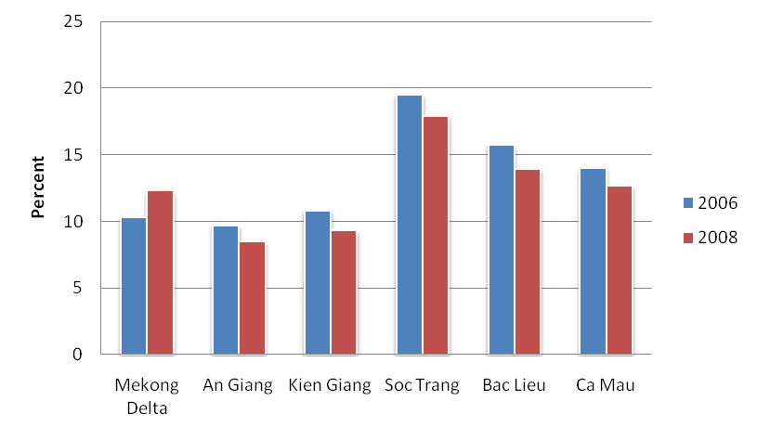
In 2002, the poverty rate was at 23.4%, accounting for 3.9 million people. 2008 figures show that poverty had declined to around 12.8% or 2.2 million people, meaning a reduction of 1.7 million poor people in the region. Figure 1 shows the poverty situation of the five target provinces and the delta as a whole between 2006 and 2008 (see also Annex 5.4).
There are a number of important caveats to these impressive poverty reduction figures. Firstly, as pointed out by a number of provincial staff, a large proportion of the population remains vulnerable to poverty with incomes just above the poverty line. This is reflected in income figures in 2008 (Annex 5.4) with a poverty line of VND 280 thousand per month and the second quintile average income of around VND 500 thousand, suggesting another 10% of the population are within VND 200 thousand/month of the poverty line. Secondly, growing wealth has bought with it growing inequality; the Gini co-efficient in the delta has risen from 0.39 to 0.395. The observation that some groups remain relatively untouched by economic development on the delta supports this contention. However, this level of inequality on the delta is significantly lower than the national average, whose Gini stands at 0.434. This is probably related to the continuing importance of agricultural employment, which has prevented significant income differentials.
Poverty differs between geographical locations and social groups. In all the target provinces ethnic minority groups tend to have much higher poverty rates than the general population except for the ethnic Chinese. By 2002, the official poverty rate among the Khmer was 32% as compared with the delta rate of 24%. In some project communes, up to 90% of the poor are currently Khmer. Poor Khmer often rely to a greater extent on wage employment in unskilled manual labour (both on-farm and off-farm). Yet their participation in the labour market is severely limited by a low level of education, language barriers and lack of social connections. Families with land tend to focus on rice farming and are excluded from shrimp farming due to lack of capital and knowledge. In An Giang, poverty is also associated with less productive locations such as the hilly areas used for Melaleuca in An Minh district. These areas are populated mostly by Khmer or landless Cham households who rely predominantly on river fishing for their incomes. Similarly, in Kien Giang and Ca Mau provinces, poverty is associated with areas where production is marginal, such as in and around national parks and protected areas. In contrast, poverty is not concentrated in particular geographical locations in the provinces of Bac Lieu and Soc Trang, which has higher poverty rates than the rest.
Agricultural productivity and types of natural resource based production differ widely across the delta. An Giang along with provinces like Dong Thap and Long An is in a highly fertile area with a large proportion of land used for rice production. The provinces on the coastal fringes of the delta have in general poorer quality soils due to saline intrusion and higher acidity levels. Many of these areas have seen major increases in brackish water aquaculture where shrimp is widely promoted as a higher value-added crop, especially in Soc Trang and Bac Lieu. Land use figures illustrate these changes in production (Table 4). Over the last decade the area under cereals cultivation in Kien Giang and An Giang has increased 21% and 15% respectively while in Soc Trang, Bac Lieu and Ca Mau the area has decreased by 9%, 23% and 43% respectively. Most of this land in Soc Trang and Bac Lieu has been converted to shrimp production.
Table 4: Water surface area for aquaculture 1995-2009, 1,000 ha (GSO statistics on-line)
Area | 1995 | 2009 | Change 1995-2009 (%)
An Giang | 1 | 3 | 159
Kiên Giang | 13 | 127 | 915
Sóc Trăng | 3 | 68 | 2,177
Bạc Liêu | 41 | 126 | 203
Cà Mau | 160 | 293 | 83
Mekong River Delta | 218 | 738 | 238
Vietnam | 454 | 1,045 | 130
Another important trend in the delta is that of increased mechanisation and land consolidation, accompanied by a rise in landlessness. Figures for the lower Mekong Basin countries show that Vietnam’s Delta has both the highest levels of chemical inputs and the largest number of tractors per capita. Currently, 90% of the rice land on the delta is prepared by tractor, 80% is mechanically harvested and around 100% of rice is machine threshed. Simultaneously, figures suggest that landlessness and the number of households with marginal land holdings in the delta is rising. In 1994, 28% of rural households on the delta had landholdings of less than 0.2ha; by 1997 this figure was 37%. Landlessness has also risen from 16.9% of rural households in 1993 to 28.9% in 2002. Moreover, landlessness is increasingly concentrated amongst the poorest groups. In 1998 the poorest 20% of the population accounted for 26% of landless households, by 2002 this figure was 39%. While recent figures on landlessness and farm size on the delta have not been available, there is a consensus amongst provincial officials interviewed that land holdings are becoming more concentrated and landlessness is rising.
The rapid growth in aquaculture has already been noted, but very little has been said relating to capture fisheries. Interviews with provincial officials suggested that fresh water capture fisheries were not important in the delta. However, estimates developed by the Mekong River Commission suggest that fresh water fisheries in the delta employ almost 300,000 people (see Annex 5.5). These fisheries are most important in areas along the mainstream or main distributaries of the Mekong such as An Giang and Soc Trang. As already noted, they are particularly important for groups such as the Cham in An Giang. Marine fisheries are also an important source of livelihoods in all coastal provinces. Ca Mau in particular has a large marine fisheries sector that employs an estimated 250,000 people. Moreover, these figures probably underestimate the importance of capture fisheries, as they do not include part-time fishers, estimates which include part-time fishers suggest that in total around 57% of households have at least one member who spends some of their time fishing. Around 1/3 of those involved in fisheries as their main occupation are women. This is discussed in greater detail below.
There is very little data on the importance of forestry and related resources on the delta. Forested areas in the project provinces were of three main sorts, coastal protection forests – usually mangroves, inland protection forests consisting of Melaleuca and Dipterocarp forests, and Melaleuca forests on upland areas in An Giang province. Melaleuca timber had been widely used for construction purposes, until the Ministry of Construction advised against using it in building. Prices have since fallen and landholders are keen to clear forest land for rice production where possible. Fuel-wood is collected from forests all over the delta despite restrictions on the use of protection forests. However, the most important socio-economic values derived from forests are indirect, either in the form of protecting coastal areas from erosion and storms or acting as nurseries for marine fisheries.
The major rural livelihoods options observed in the areas visited in the five provinces (see Annexes for exact locations) include the following:
- Industrial shrimp farming (Soc Trang, Bac Lieu). This is highly technical and uses high levels of chemical inputs to control the Ph of the water and diseases. It also requires high level of investments both in terms of land and fry. The land for industrial shrimp farming has mainly been converted form paddy land over the last two decades or so.
- ‘Natural’ shrimp/shellfish farming combined with forest protection (Bac Lieu, Ca Mau, Kien Giang). This option is more the case along the coast, involving the use of naturally available fry in the sea water and less chemical treatment. In the late 1980s, much of the mangrove forest in these areas was cleared for shrimp farming, which proved unsustainable. In the last 15 years or so, these areas have generally been allocated to individual households on forest protection contracts (referred to as ‘Green Books’). Households are allowed to farm shrimps or shellfish on 30% of the land area (40% in Ca Mau) and are required to protect the forest on the remaining 70% (60%) of the land.
- Rice farming combined with shrimp farming (Kien Giang). This option has been promoted over the last two decades in some areas of the province and elsewhere on the delta prone to seasonal saline intrusion. In the dry season, saline water is allowed into the flooded paddy for shrimp farming. With the beginning of the wet season, rains flush the paddy of salt and a rice crop can be planted. Where this model ahs been adopted it has replaced the traditional wet paddy farming system.
- Farming of rice alternated with other crops (Soc Trang, An Giang). This option is further inland and predominant in An Giang. A number of landless people who could afford it also rent land in the local areas for farming rice and crops, often on less than 1ha of land.
- Small-scale livestock husbandry, including pigs, cows and poultry. Most rural households engage in small-scale animal husbandry, with the exception of landless households whose temporary residence is unsuitable for the activity.
- Local wage labour performed mainly by people who are landless or with marginal land holdings. This is usually seasonal on-farm labour with most employment lasting for two to three months a year during planting and harvest time.
- Collection of natural resources for sale and home consumption, including fishing, near-shore products, non-timber forest products, fuel-wood, fish and other by-products of rice farming. This is common in all five provinces. As with on-farm wage labour this work is usually undertaken by households with little or no land. Collection of natural resources along the coast takes place throughout the year, yet between June and August, mudflat products are scarce and many tend to be without an income at this time. Fishing is also seasonal with the peak season being during annual floods.
- Labour migration. Out-migration is a common trend in all provinces. Main destinations for people from most provinces are the Southeast and Ho Chi Minh city and Binh Duong. A smaller number of young people aim for labour export, mostly to Malaysia.
These different livelihoods strategies are pursued to varying degrees depending on a household’s access to resources and knowledge. The poorest and most marginalised groups tend to be landless who are most likely to be Khmer, Cham or recent in-migrants (e.g. in Ca Mau or Kien Giang). The migrants tend to be landless people coming from other provinces. Their livelihoods are highly dependent on wage labour and collection of natural resources. On the other hand, better-off households tend to have more diversified livelihood strategies (see Annex 5.).
In some local areas, we found a high degree of social differentiation. An example is Ap Cho hamlet in Soc Trang, where many landless Khmer households live at a subsistence level, whereas some local shrimp farmers had land holdings of between 10 and 20ha in size. Khmer children often failed to finish lower or higher secondary schooling, whereas children of the wealthier shrimp farmers were able to attend college. In the words of one male farmer in the hamlet:
‘On one side the forest protection unit office are poor people without any land and on the other side are rich people with land who could do shrimp farming.’
Landlessness is a major problem for many Khmer people in Soc Trang, Bac Lieu and An Giang, for the Cham in An Giang, and for recent migrants in Ca Mau and Kien Giang. This includes inherited landlessness and recent land losses due to failure to repay debts, medical costs and the like. Some of the landless rent land from other people for rice or crop production at the rate of VND 2 million/ha/year for which the payment has to be made in advance (in Soc Trang and An Giang). In many cases such agreements resulted in the tenants making a loss. In the commune we visited in Soc Trang, a number of landless Khmer were also involved in shrimp-farming, yet their farming areas (47ha divided among 78 households) were not part of the official land use planning, being ‘spontaneously developed’. As a result, this area is not irrigated and farmers working the land do not get any support. Differences between Kinh and Khmer shrimp farmers seem significant. In general, the small number of Khmer shrimp farmers have little shrimp farming areas of more or less 1 ha. They seem also more likely to ‘fail’ (thất) than the Kinh shrimp farmers because of less know-how about shrimp-farming techniques as well as less market information.

- Gender Context

Division of labour, decision making and participation
According to the 2009 population census, women in the Mekong Delta participate to a lesser extent than men in the labour force (44.7% compared to 55.3%), compared to a more equal participation of women and men in the north of Vietnam. This seems to indicate greater attribution of women to the home in the delta. Similarly, our findings indicate that gender roles in the programme region are highly segregated and gender relations characterised by male dominance. Men are associated with ‘heavy’ (việc nặng), ‘more important’, ‘main’ income-earning work whereas housework and home-based care activities are ‘naturally’ attributed to women. In all study sites, a typical comment was:
‘Of course women have to be in charge of domestic matters. Men already work so hard, they have to rest.’
In general, women are extremely restricted to the home, particularly while their children are young. In poorer families, however, women are also under pressure to work for income since their husband’s earnings alone are not enough to cover daily subsistence needs. Income contribution to the household thus is highly differentiated between men and women.
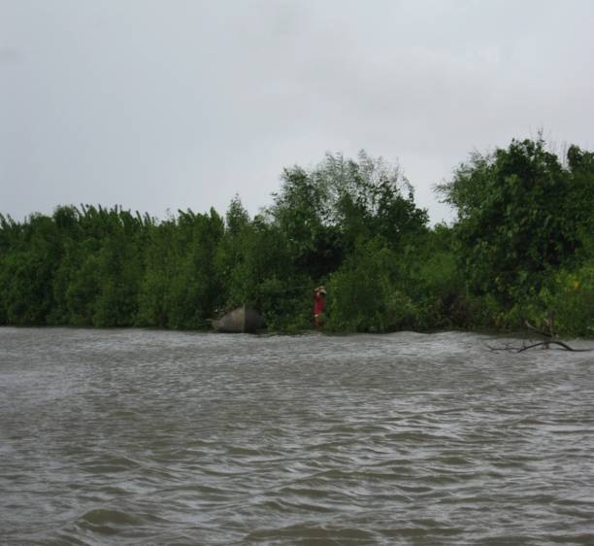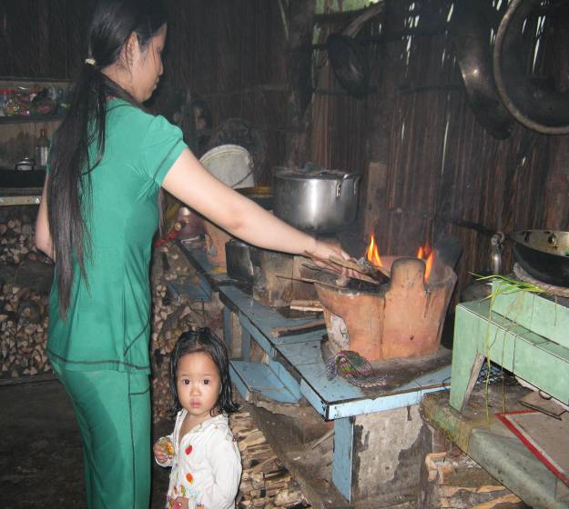
Photos: (Left) A woman collecting fuel-wood along the river and (right) a woman cooking while tending to a young child in An Minh district, Kien Giang
However, women are usually in charge day-to-day household income and expenditures. For larger expenditures there is some level of joint decision making though this varies depending on ethnic group. Joint decision-making is more the case among the Khmer ethnic group, whereas Kinh and Cham men have greater final say in major household expenditures. Traditionally, Khmer marriage and residence is matrilocal, i.e. with the family of the wife, and this seems to play a part in a less dominant male role in Khmer households than in the other ethnic groups. A common observation by Kinh local WU officers is that gender equality is higher among the Khmer:
‘I think that Kinh people still have to catch up with Khmer in terms of gender equality. For example, whenever guests stay for a meal, both husband and wife would be present to receive the guests. This is not always the case in a Kinh family’ (Local WU officer in Soc Trang)
Nevertheless, Khmer women are similarly tied to domestic roles as women in other groups, and since they tend to have large numbers of children - about two thirds of the women we met have more than three - their confinement to the home and dependency on their husbands’ income is greater. Their status in the family is lower as a result:
‘Of course the wife has to take care of housework and family matters. We are women and we have to do these things. My husband does more heavy things and he is the leader in the family, I just follow his words.’ (Khmer female villager, Soc Trang)
‘I decide most things in my family. I do discuss those things with my wife, but she generally agrees with me.’ (Khmer male villager, Bac Lieu)
Corresponding to the household division of labour, men are predominantly involved in community activities and events, are often organised on the basis of ‘representative of the household’. In Soc Trang for instance, the women said that their husbands attend training courses given by the agricultural extension service and they would only go when their husbands were unable to attend. When asked who in the family goes to village meetings, one man said he ‘sends his wife’ when he cannot. Similar observations were made by provincial officials in An Giang and Kien Giang.
Women are less involved community events not only on account of their household tasks but also because of lack of confidence and language skills. One of our meetings in Kien Giang serves as a good example where Kinh men and women were both present. The women hardly spoke and were timid when answering questions in contrast to the more vocal and articulate men. Likewise, Khmer women who attended hamlet meetings to decide on poor benefits and project planning in An Giang said they do not speak up in those meetings commenting that they ‘don’t know why, but it is just very difficult to talk in front of a crowd.’ However, when meetings were held separately for women with the help of translators, they were actively involved in discussions and voicing opinions. Most Khmer women we met speak none or very little Vietnamese while the men tend to speak the language better. Therefore, unless community meetings are run in the local language, Khmer women are likely to be excluded. In contrast, language does not seem to pose the same barrier for the Cham people, many of whom speak Vietnamese well.
Our findings generally resonate with gender analyses conducted by the Asia Foundation in An Giang and CARE International in Kien Giang.

Male and female involvement in livelihoods activities
Most of the local livelihoods activities (see 3.1.3) are gender sequential, i.e. men and women taking over different tasks or differently involved in the same activity, except for industrial shrimp farming and river fishing which tend to be gender segregated. Industrial shrimp farming is highly segregated, with men dominating much of it. It is often explained by both men and women that this is technically demanding and requires physical strength and thus is only suitable to men. In contrast, ‘natural’ shrimp farming could be done by both men and women because it is thought to be simpler and lighter:
‘Only men could work with industrial shrimp farming because there is a need to operate machines, regularly monitor the chemical content of the water, the saline content, the acid content, women cannot do those things.’
‘Both men and women could do natural shrimp farming because there is no use of chemicals or machines. One just needs to release the fry and harvest them when the time comes and then sell them. So either men or women can do everything in this. In some families, the husband takes charge of one pond and the wife another.’ (Female shrimp farmer in Bac Lieu)
Nevertheless, in Ca Mau and Kien Giang, we found that men take over a large part of the ‘natural’ shrimp/shellfish farming as well. The gendered division of labour, i.e. men mainly involved in productive and women in reproductive activities, seems even more distinct in those locations. This notwithstanding, the work of harvesting the farmed shellfish is mainly done by women and female labourers are often hired to do the work.
River fishing in the local communities is also mainly performed by men, although women may assist with support activities such as net repairs and preparation. In terms of other natural resource collection, women and children generally collect more for subsistence in areas closer to the home, whereas men do for processing into marketable products (e.g. charcoal making) and for sale (the selling of those products is actually done by women). Men also cover longer distances and further away from the shore, making greater use of equipment.
In terms of rice and crop farming, men tend to work more with land preparation whereas women are more involved in planting, transplanting and weeding. During harvest, male tasks tend to be transport and machine operation and women take over the cutting. Women are almost always responsible for livestock keeping except for the case of cattle, which tend to be taken care of by men on account of the need to travel far to obtain grass for fodder, particularly in An Giang. Women in general are more involved in selling and marketing products from both farming and natural resource collection.
Men tend to be engaged in wage labour to a greater extent than women, though both poor men and women are under constant pressure to earn income for their daily survival. Where both men and women are involved in wage labour, the type of work often corresponds to the traditional division of labour within the household. That is, men are more associated with tasks requiring technical skills and physical strength, whereas women typically take on lighter tasks.
In contrast, age seems to be a more important determinant of labour migration, even though gender does play a role. Migration data disaggregated by gender is not available at the local level as it is no longer required for individuals to register their absence (tạm vắng). A common perception both amongst local officials and people is that both young males and females (aged 18-30) migrate in large numbers to the cities. Married women are less likely to migrate than married men because of their duties at home.

gender issues in livelihoods
The varying involvement in livelihood activities by men and women is closely connected to the household division of labour. This assigns women to the domestic sphere and men to productive and income earning realm outside the home. The main problem is that reproductive activities undertaken by women are not as recognised as the productive and income earning activities undertaken by men. To illustrate, it was frequently stated by men in most places visited for the fieldwork that women in the delta are lucky because their husbands work while they have an easy time staying home with the children. This comment is often made in reference to the north where ‘women are expected to do heavy tasks like men’. Not only are domestic tasks considered as non-work, other activities performed by women for the neighbourhood or community, such as the organisation of parties and celebrations are also taken for granted. Indeed, the household division of labour also corresponds to the productive tasks that men and women take in the household and the labour market, such that male tasks are heavier and more technical than those of women, and thus more valued. Indeed, many of the gender issues discussed below arise as a result of the household division of labour and the differential recognition of male and female labour.

Local Employment Opportunities
In all the districts visited employment opportunities were limited. There were very few industrial facilities, and existing ones tend to be small-scale, employing a small number of workers and operate only on seasonal basis. Small-scale trading provides an outlet for local labour, yet this requires skills and access to credit and is not easily accessible. Farm work still is the main source of wage labour opportunities for local people. However, women’s access to this is affected in various ways.
As shown above, women are frequently restricted by their domestic roles when it comes to wage labour or income generating activities outside the home. A number of wives of shrimp/shellfish farmers in Kien Giang used to be involved in tailoring or small trading but had to give these activities up as soon as they were married and had small children. This situation is reinforced by total absence of early age childcare options in all communes visited. In remoter communes there are no kindergartens. Communes closer to the district centres often have one or two kindergarten classes attached to the primary school. However, these classes are only open to children starting age four. Nurseries for smaller children were found in some district centres but they are costly and ‘only some rich families could send their small children to the nursery in the district.’ (Local WU officer, An Giang). As a result, most children in poorer families and remote places tend to stay home with their mother or grandmother until they go to school at the age of six.
When women do take part in wage labour, their tasks are less valued than those performed by men. This is seen in the high male-female wage differentials across all sites visited. Female wage ranges between VND 40 – 70 thousand/day whereas male wage falls between VND 65 – 100 thousand/day depending on the local wage level.
The mechanisation of rice farming was mentioned as a reason women find less wage work as men tend to be employed to operate machines, particularly in An Giang. Similarly, we found that the conversion of paddy land to industrial shrimp farming was a major factor reducing wage labour opportunities for women as labour opportunities in this sector are deemed only suitable for men. For instance, a 10-ha shrimp farm typically hires more than ten male labourers but no women. This is especially the case in Soc Trang and Bac Lieu, where large scale industrial shrimp farming takes place. In these provinces local people, WU officers and line agency staff all talked about how difficult it is nowadays for women to find wage labour on and around the shrimp farms compared to the past when rice farming provided abundant work for local women at different points in the year. These further limit opportunities for wage employment especially amongst poor women.
A different yet related issue encountered in parts of Ca Mau is the unsuccessful conversion of areas further in-land for shrimp production. This has degraded the land such that it is no longer suitable for rice production. This has affected both men and women in the area; yet the latter have been affected more severely due to their restricted mobility.
In Soc Trang, there is a local practice of hiring labour that seems highly exploitative (see Box 1), which arguably could exist because of the lack of local employment. Accordingly, wage labourers have to agree to work with the employers to secure employment and get paid in advance at a fraction of the actual rate. Currently, this local rate is at 40 to 50 thousand VND for women and 60 to 80 thousand for men. As a result, women get 20-30 thousand VND for a day of work.

Box 1. A poor Khmer family in Vinh Binh hamlet, Soc Trang
Ms Duy (34) has 5 children ranging between four months and 14 years old. One of the children (5) went with her once into the onion processing facility in the district and badly injured his left foot playing there. This is where she works for some time during the year on a casual basis when she could. Right now she cannot do that because she has to be home looking after the new-born baby. She and her husband do not have any land, nor do their parents. Both the couple and their parents live in simple terraced housing made of thin walls and tin roofs. They were given these houses (VND 10 million) as part of a program supporting housing for poor people, yet afterwards they are not classified as a poor household anymore. They thus do not have a poor household book, which is associated with free medical costs and access to credits through the WU. When the child was injured they had to take our VND 5-6 million to cover the cost of his operation. Their only sources of income is her husband’s ‘going to sea’ (collecting clams and other near-shore products), his and her waged labour which she could only carry out when she does not have to look after the children. His income could bring about VND 50 thousand on a good day, but he also comes back empty handed quite often. For some time he traded junk but had to give up not having adequate means of transport and losing the capital needed for doing so (about VND 500-700 thousand). Her occasional waged labour brings VND 20-25 thousand a day, which is paid in advance. She said work would not be available anymore if she did not get this advance payment and wait until the harvest or planting times come.

Access to natural resources
In the previous section, we pointed out that the poor, particularly women and children, are heavily dependent on natural resources for subsistence. We found in most program provinces that their access to natural resources have been affected by various factors.
First, coastal common pool resources, particularly the mudflats, are in the process of being rented out in some areas. This is most observable in Kien Giang where many of the mudflats have been claimed and rents have been collected by local authorities. The province has recently issued a decision providing for the rental of the mudflat areas (Provincial Decision No 35). The development is likely to affect the access of poor women and children, who could previously freely access the area for collection of shellfish. In fact, a similar situation has been observed in Xuan Thuy, Nam Dinh where poor women and girls lost a significant livelihood activity as a result of the effective privatisation of the mudflats. Meanwhile, the uncontrolled access to the mudflats and sand banks in Soc Trang or Bac Lieu has also lead to a depletion of the resources which is a concern for local people.
One management option for mudflat areas that is being tried out in various places in the Mekong Delta is the Clam Cooperative. A large area of the mudflat is assigned to a cooperative made up primarily of poor households. Members are eligible for small-scale credit to allow them to buy and seed baby clams in the managed mudflat area. In principle, the members will be hired for harvesting and the outputs sold through the cooperative. Profits will then be divided among the members after deducting costs.
The experiment seems to be more successful in some areas and less so in others. Apparently it is working well Can Gio, Ben Tre. Local officials in Soc Trang and Bac Lieu who went to visit seemed positively impressed. In Bac Lieu, we had the chance to talk about two different cooperatives in Vinh Trach Dong commune. One has already been dissolved. According to a commune leader, this was primarily because local people believed that the ‘better areas’ had been assigned to the cooperative leaving them with depleted parts. Secondly, poor households depend on collection of clams for daily survival and frequently could not wait until the harvest, which often takes about a year. Third, it is difficult to manage resources that are naturally available (chim trời cá nước) – local people just collect the baby clams for sale. Some local people, meanwhile, expressed dissatisfaction with how the dissolved cooperative was run, saying that its leadership was not transparent in their conduct. The other clam cooperative, which is still operational, has paid dividends to member families (mostly poor households) twice, worth about VND 900 thousand over the last 18 months. This was based on member contributions of VND 2 million each borrowed by the cooperative on their behalf. Several poor Khmer families we talked to, however, had no idea about this loan and they also were not informed of how the money they get from the cooperative is calculated or how it is run. They were also not hired for harvesting the clams.
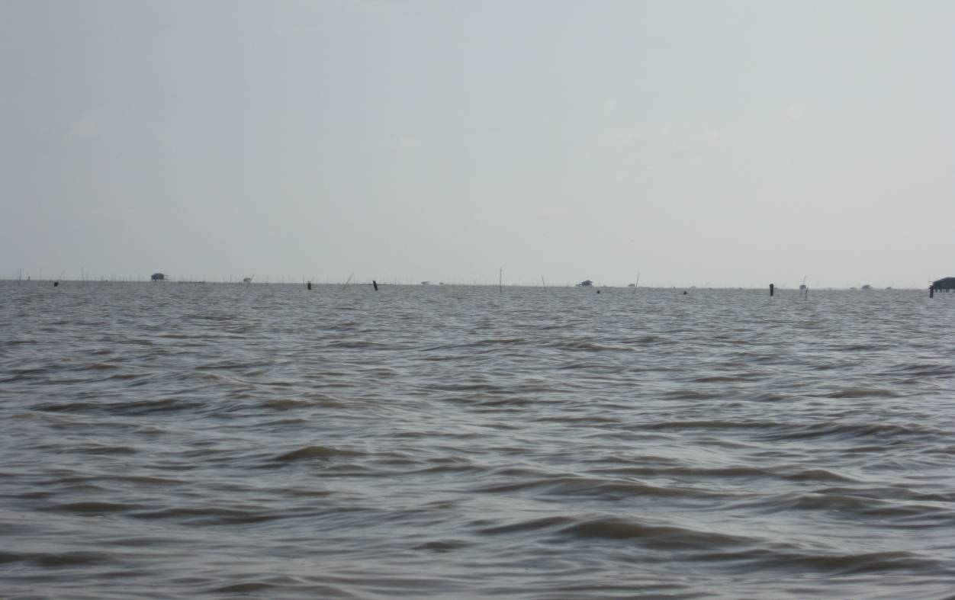
Photo: Fences marking off the mudflat areas with greater availability of products in Kien Giang. Most plots have a guard house where a hired labourer lives.
The second factor that affects women’s access to natural resources is the reduction in paddy field biodiversity as a result of high chemical inputs, according to farmers in An Giang. This biodiversity, meanwhile, is lost when paddy is converted to shrimp farming. Fresh water fish, mud crabs, reptiles etc are all important as daily subsistence products. Their reduction or elimination severely affects the ability of poor women to ensure nutrition for their family. This problem was mentioned by a number of women in most other provinces, including in areas where combined shrimp and rice farming are practised:
‘In the past when we just planted rice, there were plenty of fish of all sorts in the rice field. And we had the rice. Nowadays, shrimps fail and rice also fail and there is nothing.’ (Women group discussion in Kien Giang)
Thirdly, we found that forest protection and conservation measures make it more difficult for poor women to collect fuel-wood and non-timber forest products for daily subsistence. Women in Ca Mau for instance mentioned that it is much harder nowadays to collect crabs or kèo fish (Goby fry) since it is now forbidden. In fact, the mudflat areas in Ca Mau are now protected, perhaps as a result of Ca Mau becoming World Biodiversity Conservation site. Notwithstanding, local people still collect the resources for their daily survival, but this has become challenging:
‘Everywhere is now restricted. They are forbidden to go to the forest, and they are forbidden to go to the sea (to collect natural resources).’ (District discussions in Ca Mau)
Meanwhile, fuel-wood collection has become more arduous due to stricter protection, like for this Khmer young mother:
‘I only collect fuel-woods around abandoned shrimp ponds now. It is forbidden to collect fuel-wood in the mangrove forest. They allowed us to in the past, but now that it is forbidden we’ll be arrested if we enter the forest. Sometimes a rich family let us look for fuel-wood in their garden because they don’t use it, but people like that are few.’ (Khmer young mother, Vinh Trach Dong commune, Bac Lieu)
Some of the extraction practices are destructive, including the excavation for a sea worm (sâm đất), which requires uprooting mangroves (Ca Mau), or making charcoal from several mangrove species for sale (Ca Mau, Kien Giang). However, there are obviously conflicts between protection and conservation goals and the livelihoods of poor people, particularly women, who had been dependent on the protected resources. This is part of the reason why protection measures in many cases are not effective, as recognised by the People’s Committee of Thuan Hoa commune in Kien Giang:
‘…the work of forest patrolling and management is given regular attention in combination with communicating to local people about the benefits of forest resources, but forest destruction and violations remain frequent’ (công tác tuần tra quản l‎y rừng cũng được các ngành chức năng thường xuyên quan tâm, kết hợp với công tác vận động tuyên truyền cho nhân dân hiểu rõ về lợi ích của tài nguyên rừng nhưng tình trạng chặt phá rừng vẫn thường xuyên xảy ra…’
Also, there is a question to be asked about the differential impacts on forest resources of poor women’s collection for subsistence and of the extraction activities by commercial interest groups. A good example is the stone mining activities of private companies in Tri Ton district of An Giang versus the collection of fuel-wood by landless women there (see photos below).
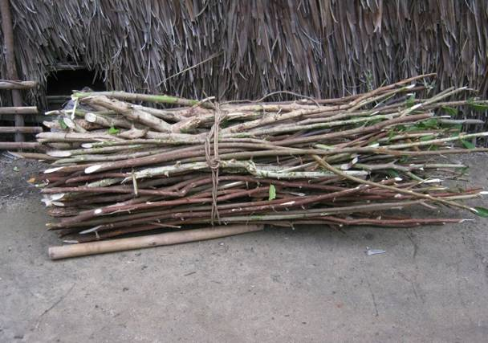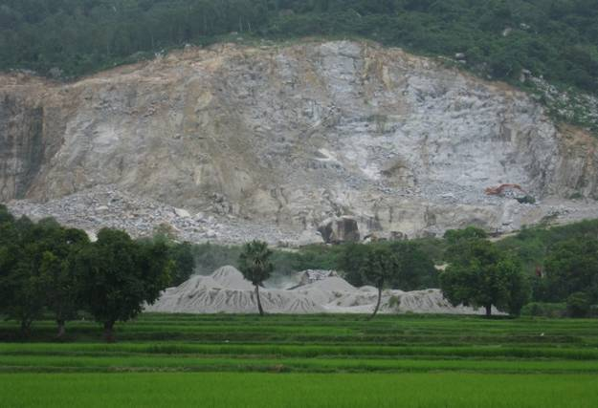
Photos: (Left) Fuel-wood daily collected by landless Khmer women and (right) stone mining by private companies in An Giang
Both male and female shrimp farmers in the protection areas in Bac Lieu were highly concerned about the overgrowth of the mangroves around their shrimp ponds, which they said is causing shrimps/crabs to catch diseases and die. However, they are not allowed by Forest Protection to thin the mangrove to improve the situation. A woman commented that even if they could use their Green Book to access loans, it would be of no use if they were not allowed to thin the mangrove, ‘for the shrimps would die anyway, and we’d still go hungry.’ Meanwhile, these farmers also mentioned that water pollution was a major problem, especially that caused by the discharge from industrial shrimp ponds further inland.

Legal status
Our findings regarding the issue of land-titling support the conclusions of the Oxfam-UN study that despite legal provisions for joint titling, women remain underrepresented as holders of land titles. This is due to the fact that most of the titles had been granted before the new provision, so the majority of Land Use Certificates still bear only the names of the head of households which are predominantly male. Joint signature is required for bank loans in most cases. Yet women could only sign and are not in a position to be the main applicant, unless the husband authorises her to. The joint titling provision, however, is appreciated by various local Women Officers as a sign of progress and a positive measure to reduce women’s vulnerability.
Meanwhile, we found that land titling is extremely complex at local level, particularly in coastal protection areas. First, the only form of tenure for farmers in those areas is actually the forest protection contract, locally referred to as ‘Green Book’. While not having the same status as the Red Book (non transferable, greater responsibilities), the Green Book provides long-term tenure (between 20-50 years). Meanwhile, local authorities in Ca Mau have been proceeding with granting Land Use Certificates to certain residential clusters within the less critical protection areas. This seems to be a local controversial issue. Priorities have first been given to the land allocated to households resettled from critical protection area, which account for about 25% of the households in the commune visited. So the ‘new comers’ were the first to have Red Books for their residential plots, while long-time residents are still waiting. However, many of the former have left the new homes due to their unsuitability to their livelihoods and lifestyle. In the meantime, households sometimes have several Land Use Certificates for different production plots and each may bear the name of a different family member (Vinh Trach Dong commune, Bac Lieu). Commune officials there also mentioned that production plots under 1000m² in size are not illegible for Land Use Certificates. This practically excludes poor households who could only afford smaller plots. In An Giang, it was mentioned that temporary Land Use Certificates are being granted for 5 years and will only become permanent if the family has met certain conditions.
The point is that joint titling is important as far as gender is concerned, yet one should bear in mind that: 1) It is only important insofar as men and women have access to land and viable livelihoods associated with it; 2) There are locally specific forms of tenure that should be also considered. The Green Books for example often bear the name of the head of household. Currently, they are generally not permitted as collateral for bank loans in most program provinces. The only exception is Ca Mau, where farmers could use it as collateral for loans of up to 30 million VND over a certain period. Many shrimp farmers in other provinces expressed hope that their protection contracts could be used to access bank loans. If this were the case, joint titling would be come equally important for Green Books as for Red Books.
Finally, whereas better-off households could use their land use certificates to access credit and loans with values depending on the size of their land, poor households are eligible to smaller credits of up to 5 millions provided by the Bank for Social Policy (Ngân hành chính sách) through the local Women’s Union as well as benefits (housing, sanitation) from targeted programs for the poor (Decrees 74, 168). This is decided on the basis of the Poor Household Book (Sổ hộ nghèo), which is given to households officially classified as poor. The Poor Household Book is also a means through which free medical examinations and schooling support are provided. In fact, poor women have an advantage in terms of accessing the micro-credit and in many cases it is the only form of financial assistance a poor household has. Nevertheless, since the difference between being poor and near poor is very small (in cases just by a margin of VND 10,000 in monthly income), many ‘actually poor’ households are not entitled to these. Furthermore, as in the case of Ms Duy above, benefits from the housing programs practically exclude her families from other forms of support/social benefits that are vital to the well-being of the household. Also, migrant households are not eligible to be considered as Poor Household once they have been away for more than six months, as mentioned by local people in Ca Mau.
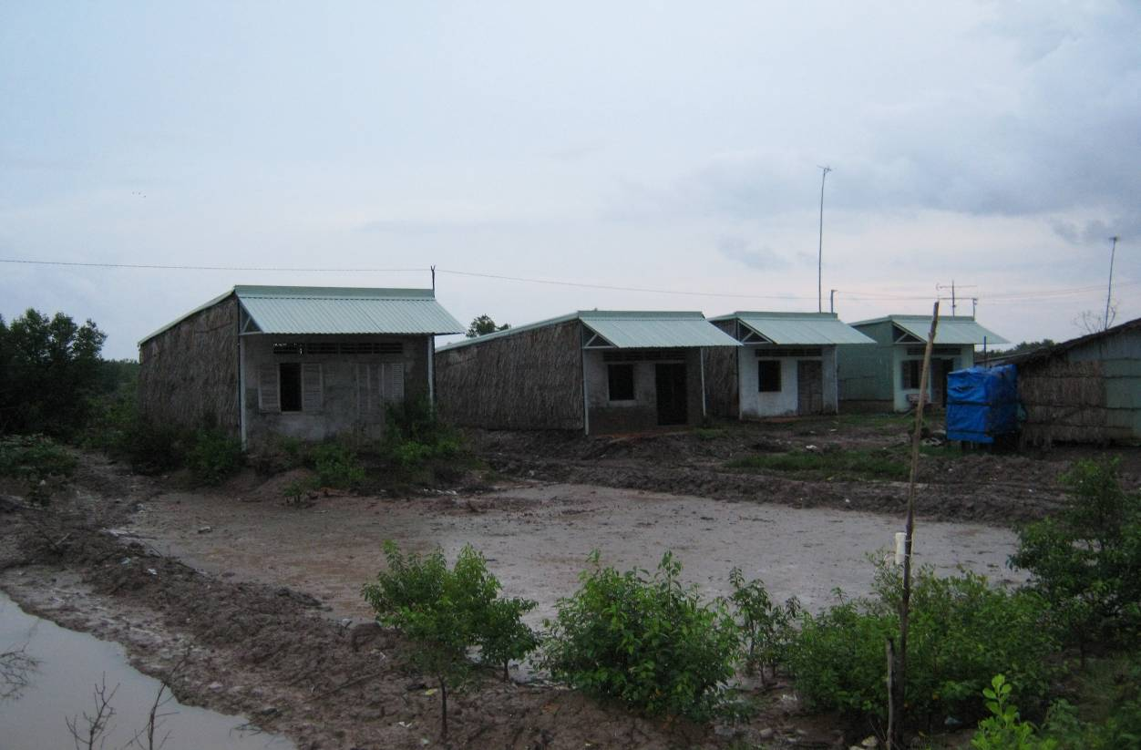

Photo: Rows of empty houses left by resettled families in Ca Mau

Labour mobility
Labour migration is a common feature in all program provinces. It is difficult to gauge sex disaggregated data at local level, but according to both local people and authorities, mainly young people aged between 17 and 30 leave, including men and women. According to the district WU officer in Ca Mau, two thirds of the young people in the district visited have left. In predominantly industrial shrimp areas, more young women leave. Married women with children are much less likely to migrate, though a number migrate together with the husband and leave the children in the countryside. The main destinations mentioned are Ho Chi Minh city and Binh Duong. Factory work and service work, particularly domestic service for women and construction work for men, are the most common occupations in these two urban centres. Labour export is also an option, often for male members, by households who could access credits to cover the costs of relocation and job training, with Malaysia being a popular destination. Interestingly, some Cham women in An Giang have left for Malaysia in recent years to do door-to-door textile trading there, using their social networks and advantage of speaking a similar language. Out-migration by the young seems to be generally strong in the Cham community visited.
While most local authorities see labour migration as a way to relieve the local employment pressure, especially for the young, local people are generally sceptical about it as a viable livelihoods strategy. Almost all villagers interviewed mentioned the low-pay work labour migrants get in the city as a result of their low education and skills. Given the high costs of living in the city, ‘there is hardly anything to set aside’. Even labour export is not seen as highly desirable, because the overseas earning is often not enough to cover the initial investments and costs, which in many cases make the household indebted. In Bac Lieu and Ca Mau, we met a number of poor migrant Khmer and Kinh households who returned since they could not make a life in the city. Returning families have to spend time rebuilding their house, which had been destroyed when they were away, and start all over again.
Some young families also came back after a child is born, but many others opt to send their children to the countryside in the care of grand mothers. In fact, a major gender issue arises as a result - older rural women become heavily burdened with caring for and educating grand-children left behind. Given the lack of early age childcare options, it is a drain on many poor older women who simultaneously have to work to make a living. As an instance, a 58-year-old Khmer woman in Bac Lieu has seven grandchildren altogether to look after, including those with parents in the city and those with parents working locally. Whenever she has to go out collecting fuel-wood or seashells, she leaves them in the attention of the neighbours. In the meantime, migration by young people, particularly young women, causes anxiety in local communities. Commune WU officers in An Giang explicitly raised the issue of trafficking as a potential risk for female migrants from the area. Khmer and Cham WU officers, on the other hand, express concerns about the decline in moral behaviours of young women who migrate. There is thus a strong desire for better locally available employment opportunities, particularly for women.
Finally, while out-migration is strong in the region, in-migration should also be taken into account, particularly in Ca Mau and to some extent in Kien Giang. No data are available on this, since these migrants are largely unregistered and many are seasonal migrants. According to the district officers in Ca Mau, these are ‘free floating migrants attracted to the still abundant natural resources in the areas. They are often the poor from all over the country and represent social burdens for the area’. As an example, a number of landless Khmer families from Soc Trang are found in the commune visited in Ca Mau. As with the landless there and elsewhere, these migrants, particularly women, are precisely the people who are most heavily dependent on the resources of the mudflats and the forests.

Climate change effects, Adaptation and gender issues
In this section we examine the likely effects of climate change on local livelihoods and well-being and how their impacts could be gendered. Adaptation measures by local people and local government are also analysed as regards their implications on gender relations in the region. It should be cautioned that most of the information presented originates from observations made by local people and government staff, which are subjective and based on short-term experiences, particularly what happened this year. However, we could make the case that if the effects continue; the problems identified will be exacerbated. Secondly, since the establishment of the degrees of exposure to climate change induced risks is beyond our mandate, we focus mainly on social vulnerability.

Gender and climate change effects
In Table 5 below, the major effects of climate change on the main livelihoods are presented and their differing implications on men and women are explored. These effects among others include saline intrusion which affect both soil and water; irregular rainfall, including drought and sudden downpour; prolonged heat; erosion as a result of stronger tidal waves; and irregular flooding, including too high and two low inundation. Depending on the predominant livelihoods options, they affect local livelihoods in different ways in each program province. Men and women are accordingly affected to varying degrees depending on their differential involvements in those activities (see 3.3.2). However, two observations can be made. Firstly, while both women and men are affected by climate change effects with implications on the general well-being of the household, women’s subsistence activities are severely hampered, adding to their existing domestic burdens. This is indeed well illustrated by the following testimony of a female villager in Kien Giang, whose 3ha of paddy combined shrimp area has brought little this year:
‘Yes, it is no good not having any land. But having land like me without getting any shrimps or fish from the land for whole year is no good either. Looking after the old mother and the small children, it is so tiring to wake up in the morning and think about it. No money. There has been not a single shrimp in the last year.’
Secondly, the poor, particularly poor women, are doubly affected as a result of direct impacts on the natural resources they collect and reduced wage labour opportunities. Since these are the cornerstones of their livelihoods, their vulnerability and poverty are further entrenched. Again, what another female wage labourer in the same hamlet in Kien Giang said serves as a good example:
‘Men often go to work more, but women also have to go to work to supplement the income. I often rise at 4 or 5am to do the housework and make food for the children. Then I leave at 6am to do waged work until 1 or 2pm. When I come back I may still go and try to catch some fish in the field. But there are also not a lot of fish to catch anymore.’
Meanwhile, in terms of the impacts of climate change effects on general well-being, the following issues were raised in local discussions:
- High tidal waves submerge houses in water in areas along the river mouth and in the protection areas in Kien Giang and Ca Mau, which creates insecurity for the household in general and greater difficulties for women to carry out their subsistence activities. However, local people seemed to have different views on whether this is an annual event or if it has been more the case in recent years.
- Similarly, many households outside the dikes, particularly in Kien Giang, are facing the loss of their homes, together with the shrimp ponds, as a result of erosion. This obviously affects the household as a whole, but the women in these families will be heavily burdened when these households are forced to relocate and/or take up wage labour elsewhere as a result.
- Lack of fresh water both as a result of drought and floods was seen by local authorities and people as having a major impact on the life of women in Ca Mau, Kien Giang and An Giang. A male district officer in An Phu district of An Giang for instance drew the link between the lack of safe water in the region and the high incidence of female reproductive diseases in the district. In Ca Mau, women talked about their small-scale income generating activities such as bean-sprout making or small processing having difficulties because of the lack of clean fresh water.
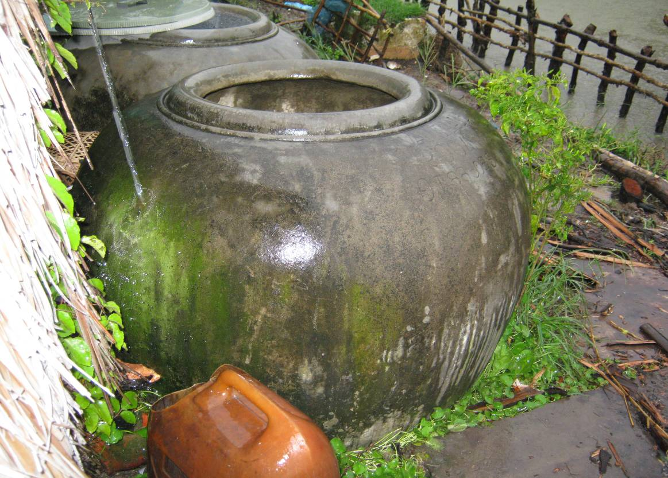
Photo: A traditional water tank. 1m³ of fresh water costs 45,000VND in parts of the commune visited in Kien Giang. Fresh water, not necessarily clean, is sold by retailers who bring the water in by boat.
The problem with drinking water, however, seems locally specific and is only indirectly connected to natural hazards. For instance, people in half of the commune we went to in Kien Giang could extract underground water from bore-holes whereas in the other half of the commune there is no underground water. People there either purchase water at very high price or use surface water during the fresh water months of the river, which this year has been affected by late rainfall. Likewise, a large part of underground water in An Phu district of An Giang is not drinkable because of its high arsenic content and people mainly rely on surface water, which is vulnerable to natural hazards and environmental problems. Drinking water provision seems diversified in the program areas, including the state provision, which seems to have relatively good coverage in Bac Lieu and Soc Trang; by private investors such as in Ca Mau; by small retailers in Kien Giang; and household self-provision, mostly by drilling or pumping directly from the river. Unlike in other parts of the world, the need to travel long distance to fetch water is not the case in the program region.
- Health impacts on the household, including increased incidence of dengue fever and diarrhoeal, as well as reproductive problems. These were perceived as higher during times of inundation in Ca Mau, Kien Giang and An Giang. These have implications not only on the health status of women, but also regarding their increased burden in caring for the sick, children and the elderly. This issue was in fact raised by various local Women Union officers.

- The need for sanitation is much higher after times of inundation, which is an additional stress factor for women.
Table 5: Observed linkages between effects likely to be associated with climate change and gender
Livelihoods activities | Impacts by CC effects | Possible gendered implications
Industrial shrimp farming (Soc Trang, Bac Lieu) | - Increased saline content in water and prolonged heat cause shrimp diseases  - Ponds along the dike in Soc Trang threatened by high erosion | - Increased stress and workload for men  - Indebtedness for the household  - Abandoned farms means reduced wage labour opportunities for male wage labourers
Natural shrimp/shell farming combined with forest protection (Bac Lieu, Ca Mau, Kien Giang) | - Sudden downpour after long period of drought kills blood-shells and shrimps  - Erosion wipe out shrimp ponds and mangrove in protection areas outside dykes  - Unusual high tides increase the saline content of water, killing blood shells in Kien Giang | - Increased stress and workload for both men and women  - Indebtedness for the household  - Shrimp/shell farmers outside the dike may become landless and forced to take up wage labour, women in these families face great difficulty with subsistence
Rice farming combined with shrimp farming (Kien Giang) | - Late rainfall affects effectiveness of the option as a result of increased soil salinity (problems seem however complex) | - Increased workload for women in re-transplanting  - Reduced paddy biodiversity affects women’s subsistence activities
Rice and crop farming (Soc Trang, An Giang) | - Crop areas along the dike in Soc Trang threatened by high erosion and high waves; salt intrusion affects both rice and crop land in the province;  - Late rainfall and sudden downpour creates more diseases and pests; water shortage and destruction of crops (e.g. onion in Soc Trang)  - Reduced flood level in the last 2-3 years affects rice productivity in An Giang (less sedimentation, more weeds) | - Increased household insecurity, particularly for families who rent land for farming  - Increased workload for men in irrigating rice, particularly in higher elevations in An Giang  - Increased workload for women in watering the crops and weeding
Collection of natural resources (all provinces) | - Availability of mudflats products reduced with stronger waves, which wash away the mud layer where sea creatures live (but also over collection)  - Increased saline intrusion reduces paddy biodiversity  - Reduced flood level means lower fish availability in river (e.g. An Giang) | - Women and children’s collection for subsistence most affected  - Men earn less from river fishing, some have had to give up
Wage labour (all provinces) | - Affected farms no longer need or need less hired labour | - Less wage work opportunities for poor men and women  - Women’s already limited opportunities further reduced
Livestock keeping (all provinces) | - Prolonged heat and sudden rainfall cause pig and chicken diseases | - Women’s workload increased  - Women’s subsistence activities more difficult

Adaptation, MItigation and gender issues
Local communities
Farmers have tried different options to cope with environmental problems they describe as affecting their livelihoods activities. For instance, women and men in Soc Trang talked about shifting the cropping time for rice and shrimp respectively so that the late rain will not greatly affect productivity. Women in An Giang said they are planning to plant crops instead of rice in the rain-fed areas next year to cope with the lack of rain. However, in both cases, they were not confident about the effectiveness of the coping strategies:
‘The problem is, maybe next year the rain will come earlier and destroy the crops. We don’t really know what is right anymore. (Female group discussion in An Giang)
A male shrimp farmer in Bac Lieu mentioned that those who followed the official advice and shifted the shrimp fry release time failed this year, whereas those who stuck to regular schedule did not have any problems. In general, local people are deeply concerned about the potential for climate related problems but do not yet have long-term effective adaptation strategies, as illustrated by the following statements:
‘Yes of course we are extremely worried about erosion. If it goes on like this, we’ll soon have nowhere to live. But so far we’ve just tried to work the land. We do not have any plans yet nor think about what to do.’ (Female villager in Kien Giang, whose shrimp pond and house are endangered by erosion)
‘I have no measures to cope with climate and weather problems. I harvest what I could from the amount of fry I release. It’s heaven’s will. I can’t give up since I wouldn’t know what to do otherwise’. (Male shrimp farmer in Ca Mau)
A male villager in the same hamlet said that ‘the whole area will be lost in about 5 years’. An old couple, who rents a 2ha-pond for farming, are thinking about relocating and have bought half a hectare of rice combined with shrimp land for about 10 million VND. However, the soil on the land they have bought is very acid and they are not sure if it will work out. In Ca Mau and Kien Giang, shrimp farmers try to reinforce the banks of the ponds to prevent salt-water intrusion as a result of high tidal waves, but this option is only affordable to the better-off. A woman in Kien Giang, for instance, mentioned that her pond is ‘open to both salt and fresh water whenever they want to come in’, explaining that it would cost a tens of millions to build higher banks which she did not have.
Meanwhile, as we have pointed out, those most vulnerable to the direct and indirect impacts of climate change effects are the poor and the landless, particularly so female landless ethnic minorities and recent migrants. This is due to their existing social vulnerabilities, including lack of skills, education, language skills, limited livelihoods options and high level of marginalisation. However, these groups generally are less concerned with climate problems than farmers involved in aquaculture and agriculture, since they have less productive assets and thus less directly affected than the others. When their situation gets worse, both in terms of wage labour and collection of natural resources, the usual reaction is to migrate, yet this option proves to be problematic, not least for them (see 3.4.4).
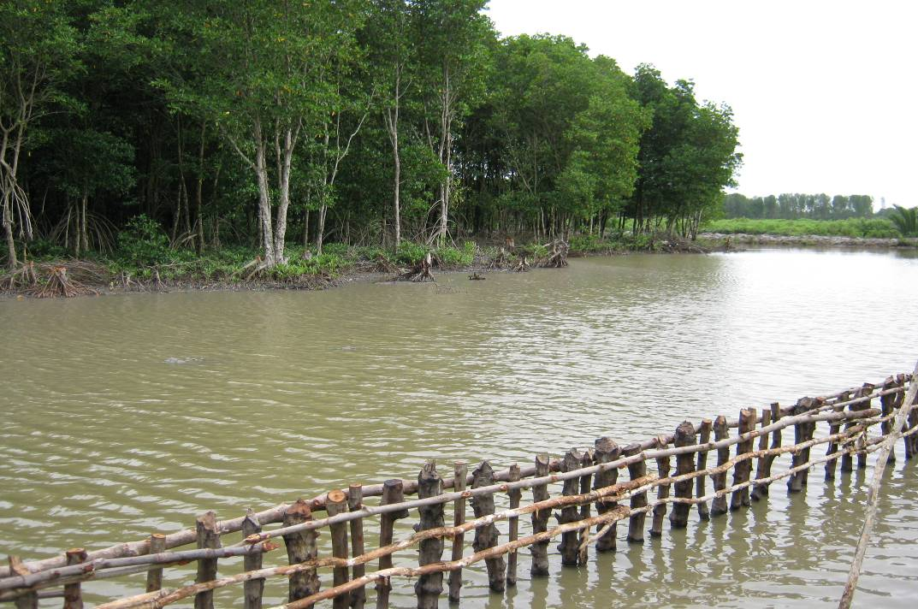
Photo: Shrimp pond of a well-off farmer, which is well protected by high and solid banks
Access to government support and technology varies between provinces and communities in the same province. As an example, Government Degree 74 allows local government to support the poor through either providing production land if this is locally available or job skills training otherwise. In Soc Trang, only the former option is possible, whereas in An Giang, poor people may get a chance to be allocated with production land. Another example is a provincial policy in Bac Lieu supporting the development of biogas using wastes from pig-raising, which is not present in other provinces. Meanwhile, communities living in the critical protection areas, e.g. Hamlet 14 in Vinh Trach Dong commune, Bac Lieu or Hamlet 8I, Thuan Hoa commune, Kien Giang, or remoter part of Da Phuoc commune, An Giang, feel highly marginalised:
‘We feel like being abandoned, being left alone with our problems.’ (Mixed group discussion, Bac Lieu)
‘This hamlet is an outsider hamlet (xóm dân đen). Nobody pays attention to us. (Female group discussion, Kien Giang)
The women and men point to problems in infrastructure (e.g. road access, electricity) and services (e.g. extension), which they view as inferior to other parts of the commune. Women particularly emphasises the impacts on child education, which is difficult not only for the children but also the mothers. It takes the latter much more time and effort to bring their children to school and back. A mother in Thuan Hoa commune, Kien Giang mentioned that she often brings her two children to school in the commune centre and stays around the school until they are finished because it takes too long to go back and come in again. Another mother in Vinh Trach Dong mentioned that it was extremely difficult for her to find medical service in the area when her children were sick. In those remoter areas, Women Union activities seem weak and its presence hardly felt by local women.
Simultaneously, access to technology and government support is highly gendered. Similar to the situation with literacy classes, married women are less able to attend job skills training than men and younger women, though these are provided for free to ethnic minorities and the poor. Meanwhile, extension activities predominantly target men: 70 - 80% of participant in extension events in most project provinces are men. The usual reasoning behind this male prioritising is that households are targeted and the person responsible for the activity supported through the intervention could go. DARD Soc Trang is planning a study tour funded by GTZ for farmers to look into the value chain of industrial shrimp farming. Logically speaking, all participants invited are men since they often take the main responsibility in this. Yet it could also be argued that if no room is given to women’s participation in such events, the idea that only men are capable of dealing with technical matters will be perpetuated.
Indeed, there are clear indications that unless women are explicitly invited, men are automatically understood to represent the household. One example is a conference to congratulate ‘excellent farmers’ in Ca Mau where hardly any women were present. Another instance is a female farmer who specialises keeping livestock, including 10 pigs and herds of chicken and ducks. This is what makes the income of her family, yet when it came to attending a training on pig-raising some years ago, her husband went instead and later ‘pass on the knowledge’ to his wife.
Finally, as a household level mitigation measure, biogas has potential to support women’s livestock raising activities while reducing the need for collecting fuel-wood for them. However, there are several conditions for this to be successful: i) One needs to have land, since at least five pigs are needed to provide enough waste, requiring a sizable shed; ii) One needs access to credit, since the sucklings and feed are costly; iii) There has to be a market for the meat; and finally, iv) Veterinary issues are adequately dealt with. A woman in Bac Lieu, for instance, is thinking about giving up her pig-raising (and biogas) because she can only get informal credit at very high interest rate, which makes the activity hardly profitable. As mentioned, biogas development is given support by Bac Lieu province, but only by way of a small part of the cost of establishing facility. In most places, women are keen to try this out, but are prevented by difficulties related to the above four issues. Meanwhile, other mitigation measures such as improved fuel-wood processing or fuel-efficient stoves are introduced in some parts of the program areas (by CARE in An Giang and GTZ in Soc Trang). These are in principle initiatives that could both help women and reduce the level of dependency on natural resources but they do not seem to be well received locally. In Soc Trang for instance, local people do not like the fact that the fuel efficient stoves are too low on the ground.
Local government
Local governments generally are concerned with the climate change problems and how these are affecting the achievement of production targets as well as local livelihoods. However, the urgency of these problems is felt differently. In Soc Trang, Kien Giang and Ca Mau, the districts and communes seemed alarmed by the level of climate impacts, particularly erosion. Meanwhile, in Bac Lieu and An Giang, the perception is that effects do not yet have clear patterns that strategic adaptation measures.
Common mitigation and adaptation measures include:
- Building and reinforcing dikes;
- Raising the foundation of the infrastructure items to be built (Ca Mau);
- Establishing the forest protection belt and forest plantation (most project provinces);
- Improving the irrigation system; and,
- Shifting cropping time and adopting improved seeds, such as drought resistant varieties.
This list indicates that the focus is greater on large infrastructure items than on local livelihoods. The cropping and seeding measures seem not well tested in most program areas, particularly against the highly diverse local conditions in the area. The adaptation thinking, in the meantime, seems technically oriented and do not include measures tackling social vulnerabilities, let alone the gender dimension. Indeed, only in Ca Mau were measures to support people living along the coast find employment mentioned as part of adaptation efforts. However, this remains limited to provision of skills training. In addition, district leaders in An Giang talked about the need to extend the existing flood based day care centres into longer-time childcare facilities to improve the employment status of women.
Most local governments implement employment support programs, particularly for the poor, and the Women Union has female employment as one of its five mandates. The support level through these programs, however, is generally low both in terms of value and coverage. Job skills training programs are not effective as a result of weak linkage to job creation. There is generally a lack of coherent and feasible local job creation strategies, particularly for female labourers. This is in despite of various local potentials, including tourism in ethnic areas of Bac Lieu and An Giang, traditional crafts in An Giang and household-based aqua-product processing in most places, which is mainly done by women. In fact, eco-tourism was mentioned by local authorities in Bac Lieu and Ca Mau as a potential employment generation option. However, this remains in its infancy. As a result, little local employment is available in all visited areas.
Current mitigation strategies implemented by local governments, including forest plantation and protection, are focused on the household, particularly households with land, not taking into account the likely exclusion of the landless and female poor in particular (see 3.4.2). Co-management, which is currently promoted by GTZ Soc Trang (see Box 2), seems to provide scope for addressing this issue. Our impressions from talking to a particular group of local people involved in the project were that poor women were effectively engaged in the management of the local forests. The project documentation on co-management also indicates consideration of female involvement in project activities, such as through the monitoring of women and men’s participation in consultation meetings. Female participation in these meetings average 40%, which seems relatively high in the region. However, there are few women leaders for the co-management groups and it was not clear if they received extra support in their leadership roles. Meanwhile, the project documentation on co-management indicates that gender is not made an explicit emphasis in the project approach.
Box 2. Co-management in Ap Cho hamlet, Tran Dien district, Soc Trang
Both men and women who are shrimp farmers and wage labourers indicated an awareness of the benefits of managing mangrove forests and actively involved in the management and protection of the forest. A male shrimp farmer said: ‘If it were not for the mangroves, my shrimp farms would be gone’. On the use of fuel-wood, a Khmer woman said: ‘We appreciate the ban tree. We still remember the Storm No 5 in 1997 when things were destroyed. The mangrove helps to protect us’.
Ms Lien, the head of a forest plantation group in the village, seemed proud of the involvement of the village in co-management: ‘There will be 15 people in my group and we will have our uniform as well as a card. We know of the benefits of protecting the forest. Everyday we went to check if there is anything’. Another male villager commented that that the awareness is high in their area in terms of forest protection, unlike in Vinh Chau where management is impossible. The plantation group headed by Ms Lien is comprised of mainly women and for them, the income from planting trees is very helpful, especially in the months when ‘going to sea’ (collecting natural resources) does not bring much.
Existing GTZ projects have made efforts to include local women though approaches seem varied among provinces. For instance, GTZ Kien Giang explicitly forges cooperation with the provincial Women Union, whereas GTZ Soc Trang does not. Meanwhile, the Soc Trang project has considered gender issues its implementation and monitoring system, though this is not done in all its areas of work. For instance, the environmental education program targets school children between 11 and 18 years of age. This means that most of the school dropped-outs are not included many of whom female and poor who are already out of school at grade 4 or 5. Since the idea of the program is to reach out to parents as well through engaging the children, poorer segments of the populations such as the landless Khmer will not be targeted. In general, it seems that existing projects have not explicitly targeted the landless poor, particularly the women.
Finally, the local Women Union, including district and commune levels, seems active in most places, particularly through their role in the provision of small-scale credits and benefits of certain target programs. They seem generally to have a good understanding of the issues faced by local women. However, they face several constraints, including:
- The capacity of commune WU officers, some of those we met have not finished higher secondary school;
- Under staffing, given that most of the implementation activities take place at this level. While there are two commune staff, only the chairwoman has a salary and the other is eligible to just a monthly allowance of about VND 500,000;
- Given the difficult travelling conditions in the delta, their limited operation fund means limited outreach in remoter parts of the delta. A commune WU officer in Ca Mau said that it would cost 200,000VND to travel by boat to a remote hamlet of the commune, which she is supposed to pay out of her monthly allowance.
The status of the Women Union seems also varied from province to province. In most places, the local Women Union appears vocal and articulate relating to their mandate. In contrast, the district WU staff in Ca Mau feel marginalised both in terms of resource allocation (not having a proper office) and voice in the local administration. It is thus important to improve the capacity of the local Women Union, yet equally important are measures to develop awareness among the leadership and other institutions of the local government. Simultaneously, there seem also provincial variations in terms of staff awareness on gender issues. This appears related to the experiences with projects and approaches that promote such awareness. In An Minh district of Kien Giang for instance, district leaders and staff demonstrated a relatively sound understanding of gender issues, pointing out the linkage between improving women’s social status and the well being of the household as well as the development of the region. This district has benefited from a gender awareness raising campaign as well as other gender-focussed programs of various NGOs. This understanding appears negligible in the district we visited in Ca Mau.
- Conclusions and reccomendations

Conclusions
Gender differences in the five project provinces are pervasive. Women’s roles remain centred around the home, focusing on housework and care for children, the elderly and the sick, work on gardening and livestock keeping as well as household finances and budgeting. Women are also predominantly involved in the use of common pool resources, collecting firewood, shellfish and non-timber forest products primarily for subsistence. They are less employed in large-scale aquaculture than men, particularly industrial shrimp farming. Meanwhile, men and women are involved in agriculture to differing extents. However, female tasks however tend to be considered less technical, requiring less physical strength than male tasks, which as a consequence are less valued than the latter.
Continuing wage differentials between men and women for similar jobs reflect deep-seated preconceptions about the value of women’s work. Women are also regarded as unsuited to more ‘technical’ work such as industrial shrimp farming. These preconceptions and the implications they have for female wage levels are interrelated with intra-household gender relations. The man remains the ‘bread-winner’ perceived as having primary economic responsibility for the household while the women assumes a secondary status caring for the household.
Migration has been taking place on a major scale in the region. While being associated with employment opportunities and potential changes to these gender roles, this livelihood option is not unproblematic. First, married women are generally restricted in terms of mobility on account of their domestic duties and migration is much less an option for them than for men. Secondly, where mothers migrate, additional care burden is created for older women in the household who are expected to look after the grandchildren. Third, increased migration is perceived as highly risky for young women in particular by local people and there is a general anxiety in this regard.
Gender differences seem compounded by poverty, which in turn is frequently associated with ethnicity and landlessness. Khmer women, for example, are restricted in the roles they can play due to limited Vietnamese language ability. Gender segregation in employment can pose greater problems for women in landless households, as wage employment opportunities are increasingly limited. As a result, they frequently have no other option but to rely on common pool resources, for which access and availability are also being reduced. Gender wage differentials are also a greater issue for women in landless households. Meanwhile, poverty is also associated with poor housing, sanitary conditions and lack of access to potable water supplies. These have health impacts on the women themselves and other family members whom they are expected to care for.
While it is difficult to identify the current climate change impacts in the delta, environmental changes likely to be associated with climate change are already affecting women and men differently. Saline intrusion in particular has multiple gendered impacts. Firstly, in areas where potable water supplies are not available this can increase the burden on women who are responsible for household subsistence. Secondly, it restricts household production activities usually associated with women such as livestock husbandry and gardening. Thirdly, increased salinity makes conditions unsuitable for rice production and fitting for shrimp production. Given the current gender segregated nature of employment in the shrimp industry this is likely to restrict employment opportunities for women further. Therefore, saline intrusion could be associated with higher levels of female out-migration.
Meanwhile, the gender dimensions of other identified impacts likely to be associated with climate change are less clear. Yet it has been demonstrated that increased erosion, more frequent floods and droughts, temperature rises and extreme events are adding to the local gendered vulnerabilities. Indeed, increased female burdens and difficulties in both their productive and reproductive activities as a result of these phenomena are likely to reinforce existing patterns of gender inequality in the region.
Simultaneously, it seems that climate change impacts are not an immediate concern for the poorest as their livelihoods activities are not directly affected, nor do they have assets that might be compromised by climate change. For them, meeting immediate subsistence needs is a more pressing concern. At the same time, climate change poses a greater threat to those groups with most to lose, namely the slightly better-off groups who are highly dependent on agriculture. These groups are likely to lose valuable assets or see the productivity of their assets reduced by climate change impacts.
Meanwhile, policies for climate change adaption and addressing environmental pressures seem to be having as many gender implications as climate change itself. First, existing options to manage natural resources, including enforcement of forest protection and granting individual household tenure rights to what were common pool resources, are likely to have negative impacts on poor women who depend upon these resources. Secondly, forest protection contracts do not enjoy the same gender safeguards as land tenure rights. Whereas for the latter, legislation requires joint titling, there is no such requirement for the former. Thirdly, current adaptation plans and activities tend to be focused on infrastructure and technical solutions to preserve what are regarded as ‘productive’ activities. As a consequence, social infrastructure is little considered, let alone gender. This indeed reflects men’s predominant role in local and provincial level planning.
Gender differences also extend into the realm of policy making and development planning. While the importance of gender equality is recognised by law, gender mainstreaming into sectoral legislation, including climate change legislation, has a long way to go. Staff in MARD and MoNRE do recognise the importance of gender, yet capacity seems limited. Also, a large gap exists between the gender legislation and its local level implementation, as is often the case with other legislations in Vietnam’s increasingly decentralised governance system.
Meanwhile, there was no clear evidence that gender issues have been specifically addressed at provincial level. Currently, provincial gender action plans are still being formulated by DoLISA in the provinces. However, gender awareness and capacity vary from province to province. Staff at agencies in An Giang and Kien Giang showed relatively high gender awareness whereas in other provinces this seemed limited. In all provinces, it was noted that the gender capacity of DoLISA is relatively low. As the agency is responsible for mainstreaming gender into provincial planning, this represents a concern. On the other hand, the Women Union has generally good capacity at all levels yet local Women Union offices are constraint by lack of resources.
While female participation in the provincial administration is according to national standards, this seems less the case at local level, where fewer women are involved in administration and usually confined to clerical positions. Similarly, local women’s participation in community and extension activities is limited while men generally dominate these events. Moreover, it is unclear whether women are able to fully participate in these events being more inhibited whereas men are more vocal and articulate. In the case of Khmer women in particular, limited Vietnamese language ability can be an additional barrier.
Finally, there are few climate change related polices to date and the existing framework, i.e. the NTP, pays superficial attention to gender issues. State gender principles are not yet translated into concrete steps and actions. Generally there has as yet been little effort to incorporate gender issues into climate change policy and planning.

REccomendations
The following recommendations are based on our analysis of the findings and discussions with provincial and project staff. The recommendations are grouped into three categorises, i) Those related to the programming and organisation of the program, including proposed program gender indicators; ii) Those related to the actual implementation of the program; and, iii) Those related to policy processes that the program may want to influence.

Programming and organisational recommendations
1. The program should prioritise support for remoter parts of project communes and districts. Priority should be especially given to supporting communities living in or close to critical protection areas which are currently disadvantaged on account of their location and resulting unequal access to infrastructure and services.
2. The program should pay greater attention to involving the landless poor, including those belonging to the Khmer and Cham ethnic groups as well as recent migrants, in the implementation and as beneficiaries of the project activities. Landless women thereby should be especially paid attention to. They are simultaneously the most dependent on the natural resources and most vulnerable to the direct and indirect impacts of climate change. Sustainable improvements in their livelihoods and status are essential to the achievement of both resource management and sustainable livelihoods objectives of the program.
3. In the development of REDD or/and PES schemes landlessness issues must be carefully considered so that the poor, the landless and women are not excluded. This is not only important from an equity perspective but also in terms of securing the sustainable use of these resources. In fact, if these schemes only focus on household based forest protection and compensation, existing social and gender inequalities are likely to be exacerbated. We thus strongly recommend that PES should be seen as opportunities to create local employment rather than simply focus on compensation. More specifically, the following considerations should be made:
- Women and Women’s organisations should be enabled to participate in decision-making, designing and monitoring the implementation of REDD initiatives at all levels. This could only be achieved if they have an adequate understanding of the benefit schemes and implementation procedures.
- Current protection and conservation measures are already affecting the poor and the landless, particularly women’s access to forest resources that are vital to their subsistence activities. Unless REDD and PES mechanisms to be adopted in the region address this issue, the exclusion will be further accentuated.
- As most of the current forest protection is based on the Green Book, the forest protection contract, while female tenure rights under this remains unclear, any further REDD+ interventions should clarify this issue beforehand.
- There should be proactive measures to include the landless and particularly landless women in the benefit sharing through REDD financing. Where co-management is not the case, there is a need to involve these groups in income generating opportunities that could arise from managing nurseries; providing seedlings or tree planting services, or sustainable non-timber forest product development projects. Other options may include the development of local level funds and management bodies that can extend funds to poor households or improve infrastructure in remoter communities.
4. A national Gender and Social Development Advisor should be appointed who is in charge of developing and overseeing the implementation of a Gender and Social Development Strategy for the program. This person will coordinate the gender component of the program across provinces, making sure that gender considerations are incorporated in planning and implementation; monitoring these and offering support as well as training to provincial projects and counterparts. She/he will liaise with related national agencies for information and experience sharing.
5. A provincial Focal Point for Gender and Social Development should also be appointed by each program province. This should be staff from an appropriate provincial line agency such as DARD, DoLISA or DoNRE. The person could be involved on a part-time basis ensuring that project activities reflect understanding of gender issues and locally specific measures to address them are in place. She/he will liaise with the Women Union at different levels on designing and implementing joint activities. DoLISA has recently been assigned with the gender mandate but both its gender capacity and resources are limited – most staff still work part-time on the mandate. In fact, this could be an opportunity to involve a DoLISA staff as a gender capacity building measure for the institution.
7. Cooperation and information sharing with interested national agencies and organisations such as Women Union, UNIFEM and the Gender Equality Department under MoLISA should be strengthened. Both the department and UNIFEM have expressed interest in an active cooperation. This is an opportunity for the program to have wider impacts. The Gender Equality Department, which is conducting a study on the differentiated effects of climate change on men and women in Bac Lieu, is keen to learn about the program’s upcoming experiences in addressing gender issues in climate change, particularly in the development of gender indicators.
8. In all provinces target groups are identified as the poor populations who utilise natural resources except for Bac Lieu and An Giang projects whose target groups are land users in areas of critical natural resource stress. Meanwhile, the planned project interventions in Kien Giang and Ca Mau do not have a specific focus on the poor or indeed women. Similarly, there is a stated focus on the Khmer in Soc Trang but not in Ca Mau. In fact, women are explicitly made a target group only in An Giang. We recommend that all project provinces should make poor women an explicit focus while considering them in all project activities. Table 6 below assesses the significance of gender considerations to each programme activity and impact (as given in the project design document). The table shows where women are important as beneficiaries, participants and assesses the level of significance of gender to particular programme activities.

Table 6: Project impacts, activities and importance of gender considerations
Indirect impact | Activities | Women important as: |  | Gender importance
Indirect impact | Activities | Beneficiaries | Participants | Gender importance
Coastal ecosystems area maintained | Stakeholders on all levels involved in the development of legal and institutional systems | - | XXX | X
Coastal ecosystems area maintained | Support the introduction of a conducive legal framework for CECE | - | - | XX
Coastal ecosystems area maintained | Test implementation of new and existing policies at provincial level | XX | - | XX
Coastal ecosystems area maintained | Capacity building | XXX | - | XXX
Coastal ecosystems area maintained | Participatory planning and monitoring of CE | - | XX | XXX
Coastal ecosystems area maintained | Protection and rehabilitation of CE | X | X | XX
Coastal ecosystems area maintained | Introduction of new management mechanism for CE | XX | XXX | XX
Coastal ecosystems area maintained | Introduction of financing mechanism (PES, REDD) | XXX | XXX | XXX
Biodiversity maintained | Assemble existing data on biodiversity | - | - | -
Biodiversity maintained | Conduct new surveys of current situation | - | X | -
Biodiversity maintained | Develop biodiversity conservation management plan | - | XX | -
Biodiversity maintained | Capacity building for biodiversity conservation | X | X | -
Biodiversity maintained | Reestablishment of flora and fauna species | X | X | -
Biodiversity maintained | Establish biodiversity | - | - | -
Poverty reduction | Community consultation to identify needs | XXX | XXX | XXX
Poverty reduction | Conduct value chain surveys | - | XX | XXX
Poverty reduction | Identify ways to improve livelihoods | - | XXX | XXX
Poverty reduction | Support implementation of livelihood initiatives | XXX | - | XXX
CE adapted to impacts of Climate change | Assemble and share existing data and maps between provinces | - | - | -
CE adapted to impacts of Climate change | Develop new maps and data | - | - | -
CE adapted to impacts of Climate change | Plan the pilots (including mangroves and dykes) | - | X | X
CE adapted to impacts of Climate change | Design the pilots with quality standards | - | X | X
CE adapted to impacts of Climate change | Monitor implementation of pilots | - | XXX | XXX
CE adapted to impacts of Climate change | Workshops between and among CECE components | - | - | -
CE adapted to impacts of Climate change | Identify areas of cooperation | - | - | -
CE adapted to impacts of Climate change | Develop cooperation strategy and plans | - | - | -
CE adapted to impacts of Climate change | Implement cooperation strategies and plans | - | - | -
CE adapted to impacts of Climate change | Involve community groups in CE | - | XXX | XXX
CE adapted to impacts of Climate change | Establish participatory community development groups | XXX | XXX | XXX
CE adapted to impacts of Climate change | Involve community groups in benefit sharing and co-management | XXX | XXX | XXX

8. In Table 7 below, we propose the following gender indicators for the program based on the overall program indicators:
Table 7: Gender indicators
Overall Program Indicators | Gender indicators
Climate Change Adaptation Initiatives are incorporated into provincial planning processes and resourced under annual provincial budgets. | Proportion of initiatives that demonstrate gender sensitivity with clear linkages between gender and climate change issues incorporated.  Amount of provincial budgets are allocated to the provincial Women Union and the Gender Equality Offices for activities on gender and climate change.
The protection forest area in the targeted provinces is maintained at the same level compared to 2011 baseline survey data. | Synergy is created between forest protection goals and improvement of livelihoods options through i) Number of women in these areas engaged in sustainable income generating activities; ii) Proportion of women in local wage employment (options tailored to the specific gendered needs of landless and poor women); and iii) Increased uptake of sustainable low-cost alternative household fuel options and technologies (no. of households)
Government resources for effective management of protected areas in the targeted provinces increase by at least 10% as determined by annual management plans. | Resources are allocated to the development and improvement of early age childcare options, health services and female adult education in these areas.  Government targeted programs have greater emphasis on improving basic social services for women and infrastructure of communities living in and close to protected areas (absolute increase in spending and increase as a proportion of spending and availability of these services).
New innovative income opportunities generated by CCCEP such as PES, REDD, co-management and benefit sharing contracts, sustainable aquaculture increase the average income rates of the program target groups by 10 % compared to 2011 baseline data | At least 40% of participants in consultation and decision-making exercises are women.  At least 30% of local group leaders are female. Female leaders are given extra training and support in leadership and decision-making skills.  The landless poor and the poor with little land, particularly women, are formally involved in the benefit sharing from such schemes (proportion of landless and women in beneficiaries). Local employment opportunities for women are created through these financing schemes (proportion of women employed in these schemes, >50%).
The awareness of political decision makers, staff of government institutions and local populations about impacts of climate change has increased by at least 15% compared to 2011 baseline data | The awareness of gender issues related to climate change has increased by a similar extent.  Training/briefing events related to gender and climate change are organised in all project provinces for relevant staff and decision makers.
A coherent national policy framework for coastal ecosystem management ratified by the Government of Vietnam is implemented. | An integrated gender component is visible in the framework with specific implementation measures and steps.

Recommendations for program implementation
- Awareness raising and capacity building should be carried out to improve understanding in both gender and climate change issues. These could be done through providing the Women Union and the Gender Equality Department under MOLISA at different levels with information and knowledge on climate change adaptation and improving the gender capacity of agencies responsible for climate change policy implementation, particularly DoNRE and DARD. Alternatively, training courses/workshops on Gender and Climate Change that are designed based on the locally specific conditions could target both the Women Union and implementation agencies. These training courses/workshops could analyse GTZ pilot models as part of their program, possibly using the ‘peer review’ approach adopted by Ausaid in some places. Gender awareness raising and capacity building activities should target both women and men in institutions and particularly those in decision-making and leadership positions.
- Khmer language skills development of staff working in Khmer areas should be supported. There should be incentives to encourage this. Kien Giang province for instance apparently has a policy considering a certificate in Khmer language as of having equal value as a foreign language certificate. Another incentive could be an extra allowance for staff who could work in the language. A budget for ethnic minority translators should be included.
- Separate consultations with local women and men should be a standard approach in project planning. The women and the men should discuss their priorities and concerns in separate meetings before any joint planning exercise.
- Project meetings should consider appropriate timing and locations that are convenient to local women. There should always be explicit encouragement of female participation in such events.
- Local women should be encouraged and supported to take over leadership roles in community based groups and organisations facilitated by the projects.
- Technical interventions which support aquaculture and agriculture farmers should be carried out alongside with livelihoods support for the landless poor, particularly poor women. This could be done through developing locally specific strategies in income generation and local employment. Existing local income generating initiatives with potential should be identified and supported, particularly in terms of value chain and marketing.
- Related to 6., local governments and Women Union could benefit from capacity building or strategic advice in improving their existing local employment programs or plans. The communes Vinh Trach Dong in Bac Lieu or Da Phuoc in An Giang for instance have potential for developing tourism (i.e. Khmer pagodas and Cham mosques). Commune authorities and Women Union are keen to develop these into sustainable activities that employ local people, particularly women who could be easily involved in them. They are however prevented from doing so by lack of resources and capacity.
- Other uses of Melaleuca timber and non-timber forest products from Melaleuca forest should be investigated and promoted. Development of non-timber forest products, including production and market development, could potentially be beneficial to local women, provided that they are actively involved.
- The current targeted support such as the micro-credit program run by the Women’s Union mainly targets the poor directly. Locally based entrepreneurs and producers, however, should also be supported as part of the local employment schemes in order to increase the availability of non-farm employment.
- The following points are recommended for improving the capacity of the extension system in targeting women better:
- Support should be given to improve extension’s capacity in assisting local people regarding marketing and business development, particularly women who are primarily involved in marketing and processing products. This is even more important for Khmer farmers who have limited access to market information and linkages.
- Ways should be explored in which greater added value can be generated to products from ‘natural’ farming in the protection areas, which have the potential to be marketed as higher value-added products, e.g. shrimp produced without chemical inputs. It is recommended that value-chain experts brought in to develop a strategy for this. Women should be strongly encouraged in this regard on account of their greater role in selling and marketing products.
- Training courses should always be organised with explicit encouragement and incentives for women to attend. Even training courses on topics that are seemingly more male relevant should seek to include women who are interested.
- A coherent strategy in supporting the development of biogas in the project region should be developed. This proves to be a popular fuel solution in most program areas that is potentially helpful for women both in their livestock keeping and daily subsistence activities. However, this could only be successful with access to credit and market as well as effective veterinary services. In addition, farmers currently only use pig manure for the purpose and technical assistance should be provided to explore the use of other types of waste for biogas development.
- Introduction of other household fuel solutions such as fuel-efficient stoves and improved charcoal processing should take into account local conditions and preferences both in terms of design and utility.
- Other energy efficiency and mitigation technologies should also be pursued, which are household-level technologies and can enjoy a potential gender dividend, for example:
- Solar water filters for households who do not have access to potable water. There is a successful Helvetas funded project in An Giang run by the WU which provides households with financial support to buy this equipment.
- Solar photovoltaic and battery type systems could be piloted by the project for more remote locations where access to public grid based energy is limited.
- Solar charged lanterns could reduce reliance on fossil fuels and could be cost effective for households. The technology has been successfully disseminated in a number of other counties (e.g. India);
- Solar water heaters, common in urban areas in Vietnam, the purchase of which is often subsidised by government;
- Energy efficient household technology such as energy efficient bulbs and lighting.

Policy level recommendations
- It should be explored how protection farmers in other provinces than Ca Mau could access credits through the forest protection contract (Green Book). This, however, should ensure that women and men are equally represented in the contract.
- Support should be given to the development of provincial strategies and capacity in creating rural non-farm employment. Generally, there should be better linkage between job skills training and job creation in local areas. This should be done in parallel with fostering linkages between local areas and industrial employers in major urban centres.
- Options should be explored to ensure that the poor and vulnerable groups, especially women and children, are not excluded from the use of common pool resources. Clam cooperatives are one tested option in the program region, which shows various issues in terms of management and local participation. There should be an investigation into how to best manage these cooperatives.
- A strategy for providing low-cost early-age childcare (for children below 4), particularly in the remoter parts of the delta should be developed. Currently, there are experiments with day-time childcare during floods in some locations, such as in An Giang. The model is based on the work of local volunteers and resource support developed by UNICEF. This should be further explored and supported as an all-year childcare option.
- The quality of the water supply seems uneven in the delta. Communities with where no underground water reserve exists are most affected by the quality and quantity of surface water, which are partly effected by saline intrusion. Support should be given to the development of viable water supply schemes in such locations.
- Current support in terms of environmental sanitation (credits for building toilets, communication programs) should have wider coverage in the delta.
- There should be better support and incentives for ethnic minority women to attend literacy or job skill training courses.
- In-migrants should be supported to able to access services and support available to local residents. Meanwhile, out-migrants who return should be considered for support from targeted programs, regardless of the time they are away from local areas.
- Support should be given to MoNRE and the national Women Union in developing a joint climate change adaptation programme. This is specified in the NTP-CC, but is not yet elaborated and neither agency is clear on how this could be carried out.
- MoLISA and DoLISA should be supported in developing gender policies and their advocacy role. Linking the cross-cutting themes of gender and climate change will be important for them to achieve this.
- Support should be given to the development of gender indicators for regular data collection exercises at ministerial and provincial levels regarding climate change impacts.

Process reflection
This study covers a wide range of areas most of which could be investigated on their own merits, such as land use and planning, livelihoods, migration, and resource use. There are potential significant gender implications in these areas that demand more in-depth studies. The wide coverage of the study thus means that it could not treat each of these topics as thoroughly as should be. Meanwhile, there were a number of practical issues that make this even more the case.
First, the two-member team had to split up each working on different schedules, namely one with the local level and the other with provincial and national levels, to ensure that all provinces and levels were covered. The team thus could not discuss closely and it has been a challenge to integrate the findings from the two parts of the fieldwork. In fact, the Soc Trang project is discussed in greater detail in the report because it is the only project that both of us had the chance to engage with. Generally, we found it unnecessary to have covered all the five provinces; the study would have achieved greater depth with less locations. For instance, if two or three major prototypes of local livelihoods - natural resource management had been focused on, we could have spent more time working with each other and less time travelling and coordinating. The rush through the five provinces means that there remain many gaps in the analysis.
Despite enthusiastic support from different people in the project and the provinces, the time constraint of the study means that organisation of the process was not ideal. We started the assignment with hardly any project documentation so were little prepared in terms of the linkages that the project was most interested in.
At the provincial level, meetings were often organised involving more than one agency. These meetings proved unwieldy where less senior individuals were less willing to contribute. Meetings with separate line agencies tended to be more successful. Meanwhile, better involvement of the provincial project offices in Soc Trang, Bac Lieu and Kien Giang would have helped facilitate some of the meetings and site visits.
Regarding the local consultation, the information about the assignment reached the local level through several layers of administration with differing interpretations of its purposes and form, thus the turn-out of the consultations was greatly varied. In Bac Lieu, we did not get a chance to talk to the district level, while in most other provinces we could. The number of local people we met in Ca Mau was small, including only three households and one discussion group of about 8 women. Meanwhile, meetings in one district in An Giang were attended by more than 30 participants including male and female villagers, village and commune cadres from all mass organisations. In Soc Trang, the number of participants to the discussion groups was often twice as many as appropriate for such discussions. Separate group men and women meetings were only possible in Kien Giang. In other provinces we made do with whatever constellation of informants that the communes could prepare; in most cases it was a mix of local men and women. The information obtained is thus not standardised even though similar questions were asked in all provinces.
Finally, the views expressed by local people may have been influenced by the settings in which the consultation took place. Many group discussions with local people took place in a commune meeting room rather than where they live. These discussions were also attended by provincial, district and commune staff. Household interviews were also often attended by government staff and curious neighbours. These are very likely to restrict the kinds of issues and content that people are willing to discuss, such as domestic violence or reproductive health issues.

- Annexes

Programme areas by province

Component/ Subject areas | Support to legal and institutional framework | Planning & mgt. of CE for CC | Biodiversity conservation | Promotion sustainable income opportunities | Piloting protection and rehabilitation measures | Cooperation Between Provinces | Participatory community development
Kien Giang (phase 2) | XX | XX | XXX | X | XX | XX | XX
An Giang (new) | X | XXX | X | Potential for 2nd Phase | Potential for 2nd Phase | XXX | Potential for 2nd Phase
Ca Mau (new) | XX | XXX | XX | X | XX | XX | XX
Bac Lieu (phase 1) | X | XX | XXX | XX | XX | XX | XX
Soc Trang (phase 2) | XX | XX | X | XX | XX | XX | XXX
Policy, Capacity and Institutional Development (new) | XXX | XX | XX | X | XX | XX | X

data collection methods
There are two levels of analysis, namely at target group level (household and community) and at policy level (decision-making and policy-making bodies and processes). Accordingly, different research methods are used:
Target group level research - Topics addressed in the fieldwork with the households and communities include the impacts of climate change on gender roles and local livelihoods, including land-use patterns and land titling, extensive agriculture, involvement in wage labour, intra-household resource allocation, migration and participation in local development projects.
i) Focus group discussion - In each of the five provinces, focus groups were held at community level and with local authorities and organisations. The two community focus groups include a female group and a male group of 7 to 9 participants. The participants should come from diverse family backgrounds in terms of wealth and familial circumstances (rich/poor; migrants, owners of shrimp farms and hired labourers etc). The meeting with local authorities include members of the village/hamlet leadership, including village head, WU cadre, commune and village extension worker, staff from the commune cadastral office.
ii) In-depth interviews - Since focus group discussions often reflect group norms and identity, interviews with individuals provide important information about household relations and issues as well as the differences between households. Between 4 and 6 interviews with household members in a community in each province will be conducted. Half of the interviewees are female and the other half male householders. The households selected should be from a diverse range, including male and female-headed households, rich and poor households, household with migrants, etc. Ideally each household member should be interviewed separately, but given the time constraint, it may be possible to interview one representative from each household only.
Policy research - Research at this level was carried out with people working at different levels of decision- and policy-making organisations and authorities as well as climate change policy documents. Topics covered in the research include the inclusion of gender perspectives in policy processes, female roles in the organisations and authorities as well as the constraints to women fulfilment of these roles.
i) Background documentation review - This involved, primarily, a review of available policy and planning documentation relating to climate change, both at the national and provincial level. Where appropriate, policy documentation with a broader focus such as socio-economic development plans, the land law or the law on environmental protection was also considered. In addition, secondary evidence relating to rural livelihoods in the delta was also examined.
ii) Semi-structured interviews - This was conducted with government stakeholders and policy makers to understand their views on the relationship between gender and climate change impacts, adaptation and mitigation. A semi-structured approach was deemed appropriate to ensures that key areas are covered while allowing stakeholders the freedom to address issues they see as relevant and appropriate.

Population growth 2000-2009 (GSO statistics on-line)
Area | Total population (1,000) |  |  | Rural population (1,000) |  |  | Urbanisation rate (%)
Area | 2000 | 2009 | AAGR 2000-2009 (%) | 2000 | 2009 | AAGR 2000-2009 (%) | 2000 | 2009
An Giang | 2,062 | 2,149 | 0.4 | 1,604 | 1,539 | -0.4 | 22.2 | 28.4
Kien Giang | 1,523 | 1,688 | 1.0 | 1,181 | 1,234 | 0.4 | 22.4 | 26.9
Soc Trang | 1,193 | 1,293 | 0.8 | 979 | 1,041 | 0.6 | 18.0 | 19.5
Bac Lieu | 750 | 858 | 1.4 | 565 | 632 | 1.1 | 24.6 | 26.3
Ca Mau | 1,134 | 1,207 | 0.6 | 921 | 960 | 0.4 | 18.8 | 20.5
Mekong Delta | 16,297 | 17,213 | 0.5 | 13,443 | 13,283 | -0.1 | 17.5 | 22.8
Vietnam | 77,631 | 86,025 | 1.0 | 58,906 | 60,559 | 0.3 | 24.1 | 29.6

Income data in the Mekong Delta
5.4.1 Mekong Delta average monthly income per capita by income source 1,000 VND at current prices (GSO VHLSS various years)
Income source | 2002 | 2008 | Change 2002-2008 (%)
Wage employment | 92.7 | 244.4 | 164
Agriculture | 100.8 | 281.1 | 179
Forestry | 2 | 2.5 | 25
Fisheries | 36.8 | 82.4 | 124
Industry | 17.1 | 33.8 | 98
Construction | 3.4 | 2.7 | -21
Trade | 39.8 | 94.9 | 138
Services | 27.4 | 63.3 | 131
Others | 51.3 | 134.8 | 163
Total | 371.3 | 939.9 | 153
5.4.2 Mekong delta average monthly income per capita by income quintile 1,000 VND current prices (GSO VHLSS various years)
Income group | 2002 | 2008 | Change 2002-2008 (%)
First quintile | 126.2 | 301.2 | 139
Second quintile | 203.8 | 502.1 | 146
Third quintile | 277.3 | 703.5 | 154
Fourth quintile | 389.3 | 1,001.5 | 157
Fifth quintile | 860.1 | 2,182.8 | 154
Total | 371.3 | 939.9 | 153

Mekong river delta district poverty rate 2008 (MRC BDP Social assessment based upon VHLSS 2008)

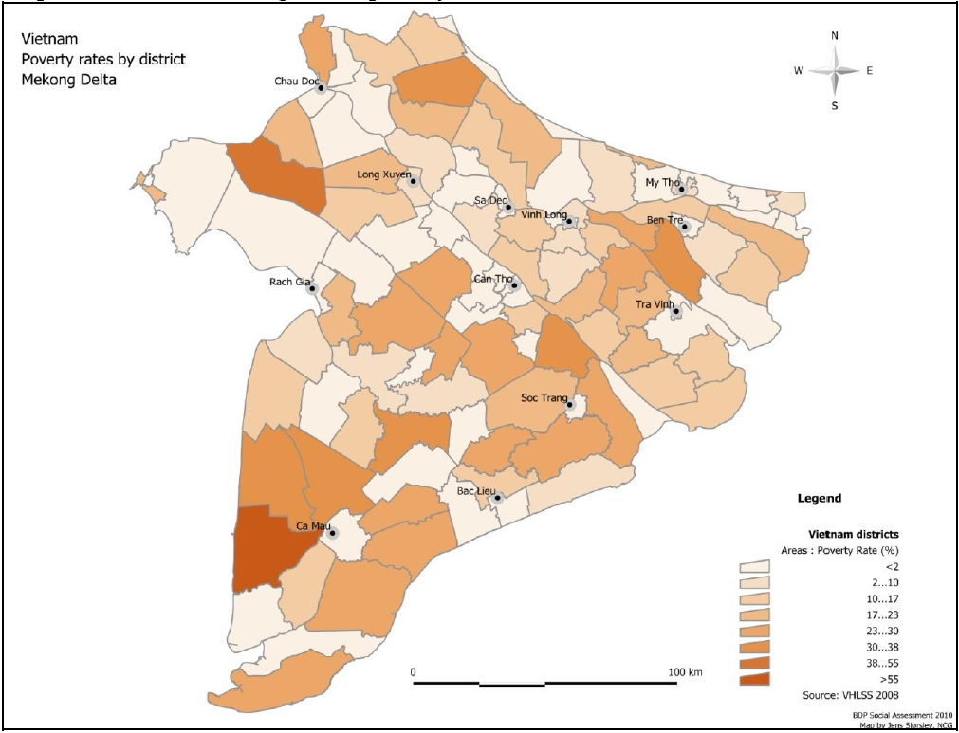

Individuals citing their main job as fishing (MRC Basin Development Plan Social Assessment based upon VHLSS 2008)

Area | Total |  |  | Female (%)
Area | Inland | Marine | Total | Inland | Marine | Total
An Giang | 26,140 | - | 26,140 | 29 | - | 29
Kiên Giang | 17,649 | 79,400 | 97,049 | 23 | 19 | 20
Sóc Trăng | 42,706 | 36,735 | 79,441 | 37 | 24 | 31
Bạc Liêu | 153,030 | 64,589 | 217,619 | 3 | 35 | 13
Cà Mau | - | 250,487 | 250,487 | - | 28 | 28
Mekong Delta | 280,955 | 431,211 | 712,166 | 28 | 27 | 27

Observed differential livelihoods strategies in the program areas visited

Wealth rank | Characteristics | Livelihoods
Poor | - landless (predominantly Khmer, Cham or recent migrants in Ca Mau and Kien Giang)  - no capital or access to loans, except selective cases of micro credit  - marginalised (social connections, language, access to education and services) | - primarily focussed on daily survival  - Local wage labour  - Collection of natural resources  - Labour migration (returns seem more common)
Medium | - having or being able to rent land for farming (size relatively modest)  - access to loans or financial support from family  - good connections locally and outside | - more diversified livelihoods  - mixture of aquaculture and agriculture  - small livestock and/or small trading activities  - salaried work by at least one member
Better-off | - having accumulated large land areas, including agriculture and aquaculture land.  - having accumulated capital  - owning large fishing or farming equipment  - more the case with shrimp farmers  - easy access to loans and land  - well connected to the market and local institutions | - diversified livelihoods  - large scale farming (15 - 20 ha) and high revenue  - larger scale collection of natural resources (having large mudflat areas for instance)  - employing a number of local labourers people on permanent basis

Field locations in 5 program provinces

Province | Locations | Ethnic Composition
Soc Trang | 1. Trung Bình commune, Trần Đề district  2. Vĩnh Châu commune, Vĩnh Châu | 1. Khmer 40%; Kinh 59%; Hoa 1%  2. Khmer 75%; Kinh 5%; Hoa 20%
Bac Lieu | 1. Vĩnh Trạch Đông commune, Bạc Liêu city  2. Vĩnh Hậu commune, Hòa Bình district | 1. Khmer 70%; Kinh 18%, 12% others  2. Half Khmer, half Kinh
Ca Mau | 1. Tân Ân commune, Ngọc Hiện district  2. Kiến Vàng hamlet, Cà Mau district town | 1. Mainly Kinh  2. Mainly Kinh
Kien Giang | 1 Thuận Hòa commune, An Minh district | 1. Mainly Kinh
An Giang | 1. Đa Phước commune, An Phú district  2. Ô Lâm commune, Tri Tôn district | 1. Cham 25%  2. Khmer 98%; Kinh 2% (in centre)

Provincial and National consultations
Agency | Name | Position
National
MARD | Mr Thin | Vice Director Foreign Relations Department
MoNRE | Mr Pham Van Tan | Vice Director Foreign Relations Department
WU | Ms Thuy | Foreign relations department
MoLISA | Mr Pham Ngoc Tien | Vice Director Gender Department
An Giang
DARD | Mr Doan Ngoc Pha | Vice director
DARD | Mr Nguyen Van Toan | Plant protection dept.
DARD | Mr Vu thang Minh | Planning dept.
DARD | Mr Phan Hong Cuong | Vice director of extension centre
DARD | Mr Tran Hoag Hung | Fisheries
DARD | Mr Mai Van Lap | Vice director irrigation dept.
DARD | Mr Y Van | Nursery dept.
DARD | Ms Huynh Thi Minh Khang | Book-keeping
DARD | Mr Duong Tang | Vetinary dept.
DARD | Ms Nguyen Thi Mi Khue | FPD
DARD | Mr Chu Quang Minh | Staff
DoNRE | Mr Tran Anh Thu | Deputy Director
DoLISA | Ms Nguyen Bao Yen | Vice director
DoLISA | Mr Nguyen Van Dat | Gender staff
DoLISA | Mr Le Van Vinh | Poverty staff
WU | Ms Lan | Vice Director
FU | Mr Chau Van Ly | Vice Director
FU | Ms Nguyen Thi Cam Ha | Monitoring and evaluation dept.
Kien Giang
DARD | Ms Tran Thi Thu Hang | Vice Director
DoNRE | Ms Vo Thi Van | Vice Director
DRAD | Mr Tran Van Chung | Deputy FPD
DARD | Mr Nguyen Tinh | FPD staff
DoNRE | Mr Tran Hoang Thanh | Vice Director EPD
WU | Ms Nguyen Hoc Xung | WU
WU | Ms Nguyen thi Nga | Staff
DoLISA | Ms Hoang Thi Ngoc Thu | Vice Director
DoLISA | Mr Doan Minh Dung | Chairman commission on social evils
DoLISA | Mr Nguyen Viet Bang | Policy dept.
FU | Ms Duong Hoang Van | Staff
FU | Mr Nguyen Duy Minh | staff
Ca Mau
MARD | Tran Van Thuc | Vice Director
DoNRE | Hong Hoang Tat | Vice Director
DARD | Mr Nguyen Long Hoai | Head of irrigation dept.
DARD | Mr Le Van Hai | FPD
DARD | Mr Nguyen Van Dac | FD
DoNRE | Mr Dang Quang Nam | Staff
DARD | Mr Nguyen Ba Tuan | Head of sub-department of rural development
DARD | Mr Pham Trung Thanh | Staff
WU | Ms Huynh Kim Duyen | Vice Director
DoLISA | Mr Nguyen Cong Chuong | Vice Director
Bac Lieu
DARD | Mr Quang | Vice Director
DoNRE | ? | Vice Director
DoLISA | ? | Vice Director
WU | Ms Tran Kim Xuyen | Vice Director
DARD | Mr Chung Tan Kiet | FPD - Vice Director of GTZ project
Soc Trang
DARD | Mr Trung Thanh Binh | Vice Director
DoNRE | Mr Tran Van Thac | Vice Director
DoLISA | Mr Nguyen Thanh Binh | Deputy Head
DoNRE | Mr Pham Hieu Lai | Head of sub-dept. of sea resource management
DARD | Mr Nguyen Quang Nam | Head of sub-department for irrigation
DARD | Ms Trieu Thi Thanh Thao | Staff planning sub-department
DARD | Mr Tran Van Hiep | FPD
DARD | Mr Phan Van Xe | Director FPD/GTZ project
WU | Ms Trenh Kim Ngan | Vice Chairperson
FU | Mr Lu Quang Chuc | Vice chair
IGOs
UNIFEM | Ms Suzette Mitchell | Country representative

IPCC 2007, Fourth assessment report; Dasgupta et al 2007
UNIFEM and Oxfam (2009), Responding to climate change in Viet Nam: Opportunities for improving gender equality. A policy discussion paper. Hanoi, Vietnam.
Few, R. et al (2010) ‘Seasonal hazards and health risks in the Mekong Delta: a multi-disciplinary approach’. DEV Reports and Policy Paper Series, The School of International Development, University of East Anglia, UK; Few, R. and Pham Gia Tran (2010), ‘Climatic hazards, health and poverty: exploring the connections in Vietnam’, Working Paper 19, DEV Working Paper Series, The School of International Development, University of East Anglia, UK.
AusAID 2010, Manual on Gender Mainstreaming for project 135 II, Hanoi, Vietnam
UNIFEM and Oxfam 2009, Ibid.
Approved by Decision No.158/2008/QD-TTg of the Prime Minister dated 2 December 2008
Trang, N.M. 2010, Integration of Climate change into national policy in Vietnam, Unpulished Master’s Thesis, University of East Anglia.
Although indications are that direct employment in agriculture is in relatively rapid decline.
Final report water sector review 2009 ADB
ICEM 2003
ICEM 2010, Final report, Strategic Environmental Assessment for Hydropower on the Mekong Mainstream, Mekong River Commission, Vientiane.
See Hiene, B. 2009, Adaption to Climate change in Coastal Areas of the Mekong Delta, Vietnam, Desk study, GTZ, Hanoi, and Chaudhry, P. and Ruysschaert, G. 2007, Human Development report 2007/2008, Climate Change and Human Development in Vietnam, UNDP, Human Development Report Office. ICEM 2010, O Mon Power Plant Rapid Climate Change Vulnerability Assessment. Draft Report. ADB, Manila.
ICEM 2009, Climate change impacts and adaption in East Asian Coastal Mega-cities – HCMC draft report volume II, ADB, Manila.
ICEM 2010, Saline intrusion in the Mekong Delta, Vietnam – Trends, impacts and adaptation. Draft report. ICEM Vietnam, Hanoi.
Much of the delta has issues with managing acid sulphate soils. Acid sulphate soils lie underneath the fertile top-soils. While water logged they pose no problem. However, if the top layer of soil is allowed to dry out sulphates can leach up into the top layer of the soil and oxidise forming acids and lowering the ph of the sols and subsequent run off. Increased acidity in soil reduces productivity and can result in fish kills
ICEM 2008 – need to look up reference to HCMC study
UNFPA and GSO 2004 – need to look up reference for this….
It should be noted that this is a different and less accurate measure of economic productivity in the sector than value-added measures, as it takes no account of additional inputs, which may have been used to lift output. This is of particular importance in agriculture and aquaculture where may of the increases in output have been driven by greater levels of inputs.
It is important to note that the little industrial development in these provinces is also mainly related to the processing of aquacultural products for export.
As yet with no discernable decline in yields, this suggests that it is not the case that increasingly marginal land is being brought into production, conversely the increase in yields in the other three provinces is likely to be an indication that marginal land has been brought out of rice production. However, if productivity figures were available we would be able to comment on this with greater certainty.
Cambodia, Lao PDR, Thailand and Vietnam.
MRC 2010, Basin Development Plan, Phase 2, Technical note 7, Agricultural impacts.
Joint Donor Report to the Vietnam Consultative Group Meeting, 2003. Vietnam Development Report 2003. Poverty. Hanoi: Vietnam Development Information Centre
Ibid.
Asia Foundation 2007, Đánh giá khoảng cách giới trong phân bổ nguồn lực tại địa phương:Trường hợp tỉnh An Giang; CARE International 2001, Gender Issues in UMT Nature Reserve Conservation and Development Project, Vietnam
It should be noted that in the delta as a whole, a third of people citing there main employment as fishing were women according the Vietnam Living Standard Survey 2008.
Le, T.V.H (2006) ‘Gender, Doi Moi and Mangrove Management in Northern Vietnam’, Gender, Technology and Development, 10 (1): 37-59
Báo cáo kết quả thực hiện kế hoạch nhà nước 6 tháng đầu năm 2010, UBND xã Thuận Hòa
UN-Oxfam 2009 – Responding to Climate Change: Opportunities for improving gender equality
The resettlement was supported through a World Bank project in the area.
It should be noted that while saline intrusion may make conditions more suitable for shrimp production and that increased expansion of shrimp production may be associated with this climate change associated impact, that it has also been provincial policy as well as unofficial practice to expand shrimp production as a higher value-added alternative to rice production.
Taken from the project design document.
Ausaid

