German Development Cooperation

Climate Change and Coastal Ecosystems Program (CCCEP)

Funded by the Australian and German Governments

Implemented by The Deutsche Gesellschaft für Internationale Zusammenarbeit (GIZ)GmbH

Environmental Policy, Natural Resources and Urban Development

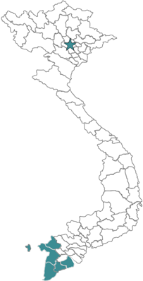
Government of Viet Nam

Executing Agencies: Ministry of Agriculture and Rural Development (MARD) and
Five Provincial People’s Committees (PPC)

Other GOV Partners: Ministry of Natural Resources and Environment (MoNRE)
Departments of Agriculture and Rural Development (DARD)
Departments of Natural Resources and Environment (DoNRE)
Department of Science and Technology (DoST)

Duration: July 2011 to June 2016

Program Areas: National and Provincial Policy
(see map) 5 Provinces: Kien Giang, An Giang, Ca Mau, Soc Trang, Bac Lieu

Funding: Australia will contribute up to A$23 million (US$ 24.3 million) to this program and Germany commits US$ 14.1 million in technical cooperation. CCCEP will be implemented by GIZ, Deutsche Gesellschaft fuer Internationale Zusammenarbeit. In addition, Germany has committed US$ 25.3 million of financial cooperation for dyke rehabilitation implemented by KfW.

Context
The Intergovernmental Panel on Climate Change (IPCC) has named Vietnam one of the countries most vulnerable to the impacts of climate change. The Mekong Delta, a densely populated and low-laying region, is particularly prone to sea level rise and increasingly frequent and intense natural disasters such as typhoons, storms and floods.
The Mekong Delta is known as the “rice bowl” of Viet Nam due to its high agricultural productivity. The Delta was once renowned for its rich biodiversity, especially in the coastal wetlands, mangrove areas and Melaleuca forests, as well as the few remaining Dipterocarp forests.
These environments are under mounting threat from population pressure and the effects of climate change. Water and soil quality in the Delta is diminishing and ground water levelcontinues to fall due to overuse. Water flow in the Mekong River is constrained by dams built upstream and insufficient levels of rain during the monsoon season.
The CCCEP will provide practical solutions for a range of environmental hazards threatening coastal ecosystems.
Provincial climate change adaptation plans will be developed as part of the initiative, and will include activities such rehabilitating mangroves and improving dyke construction and management. The plans will outline measures for better protecting coastal forests, such as teaching communities sustainable farming practices and promoting alternative income opportunities for communities dependent on coastal forests.
Objective
The overall objective of the CCCEP is to help Viet Nam manage and protect its coastal ecosystems which includes responding to the impact of climate change.
Approach
The CCCEP builds on the achievements of a two-year pilot project in Kien Giang funded by AusAID and the project in Soc Trang funded by BMZ. Both projects are implemented by GIZ, which has supported the provincial government to protect and maintain coastal forests, identify sustainable livelihood opportunities for vulnerable groups, replicate model mangrove plantations, and to develop a policy on new dyke construction techniques by using practical demonstrations. Insights were also provided by a German funded project in Soc Trang.

The expanded program will address similar issues that are relevant throughout the Mekong Delta. A national level component will assist in developing and implementing relevant policy and a legal framework at both national and provincial levels.
Program indicators
Success of the expanded program will be measured against the following key indicators:
- Climate change adaptation initiatives are incorporated into provincial planning processes and resourced
- The protection forest areas in the targeted provinces are maintained
- New innovative income opportunities increase the average income rates of the program target groups
- Gendered vulnerabilities are understood and addressed in provincial climate change adaptation plans
- The awareness of political decision makers, staff of government institutions and local population about impacts of climate change has increased
- A coherent national policy framework for coastal ecosystem management is ratified and implemented by the Government of Vietnam
At the end of five years, it is anticipated that decision makers, staff of government institutions and local population will be more aware of the impacts of climate change and potential adaptation strategies. The National Government will have provided the necessary support to incorporate and implement plans for climate change adaptation into the provincial planning and funding processes. Information from successful pilot projects will be incorporated into coastal management plans. The biodiversity and extent of coastal forests will be protected and enhanced. Participation in sustainable livelihood projects will have increased the average income rates of the program target groups and increased the local capacity to adapt to climate change.

\

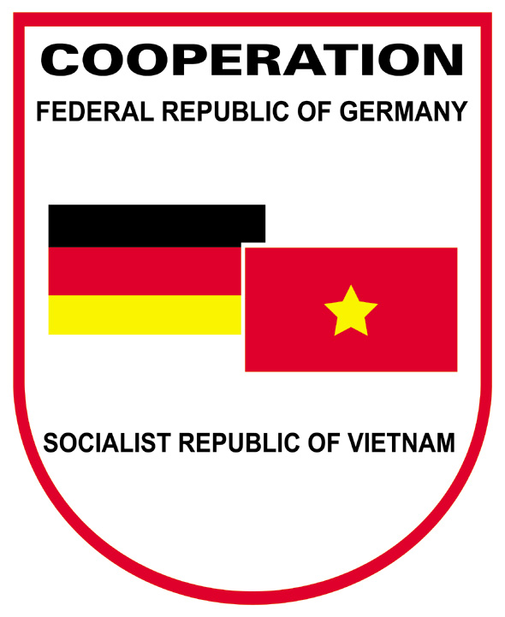


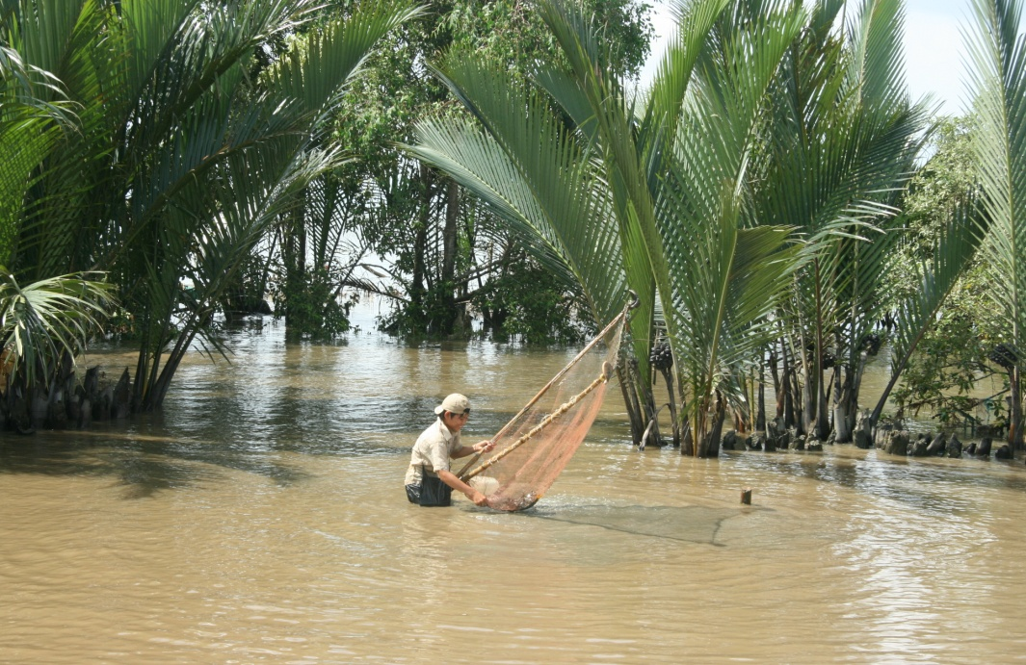

© giz 2011

Deutsche Gesellschaft für Internationale Zusammenarbeit (GIZ)

Climate Change and Coastal Ecosystems Program
6th Floor, Hanoi Towers
49 Hai Ba Trung Street, Hanoi, Viet Nam
T +84 4 39 34 49 51
F +84 4 39 34 49 50
E juergen.hess@giz.de
I www.giz.de/vietnam
www.gtz-mnr.org.vn

© giz 2011

