Helping the World’s Poor
through Effective Aid:
Australia’s Comprehensive Aid Policy
Framework to 2015–16

© Commonwealth of Australia 2012
Published by the Australian Agency for International Development (AusAID), Canberra, May 2012. Reprinted May 2012.
This document is online at www.ausaid.gov.au/publications
For further information about the Australian Government’s international development program, contact:
Communications Section AusAID GPO Box 887 Canberra ACT 2601
Phone (02) 6206 4000
Internet www.ausaid.gov.au
Contents
Ministerial Foreword 2
Introduction 3
1. Why we deliver aid 4
2. What we will focus on 6
3. Where we will provide aid 8
4. Results we will achieve 20

Ministerial Foreword
The efforts of developing countries and the donors that support them are being rewarded with results. Poverty reduction is occurring in every region of the world. The World Bank estimates the Millennium Development Goal of halving the proportion of people living in extreme poverty between 1990 and 2015 has already been met.
Serious challenges still remain. Despite all the wealth, knowledge and technology at our disposal in 2012, more than 1.3 billion people worldwide still live in extreme poverty.
Despite medical and scientific advances, 21,000 children still die each day from diseases and conditions largely overcome in wealthy countries like Australia.
This is unacceptable to Australians.
In 2007, the Australian Government committed to help the world’s poor by increasing the share of Australia’s national income spent on overseas aid. Every year since, with bipartisan support, the Government has delivered increases in the aid budget which have translated into benefits for poor people all over the world.
Building on achievements such as the eradication of polio from the Pacific, we have worked with others to vaccinate 325 million children against preventable childhood diseases, averting 5.5 million future deaths. Since 2007–08, we have provided 2.2 million people with access to safe drinking water and two million with better sanitation services in more than nine countries across Asia, Africa and the Pacific.
These results matter. Australia’s own peace and prosperity is inextricably linked to global peace and prosperity. It is in our national interest to promote development, particularly in our immediate region, where 22 of our 24 nearest neighbours are developing countries.
In 2011, the Government released a new aid policy, An Effective Aid Program for Australia: Making a real difference—Delivering real results, in which the Government undertook to develop a Comprehensive Aid Policy Framework to guide future increases in the aid budget.
This Comprehensive Aid Policy Framework sets an unprecedented standard for aid predictability, transparency and accountability for Australia and our development partners. It provides a roadmap for where and how Australian aid will be spent over the next four years. It outlines the results we expect to achieve and the measures being taken to improve aid delivery. The Government is making itself accountable for these results by publishing each year an Annual Review of Aid Effectiveness.
Australians can have pride and confidence in their overseas aid program. It is effective, well managed and achieving outcomes for poor people around the world. Over the coming years, our aid program will continue to set standards in results and transparency that are world’s best practice.

Bob Carr
Minister for Foreign Affairs, Australia

Introduction
On 6 July 2011, the Australian Government released a new aid policy—An Effective Aid Program for Australia: Making a real difference—Delivering real results. To give effect to this new policy, the Government announced that it would prepare a Comprehensive Aid Policy Framework containing a four-year budget strategy that would inform the 2012–13 aid budget and future aid budgets to 2015–16.
This Comprehensive Aid Policy Framework, or CAPF, includes indicative budget allocations for the recipients of Australian aid to 2015–16, headline results that will be achieved and new standards for the efficient and effective delivery of Australian aid, aligned to the strategies outlined in An Effective Aid Program for Australia: Making a real difference—Delivering real results.
The CAPF encompasses the aid spending of all federal agencies, not only the Australian Agency for International Development (AusAID), and will underpin whole-of-government aid efforts over the next four years. The budget allocations shown in the CAPF are indicative and subject to:
- partner governments and organisations meeting their commitments under partnership agreements with Australia;
- an annual review of the performance of the aid program, including against expected results (see Section 6 for more details); and
- annual budget processes.
A primary purpose of the CAPF is to enable the Australian Government and Australian aid recipients to plan and implement aid investments more effectively. This will deliver better results in terms of lives saved, people lifted out of poverty, children educated and vulnerable people provided with life-saving assistance in times of crises. The CAPF also provides the Australian people with clarity on what the aid program is trying to achieve.
The development and publication of the CAPF is unprecedented in the history of the aid program. It also represents a very high standard in budget forecasting, aid predictability, transparency and accountability, which is matched by very few other donors worldwide.

The main features of the CAPF are:
- an overview of why we provide aid and what we will focus our aid on: this includes a summary of the objective and strategic framework for the aid program (as outlined in An Effective Aid Program for Australia: Making a real difference—Delivering real results)
- an outline of where we will provide aid through a rolling four-year budget strategy: the budget strategy provides indicative regional and global program aid allocations to 2015–16 based on a whole-of-government assessment of the best use of our aid dollars
- results we will achieve through our aid investment by 2015–16: this includes specifying the major successes the aid program will pursue and new standards for operational efficiency and effectiveness
- how we will deliver aid: this includes how we will ensure that the aid program is efficient, effective and delivering value for money.

1. Why we deliver aid
We provide aid because Australians find it unacceptable that people still live without sufficient income to lead a decent life, or have the resources to buy medicines or send their children to school. Despite remarkable progress in reducing poverty, today 1.3 billion people live in extreme poverty on less than $1.25 a day in our region and around the world. A further 1.1 billion people, many of whom are in Asia, live just above the extreme poverty line but still on no more than US$2 a day (see Diagram 1).
Diagram 1: Population living in poverty in 1981 and 2008, by region
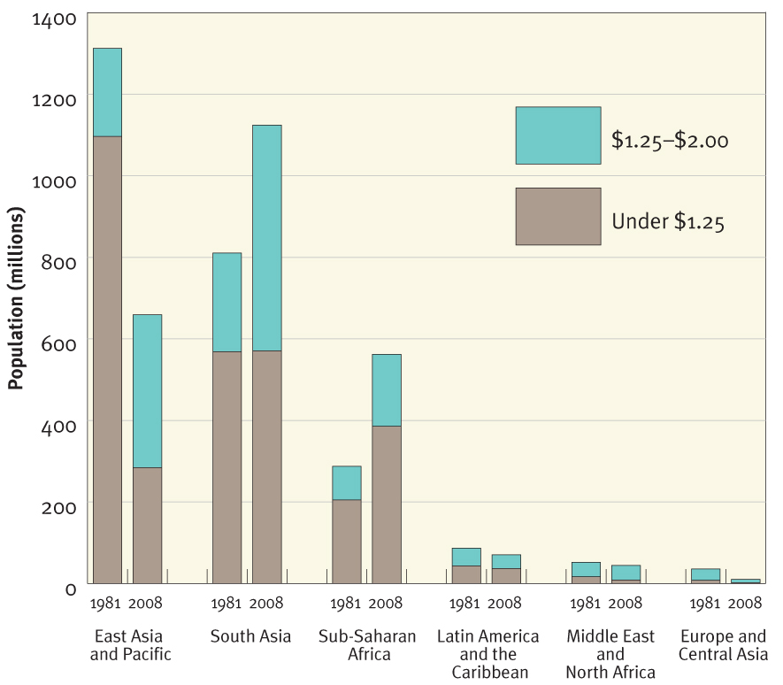
More than 10 years have passed since world leaders agreed to the Millennium Development Goals, to reduce extreme poverty, hunger, illiteracy and disease by 2015. Since then, there have been many positive gains. By 2015, it is expected that the global poverty rate will fall below 15 per cent, which is well under the 23 per cent target set in 2000. Targeted interventions have succeeded in reducing child mortality. The number of deaths of children under the age of five declined from 12 million in 1990 to 7.6 million in 2010. Deaths from malaria have been reduced by 20 per cent worldwide since 2000. New HIV infections are also declining steadily, with a drop of 21 per cent since 1997, when new infections peaked. Around the world, deaths attributed to tuberculosis have fallen by more than one third since 1990.
Yet despite this progress, more remains to be done, particularly in reaching the most vulnerable. Lifting the last 1.3 billion people out of extreme poverty will be even more challenging than achieving the progress made in the last 20 years. Many of the people who remain in extreme poverty live in conflict-affected or fragile states, or remote regions, making it increasingly difficult to make further inroads into poverty reduction. Furthermore, progress at the global and regional levels in some cases mask large differences in country performance. And many of those lifted out of poverty in recent years are vulnerable to slipping back into poverty. Food, fuel and financial crises have had negative impacts on vulnerable populations and slowed the rate of poverty reduction in some countries. Economic risks and uncertainties, particularly in Europe, continue to put at risk the growth prospects of developing countries.
The Australian community has demonstrated its commitment to the elimination of poverty through private donations to overseas aid efforts that now total almost $1 billion per year. This commitment is shared by the Government, which has been increasing the aid budget with bipartisan support each year, and by the international community, of which Australia is a responsible member.
We provide aid because it works, and there is extensive evidence demonstrating its positive impact on the lives of poor people. The quality of life in developing countries has improved appreciably over the last 50 years and aid has contributed significantly to these gains. For example, about 80 per cent of children around the world now get basic vaccinations, and this is saving about 3 million lives a year. In addition, recent evidence suggests that developing countries which receive higher levels of aid have experienced greater reductions in infant mortality, malnutrition and the numbers of children living with HIV/AIDS, compared to developing countries receiving low levels of aid.
The aid program builds other important links between Australia and developing countries. Over the past decade, the aid program has created educational opportunities for millions of students in developing countries at all levels, from primary school to university. While a majority of our education assistance has focused on building better education systems within developing countries, we have also given scholarships to study in
Australia to more than 12,600 students between 2009 and 2012, many of whom are now leaders of development in their own countries. For example, the current Vice President of Indonesia, two Indonesian Cabinet ministers and the Secretary of Education in Papua New Guinea were all Australian aid scholarship recipients. The ultimate aim of aid is to help people to become self-sufficient and to lift their own standards of living. Cultivating educational opportunities and supporting future leaders has proven an effective way of doing this.
We also provide aid because it advances our national interests by promoting stability and prosperity both in our region and beyond. Poverty and inequality are significant sources of social tension that undermine states’ ability to maintain social harmony, threatening their own security and that of their neighbours.
Of Australia’s 24 nearest neighbours, 22 are developing countries in which poverty is widespread. Growing the economies of these nations promotes prosperity and our interests by assisting existing and potential trading partners. Countries such as Thailand and South Korea were once aid recipients and are now among Australia’s 10 largest trading partners.
Australia’s aid program also provides an opportunity to develop close bilateral relationships with our neighbours, providing a strong platform for cooperation in major regional and global forums. Such cooperation is critical in an increasingly uncertain and globalised economy.

2. What we will focus on
As outlined in the Government’s new aid policy, An Effective Aid Program for Australia: Making a real difference—Delivering real results, the fundamental purpose of Australian aid is to help people overcome poverty. This also serves Australia’s national interests by promoting stability and prosperity both in our region and beyond. We focus our effort in areas where Australia can make a difference and where our resources can most effectively and efficiently be deployed.
Australia’s aid program is guided by five strategic goals which are outlined in Diagram 2. These strategic goals operationalise Australia’s contribution to the Millennium Development Goals (MDGs). For example, under the strategic goal of saving lives, the Government has committed to save the lives of poor women and children through greater access to quality maternal and child health services (MDGs 4 and 5) and support for large scale disease prevention, vaccination and treatment (MDG 6). Our strategic goals recognise that performance in other sectors, particularly good governance through better public financial management and the maintenance of law and justice, makes a vital contribution to the achievement of the MDGs. And progress in any of these areas can be undermined by inadequate preparation for humanitarian and natural disasters.
Diagram 2: The purpose and strategic goals of the Australian aid program
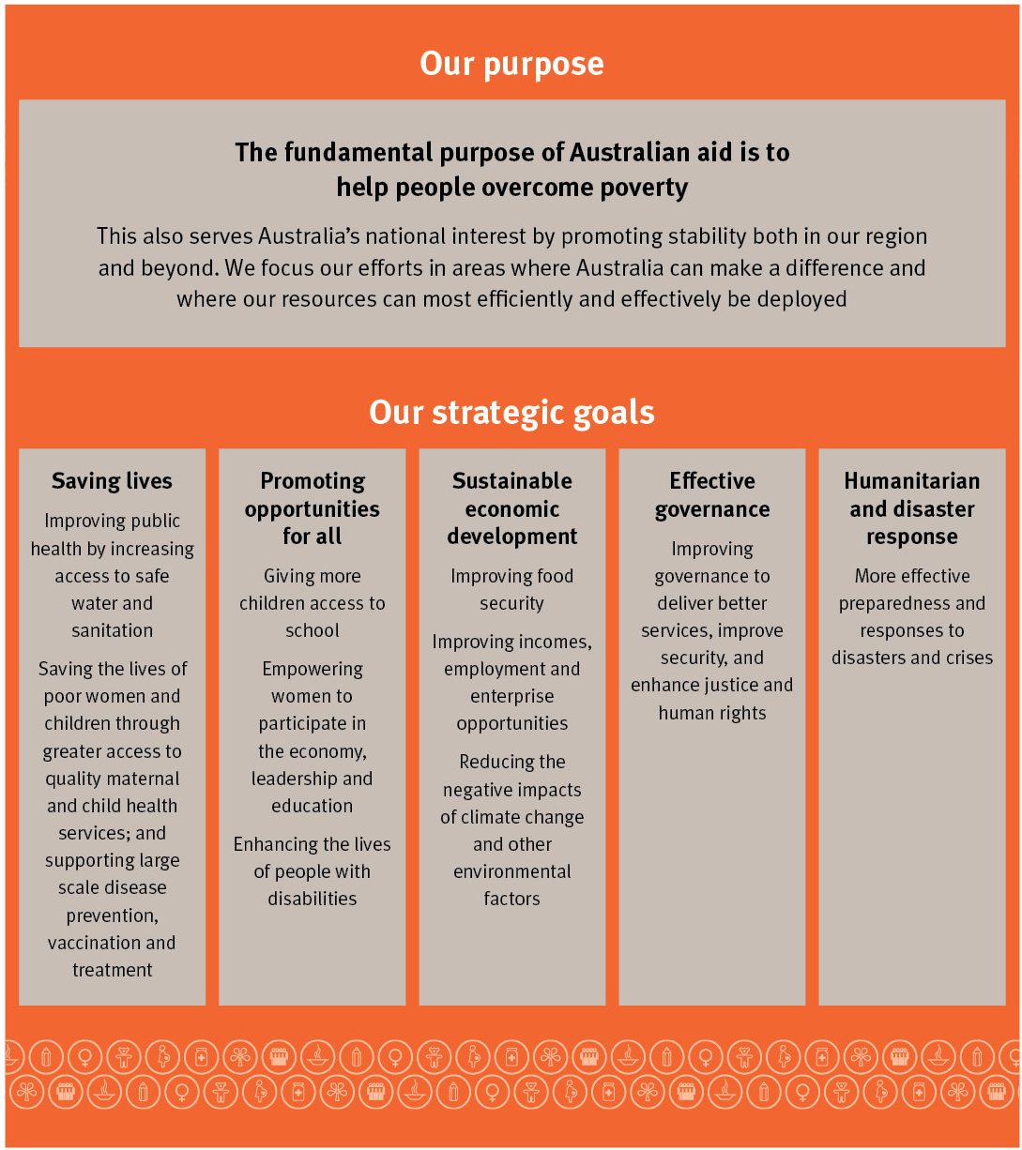

3. Where we will provide aid
In the new aid policy, An Effective Aid Program for Australia: Making a real difference—Delivering real results, the Government announced that it would prepare a four-year budget strategy, basing the allocation of the aid program on an assessment of four criteria—poverty, national interest, our capacity to make a difference, and the scale and effectiveness of our current programs. This section outlines the methodology underpinning the budget strategy and the outcome for indicative aid allocations by 2015–16. The outcome of the budget strategy for the shape of the aid program by 2015–16 is shown in Box 1.

Box 1: Shape of the aid program by 2015–16
By 2015–16:
- Asia and the Pacific will continue to be the highest priority regions, receiving around 75 per cent of Australian aid
- our 12 largest bilateral aid recipients will be in Asia and the Pacific—Indonesia, Papua New Guinea, Afghanistan, Solomon Islands, Vietnam, Philippines, Bangladesh, East Timor, Pakistan, Cambodia, Burma and Vanuatu
- more than 30 per cent (up from 27 per cent now) of the aid budget will be delivered through global partnerships, expanding the reach and influence of Australian aid
- the World Bank Group, Asian Development Bank, World Food Programme and United Nations Children’s Fund will be our most significant multilateral partners
- 25 per cent of the aid budget will be spent on education assistance to get 4 million more children into school and provide 20 million children with a better quality of education
- at least 10 per cent of the aid budget (up from 6 per cent in 2007) will be delivered through partnerships with non-government organisations.

Methodology
The aid budget is organised by regional groups—Pacific, East Asia, South and West Asia (including Afghanistan and Pakistan), sub-Saharan Africa, North Africa and the Middle East, Latin America and the Caribbean—and global groups—multilateral and non-government organisations.
In determining the future direction of the aid program in particular countries and regions, a comparative analysis was undertaken to determine priorities for additional aid. This analysis was based on four criteria (Box 2)—poverty, national interest, Australia’s capacity to make a difference and the scale and effectiveness of our current aid programs. This analysis was undertaken by AusAID, with input from across government and oversight by the Development Effectiveness Steering Committee.
The analysis drew on quantitative data available from international and our own statistical sources (such as the World Bank Development Indicators database) and the more qualitative assessments of key organisations and relevant experts. Some of the indicators used in the assessment are listed in Box 2.

Box 2: Aid allocation criteria
- Poverty: the proportion and absolute number of people living below the US$1.25 and US$2.00 a day poverty lines; each country’s Human Development Index (HDI) ranking; Gross Domestic Product (GDP) per capita; child and maternal mortality rates; proportion of the population with access to improved sanitation; primary education completion rates; and the number of females enrolled in primary education (per 100 males).
- National interest: proximity to Australia; Australia’s security interests (including the impact of conflict and fragility); total two-way merchandise trade flows with Australia; total migrant flows (excluding tourists); relevant ranking as Australia’s trade partner; community interests; and membership of groups (for instance APEC, ASEAN, the Commonwealth and the G20).
- Our capacity to make a difference: partner government capacity and levels of corruption, measured by the World Bank’s World Governance Indicators; levels of aid saturation, measured by total Official Development Assistance (ODA) to GDP ratio; levels of aid fragmentation, measured by the number of donors delivering less than 10 per cent of total ODA; whether or not poverty has been increasing or decreasing over time; democracy, justice and security in poor communities; freedom of the press; and how these factors are affecting our ability to deliver results through ODA.
- Current scale and effectiveness: Australia’s contribution and influence within a country or region relative to other Organisation for Economic Co-operation and Development (OECD) donors, measured by our share of total ODA; current program performance, derived from ratings and information provided in annual country performance assessments and evaluations undertaken by the Office of Development Effectiveness; the current intensity of our programming, measured by ODA delivered per AusAID officer based in a country and the average activity budget; and our ability to scale-up existing programs and partnerships and develop new programs and partnerships.

Each regional group (and a small number of individual countries) was assessed and then assigned to one of three growth bands—high (67 per cent or more), medium (34–66 per cent) or low (0–33 per cent). Assignment to a higher band reflects higher priority or greater scope to use additional aid to positively impact the lives of poor people over the next four years.

Two additional policy decisions that the Government committed to in An Effective Aid Program for Australia: Making a real difference—Delivering real results were also taken into account:
- increasing as a share of the aid program core funding to multilateral organisations
- phasing out bilateral aid to China and India. Both countries are members of the G20. They have respectively the second and sixth largest economies in the world, considerable economic capacity and have begun their own development assistance programs.
Outcomes of the assessment
A summary of the assessment findings is shown in Table 1, along with forecasts of volume in 2015–16 compared to 2011–12 (the base year for the budget strategy). These estimates are indicative only and will be subject to:
- partner governments and organisations meeting their commitments under partnership agreements with Australia;
- an annual review of the performance of the aid program including against expected results (see Section 6 for more details); and
- annual budget processes.
In Table 1, AusAID departmental funding (which will decrease from 6 per cent to 5 per cent of the total aid budget by 2015–16) and adjustments to the ODA Contingency Reserve are excluded from the totals shown. The totals also assume that total ODA by 2015–16 will be equivalent to 0.45 per cent of GNI but this could change depending on the performance of the Australian economy and future budget decisions.

Table 1: Outcome of program assessments
Program | Growth band | Comments | Estimated volume 2011–12 $m | Estimated volume 2015–16 $m
Pacific  including Papua New Guinea | Medium  Medium | Due to their small size and remoteness from international markets, Pacific island countries have limited opportunities to improve the lives of their people. Australia has an enduring interest in the stability and prosperity of the Pacific, and is the largest donor in this region. While progress against the MDGs has been mixed, our aid is effective and delivering results, for example in underwriting stability in Solomon Islands and reducing the incidence of malaria in Melanesia. More aid needs to be weighed against the already high levels of aid per capita, including in Solomon Islands. | 1,160 | 1,600
East Asia  including Indonesia | Medium  High | Growth and poverty reduction is uneven across East Asia and substantial developmental challenges remain, with approximately 500 million poor people living on less than US$2 a day. Australia has strong economic, humanitarian and security interests in the prosperity and stability of this region. Burma in particular would benefit from a substantial increase in aid given the high levels of poverty, low volume of aid and recent reform efforts. | 1,249 | 1,950
South and West Asia | Medium | South Asia has the largest number of poor people in the world and there are important and enduring linkages between this region and Australia. Bangladesh in particular warrants an increase in aid, given the high incidence of poverty and positive development progress being made.  In West Asia, Afghanistan suffers some of the highest child and maternal mortality rates in the world, and Australia’s involvement in the NATO-led coalition efforts to end the war means we have a clear and pressing interest in its longer term stabilisation and development. Conversely, the current conflict and the state’s fragility make the delivery of effective aid extremely difficult. In Pakistan, a third of the population lives in extreme poverty. The country’s global strategic significance and growing people-to-people links with Australia mean we have a long-term national interest in contributing to its development. Conversely, the size of the poor population and our limited presence in Pakistan make the delivery of effective aid challenging. | 465 | 725
Sub-Saharan Africa | High | Africa is the world’s most impoverished continent, with 400 million people living in extreme poverty. Sub-Saharan Africa is the region most unlikely to meet the MDGs by 2015. The fragility of many countries, as well as our trade and community links with the region, mean development is in Australia’s national interest. Current Australian bilateral aid levels to the region are comparatively low. A large increase in funding mainly channelled through effective multilateral partners who work in this region, and potentially through the African Development Bank, could have a positive impact on millions of poor people in this region. | 291 | 500
North Africa and the Middle East | Medium | Overall poverty levels in this region are comparatively low, but there is inequity and the region is undergoing rapid political and social change with major humanitarian consequences. The region’s democratic transition and rapidly increasing links through trade, investment and migration make this region of significant national interest at the present time. | 93 | 125
Latin America and the Caribbean | Low | While poverty levels are lower compared to other regions, inequality is widespread throughout Latin America and the Caribbean. However, Australia’s bilateral programs are relatively small and we will need to continue to deliver most of our assistance through our regional and multilateral channels, to maximise efficiency and value for money. | 47 | 50
Global Programs (including core funding to multilateral organisations) | High | Compared to other donors, Australia currently provides a small proportion of our program in core funding to multilateral organisations. Working through partners such as these allows Australia to increase its global influence, avoid fragmentation of the aid program, influence the organisation in areas of interest to Australia and maximise impact and value for money. Individual allocations within the global program will be based on effectiveness, determined in light of the Australian Multilateral Assessment findings and a new Civil Society Engagement Framework. | 1,310 | 2,350
Total |  |  | 4,615 | 7,300

Whole-of-government approach
These forecasts estimate total aid flows, that is, the sum of all the aid efforts of all parts of the Australian Government in these regions. Australia’s whole-of-government approach to aid delivery has been praised internationally and its strength forged through a decade of cooperative work in East Timor, Solomon Islands, Papua New Guinea, in the aftermath of the Indian Ocean tsunami, and more recently in Pakistan and Afghanistan.
Just over 10 per cent of the aid program is delivered by federal agencies other than AusAID. A further 4 per cent is delivered through joint partnerships with AusAID. In 2011–12, the aid expenditure of other federal agencies is forecast to be more than half a billion dollars, compared to less than $200 million 10 years ago. By 2015–16, this share is forecast to increase to closer to 12 per cent or up to $900 million per year.

Diagram 3: Budget strategy—Proposed indicative geographic distribution of the aid program by 2015–16
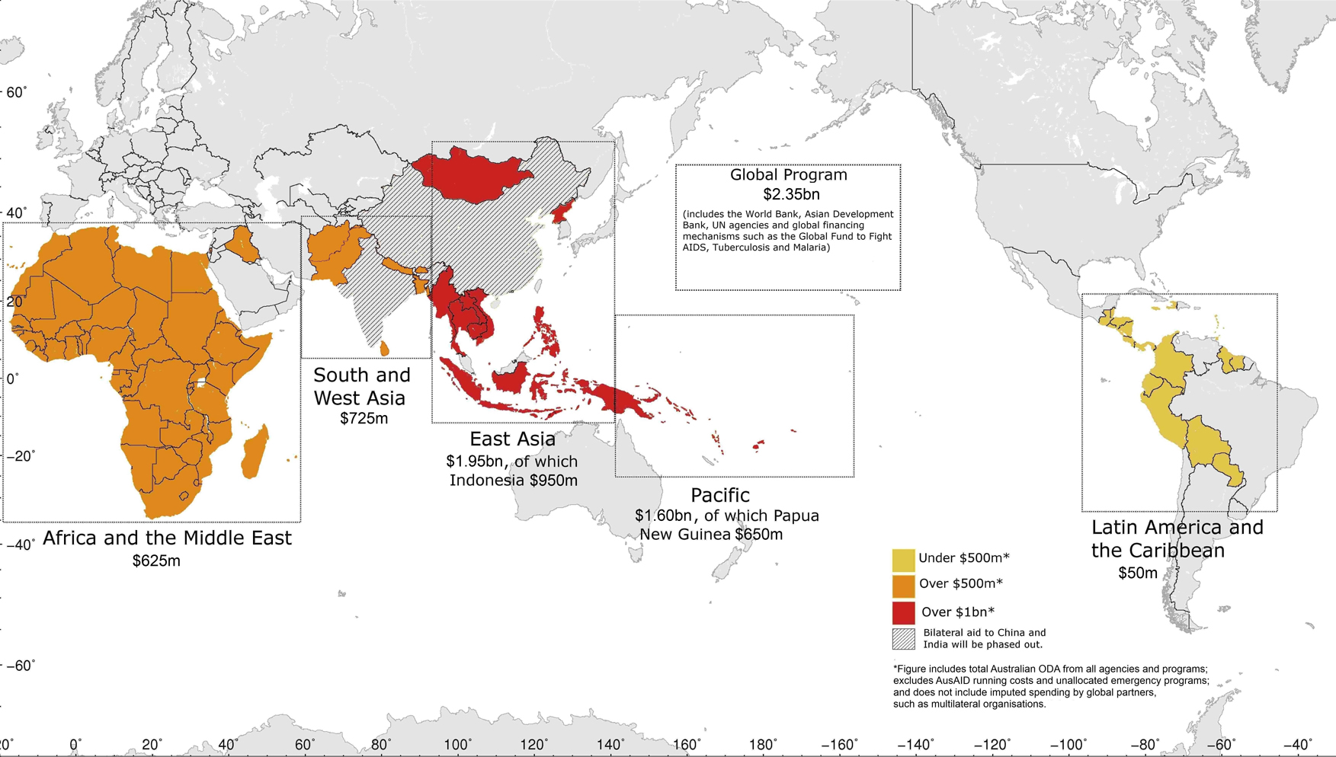
The estimates shown are indicative and subject to annual budget processes (refer page 10).
Priorities for our bilateral program
Australia’s current top 12 aid recipients are all in Asia and the Pacific. Indonesia and Papua New Guinea are forecast to remain our largest aid recipients by a significant margin, reflecting poverty needs and our very clear national interests.
The next major recipients will include:
- Solomon Islands
- Afghanistan
- Vietnam
- Philippines
- Bangladesh
- East Timor
- Pakistan
- Cambodia
- Burma
- Vanuatu.

Priorities for our global program
Increased core funding to effective global partners (multilateral and non-government organisations) will:
- enable Australia to contribute to development efforts on a broader scale and in countries where establishing a bilateral aid program would be less effective
- increase our influence within multilateral organisations, to improve their performance and focus on issues of interest to Australia
- reduce fragmentation by reducing the number of individual activities within the Australian aid program and helping to consolidate international efforts
- enable more Australian non-government organisations to undertake development work.
Diagram 4 shows forecast spending to groups of global partners in 2011–12 and 2015–16.
Diagram 4: Forecast spending for groups of global partners
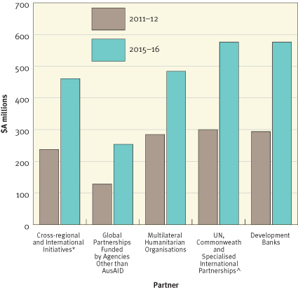
* This includes the Civil Society Water, Sanitation and Hygiene Fund, the Extractive Industries Transparency Initiative and the World Bank East Asia and Pacific Region Infrastructure for Growth Trust Fund.
^ This includes specialised international partnerships including the GAVI Alliance, the Global Fund to Fight AIDS, Tuberculosis and Malaria, the Global Agriculture and Food Security Program, and the Global Partnership for Education.
Most funding to global partners is managed by AusAID. However, other federal government agencies are also responsible for managing these relationships. For example, the Department of Foreign Affairs and Trade provides Australia’s core payment to the United Nations Department of Peacekeeping Operations and the Treasury makes payments for Australia’s capital contributions to the international development banks.

Non-government organisations
Working with non-government organisations is an integral part of Australia’s approach to achieving the five strategic goals of the aid program outlined in An Effective Aid Program for Australia: Making a real difference—Delivering real results.
Non-government organisations are effective in reaching disadvantaged groups that governments sometimes fail to reach. The Australian Government partners with and funds Australian non-government organisations to work with communities and vulnerable people in more than 50 countries across Asia, the Pacific, Africa, the Middle East, Latin America and the Caribbean.
Australian non-government organisations bring particular strengths to the aid program. Some have been working in international aid and development for more than 60 years. They mobilise public support and voluntary contributions for aid, and they often work in areas where government-to-government aid is not possible. Many also have expertise in working in emergency situations where fast and flexible responses are essential.
Many Australian non-government organisations receive funding through the AusAID-NGO Cooperation Program (ANCP). The ANCP supports more than 40 accredited Australian non-government organisations to undertake community-based development work. The Government provided $244 million in new funding in the 2011–12 Budget to double the ANCP program by 2014–15.
The four-year budget strategy anticipates that total funding to non-government organisations will increase from roughly $500 million in 2011–12 to between $700 and $800 million by 2015–16, with more than half channelled through partnerships between AusAID and Australian non-government organisations.
The future geographic focus of Australian aid—bilateral aid and global program forecasts combined
A different perspective on the distribution of the aid budget can be shown by imputing global program spending. By definition, core funding to global and non-government organisations is not earmarked for particular geographic regions. Decisions on how funding is allocated are up to the particular international organisation. That said, funding to global organisations does ultimately end up benefiting poor people in specific countries and regions.
Most multilateral and non-government organisations spend more of their core funding in sub-Saharan Africa, East Asia and South Asia than in other regions (e.g. the Pacific). Combining forecasts of imputed global allocations and bilateral allocations in 2015–16 produces the geographic distribution of aid expenditure shown in Diagram 5 below.
This provides a different perspective compared to Diagram 3 on the future distribution of the aid budget. For instance, when our contributions to multilateral and international organisations are taken into account, Australia’s total aid to the Pacific and sub-Saharan Africa is forecast to be around the same level in 2015–16 and our aid contribution to South Asia is doubled. When the global program is imputed, total spending in the Asia-Pacific region also accounts for around 75 per cent of the aid program.
These estimates are indicative only and will be subject to an annual review of the performance of the aid program, including against expected results (see Section 6 for more details); and annual budget processes.
Diagram 5: Projected bilateral and imputed global program expenditure for major regions in
2015–16
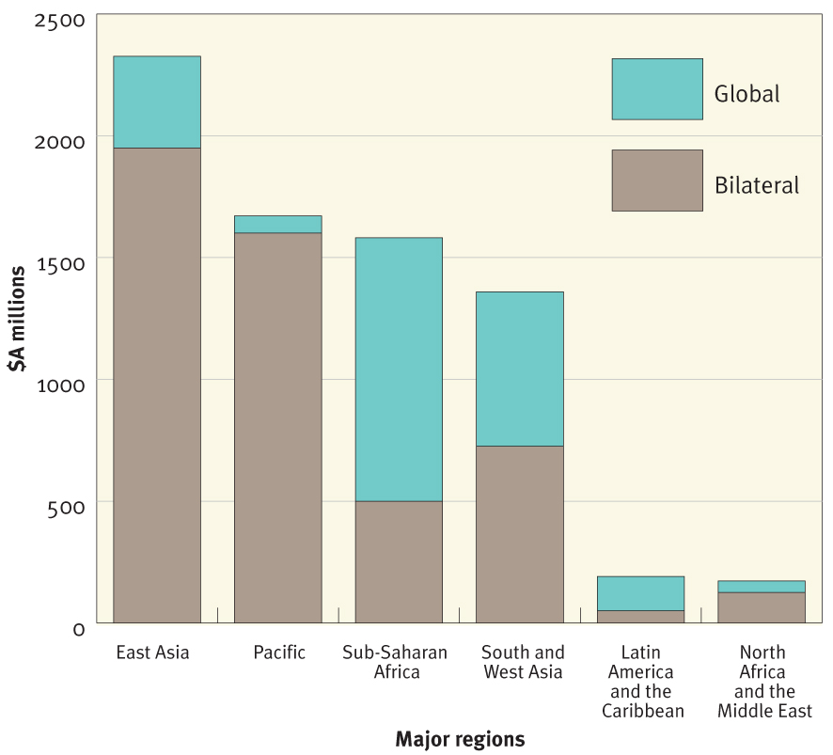
Strategic goals
Within regions and countries, aid expenditure is informed by strategies that are based on a detailed analysis of the operating environment and consultations with our partners, not by predetermined sectoral targets. Nevertheless, it is possible to project how the aid program will be spent against the five strategic goals (Section 2 refers).
Preliminary 2015–16 forecasts suggest expenditure will increase in absolute terms across all the strategic goals, with the biggest increases focused on education (promoting opportunities for all), health (saving lives), food security (sustainable economic development), and humanitarian assistance. While there is forecast to be a reduction in the share of total ODA spent on governance, increasingly governance initiatives will be integrated into sectoral programs in areas such as health and education (see Diagram 6).
Diagram 6: Share of total ODA expenditure in 2011–12 and 2015–16 by strategic goal
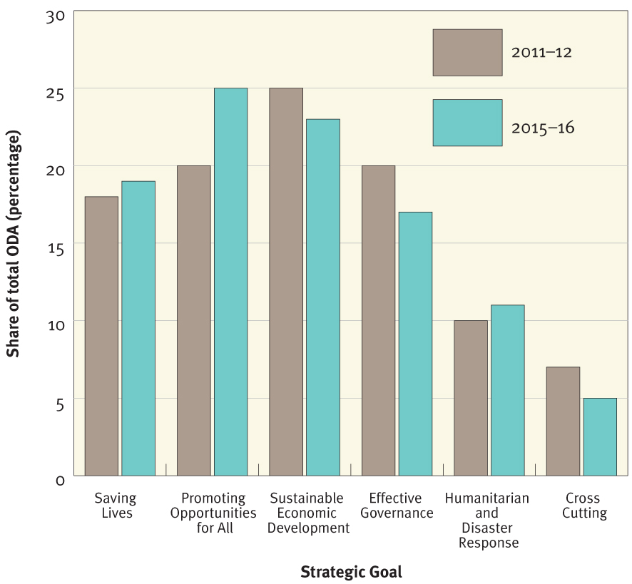

4. Results we will achieve
The four-year budget strategy is aligned to a set of key results to be achieved by 2015–16. These provide a snapshot against which the performance of the aid program will be judged (see Diagram 7).
The Results Framework contains three tiers, as outlined below. It places Australia at the forefront of aid transparency, accountability and predictability, and its implementation will provide a robust evidence base for the next independent external review of the aid program and for annual reports on progress.
Tier 1 Results: Progress against the Millennium Development Goals (MDGs)
Tier 1 results encompass high level development outcomes, such as reduced global poverty and universal primary education. We will report on global progress towards the achievement of the MDGs and how Australian aid contributes to this progress.
Tier 2 Results: The contribution of Australian aid
Tier 2 results articulate the contribution of Australian aid to development outcomes in our partner countries. In line with the strategic goals of the aid program, headline results to be achieved by 2015–16 are identified in Diagram 7. Reporting against the headline results will provide a snapshot of the aid program and act as an indicator of its effectiveness, but other results will also be tracked at a more detailed level within individual programs.
Tier 3 Results: Operational and organisational effectiveness
Effectiveness is the cornerstone of the Government’s aid policy. Building on recent efforts, the CAPF outlines accelerated reforms to ensure the effectiveness of the aid program. In the Results Framework, Tier 3 results measure performance against key operational and organisational effectiveness criteria that were identified in the Strategic Framework for the Australian aid program, outlined in An Effective Aid Program for Australia: Making a real difference—Delivering real results. These results will lead to better value for money and a higher standard of aid delivery. Actions to make the delivery of our aid program more effective and more efficient are described in greater detail in Section 5 which follows.
Box 3: Are the results additional to the ‘hurdles’ stated in the Independent Review of Aid Effectiveness in 2011?
The Results Framework reflects the intent of the ‘hurdles’ outlined in the Independent Review of Aid Effectiveness (Independent Review) but is much more comprehensive. The Independent Review suggested an indicative performance plan for the aid program, with milestones to be met every year from 2010–11 through to 2015–16. The Government has met all of the suggested hurdles for 2010–11 and 2011–12, and those suggested for 2012–13 will also be met. However, the Results Framework shown in Diagram 7 goes much further—it establishes milestones and benchmarks for the effective delivery of aid (Tier 3) and signals the anticipated impact of our aid on the lives of poor people by 2015–16 (Tier 2).

Diagram 7: The Results Framework
Tier 1—Millennium Development Goals
 | Eradicate extreme hunger and poverty |  |  | Achieve universal primary education |  |  | Promote gender equality and empower women |  |  |  | Reduce child mortality
 | Improve maternal health |  |  | Combat HIV/AIDS, malaria and other diseases |  |  | Ensure environmental sustainability |  |  |  | Develop a global partnership for development
Tier 2—Australia’s Five Strategic Goals
Saving lives |  | Promoting opportunities for all |  |  | Sustainable economic development |  |  | Effective governance |  | Humanitarian and disaster preparedness and response
- More than 10 million children will be vaccinated, reducing child deaths and illness  - More than 1 million additional births will be attended by a skilled birth attendant  - More than 8.5 million people will be provided with increased access to safe water and women will be equally represented on water and sanitation management committees  - More than 5 million additional people will have increased access to basic sanitation and 5 million people will have increased knowledge of hygiene practices |  | - 4 million more boys and girls will be enrolled in school with 24,000 classrooms built or upgraded and 1.2 million students provided with financial or nutritional support  - 190,000 teachers and 300,000 school officials will be trained and 12 million textbooks provided, contributing to 20 million boys and girls obtaining a better quality education  - More than 100,000 people will be provided with disability services like prostheses and more than 500,000 boys and girls will attend schools that are more accessible to children with disabilities  - 40,000 women survivors of violence will receive services, including counselling  - At least 17,000 people (at least half of them women) will be awarded tertiary scholarships and return home to assist their countries’ economic development |  |  | - People’s access to services and markets will be improved with 9,600km of roads constructed, rehabilitated or maintained  - 750,000 farmers (at least 40 per cent women) will be able to access new agricultural technologies, resulting in increased crop value of over half a billion dollars  - 2.3 million poor people (at least 50 per cent women) will have increased access to financial services such as loans to start small businesses and 1.4 million poor people will increase their incomes through market development programs  - At least 4.2 million vulnerable women and men and children will be provided with social protection support such as cash transfers or basic nutritional support  - Up to 20 countries will be assisted with adaptation programs to reduce vulnerability to climate change and up to 10 countries will be assisted to minimise carbon emissions through technological and regulatory support as their economies grow |  |  | - Communities will have improved safety with 14,000 law and justice officials trained  - Partner governments will become more effective at providing basic services to the poor with 23 countries supported to improve public financial management, training provided for 17,000 public servants (at least 25 per cent women), and 680 civil society organisations supported to track service provision |  | - 30 million vulnerable people will be provided with life-saving assistance in conflict and crisis situations  - AusAID disaster response will be launched within 48 hours of a request for assistance in anticipated humanitarian crises

Tier 3—Delivering Aid Efficiently and Effectively
A clear strategy | Value for money and consolidation | Risk management and performance oversight | Transparency and results | Involving the Australian community
- Comprehensive Aid Policy Framework developed, incorporating four-year, whole of ODA budget strategy  - Top 20 country strategies updated before the end of 2012  - Thematic policy notes published  - Australian Multilateral Assessment completed and updated annually  - AusAID Mission and Value Statement introduced by June 2012  - Career streams defined in each sector for which AusAID has a Principal Sectoral Specialist as Head of Profession by 2015–16  - Women occupy 40% of leadership roles within AusAID by 2015–16 | - Maintain minimum of 76% of tenders by value open and competitive  - 100% of adviser remuneration will remain within Adviser Remuneration Framework limits  - The number of initiatives will reduce by more than 25% by 2015–16  - The proportion of aid delivered through the systems of our developing country partners is increased by 30% by the end of 2014  - Internal movement of staff between branches reduced to 7.5% per year | - AusAID Fraud Control Plan compliant with Australian Government Fraud Control Guidelines by June 2012  - 100% of suspected fraud reported to the AusAID Chief Auditor within 5 days of discovery by staff or aid delivery partners  - Independent Evaluation Committee established by mid 2012  - At least 95% of the monitorable initiatives to report annually on performance through the quality at implementation mechanism  - At least 75% of initiatives that are given a low quality effectiveness rating are cancelled or improved within two performance cycles | - High level results developed and released publicly in the 2012–13 Budget and assessed each year as part of the Annual Review of Aid Effectiveness  - Transparency Charter released  - All independent evaluations listed in the annual evaluation plan will be published  - Enrolment, transition and completion rates at all levels within the education sector will be disaggregated by gender by 2014 | - 1,000 new volunteers per year by 2015–16  - At least 50 accredited Australian international development NGOs participating in ANCP by 2015–16  - At least 500 Australians on the Australian Civilian Corps register who are screened, trained and ready to deploy overseas  - 100,000 teachers are trained by 2015–16 in the Global Education Program curricula

5. How we will deliver aid effectively
In An Effective Aid Program for Australia: Making a real difference—Delivering real results the Government committed to delivering aid more efficiently and effectively across five areas, to which the Tier 3 results have been aligned.
A clear strategy
A critical element of ensuring aid is delivered effectively is to have clarity of purpose and a clear strategy for implementing concrete programs consistent with that purpose. The fundamental purpose of Australian aid is to help people overcome poverty. The Government has enhanced its forward strategic planning by preparing the four-year budget strategy. This more predictable approach to funding will help poor people by providing partner countries with greater certainty to plan ahead. In return, AusAID and the aid delivery agencies with which it works will be made more accountable for results.
Risk management and performance oversight
The Australian aid program is delivered in many difficult environments where corruption is high—a fact acknowledged by the Australian National Audit Office (ANAO). Some of our partner countries have weak probity systems and rate poorly on international corruption indicators. For example, all 12 of Australia’s top aid recipients rank in the bottom quarter of Transparency International’s Corruption Perceptions Index. Yet these are all countries where our aid is needed most.
In delivering the aid program, risks have to be taken to achieve results but we manage these risks by building safeguards into our designs; monitoring and auditing aid delivery very closely; helping to strengthen systems in developing countries that are weak; and holding to account those who attempt to misdirect our aid for purposes other than for which it was given.
The Australian Government maintains zero tolerance of any fraud in the aid program and has a range of systems in place to mitigate fraud. These control systems have helped the aid program to keep fraud at a minimum. In the 2010–11 year, the estimated potential loss due to fraud was 0.03 per cent of AusAID’s appropriated funds. In dollar terms, this was 30 cents for every $1,000 spent and is much lower than the rates of fraud recorded by many other government agencies, private sector companies, and other donors. Further investments in fraud control will be needed as the aid program grows.
The aid program is also subject to a number of internal and external oversight mechanisms covering financial and program accountability, including by the ANAO. AusAID’s internal system of program performance management has been rated as robust by the ANAO and among donor best practice by the Organisation for Economic Co-operation and Development (OECD).
Transparency
The Government has increased the amount of information available on the aid program in a timely and user-friendly form for the Australian public and is committed to doing more.
In November 2011, the Government announced a new Transparency Charter (‘the Charter’) for the aid program. The Charter commits the aid program to publishing documents and data in a way that is comprehensive, accessible and timely. It commits AusAID to:
- be transparent and open about Australia’s international development programs
- publish detailed information on AusAID’s work—our policies, plans, processes, the results of Australian aid activities and our evaluations—on AusAID’s website to explain where Australia’s money is spent and its impact on reducing poverty
- publish this information in a timely fashion and in a useful and accessible format
- welcome public feedback to help us further improve the effectiveness, efficiency and transparency of the aid program and achieve better value for money
- allow anyone to re-use our information when AusAID is the source, provided AusAID is acknowledged.
The Charter is closely aligned with the International Aid Transparency Initiative (IATI), a global strategy to make information about aid spending easier to find, use and compare. Australia was a founding member of IATI and last year was just the third major donor (after the United Kingdom and the World Bank) to publish data on the IATI registry. Through AusAID and the IATI, those involved in aid programs will be able to better track what aid is being used for and what it is achieving. This stretches from taxpayers in donor countries, to those in developing countries who benefit from aid. Improving transparency helps governments in developing countries to manage aid more effectively. This means each dollar will go as far as possible towards fighting poverty.
Involving the Australian community
Australians have a reputation for ingenuity, know-how and drive. As outlined in An Effective Aid Program for Australia: Making a real difference—Delivering real results, we are making greater use of the talents available in Australia’s non-government sectors, academic and research institutions and business, as well as members of the wider Australian community.
Funds have been committed to double the AusAID-NGO Cooperation Program (ANCP), supporting more Australian non-government organisations to participate in our aid program. With the help of funding received through the ANCP, Australian non-government organisations are working to improve the lives of millions of people in almost 50 countries across Asia, the Pacific, Africa, the Middle East, Latin America and the Caribbean.
The Australian Government is also increasing the number of Australian volunteers to 1,000 a year under the integrated Australian Volunteers for International Development program. The inaugural Consultative Forum with Business will be held later in 2012.
Effectiveness and value for money
In addition to these actions, the Government reaffirmed the centrality of value for money within the aid program in An Effective Aid Program for Australia: Making a real difference—Delivering real results. Value for money is pursued at multiple levels of decision making in the aid program, as shown in Box 4 and Diagram 8.
Box 4: Value for money in the aid program
- At the highest level, this Comprehensive Aid Policy Framework outlines budget allocations across the aid program based on a comparative assessment of poverty, Australia’s national interests, our capacity to make a difference, and current scale and effectiveness. These assessments have been contested and agreed across government and will be updated regularly.
- At the country and regional level, country and regional strategies, developed and agreed across government and in consultation with external stakeholders, such as non-government organisations and partner governments, will determine what budget allocations should be spent on (e.g. health or education, training teachers or building classrooms) and how aid will be delivered (e.g. through partner government systems, multilateral organisations, non-government organisations or managing contractors). For global programs, the Australian Multilateral Assessment will be updated annually to assess the ongoing performance of each major multilateral organisation. The findings of the assessment will inform budget allocations.
- At the strategic goal level, thematic strategies (covering education, health, governance, humanitarian assistance, sustainable economic growth, gender, food security and climate change) provide guidance on which sub-sectors and approaches represent the best returns on investment, whether universally or in particular countries and regions.
- At the initiative or activity level, value for money is explicitly addressed in design, implementation and performance management. Recently strengthened program implementation arrangements, including the findings of the Joint Adviser Review, the establishment of a market-tested Adviser Remuneration Framework and strengthened fraud and risk management arrangements, are also enhancing value for money across the aid program. Ongoing review of procurement and agreement services will also ensure that AusAID’s tender and grant selection processes are always best practice. This includes strengthened fraud clauses in our agreements with multilateral organisations.
- Value for money is also assessed through internal and external review and oversight of the aid program. This includes annual assessments of program performance at the country, regional and global program level. At the initiative level, AusAID’s Quality Reporting System helps ensure we are getting value for money by assessing and rating performance throughout the design, implementation and completion stages. An annual fraud plan and regular audits by the ANAO provide further verification and testing of the aid program’s performance in delivering value for money.

Diagram 8: Driving value for money in the aid program
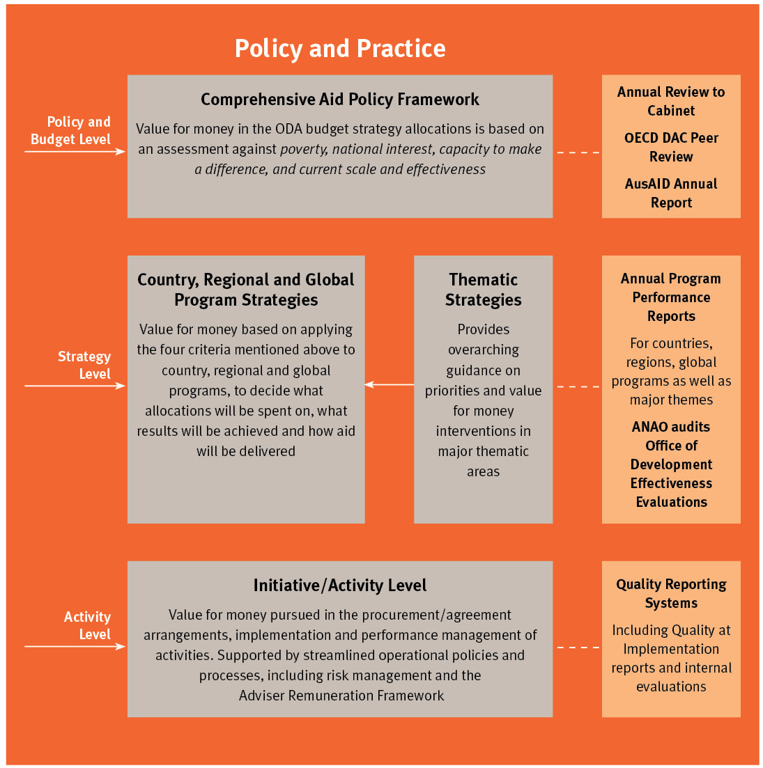

6. Annual Review of Aid Effectiveness
One of the key reforms flowing from the Government’s new aid policy is an Annual Review of Aid Effectiveness (‘the Review’).
Each year, there will be a report to the Cabinet on the performance of the aid program. The Review will encompass the aid spending of all government agencies, not just AusAID.
The Review will judge the performance of our aid program against the headline and organisational effectiveness results contained in Diagram 7. The Annual Review will also recommend any changes to the rolling four-year budget strategy as a result of performance and/or changing circumstances. The first Annual Review is due by the end of October 2012, and will be made publicly available soon after.

Overseas Development Institute, Critical Drivers of Change for Child-Sensitive Development, Report commissioned by Save the Children UK and UNICEF, April 2012.
Based on bilateral aid and imputed spending by multilateral organisations and other global partners.
The Development Effectiveness Steering Committee, or DESC, is chaired by the Director General of AusAID and includes Deputy Secretaries from the Treasury and Departments of Prime Minister and Cabinet, Finance and Deregulation and Foreign Affairs and Trade.
World Bank East Asia and Pacific Economic Update 2010, Volume 1, http://siteresources.worldbank.org.
Note: This does not include AusAID departmental funding.

