The Railway Rehabilitation Project in Cambodia

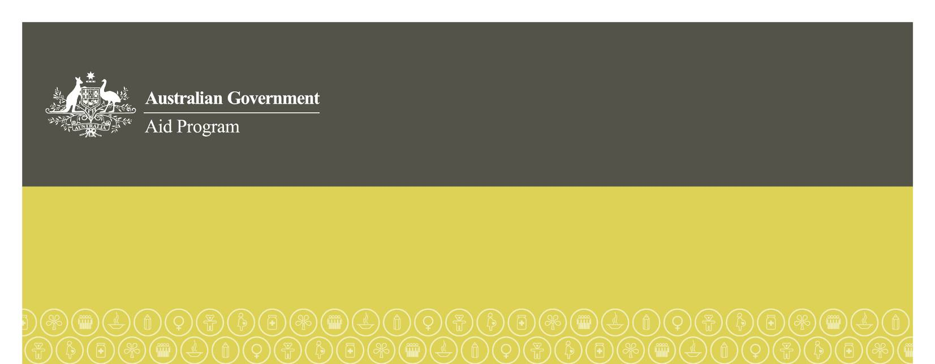

March 2013

### What is the Cambodia Railway Rehabilitation Project?

The Cambodia Railway Rehabilitation Project is a US$143 million project managed by the Asian Development Bank (ADB) in partnership with the Government of Cambodia that will help to rebuild Cambodia’s railways, including stations and terminals, which have deteriorated over many years because of war, neglect and asset stripping. The project will help the poor of Cambodia through increased economic growth and better transport.

The project will see the railway repaired to meet international standards and restore a missing link between Sisaphon and Poipet on the Thai border. The Cambodian railway network consists of two lines: (i) the northern line, which was built in the 1930s and connects Phnom Penh to Poipet on the border with Thailand, and (ii) the southern line, which was built in the late 1960s and connects Phnom Penh with Cambodia’s main seaport in Sihanoukville. To date, approximately 93 per cent or 266 kilometres of the southern line has been rehabilitated, and trains are operating between Phnom Penh and Sihanoukville port.

### What benefits will the Cambodia Railway Rehabilitation Project bring to the people of Cambodia?

The repair and rehabilitation of the railway will enhance the country’s economic growth and help reduce poverty. The project will help all Cambodians by reducing the number of heavy vehicles on the road by up to fifty per cent, leading to:

* fewer road accidents (almost 1,800 people die in Cambodia each year in road accidents and thousands more are injured)
* savings (estimated at over $US1 billion) in road and sea transport costs in the first thirty years of operations (trains require less than 20 per cent of the fuel used by commercial trucks). Typical container transit time between Bangkok and Phnom Penh by sea and road is usually 11 days; this will drop to about 20 hours by rail, resulting in a 67 per cent reduction in costs
* lower CO2 emissions
* savings in road maintenance costs of $39 million (one fully loaded truck causes as much wear and tear on roads as 7,000 passenger cars), and
* removal of dangerous or inflammable cargo from roads to rail.

### What is Australia’s role and contribution to the project?

Australia became involved in this project in 2010. Australia (AusAID) works closely with the ADB to monitor the civil works procurements and to monitor the social, economic and transport benefits of the railway. This includes monitoring the implementation of resettlement, and enhancing the Cambodian Government’s capacity to manage resettlement. The total expenditure by Australia on this project until 2014 will be around AU$27 million, or about 15 per cent of the total cost.

Although the project has made significant progress, construction delays, cost-overruns and resettlement issues have impacted on the project. These issues contributed to the project’s slow progress in meeting its objectives, as assessed by AusAID as part of its internal annual assessments. AusAID subsequently made the decision in September 2012 to change the nature of its involvement in the project to improve its effectiveness.

AusAID is now working with the ADB and the Cambodian Government to address in a targeted manner some of the construction bottlenecks that are causing delays. AusAID’s financial involvement is being restructured to that end. AusAID is also providing up to an additional AU$1 million to help families at the relocation sites, monitoring of the resettlement process, community consultation and help resettled people to earn a living and manage their finances.

*Funding through the Asian Development Bank*

Australia is providing approximately AU$27 million through the ADB amounting to 15  per cent of the US$143 million Railway Rehabilitation Project. This support includes around:

* AU$21 million to support civil works such as purchasing railway sleepers, undertaking earthworks, and building bridges and stations.
* AU$3.4 million to provide training for Cambodian Government staff to work in a new Cambodian rail agency that will manage the railway.
* AU$567,860 to ensure civil works procurements are carried out appropriately and to monitor the resettlement of communities along the railway line to ensure it is conducted in a way that supports communities to re-establish themselves, their families and their livelihoods, according to ADB standards.
* AU$1 million to support relocated communities to improve their income by providing funding for grants that can be accessed in times of need, such as when a family has a health emergency, as well as a revolving community development fund managed by the communities from which families can borrow low-interest loans to invest in their income-generating activities to gain the skills or resources necessary to earn a living after they have been relocated (eg. raising animals, planting food gardens).

In 2012, Australia also committed to provide up to AU$1 million in additional funds to further support families adjust to life after being resettled. These funds will be used to:

* + improve community consultation and monitoring and extend technical advice on resettlement;
  + assist relocated households in their new sites by building community centres and providing small infrastructure works;
  + respond to concerns about financial hardship, such as by providing increased access to financial training, and training and advice on local job opportunities; and
  + help resettled people get affordable health care while they establish themselves in their new locations, particularly in Phnom Penh.

*Other funding by AusAID*

In addition, AusAID will contribute AU$550,000 in program management costs to complete independent monitoring and evaluations of the project and carry out public information activities.

### How is the project being managed?

The Cambodian Government and the ADB signed a loan agreement in May 2007 to provide the financing necessary to rehabilitate the railway. Contracts for the rehabilitation works were signed in 2008, and the railway is expected to be carrying goods to export markets by the end of 2013.

ADB has lead management responsibilities on this project.

### Why is resettlement occurring and how is it being carried out?

Around 4,000 families who live in often squalid conditions near rail tracks will be affected by this project. Around one quarter of these families will need to be relocated or resettled to allow for rehabilitation of the railway track to take place and for trains to run on the line safely. Under the funding agreement with the ADB, the Cambodian Government is responsible for relocating those affected by the project, in line with ADB standards. The core principle of these standards is that no affected person will be worse off as a result of the railway project.

Those people affected by the railway rehabilitation are living on state land and do not have a legal claim to the land on which they live, but this doesn’t bar them from receiving compensation. The project supports all affected people. The Cambodian Government has agreed to provide compensation at replacement cost for the loss of their house (i.e. compensation for the cost of rebuilding the same house), or any of their property (including fruit trees or fences, for example), allowances to help families through the relocation transition and support to restore people’s ability to earn an income. The Cambodian Government has also agreed to provide a plot of land to some affected families, and these families will formally receive land title after living there for five years – a significant benefit for households who were previously landless. Resettled communities have also been provided with access to basic essential services, like safe drinking water and electricity and support to re-train and start small businesses to earn a new living.

Resettlement and compensation is being conducted under the relevant laws and regulations of the Government of Cambodia and ADB policies on involuntary resettlement (1995), indigenous peoples (1998), gender and development (1998), accountability (2003), and public communications (2005).

### What is Australia doing to ensure the resettlement process is fair?

Since becoming involved in the project, AusAID has worked closely with the ADB and the Cambodian Government to monitor resettlement progress. AusAID has also actively raised resettlement concerns through formal representations to ministers and senior officials in the Cambodian Government.

Australia has been closely monitoring implementation of resettlement since late 2010, and our advice has improved the resettlement process. Improvements have included the provision of grievance process training for local officials, the installation of water and electricity at resettlement sites before relocation occurs, and enhanced community consultation.

In addition, when AusAID realised there were shortcomings in the initial income restoration program and that families were experiencing transition problems, we provided an additional AUD 1 million for an expanded income restoration program, which began in November 2011. This expanded program includes a revolving fund which is providing loans to affected households for income generation activities and a social safety net to provide grants to any of the relocated households in times of need—for instance, for people with unforeseen medical expenses. The management of the program is handled by the affected people themselves, through the establishment of self-help groups.

Since July 2012, the expanded income restoration program has transferred the first funds to 13 self-help groups (covering 404 households). This transfer of $281,007 is being used by 208 households as start-up capital for income earning activities, such as moto taxis. Members of the self-help groups also access the funds as grants to cover emergency costs such as healthcare or deaths in the family. So far 100 households have received close to $5,000 in grants.

### Related documents

Report: Economic benefits of trade facilitation in the Greater Mekong Subregion <http://www.thecie.com.au/content/publications/Report_GMS_TTF_3%20August_2010.pdf>

ADB Project Information Document: Greater Mekong Subregion: Rehabilitation of the Railway in Cambodia

<http://www.adb.org/Projects/project.asp?id=37269>

Concept note; environmental and social monitoring reports; grant agreement:  
<http://www.ausaid.gov.au/countries/eastasia/cambodia/Pages/initiative-rehabilitation-railway.aspx>

ADB Railway Project Briefing Sheets:

<http://www.adb.org/projects/37269-013/background>

AusAID webpage: Community resettlement on the Cambodia railway  
http://www.ausaid.gov.au/countries/eastasia/cambodia/Pages/resettlement-cambodia-railway.aspx