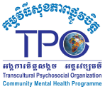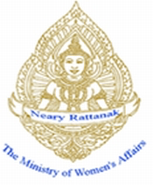

IMPROVING MENTAL HEALTH FOR SURVIVORS OF GENDER BASED VIOLENCE

DFAT Agreement No. 66159

Yearly Report

**Sub-Grantee:** Transcultural Psychosocial Organization Cambodia (TPO)

**Duration of Sub-Grant:** March 1, 2013 – June 31, 2017

**Reporting Period:**  **March 1, 2015 - February 29, 2016**

**Sub-Grant Total Amount: AUD 284,219**

# Description

***What did you do?***

|  |
| --- |
| ***Describe the key activities (including modality) and outputs delivered by the investment. The reporting period should cover the lifetime of the investment. Discuss any changes to the investment’s design over time. Include any extensions which were granted (their period and value).*** |
| Project purposes/objectives/Outputs:  Purpose: To contribute to the promotion of gender equality and improving access to psychosocial service for survivors of gender-based violence (GBV) and sexual assault.    Overall Objectives:   1. To increase capacity of 80 community resource people (CRP) in identifying, managing and referring survivors of GBV and sexual assault. 2. To increase mental health and wellbeing for approximately 450-600 survivors of GBV and sexual assaults 3. To strengthen a support network for survivors of GBV and sexual assault at the community level.   Outputs:   1. Number community resource people (CRPs) trained in basic psychosocial and mental health care. 2. Numbers of cases identified, managed and referred by CRPs. 3. 450-600 survivors of GBV and sexual assault will access to mental health/psychosocial, legal and human rights services. 4. Estimated 60%-70% survivors of GBV and sexual assault improve their physical, psychological functioning, and mutual support. 5. A support network offering psychosocial, physical, legal and human rights assistance for survivors of GBV and sexual assault established and functioned.   Activities:   * Identify, select and train CRPs on mental health after effects, basic psychological issues, GBV, and on psychosocial support services for survivors of GBV and sexual assault(TPO counsellors use selection criteria to select CRPs. * Conduct awareness raising/psycho-education on basic mental health, psychosocial issues, gender, sexual assault, legal and human rights matters to community members, survivors of GBV and sexual assault. * Provide individual counselling to survivors of GBV and sexual assault * Form/Establish Self Help Groups/Group Therapy for survivors of GBV, sexual assault and alcoholics who suffer from mental health and psychosocial problems * Set up a functional support network for survivors of GBV and sexual assault (psychosocial, physical, legal and human rights services)   There is no change in design of the investment and there is no extension period of the investment. |

**II. Results**

***What did you achieve?***

|  |
| --- |
| ***How successful was the investment overall? Did it achieve its objectives and outcomes? Did it deliver on time, on budget and to the extent envisaged in the design?*** |
| The overall investment was implemented successfully. The investment has responded to proposed objectives and outcomes.  The activities and budget are delivered within the timeframe envisaged.  During this report period, TPO has achieved the following results:   * There are 19 community resource people who actively involve in the follow up training and strongly committed with TPO to facilitated Psycho-education, Self Help Group for survivors of GBV and sexual assault. * During this project period, about 93% (N=93) of beneficiaries who were identified by trained CRP have received emotional support and educated by trained community resource people (CRPs). * 50% of beneficiaries (N=33) who received TPO counselling service were identified and referred by trained community resource people * During this report, TPO staff and trained CRPs have facilitated psycho-education/awareness raising to community members. There were about 465 community members participated in this activity (F=367, M=98). * There are 26 survivors of GBV receive individual counselling and on going follow up from TPO ‘ counsellor (Figure 1: present about the result of this intervention) * There are 12 groups of survivors and alcohol abusers (F=67, M=14) receive group therapy from TPO staff on how to manage their anger/stress. In the group treatment, it does allow the survivors to express and share their feeling/experiences in the group.   Figure1: The changes in symptoms of participants who received individual counselling  *(The higher score the more problem, 0= not at all bother, 4= extremely bother)*  Figure2: The changes of symptoms in participants attending self-help group  *(The higher score the more problem, 0= not at all bother, 4= extremely bother)* |

**III. Lessons Learnt**

***What lessons did you learn?***

|  |
| --- |
| ***Summarise the lessons learnt from this investment and key recommendations for future investments.*** |
| 1. During this reporting period, project staff noticed that good relationship with local government is built through actively participated in regular meeting with CCWC at the district level. As the result of this strong relationship, it create a safe space for the trained CRPs or outstanding SHG members to participate in the meeting with government staff to share about the concern related to violence, mental health. 2. Spending more time to provide coaching to CRPs, which support CRPs to build their confident and become more active in helping survivors of GBV. 3. CRPs should be selected from amongst CCWC members because they can share/inform the other CCWC to understand about the mental health, and they are able to deal with women and girl more professional in term of case counselling. |

**IV. Success Stories, Photos or Comments**

It is not required to write something here; however, if a relevant piece of information was not discussed in the previous sections include it here. **ONLY IF IT DOES NOT COMPROMISE CONFIDENTIALITY OR SAFETY**, please include a few photographs taken of project activities during this reporting period.

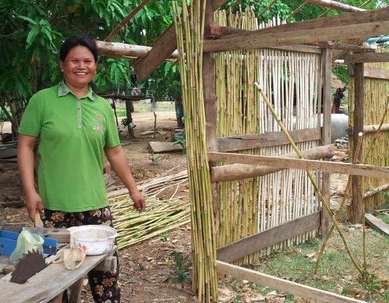From Victim to Community Leader

*My name is HAT Hang. I am 34 years old, a mother of three and I’m a farmer. I live in Banan district, Battambang province. Before receiving psychological support from TPO Cambodia, my family experienced domestic violence at the hands of my husband. First, we were happy, but over time, my husband started drinking heavily. We had to sell all our belongings because of his gambling and he never took care of the family. Domestic violence, fighting and insults happened almost daily our family, and this had an adverse and profound impact on me, causing psychological problems for year.*

*When TPO Cambodia started working in Banan district thanks to funding from DFAT, they interviewed me to get a better understanding of my problems. They found that my psychological problems were caused by the ongoing domestic violence* *and they encouraged me to participate in a self-help group to get support and learn to deal with the problems. I got better through the self-help group. This made me want to help other women experiencing similar problems.*

*After participating in the self-help group, I was selected by TPO Cambodia to be further trained by them in mental health so that I would be able to help other victims of domestic violence in my community. I felt really encouraged by TPO and the other women in the self-help group to do that. During the training, and by participating in the self-help group, I learnt a lot about mental health and developed coping skills and techniques. For example, I learnt about relaxation techniques, anger management, psycho-education and parenting. I also learnt to better understand gender issues. I have used those new skills and knowledge to help my husband drink less, not gamble and stop the domestic violence. It has helped me share my feelings with him and to better understand him and how we can better relate to each other and other people. With TPO’s support I have gained a lot of confidence, which has helped me talk with my husband and find solutions together with him. My husband has changed.*

*In June 2015, I have trained on chicken raising which was organized by TPO and I received $150 from TPO under funding of Friend International to build chicken cage and buy chickens. From this support, I have applied chicken raising techniques. As the result, I have many healthy chicken and I sold it two times. I am much happy that I have increased my income and with a support of my husband. Now we are building a bigger house and our children go to school regularly. Our family is happy now.*

*Thanks to the training I am now educating others on mental health and the causes of their problems. And I teach them coping skills. I’ve been helping others experiencing domestic violence and I have achieved good results. As a consequence, the community started to recognize and value me as a community resource person – this is someone from the community who is able to help other community members. These days, members of the community seek me out. They come to my house to share their problems with me and seek help. Also in 2014, I was appointed as the vice-village chief because of my accomplishments in helping people in the village. The local authorities decided this on the basis of my hard work, my commitment to helping the community and the courage I’d shown in raising issues with the authorities and reporting to them about the needs of the villagers and the mental health issues they experience. I now also meet on a monthly basis with the Commune Council for Women and Children where I report about the state of the mental health of the people in my community and related problems they are experiencing.*

*In the future, I’d like to do more awareness raising about mental health and psychosocial issues in schools – for teachers and students – and with local authorities. During meetings at the commune or district level, I can discuss and raise awareness about mental health, but also work with the authorities on preventing issues such as domestic violence in the community. I really want to support my community, and restore the dignity of my people in the villages so that they can be happy and healthy, get proper jobs, increase their incomes, send their children to school and no longer experience domestic violence.*

**V. Australian Government Promotion**

TPO continue to promote the visibility of the Australian government fund through the inclusion of Australian Government logo on the cover of booklets, leaflets, T-shirt, banner for running the workshop and training to relevant stakeholders such government staff, NGO partners and community resource person.

Beside that TPO HQ has included the Australian Government logo on the donor board and TPO is going to publish the annual report with the Australian Government logo.

At the end of psycho-education session as well as other community activity, TPO staff always mentions that this project is made possible through the generous donation from the people of Australia.

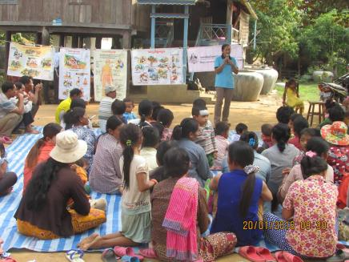 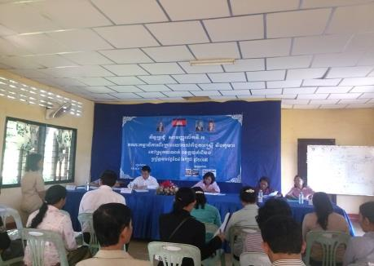

*Figure I: TPO staff conducted Psycho-education in community Figure 1: Commune Committee for women and children meeting*