



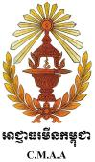



**Annual Project Report** 2013

Clearing for Results | Phase II







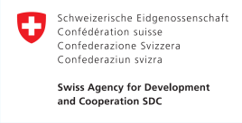



**Project ID & Title**





Clearing for Results II

– Annual Project Report 2013 | 2

00076990

(Clearing for Results II)

**Duration**

1/1/2011--‐31/12/2015

**Total Budget**

US$ 25,720,359

**Implementing Partner** Cambodian Mine Action and Victims Assistance Authority (CMAA)

**Country Programme Outcome** National and sub-national capacities strengthened to develop more diversified, sustainable and equitable economy.

*Thirty-year old Chea Phearin from Kouk Roka village in Battambang province tends to her crops grown on land that was cleared of landmines through the Clearing for Results II project.*

*©CMAA*

**Contents**

Acronyms ................................................................................................................................................ 4

Executive Summary................................................................................................................................. 5

I. Implementation Progress................................................................................................................ 7

CFR II Mid-Term Review .................................................................................................................. 7

II. Progress Toward Country Programme Action Plan (CPAP) Output .............................................. 14

III. Progress Toward CPAP Outcome .................................................................................................. 15

*Capacity Development* .................................................................................................................. 15

*Gender*........................................................................................................................................... 15

*Communications and Public Relations* .......................................................................................... 16

*Monitoring and Evaluation* ........................................................................................................... 17

IV. Project Implementation Challenges .............................................................................................. 18

V. Financial Status and Utilization ..................................................................................................... 20

Table 1: Contribution Overview .................................................................................................... 20

Table 2: Annual Expenditure by Activities .................................................................................... 21

Annex .................................................................................................................................................... 23

**Acronyms**

|  |  |
| --- | --- |
| **APMs** | Anti-Personnel Mine |
| **APBMC** | Anti-Personnel Mine Ban Convention |
| **ATMs** | Anti-Tank Mines |
| **CFR II** | Clearing for Results II |
| **CIDA** | Canadian International Development Agency |
| **CMAA** | Cambodian Mine Action and Victims Assistance Authority |
| **CMAS** | Cambodia Mine Action Standards |
| **CMDG 9** | Cambodia Millennium Development Goals 9 |
| **CMVIS** | Cambodia Mine/UXO Victim Information System |
| **CPAP** | Country Programme Action Plan |
| **CDRI** | Cambodian Development Research Institute |
| **EDDs** | Explosive Detection Dogs |
| **ERWs** | Explosive Remnants of War |
| **GICHD** | Geneva International Center for Humanitarian Demining |
| **GIS** | Geographic Information System |
| **IMSMA** | Information Management System for Mine Action |
| **MAPU** | Mine Action Planning Unit |
| **MDDs** | Mine Detection Dogs |
| **MRE** | Mine Risk Education |
| **MTR** | Mid-Term Review |
| **NIM** | National Implementation Modality |
| **NIS** | National Institute of Statistics |
| **NMAS** | National Mine Action Strategy |
| **NPMEC** | National Center for Peacekeeping Forces, Mines and ERW Clearance |
| **NSDP** | National Strategic Development Plan |
| **PCM** | Post-Clearance Monitoring |
| **PWDs** | People with Disabilities |
| **QM** | Quality Management |
| **SDC** | Swiss Agency for Development and Cooperation |
| **TWG-MA** | Technical Working Group in Mine Action |
| **UNDP** | United Nations Development Programme |
| **UNV** | United Nations Volunteer |

Clearing for Results II – Annual Project Report 2013 | 4

**Executive Summary**

2013 is the halfway part of the Clearing for Results II (CFR II) with combined activities from the previous year, such as mine clearance and capacity development, as well as significant initiatives such as the project Mid-Term Review (MTR). The MTR was key in ensuring that the Cambodian Mine Action and Victims Assistance Authority (CMAA), as the lead national implementer of CFR II, maintained its ownership while aligning resources with priority areas and further strengthening its capacity to promote a programme-based approach in the mine action sector.

Based on recommendations from the Mid-Term Review, funds were reallocated to Deliverable 3, i.e., clearance contracts, decreasing the budget items in Deliverables 1 and 2. Through competitive bidding, three contracts were issued with a total amount of US$ 3.7 million for mine clearance in Battambang and Banteay Meanchey, awarded to the Cambodian Mine Action Center (CMAC), and in Pailin through a contract awarded to the National Center for Peacekeeping Forces, Mines and ERW Clearance (NPMEC). All deliverables were on track during the year (February to December 2013, with remaining contractual activities ending in January 2014). Some 17,331,094 m2 of land in the three provinces were cleared/released, with a 67% reduction in the number of reported mine casualties in the three target provinces.

In Q3, the project gained a new development partner through the Swiss Agency for Development and Cooperation (SDC) which contributed US$ 3 million to CFR II for 2013-2015. This allowed the Project Management Team to increase the volume of clearance contracts by almost 20% covering activities from September to January 2014, as well as use some amount for Deliverables 1 and 2. AusAid also signed an agreement with UNDP for an additional AUD 4 million in Q4.

CMAA continued to play a key role in leading the implementation of the National Mine Action Strategy (NMAS) through the Technical Working Group on Mine Action (TWG-MA), which held meetings with provincial department representatives, and promoted the programme-based approach in the mine action sector. Similarly, CMAA through the CFR II project, led the preparation for the mine action segment of the National Strategic Development Plan (NSDP), ensuring that resources allocated through the sector supported national development priorities.

Through CFR II, CMAA further developed its capacity in carrying out its mandate and in managing the project. Particularly, staff enhanced their knowledge and skills in financial management, procurement and human resources management with help from a national consultant. Additionally, UNDP provided training to selected CMAA staff on its Corporate National Implementation Modality (NIM), project cycle and rules and regulations in the aforementioned business processes.

CFR II faced challenges during the year, including budget shortfall, budget revisions, review of the bidding process for clearance contracts issued from 2011-2013, and resignation of two international staff from the advisory team. Budgetary issues were addressed as successful resource mobilization resulted in new contribution from the SDC and additional funds from AusAid. Budget realignment gave greater focus on demining activities. The procurement process of demining contracts for 2014 and 2015 need a continuing discussion and agreement by UNDP and CMAA, to be presented at the

Board meeting in early 2014. Finally, gaps in the advisory team were filled later in the year with the hiring and deployment of the new Mine Action Advisor and the UNV Project and Communications Specialist.

Total funds utilization in 2013 amounted to US$ 4.6 million, of which US$ 3.7 million were utilized for clearance contracts (Deliverable 3), US$ 404,198 for Deliverable 1, and US$ 507,672 for Deliverable 2, with an overall 97% delivery rate and a project budget balance of US$ 123,789 in

2013.

In Q4, the total project budget requirement of US$ 24.5 million was exceeded and amounted to US$

25.7 million, thanks to the additional contributions from SDC and AusAid.

**I. Implementation Progress**

**UNDAF OUTCOME: By 2015, more people living in Cambodia benefit from, and participate in, increasingly equitable, green, diversified economic growth.**

**EXPECTED COUNTRY PROGRAM OUTCOME: National and sub-national capacities strengthened to develop more diversified, sustainable and equitable economy.**

**OUTPUT: National structures and mechanisms ensure demining resources are effectively allocated promoting the release of land for productive use by the poor.**

On 17 January 2013, the first Project Board meeting was held under the chairmanship of the CMAA Vice President with representatives from development partners including the Canadian International Development Agency (CIDA), AusAid and UNDP. Participants were briefed on the implementation results of the CFR II 2012 work plan and the 2013-2014 work plan was presented. The second Project Board meeting was held virtually in Q3 to present budget revisions.

In October 2013, AusAid signed an amendment to a cost-sharing agreement with UNDP to contribute an additional AUD 4 million. In November 2013, the SDC contributed US$ 3 million to the CFR II project for 2013-2015. These funds were mostly allocated to activities under Deliverable 3.

**CFR II Mid-Term Review**

In 2013, a Mid-Term Review was conducted to assess the project’s progress and to highlight any risks to the full achievement of the project’s outputs and overall outcome. Each of the project’s key deliverables were analyzed to determine its contribution to the project output, within the context of the deliverable’s relevance, effectiveness, efficiency, impact and sustainability.

Among the management response for the CFR II review include the need for: 1) CMAA to develop an annual clearance plan and an annual mine action plan for 2014; 2) a more efficient way of data collection through the Information Management System for Mine Action (IMSMA) as well as in monitoring and data consistency; 3) measures for budgetary shortfalls; 4) close monitoring of the implementation of the Gender Mainstreaming in Mine Action Plan; 5) a new coordinating and planning process; 5) a visible strategy for each of the CFR II donors; 6) revision of some project outputs to reflect the target outcomes; and 7) strategic analysis of the coordination framework and the current approach to the mine action sector.

Some of the review recommendations were addressed by the CMAA in 2013, as detailed in the succeeding pages.

**Key Deliverable 1: Mine action policy and strategic frameworks ensure most resources are effectively allocated onto national priorities as defined by local planning processes, and maximize the land available for local development.**

|  |  |  |  |
| --- | --- | --- | --- |
| **Output Indicators** | **Baseline** | **Target** | **Current Status** |
| Land cleared1 annually  through MAPU planning  used for agriculture | 50% (2009) | 70% (2011) | 76% (according to clearance work plans of the three contracts awarded  in 2013, 75.61% of the released land would be used for agriculture.) |
| Percentage of funding for  mine action that is endorsed by CMAA2 | 0% (2010) | 80% (2015) | 20% |
| Capacity3 of the CMAA to  lead the implementation of the NMAS annually | 0 point  (2009) | 5 points  (2015) | 1 point – The Gender Action Plan was  endorsed and implemented in 2013. |
| **Annual Expenditure 2013** | **US$ 404,198** | | |

1.1. During the year, the project hired a consultant to develop a National Strategic Plan (NSP) for Mine Action in Cambodia. The NSP sets out an overview of concepts for understanding, implementation methodologies, and calculations of the resources required to meet the targets as set out in the National Mine Action Strategy (NMAS). CMAA will share the draft NSP with stakeholders for their review and comments within the first quarter of 2014.

1.2. In 2012, the Cambodian Development Research Institute (CDRI) was commissioned to develop a methodology to assess the outcome of mine clearance. Such an assessment would help the CMAA to better understand the development outcomes and contributions towards the NMAS and Cambodia Millennium Development Goals (CMDGs). It would also help improve planning and prioritization process of mine clearance. In 2013, the National Institute for Statistics was commissioned to collect household baseline survey data based on the methodology proposed by CDRI. A local consultant had been hired to interpret the data gathered. Key findings showed that socio-economic situation in villages without mine clearance interventions seemed to lag behind those in the intervened villages. Baseline indicators include land price, poverty headcount ratio, income per capita, and wealth index. An initial draft of the report was submitted to the CMAA and UNDP for comments. The final report is due for submission and approval in the first quarter of 2014. The study serves as a source of baseline data; a follow-up survey may be conducted in

2015 or 2016 when the outcome of mine clearance can be determined.

1.3. The Technical Working Group for Mine Action (TWG-MA) finalized its work plan in Q2 and held a number of meetings to raise awareness on the programme-based approach in the mine action sector. These meetings were instrumental for the CMAA in promoting its role in implementing the NMAS and providing a better understanding of the NMAS. By year’s end, the TWG-MA

reached 486 participants from relevant provincial departments in 14 mine-affected provinces.

1 Based on socio-economic monitoring data. Indicator to be refined to reflect contribution to poverty reduction and economic growth

based on Impact Assessment methodology and UNDP’s forthcoming Local Economic Development strategy.

2

% of total funding for the mine action sector in 2013 which is US$ 25,378,881, endorsed by the CMAA through Clearing for Results II

3

NMAS annual work plans (2 points) + progress reports (2 points) + NMAS integrated gender-sensitive M&E system in place and endorsed

by TWG during Year 1 and sustained during Year 2--‐5 (1 point)

However, the TWG-MA was not able to meet during the year as planned and postponed the bi- annual meeting to early 2014.

1.4. The CMAA participated in several national and international meetings in 2013 where it discussed issues in the mine action sector. In January, the CMAA Deputy Secretary General, who is also the Project Manager of the CFR II and in his capacity as IMAS Review Board member, participated in the International Mine Action Standards (IMAS) Workshop on Land Release IMAS Series in Geneva. In May, it reported on the mine clearing along the Cambodian-Thai border at the Anti- Personnel Mine Ban Convention (APBMC) Standing Committee. CMAA also shared its Article 5 implementation and the Cartagena Action Plan on victims assistance. Further, CMAA Deputy Secretary General, who also heads the TWG-MA Secretariat, participated in the 4th ASEAN Regional Mine Action Centre workshop where a working group level between CMAA and the Ministry of Foreign Affairs and International Cooperation was established.

1.5. The CMAA also attended meetings to raise funds from international donors through the International Mine Action Strategy (IMAS) Review Board meeting and the UN National Directors’ Meeting, both held in Geneva in April. The Secretary General and the Deputy Secretary General also represented CMAA in the 13MSP Meeting on APMBC in Geneva. At the 4th Meeting of State Parties to the Convention on Cluster Munitions held in Lusaka, Zambia, CMAA represented Cambodia as observer state where it promoted its work, the signing of the Partnership Principles and to raise funds. Lastly, the Socio-Economic and Planning Department (SEPD) held a meeting in Sihanouk Ville to review policy and operational guidelines on socio-economic management of mine clearance operation as well as to integrate gender, victims assistance and mine risk education (MRE) activities in the guidelines. Officials from MAPUs, demining operations, CMVIS and staff from the Provincial Department of Planning attended the meeting.

1.6. The CMAA led the preparations of the mine action segment of the National Strategic Development Plan (NSDP) 2014-18 and the Cambodia Millennium Development Goals (CMDG) 9 in cooperation with all mine action stakeholders. Both documents were approved by the CMAA management and submitted to the Ministry of Planning.

1.7. The CMAA through its Victims Assistance (VA) Department conducted field visits to update data from the Quality of Life Survey of mine/ERW survivors. The survey results were disseminated through a workshop in Preah Vihar province where 65 individuals from relevant provincial departments, victims assistance operators, commune councilors, survivors’ networks and people with disabilities (PWDs) participated in. In addition, VA participated in meetings on the Convention on the Rights of People with Disabilities (CRPD) to develop CMAA’s relevant capacities in implementing articles under the CRPD.

**Key Deliverable 2: The CMAA is equipped with the technical and functional capacities required to manage, regulate, coordinate and monitor the sector within an evolving environment.**

|  |  |  |  |
| --- | --- | --- | --- |
| **Output Indicators** | **Baseline** | **Target** | **Current Status** |
| % of beneficiaries from  mine clearance that are women and PWD | 48% women and  0.3% PWD (2010) | 54% women (2015)  and 4% PWD | 50% women (38,076 individuals)  15% PWDs (1,064 individuals)  *Based on Post-Clearance Monitoring data in 2012-2103, direct and indirect beneficiaries* |
| % of annual tasks  conducted in accordance with the MAPU work plan | 45% (2009) | 90% (2015) | 91% of clearance from January to  November 2013 was according to MAPU work plan of the 8 western provinces |
| **Annual Expenditure 2013** | **US$ 507,672** | | |

2.1. Early in the year, an independent review of the bidding process on mine clearance contracts awarded in 2011-2013 was conducted by the Geneva International Center for Humanitarian Demining (GICHD). The review aimed to determine the cost-efficiency of the bidding process as well as identify its limitations and challenges. The review showed that while CMAA had successfully established the market price for land release in Cambodia, only two operators were able to offer services at this price. Since the operators have not bid against each other since

2012, the competitive element of the process was absent. Further discussions on this between

CMAA and UNDP will have to take place and presented at the Board meeting in 2014.

2.2. The CMAA continued implementing its Capacity Development Plan under CFR II despite budget reductions in 2013. UNDP conducted a two-day orientation workshop on UNDP’s Corporate National Implementation Modality (NIM) Guidelines which three CMAA staff attended. UNDP discussed program and project cycle management as well as rules and regulations applicable to human resource management, procurement and financial management. Additionally, 35 CMAA staff enrolled in Q1 in an English language proficiency course. Some 23 staff passed the exam, out of which four dropped out either due to low scores or declining commitment. By Q4, 19 staff remained enrolled during the second term. Also in Q4, the Council of Ministers committed funds to CMAA’s capacity development for cooperation with government counterparts in Cambodia, Laos, Myanmar and Vietnam. Thereafter, CMAA developed concept notes which were sent to the Ministry of Foreign Affairs and International Cooperation for consideration. CMAA would have to compete with other ministries based on concept notes submitted. CMAA is awaiting the status of this.

The CMAA staff further developed their skills in managing contracts for demining services, particularly on financial management, procurement and human resources with support from a national consultant. Also, nine CMAA staff from the Regulation and Monitoring Department joined a two-week refresher training on Mine Detection Dogs (MDD)/Explosive Detection Dogs (EDD) conducted by CMAC. Thirteen quality management (QM) staff attended an advanced course in Explosive Ordnance Disposal organized by US military experts in Kampong Speu province. Quality assurance/quality control teams received training on QM and Geographic

Information System (GIS) for **I**MSMA and a refresher training course on land release and IMSMA. It is envisaged that both teams will be integrated into QM teams to increase their operational effectiveness and efficiency. Finally, to enhance performance management systems within the CMAA as well as in CFR II, the Internal Control Procedures was issued in Q3.

2.3. The CMAA organized a two-day Technical Reference Group meeting in Siem Reap which provided operators and stakeholders an opportunity to discuss technical challenges and to explore practical solutions. Among the challenges identified include clearance operations, planning and working procedures and database management. The CMAA and operators agreed on solutions to key issues, after which guidelines and comments were shared. Operators agreed to closely track results following the meeting.

2.4. The Policy and Operational Guidelines on Socio-Economic Management of Mine Clearance Operation (known as planning guidelines) was reviewed and updated by the CMAA**.** The guidelines were revised according to comments and feedback from MAPUs, demining operators and provincial planning departments. The revised guidelines reflect clearer roles and responsibilities of institutions involved in sub-national planning. These are being translated into English.

2.5. The Cambodian Mine Action Standards (CMAS) review committee meeting was held again after a long hiatus. All operators accepted the terms of reference of the committee and the next meeting plan.

**Key Deliverable 3: At least 35 km2 of contaminated land mapped through baseline survey, cleared and released for productive use**

|  |  |  |  |
| --- | --- | --- | --- |
| **Output Indicators** | **Baseline**  **(month/year)** | **Target**  **(month/year)** | **Current Status**  **(month/year)** |
| Million square meters  cleared using CFR II  resources | 37 (2010) | 72 (2015) | **17,331,094 m2** of land released from  February to December 2013 using CFR II resources in the three target provinces  **42,694,329 m2** total land area released from 2011-2013 |
| Reduction in the number  of landmine casualties in Battambang, Banteay Meanchey and Pailin | 8% (2010) | 10% (per year) | 67% reduction in reported landmine  casualties from 39 in 2012 to 13 in  2013 |
| **Annual Expenditure 2013** | **US$ 3,727,1734** | | |

3.1. A total of US$ 3,470,733 worth of mine clearance contracts were awarded in 2013, based on casualty rates in the last five years as the main criteria. The total amount includes the 20% increase in the volume of contracts, due to the recent contribution from SDC. The increase in

budget allocation, contained in the contract amendments, allowed the operators to increase the

4 Total amount of clearance contracts issued in 2013 + GMS 7% + final payment for 2012 contracts

total output (number of square meters cleared/released) within the same contract period from

February 2013 to January 2014.

The increases account for:

• Battambang – US$ 278,560 to clear an additional 1,673,836 m2 land

• Banteay Meanchey – US$ 188,1970 to clear an additional 1,015,958 m2 land

• Pailin – US$ 106,084 to clear an additional 518,566 m2 land

It should be noted that clearance contracts awarded in 2013 cover planned activities from February 2013 to January 2014. This Annual Project Report only reports activities accomplished until December 2013. The remaining activities will be reported in the 2014 Annual Project Report.

3.2. The result of these contracts showed a total of 17.3 km2 of land released in the three provinces in 2013. Based on work plans under the contracts, the land released in 2013 is planned5 for agriculture (75.61%), risk reduction (22.87%), housing (0.92%) and schools (0.6%). The released land allotted for agriculture and housing is projected to directly benefit 539 families or 2,241 individuals6, of whom 1,252 are females. Also, around 23,922 families or 90,651 individuals (46,881 females and 250 students) are seen to benefit indirectly from the released land allotted for risk reduction and building schools.

***Table 1. Summary of Contracts Issued for Land Clearing in 2013***

|  |  |  |  |  |  |  |
| --- | --- | --- | --- | --- | --- | --- |
| **Operator** | **Total**  **Contract Amount (US$)** | **Actual land**  **area released**  **(m2) (Feb-Dec**  **2013)** | **No. of**  **Villages demined** | **No. of**  **APMs removed** | **No. of**  **ATMs removed** | **No. of**  **ERWs destroyed** |
| **CMAC\*** |  |  |  |  |  |  |
| Battambang | 1,678,276 | 8,840,308 | 12 | 995 | 4 | 1,050 |
| Banteay Meanchey | 1,138,848 | 5,516,421 | 19 | 569 | 3 | 370 |
| *Sub-total* | *2,817,124* | *14,356,729* | *31* | *1,564* | *7* | *1,420* |
| **NPMEC\*\*** |  |  |  |  |  |  |
| Pailin | 653,609 | 2,974,365 | 18 | 842 | 4 | 671 |
| **TOTAL** | **3,470,733** | **17,331,094** | **49** | **2,406** | **11** | **2,091** |

*\* Contracts duration: 01 Feb 2013 – 31 Jan 2014*

*\*\* Contract duration: 28 Feb 2013 – 31 Jan 2014*

5

Released land are planned by MAPUs for various uses based on consultations with communities and MAPU verification.

6

Total no. of individuals based on estimates provided by village chiefs, community members and through MAPU verification

3.3. The number of reported landmine casualties in the three target provinces dropped by 67% compared to the previous year. Reported casualties from both landmine and ERWs in the three provinces also decreased by half or about 27 casualties in 2013. In all 24 provinces in Cambodia, CMAA reported a continuing decline in mine/ERW casualties, with a 40% drop in 2013, 11% in

2012, and 26% in 2011.

3.4. From 2012-2013, post-clearance monitoring was conducted on 10 million m2 land cleared in

2011 through CFR II. The following chart shows the actual use of these lands:

**Actual Land Use Released in 2011 (%)**

Other purposes, 7.1

Pagodas, 1.2

Irrigation, 1.5

Housing, 2.3

Schools construction and expansion, 2.3

Roads, 6.0

Agriculture, 79.8

3.5. The clearance benefited 18,971 families consisting of 76,198 individuals, of which 38,076 are females. Among the 76,198 individuals, 1,064 are people with disabilities. The clearance also benefited 602 students. Among 18,971 families, 1,558 families are headed by women.

3.6. All clearance and survey contracts awarded in 2012 were successfully and timely completed as planned on 31 January 2013, the total contract amount of which was US$ 3,462,221. These included clearance projects awarded to CMAC working in Battambang and Banteay Meanchey with a total amount of US$ 2,299,672; and a clearance project awarded to the NPMEC in Pailin, amounting to US$ 583,362.

**II. Progress Toward Country Programme Action Plan (CPAP) Output**

|  |  |  |  |
| --- | --- | --- | --- |
| **Output 1.2: National structures and mechanisms ensure demining resources are effectively allocated**  **promoting the release of land for productive use by the poor.** | | | |
| **Output Indicators** | **Baseline**  **(month/year)** | **Target**  **(month/year)** | **Current status**  **(December 2013)** |
| Capacity7 of the CMAA to  lead the implementation of the NMAS annually | 0 point (2009) | 5 points (2015) | 1 point – The Gender Action Plan was  endorsed and implemented in 2013 |
| % of annual tasks  conducted in accordance with the MAPU work plan | 45% (2009) | 90% (2015) | 91% of clearance from January to  November 2013 was according to MAPU work plan of the 8 western provinces |
| Percentage of funding for  mine action that is endorsed by CMAA8 | 0% (2010) | 80% (2015) | 20% |
| Reduction in the number  of landmine casualties in Battambang, Banteay Meanchey and Pailin | 8% (2010) | 10% (per year) | 67% (reduction in casualties from 39  in 2012 to 13 in 2013) |

Project progress made in 2013 has contributed to the CPAP output, showing that the CMAA has continued to take the lead in ensuring that resources allocated for the project promoted land release, as evidenced by the increase in volume contracts for land clearing and the subsequent increase in land area cleared. It led the implementation of the NMAS by engaging with MAPUs, whose work plans showed a high percentage of clearance tasks achieved.

While, the CMAA continued to promote the programme-based approach for implementing NMAS during the year, it has yet to finalize its annual work plans and produce the 2013 progress report. On the other hand, the CMAA made headway in endorsing the Gender Action Plan (GAP) and continued to conduct training for MAPUs on gender mainstreaming in the sector, ensuring that the GAP implementation remained on track until its completion and evaluation in 2015.

The CMAA also reported a 67% reduction in reported landmine casualties in the three provinces, with 13 in 2013 compared to 2012’s 39 casualties. An overall declining trend in reported mine/ERW

casualties in all provinces in Cambodia was also reported: 211 in 2011; 186 in 2012; and 111 in 2013.

7 NMAS annual work plans (2 points) + progress reports (2 points) + NMAS integrated gender-sensitive M&E system in place and endorsed by TWG during Year 1 and sustained during Year 2--‐5 (1 point)

8

% of total funding for the mine action sector in 2013 which is US$ 25,378,881, endorsed by the CMAA through Clearing for Results II

**III. Progress Toward CPAP Outcome**

**Outcome 1: By 2015, national and sub-national capacities strengthened to develop more**

**diversified, sustainable and equitable economy.**

|  |  |  |  |
| --- | --- | --- | --- |
| **Outcome Indicators** | **Baseline**  **(month/year)** | **Target**  **(month/year)** | **Current status**  **(December 2013)** |
| NSDP 2014-2018 includes  new priorities and targets for inclusive growth | No  (2010) | Yes  (2014) | CMAA led the preparations of the mine  action segment of the NSDP 2014-18 which was approved by the CMAA management and submitted to the Ministry of Planning. |
| % of land cleared from  mines annually through local planning process used for agriculture9 | 50%  (2009) | 70% | 76% (according to clearance work plans  of the three contracts awarded in 2013,  75.61% of the released land would be used for agriculture.) |
| No. of countries that benefit  from Cambodia expertise on demining | 4  (2009) | 10  (2015) | 6 countries in 2013:  Vietnam, Myanmar, Lebanon, Libya, Lao PDR, Afghanistan  *21 countries total from 2009-2013* |

***Capacity Development***

Following the Mid-Term Review, the CMAA revised its project budget to re-align more resources to Deliverable 3, thus decreasing the budgets for the two other deliverables. Despite this, the Capacity Development Plan which began in 2011 continued in 2013 as detailed under Key Deliverable 2. This partially ensured that CMAA’s capacity in managing contracts and project resources were continuously enhanced.

***Gender***

In 2012, the CMAA established a gender team and appointed a gender focal person to oversee the implementation of the Gender Mainstreaming in Mine Action Plan (GAP) 2013-2015. In January

2013, the CMAA finalized and endorsed the GAP.

According to a baseline survey conducted by CMAA in 2012 to aid GAP implementation, interviewees cited an increasing number of women in clearance work although the number of female participants in commune, district and provincial meetings and the number of women in clearance teams remains low compared to the number of participating men. However, most operators had begun advertising job announcements for MRE trainer wherein women were being encouraged to apply. It was also observed that women had been attending MRE activities, a good

indication of increasing awareness on gender equality.

9 Based on socio-economic monitoring data. Indicator to be refined to reflect contribution to poverty reduction and economic growth based on Impact Assessment methodology and UNDP’s forthcoming Local Economic Development Strategy.

On the other hand, it was found out that women’s participation in advocacy activities at the national and sub-national levels in the mine action sector remains low. Collaborative work is needed to encourage equal participation and representation.

In response, the CMAA conducted five field missions in 2013 in mine-affected provinces to learn how provincial units of the Department of Women’s Affairs had been mainstreaming gender equality in various communities. In addition, the CMAA interviewed female deminers and dog handlers about their working conditions.

To aid the GAP implementation by reaching wider audiences, 600 copies of the GAP handbook were printed in both Khmer and English and distributed to mine action operators, MAPUs and to participants in the National Mine Action Conference held in April 2013. CMAA also held a Gender Technical Reference Group meeting to endorse results of the 2012 baseline survey, and shared the gaps that need to be addressed to ensure that GAP implementation is on track.

In 2014, CMAA plans to conduct awareness training in Q2 for MAPUs from eastern and western provinces, as well as a year-end workshop to discuss issues, challenges and ways to improve the implementation of the GAP.

***Communications and Public Relations***

Three quarterly issues of the CMAA newsletter were produced and distributed to relevant stakeholders. Two beneficiary stories were produced and published on the CMAA newsletter, the UNDP Monthly Update newsletter as well as in the UNDP Cambodia website and the UNDP Global website (see Annex). Communication materials were printed and distributed to relevant stakeholders including copies of the NMAS 2010-2019 (in Khmer and English), Partnership Principles, Gender Mainstreaming for Mine Action Plan 2013-2015 (in Khmer and English), and the CMAA corporate folder. The public relations department also developed an internal communications system that required relevant departments to provide monthly information or updates that could be a useful source of news for the CMAA newsletter, website or for a possible press release.

As part of its knowledge exchange, CMAA coordinated visits from the Lebanese Mine Action Center. It also welcomed delegations from Vietnam, Myanmar, Lebanon and Libya, as well as Lao PDR’s National Regulatory Authority, the National Committee for Disabled People and the Ministry of Labor and Social Welfare during a study tour in August where best practices, experiences and lessons learned in survey and clearance of ERW were shared. Later in the year, CMAA welcomed delegations from the Afghanistan Mine Action Coordination Center. Additionally, CMAA welcomed students from the Japanese Hosei University and Chuo University who were conducting research on landmine victims’ job training and income.

February 24 marked National Mine Awareness Day in Cambodia when CMAA organized a mine/ERW awareness event in Kampong Chhnang province in 2013, hosted by the CMAA Vice President and the provincial Governor. Representatives from CMAC, NPMEC, other operators and national organizations conducting mine/ERW awareness activities joined the event. About 1,000 people gathered in the event, including survivors of mine/ERW accidents. Mine awareness products were handed out during the event which was covered by various national media.

***Monitoring and Evaluation***

In 2013, the CMAA conducted a total of 2,060 visits for Quality Assurance/Quality Control of field operations in 17 provinces, of which 1,292 visits were done in the three target provinces where land release is being conducted. MAPU visits totalled 438, which supported operational task development and Post-Clearance Monitoring (PCM) of released land. UNDP on the other hand conducted 12 field monitoring and support visits, totalling 46 days. These visits provided support to the CMAA, MAPU and other stakeholders. Field operations by contractors were visited to ensure that standards were being met.

**IV. Project Implementation Challenges**

**1. Budget revision constraining capacity development activities**

Following the CFR II Mid-Term Review and consultations with development partners, CMAA revised the budget to decrease budget items in Deliverables 1 and 2 to increase Deliverable 3, i.e. clearance contracts. This decreased the funds allocated to capacity development. Capacity development activities, as noted in the review need to be re-oriented to the planning/ coordination/ facilitation functions of CMAA.

**Action taken:**

To ensure the continuation of critical capacity development activities, the CMAA initiated discussions with specific development partners to cover particular items, such as training. In Q4, the Council of Ministers agreed to fund approved proposals from CMAA that builds its capability for cooperation with government counterparts in Cambodia, Laos, Myanmar and Vietnam. CMAA developed and sent concept notes to the Ministry of Foreign Affairs and International Cooperation for consideration.

In Q4, a draft National Strategy Plan (NSP) was developed by a consultant to support the delivery of the National Mine Action Strategy (NMAS). The draft NSP is currently under discussion and includes recommendations for the development of a Terms of Reference for a formal capacity development plan for the CMAA to deliver the NMAS through the NSP.

The project team and CMAA started discussing the need for a national consultant to play a coordination role to support the follow-up actions on NSP, Management Responses to MTR and NMAS capacity building and project administration. An agreement has yet to be made.

**2. Staff turnover at UNDP Advisory Team**

In Q2 and Q3, two International staff from the UNDP advisory team resigned from their positions, the Project Advisor and the UNV Project and Communication Specialist. The delay in recruiting a new UNDP Project Advisor resulted in the absence of a Project Advisor for some time. This absence had an impact on the support provided by UNDP to the CMAA and the follow-up on the Mid-Term Review recommendations.

**Action taken:**

The remaining members of the UNDP team divided the tasks incumbent to the Project Advisor as a temporary measure focusing primarily on supporting CMAA in ensuring the follow-up of the reviews. The UNV Project and Communication Specialist continued to work remotely for the project until the end of Q3 to ensure a smooth transition. UNDP hired a temporary consultant to coordinate the advisory support to CMAA during the transition. Recruitment for the two vacant posts soon followed and by mid-December, a new Mine Action Advisor and a UNV Project and Communications Specialist were hired and deployed.

**3. Implementation of the review of the bidding process**

Following a review of the bidding process conducted by the Geneva Centre for Humanitarian Demining (GICHD), a final report was produced. The recommendations of this report did not take into consideration the international procurement regulations that are required to ensure compliance

with the audit recommendations. Management response to the report was prepared and shared with the Board. The discussion to ensure full compliance and develop a mutual agreement is ongoing.

AusAid expressed its wish to see an agreement by the Board on a revised contracting modality before considering a new funding allocation to the project.

**Action taken:**

The issue on the contracting modality is still under discussion between UNDP and CMAA but to avoid delaying the process for current funding, the CMAA senior management has decided to use the previous contracting process. This will now include compliance with the international procurement regulations that is required to comply with the audit recommendations.

With the delay in the international procurement process for 2014, the CMAA is preparing supporting documents to request a three-month extension to the existing contracts to 30 April 2014. This request will be submitted to the Project Board in Q1 of 2014 for its endorsement. This will allow sufficient time to complete the international procurement process for the 2014 demining contracts, due to start on 01 May 2014.

**V. Financial Status and Utilization**

Total funds utilization in 2013 amounted to US$ 4.6 million, of which US$ 3.7 million were utilized for clearance contracts (Deliverable 3), US$ 404,198 for Deliverable 1, and US$ 507,672 for Deliverable 2, with an overall 97% delivery rate.

Around US$ 123,789 of the project budget for 2013 was not spent due to several factors. For instance, the TWG-MA was not able to hold meetings during the year. With human resource gaps in the project advisory team in 2013, salary allocated for the Mine Advisor was not utilized. In turn, some planned travels and related costs (DSA, car maintenance), as well as budget for supplies remained unused. Some translation and printing costs were also unutilized that were allocated for the Financial Manual, the revised Planning and Prioritization Guidelines, the CMAS and the BLS report. In addition, actual costs of some activities were much lower than the budgeted costs, such as advertisements of Call for Proposals and hiring, and conducting the Gender Technical Group meeting. Payment remains outstanding for building a facility for a dog testing area, pending completion of tasks. Finally, payments for cleareance contracts ending in January 2014 remain outstanding, pending completion of tasks.

CFR II by far has received around US$ 19 million from 2011-2013, with actual cumulative expenditure amounting to almost US$ 14 million, and balance from total committed funds of US$ 11 million.

**Table 1: Contribution Overview**

[Project start: 2011 – Project end: 2015]

|  |  |  |  |  |
| --- | --- | --- | --- | --- |
| **Donor Name** | **Contributions** | | **Actual Expense** | **Balance** |
| **Committed** | **Received** |
| United Nations Development  Programme (00012_UNDP) | 1,000,000.00 | 637,836.25 | 766,074.60 | 233,925.40 |
| Australian Agency for  International Development  (00055_AUL) | 10,241,889.55 | 6,241,889.55 | 4,556,048.14 | 5,685,841.41 |
| The Government of Austria  (00056_AUS) | 533,485.49 | 533,485.49 | 533,485.49 | - |
| The Government of Belgium  (00061_BEL) | 68,212.82 | 68,212.82 | 68,212.82 | - |
| The Government of France  (00112_FRAN) | 42,796.01 | 42,796.01 | 42,796.01 | - |
| Department for International  Development (00296_DFID) | 432,786.00 | 432,786.00 | 432,786.00 | - |
| Canada International  Development Agency  (00550_CIDA) | 10,007,806.46 | 10,017,386.19 | 7,006,566.82 | 3,001,239.64 |
| Department of Foreign Affair &  Int'l Trade, Canada  (10281_DFAIT) | 102,986.61 | 102,986.61 | 102,986.61 | - |
| Ministry of Foreign Affairs, Norwegian (10503_NORW) | 219,699.74 | 219,699.74 | 219,699.74 | - |
| Ministry of Foreign Affairs & Trade of Ireland (11211_IRISH) | 70,721.36 | 70,721.36 | 70,721.36 | - |
| Swiss Agency for Development and Cooperation (10511_SDC) | 2,999,975.00 | 1,499,975.00 | 100,000.00 | 2,899,975.00 |
| **Total** | **25,720,359.04** | **19,867,775.02** | **13,899,377.59** | **11,820,981.45** |

**Table 2: Annual Expenditure by Activities**

(01 January – 31 December 2013)

|  |  |  |  |  |  |  |
| --- | --- | --- | --- | --- | --- | --- |
| **Activities - Description** | **Budget**  **[2013]** | **Annual Expenditure 2013** | | | **Balance** | **Delivery**  **(%)** |
| **CMAA (Disbursed)** | **UNDP (Disbursed)** | **Total** |
| **Activity 1**: Build further stage for a  Programme-Based Approach in Mine  Action Sector by: holding 2 TWG, continuing to promote the signing of the Partnership Principles by more DPs, continuing to promote joint programme formulation with DPs by applying the project review process, formulating, implementing and monitoring a TWG Work plan and monitoring JMIs 2012-  2013, conducting a Mid-term Review of  CFR 2 project and a review of the NMAS. | 249,992.38 | 31,430.41 | 188,924.86 | 220,355.27 | 29,637.11 | 88% |
| **Activity 2**: Enhance national cross-sector coordination for the implementation of the NMAS by: promoting the use of policies, tools, standards and best practices through quarterly workshops with operators and line ministries and annual Mine Action Conference, strengthening collaboration between MAPU/CMVIS at sub-national levels, advocating for the integration of survivors assistance in disability frameworks, conducting cross- departments joint-missions to assess priorities and gaps. | 81,567.66 | 21,884.94 | 42,575.70 | 64,460.64 | 17,107.03 | 79% |
| **Activity 3**: Strengthen mine action  planning, monitoring and outcome assessment by: conducting the baseline data collection on the Outcome Assessment in Q1 2013, compiling a 2014 mine clearance work plan, updating PIP for a 2013-2015 period, enhancing CMAA's capacities to monitor and disseminate progress on JMI, CMDG 9, NMAS. | 86,985.21 | 19,035.93 | 60,942.56 | 79,978.49 | 7,006.72 | 92% |
| **Activity 4**: Increase the visibility of the  CMAA and improve its capacity to communicate effectively by: preparing Quarterly newsletters and Annual Reports; supporting the preparation of knowledge exchange visits from external stakeholders. | 43,862.95 | 10,447.72 | 28,956.31 | 39,404.03 | 4,458.92 | 90% |
| **Activity 5**: Monitor the implementation  of the capacity development plan including provision of training and specific management measures. | 46,100.95 | 38,540.78 | 2,697.85 | 41,238.63 | 4,862.32 | 89% |

*Cont…*

|  |  |  |  |  |  |  |
| --- | --- | --- | --- | --- | --- | --- |
| **Activities - Description** | **Budget**  **[2013]** | **Annual Expenditure 2013** | | | **Balance** | **Delivery**  **(%)** |
| **CMAA (Disbursed)** | **UNDP (Disbursed)** | **Total** |
| **Activity 6**: Enhance finance, procurement and HR capacities by: implementing  CMAA staff performance assessment guideline, finalizing HR and Administrative guidelines, reviewing audit findings and amending manuals and processes as necessary, reviewing the 2011-2013 competitive bidding processes in light of the projects' objectives and formulating recommendations for future procurement. | 107,359.45 | 63,969.44 | 32,780.36 | 96,749.80 | 10,609.65 | 90% |
| **Activity 7**: Support the implementation  by the MAPU of the new Guidelines on Planning and Prioritization by: providing training and follow-up assistance to MAPU staff in the west, ensuring all relevant stakeholders are familiar with the guidelines and will commit to the process, supporting MAPU in its efforts to orientate authorities, ensuring the guidelines roll-out to gather lessons learned and fine tune the guidelines and processes. | 76,121.14 | 39,159.45 | 40,044.98 | 79,204.43 | 3,083.29 | 104% |
| **Activity 8**: Act as a national gender focal  point to mainstream gender in MA by: organizing TRG meetings to disseminate Gender Action Plan 2013-2015, conducting gender assessment missions. | 39,697.00 | 1,931.41 | 34,233.96 | 36,165.37 | 3,531.63 | 91% |
| **Activity 9**: Enhance the quality of  demining operations and ensure highest levels of confidence in the land being released by demining operators by: monitoring QA & QC activities to ensure sampling is carried out to provide extra confidence in the land release process, establishing, completing and making operational the Dog Accreditation facility in 2013. | 294,327.84 | 210,118.47 | 44,464.99 | 254,583.46 | 39,744.38 | 86% |
| **Activity 10**: Support completion of baseline survey. | 10,700.00 | - | 10,700.00 | 10,700.00 | - | 100% |
| **Activity 11:** Analyzing all BLS data and  updating mine clearance WP for SPs, supporting clearance that promotes poverty reduction & economic growth based on annual clearance plans and the use of improved methodologies for demining. | 3,726,388.10 | - | 3,716,473.52 | 3,716,473.52 | 9,914.58 | 100% |
| **Total** | **4,763,102.68** | **436,518.55** | **4,202,795.09** | **4,639,313.64** | **123,789.04** | **97%** |

Clearing for Results II – Annual Project Report 2013 | 22

**Annex**

Stories of CFR II beneficiaries published on the CMAA newsletter and the UNDP CO and Global websites.



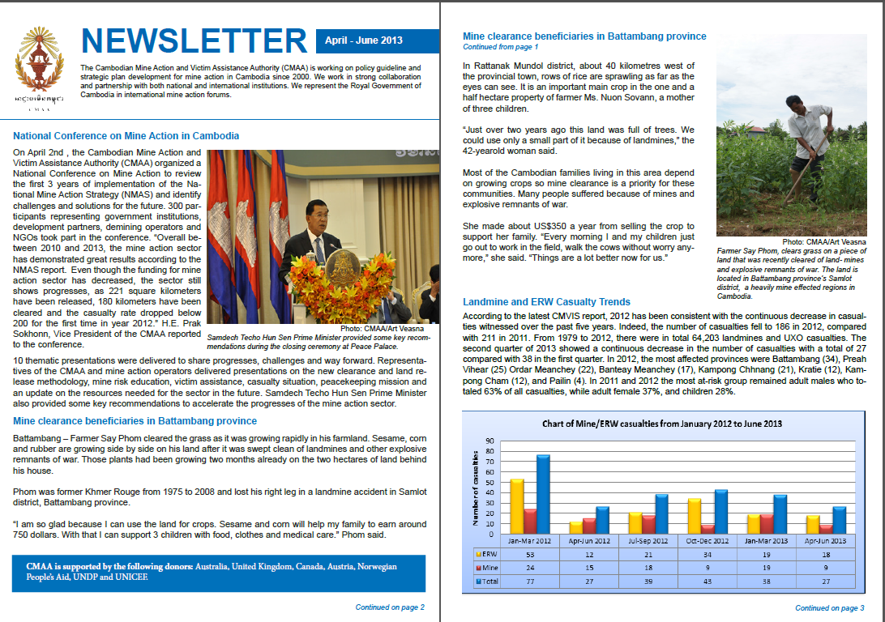



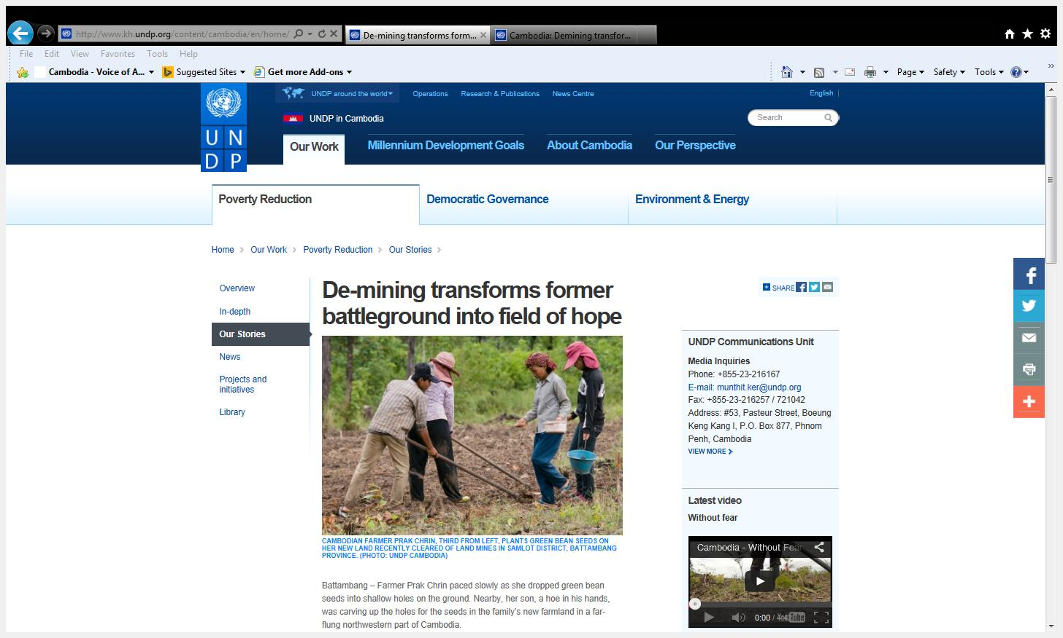

**De-mining transforms former battleground into field of hope**

Battambang – Farmer Prak Chrin paced slowly as she dropped green bean seeds into shallow holes on the ground. Nearby, her son, a hoe in his hands, was carving up the holes for the seeds in the family’s new farmland in a far-flung northwestern part of Cambodia.

*Cambodian farmer Prak Chrin, third from left, plants green bean seeds on her land recently cleared of landmines in Samlot district, Battambang province.* ***©*** *UNDP Cambodia*

Two years ago the field was once a shrub land infested with landmines. Now it is a ticket to a more stable future for the 50-year-old woman and her three sons. Rice, corn and bean are growing side by side on the land after it was swept clean of landmines and other explosive

devices.

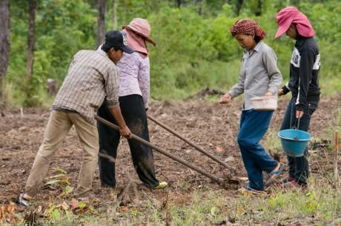

**Highlights**

• 5,400 ha of land have been cleared from landmines and UXOs under UNDP’s mine action project

• The casualty has fallen from 4,300 people in 1996 to 186 in 2012

• 80% of the cleared land have been used for agricultural and resettlement purposes

“I am so glad to finally be able to use the land for crops,” said Prak Chrin who lives in O Tatiek village

in Samlot district, Battambang province.

By any standards, the village’s landscape is one of the country’s heavily-mined regions. But years of de-mining work, with support from international community including the United Nations Development Programme, are gradually transforming a former battle ground into a field of hope for the rural folks.

Since 2006, a UNDP’s mine action project – with support from international donors including Canadian International Development Agency (CIDA), Australian Agency for International Development (AusAid) and Austria – has helped get rid of the deadly devices and free more than

5,400 hectares of land in Cambodia. Some two-thirds of the cleared areas have been converted into farmland.

In Rukha Kiri district, about 60 kilometers east of the provincial town, rows of pineapple are sprawling. It is a new cash crop in the one hectare property that farmer Thong Yeuy, a mother of six children, owns in her backyard.

“Just over a year ago this land was full of shrubs. We could use only a small portion of it because of landmines,” the 42-year-old woman said while navigating through pineapple rows to pick the fruit. She said she made about US$250 a year from selling the crop to supplement rice farming.

The amount may not seem that much but it can go a long way for rural families in a country where about a quarter of estimated 14.5 million people eke out a living on less than US$1 a day.

The work of various mine clearance operators have drastically reduced the number of casualties – to

186 in 2012 from 4,300 in 1996. Meanwhile, Cambodia has also grown in the know-how and capacity to even send de-miners to assist other mine-afflicted nations in the context of U.N.-peacekeeping missions.

Back in O Tatiek village, farmer Prak Chrin now owns a total of three hectares of land compared to just one she had four years ago. With bigger land, she said she looked forward to collecting higher yields form harvest at the end of the year. In the long run, she hopes to increase her saving from selling crop surplus to build a larger house to replace the 15-square meter, rickety cottage she is currently sharing with her three boys.

That’s her dream, but for now the most important thing for her is the absence of fear factor.

“Every morning I and my children just go out to work in the field, walk the cows without worry anymore,” she said. “Things are a lot better now for us.”

**Mine clearance beneficiaries in Battambang province**

Battambang – Farmer Say Phom cleared the grass as it was growing rapidly in his farmland. Sesame, corn and rubber are growing side by side on his land after it was swept clean of landmines and other explosive remnants of war. Those plants had been growing two months already on the two hectares of land behind his house.

Phom was former Khmer Rouge from 1975 to 2008 and lost his right leg in a landmine accident in Samlot district, Battambang province.

“I am so glad because I can use the land for crops. Sesame and corn will help my family to earn around 750 dollars. With that I can support 3 children with food, clothes and medical care.” Phom said.

*Farmer Say Phom clears grass on a piece of land that was recently cleared of landmines. The land is located in Battambang province’s Samlot district, a heavily mined area in Cambodia.* ***©*** *CMAA/Art Veasna*

In Rattanak Mundol district, about 40 kilometres west of the provincial town, rows of rice are sprawling as far as the eyes can see. It is an important main crop in the one and a half hectare property of farmer Ms. Nuon Sovann, a mother of three children.

“Just over two years ago this land was full of trees. We could use only a small part of it because of landmines,” the 42-yearold woman said.

Most of the Cambodian families living in this area depend on growing crops so mine clearance is a priority for these communities.

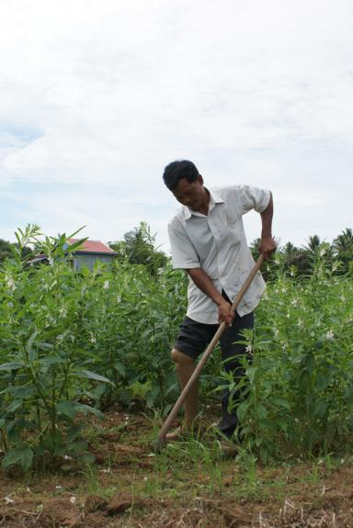

Many people suffered because of mines and explosive remnants of war.

She made about US$350 a year from selling the crop to support her family. “Every morning I and my children just go out to work in the field, walk the cows without worry anymore,” she said. “Things are a lot better now for us.”