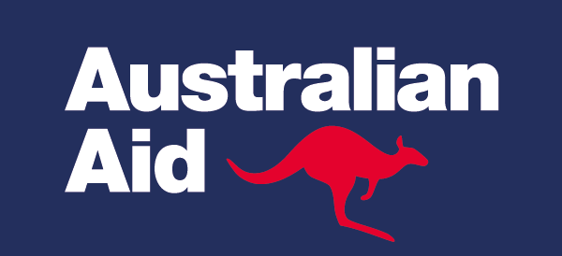

# Building Strong, Sustainable Immunisation Programs in East Asia and the Pacific

### Early Findings from the World Bank Group’s Multi-Donor Trust Fund for Integrating Donor-Financed Health Programs

*October 2017*

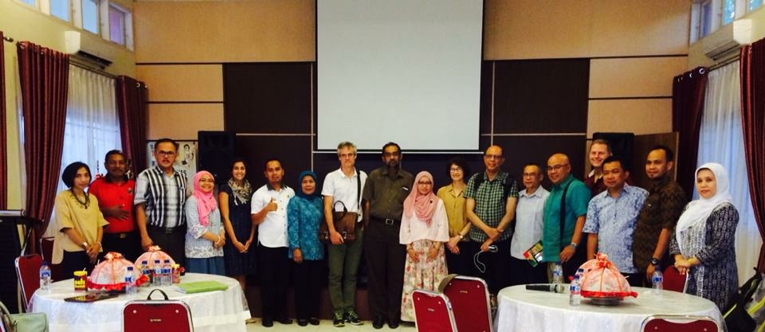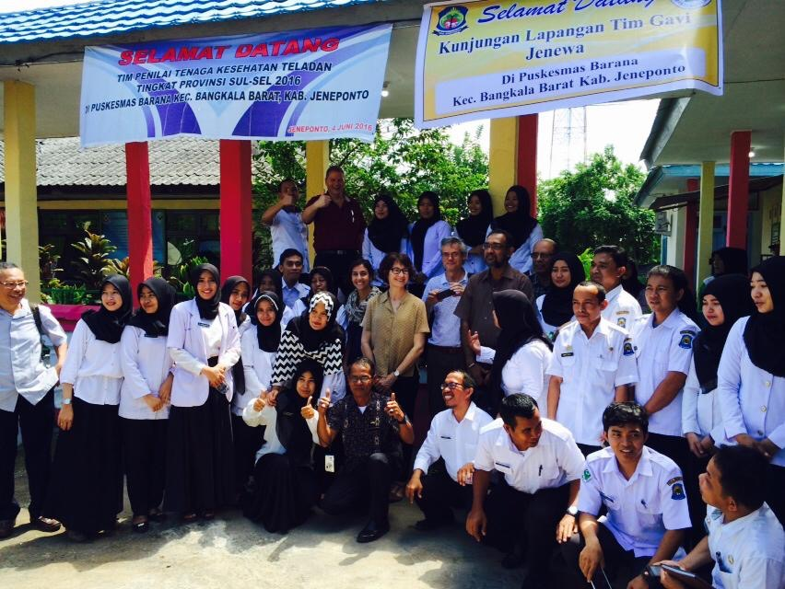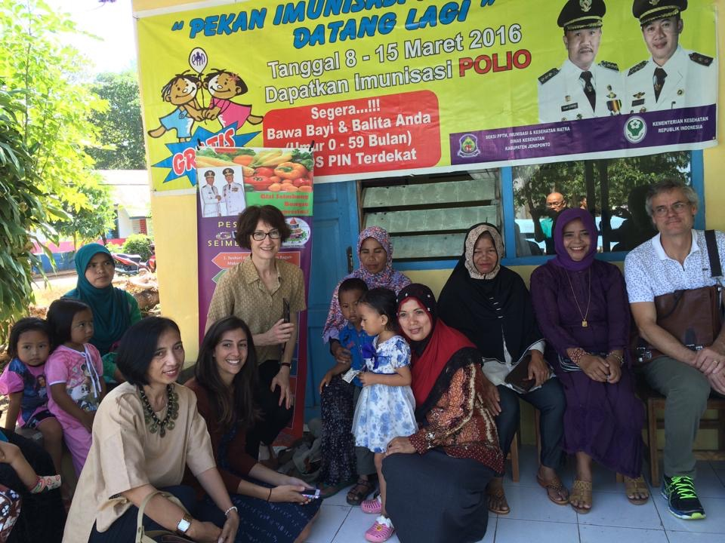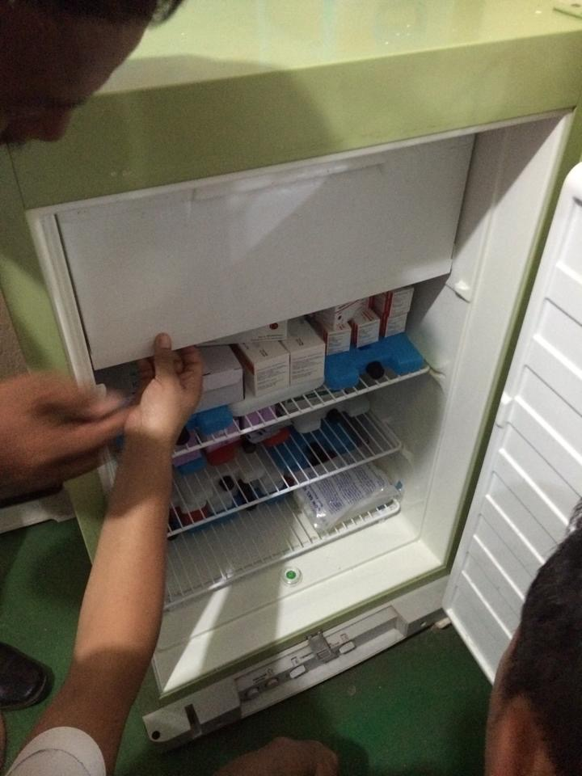

**Source:** *Jeneponto District, South Sulawesi during the Gavi transition planning mission in Indonesia, July 2016*

*The findings, interpretations, and conclusions expressed herein are those of the author(s), and do not necessarily reflect the views of the International Bank for Reconstruction and Development/The World Bank and its affiliated organizations, or those of the Executive Directors of The World Bank or the governments they represent. The World Bank does not guarantee the accuracy of the data included in this work.*

# Building Strong, Sustainable Immunisation Programs in East Asia and the Pacific

## Why is immunisation important for East Asia and the Pacific’s goal of achieving universal health coverage?

Almost all low- and middle-income countries (LMICs) have made explicit policy commitments for attaining universal health coverage (UHC). UHC is also a target and an important precursor to achieving Goal 3 of the 2030 Sustainable Development Goals (SDGs): “*Ensure healthy lives and promote well-being for all at all ages*”. Investing in countries’ efforts to achieve UHC saves lives and underpins economic growth and prosperity.

***One of the most important steps countries can take as they progress to UHC is ensuring adequate and predictable financing is channelled to the most basic health services, including immunisation.***

One of the most important steps countries can take as they progress to UHC is ensuring adequate and predictable financing is channelled to the most basic health services, including immunisation. Strong immunisation programs can serve as an entry point for delivering other services, and focusing on prevention can reduce future burden on the health system, reduce infant and child-mortality rates, and avert outbreaks of diseases such as measles and polio. In fact, immunisation is one of the best buys in public health, with recent studies citing a 16-fold return on investment over a ten-year period.[1][2] Given its importance, immunisation is included in the list of tracer conditions in the World Bank & WHO Global Monitoring Framework for UHC.[3]

## What challenges does East Asia and the Pacific face with respect to immunisation?

### Low immunisation coverage and high inequities indicate poor health outcomes but also put the region at risk of outbreaks

* At least one fifth of children are not immunized with the recommended three doses of diphtheria, tetanus and pertussis (DTP3) in Indonesia, Papua New Guinea (PNG) and Vanuatu where coverage levels are below 80%, and measles coverage rates are much lower [4](See **Figure 1**).[2] However, it is important to note that coverage estimates across sources are highly variable in much of the region, and there are problems in estimating coverage due to lack of completeness of data, and lack of reliable censes to estimate the target population.

Although East Asia and the Pacific (EAP) is polio-free, weak immunisation and health systems puts many countries at risk of outbreaks of vaccine-derived polio virus (VDPV). In 2016 the Polio Independent Monitoring Board identified PNG, Myanmar, Vanuatu, Kiribati and Indonesia as being particularly vulnerable to polio outbreaks because of low immunity, weak surveillance or poor infrastructure. In recent years, Lao People’s Democratic Republic (PDR) and Myanmar experienced outbreaks of VDPV – Myanmar had two cases in 2015 and Laos had eight cases in 2015 and three cases in 2016 [5].

* Newer World Health Organization (WHO)-recommended vaccines to prevent pneumonia (i.e., pneumococcal conjugate vaccine) or diarrhoea (i.e., rotavirus vaccine) have not yet been introduced in many EAP countries due to competing priorities, limited implementation capacity and health system readiness concerns, or financial considerations.
* Immunisation coverage varies by income levels, sex and geography. For example, DTP3 coverage rates in Indonesia varied from 61% to 85% respectively, between the bottom 40% of the population and the top 20% of the population, when organized by socioeconomic status[6]. In Kiribati, only 56% of girls were immunized with DTP3 in 2016, compared with 66% of boys.
* Immunisation is just one of the many services used to measure a country’s progress to UHC. It is also one of the most cost-effective interventions and therefore low coverage rates for immunisation are indicative of system inefficiencies.
* The large cohort of unimmunized children leaves the region prone to outbreaks of vaccine-preventable illnesses such as measles and polio.

**Figure 1. Coverage of DTP3 and measles-containing vaccines (MCV*) in East Asia and the Pacific, 2016**

*Some countries are moving to delivering 2 doses of measles vaccines, as per WHO recommendations, but are still transitioning to this schedule.

***Source:*** *WHO-UNICEF estimates, WHO vaccine-preventable diseases: monitoring system,* [*www.who.int*](http://www.who.int)

### The“health financing transition” poses both risks and opportunities for immunisation programs

In parallel to the demographic, epidemiological, and nutrition-related transitions faced by countries as they grow and develop, countries also go through a “health financing transition”: the tendency for the *level* of total health expenditures to increase accompanied by a rise in the domestically financed prepaid/pooled *share* of total health expenditure (See **Figure 2**) [7].[3] As countries move from low-income to lower-middle income status they also experience a sub-transition away from externally-financed health programs from bilateral and multilateral agencies, including Gavi, the Vaccine Alliance (Gavi) and The Global Fund to Fight AIDS, Tuberculosis & Malaria (GF)[4]. Additionally, some countries experience changes in eligibility for different types of World Bank Group (WBG) support.[5] These prospective changes in development assistance are bringing attention to the need to mobilize domestic resources for health in a way that contributes to financial protection, and to improve efficiency in the use of resources.

A key challenge is that the transition from development assistance often starts as countries are still developing their health financing systems – that is, before they are able to effectively increase domestic, prepaid, pooled financing. Health financing transitions do not follow the same pattern in every country, and many factors can shape the timing and magnitude of the transition and the extent to which this poses a challenge. For instance, in Myanmar, the external share of total health spending has been rising despite solid economic growth due to changes in the country’s political context in recent years. In some Pacific countries, out-of-pocket payments (OOPs) [6] have traditionally been low, and so the major challenges facing those countries is keeping OOP low during the transition from external to domestic public sources of financing, while also addressing systems challenges such as poor quality of care and inefficient health spending. In other countries, such as Indonesia, Vietnam, and the Philippines, the challenge is about replacing *both* external and OOP sources with domestic prepaid/pooled financing. In general, health financing transitions are complex, non‐linear, and context‐specific. Hence, careful navigation of the health financing transition is key for sustaining progress towards UHC. If managed effectively the health financing transition offers an opportunity to significantly accelerate progress toward UHC.

**Figure 2: The "health financing transition"**

This figure illustrates the financial transition of health expenditure from low income countries with high external funding through to high income countries with low external funding.


*Source: Produced by World Bank Group, based on World Development Indicators and World Health Organization Global Health Expenditure Databases*

Gavi has been the largest source of support for immunisation programs and many countries in the region are transitioning, or have already transitioned from support (See **Figure 3**). Indonesia and Myanmar are also in the midst of a transition from the Global Polio Eradication Initiative (GPEI), which has been a substantial source of support for immunisation programs in these countries. A key challenge for countries transitioning from Gavi and GPEI is to figure out how to replace external financing, while maintaining results achieved with this assistance. However, support from donors is often a substantial share of the immunisation program and governments may not have the capacity to finance essential program elements, or to offer adequate support for key programmatic functions such as procurement, budgeting and planning, service delivery, and monitoring and evaluation. Fortunately, many countries in the region are taking action to ensure that financing is directed to frontline services, that staff are well-trained, and that financial management systems are sufficiently developed to ensure that funds flow to their intended beneficiaries. These improvements will also bring about benefits for immunisation services.

This figure illustrates the four phases of support provided by Gavi which starts with initial self-financing, then preparatory transition, accelerated transition and finally fully self-financing. 

**Preparatory transition (Myanmar and Cambodia):** The government’s share of the vaccine price (known as “co-financing”) increases by 15% annually.

**Accelerated Transition (Lao PDR, PNG, and Vietnam; Solomon Islands to enter in 2018):** Co-financing requirements increase gradually over 5 years to reach the full projected Gavi price of vaccines.

**Fully Transitioned from Gavi support: (Indonesia and Kiribati entered this phase in 2016, although Indonesia will receive support for new vaccine introductions for one additional year):** In this phase, the country has transitioned from Gavi but may continue to receive financing for vaccines and immunization from other partners.

Philippines and Vanuatu have never received su

**Figure 3. Overview of Gavi’s phases of support**

## How is the Multi-Donor Trust Fund helping to strengthen immunisation within the overall context of UHC?

The MDTF for Integrating Donor Financed Health Programs was established by the World Bank and the Australian Government Department of Foreign Affairs and Trade (DFAT) to strengthen health systems and support sustained gains as countries transition from donor financing. The initial focus was on sustaining gains in the prevention and treatment of HIV/AIDS, TB and malaria after countries transition from Global Fund assistance. DFAT provided $8 million in June 2015 towards this first ‘window’ of the MDTF.   In December 2015, DFAT initiated Window 2, with a focus on routine immunisation systems strengthening to help prevent outbreaks of vaccine-preventable diseases, including polio. $36 million has been committed for 2015-2019 (with implementation to 2020) to strengthen health and routine immunisation systems and to ensure these programs are sustainably financed and managed.

DFAT is partnering with WBG to take advantage of the WBG’s expertise in data analytics, fiscal and governance reform, and public financial management, and its track record of providing, managing and leveraging a wide range of long-term financing for countries. The WBG is ideally placed to engage Ministers of Finance and Planning to make the economic case for countries to increase their own public expenditure on health and routine immunisation.

Since DFAT and the WBG developed this funding mechanism, other development partners, including Gavi, the Bill and Melinda Gates Foundation (BMGF), and the Global Fund, have joined and are co-financing some country activities, along with WBG funding.[7] Funding from Gavi and BMGF is also being used to expand the MDTF to regions beyond EAP. Thus, DFAT’s pioneering initiative and investment has since leveraged and pooled other sources of funding and allows development partners to harmonize efforts, making more efficient use of development resources. Funding from other key development partners also demonstrates the high value placed on the work of the MDTF, and has widened the footprint of the activities across a larger range of countries.

Through the MDTF, DFAT supports four major pillars focused on immunisation strengthening in the East Asia and Pacific, which are ideally implemented sequentially (See **Figure 4**).

**Figure 4. The World Bank’s Multi-Donor Trust Fund’s Pillars of Support**

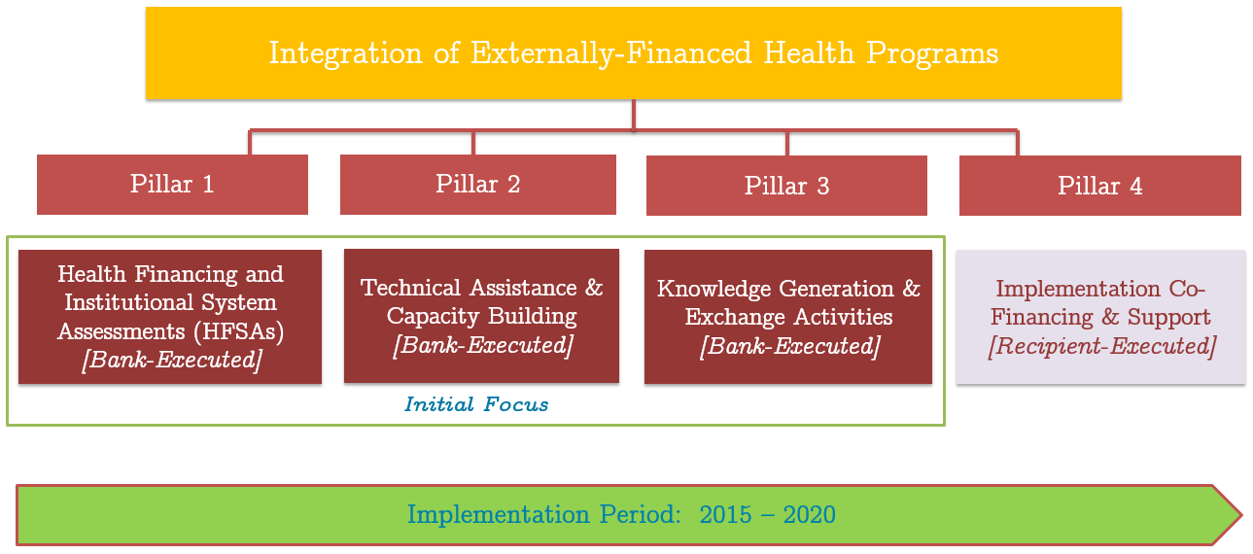

**Pillar 1** focuses on analytical work, including Health Financing System Assessments (HFSAs) and in-depth immunisation analyses. These assessments provide governments and stakeholders with understanding of the challenges and opportunities they face as they move towards UHC. This analytical work forms the foundation for **Pillar 2**; the provision of in-country technical assistance and capacity building to address the challenges identified in Pillar 1. Through **Pillar 3**, in-country knowledge-generation and regional/global knowledge-sharing synthesizes lessons from activities across all pillars. Finally, a subset of countries move on to **Pillar 4** and develop their own targeted immunisation systems strengthening programs, which are directly executed by governments and additionally leverage investment financing from the World Bank.

## What has DFAT’s investment through the World Bank’s Multi-Donor Trust Fund helped to achieve?

Just over 18 months into implementation, DFAT’s investment in the MDTF is delivering results. A selection of the results achieved across each pillar is outlined below, including highlights from country programs. Box 2 highlights the experience of Lao PDR, which has received support across all four pillars of the MDTF, demonstrating the value of the MDTF’s phased approach.

**Box 2: The MDTF’s Phased Approach to Strengthening Immunisation: The Lao PDR Experience**

Lao PDR faces a number of health and immunisation system challenges: the country has the highest infant and under-five mortality rate in the East Asia and Pacific and large disparities in mortality across socio-economic, ethnic, geographic and educational dimensions. Weak immunisation systems and gaps in coverage were the underlying reasons for a recent outbreak of vaccine-derived poliovirus in Laos (8 cases in 2015 and 3 cases in 2016). In addition, Lao PDR has now entered Gavi’s final phase of support, known as the Accelerated Transition phase, and is expected to fully transition from Gavi support by 2021.

Responding to these challenges, the World Bank MDTF first supported the development of a comprehensive HFSA and in depth immunisation assessment under **Pillar 1**. These analyses have helped the Lao Government to understand the specific health financing challenges facing the country as it prepares to transition from donor financing, and to identify the bottlenecks, gaps and opportunities going forward. The findings are also helping the National Program for Immunization (NIP) and development partners plan for transition from Gavi support.

Under **Pillar 2**, the HFSA and immunisation assessment are informing a program of technical assistance focused on strengthening the integrated model of maternal and child health care (including immunisation) in 14 provinces, including plans to make the model more equitable and efficient. With a substantial share of funding for vaccines currently coming from Gavi, a shift toward a more efficient service delivery model, that also reaches the most remote populations, is critical for sustainability. Under **Pillar 3,** the WBG is working to build capacity of Lao government officials at central and provincial levels in UHC and health financing, through workshops, trainings, and engagement in all aspects of the MDTF work program. Lao officials are also learning from the experiences of other countries in the region facing similar challenges.  Finally, these activities have fed into the development of a program of work under **Pillar 4**, which uses a results-based financing approach to incentivize provinces to improve the provision of essential maternal and child health services. MDTF funding under this pillar is supporting the inclusion of an immunisation specific indicator to incentivise better immunisation provision amongst lowest performing and remote districts in the country. WBG is also providing technical support to integrate immunisation data into the health information system (DHIS-2), including data on coverage of Inactivated Polio Vaccine (IPV).

### Pillar 1: Health Financing System Assessments

The World Bank Group carried out comprehensive HFSAs and immunisation assessments in **Indonesia**, **Lao PDR, Papua New Guinea (PNG), Solomon Islands, Vanuatu** and **Kiribati,** and has initiated HFSAs in **Philippines, Cambodia and Myanmar.** The HFSA examines the constraints and opportunities to achieving UHC, with a detailed assessment of how these broader challenges affect disease specific programs such as the immunisation program. Framing the transition from donor financing in the broader context of UHC represents a shift away from a traditional approach of focusing on disease-specific programs through a vertical lens. **Box 1** describes key highlights from the HFSA undertaken in Indonesia.[8]

### Key highlights from Indonesia’s Health Financing System Assessment

The HFSA findings show that while Indonesia’s overall dependence on external financing is relatively small, the support to the immunization program is substantial, accounting for 33% of financing in 2014. External technical support to the immunization program is also substantial [1]. The HFSA also highlighted challenges facing immunization during health sector reforms. For example:

* Immunization services are included in the social health insurance (JKN) benefit package and delivery of services is paid for using a capitation payment to providers who deliver the services. However, providers participating in the JKN scheme are not necessarily aware that immunization is included in the capitation payment and therefore do not encourage the provision of immunization.
* Decentralization has implications for the financing and provision of immunization, given that many districts fail to spend the mandated 10% of their budget on health. This underspending on health has implications for provision of service delivery and immunization outreach, and maintenance of cold-chain equipment.
* Lack of service readiness is a major barrier to accessing primary health care services (including immunization).
* Weak accountability arrangements governing fiscal transfers from the central to sub-national governments result in local payment systems for primary care that favour curative over preventive services.

Ongoing work through a health facility survey will measure service readiness of facilities in the public and private sector, with a specific focus on performance of immunization and other priority services. The findings from the HFSA informed the governments’ 2017 budget decisions and reforms that will strengthen efficiencies in the allocation and use of resources (See description in Pillar 2).

### Pillar 2: Technical assistance and capacity building

The value of the MDTF investment is that the WBG works together with Ministries of Health, Finance, and Planning to ensure that rigorous analytics support policy dialogue and evidence-based planning. The dialogue made possible by the HFSAs feeds into decisions about how much to spend on health, how to allocate funds efficiently, and how to ensure accountability mechanisms are in place so that funds flow to the right places at the right time. The HFSA also informs decisions about how service delivery can be improved. Some highlights are below:

**Indonesia:** The Indonesian Ministries of Finance (MOF), National Planning (Bappenas), and Ministry of Health (MOH) have used the HFSA findings to revise the 2017 budget plan, and, for longer term, to identify areas and issues of public financial management in health sector that contribute to inefficiency in health spending. This improved efficiency will create additional fiscal space that enables increased allocation for immunisation, and other priority health programs. The HFSA and immunisation assessment also served as the key background document for the transition mission with Gavi. In 2016, the country made its final co-financing payment to Gavi and it was delivered on time. In 2017, the government began fully financing the cost of the Pentavalent vaccine. Although the country has officially transitioned from Gavi support, Gavi has provided an extension of support to help with the introduction of four new vaccines: Inactivated Polio Vaccine (IPV), Japanese Encephalitis, Measles-Rubella and Human papillomavirus(HPV). Nevertheless, the country has transitioned from financing 78% of its vaccines with government resources in 2014, to 90% in 2016 [8].

In **Solomon Islands and Kiribati** the Ministries of Health have used the HFSA to inform discussions with ministries of finance on their 2017 and 2018 annual plan and budget submissions. WBG has worked with governments in Solomon Islands and Kiribati to ensure projections for Gavi co-financing obligations are updated annually in the Medium Term Expenditure Pressures (MTEP) document. This document feeds into the government’s planning and budgeting process and raises awareness among Ministries of Finance and Budget about the financial implications of the transition. The most recent data on vaccines financing shows that Solomon Islands has moved from financing 26% of its vaccines in 2015 to 34% in 2016 [8], although there is some variability from year to year due to the timing of procurement and number of vaccines offered. Kiribati has now completely transitioned from Gavi support, with the exception of a small grant from Gavi for IPV this year.[9]

In **Lao PDR**, the WBG team involved the National Immunisation Program (NIP) and Maternal and Child Health Centre of the MOH in data collection at the facility level. Through this involvement staff increased their understanding of the system readiness issues in service delivery. Findings were used to inform the Gavi transition mission and planning process in March 2017. The work also helped NIP understand the priority areas for improving quality and efficiency of service delivery. For example:

* 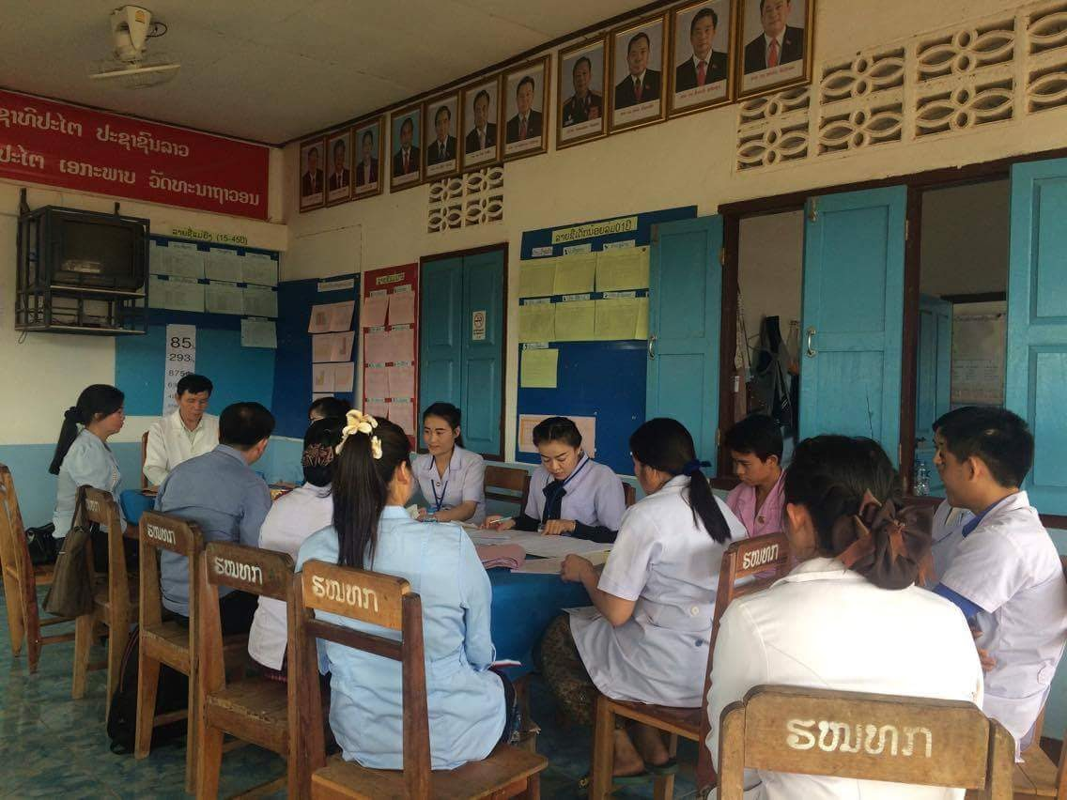HFSA immunisation “deep dives” combined with information from MOH/WHO service availability and readiness assessments identified the key bottlenecks at the frontline service delivery level; this information informed a program of technical assistance to strengthen the integrated model of maternal and child health care in 14 provinces.
* WBG staff are now supporting the country to improve Lao’s integrated maternal and child health outreach program so that it focuses on remote areas, while shifting users who live near fixed primary care facilities to use those sites. This shift will also need to be accompanied by improved service availability and quality of services, which is a focus of the current WBG project.

*Source: WBG and Lao PDR National Immunisation Program staff members visiting a health facility in Lao PDR, 2016*

* Technical support has been provided to integrate immunisation data in the country’s District Health Information System (DHIS2), in order to harmonize data across priority programs and prevent duplication of data collection and analyses.
* These reforms are timely given that Lao PDR entered the Accelerated Transition phase of Gavi, which is the last five-year period of support before the country transitions. This year, the government had to increase its co-financing payment to Gavi, and met its co-financing obligation on time.

In **PNG**, the HFSA helped to make the case that immunisation should be elevated as a national priority, which would ensure it is given high priority during funding allocation decisions. The WBG is providing important support to the National Department of Health (NDOH) with the development of a transition plan from Gavi support**[10]**. The activities identified in the plan take a long-term perspective and help the government understand short-term actions that can be taken to strengthen immunisation performance, but within a broader framework of strengthening frontline services for the entire country.

**Solomon Islands**: The HFSA findings fed into the design of the country’s transition plan from Gavi, which identifies steps that need to be taken to strengthen immunisation financing and programmatic support prior to transition. In line with the messages from the HFSA, the

Ministry of Finance and Treasury highlighted the increasing financial pressures facing Government and gave clear instructions on the need to improve the prioritization of expenditure. This message was reinforced by MHMS Permanent Secretary at the Budget 2018 workshop in June who noted that addressing the financing and related resource management issues (particularly around health workforce) is needed if gains from predominantly externally financed programs are to be maintained.

### Pillar 3: Knowledge generation and Exchange Activities

The DFAT investment makes it possible for countries to learn from one another and to problem solve during the transition from externally financed programs. This work leverages existing platforms such as the Prince Mahidol Award Conference (PMAC), the Joint Learning Network (JLN) for UHC, and the OECD’s Asia Senior Budget Officer network, as well as customized inter-country learning exchanges within MDTF countries. Specific capacity building efforts are summarized below.

**Regional capacity building workshop at Prince Mahidol Award Conference:** In January 2017, the World Bank held its second annual capacity building workshop on health financing transitions as part of the pre-meeting session at the PMAC annual meeting in Bangkok, Thailand. Government counterparts from Cambodia, Indonesia, Kiribati, Lao PDR, Myanmar, PNG, Solomon Islands, Vanuatu, and Vietnam attended, including immunisation program managers from Myanmar, Indonesia and Lao PDR. Representatives from DFAT, Gavi, GFATM, BMGF, and GPEI (i.e., WHO and UNICEF) also participated. The purpose of the workshop was to strengthen counterparts’ understanding of the issues facing countries as they go through the “health financing transition”, and specifically the transition from development assistance. Participants shared experiences and lessons from in-country transition processes, and identified priority topics and areas for further analysis, training, and capacity-building.

**Participation in the Joint Learning Network for Universal Health Coverage.** The JLN is a practitioner-to-practitioner learning network that helps LMICs learn from one another, problem-solve together, and collectively produce and use new knowledge, tools, and innovative approaches to progress toward UHC. The JLN currently consists of 27 countries represented by senior policymakers with experience implementing UHC reforms. The MDTF supports countries to participate in this network, particularly as part of the working groups on Domestic Resource Mobilization and Efficiency. A recent meeting on efficiency was held in Indonesia, with stakeholders from Lao and Myanmar also participating.

**Sustainability discussions at the Joint Network of Senior Budget and Health Officials (SBO) on Fiscal Sustainability of Health Systems for the Asia Region:** In May 2015, the first Asia SBO meeting was held in Tokyo, organized by OECD, ADB Institute, ADB, the Global Fund, WHO and the World Bank. The meeting brought together budget officials from the finance and health ministries from 10 countries, as well as several development partners, to discuss challenges in health sector budgeting, and identify effective policies to ensure the financial sustainability of health as countries transition from external financing. Ongoing work will help countries better understand potential solutions and good practices for overcoming these challenges.

**Capacity building for immunisation in Lao PDR:** National workshops in Lao PDR have strengthened the capacity of government officials (at central and provincial levels) with respect to knowledge of UHC and health financing. A key topic of the workshops was how to expand essential services, including immunization, in a way that increases coverage, quality and efficiency of resources. The workshops, combined with the capacity building work in pillar 2 in which the NIP was directly involved in data collection for the immunisation assessment, has increased the NIP team’s understanding of key issues facing the immunisation program. The Lao NIP manager presented the challenges and opportunities during the PMAC pre-meeting, and other countries benefitted from hearing about the country’s plans for reforms toward a more efficient model of MCH care that includes immunisation.

### Pillar 4: Implementation of Health Systems Strengthening Interventions

DFAT is supporting the development of WBG projects that aim to put in place reforms that will move countries to UHC. Lao PDR and Indonesia have come the furthest with the design of projects, and other countries will launch projects in the future.

**Lao PDR:** The HFSA diagnostic under pillar 1, the technical assistance and capacity building under pillar 2, and the inter-country learning under pillar 3, have finally culminated in a co-financed investment operation in Lao PDR- the additional financing of WBG’s current Health Governance and Nutrition Development Project (HGNDP), which was approved by the World Bank’s board of executive directors in September 2017. This additional financing also serves to restructure and redefine the performance-based indicators aimed at the provincial level and to link their achievements directly to the number of villages receiving the prescribed number of integrated outreach sessions per year. Furthermore, an immunisation specific indicator was also added to incentivize the country’s lowest performing and remote districts to increase their coverage of Pentavalent 3 and of Measles and Rubella (MR). Funding from MDTF co-finances these elements of the project to strengthen routine immunisation. The project also supports integration of information systems for immunisation, and integration of field supervision and outreach efforts across the health system.

***Lao PDR has included an immunisation specific indicator to expand coverage of Pentavalent 3 and Measles & Rubella vaccinations in priority districts.***

As part of strengthening data quality and information systems, the WBG has also provided technical support to integrate immunisation data into financial management information systems. For example, the team has supported the introduction of a mechanism to collect regularly reported data on integrated outreach sessions, listed by village with dates and services provided, in the DHIS2. This data will help to provide better monitoring of progress, while also allowing the government to provide targeted technical assistance for provinces, districts and health centres that are lagging.

Additional technical assistance is also planned to support the priority districts to improve low immunisation coverage through the following initiatives:

* hands-on data entry and data quality supervision at district level,
* create district and provincial specific immunisation dashboards to monitor immunisation progress and coverage; and
* exploring culturally appropriate immunisation awareness and knowledge for ethnic communities to increase fixed site usage and improve attendance during outreach sessions.

The ongoing technical assistance on integration of health financing programs and ensuring the continuity of free maternal and child health services also continues steadily, ensuring that investments in pillar 4 are closely supported by activities under pillars 2 and 3 of the MDTF.

**Indonesia:** DFAT funds are being used to develop a potential investment project between the government and World Bank, with a focus on improving health service delivery at the sub national level in three provinces (East Nusa Tenggara, Maluku and Papua) in Eastern Indonesia.  The new project builds on the HFSA findings by incorporating a quality improvement and accreditation program of primary care facilities, and changing the rules governing interfiscal transfers. Districts with the lowest immunisation coverage levels, identified through the HFSA in Pillar 1, will be the focus of the project, with specific targets set for increasing coverage and quality of services. These reforms are expected to have important implications for both UHC and immunisation.

### Conclusion

In its second year of support, DFAT’s investment in the World Bank’s MDTF has already achieved key milestones that will be critical for success in the coming years. The investment takes a phased approach and therefore most of the initial outputs are analytical in nature, but are already helping governments to understand the key issues facing their health systems and immunisation programs, and to take action through reforms. Looking forward to 2020, the WBG will continue to scale up activities in target countries and continue to implement recipient-executed activities funded under pillar 4. DFAT and WBG will continue to closely monitor progress against MDTF objectives using a recently developed monitoring framework. Through the MDTF’s phased approach, DFAT and WBG will help to ensure that as countries in East Asia and the Pacific transition towards domestic health financing, universal immunisation will become a national, funded priority. The investment will also ensure that immunisation is sustainably integrated into national health financing and service delivery systems, and that governments have the requisite resources, skills and knowledge to improve coverage and quality of immunisation services within the overarching framework of universal health coverage.

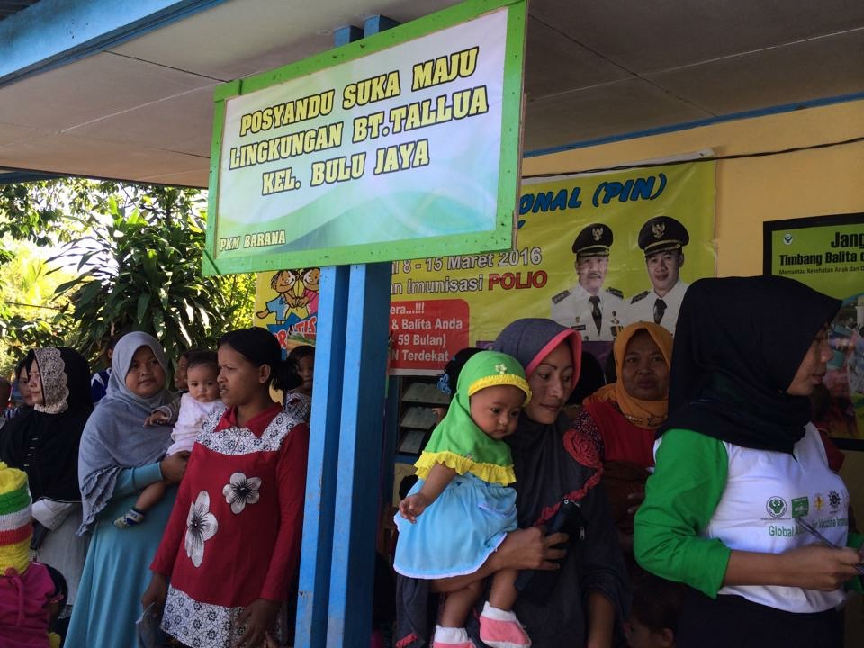

**Source:** *Jeneponto District, South Sulawesi during the Gavi transition planning mission in Indonesia, July 2016*

**References**

1. World Bank Group, *Indonesia Health Financing System Assessment: Spend More, Right and Better.* . 2016, World Bank: Washington, DC.

2. Ozawa, S., et al., *Return On Investment From Childhood Immunization In Low- And Middle-Income Countries, 2011-20.* Health Aff (Millwood), 2016. **35**(2): p. 199-207.

3. WHO and World Bank, *Tracking universal health coverage: first global monitoring report*. 2015, World Health Organization

4. WHO. *WHO-UNICEF estimates, WHO vaccine preventable diseases: monitoring system 2017 global summary*. 2016 September 2017].

5. Independent Monitoring Board of the Global Polio Eradication Initiative, *The 13th Report of the Independent Monitoring Board (IMB) of hte Global Polio Eradication Initiative (GPEI).* 2016.

6. Statistics Indonesia - Badan Pusat Statistik - BPS, et al., *Indonesia Demographic and Health Survey 2012*. 2013, BPS, BKKBN, Kemenkes, and ICF International: Jakarta, Indonesia.

7. Fan, V.Y. and W.D. Savedoff, *“The Health Financing Transition: A Conceptual Framework and Empirical Evidence,” Working Paper, Results for Development Institute, Washington, DC. .* 2012.

8. WHO & UNICEF, *WHO & UNICEF Joint Reporting Form Database*. 2016.

1. The vaccines considered in the study were *Haemophilus influenzae* type b, Hepatitis B, Human Papillomavirus, Japanese encephalitis, Measles, *Neisseria meningitidis* serogroup A, rotavirus, rubella, *Streptococcus Pneumoniae*,and yellow fever.
2. These coverage rates may be even lower, given the problems with data quality in the region. Estimates of coverage vary widely across sources.
3. Increased expenditure is driven by a range of factors including changes in population priorities, institutional development, medical technology, demographic/epidemiological shifts, as well as changes in the financing and management of healthcare.
4. Eligibility varies by donor and not all donors use the LMIC threshold. For example, Gavi transitions countries at GNI of $US1,580 p.c. Other donors use additional criteria. In the EAP region, Global Fund will continue to support the region but some cuts in disease programs will take place.
5. Cambodia, Myanmar, Kiribati, Solomon Islands, and Vanuatu still have access to concessionary financing from the International Development Association (IDA), while Lao PDR, PNG and Vietnam are “blend” countries, meaning that they are IDA-eligible but are also eligible for borrowing on market-based terms (although at considerably favorable terms) under the WBG’s International Bank for Reconstruction and Development (IBRD) window. Indonesia and Philippines are full IBRD countries.
6. Out of pocket payments refers to direct payments made to a health care provider by an individual to use health services.
7. Prior to the MDTF, Gavi financing was channeled to the WBG through another financing mechanism, but has since been folded into the MDTF.
8. The HFSA in Indonesia also received co-financing from Gavi and other WBG resources.
9. Although Kiribati has transitioned from Gavi, the country still receives support for vaccines from other development partners.
10. The assessment mission in PNG was not a traditional transition assessment, but findings from the HFSA were used to help Gavi and other partners understand the challenges the country faces as Gavi prepares to transition, including the current macroeconomic and fiscal constraints due to the recession.