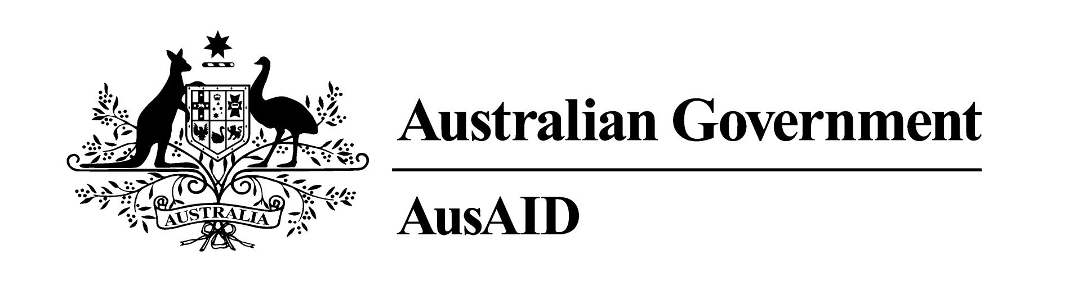

Summary of Australia’s Overseas Aid Program 2012-13

BUDGET HIGHLIGHTS
8 may 2012
The 2012-13 Budget will increase Australia’s Official Development Assistance (ODA) to $5.2 billion, maintaining ODA at 0.35% of GNI over the coming year. Returning the budget to surplus is Australia's best defence at a time when the global economy is changing dramatically. To deliver this surplus, the Government has taken the tough, but fiscally responsible, decision to defer providing 0.5% of Gross National Income (GNI) as aid until 2016-17.
The Government remains committed to achieving the Millennium Development Goals. Australian aid tackles poverty through saving lives, creating opportunities for all, promoting sustainable economic development and effective governance, and by responding to humanitarian crises and disasters. Over the next four years, Australia will help 4 million children from poor families to enrol in school, vaccinate more than 10 million children and provide over 2 million poor people with access to financial services. We will also provide 30 million vulnerable people living in conflict and crisis situations with life-saving humanitarian assistance.
Over 70% of Australian aid is delivered in Asia and the Pacific, promoting prosperity in our region and reducing border security and health risks for Australians. Australian aid is delivered by Australian volunteers, businesses, non-government organisations, and government agencies working together with developing countries and international organisations.

The Aid Program at a glance

The purpose of Australian aid is to help people overcome poverty. Less than 2% of federal expenditure is on overseas aid, or roughly 0.35% of GNI in 2012-13.
Australia’s aid program is expected to grow to 0.45% of GNI by 2015-16 and 0.50% of GNI by 2016-17.
Consistent with the Government’s aid policy ‘An Effective Aid Program for Australia: Making a real difference—Delivering real results’, announced in July 2011, in 2012-13:
- our top twelve aid recipients will all be in the Asia-Pacific region, namely: Indonesia, Papua New Guinea, Afghanistan, Solomon Islands, Philippines, Vietnam, Bangladesh, East Timor, Pakistan, Vanuatu, Cambodia, and Burma;
- more than 30% of the aid budget will delivered by international organisations, significantly increasing the reach and influence of Australian aid, and helping these organisations focus on the needs of poor people in our region;
- the World Bank Group, Asian Development Bank, World Food Programme and UNICEF will be our main multilateral partners;
- over 21% of the aid budget will be spent on promoting opportunities for all through education, the flagship sector of the aid program given its centrality to the achievement of all the Millennium Development Goals;
- around 19% will be spent on saving lives, 26% on sustainable economic development, including by building resilience to climate change, 19% on improving effective governance and 10% on humanitarian and disaster preparedness and response;
- 1,000 Australian volunteers will accept assignments in developing countries; and over $100 million in funding will be provided for the programs of effective Australian non-government organisations (NGOs).

- prioritise aid to East Asia and the Pacific, which will comprise 45 per cent of total ODA, with Indonesia and PNG remaining the two largest bilateral programs
- focus on education, which will become the flagship sector of the aid program
- grow aid to sub-Saharan Africa, South Asia, Afghanistan and Pakistan, which together will comprise around 16 per cent of total ODA
- phase out of bilateral assistance to China and India
- build faster and better capacity for Australia to respond to humanitarian disasters and conflict-affected states, particularly in our region.
- increase engagement with select multilateral organisations that are performance-oriented, in line with the outcomes of AusAID’s Australian Multilateral Assessment, released in March 2012.
Funding allocations under the four-year budget strategy were determined using four criteria – poverty, national interest, Australia’s capacity to make a difference and current scale and effectiveness.
The Government’s budget strategy is linked to a set of key results that will be achieved by 2015-16. The results align to the five strategic goals of the aid program – saving lives, promoting opportunities for all, sustainable economic development, effective governance and humanitarian and disaster preparedness and response (see over page). Results have also been defined to measure operational and organisational effectiveness, which will lead to better value for money and a higher standard of aid delivery.
The Minister for Foreign Affairs will report against results in an Annual Review of Aid Effectiveness. This will inform Cabinet of the performance of all aid-delivering government agencies and recommend changes due to performance or changing circumstances. The first Annual Review is due by the end of October 2012.

The 2012-13 Aid Budget at a glance

The 2012-13 Budget implements the Government’s aid policy ‘An Effective Aid Program for Australia: Making a real difference—Delivering real results’, through $1.5 billion over four years in new initiatives for Asia and the Pacific and in support of our global and humanitarian commitments, comprising:
Asia and the Pacific
- Overcoming poverty and building stability in the Pacific ($384.5 million over four years) by immunising 41,000 children, supporting 4,000 young people across the Pacific to achieve higher-education qualifications and providing drinkable water to 60,000 people in Kiribati.
- Closing development gaps in East Asia ($208.6 million over four years) by providing 220,000 students with basic school equipment in Burma, increasing agricultural productivity for 60,000 Cambodian farmers and helping 47,000 poor children in Laos enrol in school.
- Continuation of the Pacific Police Development Program ($97.1 million over four years) to improve the effectiveness of, and public confidence in, Pacific police by investing in skills, leadership training and community policing.
- Continuation of Australia’s Aid Program in Afghanistan ($190.3 million over two years) to put over 30,000 boys and girls in school, build roads for farmers to access markets, and improve effectiveness of the Afghan National Police.
Global
- Strengthening preparedness and response to humanitarian crises ($435.6 million over four years) by leading the response to an anticipated 40 crises in the Asia-Pacific, providing life-saving assistance for approximately 30 million people and supporting disaster risk-reduction, mine action and conflict prevention.
- Australia’s development partnership with the United Nations ($154.3 million over four years) to work with the most effective and relevant organisations to accelerate achievement of the Millennium Development Goals.
For further information on the Australian Government’s international development assistance program contact:
AusAID Communications & Media—phone + 61 2 6206 4000, fax +61 2 6206 4880
or write to GPO Box 887 Canberra ACT 2601.
The full Ministerial Budget Statement is at www.budget.gov.au.

BUDGET HIGHLIGHTS (CONTINUED)

8 MAY 2012
Regional distribution of Australian aid in 2012-13
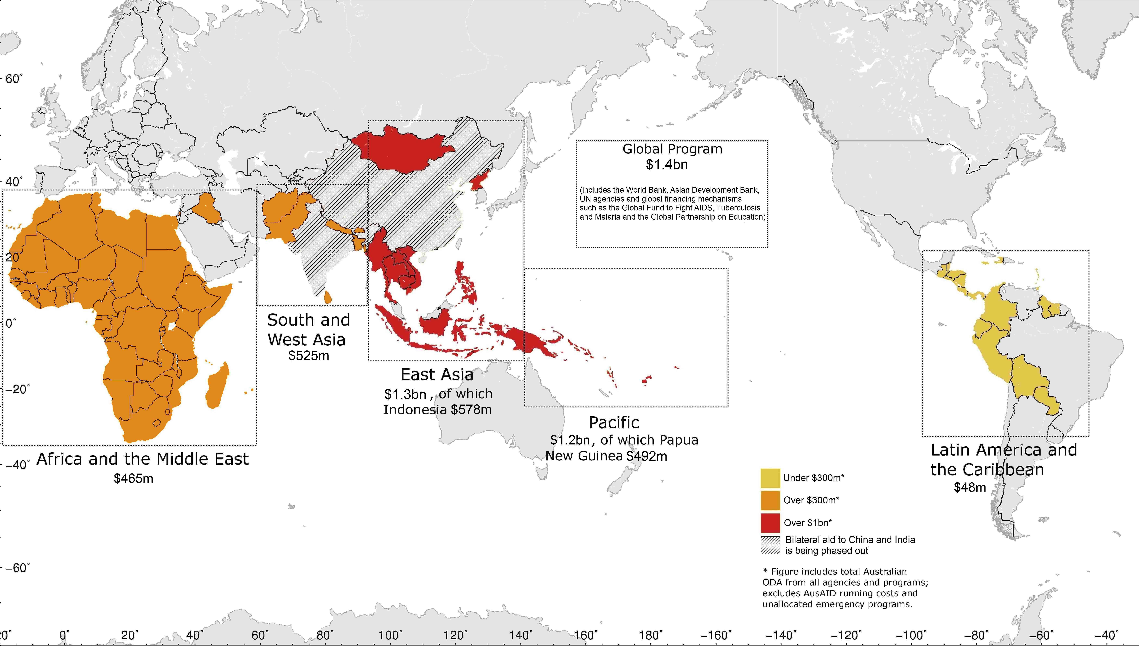
For further information on the Australian Government’s international development assistance program contact:
AusAID Communications & Media—phone + 61 2 6206 4000, fax +61 2 6206 4880 or write to GPO Box 887 Canberra ACT 2601.
The full Ministerial Budget Statement is at www.budget.gov.au.

What the aid program will deliver by 2015-16

Saving lives | - More than 10 million children will be vaccinated, reducing child deaths and illness  - More than 8.5 million people will be provided with increased access to safe water  - More than 5 million additional people will have increased access to basic sanitation and 5 million people will have increased knowledge of hygiene practices  - More than 1 million additional births will be attended by a skilled birth attendant
Promoting opportunities for all | - 20 million boys and girls will obtain a better quality education, through the training of 190,000 teachers and 300,000 school officials, and the provision of 12 million textbooks  - 4 million more boys and girls will be enrolled in school with 24,000 classrooms built or upgraded and 1.2 million students provided with financial or nutritional support  - More than 100,000 people will be provided with prostheses and other disability services and more than 500,000 boys and girls will attend schools that are more accessible to children with disabilities  - 40,000 women survivors of violence will receive services including counselling  - At least 17,000 people (half of them women) will be awarded tertiary scholarships and return home to assist their countries’ economic development
Sustainable economic development | - People’s access to services and markets will be improved with 9,600km of roads constructed, rehabilitated or maintained  - At least 4.2 million vulnerable women and men and children will be provided with social protection support such as cash transfers or basic nutritional support  - 2.3 million poor people (at least 50 per cent women) will have increased access to financial services such as loans to start small businesses and 1.4 million poor people will increase their incomes through market development programs  - 750,000 farmers (at least 40 per cent women) will be able to access new agricultural technologies, resulting in increased crop value of over half a billion dollars  - Up to 20 countries will be assisted with adaptation programs to reduce vulnerability to climate change and up to 10 countries will be assisted to minimise carbon emissions through technological and regulatory support as their economies grow
Effective governance | - Communities will have improved safety with 14,000 police and other law and justice officials trained  - Partner governments will become more effective at providing basic services to the poor with 23 countries supported to improve public financial management, training provided for 17,000 public servants (at least 25 per cent women), and 680 civil society organisations supported to track government service provision
Humanitarian and disaster preparedness and response | - 30 million vulnerable people will be provided with life-saving assistance in conflict and crisis situations  - AusAID disaster response will be launched within 48 hours of a request for assistance in anticipated humanitarian crises

