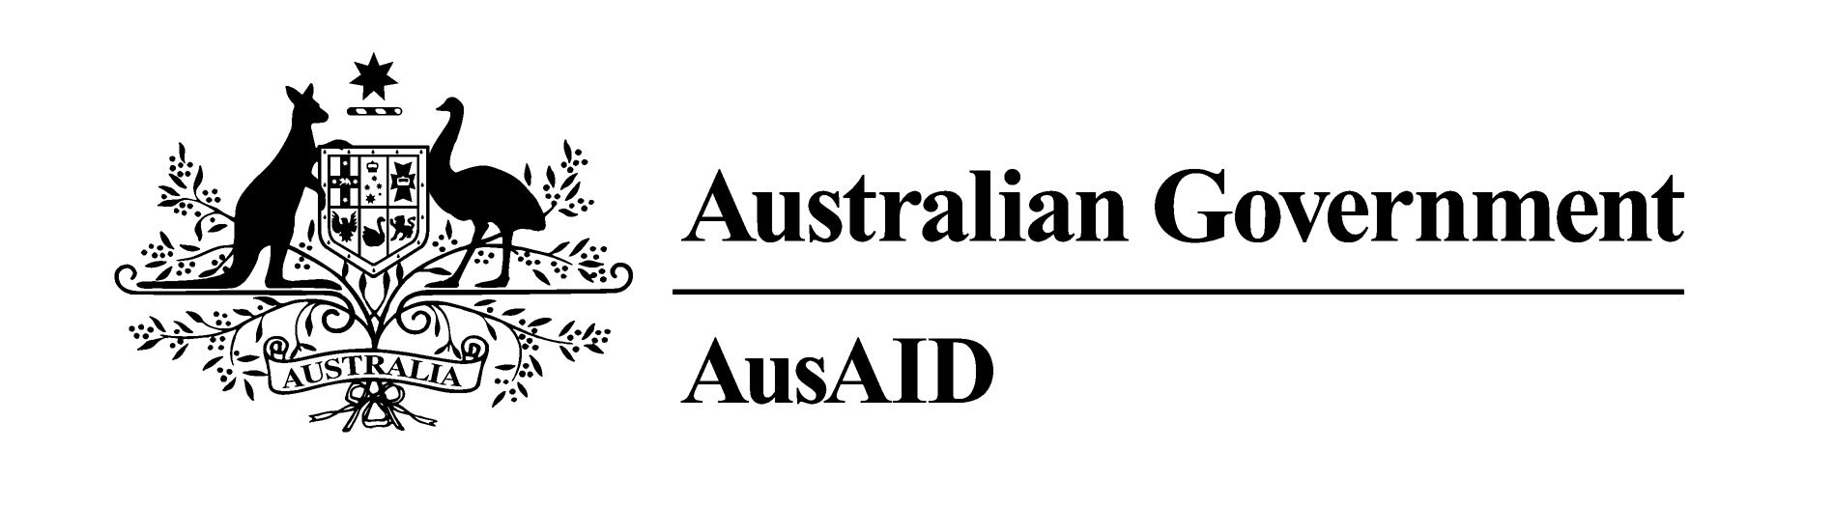

Summary of Australia’s Overseas Aid Program 2011-12

BUDGET HIGHLIGHTS
10 MAY 2011
Over one billion people still live in extreme poverty. Every day, 22,000 children under the age of five die from preventable or treatable conditions that have largely been overcome in Australia and almost 1,000 women and girls die in pregnancy and childbirth. Today, some 67 million children don’t have the opportunity to attend primary school.
Reducing poverty is in our national interest. Poverty breeds instability and extremism and creates conditions that lead to more refugees, as people flee from violence or hardship. Most of the developing countries in our region are also important trading partners for Australia. It is for these humanitarian, national security and economic reasons that the Government remains committed to increasing our aid to 0.5 per cent of our Gross National Income by 2015-16.
Australia’s foreign aid is forecast to increase from 0.33 per cent of Gross National Income (GNI) in 2010-11 to 0.35 per cent of GNI in 2011-12. Australia is committed to delivering better aid. We want to save as many lives, educate as many children and lift as many people out of poverty and as we can with our aid investment.

The 2011-12 Aid Budget at a glance

Total Australian Official Development Assistance (ODA) in 2011-12 is estimated at $4.8 billion, this is equivalent to 0.35 per cent of Gross National Income (GNI).

New aid funding in the 2011-12 Budget will implement the Government’s 2010 election commitments for the aid program on:
- improving access to education,
- better maternal health for women and children,
- access to water and sanitation,
- tackling avoidable blindness,
- eliminating violence against women, and
- Australian volunteers.

In 2011-12 around 89 per cent, of Australia’s aid will be delivered through AusAID, the remainder will be delivered through other Australian government agencies, such as the Australian Federal Police and the Australian Centre for International Agricultural Research.

Around half of Australia’s aid in 2011-12 is expected to be provided to the Asia Pacific region. The ten countries that are expected to receive the most Australian aid in 2011-12 – Indonesia, Papua New Guinea, Solomon Islands, Afghanistan, Vietnam, East Timor, Philippines, Pakistan, Bangladesh and Cambodia – are all in the Asia Pacific.

Assistance in the education, health and economic growth sectors is expected to comprise more than half of Australian aid expenditure in 2011-12.

AusAID’s humanitarian and emergency related expenditure is estimated to increase to $325.0 million in 2011–12. This will support the United Nations, Red Cross, and other international and Non-Government Organisations (NGOs) to meet humanitarian needs in Asia and the Pacific, Africa and other developing regions.

New initiatives in 2011-12

- Expanding assistance to Indonesia by building 2,000 schools and improving the quality of tertiary education; deliver rural infrastructure; and improve access to justice by piloting legal aid in fifty courts.

- Improving education in the Pacific to get more children into and completing basic education by providing textbooks, renovating schools, training teachers, and assisting with fee relief for disadvantaged communities.

- Expanding volunteer and NGO programs to provide for 1,000 Australian volunteers per year by 2013-14 and double the AusAID-NGO Cooperation Program by 2014-15, to allow a further 10 NGOs to participate in the program.

- Eliminating violence against women by supporting women’s crisis centres in the Pacific and through a partnership with the new United Nations agency for women, UN Women.

- Improving water, sanitation and hygiene to help over 4 million people access safe water, basic sanitation and improved hygiene practices across Asia and Africa.

- Tackling avoidable blindness to treat over 8,000 sufferers in East Asia and provide routine screening for a further 100,000 people.

- Expanding assistance to Africa and the Middle East
to improve health care for mothers and children in East Africa, provide safe water and sanitation to 1.2 million people in Southern Africa, build the capacity of African governments and respond to humanitarian needs.

- Australian Civilian Corps to deploy specialists to countries experiencing or emerging from conflicts and disasters.

For further information on the Australian Government’s international development assistance program contact:
AusAID Communications & Media—phone + 61 2 6206 4000, fax +61 2 6206 4880
or write to GPO Box 887 Canberra ACT 2601.
The full Ministerial Budget Statement is at www.budget.gov.au.

BUDGET HIGHLIGHTS (CONTINUED)

10 MAY 2011
Key sectors of the Aid Program
Development assistance programs in education, health and economic growth are expected to comprise more than half of Australian aid expenditure in 2011-12.
The Australian Government has refined the key sectors reported on in 2011 -12 to more closely reflect the objectives and nature of its activities.
The new key sectors which are used in 2011-12 are:
- Civil Society, Justice and Democracy - includes civil society and human rights, law & justice, and improving democratic processes. The sector includes core funding to Australian NGOs through the AusAID-NGO Cooperation Program.
- Economic and Public Sector Reform – to improve public sector performance to promote economic growth and deliver basic services.
- Economic Growth – includes programs in transport, energy and communications (formerly Infrastructure) as well as with agriculture, rural development and food security programs (formerly Rural Development).
- Health – this now also includes water, sanitation and hygiene programs reflecting their focus on public health outcomes.
- Education and Scholarships – includes basic education (primary and secondary education), higher education, technical and vocational education and scholarships.
- Climate Change and Environmental Sustainability – includes climate change adaption and mitigation, environment and natural resource management (fisheries and forestry).
- Humanitarian, Emergencies and Refugees – includes humanitarian and disaster relief assistance, support for refugees and contributions to UN peacekeeping missions.
- Multi-sector– other programs not able to be apportioned to particular sectors, including debt relief, core contributions to some international organisations, and the Australian Volunteers for International Development program.

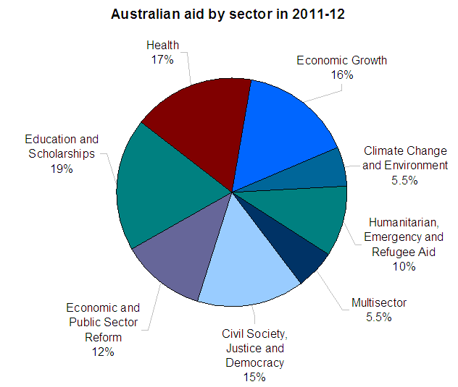
Geographic focus of the Aid Program 2011-12
In 2011-12 half of Australia’s aid is expected to be provided to the Asia Pacific region, our closest neighbours. Global programs, including contributions to the United Nations, World Bank, Asian Development Bank and other international agencies are a further 30 per cent of the aid program.

Increasing Australian aid
The Australian Government has committed to tying the aid budget to growth in the Australian economy. This commitment has been met in 2011-12 with an increase in Australia’s official development assistance (ODA) to 0.35 per cent of Gross National Income (GNI).
Although still below the OECD Development Assistance Committee member country average of 0.49 per cent of GNI, Australia’s ranking amongst the 23 member countries rose from 16th in 2009 to 15th in 2010.
Australia’s aid is expected to increase to 0.38 per cent of GNI in 2012-13, 0.42 per cent in 2013-14, 0.46 per cent in 2014-15 and 0.50 per cent in 2015-16.
Continued improvement in Australia’s ranking as a donor is to be expected in the coming years as the aid program increases to 0.5 per cent of GNI by 2015-16.

For further information on the Australian Government’s international development assistance program contact:
AusAID Communications & Media—phone + 61 2 6206 4000, fax +61 2 6206 4880 or write to GPO Box 887 Canberra ACT 2601.
The full Ministerial Budget Statement is at www.budget.gov.au.

