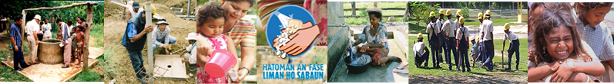
BESIK
c/o Direcção Nacional dos Serviços de Água (DNSA),
Ministério das Obras Públicas, Rua Jacinto Candido,
Caicoli, Dili
TIMOR-LESTE
Tel: +670 332 1978

BESIK
Australia East Timor Rural Water Supply and Sanitation Program (Phase 2)

Monitoring & Evaluation Plan

Update#1, Oct 2014

Public

BESIK
c/o Direcção Nacional dos Serviços de Água (DNSA),
Ministério das Obras Públicas, Rua Jacinto Candido,
Caicoli, Dili
TIMOR-LESTE
Tel: +670 332 1978

Disclaimer
This document has been published by the BESIK program, an Australian Government funded activity designed to improve sustainable rural water supply and sanitation in Timor-Leste, including services provided by Aurecon International Projects Pty Ltd in accordance with the provisions of DFAT Contract 64259. This report has been prepared for the exclusive use of DFAT. The views of this report do not necessarily reflect the views of Australian Government. Aurecon International Projects Pty Ltd and DFAT accept no responsibility whatsoever for any use of or reliance upon this report by any third party.

Document control 
Report Title |  | BESIK Monitoring & Evaluation Framework , July 2013
Document ID |  | M&E Plan#1 | Project Number |  | 232450
Client |  | DFAT | Client Contact
Rev | Date | Revision Details/Status | Prepared by | Author | Q & A | Approved
0.1 | 26 July 2013 | Draft – for comment | M&EA | M&EA | AUMEL | PD
1.0 | 21 0ctober 2013 | Final M&E Plan | M&EA | M&EA | AUMEL | PD
2.0 | 30 June 2014 | M&E Plan Update#1 | M&EA | M&EA | AUMEL | DFAT
2.1 | 30 October 2014 | M&E Plan Update incorporating DFAT comments | M&EA | M&EA | AUMEL | DFAT
2.2 | May 2015 | Public | AUMEL
Current Revision |  | 2.2

Aurecon International Projects Pty Ltd
Aurecon Centre
Level 8, 850 Collins Street
Docklands VIC 3008
PO Box 23061
Docklands VIC 8012
T +61 3 9975 3000 F +61 3 9975 3444 E melbourne@aurecongroup.com

Glossary & Abbreviations ii
1. Introduction 1
1.1 Program Description 2
1.2 Scope of BESIK M&E System 3
1.3 Strategic Approach 3
1.4 Evaluability Assessment 4
2. BESIK’s Monitoring and Evaluation System 5
2.1 M&E Principles, Purpose and Scope 5
2.2 M&E Plan 6
Program Logic 7
Performance Assessment Framework 9
The M&E Framework 10
2.3 Risk Monitoring and Management 11
2.4 M&E Tools 11
2.4.1 Existing BESIK databases 11
2.4.2 GoTL Management Information Systems 14
2.4.3 Other BESIK monitoring tools (still under development) 15
2.4.4 Baseline Studies, Formative Research and Evaluations 16
2.5 Utilization Approaches 17
Communication and Reporting 17
Critical Reflection and Continuous Learning 17
Joint Monitoring Visits 18
BESIK Six-monthly Performance Review 18
3. Resources Required to Implement the Performance Management System 19
3.1 Human Resources 19
3.2 M&E Budget 20
4. Cross-Cutting Issues 21
5. Risk Management Planning 22

Figures & Tables:
Figure 1: The Results-Based Approach 6
Figure 2: BESIK Program Logic (Revised June 2014) 8
Table 1: Key M&E Competencies Required 19
Table 2: Budget Sources for M&E 20
Table 3: M&E Inputs & Costings (AUD) 21

Annexes
Annex 1: BESIK Stakeholders and Data Needs 1
Annex 2: Revised Program Outcomes 2
Annex 3: Performance Assessment Framework (October 2014 revision) 4
Annex 4: BESIK Monitoring and Evaluation Framework (October 2014 revision) 10
Annex 5: Risk Management Matrix (June 2014) 15
Annex 6: Schedule and Contents of BESIK Reports 18
Annex 7: Schedule of Planned M&E Activities 19

Glossary & Abbreviations
ADN | National Development Agency
BESIK | Community WASH / Bee, Saneamentu no Ijiene iha Komunidade
BoQ | Bill of Quantities
CAP/PAK | Community Action Planning / Planu Aksaun Komunidade
CLTS | Community Led Total Sanitation
CoM  DAA | Council of Ministers  Department of Water Supply (district) / Departamento de Abastecimento de Água
DFAT | Department of Foreign Affairs and Trade
DGAS | Direcção Geral de Água E Saneamento (DNSA, DNSB, DNCQA)
DNCQA | National Directorate for Control and Quality of Water / Diresaun Nasional Controlo no Qualidade Aqua
DNSA | National Directorate for Water Services / Diresaun Nasional Serbisu Aqua
DNSB | National Directorate for Basic Sanitation / Diresaun Nasional Saneamentu Baziku
DNSP | Direcao Nasional Saude Publiko National Directorate for Public Health / previously DNSC Diresaun Nasional Sáude Komunitária
DPES | Department of Health Promotion and Education / Departmentu Promosaun no  Edukasaun Saude
DRWSA | District Rural Water Services Advisers
DSA | Department of Environmental Health / Departemento de Saude Ambiental
DTO | District Technical Officer
EA | Evaluability Assessment
EOPOs | End of Project Outcome(s)
GoA | Government of Australia
GMF | Water Facility Management Group / Groupo Managemen ba Fasilidade
GoTL | Government of Timor-Leste
HWWS | Hand Washing with Soap
LTA | Long Term Adviser
M&E | Monitoring and Evaluation
MAE | Ministry of State Administration/ Ministériu Administrasaun Estatal
MDGs | Millennium Development Goals
MoE | Ministry of Education
MoH/MdS | Ministry of Health / Ministériu de Saúde
MoPW | Ministry of Public Works
NGO | Non-Government Organisation
NRWSA | National Rural Water Services Adviser (heads Water Services Team, WST)
O&M | Operations and Maintenance
ODF | Open Defecation Free
PAKSI | Planu Aksaun Komunidade, Saneamentu no Ijiene / Community Action Planning, Sanitation & Hygiene
PDD | Program Design Document
PDID | Integrated District Development Planning
PSF | Family Health Promoters / Promotor Saude Familia Nian
RPP | Relatorio Provokasaun PAKSI – PAKSI Triggering Report
RWASH | Rural Water, Sanitation and Hygiene
RWSE | Rural Water Services Engineers
S&H | Sanitation and Hygiene
SAS | Serviço de Água e Saneamento / District Water and Sanitation Service
SDF | Sub-district Facilitator
SIBS | Water and Sanitation Information System / Sistema Informasaun Bee no Saneamentu
SISCa | Servisu Intergradu Saude Comunidade /Integrated Community Health Service
STA | Short term Technical Adviser
WST | Water Services Team – NRWSA, DRWSAs and RWSEs

Introduction
This document represents the first revision of the BESIK Monitoring and Evaluation Plan. Over the past six months, the interim DFAT BESIK Program Director and BESIK team have further integrated the intent of the Program Design Document (PDD) and pilots with the capacity development focus of this phase of the BESIK Program. In the first year of BESIK II implementation, the M&E focus was on measuring the community and household level outcomes that resulted from the pilot service delivery programs (eg: Hand Washing With Soap, HWWS). This was clearly reflected in the PAF and M&E framework.

The inputs of the interim Program Director and STA Capacity Development Specialist along with the Monitoring Review Group (MRG) have resulted in a change in the BESIK M&E system. The end-of-program outcomes have been reformulated back to the active tense of the PDD to focus on the desired change in the actors that BESIK is influencing. In addition to the indicators of community change reflecting successful service delivery approaches, the focus of the indicators for outcomes related to government and other actors is related to the extent to which they are carrying out their defined functions under both the pilots and other government functions supported by BESIK.

The outcomes have been consolidated so as to facilitate progress reporting that is more analytical and less fragmented against numerous outcomes for the same program area. For example, the government functions in implementing the hand washing with soap (HWWS) campaign have been consolidated into a single outcome that includes the functions of national, district and sub-district actors that are required to implement a successful campaign. A new tool – Capacity Development Monitoring Tool has been developed to support the Adviser-Counterpart discussion about the responsibilities of each and progress towards the counterpart assuming responsibility for a great number and range of functions and tasks. As such, the M&E of the pilots is also tracking the implementation system and processes as well as the final results in communities. This is still under development and will be rolled out with more advisers and program areas in the next six months.

The Change Strategies component of the previous M&E system was not being used for planning and reporting, and had not been utilised as a means of articulating the program logic or theory of change for the various program areas and pilots. It has been removed from this iteration of the M&E Plan. A new proposal format was introduced by the Interim Program Director in February 2014 that included Logic Model and a “mini-M&E Matrix” as annexes. These provide advisers with the tools to identify and articulate with their counterparts the theory of change of the program approach they are implementing. The “mini-M&E Matrices” that had been developed to date with Advisers were used to build the PAF and M&E framework for this document. They are also more specific and a more manageable size, for local staff and counterparts to begin to develop and understand M&E frameworks.

Some of the BESIK-specific databases have not been in use through BESIK II and some advisers and local staff have developed their own Excel-based systems for managing the data they need to inform program implementation. The preparation of the next Progress Report (July 2014) will clarify exactly what information is being sourced from databases such as the District Reporting Tool (DRT) and which are being stored and analysed with Excel spreadsheets. It has been identified that at least three of the custom-built databases from BESIK I - the Community Snapshot, OCAT and ZING have not been used for at least two years, thus have been eliminated from the description of BESIK M&E systems. A number of simple tools, utilising Excel for storage and analysis will be utilised for specific BESIK purposes with data managed by the responsible officers. The M&E Adviser will work with them for basic analysis to inform both program implementation and reporting. The focus for data collection for water system, GMF, and water and sanitation coverage as well as water system and GMF functionality will focus on strengthening the government information systems rather than meeting BESIK reporting needs.

Program Description
Phase 2 of the DFAT-funded Rural Water Supply and Sanitation Program, known in Tetum as BESIK (Bee Saneamentu no Ijiene iha Komunidade), commenced activities in September 2012. BESIK builds the capacity of the Government of Timor-Leste (GoTL) to deliver sustainable water, sanitation and hygiene services to rural citizens. Through BESIK, Government of Timor-Leste (GoTL) and the Australian Government (GoA) will work together to bring about change in behaviour or performance of a range of stakeholders in the sector: households, community water user groups, school students and GoTL staff, from central to district levels.

The program supports capacity building, organisational development, training and construction of water systems. It also includes community engagement in design and post-construction management in rural districts, district sanitation and hygiene promotion, including in selected schools. Market-based interventions for sanitation product marketing and distribution are also underway, together with mass media sanitation and hygiene promotion campaigns.

This support also includes the necessary research, data collection and financial analysis required to support the GoTL in its planning towards realistic MDG and future planning targets.

Program decisions will be guided by these overarching principles:
- improving shared ownership through direct dialogue and joint decision-making by GoTL and DFAT;
- maintaining a sharp focus on improved service delivery;
- promoting sustainable change across the sector, through cost-efficient service delivery models and market-based approaches; and
- generating evidence-based knowledge that can be applied by decision-makers in broader policy processes.

The principal program interventions include:
- pilot design, testing, and oversight;
- sector budget support;
- policy engagement;
- technical adviser personnel, on-the-job training and mentoring, scholarships and short courses;
- grants to NGOs and private sector for water system construction, training or community engagement;
- procurement of assets that enable improved service delivery.

The activities in BESIK Phase II are to be funded from an initial GoA four-year commitment of $AUD43 million.

Given Timor-Leste’s status as an emergent nation still establishing its structures and processes and with few rigorous systematic evaluations of approaches to water and sanitation service delivery, the BESIK M&E system needs to support program improvement and guide the evolving design, testing, and re-design of pilots and other innovative approaches that are being trialled.
In addition to regular data collection systems inherited from Phase 1 which are being refined to cater better for Phase 2, the M&E system in this Phase has an enhanced evidence-based focus requiring a more systematic approach to everyday M&E. Pilot studies to provide credible information on which to make decisions for scaled-up delivery are one aspect of this. So too is the use of formative research, participatory planning, reviews and reflection, community snapshots and simple studies to ascertain government, community and special groups’ views and issues, rapidly assess changes and target interventions better.

Scope of BESIK M&E System

The BESIK Program Logic, Performance Assessment Framework and the M&E Framework form the basis of the BESIK M&E system. Developed as part of a results-based management approach to program M&E (described in Section 2.2), these documents define outcomes, data collection and analysis that frames the accountability and continuous learning within the BESIK program.
The methods employed through the M&E aim to strike a balance between rigorous research methods that provide an evidence-base for policy outcomes and tools that provide simple measures for the capacity development outcomes of BESIK II. These tools, such as the Capacity Development Monitoring Tool (Appendix) aim to provide a mechanism for advisers and counterparts to define the precise functions required for effective program implementation and the scope of the capacity building focus. All tools have been developed with a view to the utilisation of data by program managers, rather than merely to provide data for donor reporting.
BESIK is a large, complex program that has many smaller ‘projects’ and ‘activities’ within its scope. Recognising that M&E must start with the planning phase of the project cycle, BESIK has introduced a Program Proposal template to ensure quality program planning. It requires that Advisers who are proposing and managing a set of activities articulate how their proposal fits into the broader BESIK and government strategy, define the program logic, M&E plan and get sign off from the key cross cutting advisers (GESI, PFM and M&E) prior to approval by the Program Director.
The M&E system aims to link knowledge generation with policy development and generate knowledge about the effectiveness of key initiatives. It will use systematic ‘knowledge to policy’ strategies and the partnership engagement arrangements of the BESIK Management Committee which feature direct dialogue, joint direction setting and decision-making informed by objective evidence provided by the M&E system.

Strategic Approach
BESIK works with its principal partners: three directorates in the Ministry of Public Works (MoPW) - the Directorate of Water Services (DNSA), National Directorate for Basic Sanitation (DNSB) and National Directorate for Control and Quality of Water (DNCQA) and in the Ministry of Health the National Directorate for Public Health (DNSP), Department of Environmental Health (DSA), Department of Health Promotion and Education (DPES). To a lesser degree, BESIK also works with the Ministry of Education (MoE), Ministry of State Administration (MAE/Estatal) and the National Development Agency (ADN). The BESIK Management Committee will be the key governance body for the program. The Management Committee is co-chaired by the Director-General of Water and Sanitation (DGAS) and the Director-General of Health. Members of the committee include BESIK’s counterpart Directors and Department Chiefs along with key DFAT personnel including the Program Director. The Management Committee will meet at least twice a year, providing strategic oversight to the program and approve annual work plans and budgets.
The main aim for BESIK implementation is increasing the capacity of its primary partners within GoTL to lead, plan for, directly fund and manage a growing number of activities in the Rural Water Supply, Sanitation and Hygiene (RWASH) sector, which will deliver improved and sustainable water services, sanitation and hygiene practices to rural communities.
The program has a focus on improving service delivery and management systems within the various levels of government - central, district and sub-district. The program’s service delivery focus includes:
- quality water system construction, and increasingly, operations and maintenance;
- district sanitation and hygiene promotion, including in selected schools;
- assistance to establish a network of district-based sanitarians (government sanitation promotion officers);
- market-based interventions for sanitation product marketing and distribution,
- mass media hygiene promotion campaigns;
- community engagement in design and post-construction management, enabling an effective community voice at district level for improved RWASH services.
Improved management focuses on central GoTL ministry policies; resourcing for decentralised provision of small- scale infrastructure, and the inter-ministry coordination required for sound implementation. It also includes strengthening of District Water and Sanitation Service (SAS) managers’ financial management, leadership and management practices, and the central reforms required to enable them to fulfil their roles.

Evaluability Assessment
In preparation for the M&E Plan in 2013, BESIK undertook an Evaluability Assessment (EA). An evaluability assessment is a systematic process to help determine whether a program is in a condition to be evaluated and to identify areas for improvement so that the program can put in place the necessary conditions to support an evaluation. An evaluability assessment also serves to clarify and update implementers’, partners’ and stakeholders’ understanding of the program goals, objectives and expected outcomes, and develops and/or strengthens broad involvement in and commitment to these.
The conclusion of the EA was that BESIK Phase 2 was evaluable, however a number of issues needed to be addressed before the M&E Plan could be implemented in full. These issues are still relevant and processes to address them are ongoing.

Issue | Actions to date
Refinements to the existing MIS modules | - Refinement is ongoing particularly for DRT and Traintrack.
Rationalization of the existing MIS modules | - BESIK MIS modules - ZING, Community Snapshot, OCAT no longer being used  - DRT will continue to be BESIK’s key database for community water system monitoring until SIBS/SPT issues are resolved.
Further partner dialogue | - Dialogue with GoTL partners occurred Jan-June 2014 clarifying BESIK II approach.
Quality of SIBS / SPT data | - BESIK proposal approved to create an audit team to audit SIBS for selected aldeias.  - Cross-reference SIBS data with other primary research conducted by BESIK in late 2014.
Support to partner data collection instruments and processes. | - In the second half of 2014, IMS Adviser is facilitating a review of DGAS information needs with relevant DGAS and BESIK staff. This will inform the update of the SIBS and SPT Information Management System.
Support to partners’ data collection processes | - SIBS data collection is limited by the institutional issues that affect Sub District Facilitator performance. As BESIK is taking a long-term institutional approach to addressing these issues, SIBS data collection is compromised.

BESIK’s Monitoring and Evaluation System
This section describes the BESIK’s Monitoring and Evaluation System, which is composed of the following elements:
- M&E Principles
- M&E Plan
  - Program Logic
  - Performance Assessment Framework (PAF)
  - M&E Framework
- Risk Monitoring and Management
- M&E Tools
- Approaches

M&E Principles, Purpose and Scope
It is important for the performance management system to be grounded on clear principles, to support the overall strategic direction, shape and effectiveness of the program. It is recommended that the following principles underpin the performance management system.
- Work to build the capacity of local partners to collect and use information as part of an effective performance management system
Building capacity of local partners means that government stakeholders need to be more involved in the design and implementation of the performance system. It requires achieving a balance between meeting the traditional requirements of donor reporting and accountability and the longer term needs of the RWASH sector.
- Do not be too ambitious – ‘Keep it Simple’ (but effective)
Data capture, analysis and reporting tools should be as simple as possible to ensure regular data capture and promote adoption by counterparts. This does not however, exclude the use of innovative technological tools, e.g. reporting via SMS messages or use of tablets for data collection and reporting, provided that these can be maintained and supported with the personnel and funding resources available to the sector.
- Use a balance of quantitative and qualitative information to develop a picture of program performance. Do not rely simply on quantitative measures.
Quantitative indicators are merely a measurement tool that can tell you what is happening in order to gauge progress and accomplishment. Tools that collect qualitative data, which also tell you why something is working or not, should also be incorporated into the system. Examples include evaluation studies, reviews and research, structured interviews, focus groups and case studies.
- Build learning into the performance management system
A performance management system must strengthen learning, program effectiveness and accountability for results. It must include events that promote critical refection that leads to improved action.

The purpose and scope of the BESIK performance management system is to enhance effectiveness, learning and accountability. Specifically the performance management system will:
- Provide Program partners and stakeholders with useful and timely information on program performance;
- Assess progress towards achieving BESIK outcomes, objectives and goal;
- Identify good practices and opportunities;
- Promote learning so that lessons learnt during implementation are incorporated into program plans;
- Assist BESIK and stakeholders to identify and mitigate risks;
- Assist BESIK and stakeholders to better understand the Program’s cause-effect relationships (theory of change);
- Enhance accountability to stakeholders by providing evidence to DFAT and to its partners that Program resources are being used efficiently, effectively and in a transparent and accountable manner;
- Contribute to the body of knowledge in:
- increasing community demand for improved water service delivery, sanitation and environmental health services
- improving the sustainability of community-managed water supplies
- Assist partner agencies to improve their own performance management systems.

The key stakeholders in the performance management system include:
- DFAT
- Monitoring and Review Group (MRG)
- Joint Management Committee (MC)
- DFAT Program Director and DFAT Activity Manager(s)
- MoPW-DNSA, DNSB, DNCQA
- District SAS
- MdS-DNCP, DSA, DPES
- Other Ministries involved in infrastructure
- Sector partners (NGOs and INGOs)

The roles and data needs of the principal BESIK stakeholders are given in Annex 1.

M&E Plan
The BESIK M&E System adopts a results-based management approach. This is a form of program theory or modelling where program performance can be monitored against a set of measurable indicators. Critical assumptions about conditions that will affect program success can also be identified and tested. Planning, monitoring and evaluation come together in results-based management, providing constant feedback, learning and improving. Existing plans are regularly modified based on lessons learnt through monitoring and evaluation and future plans are developed based on these lessons (Figure 2 below). At the same time the BESIK M&E System seeks to keep the focus on development assistance demonstrating real and meaningful results.

Figure 1: The Results-Based Approach
Achievement Criteria  (What are we trying to solve or achieve) | Indicators  (What evidence do we need? e.g. numbers, percentages, change in behaviour) | Baseline  (What is the situation now? | Targets  (What targets will we set?)
Outcome 1 | Indicator 1  The % who are able to…. | In June 2012  X% are able to …. | By Sept 2016  X+% are able to…
Outcome 2 | Indicator 2  Indicator 3
 |  | The movement (+ or -) from baseline to targets provides the focus for monitoring, evaluation and reporting.
The structure of this Monitoring & Evaluation Plan mirrors the structure developed for BESIK in 2010. This structure has been approved by DFAT and reviewers, and most of it is familiar to implementers and partners since mid-way through BESIK Phase 1. It consists of three distinct components:
- Program Logic
- Performance Assessment Framework
- M&E Framework
These components do not exclude other aspects of monitoring that might take place internally within each of the partners such as financial or activity monitoring. Indeed wherever possible, attempts are made to identify and utilize existing monitoring and reporting systems.

Program Logic
The BESIK goal, objectives and outcomes are fundamentally about improvements in the development and functioning of management systems and service delivery to enhance the capacity of the Government of Timor-Leste (GoTL) to provide sustainable water service delivery, sanitation and hygiene services to rural citizens. Performance monitoring and key evaluation questions within the M&E Framework will seek to reveal changes in behaviour or performance of a range of stakeholders in the WASH sector. These changes are BESIK’s end-of-program outcomes (EOPO).
The original program logic in the PDD was visually complex and conceptually difficult for stakeholders with 23 outcomes to be achieved by multiple delivery agents at a range of governance and geographic scales. Consequently the program logic has been simplified to improve its accessibility and the number of outcomes has been reduced to 16. They consolidate outcomes from the previous Program Logic and the PDD along the lines of the major program areas where BESIK is working with particular government counterparts and partners to affect behavioural and system change.
In February 2014, the BESIK Program Director introduced a new internal system whereby the approval of activities for funding is dependent on a simple proposal format that includes a logic model and M&E Plan. These documents provide the detailed back-up to the broader definition of the outcomes at a program level and articulation of the change strategies used. As such, the change strategies document has been removed from the M&E Plan. This proposal guideline is provided in the M&E Tool Appendix.
In this update, the EOP outcomes have been changed back to the active tense used in the Program Design Document (PDD) to better reflect the capacity development approach and focus on outcomes being defined as the change in behaviour of key partners.
The revised Program Logic diagram (Figure 1 below) is colour-coded to visually depict and separate water and sanitation-hygiene outcomes and the outcomes to be sought by different actors at a range of levels.

BESIK’s end-of- program objectives are:

Objective 1: All levels of Government with well-functioning systems for effective policy development, planning and management for rural water supply and sanitation
Objective 2: Rural communities have sustainable and equitable access to/ utilization of safe water
Objective 3: Rural communities and selected schools have sustainable & equitable access to/ utilization of improved sanitation and hygiene facilities

Progress against these Objectives will occur when supporting Outcomes are achieved. In order to retain a similar hierarchical look, Objective 1 was introduced in the July 2013 M&E Plan. However it does not carry out the role of an Objective; instead it merely provides a categorising label for the Outcomes listed beneath it. As such Objective 1 serves a different function from that of Objectives 2 and 3.
BESIK will contribute to the DFAT Aid Investment Plan (AIP) Goal: “People’s lives improve: healthier, safer, more productive.” BESIK’s contribution to this goal will be measured through the DFAT PAF, with the indicators and targets related to BESIK drawn from this M&E Plan. Further detail on the links with the DFAT PAF is provided in the next section.
The complete list of 16 revised outcomes is available at Annex 2 along with the rationale for their change.

Figure 2: BESIK Program Logic (Revised June 2014)

Performance Assessment Framework
The BESIK Performance Assessment Framework (PAF) is provided at Annex 3. It identifies the baseline situation and key indicators or targets that will be used to measure BESIK’s progress towards the achievement of its end-of-program outcomes and objectives.
The baseline situation for each desired outcome and objective is drawn from existing reputable published statistics, where available, or from results of end-line studies or evaluations undertaken prior to June 2012.
The PAF includes quantitative indicators developed in line with good M&E practice i.e. indicators should be specific, measurable, achievable, relevant and timed (SMART). Where appropriate, the indicators are consistent with international standards and conventions such as those established by World Health Organization (WHO) & United Nations Children’s Fund Joint Monitoring Programme for Water Supply and Sanitation (JMP, 2006).
The PAF encompasses both output and outcome indicators that have been developed to support benchmarking, i.e. the extent or measure of movement from initial baselines toward agreed targets for evaluating progress towards achieving the Program’s goal. Output indicators pertain to products, capital goods or services which are within BESIK’s control. In general, outcome indicators reflect changes in attitude, knowledge, behaviour or systems over which BESIK implementers could reasonably expect to have some influence.
The BESIK PAF includes a range of indicators that are also part of the DFAT Timor-Leste Aid Investment Plan PAF, and the core indicators that will be reported upon to Canberra by the Country Program. These include the following, with the indicators in italics those that are likely to be included as core indicators for the Country Program:
- % Caregivers of children under 5 observed hand washing before contact with food and after contact with faeces following exposure to BCC campaign in target districts
- Number of additional people with access to basic sanitation
- Number of additional people in target areas with access to safe water supply through BESIK systems (new/major rehabilitation)
- % of GMFs (Water Facility Management Groups / Groupo Managemen ba Fasilidade) in which at least 30% of members are women
- Number of people (men and women) trained in WASH-related topics.

Some performance questions have been included in the PAF to extend the complexity of the information gathered through the indicators, particularly in areas of strategic interest or program focus. They lend themselves to a more nuanced description of the situation that can be followed up by analysis of the factors that have caused the situation, the implications for the program and action required. A sample of performance questions in the PAF includes:
- What are the roles of the various directorates and ministries in RWASH service delivery and to what extent is BESIK’s support relevant?
- To what extent do RWASH national policies and implementation strategies reflect gender equality and social inclusion concerns?
- To what extent are DNCQA’s activities contributing to water supply planning and management?
- To what extent are SDFs fulfilling their key functions of facilitating CAP and supporting GMFs to engage with construction contractors?

The M&E Framework
Annex 4 depicts the M&E Framework, which is effectively a planning matrix for monitoring and evaluating the program. It details the actors both within BESIK and where relevant within partner organisations, their monitoring roles and responsibilities, timing and methodology for data collection and some indication of how the information collected will be analysed and disseminated. Roles and responsibilities have been negotiated with the responsible individuals to ensure that they have the time, resources and skills to carry out the role, and that reporting on allocated indicators reflects current political and program reality.
The planning matrix effectively operationalizes the PAF. For example, the draft M&E Framework in some cases indicates just the responsible Directorate; as discussions with partners’ progress, the names of directorates will be replaced with the names of the appropriate position titles. Both the PAF and the M&E Framework are to be modified annually to reflect changes in implementation and/or improved understanding of the type or scheduling of monitoring events or methods.
A program design focus of BESIK Phase 2 is on increasing the capacity of its direct partners (principally DNSA and MdS-DSA but also NGOs and other institutions). In order to determine the success of its intervention, the PAF indicators have been related to a broader evaluative question or ‘information need’ in the M&E framework that is related to capacity development. These broader questions will ensure that the BESIK reporting is more analytical about its context and progress, and has the scope to report on unexpected results, rather than simply reporting on quantitative indicators already defined in the PAF. Examples of these questions include:
- To what extent do GoTL management systems support efficient and effective service delivery across target MdS and MOPW Directorates?
- What are the functions required of government actors in order to sustainably implement an effective national Operations & Maintenance system for rural water supply?
- To what extent are key government actors effectively performing their functions as defined by the pilot approaches?

Once BESIK partners are fully conversant with the Phase 2 expected long-term and end-of-program outcomes, as noted above, the PAF and M&E framework will be finalised to contain further evaluative questions which seek to answer key issues from the program that are of interest to the program stakeholders and partners.
Meaningful evaluation questions can arise from a variety of program vantage points: context, implementation and/or results. Regardless of their origin, however, all parties to the evaluation need to come to agreement on the evaluation questions. Discussions at an early stage around partners’ principal, but perhaps divergent, interests in the program can help to establish a sound working relationship and lead eventually to shared ownership of the results of evaluation. Some candidates for Evaluation Questions might be:
- What is the most effective (including cost effective) approach to engage the private sector to increase coverage of improved sanitation?
- To what extent do O&M interventions improve the sustainability of rural water systems?
- To what extent are the policies, laws and regulations relevant to the needs of the RWASH sector in Timor-Leste?
The BESIK monitoring and evaluation framework is provided at Annex 5. It details the tools, processes, responsibilities and timelines for the collection and analysis of the M&E data. The M&E framework is a living document and reflects stakeholder information needs. The revised Program Logic, PAF and M&E framework will be shared with key partners, with any major changes to the PAF or to the scope of the M&E Plan approved through its annual updates.

Risk Monitoring and Management
Risk monitoring examines the context in which the program is operating to ensure that the program’s objectives and strategies remain relevant and that changes or shifts in the social, political or economic situation in Timor-Leste do not stymie the program. As a multi-faceted complex program, BESIK needs to productively navigate through a changing context. Therefore, its monitoring and evaluation system is required to provide clear guidance on how best to support a flexible and responsive program, while maintaining a strategic approach.
The original Risk Management Matrix in the Program Design Document (PDD) identified strategic level risks, which were primarily in the domain of the Steering Committee (now Management Committee) and DFAT. There will be opportunities to engage the Management Committee in risk mitigation when it convenes.
However there are also management and operational-level risks to the program that have been identified. These current risks refer to overloading government and NGO staff and systems by sharp increases in government funding; to reduced momentum for policy development if engagement of high-level government personnel proves difficult; and the possible risk of a log jam of pending activities at the district level with limited human resources available for implementation when momentum grows.
Risk mitigation responses have been identified in each of BESIK’s Progress Reports and the latest (June 2014) is provided at Annex 5. These will continue to be updated by BESIK as part of progress reporting. How risk monitoring and mitigation will be integrated into routine program reporting is described below at Section 5.

M&E Tools

2.4.1 Existing BESIK databases
BESIK Phase 2 has a number of data collection instruments available to it from Phase 1. These have been reviewed to determine the quality (reliability and validity) of data collected, their adequacy and appropriateness for reporting against activities, outputs and outcomes and their ability to support learning for this phase of the program.
While Phase 1 concentrated on creating and implementing data collection instruments to target specific program data needs as required, Phase 2 is concentrating on improving data collection, data quality and use. Phase 2 will also rationalize the existing MIS modules. This includes being clear on data collection requirements for “water access” versus “water delivery systems”. It will also involve exploiting potential synergies between established modules, especially the Sector Planning Tool (SPT), the District Reporting Tool (DRT) and SIBS in order to confirm and cross-check water system functionality with aldeia-level service delivery. Similar cross-checking for effectiveness and appropriateness will take place at the community, GMF and organisational capacity development level using improved versions of TrainTrack, DRT and GMF evaluation tools.
Phase 2 will work to ensure that current program data and information is readily available to the program implementers, in addition to partners and stakeholders, to inform planning and policy development, budgeting and implementation.
A number of separate databases with accompanying data collection systems currently make up the BESIK MIS for collecting sector-wide, district, suco (SISCa) and aldeia-level data. While this geographical spread sounds impressive, using different units of analysis complicates cross-checking from one database to another for verification or for assessment.
For example, SIBS collects information from an aldeia view of the world (aldeia access to improved water) while the DRT collects data on the basis of the water system, which may supply one or more aldeias. On occasion, one or more water systems supply a single aldeia.
In a similar manner, GMF financial and technical training is provided on a sub-district basis, not on a GMF basis, so GMF performance cannot readily be related to GMF training. In most cases, resolving these issues will require small adjustments to the content and method by which the data are collected.
An overview of the principal data collection instruments, their collection and reporting methods and proposed improvements is set out below. Hard copy data collection templates, where available, are available as a separate Appendix and provide an insight into the type of information being collected and its usefulness in tracking program implementation and achievements.

Tool |  | Focus | Collection and Reporting Methods
District Reporting Tool
 |  | Monitors the progress of activities in target communities at successive times in the water system’s life. Focuses on GMF and water system indicators over time. Also informs monitoring for gender equity and social inclusion (GESI). | Data are collected during CDO monitoring visits to Government and BESIK water system sites, stored on a memory stick and uploaded monthly to the BESIK Management Information System (MIS) for analysis and reporting. In some districts regular monitoring visits to distant sites presents challenges for data currency.
 | Proposed Improvements
With the increased emphasis in Phase 2 on district processes and management capacity building, the DRT has been expanded to include brief narratives on district activities.
It has been improved to allow the DRT to be used as a meaningful tool for the reporting of key issues either at a system or district level to National BESIK and GoTL stakeholders.
The DRT may be gradually phased out as a water system monitoring tool, as the government develops systems for the registration of water systems and GMFs that can link directly to the aldeia level monitoring.
TrainTrack
 |  | Manages training data including: training activities; personal profiles of trainees; service providers; trainee evaluation of the training | BESIK Advisers who organise/manage a training event are required to provide training data to the MEO who enters the information into the TrainTrack database. As required or requested the MEO provides summarised or individually requested data.
 | Proposed Improvements
 |  | The Learning and Development Adviser started work in June 2014 and has developed a package that builds on the existing Traintrack forms and will transition BESIK to the provision of competency-based training with follow up assessments of the change in participants’ performance in the workplace. This ‘package’ also includes peer assessment of the quality of the training and curriculum so that BESIK can have an evidence-base for the reporting of the quality of its training-related outputs.

Tool |  | Focus | Collection and Reporting Methods
Water System Checklist of Standards
 |  | Used originally by DRWSA and RWSE to monitor the extent to which system survey, design and construction complies with guidelines. | RWSDA and RWSE inspection reports are aggregated and entered into the BESIK MIS to provide information against output indicators in the 6 monthly reports and to demonstrate the quality of implementation.
 | Proposed Improvements
The use of this instrument will be updated to reflect new GoTL mandates as the locus of control over new water system infrastructure shifts. Under these arrangements Phase 2 seeks to empower communities to monitor construction. The Water System Checklist of Standards will continue to be used but as a BESIK data gathering tool and a capacity development opportunity between BESIK WST, DTOs and other interested district officers.
In 2013, BESIK was producing a Construction Monitoring Guide which is more appropriate to support community oversight of PDID infrastructure and which is usable by both communities and district technical officers. This has not yet been completed.
The utilisation of the Water System Checklist of Standards will be reviewed by the National Water Supply Adviser prior to the next M&E Plan review.
PAKSI Monitoring System (formerly Zing)
 |  | Originally created for use by BESIK to track the effectiveness of its Community Led Total Sanitation (CLTS) approach and during 2012 for the PAKSI program expanding CLTS. | Implementers of CLTS/PAKSI complete a Process Report containing details of the PAKSI Triggering Process. Information from follow up visits was entered into the Zing database at mid-line and end-line points, recording attainment of ODF status. District to National reporting is through the BESIK Saneamentors.
 | Proposed Improvements
The ACCESS database that is ZING has not been utilised by MdS or BESIK since 2012. They are however utilising the ZING/PAKSI data collection forms and BESIK is using Excel spreadsheets at a national level to manage the data from the three PAKSI pilot districts.
One of the reasons that the PAKSI monitoring has not been integrated into MdS monitoring and information systems appears to be that the program is not ‘registered’ as one of the programs for which data is officially collected at Community Health Centres. This will be followed up in Q3, 2014. Once this has been done, PAKSI monitoring can be integrated into a new ‘Supported Supervision’ monitoring system that is being developed using tablets by the MdS Monitoring and Evaluation Department. BESIK is coordinating with the M&E Adviser to move this forward.

2.4.2 GoTL Management Information Systems

GoTL data collection systems which are used by BESIK for planning and other purposes include:

Tool |  | Focus | Collection and Reporting Methods
SIBS, the GoTL Water and Sanitation Asset Information System:
 |  | SIBS provides information on a three-monthly basis of coverage, gaps and functionality of water systems in all rural aldeias in Timor Leste, not just those constructed by BESIK or the GoTL. The SIBS Community Profile is to be completed each time there is a major change to the water system. | Data are collected by SDFs and entered, via SMS texting, into a database in Dili. Results are aggregated and returned monthly to District Managers on CDs for their information needs. SIBS provides timely information on the status of water availability for all aldeias in Timor-Leste, serving as a cross-check for systems functionality data.
 |  | In the un-certainty of the political transition from elections in mid-2012 to the appointment of personnel to key positions in mid-February 2013, management and leadership for data collection at the district level lapsed. Management interest and ownership of the system has subsequently been reinvigorated with clear directives from central DNSA, but translating this into regular and accurate on-going data collection remains a work in progress. Community Profiles have rarely been updated.
 | Proposed Improvements
 |  | Scheduled individual and organisational capacity building at both central and district level will support development of management skills. At the same time, BESIK is investigating mechanisms for separating the collection of static versus dynamic data and of data on “water systems” versus “water access”. This will continue in the next quarter (Q3, 2014).
Sector Planning and Reporting Tool
 |  | The SPT monitors sector planning. It provides reports on progress towards national annual targets and global sector level indicators. Data are provided by partners twice a year on annual planned works across the whole RWASH sector to assist GoTL in its planning. | BESIK distributes the SPT to all partners in the WASH sector. Its use was later extended as a reporting tool, but unclear language and variable follow up appear to confound ‘potential beneficiaries’ with ‘actual beneficiaries’, limiting its use as a reporting tool. Sector partners’ reporting is varied and somewhat inconsistent.
 | Proposed Improvements
The SPT has been reconfigured with in-built reporting guidance and greater clarity. The first widespread data collection was conducted in November 2012 with a CD-ROM produced in March 2014 and distributed (with orientation to use it) to government counterparts and sector partners. The reconfigured version also facilitates sector linkages, e.g. with MoE school infrastructure data and potentially MdS clinic location data.
The new instrument is part of a phased approach to support sector performance management that begins by working with partners to develop and implement a performance management system to meet the needs of DNSA, MdS and the sector. The utilisation of the SPT to a water system register has been requested by government but is still under discussion with the BESIK Water Service Team.
Hydata, the GoTL hydrological database
 |  | Hydata provides storage and management of river level and rainfall data and is maintained by DNCQA. | DNCQA also collect data on the groundwater quality and quantity through two monitoring programs. However, these do not yet have any formalized data management and reporting protocols.
 | Proposed Improvements
 |  | The data collection, management and reporting activities of DNCQA will be reviewed during 2014, with the intention to establish a system where all of DNCQA’s data will be stored and implementation of regular reporting supported on all of DNCQA’s hydrological monitoring activities. This system is currently under design by the WRM Adviser, DNCQA and IMS Adviser.

BESIK Phase 2 will work to gain a better understanding of other government needs for monitoring data at national and sub-national levels and the institutional arrangements for M&E that must be established. This includes establishing stronger linkages between the planning and reporting tools referred to above and existing water system design and construction data to support future Operations & Maintenance (O&M) and improved GoTL planning. Discussions with MdS, DNSA and selected NGOs and INGOs on their respective reporting systems and requirements continue.

2.4.3 Other BESIK monitoring tools (still under development)
Tool |  | Focus | Collection and Reporting Methods
GMF Assessment
 |  | To provide the SDF with an instrument to assess the functionality of already established GMFs against key criteria.  It has a dual purpose of data collection and providing guidance for an action plan for further inputs and support to the development of GMF organisational and water system management capacity. | The SDF will utilise this tool to assess GMFs at least annually. They will initially do so with the support of the BESIK CDOs.  BESIK will initially utilise an Excel based system to store and analyse data.
 | Proposed Improvements
 |  | The GMF Assessment Tool has been developed and undergone limited field testing during the March 2014 SDF training. It will be further field tested in the next quarter (Q3 2014) and processes for the data storage and analysis will be finalised in Dec 2014.
Capacity Development Monitoring Tool
 |  | The Capacity Development Monitoring Tool was developed to assess the extent to which BESIK supports government actors behaviour change so they are able to assume responsibility for the functions necessary for improved service delivery in the areas either piloted or supported by BESIK. | Specific functions and tasks are defined by the BESIK Adviser and his/her counterpart. Data is collected through a discussion between the BESIK adviser and their government counterpart. This can be an individual or an organisational unit. Progress is monitored through a re-application of the tool at intervals defined between the Adviser and Counterpart (at least annually).
 | Proposed Improvements
 |  | The Capacity Development Monitoring Tool has been developed and utilised once by the BCC Adviser with her MdS counterparts. Other technical advisers have yet to utilise the tool. In the next quarter (Q3, 2014) the M&E Adviser will support other Advisers and GoTL counterparts to develop their assessment tools. The schedule for this is included in Annex 7. It will utilise Excel to enter and analyse data. The exact data analysis mechanisms will be developed as advisers implement the system.
Contractor Performance Assessment
 |  | To assess the performance of private sector and NGO contractors that are utilised by BESIK for service delivery.  The tool is based on the DFAT Contractor Assessment format and is general enough to be used for any service provided for BESIK. | The performance assessment will be conducted by the contract manager with the contractor or representative.  The assessment will be filed by the Contract Manager with a copy to MEO. Data will be analysed six-monthly for Progress Reporting.
Proposed Improvements
The contractor performance Assessment process will be further developed and test during the next reporting period.

DAA Meeting Monitoring Tool
 |  | To provide a simple measure of the effectiveness of the monthly DAA Management meetings.  It is a simple tool that will allow for on-the-spot real-time feedback to the DAA Chief about how to improve aspects of their monthly meetings and planning and reporting. | The BESIK officer or adviser who attends the meeting will collect the data through a discussion with the Chief DAA. The Leadership and Management Mentor is responsible for the aggregation of the data and providing 6 monthly reports to the M&E team.
 | Proposed Improvements
 |  | The format has been tested by the Leadership and Management Mentor in two districts for one month. Trialling will continue during the next reporting period.
GoTL Rural water supply environmental screening checklist
 |  | To provide an environmental compliance checklist for water systems, as per the GoTL Rural Water Supply Guidelines (Manual 4, Annex 12) | The members of the water services team (BESIK officer or adviser) will ensure that this form has been completed for all water systems to be built or rehabilitated through BESIK funds.
 | Proposed Improvements
 |  | The format has been in existence for a number of years and may need adjustment because while these assessments are being done, the documentation is not. The internal processes within BESIK will need to be adjusted. Trialling will occur during the next reporting period. Compliance will be included in progress reports.

2.4.4 Baseline Studies, Formative Research and Evaluations
This phase has an enhanced evidence-based focus requiring a more systematic approach to everyday M&E and the use of a range of instruments such as pilot studies to provide the credible information needed to make decisions for scaled-up delivery. BESIK will also employ participatory reviews, community snapshots and simple studies to probe government, community and special groups’ views and issues and rapidly assess changes. All require the preliminary collection of baseline information.
Pilot studies require careful framing and an M&E Plan developed by the key stakeholders in order to test, track and evaluate the trials to determine the approaches that will work best for scaled up delivery. Some for example, behaviour change communication initiatives, require both formative research to identify and refine effective messages and ensure the intended messages are being received as well as summative research/evaluation to determine what effect the initiatives have had on changing behaviour.
Pilots currently scheduled for 2014-16 include:
- Hand Washing with Soap behaviour change national campaign (rollout);
- Sanitation promotion (PAKSI) testing two implementation models:
  - Government sanitarians are the implementers in communities
  - NGOs are the implementers with government playing a contract management and monitoring role
- Sanitation Marketing testing two implementation models:
  - Small local producers who make and sell products
  - Larger suppliers of sanitation ‘packages’ that may include local or imported materials.
- Development of Phase 2 for Hand Washing With Soap (HWWS) campaign targeting fathers and grandparents;
- Operations and Maintenance (O&M) Pilot;
Effective gender and social inclusion interventions require preliminary research to understand the cultural and social context as well as on-going monitoring and assessment to track the impact of interventions on more equitable outcomes. Studies conducted in 2013 included:
- Menstrual hygiene practices and behaviours;
- Women’s contributions in GMFs – impacts on the GMF and on women themselves;
- Analysis of time spent by women and men in daily activities setting the baseline for a longitudinal WASH study of the social and economic activities arising from time liberated by an improved water system;
- Assessing the effectiveness of GMF technical and financial training Sanitation marketing research.

Additional interventions to provide evidenced-based data to inform RWASH policy planned for 2014-2015 may include:
- Trial of mechanisms for communities to hold RWASH service providers accountable;
- Contribute to the Monitoring of the DNSB incentives program;
- Contribute to School WASH program monitoring;
- Action research of vulnerability and access issues in the community.
Terms of Reference for studies can be requested and supplied as they become available.
As the need for additional evaluations is identified, these will be organised as required so as to assess program achievement in terms of relevance, effectiveness, efficiency, impact and sustainability. The complexity and resources allocated to each will reflect the significance and magnitude of the potential outcomes.
All monitoring and evaluation activities reflect international standards for evaluation practice, such as the Joint Committee on Standards for Educational Evaluation, Program Evaluation Standards (JCSEE). In addition qualitative research/studies follow standard NH&MRC ethics procedures to secure informed consent and ensure participants’ willing participation, privacy and confidentiality, seeking advance permission for the use of any photographs taken.

Utilization Approaches

Communication and Reporting
An analysis of the information needs of various BESIK stakeholders was undertaken as part of the Evaluability Assessment. A schedule showing content and timeframe of required reports has been prepared to meet those stakeholders’ information needs. This is provided as Annex 6.
The main substantive report for BESIK II is the six-monthly Progress Report to DFAT. Critical reflection and analysis activities will be timed around the reporting schedule (Jan 31st and July 31st). An abridged version of this report will be prepared for GoTL partners and used as a discussion tool for individual meetings with the Program Director as well as being formally tabled at the BESIK Management Committee meetings. Public versions of such reports will be made available by DFAT.

Critical Reflection and Continuous Learning
Performance management data will help improve the Program if it is used in structured critical reflections with relevant stakeholders. In general, data collection instruments report “What?” has happened. BESIK will extend this to also ask the practical questions of "So what?" and "Now what?”. This practical approach is complemented through performance questions and critical reflection to ask "Why?”. BESIK will support critical reflection and continuous learning through:
- At least six-monthly program review meetings with key institutional stakeholders to reflect and refocus and increase clarity and consensus about how to build on success and redress problems;
- Support to external events, such as Monitoring and Review Group visits and Mid-Term Reviews as these are valuable opportunities to see the project through different eyes and identify strategic improvements;
- Evaluation studies to provide evidence-based data as detailed above.

Where possible the M&E Adviser will utilise regular meetings of both government partners and of the BESIK teams themselves to encourage critical reflection. A schedule of M&E Adviser participation in these meetings, and the topics for analysis will be set for 2015. This will be done in December 2014.

Joint Monitoring Visits
BESIK will provide support for multi-partner monitoring activities including joint monitoring visits to rural communities implementing RWASH activities. These activities will provide an opportunity for information sharing and contribute to improving mutual understanding and coordination. These will also support a common basis for joint assessment and mutual accountability at an operational level, complementing strategic collaboration and joint accountability at the Management Committee level.

DNSA have requested BESIK support to rollout Joint District Monitoring Visits as has been implemented by WaterAid in Liquica. This will be the focus of BESIK’s joint monitoring efforts in 2015. A schedule for these and assessment guidelines will be developed in Quarter 1 2015.

BESIK Six-monthly Performance Review
A BESIK performance review will be conducted as part of annual planning and comprise:
- Brief summaries of progress towards achieving outputs and results with a focus on identifying activities that require alteration;
- An analysis of key strategic issues and risks affecting implementation;
- A review of cross-cutting issues;
- An analysis of lessons learnt and opportunities for improving program performance;
- A review of M&E processes and tools and recommendations for refinement; and
- A review of BESIK targets and setting of realistic targets for the subsequent year.

The schedule of all M&E Activities, whose timing is already set, is shown in Annex 7.

Resources Required to Implement the Performance Management System

Human Resources
This section addresses the capacity of BESIK and its partners to participate in the design and implementation of M&E activities. A review of M&E systems has begun generally in the context of planning current and future activities with partners. This provides some understanding of partners’ internal capacity as it relates to the BESIK M&E Framework, as well as understanding the M&E system(s) in place in each ministry.
Within the MdS, there is clearly an interest by new managers in collecting and using monitoring data to improve program delivery and management, in addition to documenting accurate health statistics. A similar interest is evident with DAA Chiefs, which is also driving a demand for timely and accurate data collection via SIBS. Further investigations will be required to assess whether interest and skills for structured reporting on outcomes (such as changes in institutions’ practices and officers’ capacities) is as strong.
The key actors and competencies required to implement the performance management system are outlined below.

Table 1: Key M&E Competencies Required

Key Competencies Required by | BESIK M&E Officer | DNSA M&E Officer | BESIK Advisers | BESIK CDOs | DNSA Managers | National Training Officer | DNSA DAA Chiefs & CWSDOs | DNSA SDFs | DSA Staff & Sanitarians | DPES staff | NGOs & Contractors
BESIK M&E processes and tools | ✔ | ✔ | ✔ | ✔ | ✔ |  | ✔ |  | ✔ | ✔
Data collection techniques | ✔ | ✔ | ✔ | ✔ |  |  | ✔ | ✔ | ✔ | ✔ | ✔
Data analysis techniques using Excel | ✔ | ✔ | ✔ | ✔ | ✔ | ✔ | ✔ |  | ✔
Report preparation using Word | ✔ | ✔ | ✔ | ✔ | ✔ | ✔ | ✔ | ✔ | ✔ | ✔ | ✔
Organizational Capacity Assessment Tool |  | ✔ |  |  | ✔
DNSA reporting systems | ✔ | ✔ | ✔ |  | ✔ |  | ✔ | ✔
MdS reporting systems | ✔ |  | ✔ |  |  |  |  |  | ✔ | ✔
Preparing lessons learned | ✔ | ✔ | ✔
Identifying risks and opportunities | ✔ | ✔ | ✔
Community Profiling/Snapshot Tool | ✔ | ✔ | ✔ | ✔ |  |  | ✔ | ✔ |  |  | ✔
Community engagement tools | ✔ | ✔ |  | ✔ |  |  | ✔ | ✔ | ✔ |  | ✔
Field monitoring and reporting | ✔ | ✔ | ✔ | ✔ | ✔ |  | ✔ | ✔ | ✔ |  | ✔
Training Database (Train Track) | ✔ | ✔ | ✔ |  |  | ✔
Training evaluation | ✔ | ✔ | ✔ | ✔ | ✔ | ✔ | ✔
SISCa and KUBASA |  |  |  |  |  | ✔ |  | ✔ | ✔ | ✔ | ✔
A number of the key competencies identified in the table above indicate new skill requirements for some program partners and stakeholders to support improved planning and management systems at both central and district levels. For example:

District (and central) managers will need to be able to:
- Read, understand and manipulate spread sheets of SIBS data to monitor water system functionality status, operation and maintenance, HR management, financial management;
- Understand training evaluation when it expands to include a practical assessment by supervisors of improved staff capacity.
Increased attention to sanitation and hygiene will require Sanitarians (MdS/DSA) to:
- Have knowledge of SISCa and KUBASA;
- Appreciate techniques for field monitoring, data collection and reporting ;
- Review and assess the appropriateness of some BESIK M&E tools such as Zing for their own program purposes, e.g. monitoring CLTS adoption and maintenance.
Increased emphasis on evidence-based knowledge and decision making requires a range of partners, stakeholders and BESIK staff to understand:
- The concept of a pilot, and pilot design, testing and oversight;
- BESIK M&E processes and tools;
- Data collection techniques.

Initial assessments have revealed a need to skill participants in reading and manipulating spreadsheets, viewing and understanding performance databases, amongst staff, partners and stakeholders. M&E Competencies will be included as part of the HR assessment to be conducted by the Learning and Development and OD/HR Adviser in the second half of 2014. As further investigation proceeds, the required competencies will be addressed through a mixture of formal and on-the-job training, taking into account existing skills and linking to other capacity building activities with the same target partners.

M&E Budget
The source of funds for various monitoring and evaluation activities is shown in Table 2.

Table 2: Budget Sources for M&E
Event | When | Participants | Budget Source
BESIK Progress Reporting | Half Yearly | BESIK Team | Personnel inputs Operational
Annual Program Review | Half yearly or Annually TBD | BESIK Team and Partners | Personnel inputs & Operational
Annual Performance Management System Review | Annually | BESIK Team | Operational
Community Snapshot Tool | Baseline and Endline | NGO/CDO/SDF/ Community | Included in contract with NGO/SAS
Capacity Development Assessment Tool | Annually | DNSA/SAS/MdS | Operational
MRG visits | 6 monthly or annually | MRG Team | DFAT from Program Funds
SDF SIBS Field Monitoring | On-going | SDFs | DNSA with BESIK operational support
Joint Monitoring Visits | Annually | BESIK and Partners | Operational
Mid-term Review | Mid-term | External evaluation team | DFAT from Program Funds
Special studies/ M&E of Pilots | As identified | Depends on subject of enquiry | Operational

According to the PDD, approximately 7% (of $43 million or $3.01 million) of BESIK’s budget will be allocated to monitoring and evaluation - one that reflects and allows the implementation of the evidence-based approach underpinning Phase 2. This allocation includes resources for managing the joint results framework; program M&E requirements; pilot studies; and independent evaluations or reviews as well as information management support.
M&E resources available to the program include:
- LTA International M&E Specialist – full time
- LTA International IMS Specialist – (10-20%)
- LTA (National) M&E Officer/Data Manager
- STA inputs for specialised technical and research inputs, e.g. designing pilot elements, training and mentoring to pilot implementers, processing data etc., either engaged directly or through a specialist research agency, e.g. university institute
- Monitoring and Review Group
- Independent Evaluation Team (Year 3/4)
- Joint Steering Committee field monitoring

The following table provides a preliminary summary and costing for various M&E inputs.

Table 3: M&E Inputs & Costings (AUD)
Item | Per year | Over 4 years
LTA & LES inputs
International M&E Specialist full time | Full time | Full time
International Information Management Specialist | Full time | Full time
National M&E Officer/Data Manager full time | Full time | Full time
National Enumerators (5) @ $7200 pa (for remaining 3 years) | $36,000 | $108,000
STA inputs
Selected technical inputs, e.g. data analysis, designing pilot elements, etc. | $15,000 | $60,000
DFAT External Input
Monitoring and Review Group |  | $360,000
Independent Evaluation Team (Year 3-4) |  | $90,000
SC/DFAT
Field monitoring (on request) |  | $32,000
Scheduled M&E Activities
Annual Program Review – Workshop | $4,000 | $16,000
M&E of Pilot @ $25,000 - $45,000 each, estimate 6 over 4 years |  | $210,000
Special Studies @ $3000 each, estimate 2 p.a. | $6,000 | $24,000
Operating Funds – field visits, SAS involvement, | $5,000 | $20,000
IMS Support and Activities
Ongoing support to SIBS - communication, training and other costs | $15,000 | $60,000

Taking into account the personnel inputs, this approximates the 7% in the PDD. As indicated in the EA report, this will need to be monitored over the life of the program.

Cross-Cutting Issues
BESIK is supporting the construction of water and sanitation facilities that are sustainably managed by communities assisted by government, which align with government policy and customary law, promote gender equity and social inclusion (GESI) and are in balance with the natural environment. The key cross-cutting issues that will be monitored during BESIK implementation include:
- Gender Equity and Social Inclusion
- Environment
- Anti-Corruption
- Sustainability (through Community-Led Management)

Indicators for monitoring and analysis of cross-cutting issues are included in the BESIK PAF. The key M&E routine data collection processes and tools that will provide data on cross- cutting issues include:
- Monitoring of the community engagement process
- Community Snapshot Tool
- Organisational Capacity Assessment Tool
- Train Track (Training Database)

Indeed, although listed here as cross-cutting issues, GESI and Environment are mainstream issues for BESIK. BESIK includes a focus on the protection of water resources both at a strategic and planning level, strengthening the systems with DNCQA and at community level in terms of community-based protection of water sources. A key component of BESIK is to support greater understanding of water resources and support planning for the impact of climate change on water resources. The BESIK Environment Policy (inherited from Phase 1 - 2011) should be reviewed and updated to ensure relevance with Phase 2 and compliance with the 2012 DFAT Environmental Management Guide.
Gender and social inclusion has been an integral part of the EA process and the workshops and stakeholder discussions. This is reflected in the strong presence of gender and inclusion indicators in the PAF. The GESI adviser will be developing a DFAT-approved Gender and Inclusion Strategy which will be integrated into the PAF during the next reporting period (Q3 2014). A preliminary outline for the GESI strategy was provided as Annex 9 of the M&E Plan, July 2013. In addition, many of the planned studies, formative research and evaluations listed in Section 2 target gender and social inclusion, vulnerability and access issues in the community.

Risk Management Planning
Annex 5 contains the Risk Management Matrix as at June 2014 that shows the key risks to project implementation and the key methods to ameliorate risks.
Risk monitoring, augmented by context assessment, has been integrated into routine program discussions and reporting. Given the potential for rapid change, DFAT and GoTL require the flexibility to adapt to unforeseen challenges, take advantage of new opportunities, and respond to identified risks to the program as implementation progresses.
Advisers have been requested to actively search for significant changes or influences in the program context which might affect the BESIK program and to report this information regularly. The Management Team then notes, discusses and subsequently tracks issues arising to improve risk management and mitigation.
As new “projects” and “activities” are proposed any key risks are identified in the approval form. Risks associated with capacity building workplans, which may be jointly owned by the BESIK program and counterparts, are noted in the capacity building plans.
Significant issues inform the preparation of consolidated risk management reports for the six-monthly meetings of the Management Committee. These latter meetings will be the main venue for stakeholders and partners to discuss intervention and development risks arising.
The Risk Management Matrix will be reviewed and updated biannually in advance of the 6 Monthly Reports to also coincide with the annual review and planning process. The Program Director also has a key role in planning, identifying and reviewing the strategic risks impacting on the program.



ANNEXES

Annex 1: BESIK Stakeholders and Data Needs
Annex 2: Revised Program Outcomes
Annex 3: Performance Assessment Framework (October 2014 revision)
Annex 4: BESIK Monitoring and Evaluation Framework (October 2014 revision)
Annex 5: Risk Management Matrix (June 2014)
Annex 6: Schedule and Contents of BESIK Reports
Annex 7: Schedule of Planned M&E Activities
Stakeholder | Roles | Strategic and Operational Data Needs
DFAT | DFAT will use data provided by Program management and from their own sources (e.g. Monitoring Review Group) to make decisions on the overall performance, the strategic directions and the type of activities it should support. BESIK progress and performance information will feed into the Quality At Implementation (QAI) reports and the country Annual Program Performance Report (APPR). DFAT is also expected to actively promote information sharing between programs and identify opportunities for developing greater synergies between GOA funded activities in Timor-Leste | - Program contribution to achieving MDG goals  - Program outcomes  - Budget and expenditure  - Risks and mitigation  - Emerging impacts  - Lessons learnt
Monitoring Review Group (MRG) | The MRG will use information provided by Program management and from their own sources (e.g. field visits and stakeholder consultations) to assess program performance and provide advice on strategic directions and challenges faced by the program. | - Program outcomes  - Risks and mitigation  - Emerging impacts  - Lessons learnt
Management Committee (MC) | The joint MC consists of Director-General, Director and Department Chiefs GoTL and DFAT representatives. The joint MC will use data provided by program management to make decisions on the strategic directions and on policies of the program and other activities it should support. | - Program contribution to achieving MDG goals and GoTL Strategic Development Plan 2011-2030  - Program outcomes  - Risks and mitigation  - Issues arising particularly affecting policy  - Emerging impacts
DFAT Program Director and Activity managers | The PM and PD will use data primarily provided by program reports to provide strategic direction to and quality assurance of operational support by Program personnel to the key counterpart agencies and other stakeholders in the planning and implementation of rolling plans. | - Program outcomes  - Budget and expenditure  - Risks and mitigation  - Emerging impacts  - Lessons learnt
DNSA | DNSA managers will use data primarily from district DAA offices to coordinate the delivery of water supply and sanitation services | - Details of water supply and sanitation activities completed in each district  - Water system locations, coverage and access
DAA  (District) | DAA Chiefs and CWSDOs will use data primarily provided by the Sub District Facilitators and NGO/Contracts to monitor the status of water supply and sanitation activities in their district. | - Status of community engagement process in BESIK communities  - SIBS data for SDF field visits including status of water supply systems across the district
MdS EHD/DSA | The Environmental Health Department will use data from KUBASA, and information provided by Program management via the Sanitarian pilot, from SIBS and BCC evaluations to monitor outcomes of the behaviour change initiatives | - Data on the implementation status of the sanitation promotion program (PAKSI)  - BCC evaluations (HWWS and Sanitation and Hygiene)  - ODF status of PAKSI-targeted aldeias.
Annex 1: BESIK Stakeholders and Data Needs

Annex 2: Revised Program Outcomes
Restated Outcome | Outcome in M&E Plan 2013 | Justification
Goal: People’s lives improve: healthier, safer, more productive | To improve the health and quality of life of rural people in Timor-Leste | Overall goal was not included in PDD. More appropriate that BESIK contribute to DFAT broader goal. BESIK contribution can be assessed through IAP PAF and broader impact studies that includes BESIK’s as well as other DFAT programs (eg: stunting – BESIK, nutrition, Seeds of Life).
1.1 DGAS and MDS develop and implement coherent national policy framework for Water and Sanitation service delivery. | 1.1 A coherent national policy framework including strategies for implementation of Water and Sanitation service delivery and Water Resources is developed by National Agencies | Change tense of outcomes back to the active tense of the PDD to emphasise that the focus of the program is on the behaviour change in key actors.  Also specify DGAS and MDS as the actors that must lead these policy processes.
1.2 Government of Timor-Leste allocates adequate resources to water and sanitation service delivery*. | 1.2 Adequate resources are allocated by Government to water and sanitation service delivery and promotion | Active rather than passive tense (as above).
1.3 MoPW and DGAS more effectively manage human, financial and material resources (HR, budgeting, planning, monitoring) for equitable and sustainable service delivery.* | Combine 1.3 and 1.4 | Active tense (as above)  Only refers MOPW and DGAS because this is where BESIK is influencing. Decision by PD (June 2014) to remove reference to MdS as the BESIK program influences only a small section of the MdS structure and cannot expect to have major influence on broader institutional systems.  Combines 1.3 and 1.4 because there was overlap in content and not a clear demarcation between the two.
2.1 DNSA effectively performs its functions to plan, manage and oversee the quality of rural water system construction and rehabilitation | Combine 2.1, 2.4 and 2.6 with relation to government functions for water supply construction and rehabilitation | Active tense.  According to Ministerial Diploma, DNSA refers to national and district structures. Consolidation of government-related outcomes to facilitate more coherent reporting with capacity development focus.  The outcome and PAF focuses on change in the partners that BESIK is working with for rural water system construction and rehabilitation.
2.2 DNCQA effectively performs water resource management functions critical to sustainable water supply. | 2.2 Water Resource management functions critical to sustaining rural water supply are performed by DNCQA | Active tense.
2.3 DNSA support communities to plan and manage rural water system operations and maintenance | Combine 2.3, 2.5 and 2.6 with relation to DNSA functions for water O&M. | As for 2.1 change but with focus on operations and maintenance functions.
2.4 Private sector (suppliers, contractors and NGOs) provide high quality and cost effective RWS services to the GoTL and community clients. | Combines outcome 2.6 (part), 2.7, 2.8 and part of 2.9 | Return to PDD Program Logic that has a level referring to desired change in private sector and NGO actors. Consolidates NGO, contractor and suppliers as private sector actors. To date BESIK II has not engaged with suppliers (spare parts) or NGOs with respect to traditional NGO roles of monitoring and holding service providers to account. This outcome is broad enough to allow for that.  Will allow for specific reporting on how BESIK is engaging with the private sector, and the contribution of private sector actors to the overall development objective.
2.5 GMFs and communities maintain their water supply systems and participate in the planning and monitoring of water system construction and complex repairs. | Combines part of 2.10, 2.11 and 2.12 | Consolidation of community and GMF related outcomes across all stages of water system planning, construction and ongoing management.
3.1 DPES, SDS and SSS deliver effective hygiene behaviour change campaigns. | Combines parts of 3.1, 3.2, 3.3 and 3.5 related to BCC campaigns | Previous reporting was confusing with the various sanitation and hygiene related ‘programs’ reporting within a single outcome.  This structure separates the various program foci – BCC campaigns, sanitation promotion (PAKSI), sanitation marketing, school WASH. Each working with different departments within MdS and DNSB in MOPW. Will allow a focus on capacity development for the functions to implement each piloted “program” to be identified and reported against more clearly.  Combines national, district and sub-district functions that will allow for reporting of how each is contributing to the implementation of the overall ‘system’.
3.2 DNSB effectively promotes the marketing and socialization of basic sanitation services and other issues of public sanitation and hygiene. | Combines parts of 3.2 and 3.3 related to related to sanitation marketing
3.3 DSA, SDS and SSS deliver effective sanitation promotion programs. | Combines parts of 3.1, 3.2, 3.3 and 3.5 related to sanitation promotion (PAKSI)
3.4 MdE and MdS deliver effective sanitation and hygiene behaviour change programs in selected schools. | Combines parts of 3.1, 3.2, 3.3 and 3.5 related to School WASH
3.5 Private sector (contractors, marketing companies, suppliers and NGOs) provide high quality and affordable sanitation and/or hygiene promotion related products and services to their GoTL and community clients. | 3.4 and 3.5 | Return to PDD Program Logic that has a level that refers to desired change in private sector and NGO actors. Consolidates NGO, contractor and suppliers as private sector actors.  Will allow for specific reporting on how BESIK is engaging with the private sector, and the contribution of private sector actors to the overall development objective.
3.6 Rural households adopt target hygienic behaviours. | 3.7 | Separates the BCC from the construction of latrines for clarity of reporting.
3.7 Rural households construct/purchase and maintain hygienic latrines. | 3.6 and 3.7 | Clarity of reporting – will allow focus on the results of PAKSI and Sanitation Marketing.
3.8 Students and school staff in target schools adopt hygienic behaviours and maintain hygienic sanitation facilities. | 3.8 | Will allow focus on behaviours of students, school facilities.
Annex 3: Performance Assessment Framework (Oct 2014 revision)
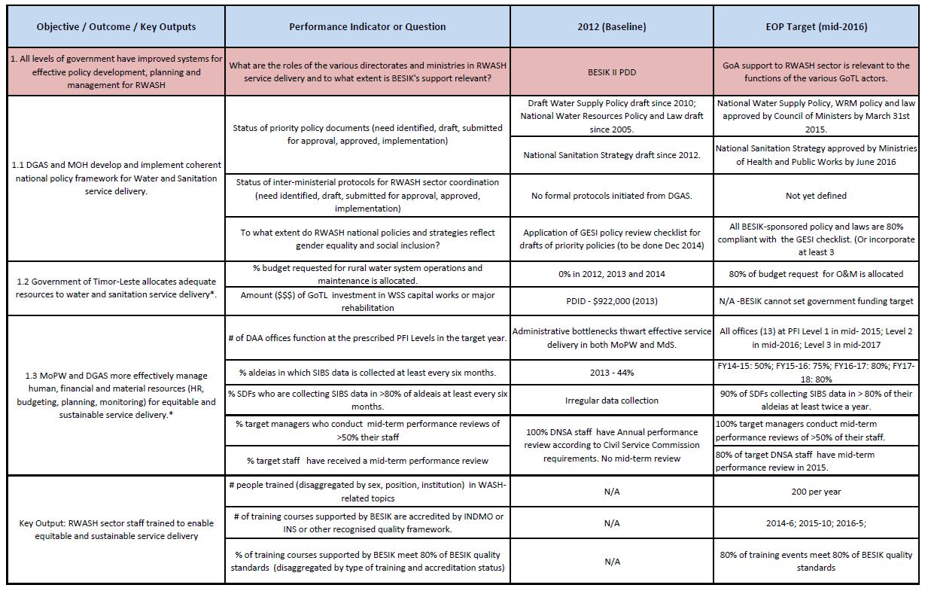
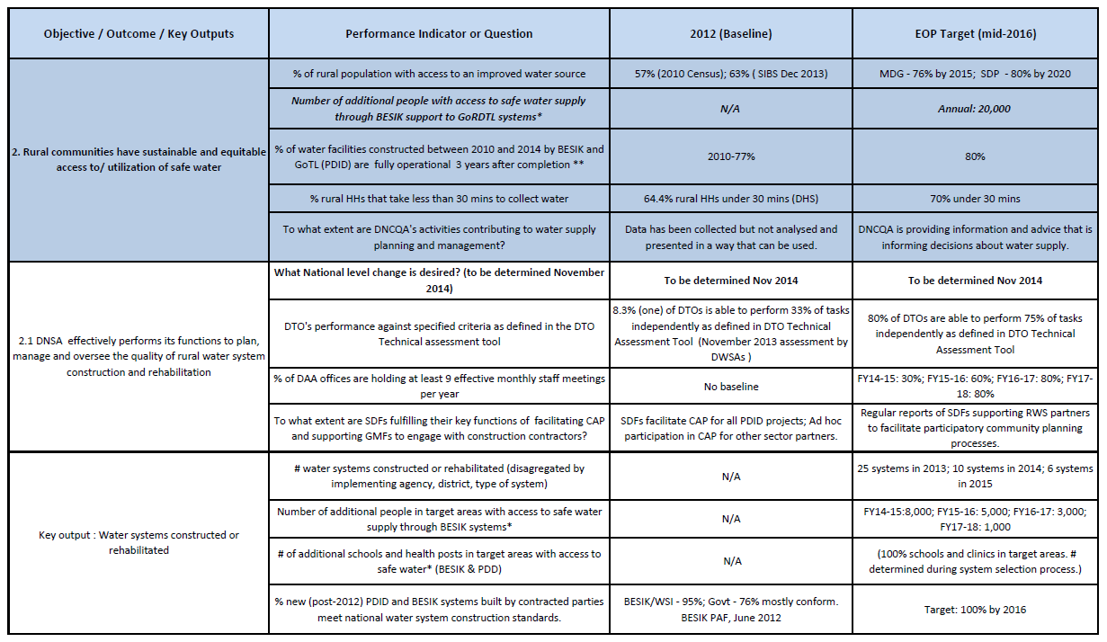
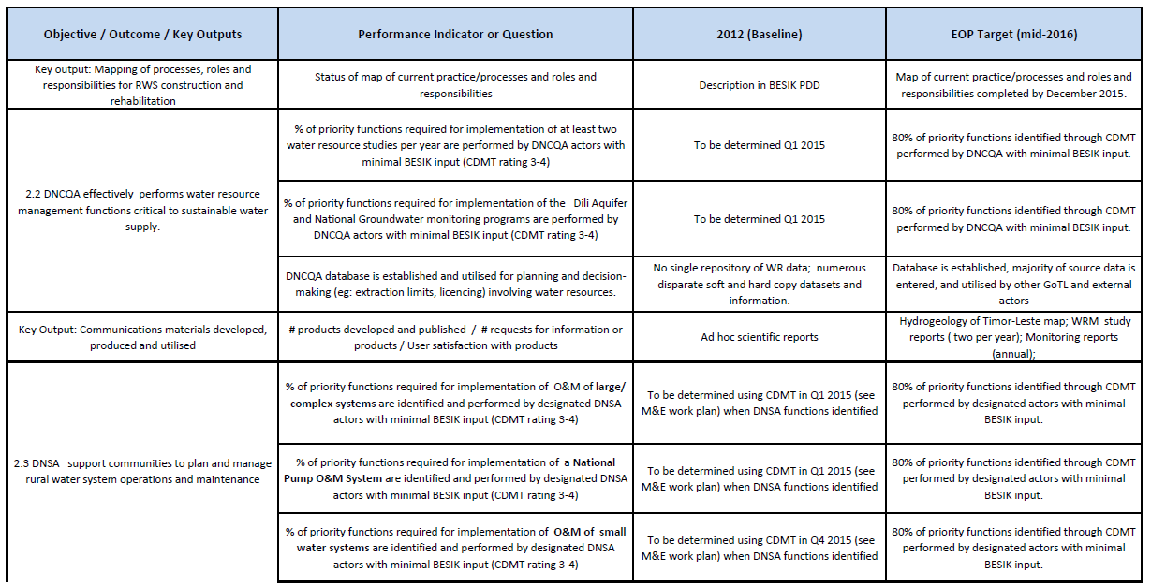
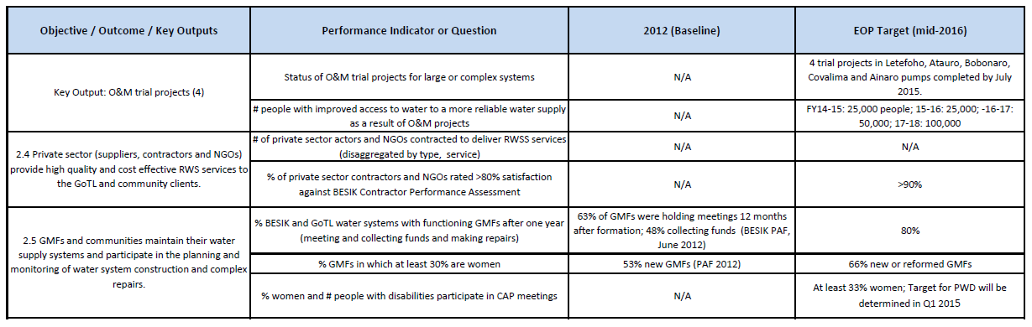

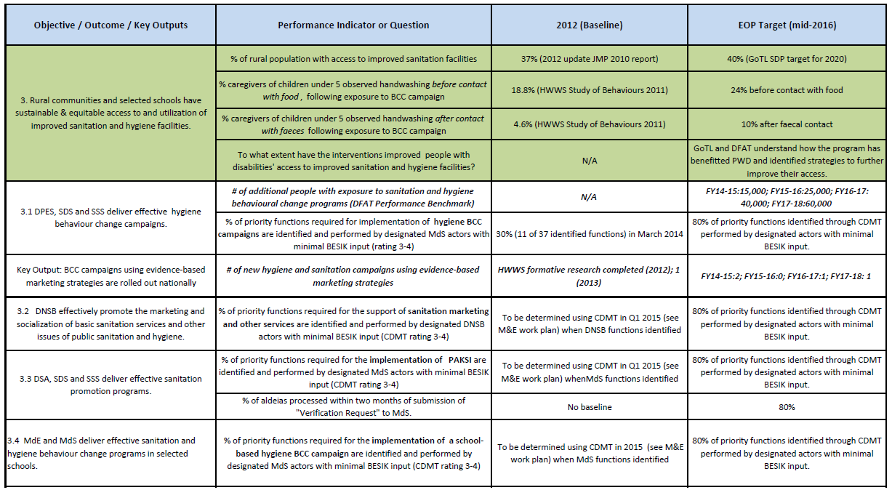
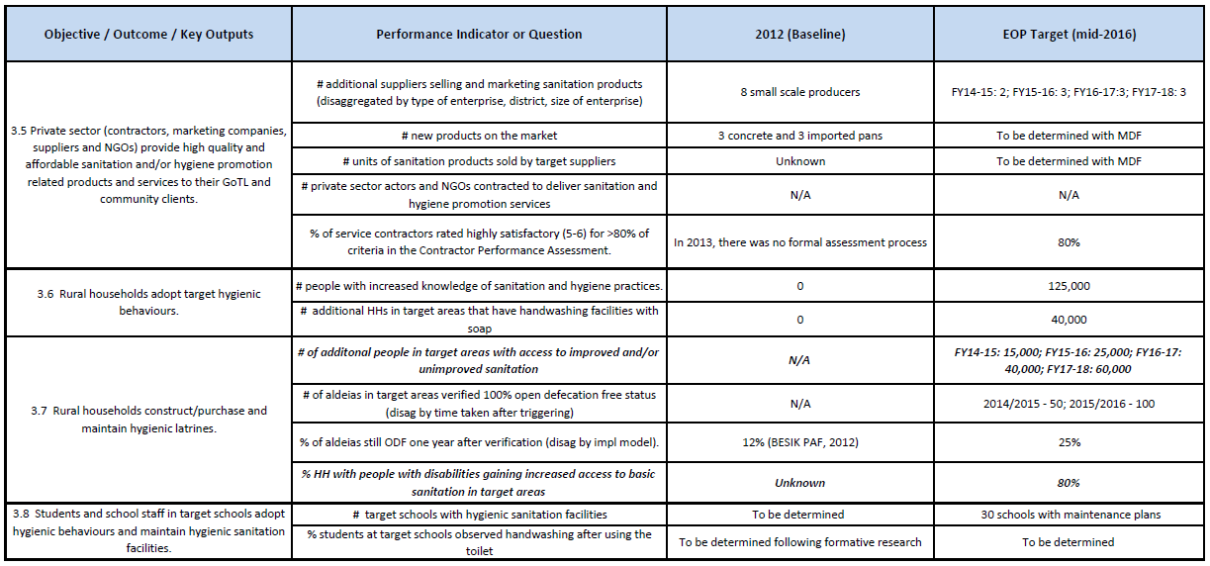
Annex 4: Monitoring and Evaluation Framework (Oct 2014 revision)
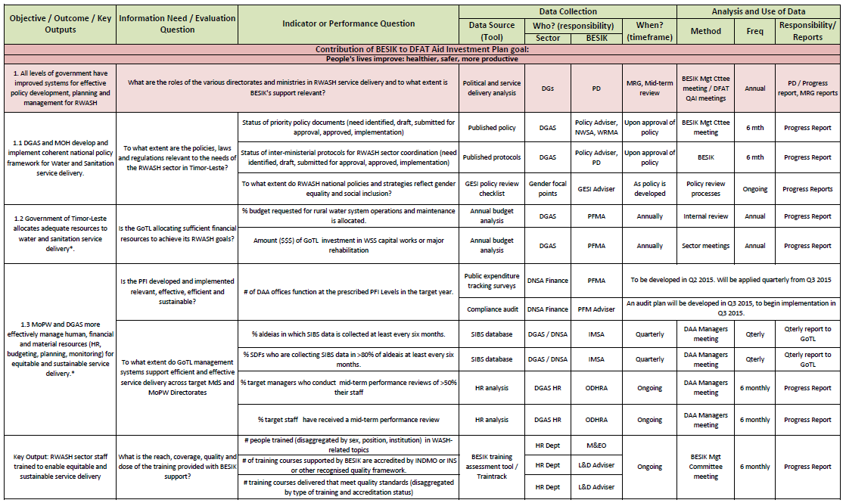
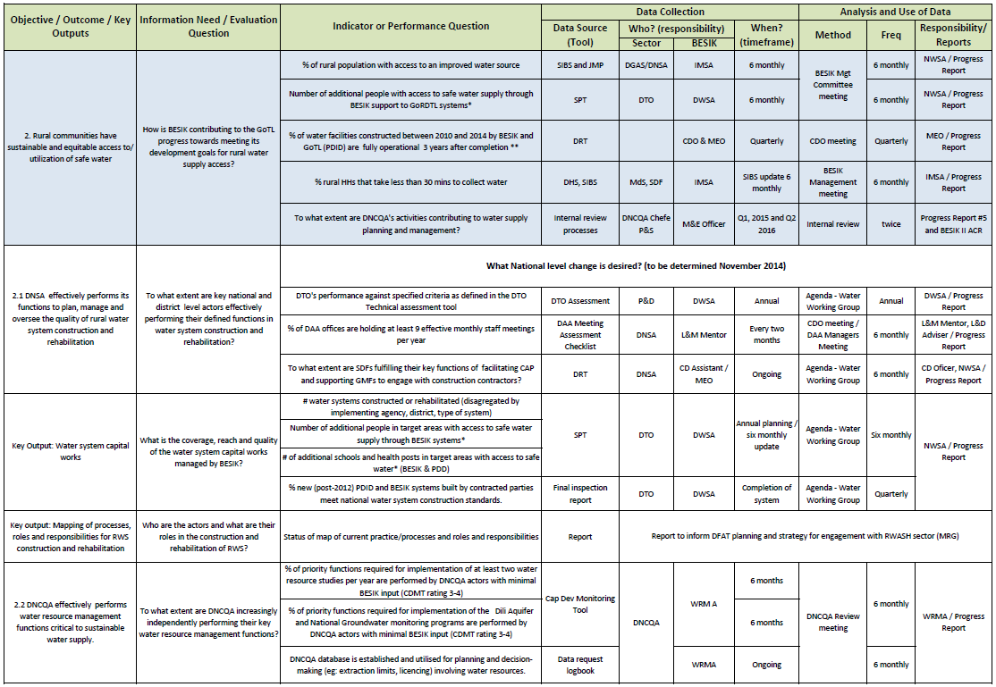
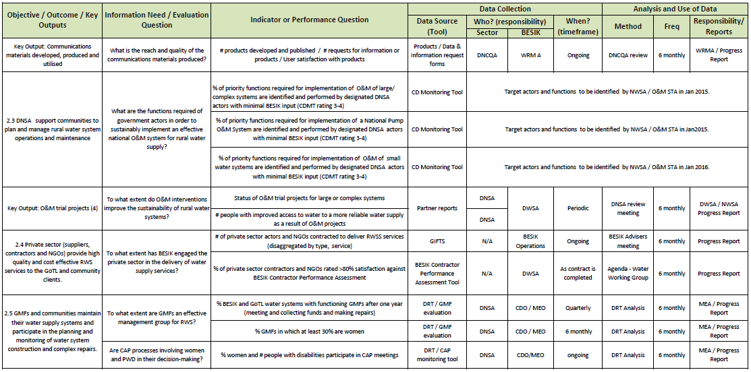
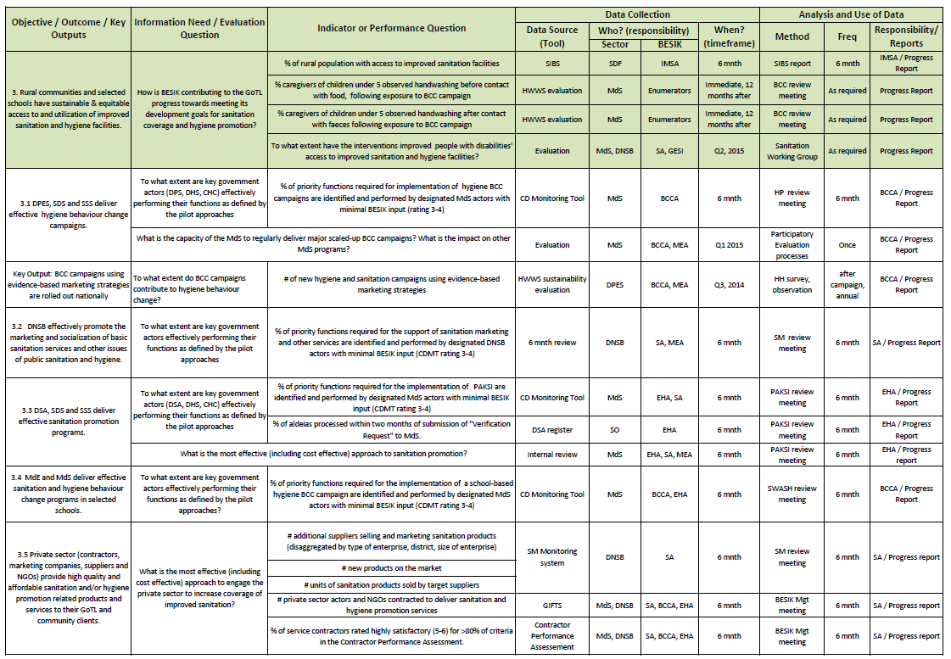
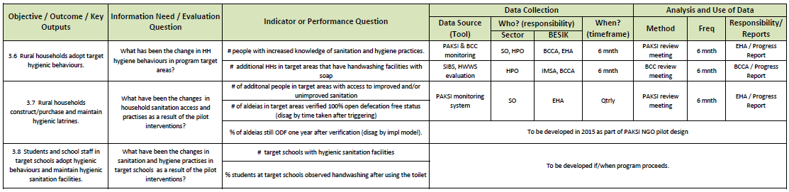

Annex 5: BESIK Risk Management Matrix (June 2014)
Not available

Annex 6: Schedule and Contents of BESIK Reports
Report Name | Content | Submitted by | Frequency
Quarterly Financial Report | - Budget and expenditure reports | Accountant | End of each Quarter
Weekly update | - Key achievements for the week,  - Key upcoming activities for the next week | BESIK Advisors | Every Friday, discussed at Monday meeting
Joint Quarterly newsletter | - Key stories and achievements across all program areas. | Communications Adviser | Quarterly
Six-monthly / Activity Progress Reports | Focus on implementation progress against expected EOPO and identify any key issues:  - Progress against objectives and outcomes  - Progress against work plan  - Progress against management actions (previous reports)  - Expenditure by Objective  - Expenditure by contract categories  - Management actions required  Timed to align with DFAT QAI report to be produced at beginning of each year and to feed into presentations for the Joint Management Committee in March and September. | M&E Advisor, Program Director, Operations Manager | Every six months:  - Report #1 –Sep12-Feb13 is completed  - #2 is for Mar13-Dec13 as per contract  - #3 Jan14-Jun14  - #4 Jul14-Dec14  - #5 Jan15-June15  - #6 Jul15-Dec15  - #7 Jan16-Jun16
Annual Work Plan | - Activity Description  - Progress to Date  - Risk management  - Sustainability  - Monitoring plan  - Work program  - Implementation and resources schedule  - Expenditure | Operations Manager,  M&E Adviser | As per contract annually: Draft by 1 August to co-ordinate with and inform GoTL’s budget cycle.  Summary detailed draft by 1 February.
M&E Plan | - Revised versions of the MEF including in particular the (operational) M&E Plan | M&E Adviser | - M&E Plan - end of June 2013  - Update #1 – end of June 2014  - Update #2 – end of June 2015
Activity Completion Report (ACR) | - As per DFAT template  - Summative review of Program strategies, inputs, activities, outcomes and impacts and extent to which Program success factors were met.  - Effectiveness, efficiency, relevance, impacts, sustainability and lessons learnt. | Program Management Team | Program Completion

Annex 7: Schedule of Planned M&E Activities (October 2014 revision)

Activity |  |  | PAF |  | Description | Lead Person | 2014 |  |  |  |  |  |  |  |  |  |  |  |  |  |  | 2015 |  |  |  |  |  |  |  |  |  |  |  |  |  |  |  |  |  |  |  |  |  |  |  |  |  |  | 2016
 |  |  |  |  |  |  | J |  | A |  |  | S |  | O |  |  | N |  | D |  |  | J |  | F |  | M |  |  |  | A |  | M |  | J |  | J |  | A |  | S |  |  | O |  | N |  | D |  | J |  | F |  |  | M |  | A |  | M |  |  | J
Deliverables
Quarterly financial report |  |  |  | Quarterly financial statement |  | Accountant |  |  |  |  |  |  |  |  | ✔ |  |  |  |  |  |  | ✔ |  |  |  |  |  |  |  |  | ✔ |  |  |  |  |  | ✔ |  |  |  |  |  |  | ✔ |  |  |  |  |  | ✔ |  |  |  |  |  |  | ✔
Progress Reports |  |  |  | 6 monthly Progress Report |  | MEA | ✔ |  |  |  |  |  |  |  |  |  |  |  |  |  |  | ✔ |  |  |  |  |  |  |  |  |  |  |  |  |  |  | ✔ |  |  |  |  |  |  |  |  |  |  |  |  | ✔ |  |  |  |  |  |  |  |  |  |  |  | ✔
Draft AWP |  |  |  | Draft AWP aligned with GoTL AWP |  | OM |  |  |  | ✔ |  |  |  |  |  |  |  |  |  |  |  |  |  |  |  |  |  |  |  |  |  |  |  |  |  |  |  |  | ✔
Summary draft AWP |  |  |  | Final AWP after GoTL budget approved |  | OM |  |  |  |  |  |  |  |  |  |  |  |  |  |  |  |  |  |  | ✔ |  |  |  |  |  |  |  |  |  |  |  |  |  |  |  |  |  |  |  |  |  |  |  |  |  |  | ✔
M&E Plan Review |  |  |  | Annual review |  | MEA |  |  |  |  |  |  |  |  |  |  |  |  |  |  |  |  |  |  |  |  |  |  |  |  |  |  |  |  | ✔
Activity Completion Report |  |  |  | Activity Completion Report |  | MEA |  |  |  |  |  |  |  |  |  |  |  |  |  |  |  |  |  |  |  |  |  |  |  |  |  |  |  |  |  |  |  |  |  |  |  |  |  |  |  |  |  |  |  |  |  |  |  |  |  |  | ✔
Regular Activities
BESIK Management Committee meeting |  |  |  | At least 6 monthly – strategic and policy decisions related to BESIK |  | PD |  |  |  | ✔ |  |  |  |  |  |  |  |  |  |  |  |  |  |  | ✔ |  |  |  |  |  |  |  |  |  |  |  |  |  | ✔ |  |  |  |  |  |  |  |  |  |  |  |  | ✔
Develop annual schedule and critical reflection topics for program review meetings |  |  |  | Utilise regular BESIK team and regular meetings with counterparts to analyse data produced by M&E and utilise it for decision making and program management.
Review meetings |  |  |  | Divisions or Departments review monitoring data and progress towards outcomes (critical reflection) |  | Advisers, MEA |  |  |  |  |  |  |  |  |  |  |  |  |  | ✔ |  |  |  |  |  |  |  |  |  |  |  |  |  |  | ✔ |  |  |  |  |  |  |  |  |  |  |  |  | ✔ |  |  |  |  |  |  |  |  |  |  | ✔
Schedule and criteria for district BESIK monitoring visits |  |  |  | Rollout the WaterAid promoted joint monitoring visits that have been implemented in Liquica district.
Joint monitoring visits |  |  |  | Joint Management Committee & DFAT monitoring of district level activity |  | PD  MEA |  |  |  |  |  |  | ✔ |  |  |  |  |  |  |  |  |  |  |  |  |  |  | ✔ |  |  |  |  |  |  |  |  |  |  |  |  |  | ✔ |  |  |  |  |  |  |  |  |  |  |  |  | ✔
Regular newsletter |  |  |  | Quarterly newsletter of joint BESIK/GoTL activities |  | Comm, OM |  |  |  | ✔ |  |  |  |  |  |  |  | ✔ |  |  |  |  |  |  |  |  |  |  |  |  | ✔ |  |  |  |  |  |  |  | ✔ |  |  |  |  |  |  | ✔ |  |  |  |  |  |  |  |  |  |  | ✔
Objective 1:
Develop GESI policy analysis checklist |  |  | 1.1 |  | To be applied in December 2014 to current draft policies | GESI Adviser |  |  |  |  |  |  |  |  |  |  |  | ✔ |  | ✔
Budget and budget allocation analyses |  |  | 1.2 |  | Analysis of budget request and actual allocation for RWASH activities | PFMA |  |  |  |  | ✔ |  |  |  |  |  |  |  |  |  |  |  |  |  | ✔ |  |  |  |  |  |  |  |  |  |  |  |  |  | ✔ |  |  |  |  |  |  |  |  |  |  |  |  | ✔
Develop Public Expenditure Tracking Survey Tool |  |  | 1.3 |  | Tool to be applied quarterly for DAA offices implementation of PFI | PFMA |  |  |  |  |  |  |  |  |  |  |  |  |  |  |  |  |  |  |  |  |  |  | ✔ |  |  |  | ✔ |  | ✔ |  |  |  |  |  |  | ✔ |  |  |  |  |  | ✔ |  |  |  |  |  |  | ✔ |  |  |  |  |  |  | ✔
Develop compliance audit plan |  |  | 1.3 |  | Plan for internal compliance audit of PFI implementation | PFMA |  |  |  |  |  |  |  |  |  |  |  |  |  |  |  |  |  |  |  |  |  |  |  |  |  |  |  |  |  |  | ✔ |  | ✔ |  |  | ✔
Audit of PFI compliance |  |  | 1.3 |  | Audit of district PFI compliance | PFMA |  |  |  |  |  |  |  |  |  |  |  |  |  |  |  |  |  |  | ✔ |  |  |  |  |  |  |  |  |  |  |  |  |  |  |  |  |  |  |  |  |  |  |  |  | ✔
SIBS data analysis |  |  | 1.3 |  | Report and analysis of SIBS data and collection rates and patterns | IMSA | ✔ |  |  |  |  |  |  |  |  | ✔ |  |  |  |  |  | ✔ |  |  |  |  |  |  | ✔ |  |  |  |  |  |  |  | ✔ |  |  |  |  |  |  | ✔ |  |  |  |  |  | ✔ |  |  |  |  |  |  | ✔
Review and restructure of SIBS IMS. |  |  | 1.3 |  | Review database structure & content and restructure to meet stakeholder needs | IMSA |  |  |  |  | ✔ |  | ✔ |  |  | ✔ |  | ✔ |  | ✔ |  | ✔ |  |  | ✔ |  | ✔
L&D/HR job and skills analysis |  |  | 1.3 |  | Identify M&E roles, capacities and gaps | OD/HR |  |  |  |  |  |  | ✔ |  |  |  |  |  |  |  |  |  |  |  |  |  |  |  |  |  |  |  |  |  |  |  |  |  | ✔
Establish SIBS audit team |  |  | 1.3 |  | TOR for audit team and work plan. Quarterly summary reports | MEA, MEO |  |  |  |  |  |  | ✔ |  |  |  |  |  |  | ✔ |  |  |  |  |  |  | ✔ |  |  |  |  |  |  |  | ✔ |  |  |  |  |  |  | ✔ |  |  |  |  |  | ✔ |  |  |  |  |  |  | ✔
Training and mentoring for M&E system implementation. |  |  | 1.3 |  | Appropriate training and OTJ accompaniment | IMS, MEA, MEO |  |  |  |  |  |  | ✔ |  |  | ✔ |  | ✔ |  | ✔ |  | ✔ |  |  | ✔ |  | ✔ |  | ✔ |  |  |  | ✔ |  | ✔ |  | ✔ |  | ✔ |  |  | ✔ |  | ✔ |  | ✔ |  | ✔ |  | ✔ |  | ✔ |  |  | ✔ |  | ✔ |  |  | ✔ |  | ✔
BESIK TrainTrack |  |  | Key Output |  | Summary of training (gender disaggregated) completed during reporting period | MEO |  |  |  |  |  |  |  |  |  |  |  |  |  |  |  | ✔ |  |  |  |  |  |  |  |  |  |  |  |  |  |  | ✔ |  |  |  |  |  |  |  |  |  |  |  |  | ✔ |  |  |  |  |  |  |  |  |  |  |  | ✔
Objective 2: Rural communities have sustainable and equitable access to / utilization of safe water
SPT data collection and analysis (with SIBS) | 2 |  |  |  | Collection of planning and reporting from sector partners | IMSA |  |  |  |  |  |  |  |  |  |  |  |  |  | ✔ | ✔ |  |  |  |  |  |  |  |  |  |  |  |  |  | ✔ |  | ✔ |  |  |  |  |  |  |  |  |  |  | ✔ |  | ✔
DTO Assessment | 2.1 |  |  |  | Assess DTO technical skills development | DWSA |  |  |  |  |  |  |  |  |  |  |  | ✔ |  |  |  |  |  |  |  |  |  |  |  |  |  |  |  |  |  |  |  |  |  |  |  |  |  |  |  | ✔
Finalise DAA staff meeting assessment tool | 2.1 |  |  |  | Develop a short guideline for use and analysis to accompany the checklist. | L&M Mentor, MEA |  |  |  |  |  |  |  |  |  |  |  |  |  | ✔ | ✔
DAA Staff meeting assessment | 2.1 |  |  |  | Assessment of quality of DAA monthly staff meeting – proxy for management capacity | L&M mentor | ✔ | ✔ |  |  |  |  | ✔ |  |  | ✔ |  | ✔ |  | ✔ | ✔ |  | ✔ |  |  |  |  | ✔ |  |  | ✔ |  | ✔ |  | ✔ |  | ✔ |  | ✔ |  |  | ✔ |  | ✔ |  | ✔ |  | ✔ |  | ✔ |  | ✔ |  |  | ✔ |  | ✔ |  |  | ✔ |  | ✔
CDO Monthly Reports | 2.1,  2.5 |  |  |  | DRT – Community engagement processes and system function monitoring report | NRWSA, NCDO | ✔ | ✔ |  |  |  |  | ✔ |  |  | ✔ |  | ✔ |  | ✔ | ✔ |  | ✔ |  |  |  |  | ✔ |  |  | ✔ |  | ✔ |  | ✔ |  | ✔ |  | ✔ |  |  | ✔ |  | ✔ |  | ✔ |  | ✔ |  | ✔ |  | ✔ |  |  | ✔ |  | ✔ |  |  | ✔ |  | ✔
DNCQA internal review | 2, 2.2 |  |  |  | Key review question: To what extent are DNCQA’s activities contributing to water supply planning and management | WRMA, MEA |  |  |  |  |  |  |  |  |  |  |  |  |  |  |  |  | ✔ |  |  |  |  | ✔ |  |  |  |  |  |  |  |  |  |  |  |  |  |  |  |  |  |  |  |  |  | ✔ |  | ✔
CDMT and baseline for DNSA, DNCQA capacity development | 2.3 |  |  |  | Identify priority functions and establish baseline situation with counterparts. | NWSA  WRMA  MEA |  |  |  |  |  |  |  |  |  |  |  |  |  |  | ✔
Develop M&E system for O&M pathway | 2.3 |  |  |  | Depends on progress of O&M Pathway planning with DNSA | NWSA, MEA |  |  |  |  |  |  |  |  |  |  |  |  |  |  | ✔ |  | ✔ |  |  |  |  | ✔
Evaluation of O&M Projects | 2.3 |  |  |  | Evaluation of effectiveness and sustainability of O&M projects | NWSA, MEA |  |  |  |  |  |  |  |  |  |  |  | ✔ |  | ✔ | ✔ |  |  |  |  |  |  |  |  |  |  |  |  |  |  |  |  |  |  |  |  |  |  |  |  |  |  |  |  | ✔ |  | ✔ |  |  | ✔
Contractor Performance Assessment Tool development | 2.4, 3.5 |  |  |  | Develop the tool linking with the MOPW contract management system and BESIK GIFTS system. | MEA | ✔ | ✔ |  |  |  |  | ✔
Aggregation of data from above | 2.4, 3.5 |  |  |  | Preparation for Progress Reports | TBD, MEO |  |  |  |  |  |  |  |  |  |  |  |  |  |  | ✔ |  |  |  |  |  |  |  |  |  |  |  |  |  |  |  | ✔ |  |  |  |  |  |  |  |  |  |  |  |  | ✔
Develop monitoring system using GMF evaluations | 2.5 |  |  |  | Implementation of new GMF evaluation tool by SDFs and CDOs | NCDO, GESI | ✔ |  |  |  |  |  |  |  |  |  |  |  |  | ✔ | ✔
Analysis of GMF evaluations |  |  | 2.5 |  | Preparation for Progress Reports | NCDA, GESI |  |  |  |  |  |  |  |  |  |  |  | ✔ |  |  | ✔ |  |  |  |  |  |  |  |  |  |  |  |  |  |  |  | ✔ |  |  |  |  |  |  |  |  |  |  |  |  | ✔
Formalise CAP and GMF training monitoring systems |  |  | 2.5 |  | Preparation for Progress Reports | NCDA, MEO | ✔ |  |  |  |  |  |  |  |  |  |  |  |  |  | ✔ |  |  |  |  |  |  |  |  |  |  |  |  |  |  |  | ✔ |  |  |  |  |  |  |  |  |  |  |  |  | ✔
3. Rural communities and selected schools have sustainable and equitable access to and utilization of improved sanitation and hygiene facilities
HWWS evaluation – immediately after campaign |  |  | 3, 3.6 |  | Evaluation of behaviour change immediately after campaign | BCCA, MEO |  |  |  |  |  |  |  |  |  |  |  | ✔ |  | ✔ |  |  |  |  |  |  |  |  |  |  | ✔ |  | ✔ |  |  |  |  |  |  |  |  |  |  | ✔ |  | ✔
HWWS evaluation – 12 months after campaign |  |  | 3, 3.6 |  | Evaluation of behaviour change 12 months after campaign | BCCA, MEO | ✔ |  |  |  |  |  |  |  |  |  |  |  |  |  |  |  |  |  |  |  |  |  |  |  |  |  |  |  |  |  | ✔ |  |  |  |  |  |  |  |  |  |  |  |  | ✔ |  | ✔ |  |  |  |  | ✔ |  |  | ✔
Evaluation of BCC campaign sustainability in MdS |  |  | 3.1 |  | Evaluation of MdS capacity to run scaled up BCC campaigns | BCCA, MEA |  |  |  |  |  |  |  |  |  |  |  |  |  |  | ✔ |  |  |  | ✔ |  |  | ✔
CDMT review for BCC campaigns |  |  | 3.1 |  | Review following HWWS campaign rollout | BCCA |  |  |  |  |  |  |  |  |  |  |  |  |  |  | ✔
CDMT development and baseline for sanitation activities |  |  | 3.2, 3.3 |  | Identify priority functions and establish baseline with counterparts | SA, EHA, MEA |  |  |  |  |  |  |  |  |  |  |  |  |  |  | ✔ |  |  |  | ✔ |  |  | ✔
Support integration of PAKSI monitoring into HMIS |  |  | 3.2 |  | Registration of PAKSI monitoring program in MdS data collection systems | EHS | ✔ |  |  | ✔ |  |  | ✔ |  |  | ✔ |  | ✔ |  | ✔
Analysis of PAKSI monitoring data |  |  | 3.2, 3.7 |  | Inform pilot review meetings (6 monthly) | EHA | ✔ |  |  |  |  |  |  |  |  |  |  |  |  |  | ✔ |  |  |  |  |  |  |  |  |  |  |  |  |  |  |  | ✔ |  |  |  |  |  |  |  |  |  |  |  |  | ✔ |  |  |  |  |  |  |  |  |  |  |  | ✔
Develop Sanitation Marketing logic model & monitoring system |  |  | 3.3, 3.5, 3.7 |  | Logic model and monitoring of pilots | SA |  |  |  | ✔ |  |  | ✔ |  |  | ✔
Analysis of SM monitoring data |  |  | 3.5, 3.7 |  | Inform pilot review meetings (3 monthly) | SA |  |  |  |  |  |  | ✔ |  |  |  |  | ✔ |  |  |  |  |  |  |  |  |  |  |  |  |  |  | ✔ |  |  |  |  |  |  |  |  |  |  |  |  | ✔ |  |  |  |  |  |  |  |  |  |  | ✔
School WASH formative research (baseline) |  |  | 3.8 |  | To inform behaviour and targets for program | BCCA
Develop School WASH monitoring system |  |  | 3.8 |  | Definition of pilot activities | BCCA, MEA |  |  |  |  |  |  |  |  |  | ✔ |  | ✔ |  | ✔
Analysis of School WASH monitoring data |  |  | 3.8 |  | Inform pilot review meetings (3 monthly) |  |  |  |  |  |  |  |  |  |  |  |  |  |  |  |  |  |  |  | ✔ |  |  |  |  |  |  |  | ✔ |  |  |  |  |  |  |  |  |  |  |  |  | ✔ |  |  |  |  |  |  |  |  |  |  | ✔
Key abbreviations

BCCA | Behaviour Change Communications Adviser | MEO | M&E Officer
CDMT | Capacity Development Monitoring Tool | NRWSA | National Rural Water Services Adviser
DRWSA | District Rural Water Supply Advisers | ODA | Organisational Development Adviser
EHA | Environmental Health Adviser | PFMA | Public Finance Management Adviser
GESIA | Gender & Social Inclusion Adviser | SA | Sanitation Adviser
IMSA | Information Management Systems Adviser | WRMA | Water Resources Management Adviser
MEA | M&E Adviser

BESIK
c/o Direcção Nacional dos Serviços de Água (DNSA), Ministério das Obras Públicas, Rua Jacinto Candido, Caicoli, Dili
TIMOR-LESTE Tel: +670-332 1978

As direct or indirect delivery is currently problematic and possibly aspirational within Phase 2, these terms were dropped from official documents, though retained in BESIK planning.
There are various ‘versions’ of the SMART acronym. The T is also said to represent time-specific or timely and the R as realistic or responsive.
Most new Government-funded rural water infrastructure is now planned and implemented through the Integrated District Development Planning (PDID) process and is driven by community- identified priorities. DNSA participates in a limited way in the decision-making alongside community representatives and delegates from other sectors to develop district multi-sector plans.

