|  |
| --- |
|  |
| 1. Mid-Term Review of the Basic Education Quality and Access in Lao PDR (Phase 2) Program   Final Report  30 May 2025 |

Front Cover Image: [Grade One Children Receiving New Textbooks: Australian Embassy, Vientiane]

**Document Review and Authorisation**

**Version Date Distributed Issued To Comments**

First Draft 11.02.2025 Sounisa Sundara Submitted per deliverables

Second Draft 12.03.2025 Sounisa Sundara Addressed DFAT and TAG feedback

Third Draft 16.04.2025 Sounisa Sundara Addressed DFAT and TAG feedback

Final Report 30.05.2025 Sounisa Sundara Addressed BEQUAL and MoES feedback

**Acknowledgements**

The support of the Australian Embassy Education Team in Vientiane, Department of Foreign Affairs and Trade in Australia, the BEQUAL Technical Advisory Group and the BEQUAL Program Team are acknowledged with appreciation. The authors of the report are indebted to those who volunteered their time for this Review.

The views expressed in this report are those of the independent consultants, and do not represent the views of the Department of Foreign Affairs and Trade or the Australian Government.

Report prepared by: Chris Northey, Team Leader

Natalia Beghin, GEDSI Specialist

Somxay Inthasone, Lao Education Specialist

Interpretation support by: Soutthida Luangphaxay

Glossary

**BEQUAL 2** Basic Education Quality and Access in Lao PDR (Phase 2)

**CP** Child Protection

**CPD** Continuing Professional Development

**CSO** Civil Society Organisation

**DESB** District Education and Sports Bureau

**DFAT** Department of Foreign Affairs and Trade

**DP** Development Partner

**DPP** Development Partnership Plan

**DTE** Department of Teacher Education

**EOPO** End of Program Outcome

**EU** European Union

**ESSDP** Education and Sports Sector Development Plan

**ESSWG** Education and Sports Sector Working Group

**FGD** Focus Group Discussion

**GE&IE** Gender Equality and Inclusive Education

**GEDSI** Gender Equality, Disability, and Social Inclusion

**GPE III** Third Global Partnership for Education

**GoL** Government of Laos

**ICT** Information and Communications Technology

**IDD** Investment Design Document

**IEPC** Inclusive Education Promotion Centre

**IPS** Internal Pedagogical Support

**JICA** Japan International Cooperation Agency

**KII**  Key Informant Interview

**KRQ** Key Review Question

**Lao PDR** Lao Peoples’ Democratic Republic

**MDAW** Ministry of Education and Sports - Division for the Advancement of Women

**MEL** Monitoring, Evaluation and Learning

**MoES** Ministry of Education and Sports

**MPI** Ministry of Planning and Investment

**MTR** Mid-Term Review

**NGOs** Non-Government Organisations

**OPD** Organisation of Persons with a Disability

**PESS** Provincial Education and Sports Services

**PSEAH** Preventing Sexual Exploitation, Abuse, and Harassment

**RIES** Research Institute for Educational Sciences

**SLP** Spoken Lao Program

**SOR** Statement of Requirements

**TAG** Technical Advisory Group

**TOC** Theory of Change

**TOR** Terms of Reference

**TTC** Teacher Training College

**UNESCO** United Nations Educational, Scientific, and Cultural Organization

**UNICEF** United Nations Children’s Fund

**USAID** United States Agency for International Development

Table of Contents

Executive Summary 7

Background 7

Context 7

Findings 9

Recommendations 11

Introduction 13

MTR Purpose and Scope 13

MTR Methodology and Limitations 13

1. Design: Relevance and Coherence of Scope and Approach 16

2. Implementation: Effectiveness 19

3. Gender Equality, Disability, and Social Inclusion (GEDSI) 30

4. Monitoring, Evaluation, and Learning (MEL) 40

5. Management and Governance 44

Annex A: Future Design Options 51

Annex B: Stakeholder Consultation List 53

Annex C: MTR Terms of Reference 54

Annex D: Data Analysis 55

Primary Completion Rates 55

General Trends 56

# Executive Summary

## Background

The Basic Education Quality and Access in Lao PDR (*BEQUAL)* is Australia’s flagship program supporting primary education in Laos. The first phase covered the period 2015-2022 and focused on supporting the Government of Laos (GoL) with major reforms to the primary school curriculum. The second phase, BEQUAL 2, commenced in July 2022 and is expected to continue to June 2026, with the option of a four-year extension. The current BEQUAL program is focusing on establishing a system for teachers’ continuing professional development that is school-based, responsive to locally identified needs and will deliver improved learning outcomes for students.

BEQUAL Phase 2 implementation is led by the Ministry of Education and Sport (MoES) and the Australian Department of Foreign Affairs and Trade (DFAT) and supported by an implementation team contracted and managed by Tetra Tech International Development. It is funded with a budget of $33.3 million (inclusive of a $3.5 million contribution from the United States Agency for International Development (USAID)) over four years and requires the Lao Government to progressively increase its ownership and funding of activities. Gender equality and inclusive education (GE&IE) considerations are mainstreamed across components and activities, and the program is aligned to the MoES’ 9th Education and Sports Sector Development Plan (ESSDP) 2021-25.

As BEQUAL 2 has passed the second year of implementation, DFAT has commissioned a Mid-Term Review (*MTR / the Review*) to assess the effectiveness and appropriateness of the program scope, main implementation approaches, and management and governance structures. The Review is intended to acknowledge achievements, identify areas for improvement, as well as to inform a decision about the extension of the program.

This report presents high level findings and recommendations from the Review process. These have been informed by a document review, stakeholder interviews and workshop discussions. The MTR consulted with a broad range of stakeholders during a visit to Laos in October - November 2024 and conducted virtual consultations with stakeholders outside of Laos. The report is organised according to the key review criteria and key review questions (KRQs) in the MTR Terms of Reference (ToR): relevance and coherence of design; implementation effectiveness; gender equality; disability and social inclusion (GEDSI); monitoring, evaluation and learning (MEL); and management and governance.

## Context

The BEQUAL program is well established and has been working at a rapid pace on completing the last year of the primary curriculum roll-out, begun under BEQUAL Phase 1. Other priorities have been the printing and distribution of the Grade 5 textbooks and teacher guides; the national scale up of the Spoken Lao Program (SLP); and designing a Continuing Professional Development (CPD) approach and associated processes under the guidance of the Department of Teacher Education (DTE).

BEQUAL’s support to the delivery of the new curriculum is a significant reform process, requiring time, momentum building, and sustained support. It requires behaviour change on the part of teachers and principals, as well as challenging established norms of the role of a teacher. This reform process is taking place in a context with high inflation, restricted government budgets, and an increasing shortage of teachers, due to natural attrition and leaving the workforce, and low enrolment rates for teacher training courses. Student dropouts are also on the rise as families make difficult decisions to take their children out of school. These contextual elements are impacting on the current design and implementation effectiveness of BEQUAL, and require close attention and adjustments to ensure ongoing program sustainability.

The findings and recommendations in this report should be considered against this dynamic and challenging context. Findings and recommendations are organised by KRQ and summarised on the following pages for the purpose of this Executive Summary. The detailed findings and recommendations can be found in the body of the report.

When reviewed against the framework of the current design and anticipated end of program outcomes (EOPOs), BEQUAL is an effective program making good progress and contributing to improved teaching practice and student learning outcomes. The SLP is a standout success story, transitioning from a pilot to a program to national policy. Improving teachers’ capacity to manage multigrade classes is contributing to teacher’s confidence and professional development. Implemented for two complete school years, BEQUAL’s approach to CPD incorporates contextualised best practice however it is currently delivering mixed results and received significant feedback from MTR stakeholders.

The Review contends the BEQUAL program is at an implementation point where approaches, models and materials are being used, tested and feedback is being provided to the program. This is an important juncture for BEQUAL where it will need to consider and act on the feedback it is receiving, invest in building an evidence base for its work, and ensure the program is adapting to manage a changing context. The Review recommends some streamlining and focus on critical areas will strengthen sustainability in the next year of implementation. While the MTR observes positive messaging from the MoES in terms of ownership and sustainability, there should be a continued focus on strengthening collaboration between program stakeholders to support the realisation of this intended outcome.

Understanding a two-year extension to BEQUAL is under consideration, the MTR recommends a design extension of the program. This is to ensure the program continues to be sustainable, relevant and effective, and provides a pathway for the MoES to continue to take meaningful ownership of program activities.

## Findings

Findings are organised by KRQ. Noting there is some overlap between KRQs, findings are summarised for the purpose of the Executive Summary, with more detailed findings provided in the body of the report.

**1 *Design:* *relevance and coherence of scope and approach***

BEQUAL is highly relevant to the priorities and commitments of the MoES and the Australian Government to inclusive, high quality education programs but could do more to leverage Australia’s position and partnerships for maximum impact. To maintain relevance, BEQUAL’s program priorities may need to be adapted and consolidated in response to a changing context in Lao PDR.

BEQUAL’s program logic and theory of change suggest pathways of change for teacher and student outcomes but are more muted on signposting BEQUAL’s contribution to policy changes.

While BEQUAL is collaborating well and harmonising its support with other development partners, overall support to the MoES is not well aligned between development partners. Existing coordination efforts are not systematic and lack sufficient traction, leading to potential duplication of effort and resources. All development partners should seek to improve their collaboration and harmonisation efforts.

**2 *Implementation:* *Effectiveness***

BEQUAL’s activities have a moderate to high degree of alignment with over half of the MoES’ ESSDP’s objectives. At the national level, MoES indicates SLP will be a core activity as new programs are being developed, providing increased support for the learning needs of students with diverse language backgrounds. Better integration of BEQUAL’s CPD approach with MoES policies and priorities will make it more sustainable.

BEQUAL’s shift from implementation to technical advisory and policy development is underway and demonstrating varying degrees of effectiveness across workstreams. The SLP is an example of where this transition has worked effectively.

BEQUAL effectively uses multiple communication channels to share its achievements with key stakeholders and the broader public. There is a need to strengthen strategic communications for and with DFAT.

**3 *Gender equality, disability, and social inclusion***

BEQUAL’s progress on transformative GEDSI outcomes has been mixed. The program has demonstrated transformative social inclusion through the SLP, alongside high-quality gender-sensitive and responsive outputs, and emerging disability-sensitive programming. BEQUAL demonstrates full compliance with DFAT's child protection (CP) and preventing sexual exploitation, abuse and harassment (PSEAH) standards.

BEQUAL's GEDSI ambitions align broadly with relevant policies and strategies, but there is limited evidence supporting the execution and effectiveness of GEDSI initiatives. The MEL system is not currently placed to provide comprehensive indicators of GEDSI, particularly in relation to child educational outcomes.

BEQUAL lacks systematic engagement with civil society organisations (CSOs) and organisations of persons with a disability (OPDs), leading to insubstantive integration of their views and expertise across program advisory, policies, and strategies.

**4 *Monitoring, evaluation, and learning***

BEQUAL’s MEL system demonstrates good alignment with DFAT’s MEL standards. Working within the parameters of BEQUAL’s current program logic, the MEL system is set up to answer the key performance questions and identify progress being made against the EOPOs. The Results Framework is focused primarily on teacher and student outcomes, which may limit opportunities to capture evidence at the national level of structural or policy outcomes.

BEQUAL has a good MEL toolkit and should utilise all aspects of it - not only to highlight positive outcomes but also to identify lessons and make adjustments to the program based on those lessons.

**5 *Management and governance***

BEQUAL’s Management Team has been appropriately structured and resourced throughout this phase, however some respondents raised concerns about its ability to adapt to evolving contextual and stakeholder needs. External stakeholders view BEQUAL as having a highly visible international team in leadership and decision making which is at odds with increasing DFAT and other donor focus on local leadership for development investments.

Evidence-based decision making does not appear to be adequately structured or dependably inform the management of BEQUAL in a systematic way.

While government stakeholders expressed a very favourable perception of the Australian Government's role in improving education quality and Australia-Laos relations are positive, more time may be needed to embed BEQUAL’s new governance structure.

Additional effort needs to be made to strengthen the working relationship between BEQUAL, the Embassy Education Team, and the Technical Advisory Group (TAG) to ensure the program achieves intended Phase 2 outcomes and is able to adapt to a changing context.

## Recommendations

Recommendations are organised by KRQ. Noting there is some overlap between KRQs, recommendations have been summarised for the purpose of the Executive Summary, with more detailed recommendations provided in the body of the report.

**1 *Design: relevance and coherence of scope and approach***

Recommend BEQUAL focus on a smaller set of high-impact initiatives, particularly those with strong potential to drive systemic educational reform.

The Embassy Education Team and BEQUAL to work together to leverage Australia’s role as a trusted partner to enable policy harmonisation, and ensure BEQUAL’s support aligns with MoES’ evolving needs.

Recommend a design extension for the BEQUAL program be undertaken. As part of the design extension, revise the program logic to more explicitly map pathways of change and integrate key factors such as policy shifts and gender equality at the EOPO or IO level.

Recommend BEQUAL, the Embassy Education Team and development partners direct their coordination and harmonisation efforts to support the MoES in managing resources and streamlining processes and activities.

**2 *Implementation: Effectiveness***

Recommend BEQUAL and the Embassy Education Team support the MoES to refine the CPD system, drawing on BEQUAL’s CPD approach, positive practices from the cluster-system and other CPD models. To embed ownership of one CPD system, MoES should be supported to finalise the CPD Guidelines, building on the framework of the CPD Decree and Concept.

Recommend BEQUAL and DFAT promote coherent assistance by all development partners, strengthening established forums to align resources and support MoES to manage and direct complementarity of resources.

Recommend BEQUAL continue to enhance collaboration with MoES to co-develop strategic communications, including by expanding outreach to provincial and district levels, establishing a feedback loop to collect input from stakeholders, and use digital platforms to share lessons and achievements. BEQUAL to be more responsive to DFAT’s requirements for strategic communications and attuned to expectations of the content.

**3 *Gender equality, disability, and social inclusion***

Recommend BEQUAL’ s design extension ensures diverse linguistic practices are preserved and sensitively integrated into the program.

Recommend BEQUAL leverage the expertise of the newly appointed GEDSI Strategic Advisor to strengthen GEDSI integration across all program activities, build technical capacity within BEQUAL and MoES, and expand the evidence base for BEQUAL’s GEDSI impacts.

Enhance GEDSI integration across all MEL frameworks and tools.

Ensure the design extension identifies the GEDSI ambition intended for the program going forward, and embed appropriate and relevant supports into implementation architecture, including by nominating a gender equality outcome at the EOPO or IO level within the program logic.

Recommend the design extension explore how to improve formal disability inclusion advisory and representation in future programming, in line with Australia’s International Development Policy commitments.

**4 *Monitoring, evaluation, and learning***

Recommend BEQUAL build the evidence base for the effectiveness of its models and approaches, and demonstrate the program adjusts and is responsive to stakeholder feedback.

The Embassy Education Team to explore deeper TAG engagement in MEL to support independence and contestability on program performance tracking and decision-making.

Recommend the design extension revise the program logic to include a policy influence and gender equality outcome at the EOPO or IO level.

BEQUAL to establish feedback mechanisms for program stakeholders and recipients, and address current imbalances in reporting by including both challenges and successes in official communications with DFAT and MoES.

**5 *Management and governance***

Recommend BEQUAL develop a localisation strategy that will address barriers to national leadership in the program.

Recommend BEQUAL strengthen and regularise contextual analysis, adopt a more flexible approach to program planning, and improve its use of data and feedback to inform strategic decisions, ensuring more timely adaptation to its dynamic operating context, and stakeholder needs, particularly DFAT.

BEQUAL to adopt a more open communication approach when engaging with the Embassy Education Team, ensuring space is made to discuss challenges and emerging opportunities.

BEQUAL and DFAT to re-evaluate the effectiveness of the new governance structure to foster GoL ownership after it has been implemented for a 12 month period.

BEQUAL, the Embassy Education Team, and the TAG work together to clarify expectations, roles and responsibilities, and enhance constructive, agile, and collaborative programming, ensuring more proactive engagement on policy issues and coordinated, strategic approaches to the GoL.

# Introduction

This report outlines findings and recommendations for the mid-term review (*MTR / the Review*) of BEQUAL Phase 2.

## MTR Purpose and Scope

The MTR Report is structured around the design, implementation, management, and governance of the program, answering high level questions of relevance and coherence, effectiveness, gender equality, disability and social inclusion (GEDSI), and monitoring, evaluation and learning (MEL). Lessons for the remaining period of the program, and design extension are provided as recommendations.

According to the Terms of Reference, the purpose of this MTR is to:

* Evaluate BEQUAL 2’s appropriateness, relevance, and effectiveness, with close consideration of GEDSI, throughout the period 2022-2024
* Identify learnings and successful practices that BEQUAL, DFAT, and other key partners can apply to their programming in future
* Provide recommendations regarding BEQUAL’s implementation, design, management, and governance to enhance performance throughout BEQUAL 2’s remaining operating period, alongside emerging priorities for the forthcoming 10th Education and Sports Sector Development Plan (ESSDP) 2026-2030
* Support strategic decision-making to inform a possible extension of BEQUAL beyond 2026, and
* Generate communications products that highlight BEQUAL’s performance and impact over the review period.

## MTR Methodology and Limitations

The Review applied a mixed methods approach, combining a key document review, key informant interviews (KII) and focus group discussions (FGD) in Vientiane and Luang Namtha Province of the Lao Peoples’ Democratic Republic (Lao PDR), and Canberra, Australia.

The review methodology and approach complied with DFAT’s [Development Evaluation Policy](https://www.dfat.gov.au/sites/default/files/dfat-development-evaluation-policy.pdf) and the [Australasian Evaluation Society Code of Ethics](https://www.aes.asn.au/images/AES_Code_of_Ethics_web.pdf). While acknowledging DFAT may use the term ‘review’ and ‘evaluation’ interchangeably, this MTR process and delivery has been guided by the definition of a review in DFAT’s Design, Monitoring and Evaluation Standards (2023): “*Reviews generally have a shorter timeframe, are narrower in scope and primarily rely on existing evidence, with some limited additional investigative work*.”[1]

Document Review:

A total of 122 documents in English and Lao were reviewed by the MTR team. These were comprised of:

* **DFAT documents** including: DFAT strategies, policies and guidance; investment reporting; learning assessments; government to government agreements; government decrees and development plans; DFAT-commissioned research and analytics; research and assessments from other development partners; and reports provided by the TAG. A total of 34 DFAT documents were reviewed.
* **Tetra Tech and BEQUAL Implementation Team documents** encompassing the design document, contract, annual workplans, annual and progress reports, strategy documents, MEL, governance, risk reporting, research reports, activity concept notes and key documents from BEQUAL Phase 1. A total of 65 Tetra Tech documents were reviewed.
* **Grey and research literature,** collected by the Review Team. A total of 23 documents were reviewed.

Consultations:

A total of 91 individuals participated in approximately 46 consultations, both KIIs and FGDs. Review Team members recorded notes and, in certain cases, retained electronically generated transcripts for each interview.

Consultations were conducted in the language the informants were most comfortable with (English or Lao) with simultaneous translation provided by the Review Team interpreter. Verbal informed consent was obtained from each respondent prior to commencing the KII or FGD. Consultation references in this report are mostly de-identified apart from where the Review Team has made a judgement on identifying a key stakeholder by organisation title. Consultation records are available only to the Review Team stored on a secure server. They will be deleted in consultation with DFAT when an appropriate time has elapsed following the conclusion of the MTR.

Consultations were conducted with:

* **Australian Embassy** representatives including the Deputy Head of Mission and Education Team;
* **Key Government of Laos stakeholders** such as the Ministry of Education and Sports (MoES), the Ministry of Planning and Investment (MPI), alongside subnational stakeholders and primary recipients (including Luang Namtha Teacher Training College, Luang Namtha Provincial Education and Sports Services, and Sing District Education and Sports Bureau, Internal Pedagogical Advisers, teachers and principals);
* **BEQUAL** including the program’s Management Team, Implementation Team (including provincial staff), and Tetra Tech Headquarters;
* **BEQUAL TAG** members;
* **Donor Partners** including USAID, World Bank, European Union (EU), United Nations Children’s Fund (UNICEF), the Japan International Cooperation Agency (JICA), and
* **Civil Society** includingOPDs and non-government organisations (NGOs).

Please note:

* The Review Team did not consult students, parents, or community members during the visit to Sing District given the time constraints and relevance to the MTR and BEQUAL Phase 2’s scope of reach.
* The Review Team attended the BEQUAL Technical Committee meeting during the in-country visit on 31 October 2024. This provided a unique opportunity to observe formal presentations, plenary discussions, and have informal conversations with a wide range of education stakeholders.
* The Review Team participated in 2 data workshops to analyse findings using content analysis methodologies to identify common and exceptional themes against the KRQs. KIIs have been numbered and are referenced throughout this report. The Team also met to review initial and second round feedback from DFAT and the TAG.
* Due to time and resourcing constraints, it was not feasible for the Review Team to consult with each of BEQUAL’s stakeholders, nor observe all BEQUAL staff and activities in-situ. The only field visit was to Luang Namtha Province with discussions held with the Provincial Education and Sports Services (PESS) and the Luang Namtha Teacher Training College (TTC). A day visit to Sing District included a meeting with the District Education and Sports Bureau (DESB) and visiting 3 primary schools.
* Established protocols and individual approaches to the MTR meant some consultations were prepared for and managed in a way that limited the flexibility the team had for spontaneous discussions or random sampling.
* The GEDSI Specialist was unable to be physically present for in-country data collection, however, they attended select interviews remotely and reviewed all interview notes and data collection in tandem with collection.

Design: Relevance and Coherence of Scope and Approach

***Strategic Focus: To what extent is BEQUAL developing and leveraging the most effective strategies to achieve its EOPOs?***

**F1.1** BEQUAL is highly relevant to the priorities and commitments of the MoES and the Australian Government to inclusive, high quality education programs.

**F1.2** BEQUAL has developed effective strategies to achieve its EOPOs based on the current design. More effort needs to be applied to leverage Australia’s position and partnerships for maximum impact.

**F1.3** To maintain relevance, BEQUAL’s program priorities may need to be adapted and consolidated in response to a changing context in Lao PDR.

**R1.1** Recommend BEQUAL focus on a smaller set of high-impact initiatives, particularly those with strong potential to drive systemic educational reform.

**R1.2** Recommend the Embassy Education Team and BEQUAL work together to leverage Australia’s role as a trusted partner to enable policy development and harmonisation, and ensure BEQUAL’s support aligns with MoES’ evolving needs.

**R1.3** The Review recommends a design extension for the BEQUAL program be undertaken.

The current design of BEQUAL is highly relevant to the priorities of the MoES and is well aligned to the *9th* ESSDP (see ‘*Effectiveness*’ section). BEQUAL remains relevant to the priorities of the Australian Government and is making an important contribution to Australia’s *International Development Policy* commitments to supporting partner government efforts for inclusive, high quality education programs[2]. The MTR understands DFAT’s Development Partnership Plan (DPP) for Lao PDR continues to prioritise support for improving basic education quality, with BEQUAL a flagship initiative for the Australian Embassy in Laos and DFAT.

Review consultations[3] indicated a high level of recognition and appreciation for the BEQUAL program from MoES, development partners, international and national NGOs and CSOs. Australia is also recognised for its 20+ year sustained support of the primary education system in Laos, which builds on a 20+ year investment that has seen a shift of support from access to education to a focus on quality education through improved teacher capability and support. The Government of Australia continues to be a trusted partner of the GoL in collaborating on significant curriculum reform.

BEQUAL is demonstrating evidence of developing and leveraging strategies with the MoES to achieve its EOPOs as described in the current *Investment Design Document* (IDD). The transition from a delivery approach to a technical advice approach is emerging at the national and subnational levels, with the MTR observing progress in transitioning with the aim of progressively transferring greater ownership of activities to MoES. An example of this and a significant success story is the Spoken Lao Program (SLP) which transitioned from a pilot to a program and is now a national policy.

There is evidence of the program’s effectiveness in meeting the improved teaching outcomes described in EOPO 1: *“By 2030, primary teachers in targeted districts demonstrate inclusive teaching practices responsive to students’ needs”*. Slower but steady progress is being made towards improved student learning outcomes in EOPO 2: *“By 2030, primary students in targeted districts demonstrate increased engagement in learning and improved learning outcomes”*. Drawing on greater support from the Embassy Education Team will leverage Australia’s position and partnerships for BEQUAL to achieve its EOPOs and strengthen harmonisation with MoES priorities.

Feedback from Review respondents indicates there are emerging challenges with the alignment of BEQUAL’s approach to CPD with MoES policies and priorities. These findings are explored in the ‘*Effectiveness’* section below. There is more limited evidence of progress in CPD (and some concerns expressed by MoES), to a degree that would be desired at this point in the program's lifecycle. Ensuring the program’s approach to CPD is aligned with MoES policies and processes is a priority going forward.

In noting these findings and considering the deteriorating economic situation in Lao PDR, increasing teacher shortages and student dropouts, the MTR recommends consistent, close attention be paid to the sustainability of the program, as it may become less relevant if it does not adapt its program priorities in response to this changing context. Review consultations consistently recommended a consolidation of program activities going forward[4]. There will be a slight reduction in BEQUAL’s budget in the coming years, necessitating an examination of program priorities and opportunities to adapt. A focus on fewer, more strategic and dependable high impact initiatives which have the greatest potential to drive meaningful educational reform should be a priority. The Review recommends a narrowing focus and consolidation of activities - with MoES’ agreement that these activities can be absorbed, resourced and taken forward.

Based on an understanding that BEQUAL is being extended for 2 years, beyond the original end date of June 2026, the MTR recommends a design extension be undertaken. This is to ensure the program continues to be relevant and effective and provides a sustainable pathway for the MoES to continue to take ownership of curriculum reform activities.

***Program Logic and Theory of Change (TOC): Do these effectively suggest and prioritise pathways of change (IOs and outputs relevant to EOPOs)? Should other factors relevant to teaching quality and learning achievement be integrated?***

**F1.4** The program logic and TOC suggest pathways of change for teacher and student outcomes but are more muted on signposting BEQUAL’s contribution to policy changes.

**R1.4** As part of the design extension, revise the program logic to more explicitly map pathways of change and integrate key factors such as policy shifts and gender equality at the EOPO or IO level.

BEQUAL’s current program logic is aligned to the priorities of the MoES with the focus on improving teachers’ capacity and student learning[5]. There are clear alignment points with the current ESSDP and BEQUAL is participating in the development process for the new ESSDP (10th) and should strive to ensure an ongoing alignment of priorities, against the changing context.

The program logic is broad, with pathways of change focused on changes to teaching quality and student learning outcomes at the IO and output level. In theory this general approach should make it easier for the program be more agile and adaptive (as the IDD and Statement of Requirements (SoR) intended), however this is not evident in the implementation approach of the program which focuses on milestone deliveries according to the contract. The pathways of change are more muted in signposting shifts in the policy environment, and these should be integrated as they will contribute to a more complete picture on overall improvements to teacher and student outcomes.

The program’s current TOC provides a good illustration of BEQUAL’s education ecosystem and identifies 3 “bright spots” within that have the potential to shift the core dynamics of the system over time. These leverage areas encompass the quality of CPD support, access to more CPD support and strengthening of CPD systems which provide an effective reference for assessing what the program is contributing to and influencing.

While the Review Team do not recommend significant changes to the program logic at this stage, a design extension should prioritise developing a revised program logic which includes policy influence and gender equality at the EOPO or IO level (consistent with DFAT”s *Design Monitoring and Evaluation Standards*) (see ‘*MEL’* section).

***Alignment with other Donor Programs: Is BEQUAL’s support harmonised with that of other development partners?***

**F1.5** While BEQUAL is collaborating well and harmonising its support with other development partners, overall support to the MoES is not well harmonised or aligned between development partners. Existing coordination efforts are not systematic and lack sufficient traction, leading to potential duplication of effort and resources. All development partners should seek to improve their collaboration and harmonisation efforts.

**R1.5** Recommend BEQUAL, the Embassy Education Team and development partners direct their coordination and harmonisation efforts to support the MoES in managing resources and streamlining processes and activities.

There are several development partners working with the MoES on improving teacher capacity and student learning outcomes in primary education, such as UNICEF, JICA, USAID and the World Bank.[6] Review documents highlight development partner alignment as being an area for sustained attention as it is a potentially crowded space, particularly on CPD approaches. This brings opportunities and challenges in terms of leverage and coordination. There is evidence of coordination and concerted attempts at harmonisation by BEQUAL with other development partner programs, but these efforts do not appear to be gaining sufficient traction. This introduces the potential for duplication of effort, and a risk of overwhelming teachers with competing tasks and guidance[7]. Review consultations acknowledged BEQUAL is leading on CPD, but other development partners are providing CPD support and advice to the MoES (e.g., Global Partnership for Education III (GPE III) and UNICEF) which could be leveraged through improved buy-in and coordination efforts by all development partners.

Final reports from BEQUAL Phase 1 highlighted the importance of alignment of BEQUAL support to MoES with support from other development partners and the critical role DFAT must play in supporting this process. The Review understands the Education and Sports Sector Working Group (ESSWG) (currently co-chaired by DFAT and the EU) should be the primary mechanism to facilitate better coordination so that MoES technical staff and implementing partners have clear guidance on how to collaborate and prioritise their work. Review consultations indicate broad recognition by development partners that coordination and collaboration efforts can be improved. It is recommended BEQUAL, the Embassy Education Team and development partners commit to and strengthen the ESSWG to support the MoES to assume a strong and effective leadership role to harmonise donor efforts and to streamline processes and activities.

Implementation: Effectiveness

***Evidence: How effectively have BEQUAL’s activities (including the Continuous Professional Development, Spoken Lao Program, and Multigrade Teaching) contributed to EOPOs and to MoES’ Education and Sports Sector Development Plan (ESSDP 2021-2025 objectives, alongside teaching quality and best practices? How effectively does BEQUAL contribute to the goals of the Laos Development Partnership Plan?***

**F2.1** BEQUAL’s activities have a moderate to high degree of alignment with over half of the ESSDP’s objectives. At the national level, MoES indicates SLP will be a core activity as new programs are being developed, providing increased support for the learning needs of students with diverse language backgrounds.

**F2.2** Better integration of BEQUAL’s CPD approach with MoES policies and priorities will enable increased MoES ownership of this workstream and make it more sustainable.

**R2.1** BEQUAL and the Embassy Education Team to support the MoES to refine the CPD system, drawing on BEQUAL’s CPD approach, positive practices from the cluster-system and other CPD models. To embed ownership of one CPD system, MoES should be supported to finalise the CPD Guidelines, building on the framework of the CPD Decree and Concept.

The Review finds BEQUAL’s activities align to a high or moderate degree with more than half of MoES' ESSDP 2021-2025 objectives, demonstrating strong synergy with GoL priorities (see Table 1).

Table 1: Alignment between ESSDP 2021-2025 High Level Outcomes, and BEQUAL Activities

1. Increased number of graduates from ECE to upper secondary including NFE, with improved learning outcomes, particularly literacy and numeracy skills but also other 21st Century skills11, with special focus on disadvantaged and gender equity.  
   HIGH degree of alignment with BEQUAL activities
2. Increased number of knowledgeable and competent teachers and principals meeting the teaching standards that are used to inform their professional development with regular performance assessment.  
   HIGH degree of alignment with BEQUAL activities
3. All schools have the financial and human resources to function effectively and efficiently, alongside strengthened school management capacity to enable improved student learning outcomes. MODERATE degree of alignment with BEQUAL activities
4. Increased adult and youth literacy rates with reduced disparities related to gender, poverty, ethnicity, disability and location.  
   HIGH degree of alignment with BEQUAL activities
5. The quality and number of school leavers and post-basic graduates entering employment, both nationally and regionally is aligned with the needs of the 9th NSEDP and graduation from Least Developed Country status.
6. Education Sector is appropriately organised, managed, resourced,monitored and assessed at all levels to efficiently and effectively further improve sector performance.
7. Disparities are reduced through a supporting ESSDP financing plan that directly addresses relevant output targets, considering the context of real resource and capacity constraints.
8. Lao citizens are healthy both physically and mentally; sports personnel amateur and professional athletes contribute to the sport's quality standards, contribute to promoting the status of role in the international stages makes pride to all Lao people.

At the national level, MoES indicates **SLP** will be a core activity as new programs are being developed. In his opening remarks at the BEQUAL Technical Committee Meeting (October 2024), Mr. Sithong Sikhao (Acting Director General, Department of Planning, MoES) noted, “*SLP is an effective program,* *and I would suggest MoES and other development partners to expand this program to their target districts.*”[8] The successful adoption of SLP by the MoES provides an opportunity for increased support for the learning needs of students with diverse language backgrounds. Development partners commented that SLP is a good example of robust data and evidence driving effective programming[9], which supported their decision making on what to fund.

BEQUAL's **CPD** approach requires better integration with MoES policies and strategic interests to facilitate ongoing MoES’ ownership. During the Review, MoES respondents expressed reservations about the current CPD approach, primarily two factors:

* **Resource Constraints** such as limited budgets for transport, communication, and internet access, impede CPD delivery, particularly in remote areas; and
* **Misalignment** in the ways that BEQUAL's CPD approach emphasises merit-based selection of Internal Pedagogical Support (IPS) trainers, as contrasted with MoES’ established cluster approach, which takes seniority and years of experience as a proxy for merit.

Indeed, CPD was the program element that elicited the strongest feedback about BEQUAL's performance, both positive and negative, from a diverse range of stakeholders. This presence of both successes and challenges across this BEQUAL workstream underlies the importance of settling a mutually agreeable path forward in partnership with the MoES for the remainder of this program phase.

The Review finds that BEQUAL’s support for **multigrade teaching** has been well-received, particularly in remote and under-resourced schools where combining grades is increasingly necessary due to declining teacher numbers. Targeted training and simplified lesson plans have improved classroom organisation and learning continuity. Further training is needed to address ongoing challenges, as many teachers still lack the resources and support to fully implement multigrade strategies. Strengthening this support aligns with ESSDP priorities and will contribute to BEQUAL’s progress toward its EOPOs and IOs by enhancing inclusive and equitable education.

With respect to the current EOPOs, BEQUAL is demonstrating appropriate progress at this stage in its lifecycle. In particular, evidence drawn from BEQUAL documentation and internal DFAT performance reporting such as investment monitoring reports indicates progress toward EOPO 1, with demonstrable improvements in teacher confidence, instructional methods, and inclusive student engagement.

Even though the program suggests that data on student learning outcomes (EOPO 2) will take longer to emerge (as anticipated in the program’s design), a review of key educational indicators drawn from MoES data provides insight into broadly positive trends. See Box 1 below for further discussion.

Box 1: Core Educational Indicator Data Review

Data Analysis at **Annex D** includes comprehensive quantitative review of a subset of core educational indicators (*Primary Cohort Completion Rate*, and *Primary Dropout Rate* [all grades]), drawn from the MoES district level database for the academic years 2017/18 – 2023/24 (inclusive) to inform the findings of this MTR.

The analysis indicates encouraging indications that BEQUAL 2 programming is having measurable and positive effects on educational attainment across Lao PDR. The data analysis demonstrated the following strengths of BEQUAL 2 districts’ performance:

* **Highest Primary Completion Rate in 2023/24**: At 81.08%, BEQUAL 2 districts outperformed all other district groupings, including the majority Lao-Tai speaking districts (81%).
* **Low Dropout Rates in 2023/24**: BEQUAL 2 districts had the second-lowest dropout rate (4.15%), only slightly higher than Lao-Tai districts (4.01%).
* **Strong Gender Outcomes**: Girls in BEQUAL 2 districts have higher completion rates than boys and demonstrated a smaller decline in these rates over time. Boys in BEQUAL 2 also had the highest male completion rate of all districts under analysis in 2023/24 (see pages 57-65 for further discussion).

Notwithstanding this, the data also indicates some challenges for BEQUAL 2 participating districts:

* **Steep Decline in Completion (-2.77%)**: Despite strong absolute performance in 2023/24 (81.08%), BEQUAL 2 districts experienced one of the sharpest declines in completion rates over the seven-year period (2017/18-2023/24), second only to BEQUAL 1 districts (-3.52%).
* **Rising Primary Dropout Rates (+18.15%)**: BEQUAL 2 districts recorded the largest increase in dropout rates of all groupings under analysis, nearly three times the rise in the combined BEQUAL 1 & 2 group. This signals growing retention issues, particularly in later years.
* **Persistent Gender Gaps:** Girls in BEQUAL 2 districts consistently had higher completion rates than boys, also demonstrating a smaller decline in these rates over time (-1.62% vs. -3.9%). However, boys' dropout rates remain a concern despite their strong relative performance in 2023/24 (4.49%, the lowest among all groups under analysis).

The MTR Team notes that a decline in completion rates was observed across all district groupings, as was rising dropout rate. This points to broader economic and social challenges, including those specific to the education sector (such as funding constraints and reduced teacher numbers) which interact with poverty status to influence educational outcomes. Please see **Annex D** for further information and discussion.

The MTR would also highlight the *Teacher Development Multi-Year Study Series: Evaluation of Australia’s investment in teacher development in Lao PDR: Final Report (2023)* finding, “The BEQUAL-supported orientation training, together with the new curriculum resources led to G1 teachers’ increased knowledge and confidence regarding the content of Lao language teaching and an expanded repertoire of strategies used for Lao language teaching”. In terms of student learning outcomes, “Data from 2021 and 2022 indicated that there have been positive shifts in student attitudes and dispositions towards learning with the introduction of the new curriculum. Study participants reported improved levels of student participation, interest, engagement, and wellbeing, and attributed this to the new curriculum.” However, the study also notes more time and support will be needed to meet the G1 literacy expectations as set out in the new curriculum.[10]

Continued calibrated monitoring and data collection are required to establish a clearer picture of BEQUAL’s long-term impact on learning outcomes (see *Monitoring, Evaluation and Learning* section below for further discussion).

Based on interviews conducted during the MTR[11], the Australian Embassy’s *Australia – Laos Development Partnership Plan* prioritises ongoing support for basic education in Laos. The Review Team did not have the opportunity to review this as it was being finalised during the MTR. This has limited the findings on the effectiveness of BEQUAL’s contributions towards this plan. To partially address this gap, the *2022-23 Laos Development Program Progress Report* was reviewed. This confirmed BEQUAL is contributing to policy change in the education sector (*curriculum* *and teachers’ professional development*) as a key result indicator for the Australian aid program. The *Aid Investment Plan 2015-16 to 2019-20* describes Australia’s commitment to increasing access to quality education for disadvantaged students. Formal and informal records of discussion with the Embassy Education Team confirmed continued prioritisation of basic education in Laos, with the understanding this support may need to take a different direction in the future, while maintaining the gains made by BEQUAL across Phases 1 and 2.

In answering this KRQ using only the EOPOs and the ESSDP as a reference point, BEQUAL is an effective program making measurable progress in meeting its EOPOs. An example of this is the completion of the implementation of the new national primary curriculum, with the distribution of the final (Grade 5) curriculum materials and supplementary resources by the end of 2023. The Review finds that adoption of the new curriculum will require behaviour change by all education stakeholders, particularly teachers and principals. The key activities BEQUAL is now delivering in teacher professional development, teacher management and support and promotion of inclusive education require increasing ownership and resourcing by MoES to support sustainability of the program achievements.

BEQUAL and the Embassy Education Team should engage and support the MoES to further refine the CPD system, drawing on BEQUAL’s CPD approach, positive practices from the cluster-system and other CPD models. To embed ownership of one CPD system, the Review recommends finalising the CPD Guidelines (highlighted by several respondents), building on the framework of the CPD Decree and Concept.

Suggested pathways to achieve this recommendation:

* Support DTE and related agencies to ensure policies for teacher performance assessment and management reinforce the CPD Decree by incorporating incentives for teachers and principals to become CPD providers, incentives for teachers to engage in CPD, and incentives for principals to create an enabling environment for CPD in their school(s), including greater appreciation for merit-based selection to the IPS.
* Address Policy Misalignment: advocate for policy adjustments to reduce the burden of mandatory lesson planning and align assessment frameworks with the new curriculum.
* Focus on Teacher Retention and Support: Support the MoES to introduce incentives for teachers such as recognition, career advancement opportunities (e.g., professional title adoption), or monetary benefits such as housing allowances, to address shortages and turnover.

***Progress: Is the program making measurable progress toward EOPOs across all target districts? What areas, if any, require improvement?***

**F2.3** BEQUAL is making measurable progress toward its EOPOs in its target districts, particularly in overall teaching quality, inclusive education, and slower but steady progress in student learning outcomes.

**F2.4** Internal and external challenges around policy alignment, teacher retention, resourcing and equitable implementation at the subnational level may impact the program’s effectiveness and requires attention.

**R2.2** BEQUAL to review and streamline monitoring processes, strengthen CPD-IPS coordination and provide targeted support for multigrade teaching to ensure equitable access and sustained improvements across all target districts.

**R2.3** Once the CPD alignment issues are resolved, BEQUAL and the Embassy Education team should collaborate with the MoES to identify opportunities for sustained resourcing support for CPD.

Field data collection for this MTR limited consultations to a 3-day visit to Luang Namtha Province and Sing District. As such, a comprehensive assessment of BEQUAL’s performance at the subnational level is infeasible, beyond the evaluation and extrapolation of comments and observations derived from key stakeholders and aggregated data from MoES (see above and Annex D for further discussion).

Noting this, and the broader trends in measurable progress towards EOPOs at the national level with respect to teaching quality, student learning outcomes, and inclusive education (including those discussed above) point toward effective implementation and impact at the subnational level. Respondent feedback on BEQUAL’s CPD, SLP and multigrade workstreams are provided below, as well as observations from the Review Team.

The delivery of the CPD approach at provincial and district level is demonstrating mixed results. The IPS teams comprise primary teachers and principals who are selected based on their primary teaching experience, subject knowledge, pedagogical skills, commitment to quality improvement and motivation to support fellow teachers. Positively, they reflect the diversity of the teacher workforce in the target areas and provide an entry point to promoting women’s leadership[12]. IPS staff provide ongoing support to teachers in their own and nearby schools through regular visits, video calls and WhatsApp messages. They use a variety of CPD practices such as co-teaching, classroom observation, one-to-one training using Teacher Support Pack modules, and screening Teacher Development Videos.

Based on interviews[13] and observations during the visit to Luang Namtha Province, the CPD delivered through the IPS is garnering positive feedback from TTCs, PESS, DESB, principals and teachers. Interviews conducted with these stakeholders reported improved pedagogical practices, increased confidence in delivering lessons, and better engagement with students.

However, subnational respondents also expressed concerns about the available budget to facilitate IPS delivery such as transport and communication costs (phone credit limits were “too low”[14]). Access to the internet to use digital training materials was also cited as a constraint[15] for schools at a distance from the centre with higher rates of poverty and infrastructure issues such as leaky roofs or limited bathrooms that required funds for repair and upgrade[16]. Some schools reported limited access to consistent IPS and teaching resources, leading to disparities in teacher competency and student outcomes due to the financial support at school levels.

Understanding BEQUAL has limited IPS resourcing as a sustainability measure, the MTR team raised the question of MoES’ budget support for CPD with several heads of department following the Luang Namtha visit. MoES acknowledged there is a need for increased budget support[17] for teacher capacity strengthening in the new curriculum so this is an opportunity for BEQUAL, the Embassy Education Team and MoES to address through strengthened discussion and collaboration.

During the MTR visit, some reservations were expressed by MoES, teachers and principals about the alignment of BEQUAL’s CPD approach with current MoES systems, policies and processes, particularly with the DTE-led cluster approach[18] to teacher capacity development which selects and deploys mentors and trainers based on seniority (e.g., principals) rather than on merit (per BEQUAL’s CPD approach). While there is stakeholder agreement that the program’s approach builds on existing systems, it needs to be better embedded in MoES policies and processes. Some examples highlighted by MTR respondents of this misalignment:

* Teachers face challenges in reconciling mandatory lesson planning requirements with the practicalities of delivering the new curriculum. This misalignment impacts their ability to implement training effectively. Addressing this policy disconnect is crucial to ensuring that teachers can apply what they learn without overburdening themselves. The lesson planning book is also a key tool for performance assessment and promotion / increases in remuneration which adds a challenge to teachers’ ability to navigate and deliver the new curriculum.
* While the MoES recognises the importance merit-based selection for CPD, there continues to be concerns this may undermine management and leadership, particularly at the school level where a teacher may be chosen over their principal for the IPS. This in turn leads to delays in CPD activities and the potential for discord in the school.
* The new curriculum promotes formative assessment techniques to monitor student progress continuously. However, the existing assessment framework within MoES is still largely based on summative assessments, such as end-of-term exams.
* DESB officials reported that the number of school monitoring forms can seem onerous, creating administrative burdens that detract from meaningful engagement with schools.
* Grade 1 students currently carry two separate textbooks, which DESB officials noted are heavy and cumbersome for young learners. They have requested a single, combined textbook for easier use by students, as well as integrated teacher guides that simplify lesson preparation and delivery. Initial feedback on this finding indicates the advice on which book to carry for Semesters’ 1 and 2 may not be clear for teachers and principals. This was consistent feedback received during the visit to Sing District and the Review recommends the advice is reviewed and clarified by BEQUAL to the DESB.

Outside of BEQUAL’s control, high teacher turnover and shortages in rural districts hinder CPD sustainability. Frequent reassignments, including the DESB policy of annual teacher transfers, disrupt continuity and require repeated training investments. Limited incentives for retention in remote areas may exacerbate the issue. For instance, Sing District experienced a 12.82% turnover of IPS-trained teachers last year, underscoring the need for sustainable retention strategies. The Review acknowledges this is a national issue beyond the scope of the BEQUAL program to address but it does speak to a need to engage more proactively in the policy space. The program may make limited progress on IO2: *Teacher Professional Development* and IO3: *Teacher Management and Support* if MoES feedback on BEQUAL’s approach to CPD is not addressed.

Respondent feedback on the visit to Sing District indicated the SLP is benefitting non-Lao speaking students, with some improvements observed by the DESB in early literacy skills, language comprehension and student participation. However, some teachers were more cautious about the efficacy of SLP, believing they could benefit from further training.

BEQUAL’s support for multigrade teachers, including training and additional guidance, has been well-received. Stakeholders have requested further training to meet the challenges of multigrade classrooms.

**Other findings**

BEQUAL has partnered with development partners in providing materials for digital tools like [*Khang Panya*](https://www.unicef.org/laos/khang-panya-lao) (UNICEF). These platforms demonstrate good potential but remain underutilised due to districts and schools having limited information and communication technology (ICT) infrastructure and low teacher digital literacy. Opportunities for improving ICT infrastructure and digital literacy could be explored by education-focused development partners in future programs.

***Transition: How effectively has BEQUAL 2 shifted program focus from implementation to technical advisory? To what extent and how? What evidence is there of increased MoES ownership?***

**F2.5** BEQUAL’s shift from implementation to technical advisory and policy development is underway and demonstrating varying effectiveness across workstreams. The SLP is a clear example of where this transition has worked effectively.

**R2.4** BEQUAL and the Embassy Education Team to support MoES to decentralise responsibilities to DESBs and PESS, adapting and integrating BEQUAL-supported tools into MoES’ systems, and advocating for dedicated budget allocations at subnational level.

BEQUAL is making sound efforts to transition from an implementation-focused program to one that emphasises technical advisory and policy development,[19] with the aim of progressively transferring greater ownership of key activities to MoES. MoES stakeholders have highlighted the relevance and effectiveness of the program, and a commitment to advancing its workstreams independently.[20] An excellent example of this increased MoES ownership is the SLP with the government adopting and seeking resources for expanding this program.

Other activity workstreams, such as CPD, demonstrate slower progress. As noted in previous sections, there is a need to address policy and process alignment as a precursor to increased MoES ownership. Although the restrictive fiscal environment may limit the extent to which the government is able to take on the full suite of activities currently delivered by BEQUAL, there remains a need to focus on sustainability and handover to MoES going forward. As noted in the “*Relevance”* section above, it is for this reason that the Review recommends a narrowing focus and consolidation - with MoES’ agreement that these activities can be absorbed, resourced and taken forward.

The MTR notes the new curriculum encourages local adaptation and flexibility while MoES’ established processes are still highly centralised. This centralisation may limit the ability of local education authorities to make necessary adjustments based on their specific contexts and needs. Assuming that BEQUAL will continue the shift to an advisory role and MoES increases its ownership with resourcing, the PESS and DESBs in the program catchment areas should be able to develop and implement their own CPD annual plans and advocate for budget support to sustain teacher training and development beyond the life of the program.

***Collaboration and Complementarity: Is the program collaborating effectively with other key partners to ensure aligned support to MoES? Are other partners collaborating with BEQUAL? If not, why? How can BEQUAL enhance coherent assistance to MoES?***

**F2.6** BEQUAL is collaborating well with key partners but this is not resulting in improved alignment of support for MoES. Challenges in coordination and the potential for duplication persist, which may limit future effectiveness of curriculum reform efforts.

**R2.5** BEQUAL and DFAT to promote coherent assistance by development partners, strengthening established forums to align resources and building MoES’ capacity to manage and direct complementarity of resources. (*see R1.5)*

To support an assessment of the complementarity and collaboration of BEQUAL with other partners, Review consultations included a specific question on coordination effectiveness to relevant interviewees, including the BEQUAL Management Team, MoES, Embassy Education team, development partners, NGOs and CSOs. The response to this question was nearly unanimous, with respondents agreeing coordination and collaboration has improved since BEQUAL Phase 1, but further efforts were needed to address duplication and build confidence in sharing information. [21] The Review finds BEQUAL is making good attempts at collaborating with key development partners, but – as highlighted in the *‘Relevance’* section above – there needs to be an overall improvement in collaboration to align support for MoES. Responsibility for a fully harmonised and aligned support position to the MoES does not solely rest with BEQUAL.

A review of annual plans and reports indicate the education sector in Laos is a crowded space, with an increase in the number and scale of development partner programs since the start of Phase 2.[22] Key development partners supporting the education sector in Laos along with DFAT are the EU, JICA, USAID, GPE III, UNICEF, the United Nations Educational, Scientific, and Cultural Organization (UNESCO), the World Bank and the Republic of China. All these partners are delivering CPD activities which necessitates coordination to avoid duplication of resources and efforts.

Interviews with the BEQUAL Management Team indicated progress on collaboration efforts with development partners and NGOs, and documents reviewed demonstrated an effective understanding of where complementary activities delivered by partners could be leveraged by the program. However, challenges persist in terms of a common, foundational CPD system, approach and coordination, openness to information sharing, and residual competitiveness between some organisations for increasingly scarce funds.[23] These lead to sector inefficiencies, and a potential for duplication in delivery across central, provincial, district and school levels.

Some Review respondents believed the MoES could take a more directive approach to development partners and determine acceptance of resourcing against advancement of its priorities (per its ESSDP). At the same time, interviews[24] acknowledged the challenging fiscal environment. The ESSWG should provide the foundation for harmonisation and alignment of support to the MoES but doesn’t appear to be reaching its full potential based on interview data.[25] It isn’t the responsibility of BEQUAL to find solutions to a lack of coordination, but there is, at minimum, a responsibility to raise these issues with the Embassy Education Team and develop a course of action.

To enhance collaboration and complementarity, BEQUAL should focus on joint planning efforts with development partners and NGOs, address alignment issues, and facilitate improved communication across all levels. Strengthening established forums for knowledge sharing, promoting shared accountability, and supporting the MoES to manage and direct complementarity of resources are essential steps. The MTR recommends that BEQUAL draw on DFAT and the Embassy Education Team support as required to continue to strengthen collaboration and complementarity of education development partner efforts.

***Sustainability and Ownership: Are Government of Laos (GoL) counterparts demonstrating ownership of BEQUAL 2-supported approaches and activities? Is there evidence of sustainable capacity building, handover, and leadership in BEQUAL 2 initiatives, particularly in Gender Equality and Inclusive Education (GE&IE)?***

**F2.7** There is nascent evidence that government counterparts are taking ownership of BEQUAL supported approaches and activities at the subnational level.

**R2.6** BEQUAL and the Embassy Education Team to facilitate and improve coordination between MoES and development partners to align resources, strengthen capacity at provincial and district levels, and integrate monitoring and evaluation into MoES systems for sustainability.

Sustainability is a key design principle for BEQUAL and is embedded across both planning and reporting processes for the program. The transition of BEQUAL from an implementation approach in Phase 1 to a technical adviser in Phase 2 requires increased sustainability and ownership of BEQUAL activities by the MoES to succeed. A review of BEQUAL program documents[26] indicates the program anticipates MoES’ ability to sustain systems, processes, and activities will be constrained over the medium-term as a result of limited sector financing, and proposes that the policy environment be strengthened. As noted in previous sections, it will be important for this policy engagement to be initiated by BEQUAL and the Embassy Education Team.

The MTR has found nascent evidence of government counterparts demonstrating ownership of BEQUAL-supported approaches and activities. At the subnational and local level, there is an emphasis on adapting activities to the local context to build sustainability, while maintaining a coherent approach across the program’s implementation districts. Some examples of these include:

* In 30 target districts BEQUAL has supported a merit-based selection process for IPS providers to identify people who areinherently motivated, have appropriate skills and demonstrate a commitment to teacher CPD. The teams include both teachers and principals, approximately 50% of which already have a cluster role. IPS teams in target districts are made up of teachers (60%) and principals (40%). They are also ethnically and gender diverse (42% from non-Lao Tai backgrounds, and 53% female). [The Review notes that at the central level, MoES’ concerns with merit-based selection remain unresolved].
* Luang Namtha TTC is one of the three target TTCs for BEQUAL, focusing on designing and implementing a school-based CPD system. This system provides direct and ongoing pedagogical support to primary school teachers, ensuring that professional development is continuous and context-specific. Based on interviews and observations, the TTC’s leadership in this initiative demonstrates strong local ownership and a commitment to improving teaching quality.
* Viewing sustainability through a different lens, the program’s use of free or low-cost online platforms such as WhatsApp, Facebook, and YouTube for CPD provide a sustainable foundation for the government to take ownership of these workstreams in the future.

***Strategic Communication and Influence: How are the program’s challenges, achievements, learnings, and strategic directions communicated to key stakeholders? Is there evidence of the program’s influence on strategic policy?***

**F2.8** BEQUAL effectively uses multiple communication channels to share its achievements and strategic directions with key stakeholders and the broader public.

**R2.7** BEQUAL to be more responsive to DFAT’s requirements for strategic communications and attuned to expectations of the content. DFAT to provide clear advice and instructuon to enable BEQUAL to meet its communications responsibiliites.

**R2.8** Recommend BEQUAL continues to enhance collaboration with MoES to co-develop strategic communications, including by expanding outreach to provincial and district levels, establishing a feedback loop to collect input from stakeholders and recipients, and using digital platforms to share lessons and achievements.

Strategic communications are highlighted as a key enabling activity for the overall effectiveness of BEQUAL. In making an assessment on the effectiveness of BEQUAL’s strategic communications and influence, the MTR reviewed BEQUAL’s *Communication Strategy*, as well as communication products, and program documents. Interviews with relevant stakeholders included a question on the effectiveness of BEQUAL’s communication activities and products. [27]

The MTR finds that BEQUAL has developed and maintained high external visibility through effective communication across various channels and platforms. There is evidence that it uses multiple communication channels to share its achievements and strategic directions with key stakeholders and the broader public. Regular coordination meetings, workshops, and joint reviews with MoES indicate that information is shared in a timely and structured manner, with the recent Technical Committee Meeting (October 2024) an example of this. The program also uses media outlets, digital platforms, and public events to highlight progress and disseminate key messages to external education stakeholders. These efforts have increased BEQUAL’s visibility and strengthened Australia’s reputation as a reliable partner in curriculum reform, as well as recognising its overall contribution to education through the BEQUAL program.

Based on respondent feedback, more could be done to ensure key messages are consistently disseminated to diverse stakeholders, particularly at provincial and district levels. Additionally, the alignment of strategic communications with MoES priorities could be further enhanced to amplify influence on national policy frameworks.

The MTR tested understanding that BEQUAL is an Australian Government investment through KIIs and FGDs and found across stakeholders (from national to district-level) there is a high level of understanding of Australia’s support to education in Laos through the program.

Based on document review and interview notes, there is an impression that communications between BEQUAL and DFAT focus mostly on achievements and positive outcomes of the program. While this is important, some balance documenting and sharing challenges and lessons learnt will be beneficial to transparency, making program adjustments and broader sector strategies. The review process collected a small sample of both positive and negative feedback on BEQUAL’s effectiveness. This feedback opportunity should be available all the time to program participants and stakeholders through comments boxes, periodic surveys or other transparent feedback mechanisms.

With respect to internal communication, DFAT respondents indicated some gaps in products from BEQUAL, citing examples where DFAT has requested written strategic advice from the program on specific issues such as the SLP scale up.[28] Although technically sound, some products received have misinterpreted the strategic nature of the requests, been submitted with delays, and can appear unbalanced in favour of technical details rather than a strategic overview of a situation contextualised for the bilateral relationship and suited for DFAT’s communication with DFAT Canberra or GoL counterparts. Addressing and improving internal strategic communications for DFAT will need to be prioritised by BEQUAL, with DFAT providing clear advice and instruction to enable BEQUAL to fully meet its communication responsibilities.

Gender Equality, Disability, and Social Inclusion (GEDSI)

***GEDSI Outcomes: Is the program demonstrating progress towards transformative GEDSI outcomes, relevant to Lao PDR and the current stage of program implementation? How might the program sustainably elevate strategic GEDSI impacts in future?***

**F3.1** BEQUAL’s progress on transformative GEDSI outcomes has been mixed. The program has demonstrated transformative social inclusion through the SLP, alongside high-quality gender-sensitive and responsive outputs, and emerging disability-sensitive programming.

**R3.1** BEQUAL’s design extension should ensure diverse linguistic practices are preserved and sensitively integrated into the program.

**R3.2** BEQUAL should leverage the expertise of the newly appointed GEDSI Strategic Advisor to strengthen GEDSI integration across all program activities, build technical capacity within BEQUAL and MoES, and expand the evidence base for BEQUAL’s GEDSI impacts.

***Social Inclusion***

Transformative outcomes[29] for social inclusion have been exhibited by the SLP, which BEQUAL shepherded from concept-stage through to nation-wide implementation. This initiative supports children with non-Lao language mother-tongues to attain foundational Lao language skills via a structured learning program delivered to whole classes during school hours. By helping to address this critical barrier to learning among students already subject to marginalisation, the SLP has expanded educational opportunities for diverse and historically underserved populations. For ethnic students with multiple and intersecting identities (such as girls and those with disability), the SLP is likely to have had a disproportionately positive impact on learning outcomes (see *“Effectiveness”* section including Box 1for further discussion).

BEQUAL’s successful implementation of the SLP is also noteworthy because it represents the first time the Lao Government has explicitly acknowledged the need for targeted remedial support for children who start primary school unable to speak Lao. The nationwide rollout of the SLP therefore marks a major shift in policy and serves as a model for how DFAT aid programming can effectively influence governments to promote inclusive development for disadvantaged groups, including by overcoming established norms to advance equity.

Notwithstanding these significant achievements, the MTR notes that the SLP may unintentionally contribute to the marginalisation and reduction of non-Lao language use and diminish critical expression of cultural heritage across Lao PDR. Next phase BEQUAL design processes should consider this issue more comprehensively, with particular attention to supporting language diversity in classrooms.

Separate to the achievements of the SLP, the review also acknowledges the positive and progressive social inclusion messaging relating to ethnic status present across select textbooks and teacher training materials sighted as part of this MTR,[30] and suggests that wherever feasible this messaging be extended into new or revised materials.

***Gender Equality***

BEQUAL has demonstrated high-quality gender equality mainstreaming, resulting in gender-sensitive and responsive[31] outputs, consistent with its program goal to ensure “*more primary school-aged children in Lao PDR, particularly those experiencing disadvantage, demonstrate increased engagement in learning and improved learning outcomes*”. Key mechanisms for this include continued professional development mapping that investigated teachers’ approaches to inclusion in the classroom, teacher training materials that support pedagogues to enhance inclusivity in the classroom (e.g. by ensuring that boys and girls are seated beside each other), alongside some representation of girls’ participation in education, and engagement in typically “male-coded” activities within curricula materials (see Figure 1).

Figure 1: Grade 1 & 2 textbooks include some depictions of girls’ participation and men modelling “care” behaviours  
women



Analysis of MoES data capturing primary completion and dropout rates for the academic years 2017/18 – 2023/24 shows positive trends for boys and girls in BEQUAL districts. For instance, with respect to:

* Primary Completion Rates: Boys in BEQUAL districts posted the highest completion rate of male students across all groupings under analysis in 2023/24 (79.83%). However, their average rate declined by -3.9% over the period 2017/18 to 2023/24, a pace that was more than double the decline observed in majority Lao Tai speaking districts (-2.7%) during the same time span. Girls’ primary completion rates in BEQUAL districts declined by -1.62% from 2017/18 to 2023/24, a smaller reduction than that observed for boys. Despite this, BEQUAL girls’ completion rates in 2023/24 (82.33%) were slightly lower than those in majority Lao Tai speaking districts (83.32%).
* Primary Dropout Rates: Boys in BEQUAL districts recorded the lowest dropout rate among all groupings analysed in the 2023/24 academic year, at 4.49%. This was almost 6.5% lower than the next best-performing group, majority Lao Tai speaking districts, which recorded a dropout rate of 4.79% for 2023/24. Likewise, girls in BEQUAL districts posted the second-lowest dropout rate (3.81%) for all groupings analysed in the 2023/24 academic year, which was only marginally higher than that in majority Lao Tai speaking districts (3.7%).

**Annex D** provides further detail about this analysis, including graphic representations of primary completion and dropout rates by gender.

Some MTR respondents indicated the CPD system was providing greater opportunities for women’s leadership, as compared to the pre-existing cluster system. This feedback is consistent with the theory of change approach proposed by the program, although at this stage of program implementation, the review was unable to substantiate this with quantitative data retrieved from program-level monitoring information. The Review Team was also unable to find quantitative or qualitative evidence suggesting a strong linkage between CPD participation and the advancement of gendered outcomes for children, however, this is likely a reflection of the complexity of these interdependencies, and the time required for more systemic gendered effects to be realised, rather than any indication that the CPD system is not contributing (however indirectly) to these outcomes.

Noting this, and the other findings discussed above, the MTR has not observed transformative gender equality outcomes at this stage of program implementation. Although there is scope for next phase design and implementation processes to more fulsomely determine gender equality objectives and approaches for the program (see below for further discussion) the Review Team does not consider the absence of gender transformative outcomes to be a matter of concern. This is both because BEQUAL has demonstrated gender-sensitive and gender-responsive outputs (as above), and because the program retains a primary focus as an education initiative.   
 ***Disability Inclusion***

When prompted, some stakeholders indicated that BEQUAL has displayed progress on disability inclusion, driven by engagement with select organisations of persons with disability (OPDs), and support to MoES’ Inclusive Education Promotion Centre (IEPC) to support celebrations for the International Day of Persons with Disabilities.

With respect to disability inclusion outputs and outcomes, BEQUAL’s *2023-24 Gender Equality and Inclusive Education Strategy Update* notes that the program will shortly “*build teachers’ capacity to support students with a disability in their classrooms [by]…deliver[ing] targeted training to TTC Technical teams to build the capacity of IPS teams to provide this support to teachers*”. Positively, this training will also include guidance on “*learning difficulties*” which appears to be the first instance of BEQUAL expressly addressing the needs children with cognitive, intellectual, or psychosocial disabilities—conditions that significantly impact educational engagement and achievement. Similarly, there are indications that select teacher guidance materials (e.g. Grade 5 English and Lao Language supports) produced by BEQUAL include guidance on “*how to support learners with disabilities*”, however these materials were not sighted by the Review Team, and it remains unclear to what extent this is replicated across other learning levels.

A review of Grade 1 and 2 textbooks did not show any depictions of children with disability (although they did include one image of a child with a broken leg, and another wearing eyeglasses). BEQUAL advised that Grade 3-5 learning materials, which were developed more recently than those for Grades 1-2, contain greater and more varied representations of children with disability.[32] The review also notes BEQUAL’s use of sign language interpretation in teacher training videos produced by the program. This progressive growth of inclusive representation over time suggests that BEQUAL’s engagements with MoES have led to meaningful shifts in approaches to diverse depictions, indicating the program’s capacity to sensitively influence changes in social norms.

At the overarching program level, the review was unable to assess the extent to which BEQUAL’s CPD approach and other activities may have contributed to improvements in learning outcomes, enrolment, and educational participation for children with disabilities. This is due to the program’s relatively modest disability inclusion focus (as compared to other social or gender equity measures), coupled with gaps in available data from both BEQUAL and MoES (Educational Management Information System), the latter of which does not disaggregate education statistics by disability status. UNICEF Lao PDR estimates that fewer than 5% of school-aged children with disabilities are enrolled in formal schooling,[33] and significant variations in disability prevalence across provinces, correlated with poverty status, indicate complex, systemic trends that are beyond the current scope of BEQUAL’s disability inclusion efforts to address effectively. This is particularly evident in rural and regional areas, where children with physical disabilities face heightened barriers to school infrastructure access.

***Looking ahead***

The Review Team welcomes BEQUAL’s recent appointment of a GEDSI Strategic Advisor in response to a DFAT-commissioned Gender Equality and Disability Inclusion review, which highlighted the need for additional technical support to advance the program’s inclusive and transformative goals. The advisor, who began work in November 2024, is guiding efforts to expand BEQUAL’s GEDSI ambitions by enhancing the integration of GEDSI into CPD resources, building technical capacity within BEQUAL and MoES, and strengthening the program’s evidence base, such as through the planned Gender and Social Norms Study in 2025.

The Review Team was also asked to comment on BEQUAL's awareness of the broader gender and disability landscape and its perceived role in driving systemic change in these areas. The Review Team conclude that BEQUAL does see itself as an active contributor to GEDSI progress, and the Review Team generally supports this view, albeit to varying extents. As discussed above, BEQUAL’s SLP efforts have engendered transformative outcomes for children who start school unable to speak Lao, and there is evidence to suggest that children with multiple and intersecting vulnerabilities (such as girls and children with disability) will have disproportionately benefited from these interventions (noting that, on average, their initial baseline educational attainment will be lower than that of peers without these intersectional identify statuses). However, it remains uncertain whether similar outcomes can be demonstrated for gender equity in this phase, although there is meaningful evidence of the program having engendered gender-responsive and gender-sensitive outputs. Additionally, and as detailed above, the Review Team does not anticipate that transformative change for disability inclusion will be achieved during this phase.

***GEDSI Alignment: Are the GEDSI ambitions, approaches, and achievements aligned with program design, TOC, and DFAT’s policies, including the International Development Strategy, and new Gender Equality and Disability Inclusion Strategies?***

**R3.2** BEQUAL's GEDSI ambitions align broadly with relevant policies and strategies, but there is limited evidence supporting the execution and effectiveness of GEDSI initiatives.

**R3.3** BEQUAL’s MEL system is not currently placed to provide comprehensive indicators of GEDSI, particularly in relation to child educational outcomes.

**R3.3** Enhance GEDSI integration across all MEL frameworks and tools.

**R3.4** Ensure the design extension fulsomely considers the degree of ambition intended for the program, and embed appropriate and relevant supports into implementation architecture, including by nominating a gender equality outcome at the EOPO or IO level within the program logic, consistent with Australia’s International Development Policy commitment.

The MTR finds that BEQUAL’s GEDSI ambitions, approaches, and achievements are broadly aligned with the program’s IDD, TOC, program logic and attendant DFAT policies, although there is scope to enhance harmonisation, particularly with DFAT policy documents, many of which have been updated or created post finalisation of BEQUAL’s Phase 2 design. Although this alignment is indicative of broadly positive performance, the Review Team observed that despite many of these documents describing GEDSI commitments, evidence in support of their execution and effectiveness was often absent. For instance:

* **Investment Design Document**: BEQUAL’s GEDSI activities are largely aligned with the commitments to “*Gender, Disability, and Other Cross Cutting Issues*” specified in the program’s IDD. Harmonisation could be enhanced by ensuring that future iterations of the program’s GE&IE strategy expand on intersectional aspects of inclusion, including “*intersectional women’s voices, rights and leadership*” as outlined in the design.
* **Theory of Change and Program Logic:**BEQUAL’s GEDSI activities align broadly with the existing TOC and program logic. However, this consistency appears to reflect the general nature of the TOC and program logic, rather than specific insights into how well inclusion activities are integrated and/or captured by the program on a day-to-day basis. Likewise, and although some BEQUAL MEL System elements commit to enhancing GEDSI, they often lack adequate detail about how this is addressed in practice (noting that the *DTE Classroom Observation Tool* is a high-quality exception which indicates effective comprehensive GEDSI mainstreaming). As such, there is scope to enhance meaningful integration of GEDSI content across all program MEL. Key approaches include:
* Incorporating dedicated disability inclusion benchmarking within the *Results Framework* (consistent with the objectives of the *Inclusive Education Strategy 2030*),
* More clearly articulating GEDSI outcomes and goals within the TOC (e.g., via the inclusion of explicit inclusivity elements under Leverage Areas 2 and 3), and
* Integrating dedicated GEDSI lines of inquiry (outside of data disaggregation) into program-wide studies (building on the positive example of the *CPD Subnational Mapping* activity).[34]

Noting this, the Review Team finds that the MEL system is not currently placed to provide comprehensive indicators of GEDSI progress (e.g. whether BEQUAL participation results in more children with disabilities enrolling and remaining in school), particularly in relation to child educational outcomes (as opposed to metrics related to teacher capacity). This is partly due to limited data collection extant for this phase, which began only in 2023, as well as the constraints within the MEL frameworks and tools themselves. While the inclusion of gender, disability, ethnicity, and other disaggregated data in the Results Framework is a positive initiative that will yield valuable insights over time, the MEL system alone cannot yet be relied upon to fully measure or determine BEQUAL’s GEDSI progress and outcomes. Further, and although it is common for MEL frameworks to supplement their findings with additional research and data, given the size and maturity of this program, the Review Team would anticipate a greater amount of GEDSI evidence being generated internally than is currently available.

* **DFAT Policies**: BEQUAL’s Goal and EOPO 1 commitment that, “*by 2030, primary teachers in targeted districts demonstrate inclusive teaching practices responsive to students’ needs*” is broadly consistent with the Gender and Disability Inclusion “*Tier 3*” indicator (“[*Australia’s] development cooperation is inclusive with a focus on gender equality and disability equity*”) which forms part of the Performance and Delivery Framework for Australia’s International Development Policy. However, BEQUAL is not compliant with the indicator’s associated requirement that “*all new investments over $3 million will include gender equality objectives*”. Noting this, the MTR recommends that next phase design ensure that a gender equality objective is explicitly incorporated into the updated program TOC and investment logic. Likewise, BEQUAL’s programming is broadly consistent with the objectives of DFAT’s *Gender Equality and Women’s Empowerment Policy* (2016), and particularly its priorities pertaining to enhancing women’s voice in decision-making, leadership, and peace-building, and promoting women’s economic empowerment. Notwithstanding this, the policy does not provide a working definition of “*transformative*” gender equality, nor does it specify DFAT standards or commitments pertaining to disability and social inclusion.

This final point is notable as multiple MTR respondents observed that BEQUAL has lacked consensus on what constitutes “*transformative*” gender equality outcomes, and what would be an appropriate level of progress to demonstrate at this stage of implementation. This has also been complicated by unanticipated delays in disseminating updated DFAT guidance notes on Gender Equality and Disability Inclusion, both of which were released months after data collection took place for this MTR. In practice, this uncertainty has contributed to reluctance to pursue more ambitious gender equality programming in the absence of formal policy and guidance from the Department.

Noting this, the Review Team recommends that next phase design fulsomely consider the degree of ambition (along the gender equality spectrum) that it intends for the program going forward and embed appropriate and relevant supports into implementation architecture.

***GEDSI Engagement: How does BEQUAL 2 engage with, and integrate the views of civil society organisations (CSOs) and Organisations of Persons with Disabilities (OPDs) into programming?***

**F3.4** BEQUAL lacks systematic engagement with CSOs and OPDs, leading to insubstantive integration of their views and expertise across program advisory, policies, and strategies.

**R3.5** Enhance disability inclusion by strengthening partnerships with OPDs, and ensuring adequate support and renumeration for their participation.

**R3.6** The design extension should explore how to improve formal disability inclusion advisory and representation in future programming, in line with Australia’s International Development Policy commitments.

The Review Team understands that BEQUAL does not maintain systematic engagement with CSOs, and none of the three OPDs[35] consulted by the Review Team while in-country reported having had direct engagement with BEQUAL. This may be partly due to the program’s disability inclusion efforts being closely coordinated with the MoES’ Division for the Advancement of Women and IEPC, which may lead OPDs to perceive BEQUAL initiatives as exclusively driven by MoES.

In December 2024, BEQUAL provided the Review Team with a series of examples of OPD engagement that the program had enacted across Phase 2, including the contracting of a supplier to produce BEQUAL polo shirts promoting gender equality and inclusive education, and the provision of sign language interpretation for all communications products including teacher training videos. Separately, BEQUAL also noted that the program had provided support to MoES to host an event showcasing successful examples of inclusive education in Lao PDR in conjunction with the *International Day of Persons with Disabilities* in December 2024, which multiple Lao OPDs attended. While these are positive examples of active engagement on the part of BEQUAL, they do not suggest substantive integration of OPD advisory into core program policy and strategy. Notwithstanding this, the Review Team views BEQUAL’s recent engagement of four Lao OPDs[36] to develop guidance for teachers on disability-inclusive pedagogy as a promising development.

The MTR recommends that BEQUAL continue to make efforts to enhance disability inclusion mainstreaming across the program, including by deepening meaningful partnerships with OPDs throughout its remaining implementation period (ensuring that adequate budget provisions for reimbursement and reasonable accommodation are made to support this) and use next-phase design processes to consider ways of enhancing formal disability inclusion advisory and representation across future programming, consistent with Australia’s *International Development Policy* architecture and commitments.

***Child Protection and Preventing Sexual Exploitation, Assault, and Harassment***

**F3.5** BEQUAL demonstrates full compliance with DFAT's CP and PSEAH standards.

**F3.6** Stakeholders raised safety concerns for women who travel alone to participate in BEQUAL activities.

**F3.7** Some BEQUAL teaching materials include illustrations that portray or imply violence against children, and model inequitable gender relations.

**R3.7** BEQUAL should review and update the protections in place for women who are required to travel alone to participate in BEQUAL activities.

**R3.8** All new BEQUAL curricula and training materials should undergo a comprehensive review process before finalisation and distribution to ensure that they do not include content that depicts violence against children or models inequitable gender relations. Wherever possible, BEQUAL should also review and revise existing materials to remove any violent or inequitable content.

**R3.9** BEQUAL’s new GEDSI Adviser should review and revise the GE&IE Assessment Tool, Scoring Workbooks, and associated Scoring Criteria to ensure that no harmful content is admitted into learning materials.

**R3.10** Next phase BEQUAL should exclude addressing forced or child marriage from its objectives.

BEQUAL demonstrates full compliance with DFAT'sChild Protection (CP) and Preventing Sexual Exploitation, Assault, and Harassment (PSEAH) standards, and there is no indication that this compliance has deviated across the life of this program phase.

The Review Team welcomes BEQUAL’s development of a *Child Protection and Safety Handbook*, rolled out to TTCs and IPS during workshops in mid-2023, and officially adopted as MoES Guidelines in June 2024. It also welcomes BEQUAL’s efforts in integrating CP principles into TSP modules, such as that on Classroom Management, which provides support to teachers to promote positive behaviour reinforcement and inclusivity.

***Considering programmatic protection and safety risks***

Although BEQUAL does not strictly deliver education services to children, it nevertheless facilitates interactions between enumerators and school children, and teachers and pupils within classroom settings. This operating context, alongside select teacher training and CPD activities that sometimes require women to travel alone, presents protection and safety risks which were raised with the Review Team throughout consultations. The MTR welcomes indications that BEQUAL will soon provide targeted support for child protection and safeguarding in schools through training for TTC technical and IPS teams, and recommends that BEQUAL reassess the protections in place for women who are required to travel alone to participate in BEQUAL activities, including the implementation of “buddy systems” and other safety measures (e.g. pre-travel briefing, designated safe transportation etc.).

***Depictions of violence in learning materials***

Separately, the prevalence of violence in schools across Lao PDR—both between teachers and students, as well as among students themselves[37]—has significant impacts on student well-being and educational attainment, particularly for children with pre-existing intersectional vulnerabilities. Noting BEQUAL has the capacity to influence social norms through its use of training materials and videos, textbooks, and other educational content provided to teachers and children, it is imperative that these resources model respectful and safe interactions and relationships. A review of a representative subset of these materials conducted by the Review Team[38] found illustrations that portrayed or implied violence against children, and at times modelled inequitable gender relations. Figure 2 provides examples of these depictions.

Each of these images has the potential to influence teachers’, families’, and children's attitudes and behaviours in ways that may unwittingly promote harmful practices and social norms that are known to depress educational attainment. As such, the MTR recommends that all new curricula and training materials undergo a comprehensive review process before finalisation and distribution, and wherever possible, that existing materials be revised (including by editing PDFs that are housed online by Khang Panya). Allowing sufficient time for donors and other partners to review and provide feedback prior to printing would also help ensure the materials encourage and model inclusive, respectful, and safe relationships. To support this process, the Review recommends that the GE&IE Assessment Tool and Scoring Workbooks be reviewed by the new GEDSI adviser to ensure these resources are fit for purpose. In particular, the that the scoring criteria[39] be revised to ensure that no harmful content can be admitted into learning materials.   
 ***Child marriage***



Figure 2: Grade 1 & 2 textbooks include some images that depict or imply violence



Figure 1: Grade 1 & 2 textbooks include some images that depict or imply violence



Figure 2: Grade 1 & 2 textbooks include some images that depict or imply violence

Multiple MTR stakeholders suggested that future iterations of BEQUAL introduce a dedicated program component to address child and forced marriage. Although this is a commendable proposal which could have meaningful implications for girls’ educational participation and attainment, the Review Team recommends that this not be pursued throughout next phase design. This is primarily because child marriage requires a nuanced, appropriately resourced, and standalone approach that goes beyond the scope of BEQUAL’s primary-education objectives.

If addressing child marriage remains of interest for further engagement, the MTR recommends that DFAT investigate funding sources to support a dedicated program. Alternatively, future ODA funding allocations could be directed to organisations such as UN Women or UNFPA, or additional supports to DFAT’s *Towards Universal Sexual and Reproductive Health and Rights in the Indo Pacific* program, all of which already work on this matter within Lao PDR.

***Enhancing child safety though comprehensive sexuality education***

**R3.11** BEQUAL’s design extension should actively explore ways to incorporate messaging, training, and support age-appropriate comprehensive sexuality education, including menstrual hygiene management.

In considering this KRQ, the MTR did not find evidence that comprehensive sexuality education is incorporated into BEQUAL activities or learning materials. The Review recommends that next phase BEQUAL design actively explore ways to incorporate messaging, training, and support age-appropriate comprehensive sexuality education, including menstrual hygiene management. This could be achieved through the inclusion of relevant content in teaching and learning materials, such as science-specific lessons and / or textbooks. Addressing these topics would support enhanced GEDSI outcomes by promoting awareness, reducing stigma, and equipping both students and teachers with the knowledge and tools needed to foster a more inclusive and supportive educational environment.

***Coordination with MoES’ Division for the Advancement of Women, and Inclusive Education Promotion Centre***

**F3.8** GoL and implementation stakeholders suggested it would be beneficial for BEQUAL to reconsider its key GEDSI coordination points within MoES.

**R3.12** BEQUAL should consider shifting its GEDSI coordination to the IEPC and clarify MDAW's role to streamline partnerships and enhance systemic impact.

Feedback from government and implementation stakeholders suggested it would be beneficial for BEQUAL to reconsider its key GEDSI coordination points within MoES. Given changes in responsibilities and the bureaucratic landscape since this phase of programming began, the IEPC may now be a more natural ‘home’ for BEQUAL’s GEDSI engagement than in the past (when it was primarily focused on school feeding initiatives, and when it had comparatively limited capacity to engage with programs such as BEQUAL)[40]. Likewise, clarifying the role of MDAW in BEQUAL’s work could help simplify partnerships and avoid duplication. This is of particular importance given that “behind-the-scenes” efforts facilitating public events appear to have constituted the predominant mode of support between BEQUAL and the Ministry to date. While these activities may align with MoES’ priorities, the Review Team questions whether this is the most efficient and appropriate use of BEQUAL’s time and resources, given its unpredictable and non-linear contribution to advancing educational outcomes. This more focused approach would ensure that BEQUAL’s GEDSI efforts are better aligned, embedded, and enabled within MoES, enhancing the program’s ability to influence systemic outcomes in the education sector.

Monitoring, Evaluation, and Learning (MEL)

***MEL Alignment: Are the program’s MEL approaches appropriate to BEQUAL 2’s context and aligned with DFAT’s MEL standards?***

**F4.1** BEQUAL’s MEL system demonstrates good alignment with DFAT’s DME Standards, and supports the measurement of quality and access to different workstreams, with a focus on the program’s CPD approach.

**F4.2** BEQUAL’s MEL training for government staff has been positively received and should continue so as to strengthen MEL capacity to support future handover of program workstreams and functions.

**R4.1** BEQUAL should simplify assessment forms to improve usability for teachers and continue to build the evidence base for its models, particularly the SLP, to strengthen policy dialogue with MoES.

**R4.2** The Embassy Education Team and TAG could explore deeper TAG engagement in MEL to support independence and contestability on program performance tracking and decision-making.

In assessing BEQUAL’s MEL alignment with the context and DFAT standards, the Review Team consulted key informants from BEQUAL’s MEL and Management Teams, as well as DFAT and TAG respondents[41]. Documents considered as part of the assessment include BEQUAL’s MEL System document and annexes, DFAT’s DME Standards and relevant program documentation.

BEQUAL has a good MEL system in place to support measuring outcomes of BEQUAL’s activities, with a strong focus on the CPD workstream. The MEL system and approaches demonstrate good alignment with DFAT’s DME Standards, including an evaluative enquiry at EOPO level. Of note is BEQUAL’s collection of data using the *Capability, Opportunity, Motivation* model of behaviour change. This is being used every six months with all key stakeholders that the program wants to see behaviour change in. A few provincial and district respondents noted some of the forms used for assessment and gathering data can be complex and time consuming for teachers and requested these be amended to use simple and concise language as much as possible[42].

BEQUAL’s MEL team comprises 6 staff members at both national and provincial level, and the MEL Manager is a member of the Management Team. This suggests an appropriate allocation of MEL resourcing against DFAT’s recommendation of 3 - 5% of budget going to support MEL annually, although the MTR did not have access to detailed financial data. Including the MEL function in the Management Team reflects good practice, enhances authority and highlights MEL as a shared responsibility for all staff. While not fully explored during the MTR, the Embassy Education Team could deepen the TAG engagement to provide a more independent view and contestability on program performance (see “*Management & Governance”* section).

There is evidence of accountability in the MEL system with regular data sharing with internal and external stakeholders, such as the World Bank. The BEQUAL team noted they will periodically reflect with the MoES on research undertakings and findings. Some respondents questioned whether the MEL system is transferable to the MoES in its current state, with a concern that it may be labour and resource intensive to a degree that is unsustainable. The MTR understand that transfer of the whole MEL System to MoES was never intended given the system’s internal focus on accountability and meeting DFAT’s DME Standards, but some elements may be transferable.

It is important to highlight the positive feedback the MTR has received on the MEL training provided to government staff by the program. This has been useful and should continue to strengthen MEL capacity and build opportunities for handover of key elements that MoES wants to sustain.

The MTR notes the commissioning of relevant research processes, for example, the *Inclusive Study*, which includes an innovative and relevant framework, the *Belonging Framework,* to understand educational performance. Given the SLP has been highlighted by many stakeholders as a highly effective program for improving primary student access and retention to education, BEQUAL should continue to build the evidence-base for this to support policy dialogue in partnership with DFAT around language diversity. Continuing to build evidence that the program’s models and approaches are relevant and effective is a priority to engender sustainability and ownership by the MoES.

***Data Quality: Does the MEL system produce data of sufficient quality and quantity to answer the program’s key performance questions, and in particular demonstrate progress towards the EOPOs and program goal?***

**F4.3** Working within the parameters of BEQUAL’s current program logic, the MEL system is set up to answer the key performance questions and identify progress being made against the EOPOs. The Results Framework is focused on teacher and student outcomes, which may limit opportunities to capture evidence at the national level of structural or policy outcomes.

**R4.3** Recommend the BEQUAL design extension revises the program logic to include a policy influence and gender equality-specific EOPO or IO.

BEQUAL’s MEL system is well established, drawing on Phase 1 results and learning, and producing data that is demonstrating how the program is improving teaching quality. There is less insight and evidence available into student learning outcomes (EOPO 2), although the MTR observes some promising signs based on MoES data (Annex D). The MEL system can track and document program implementation, performance and progress against plans and budgets. There is a good balance of monitoring information for different stakeholders, from comprehensive written reporting to one-page summaries (such as the *CPD System Activities and Insights*). This is complemented by external research studies to further inform policy engagement and activity planning.

In terms of working within the parameters of BEQUAL’s current program logic, the MEL system is set up to answer the key performance questions and identify progress being made against the EOPOs. The Results Framework is focused on individual teacher and student outcomes, which may limit opportunities to capture evidence at the national level of structural or policy outcomes. The Review Team recommend the inclusion of a policy influence focused IO or EOPO as part of the design extension.

BEQUAL’s MEL system clearly outlines the program logic, theory of change, key evaluation questions, key performance indicators and targets, data collection methodologies and sources. GE&IE is identified in the system as a mainstreamed activity, with disaggregated data points for gender, disability and ethnicity data collection. The program logic developed for the IDD was revised in consultation with DFAT in mid-2023 to include a second EOPO on student learning outcomes, as well as some adjustments to the IOs supporting the EOPOs.

The Review notes that DFAT institutionally may use the terms “program logic” and “theory of change” interchangeably, however having a program-specific logic and a theory of change which takes a broader view of the Laos education ecosystem and identifies leverage areas and systems change points is appropriate as BEQUAL transitions from an implementation model to technical advice and policy engagement, and needs to monitor and evaluate performance through this transition. Going forward, this approach will be helpful and should be used to understand context changes and make adjustments to the program accordingly.

As identified in the “*GEDSI*” section of this report, taking a mainstreamed approach to GE&IE in the MEL system reflects the current ambition for the program and the MEL system is not currently placed to provide comprehensive indicators of GEDSI progress. The Review recommends the addition of a gender equality-specific EOPO or IO to the program logic to increase gender and inclusion focus and ambition.

***Utilisation of Evidence: Is MEL evidence utilised appropriately to inform activities, Annual Plans and policy influence? How can this be strengthened? Does the program maintain appropriate feedback mechanisms that enable recipients to inform program learning and improvement?***

**F4.4** BEQUAL uses MEL data to inform activities and reporting, but its impact on policy influence is limited, with reporting often focusing on positive outcomes and lacking stakeholder and recipient feedback mechanisms.

**F4.5** BEQUAL has a good MEL toolkit and should utilise all aspects of it - not only to highlight positive outcomes but also to identify lessons and make adjustments to the program based on those lessons.

**R4.4** Recommend BEQUAL establish feedback mechanisms for program stakeholders and recipients, and address current imbalances in reporting by including both challenges and successes in official communications with DFAT and GoL.

**R4.5** Recommend BEQUAL focus on building the evidence base for the effectiveness of its models and approaches, and demonstrating the program adjusts in response to feedback and changes in context.

Based on document review, BEQUAL uses data and evidence gathered through regular MEL processes to inform activities, as well as meeting contractual and operational planning and reporting requirements. With the exception of SLP[43], there appears to be less evidence that MEL data is being used for policy influence. As an example and given the feedback this Review has gathered on the CPD system alignment issues, it is unusual the concerns of the MoES are not being picked up through regular MEL processes, reported to DFAT and addressed through dialogue and policy alignment. It may be that this is taking place however the Review could not find evidence of the CPD alignment issues currently being addressed by the program.

Given the timing of the MTR and where the program currently is in its implementation schedule (having completed the roll out of the new curriculum), there is opportunity to seek stakeholder feedback on areas like the teacher tools and training. The MTR received quite a bit of constructive feedback even with a brief visit to one province. The Review Team could not find any evidence of feedback mechanisms that enable recipients to inform program learning and improvement and recommends these be put in place with a clear process to action feedback and ensure recipients are being listened to.

DFAT respondents highlighted BEQUAL reporting often focused on presenting the positive, good news stories, with challenges or problems often not raised or reported on. This needs to be addressed going forward as BEQUAL has a good MELtoolkit and needs to use it - not only to highlight positive outcomes but also to identify lessons and make adjustments to the program based on those lessons. Respondents interviewed stressed there must be a concerted effort by the BEQUAL team to share and use program performance evidence with DFAT to identify changes the program needs to make or to facilitate policy engagement and dialogue with the MoES[44]. As noted above, building the evidence base for the effectiveness of BEQUAL’s models and approaches - and demonstrating the program makes adjustments based on feedback - will be critical for program sustainability.

Management and Governance

***Management Efficiency: Is the program management team appropriately structured, led, and resourced (financial, technical, human) to achieve the program’s objectives in a timely manner?***

**F5.1** BEQUAL’s program Management Team has been appropriately structured and resouced throughout this phase, however some stakeholders raised concerns about its ability to adapt to evolving contextual and stakeholder needs.

**F5.2** External stakeholders view BEQUAL as having a highly visible international team in leadership and decision making which is at odds with increasing DFAT and other donor focus on local leadership for development investments.

**R5.1** Recommend BEQUAL develop a localisation strategy that will address barriers to national leadership in the program.

Based on a review of financial documents provided to the MTR, approximately 46% of BEQUAL’s program budget (to FY25-26) is dedicated to personnel and personnel support costs. While this percentage allocation for personnel costs may appear high compared to other DFAT investments, this reflects the program’s shift to a focus on system strengthening through capacity building, as well as a human resource-intense, heavy lift during the first half of Phase 2 for the curriculum rollout, including physical resource production and distribution.

The current BEQUAL Management Team have a positive reputation with MoES[45], and this extends to BEQUAL staff working at the provincial and district level. Respondents consistently highlighted the technical skills and best practice experience BEQUAL’s staff bring to the Ministry, as well as appreciating their hard work and commitment in managing multiple and, at times, competing activities and deadlines during the first half of Phase 2. BEQUAL Management Team, while agreeing with this assessment of relationships with the Ministry, also noted change in MoES staff, especially at head of department level, required constant attention and nurturing working relationships which can take additional time and resources.

Stakeholder feedback also noted that, at times, the planning and delivery of the program can be rigid and not allow for adaptation which will be important as BEQUAL moves into the second half of Phase 2. While this does speak to a focus on timely implementation and outcomes, there will be a need for BEQUAL leadership to action adaptive management strategies to respond to external pressures, as well as pursue opportunities for increasing MoES’ ownership and program sustainability.

The BEQUAL Management Team has been in place for some time, and nearly all are international staff, with several having worked on BEQUAL 1. This brings advantages in terms of understanding of the context, established working relationships and networks, and program continuity. A couple of respondents noted this may also bring disadvantages in terms of a familiarity which may disincentivise agility[46].

It is notable many MTR stakeholders commented on the number of international staff on the Management Team[47]. The consistency of this being expressed in KIIs was significant enough that the Review Team reviewed staffing data for seven DFAT education programs operating across the Asia-Pacific, with total contract values spanning AUD25-53.7 million. This data indicates that BEQUAL’s staffing model reflects a slightly elevated concentration of international staff, as compared to other programs of similar scale. With 7 long-term international staff and 34 long-term national staff, BEQUAL maintains a 1:4.9 international to national staffing ratio for long-term staff. When factoring short-term staff, the total ratio becomes 1:4.1. This ratio places BEQUAL ahead of INOVASI (Indonesia), which has a 1:37.6 total international to national staffing ratio, though the program retains lower international staffing proportions than SET (Solomon Islands) (1:1.75) or EduKAIT (Kiribati) (1:3). Despite its concentration of international staff, BEQUAL’s national staff base is significant, with most working full-time.

While the MTR doesn’t necessarily question the justification for international staff with the technical skills, experience and best practice they currently bring to the program, in terms of DFAT’s policies and approaches, the current profile of the Management Team does not appear to be aligned with an increasing DFAT focus on locally led development. This includes local leadership, as specified in the *International Development Strategy*, and *Guidance Note on Locally Led Development,* among other policy commitments. The IDD for the program highlighted the reliance on international technical assistance during Phase 1 and advised on increased use of national technical assistance in Phase 2. While it appears this advice is being taken on board with national staff forming the majority of middle management roles, external stakeholders continue to view the program as having a highly visible international team in leadership and decision making.

The Managing Contractor should work with the BEQUAL Management Team to understand and respond to this prevailing view. The Review recommends the program develop a localisation strategy that will address barriers to national leadership in the program. This may include activities such as prioritising replacement of international staff with national staff through attrition, and prioritising national staff participation at higher level meetings, including creating space for them to confidently speak and represent the program.

***Adaptability and Strategic Analysis: How effectively does the management team learn and adapt to changing contexts, undertake strategic analysis, and align decisions with key stakeholder interests? How does management use program data and information to inform strategic decision making?***

**F5.3** The MTR did not find consistent evidence of BEQUAL’s Management Team adapting to changing contexts, undertaking strategic analysis, or aligning decisions with key stakeholder interests. BEQUAL contends that there are limited opportunities for changes to the program without prior approval from DFAT.

**F5.4** Evidence-based decision making does not appear to be adequately structured or dependably inform the management of BEQUAL in a systematic way.

**R5.2** Recommend BEQUAL strengthen and regularise contextual analysis, adopt a more flexible approach to program planning, and improve its use of data and feedback to inform strategic decisions, ensuring more timely adaptation to its dynamic operating context, and stakeholder needs, particularly DFAT.

This area requires significant attention based on the feedback[48] the Review has received. Evidence of the Management Team adapting to changing contexts, undertaking strategic analysis or aligning decisions with key stakeholder interests is inconsistent. The Embassy Education Team / DFAT and the TAG believe BEQUAL’s Management Team is not being as adaptive as it should be to a rapidly changing implementation context. BEQUAL management and the Managing Contractor contend there are limited opportunities for changes to the program without written instruction or prior approval from DFAT. Another BEQUAL perspective was that time is needed for activities such as CPD to take hold and stakeholders shouldn’t be too reactive and want to change direction.[49]

Although both the IDD and SoR highlight the need for a flexible and agile approach to program planning and delivery, feedback indicates the BEQUAL Management Team will often defer to what is in the contract. The contractual arrangements may be creating obstacles to BEQUAL being truly adaptive, nimble and engendering a *“One Team”* approach with DFAT. Other stakeholders noted that sometimes there is pressure from BEQUAL to deliver activities, which the Review believes may be in part related to the type of contract the Managing Contractor holds with DFAT (although this has not been sighted as part of the documents provided for MTR), resulting in a strong adherence to milestone deliverables with little room available for adaptation.

While the BEQUAL Management Team has regular reflection and learning sessions, the outcomes of these and attendant changes to program direction are not being communicated effectively to the Embassy Education Team. The Review has not found evidence of regular contextual analysis being undertaken to support learning and adaptation to a very dynamic and challenging context. Evidence-based decision making does not appear to be adequately structured or dependably inform the management of BEQUAL in a systematic way. This does not appear to be due to a lack of systems and processes. Rather, it may be due to a rigid adherence to contracted deliverables and not acting on feedback in a timely manner. This requires focused attention and improvement going forward.

***Support for Strategic Communications: To what extent does the management team facilitate effective strategic communication about the program?***

**F5.5** The BEQUAL Management Team effectively facilitates strategic communication with external stakeholders, particularily highlighting program achievements.

**F5.6** Review feedback indicates the BEQUAL Management Team could improve transparency, and enhance the sharing of challenges and emerging opportunities with DFAT.

**R5.3** Recommend BEQUAL Management Team adopt a more open communication approach with the Embassy Education Team, ensuring space is made to discuss program challenges and emerging opportunities.

As noted in the *“Effectiveness*” section, BEQUAL’s external communicationsactivities are highly effective in conveying program successes and achievements. However, BEQUAL needs to be more responsive to DFAT’s requirements for strategic communications and attuned to expectations of the content.

Feedback from the Embassy Education Team indicated a strong appetite for more frank and transparent communication on challenges and emerging opportunities with the program[50]. The BEQUAL Management Team noted they do invite Embassy Education Team members to events – as well as regular contract and program meetings - with variable attendance[51]. The relationship between the BEQUAL Management Team, and the Embassy Education Team reflects a more traditional “donor - implementing partner” arrangement, which is unlikely to be fit for purpose going forward. Suggested improvements to ways of working are captured in the *“Roles and Responsibilities”* section below.

***Governance Contributions: Are the governance mechanisms of the program enhancing GoL ownership and strengthening Australia-Laos relations? What improvements could be made?***

**F5.7** While government stakeholders expressed a very favourable perception of the Australian Government's role in improving education quality and Australia-Laos relations are positive, more time may be needed to embed BEQUAL’s new governanance structure.

**R5.4** BEQUAL and DFAT should re-evaluate the effectiveness of the new governance structure after it has been implemented for a 12-month period.

Previous BEQUAL reviews highlighted “the program’s political dividends, in terms of policy dialogue and influence on the GoL policy agenda, is mitigated or at best unclear”[52] with a corresponding recommendation to strengthen policy dialogue to foster greater government ownership, funding and leadership of BEQUAL activities, and account for greater sustainability of the program. The governance mechanism for BEQUAL should be a platform for this engagement between Australia and Laos on strategic issues, however Review findings indicate it has mainly focused on operational issues rather than policy dialogue and reform. The Covid-19 pandemic and changes in key MoES personnel has also impacted the opportunities for regular governance meetings during the first half of this phase of BEQUAL.

The current governance structure in place for BEQUAL is relatively new and may need additional time to embed before an assessment can be made on its effectiveness in enhancing government ownership. The new structure operates at three levels: strategic steering, technical and subnational operational and is an opportunity to embed the program in MoES’ sector governance mechanisms, as well as strengthening alignment with the ESSWG mechanism. Based on the Review Ream’s observation of the Technical Committee Meeting, there does appear to be an openness to raising and discussing challenges in these governance meetings and this should continue to be encouraged.

While GoL stakeholders consistently expressed a positive perception of the Australian Government’s role in improving education quality, focused attention on addressing the policy alignment issues is needed. The new governance mechanism, if working effectively, should provide a platform for frank discussions about what is working well and what isn’t with the program, as well as what the MoES wants to own and dedicate resources to in the future.

***Roles and Responsibilities: Are there clear and effective roles and ways of working among the Post, GoL, implementing team, and BEQUAL TAG? Are these structures appropriate and fit for purpose?***

**F5.8** Additional effort needs to be made to strengthen the working relationship between BEQUAL, the Embassy Education Team, and the TAG to ensure the program achieves intended Phase 2 outcomes.

**R5.5** Recommend BEQUAL, the Embassy Education Team, and the TAG work together to clarify expectations, roles, and responsibilities and enhance constructive, agile, and collaborative programming, ensuring more proactive engagement on policy issues and coordinated, strategic approaches to the GoL.

Based on Review interviews and reading key documents, there is a need to clarify key stakeholder roles and responsibilities, as well as ways of working between the BEQUAL Management Team, the Embassy Education Team and the TAG, with the assumption this will contribute to a more constructive working relationship that is guiding and adapting the program as required by the context.

As noted above, there are concerns that problems and challenges are not being raised with the Embassy Education Team in a timely manner, and that program communications focus only on positives. The SLP was cited as an example of a missed opportunity for DFAT to engage in deeper policy discussions with GoL on language diversity because of a quick launch and national rollout.[53] As noted in the previous section, concerns are being expressed about a lack of adaptive management approaches in the planning and delivery of BEQUAL workstreams.

From BEQUAL’s perspective, there is an understanding the Embassy Education Team want to be more involved but some concerns around the capacity of officers to maintain consistent engagement and leverage with MoES. They felt this is an area where the TAG could be more involved – in supporting the Embassy Education Team to provide consistent messaging through the different touchpoints with the Ministry.

On the role of the TAG, BEQUAL noted the inputs from the members are often summative rather than formative. They would like to be able to draw on the TAG for more regular, technical inputs, as well as timing TAG visits around annual planning, reporting and the Technical Committee meetings[54]. The Review suggests the TAG could deepen its engagement, particularly in providing regular contestability on program performance, as well as setting and supporting a more ambitious agenda for GEDSI going forward.

The Review recommends the BEQUAL Management Team, Managing Contractor, Embassy Education Team and TAG review current ways of working and find ways of embedding adaptive management as a key approach to working together. Adaptive management is supported by close engagement and high levels of trust and communication between key stakeholders, it is not just about having the structures in place. There is limited evidence of close and confident engagement between these key BEQUAL stakeholders which needs to be addressed. Adopting a more rigorous adaptive management approach will also support the airing of different opinions and views, leading to high levels of contestability of strategic direction and approach.

This could be captured in a *“Ways of Working*” document, that centres a *“One Team”* approach. Based on similar documents and processes for other DFAT investments, it will describe intent and guiding principles, shared and individual objectives of the stakeholders (Embassy Education Team, TAG, BEQUAL Management Team and Managing Contractor) and their joint and respective contributions to program outcomes. It should outline governance, decision-making and communications arrangements, and partnership risks. This allows for an adaptive BEQUAL program where opportunities are discussed openly, and decisions can be made quickly about priorities.

A concerted effort is required to transform the working relationships from less routine to more constructive and agile, while also balancing the resourcing and availability of staff. This will support BEQUAL to successfully develop and leverage strategies to achieve its intended outcomes for Phase 2. A significant amount of momentum has been built with the CPD and SLP, however attention is required to address system and policy alignment. This cannot be achieved by the BEQUAL Management Team alone, the Embassy Education Team needs to be engaged and involved much earlier in developing strategic approaches and discussion with the MoES.

Annexes

**ANNEX A Future Design Options Paper**

**ANNEX B Stakeholder Consultation List**

**ANNEX C MTR Terms of Reference**

**ANNEX D Data Analysis**

# Annex A: Future Design Options

The Review Team was tasked with providing high-level guidance on potential design options and approaches for consideration in the event that a third phase of BEQUAL is pursued. Drawing from the international evidence base, and the findings of this MTR, this annex proposes a series of recommended approaches for possible next phase design.

Recent meta-analyses published by the World Bank Group,[55] the National Bureau of Economic Research,[56] Nature,[57] Nature Human Behaviour,[58] and the Copenhagen Consensus Centre,[59] among others,[60] indicate that a subset of two evidenced based educational interventions provide dependably high benefit-cost ratios,[61] and statistically significant results. These are:

* ***Structured pedagogy plus teacher monitoring and coaching*** (in which teachers are provided with semi-scripted lesson plans, training, and coaching on how to implement them in practice), and
* ***Teaching according to learning level rather than age***. This approach can be facilitated by the use of technology such as tablets, or by physical interventions, such as classroom swaps. The technologically assisted approach is proven to result in a higher benefit-cost-ratio than physical interventions alone, however it also requires a higher investment at the outset.

The benefit-cost ratio for *structured pedagogy* is 105:1, and for *teaching according to learning level* 65-48:1, depending on the use of technology.[62]

Each of these interventions map to varying degrees against key BEQUAL activities, namely CPD, and multigrade teaching supports. Noting this, and the findings of this MTR, the Review Team recommends a considered and negotiated expansion of multigrade supports under a future phase. It likewise recommends careful consideration of possible adaptations to CPD that may expand MoES and other stakeholder consensus and ownership regarding its place in the education landscape. Should this not be possible to broker, the Review Team would recommend that CPD resourcing be allocated to:

1. Supporting more extensive multigrade activities (including the piloting of tablet-based learning should adequate resourcing be available) and/or;
2. Providing additional supports to SLP, including its possible expansion into a comprehensive, diverse language instruction program.

The Review Team acknowledges that evidence regarding the benefit-cost ratio attendant to investments such as SLP is less mature than that regarding structured pedagogy and teaching according to learning level, among other interventions. This is both a result of the relative nascency and complexity of these interventions, and the difficulties encountered when conducting meta-assessments of their efficacy. Notwithstanding this, the Review Team would suggest that the transformational influence and potential of this intervention’s continuation, whether by a future phase of BEQUAL, or a distinct donor or government actor, is critical.

Consistent with the long-term objectives of BEQUAL, there is also the possibility that a future design team, in conjunction with DFAT, may elect to “sunset” the program in its current form, and seek an alternative programmatic arrangement to provide targeted support to the Lao education sector. A “blank slate” approach could see consideration of a variety of interventions (alone or in combination) ranging from direct monetary contributions (e.g. earmarked grants to supplement teacher salaries) to in-kind goods and services (e.g., the provision of tablets or learning software, assistive devices, textbooks and curriculum materials), or infrastructure provision (e.g., the construction or renovation of schools and sanitation facilities, with particular attention provided in remote and rural areas).

# Annex B: Stakeholder Consultation List

**Institution**

Aid Children With Disability Association

BEQUAL Implementation Team Vientiane and Provinces

BEQUAL Managmeent Team Vientiane

Catholic Relief Services

Child Fund

Contractor Representative, Tetra Tech

Department of Education Quality Assurance, Early Childhood Education etc.

Department of International Cooperation, Ministry of Planning and Investment

Department of Planning, Ministry of Education and Sports

Department of Teacher Education

Depatment of General Education

Deputy Head of Mission, Australian Embassy Vientianne

Division for the Advancement of Women, Ministry of Education and Sports

Education, Development Performance and Advisory Branch, Department of Foreign Affairs and Trade

Embassy Education Team, Australian Embassy, Vientianne

European Union

Gender Equality Branch, Department of Foreign Affairs and Trade

Handicap International

Inclusive Education and Promotion Centre, Ministry of Education and Sports

Japan International Cooperation Agency

Lao Disabled Persons Association

Learning for Development Association

Luang Namtha Teacher Training College

Nakham Primary School

Pestalozzi Children’s Foundation

Phongsaly District Education and Sports Bureau

Plan International Laos

Provincial Education and Sports Services, Luang Namtha

Research Institute for Educational Sciences

Room to Read

Save the Children Laos

Senior Education Advisor to the Education and Sports Sector Working Group, Department of Foreign Affairs and Trade

Sing District Education and Sports Bureau

Sueadeng Primary School

Technical Advisory Group

UNICEF

United States Agency for International Development

World Bank

World Education

World Vision

Xiengmoun Primary School

# Annex C: MTR Terms of Reference

Please see attachment in pdf. format.

# Annex D: Data Analysis

This Data Analysis Annex provides additional detail to support findings and recommendations for MTR KRQs. To do so, the Review Team conducted quantitative analysis of a subset of core educational indicators *(Primary Cohort Completion Rate*,[63] and *Primary Dropout Rate [all grades]*[64]), drawn from the MoES district level database for the academic years 2017/18 – 2023/24 inclusive.

Please note that some inaccuracies were identified in the raw data extracted from the MoES database (i.e., certain districts were not correctly classified as participating in BEQUAL 2, or other programs). To address these, the data required manual coding and cleaning prior to running analysis. Although the trends indicated by the results are encouraging, some unknown or unverifiable inaccuracies (e.g., in reported rates at the district level) may remain. As such, the findings should be interpreted with an awareness of constraints.

### Primary Completion Rates

Overall Trends in Primary Completion Rates

In the 2023/24 academic year, BEQUAL 2 districts achieved the highest average primary completion rate of all groupings analysed, which was also comparable to that of majority Lao-Tai speaking districts (81.08% vs 81% respectively), reflecting strong relative performance.

Notwithstanding this, over the seven academic years from 2017/18 to 2023/24, BEQUAL 2 districts experienced a significant decline in average completion rates (-2.77%). This drop was steeper than that experienced by all other groupings over the same period, except for BEQUAL 1 districts, which experienced a decline of -3.52% in average primary completion rates.

It is important to note that average primary completion rates across all district groupings declined over the same seven-year period, reflecting broader education sector challenges, such as reduced funding and teacher numbers. A notable spike in completion rates throughout the 2020/21 academic year is likely attributable to “relaxed” (*Progressive Promotion Policy*) promotion policies exercised in the immediate wake of the COVID-19 pandemic’s first wave.

Gender-Specific Trends in Primary Completion Rates

Girls across all groupings and academic years demonstrated primary completion rates that averaged 4% higher than that of boys.

Boys in BEQUAL 2 districts posted the highest completion rate of male students across all groupings under analysis in 2023/24 (79.83%). However, their average rate declined by -3.9% over the period 2017/18 to 2023/24, a pace that was more than double the decline observed in majority Lao-Tai speaking districts (-2.7%) over the same time span.

Girls’ completion rates in BEQUAL 2 districts declined by -1.62% from 2017/18 to 2023/24, a smaller reduction than that observed for boys. Despite this, BEQUAL 2 girls’ completion rates in 2023/24 (82.33%) were slightly lower than those in majority Lao-Tai speaking districts (83.32%).

Overall Trends in Primary Dropout Rates:

BEQUAL 2 districts maintained the second-lowest average dropout rate in 2023/24 (4.15%), just marginally higher than Lao-Tai districts (4.01%).

Notwithstanding this, BEQUAL 2 districts also experienced the most significant increase in average dropout rates (+18.15%) between 2017/18 to 2023/24. This increase was almost three times the rate observed in the combined BEQUAL 1 & 2 grouping, which performed best on this measure. These results indicate that this negative trend was precipitated by the performance of districts participating only in BEQUAL 2.

Gender-Specific Trends in Primary Dropout Rates

Girls across all groupings and academic years demonstrated lower average primary dropout rates than that of boys. Notably, gender gaps in dropout rates are not positively correlated with poverty status (as might typically be expected). Instead, wealthier districts on average demonstrated greater gender gaps in dropout rates than did poorer districts.

Boys in BEQUAL 2 districts recorded the lowest dropout rate among all groupings in the 2023/24 academic year, at 4.49%. This was almost 6.5% lower than the next best-performing group, majority Lao-Tai speaking districts, which recorded a dropout rate of 4.79% for 2023/24.

Girls in BEQUAL 2 districts posted the second-lowest dropout rate (3.81%) for all groupings in the 2023/24 academic year, which was marginally higher than that in majority Lao-Tai speaking districts (3.7%).

### General Trends

The analysis indicates a strong correlation between poverty rates and educational outcomes. BEQUAL 1 and MOES 40 Target districts, the two groupings with the highest average poverty headcount rate (36.7% and 34.7%, respectively), perform worst of all groupings on both indicators analysed. Conversely, BEQUAL 2 and majority Lao-Tai speaking district groupings, which post the lowest average poverty headcounts (26.8% and 23%, respectively), performed best of all groupings, on average.

Notably, BEQUAL 1 and MOES 40 Target groupings share 18 districts between them, while BEQUAL 2 does not include any district overlap with MOES 40 Targets. Not only is this likely to contribute to the differences in observed performance, it also explains why the results of BEQUAL 1 and MOES 40 Target groupings correspond so closely.

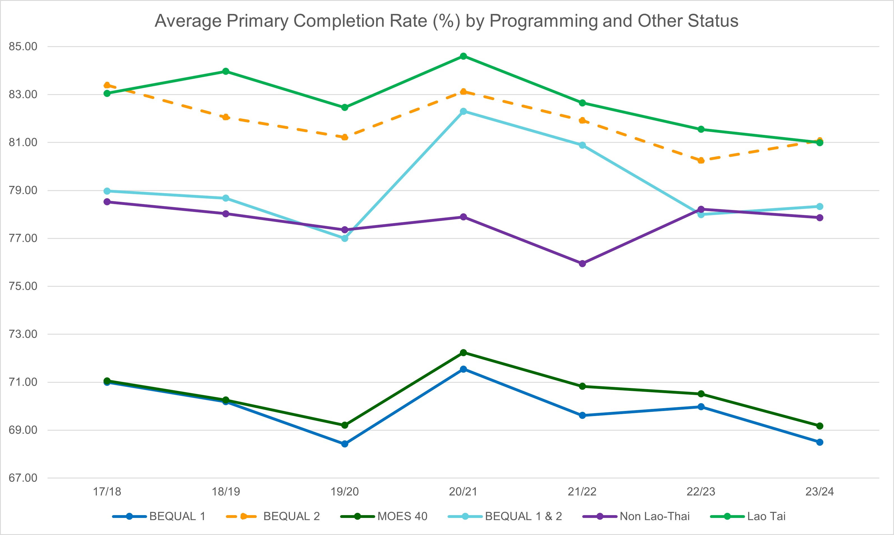

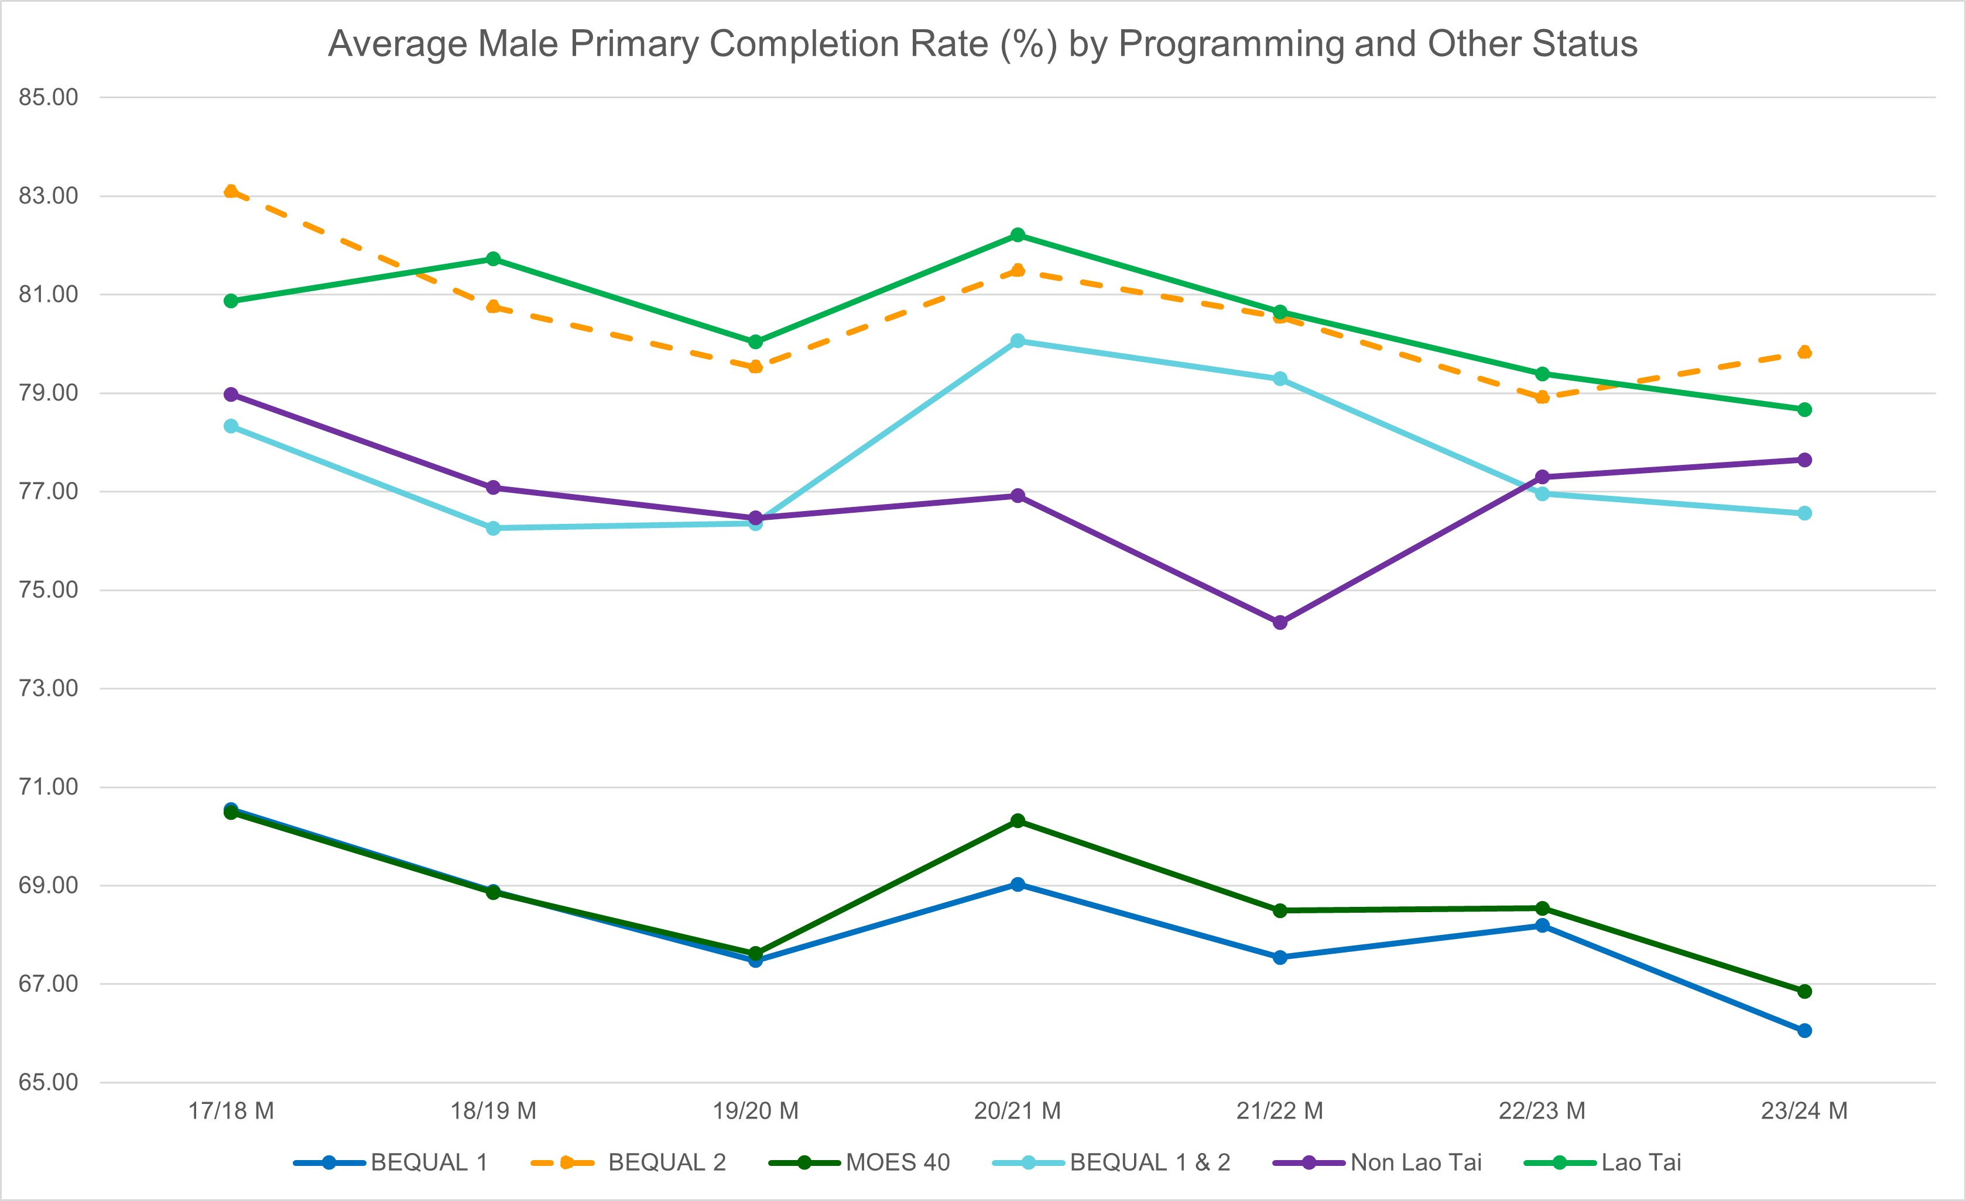

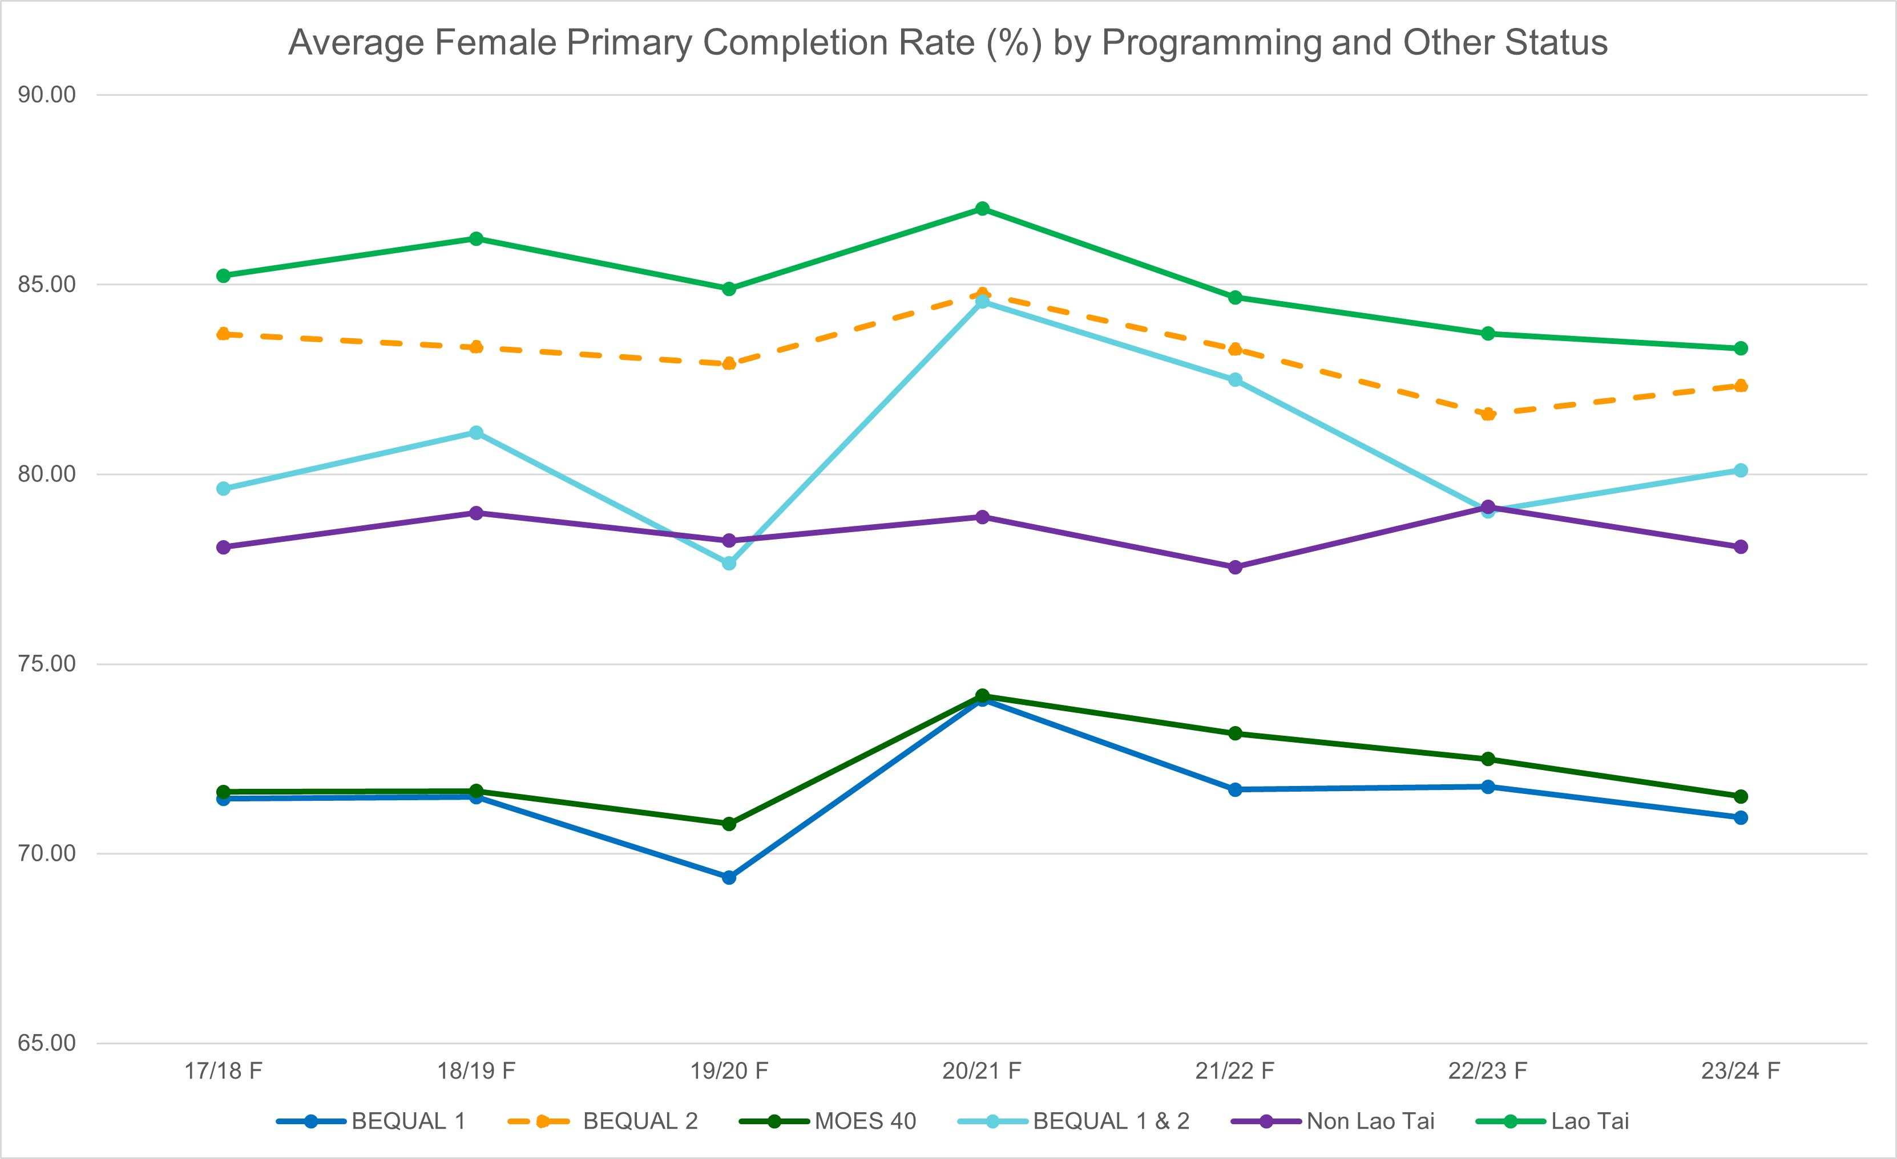

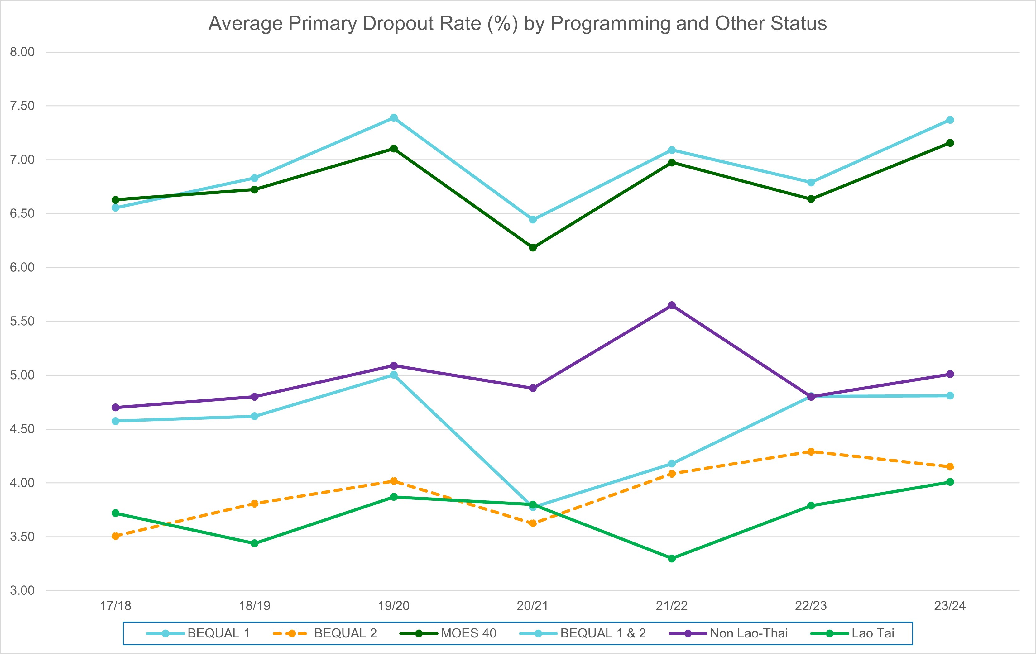

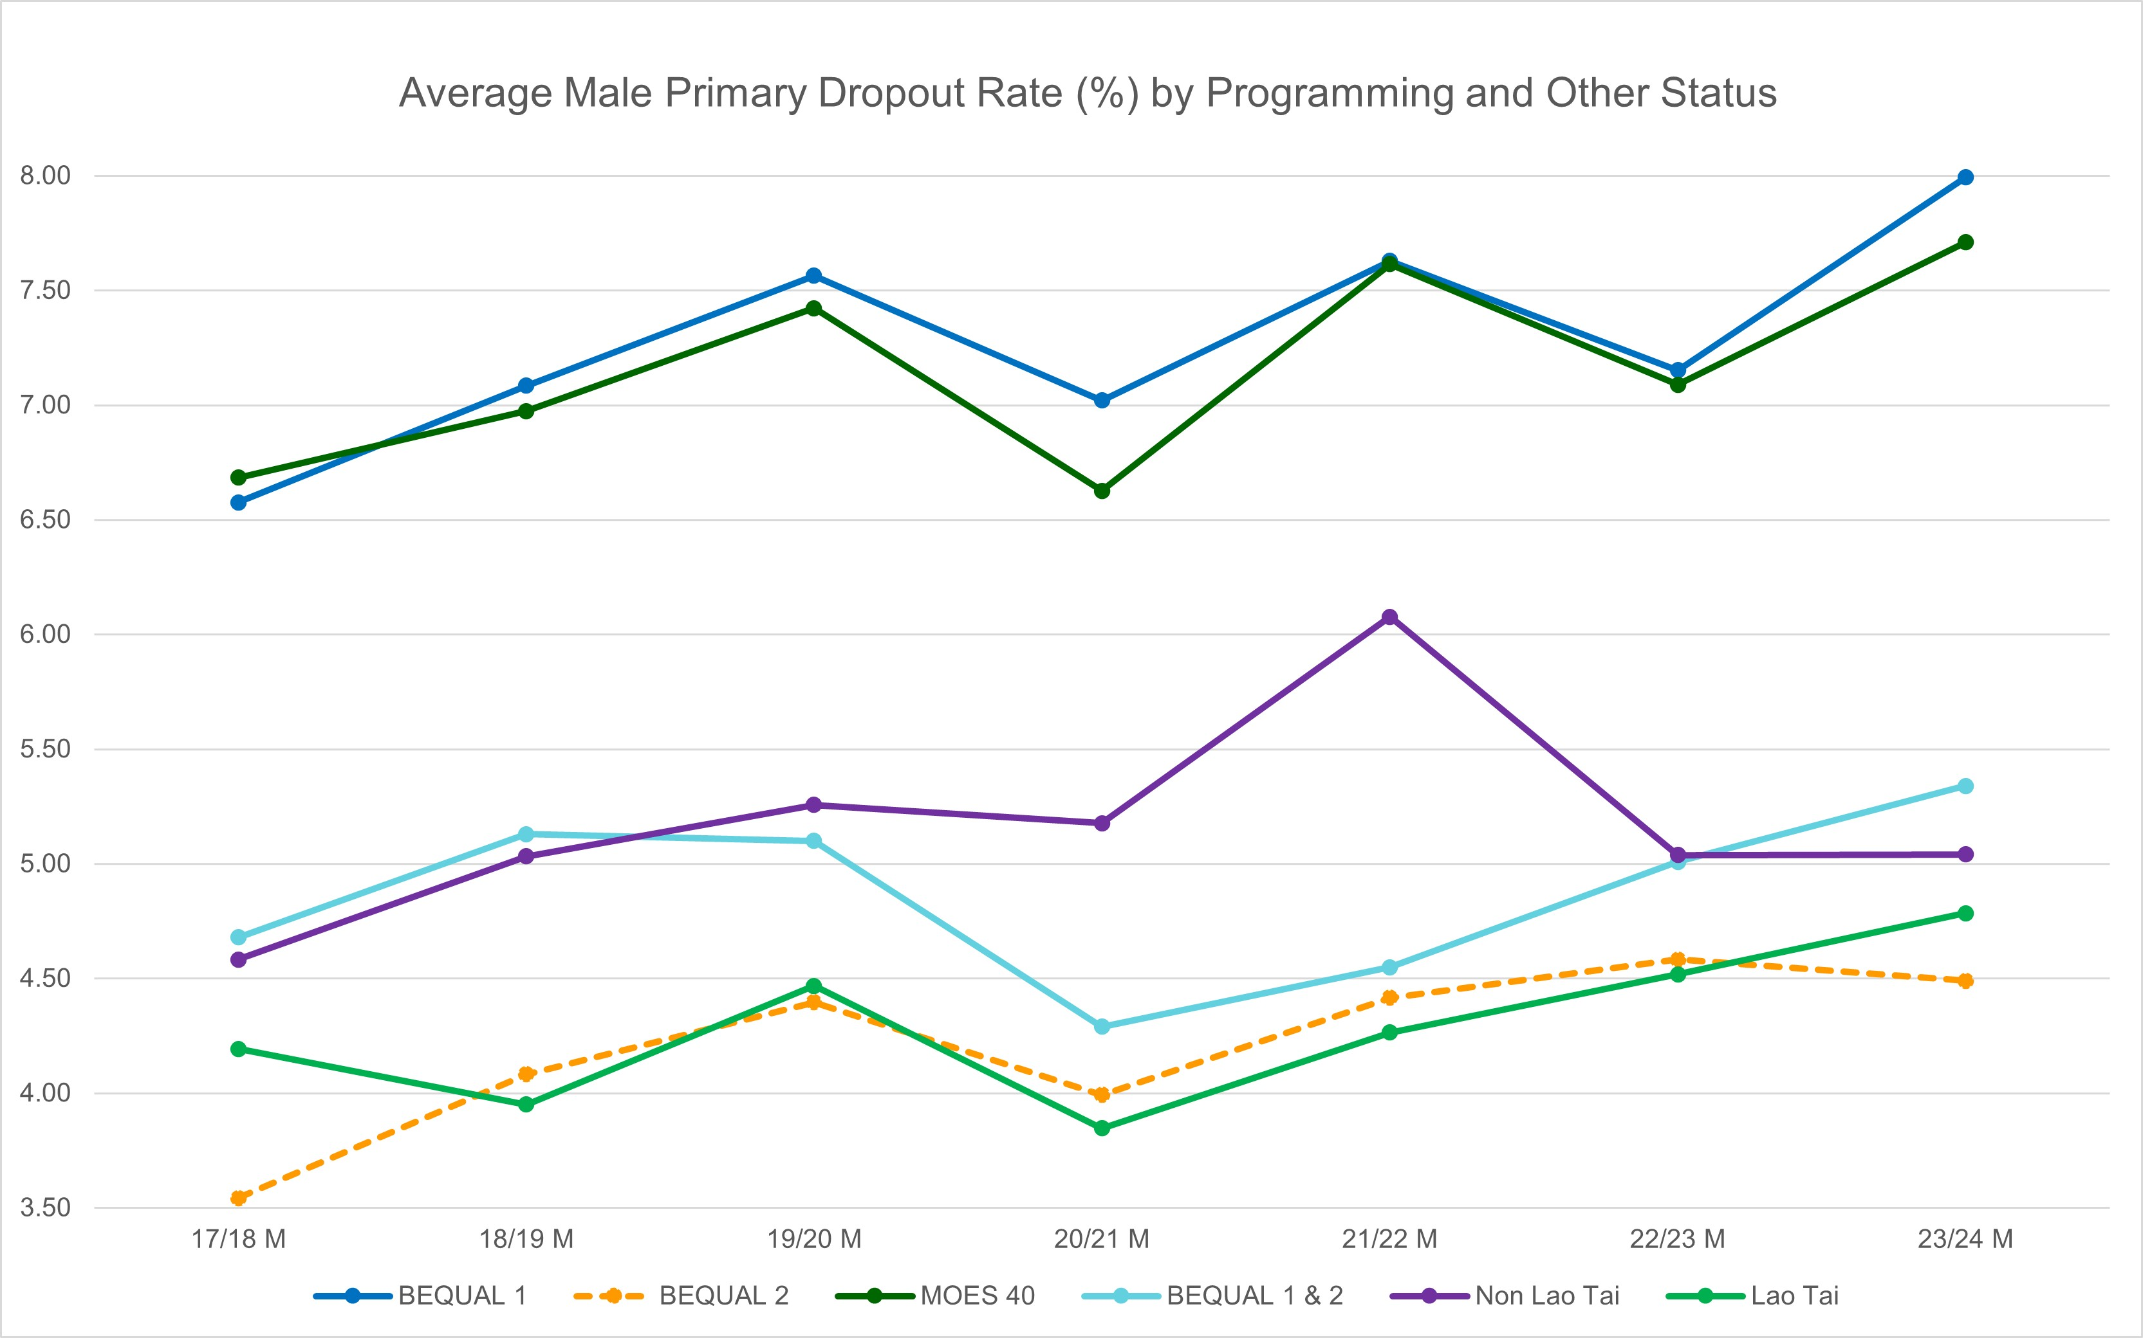

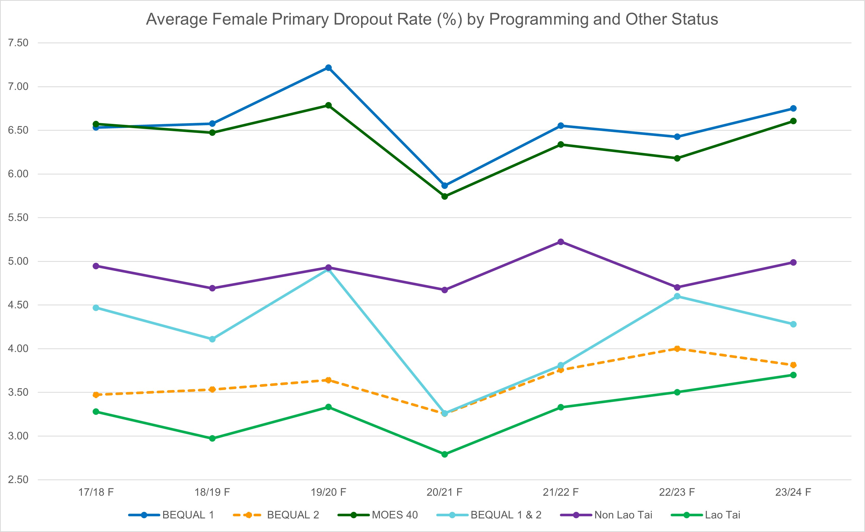

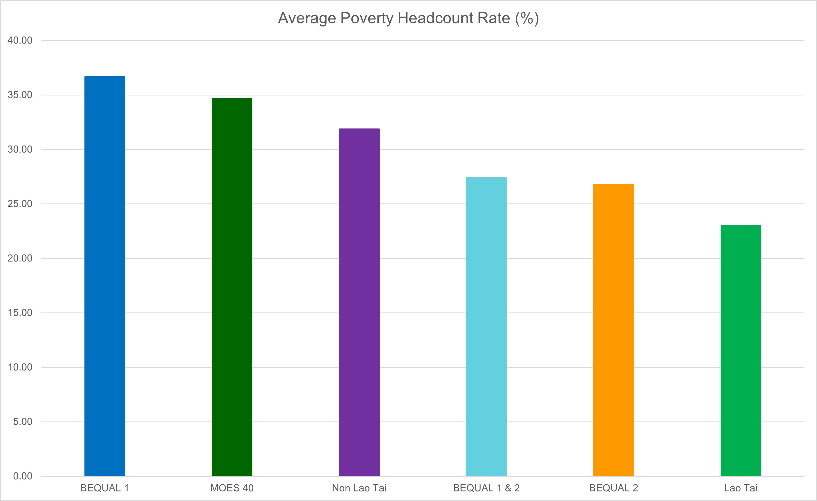



1. DFAT Design, Monitoring and Evaluation Standards (2023), p. 7.
2. DFAT International Development Policy (2023) p.24
3. KIIs 18-42
4. KII 18, 36-42.
5. KII 18, 19, 25, 35.
6. As well as EU budget support. While USAID was identified as another key DP, as of February 2025, this may be less certain given funding freezes. .
7. KII 25, 27, 28, 29.
8. KII 21
9. KII 37-39.
10. DFAT Education Analytics Services, Teacher Development Multi-Year Study Series: Evaluation of Australia’s investment in teacher development in Lao PDR: Final Report (2023) p.8, 11-12.
11. KII 12, 43
12. KII 17
13. KII 27-30
14. KIIs 30-33
15. Ibid.
16. KII 32
17. KII 18, 21
18. KII 18, 21, 34, 35
19. KII 17, 18
20. KII 18, 19, 20, 35
21. KIIs 1-7, 24, 36-42
22. BEQUAL Annual Workplan 2023-24, 2.3 Development Partner Programs p.4
23. KII 38, 39
24. KII 9, 42.
25. KII 38
26. BEQUAL Annual Workplan 2023-4
27. KII 9-12, 14
28. KIIs 9, 12, 14
29. In benchmarking progress towards, and attainment of “transformative” outcomes, this MTR has used (and, where relevant, adapted for disability and social inclusion) the UNICEF standard for Gender-Transformative Programming, available at: Marcus R, et. al. 2022, Gender-Transformative Programming, UNICEF Background Paper Series, pp. 2 & 4-5.
30. E.g., The TSP Classroom Management Module includes instruction that teachers do not make explicit reference to the ethnicity of their students: “When using the reward system to implement the classroom rules, don’t identify children by their…ethnicity…For example, rather than saying, ‘the Hmong students are working well’…instead say ‘Xaybeu, Livang, and Cheulor are working well’”.
31. Ibid please see UNICEF standard for further detail.
32. Select screenshots and examples of these depictions (comprising illustrations of children in wheelchairs, and in one case, an appearance of an adult wheelchair user in an instructional video) were provided to the Review Team, however it was not possible to sight each of these textbooks and materials for independent review.
33. UNIECEF Lao PDR. “Children with disabilities. Access for all, no matter what”. [www.unicef.org/laos](http://www.unicef.org/laos). Accessed 10 January 2025.

    <https://www.unicef.org/laos/what-we-do/child-protection/disabilities>
34. As a capacity building measure with MoES, BEQUAL 2 could also consider dedicated supports for EMIS data collection to support capture and disaggregation by disability status.
35. Lao Disabled People’s Association (LDPA) – 3 pax; Aid Children with Disability Association – 1 pax; and the Learning for Development Association – 1 pax.
36. Vocational Development for Lao-Blind Association (DSC); Intellectual Disabilities Association (IDA); Deaf Association, and Autism Association.
37. The World Health Organization’s 2015 Global School-Based Student Health Survey for Lao PDR found that more than 10% of 13-15 year-olds were “in a physical fight one or more times during the we months before the survey”, and that more than 13% of students in the same age bracket “were bullied on one or more days during the 30 days before the survey”.
38. Grade 1 and 2 Textbooks accessible via the [UNICEF Laos Learning Passport](https://laos.learningpassport.unicef.org/#/).
39. E.g. At present criteria stipulates that “Pictures/content *avoid* all implications of violence against children; showing children put in unsafe situations; sexualising children, and; inappropriate relationships between adults and children.” Simply recommending that such content be "avoided" is not sufficient. Maintaining the current language risks inadvertently allowing harmful depictions to be included. Instead, it would be advisable to prohibit these depictions under all circumstances.
40. KII Director Sithong
41. KII 1,5,10,12, 14, 15
42. KII 28-29
43. Although the rapid transition of SLP to national rollout was highlighted by some DFAT respondents as a lost policy opportunity in some respects.
44. KII 10, 12-14, 43
45. KII 18, 19, 20, 22, 23, 27, 28, 30, 35.
46. KII 9, 10, 15.
47. KII 18, 20, 36, 37, 38, 39, 40, 41, 42.
48. KII 9-15, 18.
49. KII 17.
50. KII 12, 13, 43.
51. KII 17
52. BEQUAL Phase 1 End of Program Review Final Report, Metis Analytics (April 2022)
53. KII 12
54. KII 17
55. Angrist, Noam, Evans, David K., Filmer, Deon, Glennerster, Rachel, Rogers, F. Halsey, and Sabarwal, Shwetlena. 2020. *How to Improve Education Outcomes Most Efficiently? A Comparison of 150 Interventions Using the New Learning-Adjusted Years of Schooling Metric.* Policy Research Working Papers. The World Bank. <https://doi.org/10.1596/1813-9450-9450>

    Wilichowski, T. Daviot, Q., & Arenge, G. Operationalizing Impact: A Decase of World Bank Supported Impact Evaluations. International Bank for Reconstruction and Development / the World Bank. (2024). <https://documents1.worldbank.org/curated/en/099724110022441282/pdf/IDU112e3c4c41b1c614d8a1b6131da4b9f3b7877.pdf>

    Azevedo, Joao Pedro, Goldemberg, Diana, Montoya, Silvia, Nayar, Reema, Rogers, Halsey, Saavedra, Jaime, and Stacy, Brian William. 2021. Will Every Child Be Able to Read by 2030? Defining Learning Poverty and Mapping the Dimensions of the Challenge. Working Paper. Washington, DC: World Bank. https://doi.org/10.1596/1813-9450-9588.
56. Angrist, N., Ainomugisha, M., Bathena, S. P., Bergman, P., Crossley, C., Cullen, C., Letsomo, T., et al. Building Resilient Education Systems: Evidence from Large-Scale Randomized Trials in Five Countries. Nat. Bur. Econ. Res. (2023). <https://doi.org/10.3386/w31208>
57. Angrist, Noam, Djankov, Simeon, Goldberg, Pinelopi K., and Patrinos, Harry A.. 2020. “Measuring Human Capital Using Global Learning Data.” Nature, 592(7854): 403–408. https://doi.org/10.1038/s41586-021-03323-7
58. Angrist, N., Bergman, P. & Matsheng, M. Experimental evidence on learning using low-tech when school is out. *Nat Hum Behav* **6**, 941–950 (2022). <https://doi.org/10.1038/s41562-022-01381-z>
59. Angrist N, Aurino E, Patrinos HA, et al. Improving Learning in Low- and Lower-Middle-Income Countries. *Journal of Benefit-Cost Analysis*. 2023;14(S1):55-80. doi:10.1017/bca.2023.26
60. Angrist, Noam, and Meager, Rachael. 2023. Implementation Matters: Generalizing Treatment Effects in Education. Ed Working Paper 23-802, Annenberg Institute at Brown University. https://doi.org/10.26300/ysyd-t435
61. This ratio describes the relationship between the relative costs and benefits of an intervention. Where ratio is greater than 1:1, it can be expected to deliver a positive return over time.
62. Op. Cit. Angrist, N. et. al. « Improving Learning in Low- and Lower-Middle-Income Countries. 2023. NB: Values are quoted in USD, current as at 2023. Benefits are discounted at a rate of 8%. See: Lomberg, B. 2023. Best things first: Benefit-Cost Analysis, Discounting, and Value of Life. Copenhagen Consensus Centre. pp. 263.
63. This measure represents the percentage of graduates of the cohort that commenced Grade 1 studies in the same academic year.
64. This measure represents the percentage of children who were enrolled in one grade and in the following year did not repeat or enrol in the next grade.