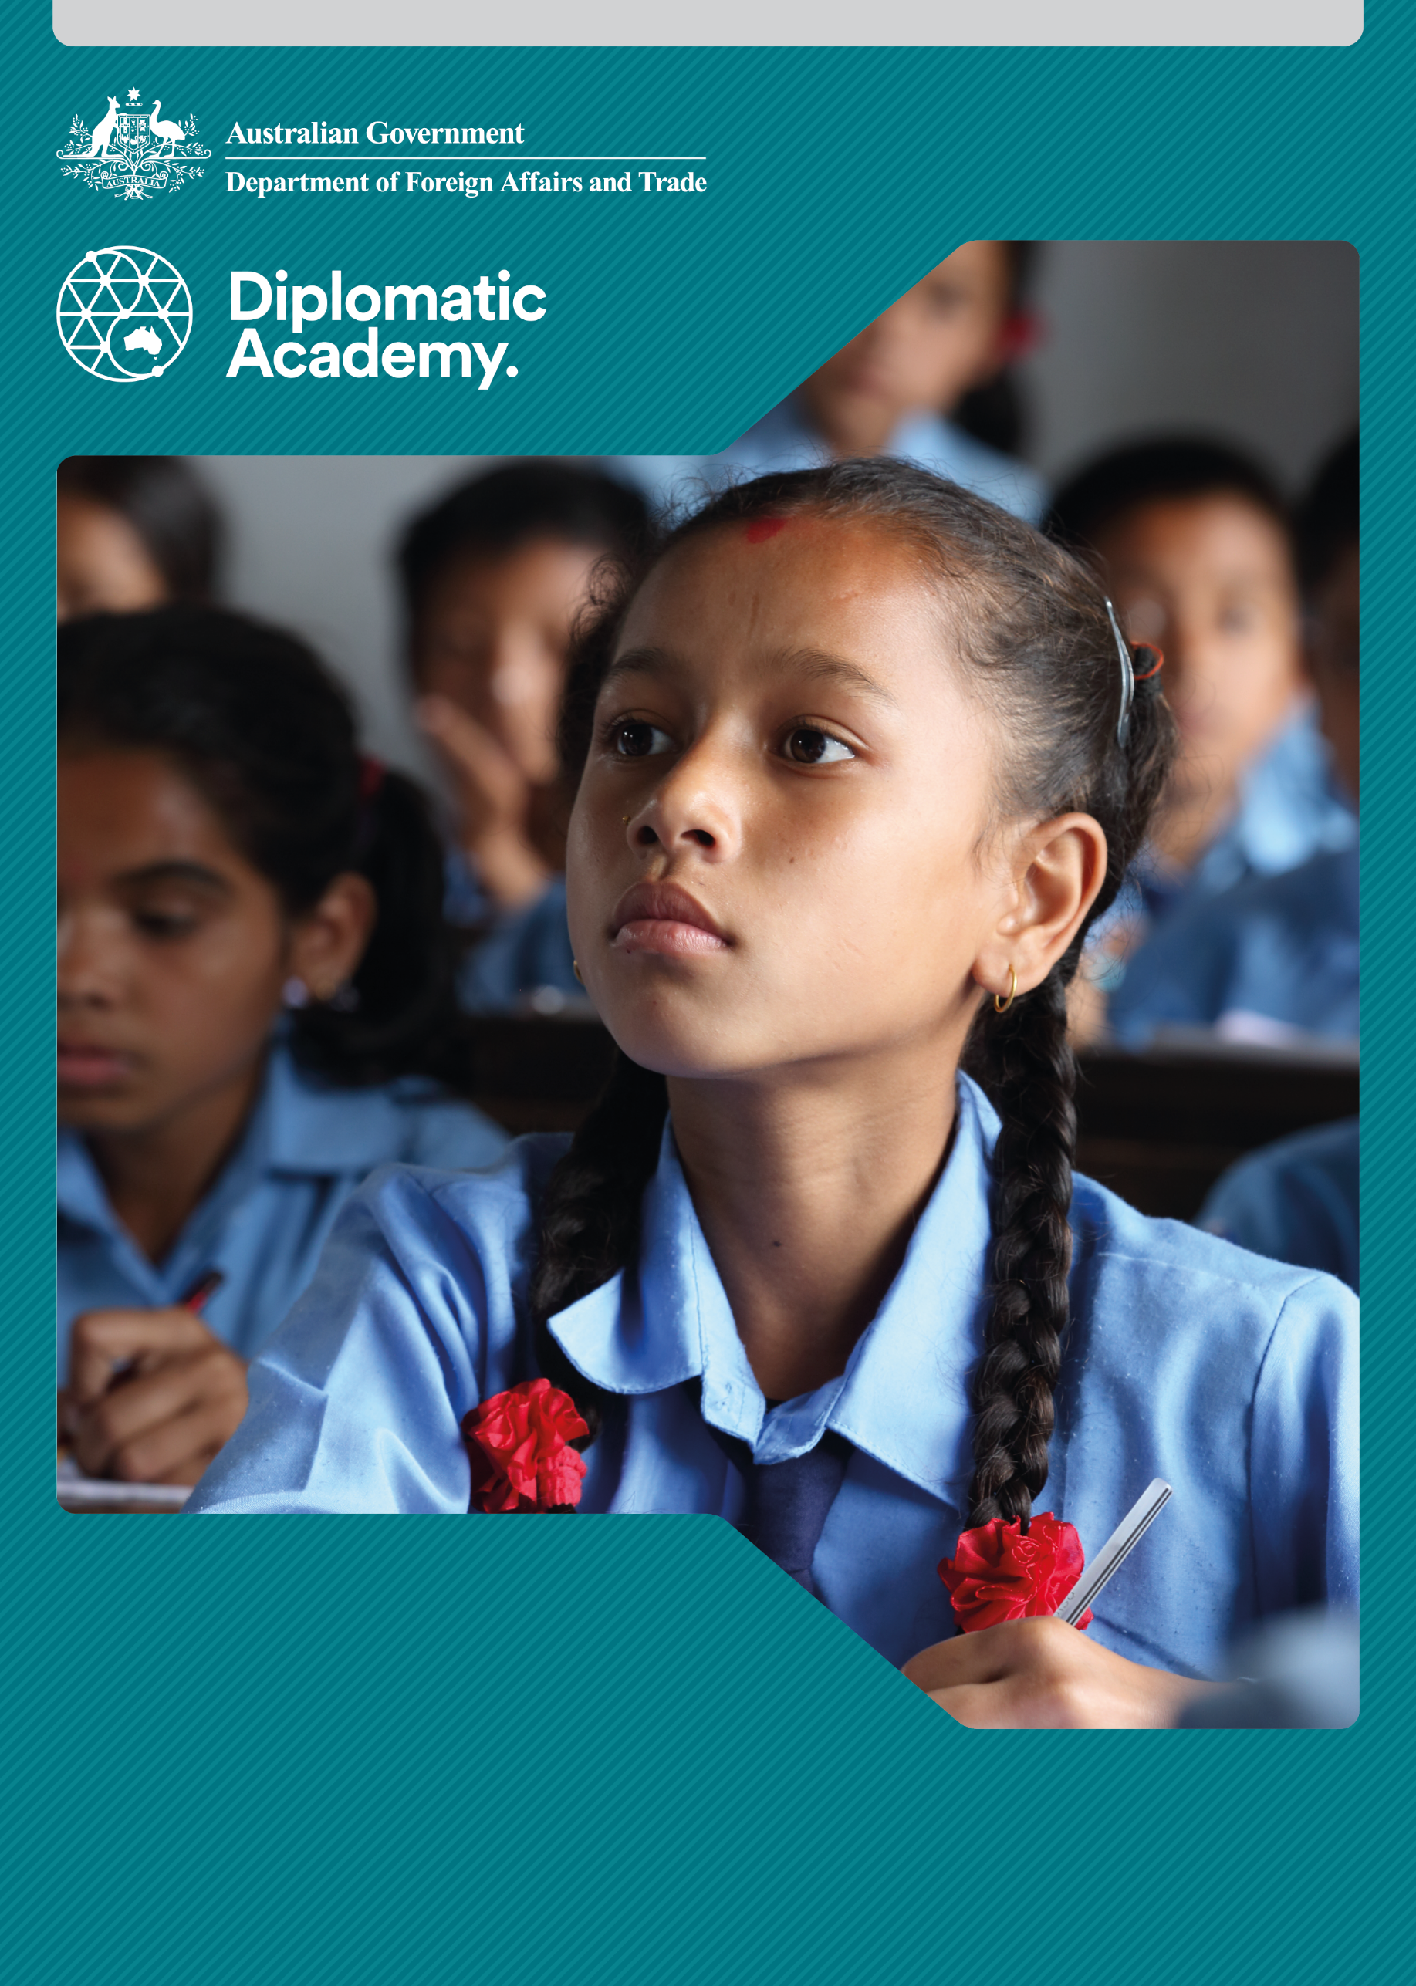

Education Learning and Development Module

**BASIC EDUCATION**

Practitioner Level

CONTENTS

Acronyms 3

1 Introduction 4

2 How do we define basic education? 4

3 How can we develop effective strategies for implementing basic education? 6

4 Key priorities in basic education 7

5 Basic education post-2015 16

6 Test your knowledge 17

References and links 19

# Acronyms

DFAT Australian Government Department of Foreign Affairs and Trade

EFA Education for All

EGRA Early Grade Reading Assessment

EGMA Early Grade Maths Assessment

EMIS Education Management Information System

GDP Gross Domestic Product

GPI Gender Parity Index

ISCED International Standard Classification of Education

MDGs Millennium Development Goals

PILNA Pacific Literacy and Numeracy Assessment

PIRLS Progress in Reading Literacy Study

PISA Programme for International Student Assessment

PLAP Performance Lag Addressing Programme (Zimbabwe)

SDGs Sustainable Development Goals

TIMSS Trends in International Mathematics and Science Study

UNESCO United Nations Educational, Scientific and Cultural Organization

WIDE World Inequality Database on Education

ZELA Zimbabwe Early Learning Assessment

# Introduction

This Practitioner level module is designed to ensure that Department of Foreign Affairs and Trade (DFAT) staff members who engage with and lead policy dialogue with international and domestic partners are informed about effective strategies for implementing basic education and key priorities in basic education.

It is recommended that staff complete the Basic Education: Foundation level module as background information to this Practitioner level module.

# How do we define basic education?

## Definitions of basic education share common elements

Basic education has been defined by a range of organisations, with each definition circling around core themes. Each of the definitions of basic education shares common elements. These include the development of competencies, knowledge, attitudes and values as a basis for lifelong learning.

|  |
| --- |
| International Standard Classification of Education (ISCED)  [The International Standard Classification of Education (ISCED)](http://uis.unesco.org/sites/default/files/documents/international-standard-classification-of-education-isced-2011-en.pdf) states that basic education corresponds to the first nine years of formal schooling and is made up of two levels. Level 1 is primary education (usually six years) and Level 2 refers to lower secondary (usually three years; grades 7-9). It also covers non-formal and informal activities intended to meet the basic learning needs of people of all ages.  Source: UNESCO Institute of Statistics 2011. |

The ISCED definition is used in DFAT’s [Strategy for Australia’s Aid Investments in Education, 2015-2020](http://dfat.gov.au/about-us/publications/Documents/strategy-for-australias-aid-investments-in-education-2015-2020.pdf) but we recognise that different countries define basic education in slightly different ways. For instance, some partner countries include pre-primary education as part of basic education. Supporting a quality basic education is a key priority for the Australian Government, as identified across all four strategic priorities of the Education Strategy.

Source: DFAT 2015.

Ensuring quality and inclusive education is also at the heart of Sustainable Development Goal 4 (SDG 4), which commits governments to providing all children with free, equitable and quality primary and secondary education and lifelong learning opportunities for all.

|  |
| --- |
| Other views of basic education  ‘Our vision is to transform lives through education, recognising the important role of education as a main driver of development and in achieving the other proposed SDGs.’ (Incheon Declaration, p. 7).  ‘Building on and continuing the EFA movement, SDG4-Education 2030 takes into account lessons learned since 2000. What is new about SDG4-Education 2030 is its focus on increased and expanded access, inclusion and equity, quality and learning outcomes at all levels, within an lifelong learning approach.’ (Framework for Action, p. 25).  Source: UNESCO 2016a, [Education 2030: Incheon Declaration and Framework for Action for the implementation of Sustainable Development Goal 4](http://uis.unesco.org/sites/default/files/documents/education-2030-incheon-framework-for-action-implementation-of-sdg4-2016-en_2.pdf).  ‘Basic education is more than an end in itself. It is the foundation for lifelong learning and human development on which countries may build, systematically, further levels and types of education and training.’ (Article 1.4)  Source: UNESCO 1990, [World Declaration on Education For All: Meeting basic learning needs](http://www.un-documents.net/jomtien.htm) (Jomtien Declaration).  ‘Education is a key need, along with other basics, in today’s world for anyone, anywhere to have a good quality of life. In developing countries particularly, such as those in the South Asia region, basic education is crucial to alleviating poverty, reducing inequality and driving economic growth.’  Source: World Bank n.d. [Brief on education in South Asia](http://go.worldbank.org/G22NKEQZP0). |

|  |
| --- |
| An activity for you  **Watch the** [RSA Animate – Changing Education Paradigms](http://www.youtube.com/watch?v=zDZFcDGpL4U) **video and reflect on the basis of basic education reforms in a developing country/region known to you.**  Are basic education reforms clearly focused on the future or are they rooted more in the past (i.e. more of the same)?  Source: The Royal Society for the Encouragement of Arts, Manufactures and Commerce (RSA) 2010 |

# How can we develop effective strategies for implementing basic education?

## Basic education reform

Based on two decades of attempts to meet firstly the Education for All (EFA) and then the Millennium Development Goals (MDGs), the overall lesson is that project-based interventions are generally not sustainable. Program-based and system-wide support for basic education reforms can result in more transformative change. Effective, country-led approaches to basic education reform may include:

* institutional management and human resource management/development
* policy, strategic and operational planning, budgeting and fiscal management systems
* system monitoring, including Education Management Information Systems (EMIS), evaluations and research

whole of system communications, including information and communications technology infrastructure.

## Ministries of Education

Supporting Ministries of Education in their multiple responsibilities is a key strategy. In basic education, Ministries of Education must simultaneously focus on:

* access
* equity
* quality

efficiency.

Being able to analyse the successes and priorities in basic education depends on a robust and accurate EMIS system (with statistics on students, schools, teachers and learning performance). This needs to include a human resource database (with data on teachers’ qualifications, experience, deployment, and record of professional development).

# Key priorities in basic education

|  |
| --- |
| An activity for you  **Barriers to access and participation in education for girls**  **Watch the following videos and reflect on the situation of girls aged 6 to 14. Identify some of the barriers to access and participation in basic education for girls and think about strategies that may be proposed for reducing these barriers.**  [A Winning Equation](http://www.youtube.com/watch?v=RdP1llxUIBc&list=EC551163BB4376C529)  [Girls' Education](http://www.youtube.com/watch?v=tQLZuTGaGuw&feature=player_embedded)  [Invest in Girls’ Education](http://www.youtube.com/watch?v=c_te9wClv3M&list=EC551163BB4376C529)  Sources: UNESCO 2011a, Global Campaign for Education 2012, UNESCO 2011b. |

## Inequality and vulnerability

Inequality is a great source of division both within and between countries. On average, while gender parity in education was technically achieved globally in 2014, this global average masks continuing disparity in many regions and countries. At the primary level, disparity persists in 37 per cent of countries, mostly in Africa and Western Asia, with girls from the poorest households the least likely to set foot in a classroom. And just as gender limits opportunities, the following factors can also exclude children from educational opportunities:

* disability
* ethnicity
* language
* displacement – of refugees and those internally displaced
* impact of natural disasters

rural residence.

Source: UNESCO 2016b, [Education for people and planet: Creating sustainable futures for all](http://unesdoc.unesco.org/images/0024/002457/245752e.pdf), p. 262.

### How does inequality affect vulnerable children?

Inequality is magnified for vulnerable children trying to access basic education. Primary school aged children in conflict-affected poor countries account for 35 per cent of those out of school. Impacts of climate change have the potential to lead to increased numbers of out-of-school children and youth, particularly in the Pacific region and South Asia.

Source: UNESCO Institute for Statistics & Global Education Monitoring Report 2016, [Leaving no one behind: How far on the way to universal primary and secondary education?](http://unesdoc.unesco.org/images/0024/002452/245238E.pdf), p. 4.

### How is information on inequality collected?

Tracking tools and data currently exist. The [World Inequality Database on Education (WIDE)](http://www.education-inequalities.org) published by the [Global Education Monitoring Report](http://en.unesco.org/gem-report/) could help each country identify marginalised and vulnerable groups, including girls, children in conflict, and those with disabilities, and set plans and allocate resources for eliminating basic education disparities.

Source: UNESCO Institute for Statistics & Global Education Monitoring Report n.d.

**Note**: For more information view the modules on *Marginalisation* and *Inclusive Education.*

### Why is it difficult to engage the disadvantaged?

Governments find it particularly difficult to engage the most disadvantaged in basic education, partly due to limited funds but also due to entrenched attitudes that discriminate against certain groups.

Schools, and the education system, must be flexible and welcoming to those who face many barriers to access and completion of basic education. Flexibility may demand changes in the local curriculum and timing of semesters (e.g. to account for the harvest season), for example. Welcoming means ensuring there are no discriminatory practices which could exclude the disadvantaged from their right to basic education.

Figure 1 – Global number of out-of-school children, adolescents and youth, 2000-2015

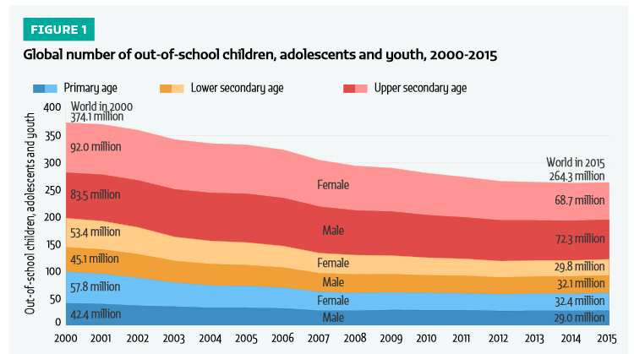

Source: UNESCO Institute for Statistics & Global Education Monitoring Report 2017, [Reducing global poverty through universal primary and secondary education](http://uis.unesco.org/sites/default/files/documents/reducing-global-poverty-through-universal-primary-secondary-education.pdf), Figure 1.

### Developmental impact

Educating girls is a global development priority because it has transformative effects. This investment can be multi-generational: women who have access to education often place a greater value on it, and encourage their daughters to attend school too.

The impact is not just economic or social: countries with more gender-equitable education have lower rates of infant mortality and malnutrition.

### What helps increase female enrolment?

Policies that build parental trust and make schools more girl-friendly—such as hiring more female teachers, forming parental committees, and providing latrine facilities for girls—have all been shown to increase girls’ enrolment.

### Government response

More and more governments now realise the importance of girls’ education.

* In Egypt, the government is integrating the successful concept of girl-friendly community schools—with active learning and child-centred class management into the formal education system.
* In Mashan County in China, villages and households that take effective measures to send girls to school are awarded priority for loans or development funds.

In Bangladesh, measures such as stipends for girls to enrol in school and the provision of separate toilets for boys and girls resulted in a rise in the Gender Parity Index (GPI) from 0.83 to 1.13 (a percentage above 1.0 means that there are more girls than boys).

## Universal basic education

While it is crucial that countries make an extra effort and institute special initiatives to target girls’ education, these endeavours will work only in the context of a broader focus on universal basic education for all children. The [2030 Education Framework for Action](http://uis.unesco.org/sites/default/files/documents/education-2030-incheon-framework-for-action-implementation-of-sdg4-2016-en_2.pdf) commits all countries to ‘ensure the provision of 12 years of free, publicly funded equitable quality education, of which at least nine years are compulsory’.

Though the educational gaps for girls are especially large, the problems for boys—particularly poor, rural boys—are also dramatic. Efforts to get girls into schools will never be successful unless there is a decent quality of education—reasonable class sizes (dependent on infrastructure, furniture and learning materials), trained teachers, and quality instructional materials—for both girls and boys.

Source: UNESCO 2016a.

### Access: what does the slowing of universal enrolment indicate?

Despite positive global trends in universal enrolment, evidence shows that progress has stalled, with the last 9 per cent of primary children still out of school. The global financial crisis has put extra pressure on stretched public funding as well as households struggling to afford schooling. These out-of-school children are being denied their basic human right to education, and their future opportunities are dramatically limited.

|  |
| --- |
| An activity for you  **Which forms of discrimination are evident?**  **Watch the video below on aspects of discrimination, and identify which forms of discrimination may be present in your country or a developing country known to you.**  [Embrace Diversity in School](http://www.youtube.com/watch?v=nhQ_9H08fY4)  Source: UNESCO 2011c. |

## Quality of basic education

Sustainable Development Goal 4 pays particular attention to ensuring quality education at pre-primary, primary and secondary levels and lifelong learning for all.

**Quality is at the heart of education. It influences what students learn, how well they learn and what benefits they draw from their education.**

Ensuring that students achieve meaningful learning outcomes and acquire values and skills that help them play a positive role in their societies is an issue on the policy agenda of nearly every country. This is captured in Priority 2: Learning for All under the [Strategy for Australia’s Aid Investments in Education](http://dfat.gov.au/about-us/publications/Documents/strategy-for-australias-aid-investments-in-education-2015-2020.pdf), 2015-2020. It focuses on ensuring quality education at all levels so that children and adults are equipped with the relevant knowledge and skills to contribute to the development and economic growth of their countries.

Source: DFAT 2015.

### Defining quality

As many governments strive to strengthen and expand basic education, they also face the challenge of ensuring that students stay in school long enough to acquire the knowledge and skills to cope in a rapidly changing world.

Quality is a much used word in the vocabulary of the global education agenda, but it is a concept that has a range of definitions. There are five components which seem central to understanding quality in basic education:

* healthy, ready to learn children
* supportive learning environments
* relevant curriculum content
* child-centred teaching and learning

accurate assessment of learning outcomes, to inform school practice and to gain an understanding of successes and challenges at the individual, school, sub-national and national levels.

### Quality education requirements

Figure 2 – Basic education and gender equality: Quality of education

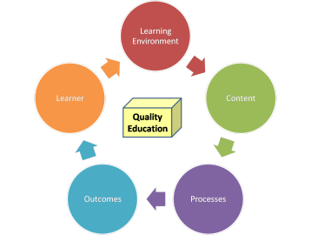

Source: UNICEF 2010, [Basic education and gender equality: Quality of education](https://www.unicef.org/education/index_quality.html).

Figure 2 shows that quality education requires: quality **learners** (healthy and ready-to-learn children), quality **learning environments** (child friendly classrooms), quality **content** (appropriate curriculum relevant to learners’ present and future lives), quality **processes** (child-centred pedagogy and active learning of children), and quality **outcomes** (learners meet established learning standards).

### Understanding quality

Learner characteristics

Learners do not come to primary and lower secondary schools as equals. Socioeconomic background, gender, disability, ethnicity, HIV/AIDS and emergency situations create inequalities. They should all be taken into account in policies to improve quality. The extent to which pupils and students have benefited from learning opportunities in early childhood also has an impact. These include parental engagement and stimulating home environments.

Learning environment

Education tends to reflect society’s values and attitudes. Circumstances ranging from a society’s wealth to national goals and standards, curriculum and teachers all influence the quality of the learning environment. Physical structures and facilities also have an impact on education quality such as appropriate technology, water and hygiene.

Curriculum content

Inputs into curriculum content include material resources (textbooks, learning materials, classrooms, libraries, school facilities) and human resources (managers, supervisors, inspectors and, most importantly, teachers). Language of instruction and attention to diversity are also important considerations. The indicators most widely used to measure these inputs are pupil:teacher ratios, teacher salaries, public current expenditure per pupil, and proportion of Gross Domestic Product (GDP) spent on education.

Teaching and learning (processes)

Teaching and learning are what happens in the classroom and the school. Pedagogical processes lie at the heart of day-to-day learning. Indicators used to measure these include time spent on learning, use of interactive teaching methods, and assessment methods.

Outcomes

Outcomes of a quality education can be expressed in a variety of ways including:

* academic achievement (measured through examination performance, continuous assessment, standardised learning assessments)
* cognitive and emotional development (e.g. school readiness in pre-primary education, critical thinking and collaborative skills at primary/ secondary/tertiary levels)

social and economic gains (e.g. employment outcomes, economic development, peace and stability, institutional systems and governance).

Sources: UNESCO 2016b, [Education for people and planet: Creating sustainable futures for all](http://unesdoc.unesco.org/images/0024/002457/245752e.pdf); UNESCO 2004, [Education for all: The quality imperative](http://unesdoc.unesco.org/images/0013/001373/137333e.pdf).

|  |
| --- |
| An activity for you  **Watch the video below and see what young people are saying about the quality of their education**  [Asia-Pacific youth discussion on learning for the future](http://www.youtube.com/watch?v=AzzjUh2M6sQ): Better Learning, Better Life  Source: UNESCO 2012. |

|  |
| --- |
| Case study: Cambodia  Cambodia has faced a number of challenges while attempting to improve the quality of basic education. An assessment in 2004 identified:   * many Cambodian children enter school already disadvantaged by years of malnutrition and lack of school readiness * they learn in classrooms that are often inadequately equipped resulting from a chronically under resourced system * learning content prescribed in the curriculum is too heavy for children to master given the low number of learning hours in Cambodian schools * the teaching-learning process is often based on rote learning with very few opportunities for active learning by children * EMIS data shows that only 45 per cent of children who start primary school will eventually reach Grade 6 and only 38 per cent will reach lower secondary * it takes an average 10.8 years for a child to complete the six-year primary education cycle * there is no national data on student learning achievement based on standardised tests, which makes it difficult to assess education quality in Cambodia objectively * school records indicate poor learning achievement by a majority of learners * low pay for teachers has emerged as the main contributor to poor teaching quality, and a major factor explaining poor student learning achievement.   **Cambodia: basic education quality improvements**  The Cambodian Ministry of Education, Youth and Sport identified strategies to improve the quality and efficiency of education. The Education Strategic Plan 2014-18 focuses on strengthening the quality of and access to a comprehensive nine year program of basic education for all school age children:  curriculum reform and a learning assessment system linked to curriculum standards, and continuous teacher development through decentralised in-service and pre-service training, including upgrading of teachers’ qualifications by 2020  an effective quality framework that promotes quality and relevance of learning and provides learners, parents, teachers, communities and policy makers with a set of clear performance indicators to be monitored, measured and reported  adopting the Child-Friendly Schools approach as national policy, to: improve teaching-learning practices; create a conducive and protective learning environment; and enable parents and communities to support education.  Sources: Ministry of Education, Youth and Sport, Kingdom of Cambodia 2004[, Education Sector Performance Report 2004](https://www.researchgate.net/publication/44840960_Education_Sector_Performance_Report_2004_ESSP_review_2004); UNESCO 2015, [Education for All 2015 national review report: Cambodia](http://unesdoc.unesco.org/images/0022/002297/229713e.pdf). |
| An activity for you  **Consider the Case Study on Cambodia.**  Identify the quality factors that seem ‘low’ in the Cambodian example.  The Cambodian Ministry of Education, Youth and Sport identified a number of strategies to address the challenges to a quality basic education. What other complementary quality strategies could be pursued?  Options for other quality strategies that could be pursued by the Ministry include:  provision of new instructional materials  decentralised teacher development and management  improvement of school performance monitoring  redefining roles of inspection and supervision services at all levels  increasing the number of teaching hours in the school day  remedial classes in all years to assist weak pupils who are unable to cope with the whole curriculum. |

## Learning outcomes and the quality of basic education

**Just enrolling in and attending school does not guarantee mastery of even the most basic skills.**

Approximately one in three primary school-age children globally are not learning the basics in reading and mathematics. There has been a shift of emphasis for development partners from supporting inputs (such as providing classroom furniture and learning materials, improved learner:teacher ratios) to the outputs of the education system. This focus on learning outcomes will provide a measure of the quality of education provided.

### Measurement of learning

The past two decades have seen a growing interest in strengthening systems for the measurement of learning in basic education. Some countries have been involved in international learning assessments such as the Trends in International Mathematics and Science Study (TIMSS), Programme for International Student Assessment (PISA), Progress in International Reading Literacy Study (PIRLS), and the Pacific Literacy and Numeracy Assessment (PILNA).

**Note**:For more information view the modules on *Learning Assessment*

## National assessment systems

|  |  |  |  |  |  |  |  |  |  |  |  |  |  |  |  |  |  |  |  |  |  |  |  |  |  |
| --- | --- | --- | --- | --- | --- | --- | --- | --- | --- | --- | --- | --- | --- | --- | --- | --- | --- | --- | --- | --- | --- | --- | --- | --- | --- |
| Case study: Zimbabwe  Some countries have engaged in the Early Grade Reading Assessment (EGRA) and Early Grade Maths Assessment (EGMA), or adapted them to become part of their own national assessment system. In some countries initiatives have been taken following a provincial or national assessment which illustrated significant failure rates at the end of primary education, for example in Zimbabwe.  In one province, Manicaland, ‘learning lag’ was noticed at Grade 7 (end of primary) which indicated that learners were operating at two or three years below their grade level, mainly due to limited reading competence. What was also noticeable was that this ‘learning lag’ grew larger the longer a learner was in school (see secondary results).  Table 1 – Percentage of learners performing at or below grade level   |  |  |  |  |  | | --- | --- | --- | --- | --- | |  | **Primary Level** | | **Secondary Level** | | | Subject | Below grade | At or above grade | Below form | At or above form | | Mathematics | 76% | 24% | 85% | 15% | | English | 95% | 5% | 100% | 0% | | Average | 85% | 15% | 92% | 8% |   **Performance Lag Addressing Programme (PLAP)**  Manicaland province put in place a remediation programme (Performance Lag Addressing Programme, PLAP). During the PLAP pilot phase, it was discovered that Grade 5 students were performing at the level of Grade 1 students, so teaching was revised to Grade 1 level. Within two months, these students had mastered Grade 1 lessons and a few months later were able to competently read, write and count. This was so successful that it was proposed to scale up to national level, following a national learning assessment (Zimbabwe Early Learning Assessment - ZELA) which underscored the poor attainment across the country as a whole, as early as Grade 3.  Development partners supporting the Ministry of Education, Sports, Arts and Culture, through funding from the Global Partnership for Education, have enabled the widening of implementation of the PLAP to provide national coverage.  Source: Global Partnership for Education: GPE Secretariat 2017, ‘[Zimbabwe: A chance to learn for every child: Improving student learning by focusing on teachers](http://globalpartnership.org/blog/zimbabwe-chance-learn-every-child)’. |

# Basic education post-2015

## Basic education after 2015

The promotion of EFA and the MDGs galvanised development partners into investing funds firstly into getting more children, particularly the disadvantaged, into school, and secondly to focus on raising the quality of education for all. The 2030 Agenda tackles the ‘unfinished business’ of the EFA movement by prioritising quality and equitable education and lifelong learning for all girls and boys, women and men.

Sustainable Development Goal 4 commits all countries to ‘ensure inclusive and equitable quality education and promote lifelong learning opportunities for all’. SDG 4 and its targets are specific about a new way of advancing education, where access to and participation in good quality education can cultivate the skills, competencies and values that influence people’s choices to create more just, inclusive and sustainable societies. That is why SDG 4 is at the heart of all other sustainable development goals. When people have access to a quality education, they can break from the cycle of poverty. Education helps to reduce inequalities and reach gender equality. It empowers people to make informed choices about a more healthy and sustainable life. It also fosters tolerance between people and help build more peaceful societies.

Sustainable Development Goal 4 ensures that all boys and girls have access to and complete free early childhood education, primary and secondary schooling by 2030. It also aims to provide equal access to affordable vocational training, and to eliminate gender and wealth disparities by providing universal access to quality technical/vocational and higher education. It seeks to achieve these targets through effective learning environments, increasing the supply of qualified teachers and expanding the number of scholarships to developing countries.

Source: United Nations 2017, [Sustainable Development Goals: Goal 4: Ensure inclusive and quality education for all and promote lifelong learning](http://www.un.org/sustainabledevelopment/education/).

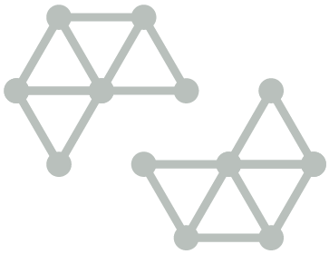

# Test your knowledge

## Assessment questions

Answer the following questions by ticking ‘True’ or ‘False’. Once you have selected your answers to all the questions, turn the page to ‘The correct answers are...’ to check the accuracy of your answers.

Question 1

Project-based interventions in basic education are better than system-wide support.

Is this statement true or false? □ True □ False

Question 2

Without good data it is difficult to target resources and plan effective basic education interventions.

Is this statement true or false? □ True □ False

Question 3

Quality in basic education is easy to define.

Is this statement true or false? □ True □ False

Question 4

It is possible to learn from quality initiatives and scale them up to national programs.

Is this statement true or false? □ True □ False

Question 5

Gender is not the only barrier to enrolling or completing basic education.

Is this statement true or false? □ True □ False



## The correct answers are...

Question 1

Project-based interventions in basic education are better than system-wide support.

**This statement is false**. Project-based interventions in basic education are generally not sustainable. Program-based and system-wide support for basic education reforms can result in more transformative change.

Question 2

Without good data it is difficult to target resources and plan effective basic education interventions.

The statement is true.

Question 3

Quality in basic education is easy to define.

**The statement is false**. Quality basic education includes at least these five components: healthy, ready to learn children; supportive learning environments; relevant curriculum content; child-centred teaching and learning; successful learning outcomes for children.

Question 4

It is possible to learn from quality initiatives and scale them up to national programs.

**The statement is true**. In Zimbabwe, for example, following a successful province-level remediation programme (Performance Lag Addressing Programme, PLAP), the government and development partners have scaled the program up to national coverage.

Question 5

Gender is not the only barrier to enrolling or completing basic education.

**The statement is true.** Other factors that are barriers to education include: disability; ethnicity; language; displacement – of refugees and those internally displaced; impact of natural disasters; rural residence.

# References and links

Department of Foreign Affairs and Trade (DFAT) 2015, Strategy for Australia’s aid investments in education 2015-2020, September, Commonwealth of Australia, retrieved 14 September 2017, <http://dfat.gov.au/about-us/publications/Documents/strategy-for-australias-aid-investments-in-education-2015-2020.pdf>

Global Campaign for Education 2012, Girls education 2012, YouTube, join1goal, 28 February, retrieved 14 September 2017, [http://www.youtube.com/watch?v=tQLZuTGaGuw&feature=player_embedded#](http://www.youtube.com/watch?v=tQLZuTGaGuw&feature=player_embedded)

Global Partnership for Education: GPE Secretariat 2017, ‘Zimbabwe: A chance to learn for every child: Improving student learning by focusing on teachers’, Education for All Blog, 13 February, retrieved 18 September 2017, <http://globalpartnership.org/blog/zimbabwe-chance-learn-every-child>

Ministry of Education, Youth and Sport, Kingdom of Cambodia 2004, Education Sector Performance Report 2004, MoEYS, UNESCO, retrieved 18 September 2017, <https://www.researchgate.net/publication/44840960_Education_Sector_Performance_Report_2004_ESSP_review_2004>

2014, [Education for All 2015 National Review Report: Cambodia](http://unesdoc.unesco.org/images/0022/002297/229713e.pdf), UNESCO, retrieved 18 September 2017, <http://unesdoc.unesco.org/images/0022/002297/229713e.pdf>

The Royal Society for the Encouragement of Arts, Manufactures and Commerce (RSA) 2010, Changing education paradigms, YouTube, RSA Animate, 14 October, retrieved 18 September 2017, <https://www.youtube.com/watch?v=zDZFcDGpL4U>

UNESCO 1990, World declaration on education for all: Meeting basic learning needs, World Conference on Education for All, Jomtien, Thailand, March 1990, UNESCO, retrieved 14 September 2017, <http://www.un-documents.net/jomtien.htm>

2004, Education for all: The quality imperative, EFA Global Education Monitoring Report 2005, UNESCO, retrieved 18 September 2017, <http://unesdoc.unesco.org/images/0013/001373/137333e.pdf>

2011a, A winning equation 2011, YouTube, UNESCO, 26 May, retrieved 14 September 2017, <http://www.youtube.com/watch?v=RdP1llxUIBc&list=EC551163BB4376C529>

2011b, Invest in girls’ education 2011, YouTube, UNESCO, 9 March, retrieved 14 September 2017, <http://www.youtube.com/watch?v=c_te9wClv3M&list=EC551163BB4376C529>

2011c, Embrace diversity in school: Say no to HIV-related stigma and other forms of discrimination 2011, YouTube, UNESCO, 30 November, retrieved 14 September 2017, <http://www.youtube.com/watch?v=nhQ_9H08fY4>

2012, Asia-Pacific youth discussion on learning for the future: Better Learning, Better Life, YouTube, UNESCO: Better Learning Better Life, retrieved 18 September 2018, <http://www.youtube.com/watch?v=AzzjUh2M6sQ>

2016a, Education 2030: Incheon Declaration and Framework for Action for the implementation of Sustainable Development Goal 4 (ED-2016/WS/28), UNESCO, retrieved 14 September 2017, <http://uis.unesco.org/sites/default/files/documents/education-2030-incheon-framework-for-action-implementation-of-sdg4-2016-en_2.pdf>

2016b, Education for people and planet: Creating sustainable futures for all, Global Education Monitoring Report 2016, UNESCO, retrieved 14 September 2017, <http://unesdoc.unesco.org/images/0024/002457/245752e.pdf>

UNESCO Institute for Statistics 2011, International Standard Classification of Education: ISCED 2011, UIS, retrieved 17 August 2017, <http://uis.unesco.org/sites/default/files/documents/international-standard-classification-of-education-isced-2011-en.pdf>

UNESCO Institute for Statistics & Global Education Monitoring Report n.d., The World Inequality Database on Education, retrieved 14 September 2017, <http://www.education-inequalities.org>

2016, Leaving no one behind: How far on the way to universal primary and secondary education? (Policy paper 27, Fact Sheet 37), UNESCO, retrieved 5 December 2017, <http://unesdoc.unesco.org/images/0024/002452/245238E.pdf>

2017, Reducing global poverty through universal primary and secondary education (Policy paper 32, Fact Sheet 44), UNESCO, retrieved 17 August 2017, <http://uis.unesco.org/sites/default/files/documents/reducing-global-poverty-through-universal-primary-secondary-education.pdf>

UNICEF 2010, Basic education and gender equality, UNICEF, retrieved 18 September 2017, <https://www.unicef.org/education/index_quality.html>

United Nations 2017, Sustainable Development Goals: Goal 4: Ensure inclusive and quality education for all and promote lifelong learning, United Nations, retrieved 18 September 2017, <http://www.un.org/sustainabledevelopment/education/>

World Bank n.d., Brief on education in South Asia, World Bank, retrieved 14 September 2017, <http://go.worldbank.org/G22NKEQZP0>

Learn more about…

* *Data on conflict affected countries at the Global Partnership for Education, found at:* <http://www.globalpartnership.org/data-and-results/education-data#conflict-affected-and-fragile-countries>
* *The EFA Global Monitoring Report, found at:* <http://www.unesco.org/new/en/education/themes/leading-the-international-agenda/efareport/>
* *The Global Partnership for Education: Girls’ Education and Gender Equality, found at:* <http://www.globalpartnership.org/focus-areas/girls-education>
* *Strategies for girls’ education, UNICEF 2004, found at:* <http://www.unicef.org/publications/files/English_Version_A.pdf>
* *The World Bank Girls’ Education, found at:* <http://www.worldbank.org/en/topic/girlseducation>
* *UNESCO – Education For All movement, found at:* <http://www.unesco.org/new/en/education/themes/leading-the-international-agenda/education-for-all/>
* *UN Sustainable Development Goals, found at*: <http://www.un.org/sustainabledevelopment/>