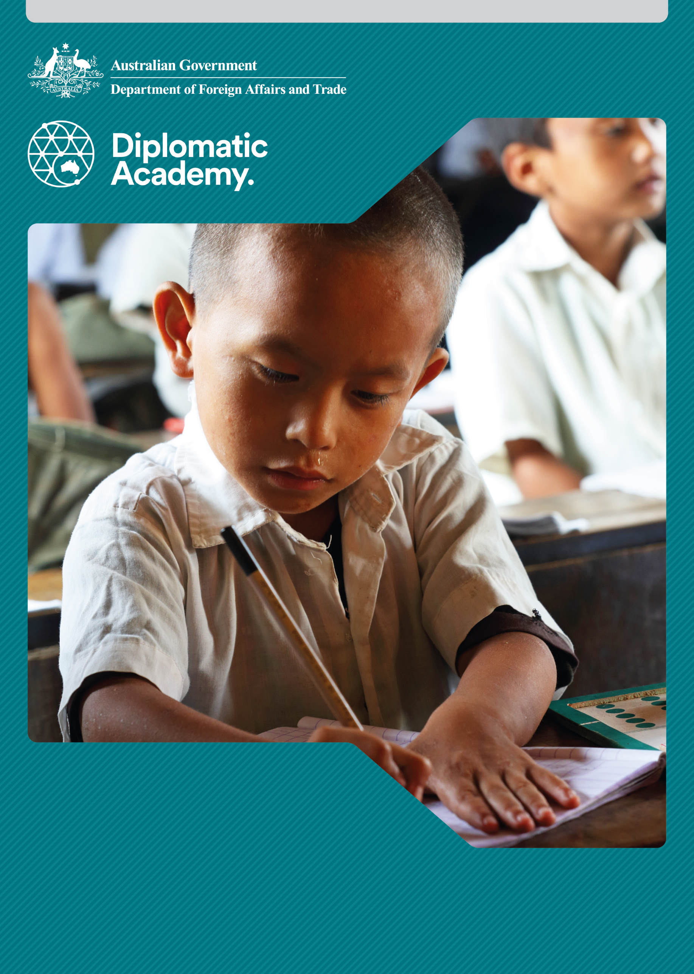
Education Learning and Development Module

BASIC EDUCATION

Foundation Level
CONTENTS

Acronyms 3
1 Introduction 4
2 What is basic education? 4
3 What are the international commitments to basic education? 6
4 Why do we invest in basic education? 9
5 What are the key challenges in basic education? 10
6 Test your knowledge 18
References and links 22

Acronyms

DFAT Australian Government Department of Foreign Affairs and Trade
ECD early childhood development
EFA Education for All
EMIS Education Management Information System
GDP Gross Domestic Product
GPI Gender Parity Index
ISCED International Standard Classification of Education
MDGs Millennium Development Goals
NER net enrolment rate
PNG Papua New Guinea
SDGs Sustainable Development Goals
SWAp sector-wide approaches
UIS UNESCO Institute for Statistics
UNESCO United Nations Educational, Scientific and Cultural Organization
WASH water, sanitation and health

Introduction
The purpose of this module is to provide introductory information about the importance, structure, purpose, key issues and outcomes of basic education. It provides a foundation to engage in this topic and apply advice from staff with operational or expert levels of knowledge in education. On successful completion you will be able to be an informed participant in forums related to basic education.

What is basic education?
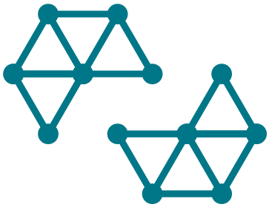
Basic Education
The International Standard Classification of Education (ISCED) states that basic education corresponds to the first nine years of formal schooling and is made up of two levels. Level 1 is primary education (usually six years) and Level 2 refers to lower secondary (usually three years; grades 7-9). It also covers non-formal and informal activities intended to meet the basic learning needs of people of all ages.
However, not all education systems define basic education the same way. For instance, a number of countries include pre-primary as part of the basic education cycle.
Source: UNESCO Institute of Statistics 2011.

ISCED Mapping
The UNESCO Institute for Statistics (UIS) collects data from member states to map national education systems according to the ISCED. The latest ISCED country mappings are available on the UIS website.
Source: UNESCO Institute of Statistics 2018.

Where is the term ‘elementary education’ used?
There are some examples where the term ‘elementary education’ is used, such as in Papua New Guinea (PNG). Restructuring of the education system in PNG defined primary schooling as nine years of basic education (three years of elementary and six years of primary) followed by four years of secondary schooling.
The creation of elementary schools (preparatory and grades 1 and 2) was intended to allow for many more schools to be established closer to communities and to be used as feeder schools for primary schools.

Why is basic education important?
In the 2013 report by UNESCO, Education Transforms Lives, it states ‘To unlock the wider benefits of education, all children need the chance to complete not only primary school but also lower secondary school. And access to schooling is not enough on its own: education needs to be of good quality so that children actually learn’.
Source: UNESCO 2013.

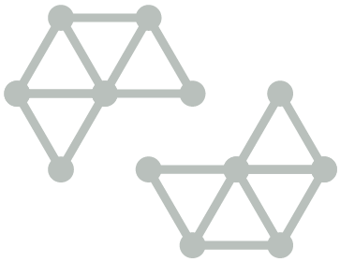
Education transforms lives
Education transforms lives by reducing poverty, enhancing economic growth, improving health outcomes for mothers and their children, and providing increased job opportunities for women and men. No country has reached sustained economic growth without attaining near universal basic education. According to UNESCO one year of additional education increases an individual’s income by 10 per cent and a country’s average annual gross domestic product (GDP) by 0.37 per cent. Early grade reading skills are particularly transformational. If all students in low income countries left school with basic reading skills, 171 million people could be lifted out of poverty, which is equal to a 12 per cent cut in global poverty.
Sources: UNESCO 2011, Education counts: Towards the millennium development goals; UNESCO 2014, Teaching and learning: Achieving quality for all, EFA Global Monitoring Report 2013/4: Summary.

What are the benefits of basic education?
Basic education benefits include:
- Education improves individual earnings and economic growth:
- each dollar invested in an additional year of schooling generates earnings of $5 in low-income countries
- each additional school year can increase a woman’s earnings by 10 to 20 per cent
wages, agricultural income and productivity are higher where women involved in agriculture receive an education.
- Education helps build more peaceful and inclusive societies:
- if the enrolment rate for secondary schooling is 10 percentage points higher than the average, the risk of war is reduced by about 3 percentage points
every additional year of schooling reduces an adolescent boy’s risk of becoming involved in conflict by 20 per cent.

- Education, especially for girls, has significant health impacts:
- if a girl is educated for six years or more, her childbirth survival rate will improve, reducing her risk of maternal mortality and illness
- if all women completed primary education, maternal deaths would be reduced by two-thirds, saving 189,000 lives
- children of educated mothers are more likely to be vaccinated and less likely to be stunted because of malnourishment
- each year of secondary education reduces the likelihood of marrying as a child by at least 5 percentage points
- women with post-primary education are five times more likely than illiterate women to be educated on the topic of HIV and AIDS
if all girls had secondary education, child marriage would drop by 64 per cent.
Sources: Adapted from the websites of the Global Partnership for Education, and The Education Commission.
Note: DFAT’s Strategy for Australia’s aid investments in education reinforces the importance of basic education across all four strategic priorities.

What are the international commitments to basic education?

International commitments to basic education
A global commitment to basic education was made at four important international gatherings: the 1990 World Conference on Education for All (EFA) in Jomtien, the 2000 World Education Forum in Dakar, the 2000 Millennium Summit in New York, and the 2015 World Education Forum in Incheon.

Education for All – Jomtien, 1990 and Dakar, 2000
The Jomtien and Dakar conferences set up global commitments to achieving quality basic education for all. In 2000, 164 governments pledged to achieve EFA and identified six goals to be met by 2015.
Source: The Dakar Framework for Action – Education for All: Meeting our Collective Commitments.

Millennium Summit– New York, 2000
At the Millennium Summit in 2000, 190 countries agreed to eight ‘Millennium Development’ goals (the MDGs), to eliminate poverty by 2015.
Ensuring universal access to primary education was one of the eight MDGs set by the leaders of the nations present. MDG 2 is to ‘Ensure that, by 2015, children everywhere, boys and girls alike, will be able to complete a full course of primary schooling’. MDG 3 has a special focus on gender, and relates to basic education (and beyond): ‘Eliminate gender disparity in primary and secondary education, preferably by 2005, and in all levels of education no later than 2015’.
Source: United Nations n.d.a

World Education Forum – Incheon, 2015
At the World Education Forum in Incheon, Republic of Korea in May 2015, more than 1,600 delegates from 160 countries adopted the Incheon Declaration which sets out the vision for education over the next 15 years to the Education 2030 Framework and 2030 Agenda for Sustainable Development, including Sustainable Development Goal 4. The Education 2030 Framework for Action commits countries to ‘ensure the provision of 12 years of free, publicly funded, equitable quality education, of which at least nine years are compulsory’.
Source: UNESCO 2016a.

Sustainable Development Goal 4 (SDG 4): Ensure inclusive and equitable quality education and promote lifelong learning opportunities for all
SDG 4 and its targets are specific about a new way of advancing education, where access to and participation in good quality education can cultivate the skills, competencies and values that influence people’s choices to create more just, inclusive and sustainable societies. It commits governments to ensure that all boys and girls have access to and complete free early childhood education, primary and secondary schooling by 2030. It also aims to provide equal access to affordable vocational training, and to eliminate gender and wealth disparities by providing universal access to quality technical/vocational and higher education. It seeks to achieve these targets through effective learning environments, increasing the supply of qualified teachers and expanding the number of scholarships to developing countries.
Source: United Nations n.d.b
Both the EFA Goals and the MDGs had sets of goals with 2015 as their target date. Globally, significant progress has been made under the EFA and MDGs. The number of children out of school has been more than halved since 1999. Gender parity in primary enrolment has improved significantly in the regions that started the new millennium with the greatest gender gaps.
While global efforts have seen 91 per cent of children currently enrolled in school, reaching the last 9 per cent of children has been a persistent challenge. The number of children, adolescents and youth out of school dropped steadily from 2000 to 2010 but has essentially stopped over the last few years. As of 2015, 61 million children of primary school age are not in school and more than 25 million of them are expected to never enrol in school – two thirds of whom are girls.
Of particular relevance are these figures:
- 300,000 primary and lower-secondary children are out of school in Oceania
- 15.4 million primary and lower-secondary children are out of school in East Asia and South-eastern Asia
- 30.1 million primary and lower-secondary children are out of school in Central Asia and Southern Asia
- 58.3 million primary and lower-secondary children are out of school in sub-Saharan Africa
Globally, girls of primary school age are still more likely than boys to be out of school. At the regional level, Oceania has the widest gender disparity at the primary level with an adjusted Gender Parity Index (GPI) of 1.23 (where anything above 1.03 is a female disadvantage).
Figure 1 – Global number of out-of-school children, adolescents and youth, 2000-2015
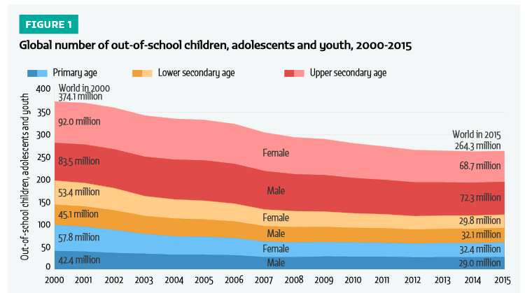
Source: UNESCO Institute for Statistics & Global Education Monitoring Report 2017, Reducing global poverty through universal primary and secondary education, Figure 1.

What has happened in East Asia and the Pacific?
East Asia and the Pacific have made spectacular progress in improving access to education over the past four decades. In 1970, there were over 50 million primary school-aged children in this region who were out of school. The latest figures from the UIS show that there are 7.2 million children not in primary school across the Eastern/Southern Asia and Oceania regions.
Source: UIS & Global Education Monitoring Report 2017, Reducing global poverty through universal primary and secondary education, p. 2.
Efforts at expanding access to primary education constitute a pillar on which the economic development of the region has been based, and provides hope for continued prosperity, national development, peace and security. However, without attention being paid to educational quality and to curriculum relevance, children will continue to drop out before completing their basic education and long term national development will be undermined.

Why do we invest in basic education?

International commitments to basic education
We invest in basic education because it is a fundamental human right. We also seek to help our partner countries deliver quality education, and to gain the developmental benefits of increasing the education standards of all children. The benefits from basic education have been shown over recent decades of development, with the Asian ‘Tiger’ economies held up as a demonstration of the connection between long term education priority-setting and sustained national development.

Many challenges remain
Despite progress in many countries, particularly in expanding access to basic education, many challenges remain.
- It has been shown that expanding access alone is not enough – many children who do attend school receive an inadequate basic education because of poorly trained, underpaid teachers, overcrowded classrooms, and an unfamiliar language of instruction. There may be a lack of basic teaching tools such as textbooks, chalkboards, and pens and paper, and there may be ‘child unfriendly’ conditions, such as a lack of sanitary facilities.
- Completion of primary school is no guarantee that children have acquired basic academic skills. According to The Education Commission’s Learning Generation report, only 19 per cent of children in low-income countries complete primary school with basic international learning standard.
The Ministry of Education is typically the lead agency for planning and providing basic education. However, the Ministry may lack both capacity and resources for expanding and improving the education system.
Source: The Education Commission 2016, p. 40.

Development partners’ investments
Development partners may invest in a wide range of basic education priorities. These include:
- sector-wide approaches (SWAp), which support a single sector policy and expenditure program, under government leadership, adopting common approaches, and progressing towards reliance on government procedures to disburse and account for all funds
- program-based investments, aligned with partner government priorities, supporting the full suite of basic education priorities (e.g. teacher training, learning resources, curriculum development, infrastructure, oversight functions, learning assessment, system strengthening, capacity development)
- support for system monitoring, learning assessment and collecting data accurately through an Education Management Information System (EMIS), so that data on facilities, staff, student attendance and achievement, fees, etc., can be used to analyse trends, successes and issues
- water, sanitation and health (WASH) facilities to help increase enrolment, particularly for girls, at both primary and lower secondary levels
- capacity development and technical assistance
school infrastructure initiatives for building new schools, satellite schools (for more isolated communities) and extra classrooms.
Source: UNESCO International Institute for Educational Planning, Educational Management Information Systems (EMIS).

What are the key challenges in basic education?

Access and quality
‘Universalising access’ has been the main and often only focus for many developing countries under the EFA Agenda. The rapid expansion of primary education, a positive result in terms of actual numbers of children in school, does not necessarily equate with basic education of good quality.
For example, a rapid expansion in enrolments – when not planned well – can mean larger class sizes (e.g. teacher numbers are falling behind enrolment growth), insufficient or inadequate school facilities, and shortages of learning materials. Therefore, ‘Enrolment for all’ is not the same as Education for All.

Enrolment for all?
According to the World Bank, between 2000 and 2010, the East Asia-Pacific region experienced an increase in primary net enrolment rate (NER) from 94.2 per cent to 95.3 per cent, but since has remained relatively unchanged. The remaining primary-school-aged children not in school are often the hardest to reach and require targeted and innovative efforts.
Globally, there are still significant numbers of out-of-school children. In 2015, 61 million children of primary school age (6-11) and 62 million adolescents of lower secondary school age (12-14) were out of school. There has been no improvement at the primary level since 2008, and at the lower secondary level since 2012.
Sources: World Bank database; GPE Secretariat 2017, ‘Universal education could greatly reduce poverty, but out-of-school numbers are not improving: Graph of the week’.
Figure 2 – Adjusted NER in primary education in selected countries in 2000, 2005 and 2012
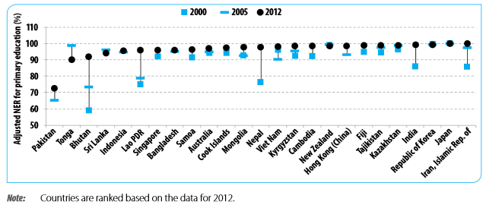
Note: Countries are ranked based on the data for 2012.
Source: Bergstrom 2015, Asia-Pacific regional education for all report: A synthesis of the national EFA reports (Figure 6, p.14).

Why are some children not in school?
Some of the main reasons why so many children are not currently in primary school include:
- poverty: families may have difficulty affording school fees or the cost of uniforms, or may need children to work to contribute to the family income
- safety: families may keep their children at home if they feel the journey to school is too long or that it is dangerous to walk to school alone. They may be worried about bullying and sexual harassment or violence, especially for girls
- local traditions: in some countries, families place more emphasis on the education of boys, and may not believe it is important to send their daughters to school. Girls may also be forced to marry young, drop out of school, and dedicate themselves to housework
emergencies: situations such as conflict, economic crises and natural disasters prevent millions of children around the world from getting an education.
Note: For more information view the modules on Education in Emergencies, Marginalisation and Inclusive Education.


An activity for you
Consider the education sector in your country program, or a developing country you are familiar with. What are some of the impediments to children accessing basic education?
What is being done by the key stakeholders to prevent or reduce these?

Quality of basic education
A quality basic education is based on a curriculum that is relevant to the needs and reality of all learners, and relies on professionally trained teachers equipped with appropriate learning materials.
As many developing countries make good progress on enhancing access, equity and inclusion, the challenge is now to focus on the quality of teaching and learning. The true measure of the quality of education programs is the learning outcomes of children. It is estimated that approximately six out of 10 children and adolescents are not achieving minimum proficiency levels in reading and mathematics. Shortfalls in learning start early. International experience shows that children who fail to read in the early grades will fall further behind each school year. These students will often struggle to catch up in the later years and some of them will simply drop out.
Therefore, ensuring quality and inclusive education is at the heart of SDG 4, which commits governments to providing all children with free, equitable and quality primary and secondary education and lifelong learning opportunities for all. There is also a greater focus on learning outcomes and the collection of test and examination data to monitor schools and assess student learning.
Source: UNESCO Institute for Statistics 2017, More than one-half of children and adolescents are not learning worldwide.

What factors impact upon the quality of basic education?
The following factors have been shown by research and monitoring to impact on the quality of basic education:
- the appropriateness of the curriculum
- active teaching methods
- access to textbooks and other instructional materials
- time on task and curriculum coverage
- quality of teachers
- pre-service and in-service training
- teacher experience
- learner assessment standards
- education sector management
- education infrastructure standards
- access to preschool
- learner health
- homework practices, including parental involvement
repetition and over-age learners.

A focus on basic education
Commitment to international development and education goals means supporting partner governments to achieve them. A focus on basic education is a key challenge for development partners.
Access and quality in basic education are both key challenges. Providing financial resources and support for capacity development to countries is one major response, but development partners need to consider what the most appropriate modality is for such support.

How can the Australian aid program help?
The Australian aid program has a number of modalities available, to be selected and agreed according to the country context:
    - whole education sector support – budget support – which would include basic education
    - targeted support on basic education through sub-sector investments
    - ear-marked support to specific components e.g. early childhood development (ECD), teacher training, literacy development, curriculum review
delegating, pooling or contributing funds to another development partner or group.
The chosen approach will need to be agreed with the partner government, other development partners, and education stakeholders. In order to assess the contribution of the Australian aid program’s support to basic education, a theory of change or program logic will need to be developed, including indicators of progress – e.g. basic education access and completion (through EMIS statistics and school census data), and quality (through assessment of reading and numeracy levels).
Note: For more information view the modules on Monitoring and Evaluation, Education Planning and Education Financing and Modalities.

Gender
Although both boys and girls may suffer discrimination and low achievement, girls consistently across the world are having their future opportunities limited by discrimination.
The 2030 Agenda for Sustainable Development clearly recognises the links between education and gender equality. It builds on the EFA movement, which prioritised improving educational opportunities for girls and boys to ensure they all participate equally in society. SDG 5 is specifically focused to achieve ‘gender equality and empower all women and girls’.
The 2016 Global Education Monitoring Report ‘Gender Review’ highlighted significant global progress over the last 15 years in achieving gender parity in schools. However, despite these positive trends, there is persistent gender disparity in access to primary education, particularly at the expense of girls, where one in 10 girls compared to one in 12 boys were out of primary school in 2014. The poorest girls are the most likely to never set foot in the classroom.
Barriers to girls’ education include school fees, additional expenses such as uniforms and books, the cultural value placed on marriage over education, the cultural priority of male over female children, violence against girls in and en route to schools, poor school conditions (lack of separate toilets, for example), and unequal treatment of girls in the classroom.
Sources: United Nations 2015, 2030 Agenda for Sustainable Development; UNESCO 2016b, 2016 Global Education Monitoring Report ‘Gender Review’.

Educational access and life chances
Unfortunately, globalisation and new information technologies are rapidly increasing the returns to education at a time when there are massive inequalities in educational opportunities.
What this means is that for the millions of those who are disadvantaged and are denied quality basic education, globalisation clearly points in the direction of rapid marginalisation. National statistics often mask the inequalities of provision and outcomes between districts and between urban and rural contexts.
Within country differences are often significant where learners in rural areas or of ethnic minorities may be disadvantaged in terms of access and achievement.
Note: For more information view the modules on Inclusive Education and Marginalisation.

Disability and infrastructure
Due to large increases in primary and secondary enrolment, severe pressure has been put on governments to provide enough schools, with sufficient classrooms and support structures (such as latrines – separated for male/female and staff/students, and access for learners with disabilities).Children with disabilities typically have low access to or participation in basic education, particularly in the higher primary grades or in lower secondary. Inaccessible school infrastructure can be a key barrier. Other access barriers include a lack of transportation, poor community infrastructure, cultural attitudes and capacity of teachers.
Note: For more information view the modules on Education Infrastructure, Marginalisation and Inclusive Education.

Teacher quality
Teachers are the key educational resource and the main investment in all education systems. Teacher costs can amount to between 70 per cent and 95 per cent of education expenditure. It is the teacher’s role to take the curriculum and make it understandable and meaningful for students.
In all countries, it is an ongoing challenge to attract and retain teachers of good quality, especially at the pre-primary, primary and lower secondary levels. To ensure that teachers are adequately prepared for the classroom, most countries have established education minimum standards and qualifications (e.g. the completion of secondary school) as well as minimum pre-service teaching training standards (e.g. a two-year tertiary level teaching certificate).

Do increases in enrolments change quality?
Rapid, unplanned increases in student enrolment can result in a short-term boost in access to basic education. However, due to the rapid increases in enrolment in many countries, some education systems have struggled to train and employ enough teachers, and also to provide sufficient textbooks and materials, and adequate classrooms.
There can be negative impacts on student learning as class sizes mushroom, affecting education quality, and as a consequence affecting education participation rates. If children (and their families) feel that they are learning little in crowded, under-resourced classrooms, children may drop out, never to return.
Some innovative approaches to teacher training and practice have been implemented. These include BRAC schools, and the development of scripted (pre-prepared) lessons, and the use of smart devices to deliver lesson plans and learning assessment tasks in BRIDGE schools.
Sources: BRAC n.d.; Bridge International Academies 2013.

Language of instruction
‘In the crucial early grades, when children are trying to acquire basic literacy as well as adjust to the demands of the school setting, not speaking the language of instruction can make a difference between succeeding and failing in school, and between remaining in school and dropping out.’
Source: Lockheed and Verspoor, p.153, 1991.
Mother tongue teaching in at least the first three grades of primary school is now common. However, this demands that teachers speak the local languages, and have available books and materials that are in various languages. It also means having the support of parents, some of whom may want their children taught in the national language, or an international language such as English.
Note: For more information view the modules on Marginalisation and Inclusive Education.

Learning outcomes
SDG 4 is specific about ensuring quality basic education, which leads to relevant and effective learning outcomes. This is captured under targets 4.1 (universal completion of primary and secondary education), 4.2 (access to quality early childhood education), 4.6 (achievement of literacy and numeracy for youth and adults), and 4.c (increase the supply of qualified teachers).
A learning outcome is the particular knowledge, skill or behaviour that a student is expected to exhibit after a period of study. Learning outcomes reflect a nation’s concern with the level of knowledge acquisition among its student population. Measuring learning outcomes provides information on what particular knowledge or skills students have gained after a stage of education is completed.
They are typically measured by administering assessments (or tests) at various levels – sub-national, national, regional and international.

What does information on learning outcomes tell us?
Information on learning outcomes tells countries about the quality of education at different levels of the education system. It enables them to make informed decisions about interventions to improve educational quality and to monitor trends in the nature and quality of student learning over time. It gives us information that can contribute to medium-term strategic planning, annual operational planning, and budget decision-making.
At the school level it is possible to take a broad view of learning outcomes so that less easily tested outcomes, such as civic responsibility and non-academic achievements, are recorded for each learner.

Test your knowledge

Assessment questions
Answer the following questions by ticking ‘True’ or ‘False’. Once you have selected your answers to all the questions, turn the page to ‘The correct answers are...’ to check the accuracy of your answers.

Question 1
All countries include six years of primary and three years of secondary in their definition of basic education.
Is this statement true or false? □ True □ False

Question 2
The Education 2030 Framework for Action commits countries to ensure the provision of 12 years of free primary and secondary education.
Is this statement true or false? □ True □ False

Question 3
Development partners invest in basic education because it represents a fundamental human right.
Is this statement true or false? □ True □ False

Question 4
Poverty is not a cause of children being out of school.
Is this statement true or false? □ True □ False

Question 5
The key challenges in basic education are access and quality.
Is this statement true or false? □ True □ False

Question 6
Improving learning outcomes is a key issue in basic education.
Is this statement true or false? □ True □ False

The correct answers are...
Question 1
All countries include six years of primary and three years of secondary in their definition of basic education.
This statement is false.

Question 2
The Education 2030 Framework for Action commits countries to ensure the provision of 12 years of free primary and secondary education.
This statement is true. It also states that the first nine years of basic education should be compulsory.

Question 3
Development partners invest in basic education because it represents a fundamental human right.
This statement is true. But this is not the only reason. Education is crucial to reducing poverty, improving general health, halting the spread of HIV and AIDS, and enabling people, particularly girls and women, to play a full part in their communities and nations. No country has reached sustained economic growth without attaining near universal basic education.

Question 4
Poverty is not a cause of children being out of school.
This statement is false. Poverty is one of the main reasons for children not being in school, alongside safety concerns, local traditions and emergencies.

Question 5
The key challenges in basic education are access and quality.
The statement is true. Although significant international progress has been made to ensure universal access to basic education, reaching the last 9 per cent of children who are out of school is a persistent challenge. Of those who are in school, many are not achieving basic literacy and numeracy skills. Girls still tend to be disproportionately affected in many parts of the world.

Question 6
Improving learning outcomes is a key issue in basic education.
This statement is true.

References and links
Bergstrom, P (ed) 2015, Asia Pacific regional education for all report: A synthesis of the national EFA reports, UNESCO, retrieved 19 September 2017, http://unesdoc.unesco.org/images/0023/002332/233236E.pdf
BRAC Education Program n.d., retrieved 17 September 2017, http://www.brac.net/education
Bridge International Academies 2013, retrieved 17 September 2017, http://www.bridgeinternationalacademies.com
The Education Commission, found at http://educationcommission.org/
The Education Commission (The International Commission on Financing Global Education Opportunity) 2016, The learning generation: Investing in education for a changing world, The Education Commission, retrieved 17 August 2017, http://report.educationcommission.org/report/
Global Partnership for Education (GPE), found at http://www.globalpartnership.org/
GPE Secretariat 2017, June 23, Universal education could greatly reduce poverty, but out-of-school numbers are not improving: Graph of the week, weblog post, Global Partnership for Education, retrieved 19 September 2017, https://www.globalpartnership.org/blog/universal-education-could-greatly-reduce-poverty-out-school-numbers-are-not-improving
Lockheed M & Verspoor M 1991, Improving primary education in developing countries, Oxford University Press for World Bank: Oxford, retrieved 12 February 2018, http://documents.worldbank.org/curated/en/279761468766168100/pdf/multi-page.pdf
UNESCO 2000, The Dakar Framework for Action – Education for All: Meeting our Collective Commitments, Adopted by the World Education Forum, Dakar, Senegal, 26-28 April, (including six regional frameworks for action), UNESCO, retrieved 5 December 2017, http://unesdoc.unesco.org/images/0012/001211/121147e.pdf
2011, Education counts: Towards the millennium development goals (New updated edition ED-2010/WS/44/REV.2 (3752.11)), EFA Global Monitoring Report, UNESCO, retrieved 19 September 2017, http://unesdoc.unesco.org/images/0019/001902/190214e.pdf
2013, Education transforms lives (ED.2103/WS/25), EFA Global Monitoring Report, UNESCO, retrieved 19 September 2017, http://unesdoc.unesco.org/images/0022/002231/223115E.pdf
2014, Teaching and learning: Achieving quality for all, EFA Global Monitoring Report 2013/4: Summary, UNESCO, retrieved 19 September 2017, https://www.unesco.de/fileadmin/medien/Dokumente/Bildung/GMR_2013_2014.pdf
2016a, Education 2030: Incheon Declaration and Framework for Action for the implementation of Sustainable Development Goal 4 (ED-2016/WS/28), UNESCO, retrieved 14 September 2017, http://uis.unesco.org/sites/default/files/documents/education-2030-incheon-framework-for-action-implementation-of-sdg4-2016-en_2.pdf
2016b, The Global Educational Monitoring Report – Gender Review: Creating sustainable futures for all, p. 15, retrieved 18 September 2017, http://unesdoc.unesco.org/images/0024/002460/246045e.pdf
UNESCO Institute of Statistics 2011, The International Standard Classification of Education ISCED 2011, UIS, retrieved 17 August 2017, http://uis.unesco.org/sites/default/files/documents/international-standard-classification-of-education-isced-2011-en.pdf
2017, More Than One-Half of Children and Adolescents Are Not Learning Worldwide (Fact Sheet 46), September, UNESCO, retrieved 5 December 2017, http://uis.unesco.org/sites/default/files/documents/fs46-more-than-half-children-not-learning-en-2017.pdf
2018, ISCED Mappings, UIS, retrieved 18 September 2017, http://uis.unesco.org/en/isced-mappings#slideoutmenu
UNESCO Institute for Statistics & Global Education Monitoring Report 2017, Reducing global poverty through universal primary and secondary education (Policy paper 32, Fact Sheet 44), UNESCO, retrieved 17 August 2017, http://uis.unesco.org/sites/default/files/documents/reducing-global-poverty-through-universal-primary-secondary-education.pdf
UNESCO International Institute for Educational Planning 2018, Educational Management Information System (EMIS), retrieved 13 March 2018, https://learningportal.iiep.unesco.org/en/glossary/Sistema%2520de%2520Informaci%25C3%25B3n%2520sobre%2520la%2520Gesti%25C3%25B3n%2520de%2520la%2520Educaci%25C3%25B3n
United Nations n.d.a, Millennium Development Goals, retrieved 5 December 2017, http://www.un.org/millenniumgoals/
n.d.b, Sustainable Development Goals, Goal 4 Quality Education, retrieved 5 December 2017, http://www.un.org/sustainabledevelopment/education/
2015, The 2030 Agenda for Sustainable Development, Resolution adopted by the General Assembly on 25 September 2015, retrieved 5 December 2017, http://www.un.org/sustainabledevelopment/development-agenda/
World Bank database, found at https://data.worldbank.org
Learn more about…
- DFAT’s Strategy for Australia’s Aid Investments in Education 2015-2020, found at: http://dfat.gov.au/about-us/publications/Pages/strategy-for-australias-aid-investments-in-education-2015-2020.aspx
- DFAT’s Development for all 2015-2020: Strategy for strengthening disability-inclusive development in Australia’s aid program, found at: http://dfat.gov.au/about-us/publications/Pages/development-for-all-2015-2020.aspx
- The importance of education quality and student enrolment to long term national development, found at: http://www.unicef.org/eapro/03_Education.pdf
- The challenges of educating children in poor countries and the importance of completion of primary school by reading this report, Hillman, Arye L & Jenkner, Eva 2004, Educating children in poor countries, International Monetary Fund, found at: http://www.imf.org/external/pubs/ft/issues/issues33/
- The issues of fighting poverty and exclusion through Basic Education (Dakar) by watching this video: Fighting poverty and exclusion through basic education 2000, YouTube, UNESCO, found at: http://www.unesco.org/archives/multimedia/index.php?s=films_details&pg=33&id=412
- Girls’ education, found at: https://www.unicef.org/education/bege_61718.html.

This figure is based on a 2017 set of regional groupings used to monitor the SDGs, which differ from the regions defined under the MDGs. Therefore, caution should be taken when making historical comparisons.
Primary school NER is the number of children enrolled in primary school that are of official primary school age, expressed as a percentage of the total number of children of official primary school age. Adjusted NER is the total number of students of the official primary school age group who are enrolled at primary or secondary education, expressed as a percentage of the corresponding population.

