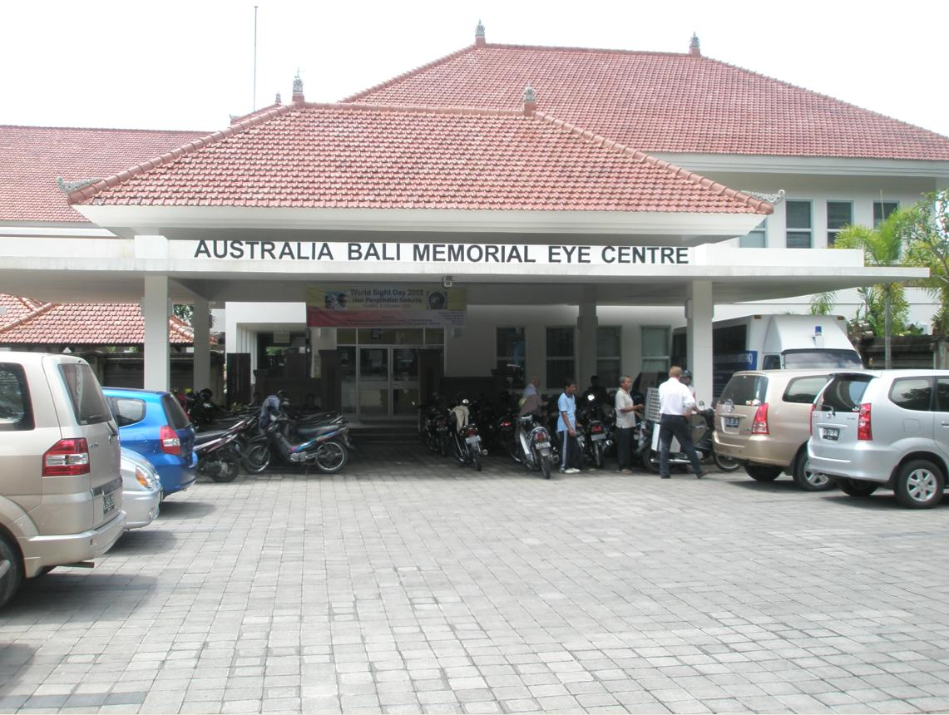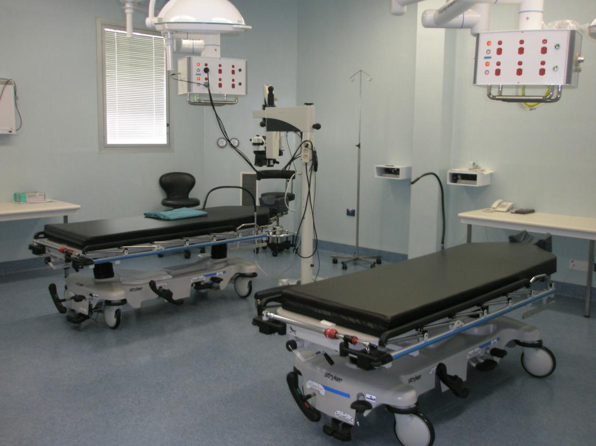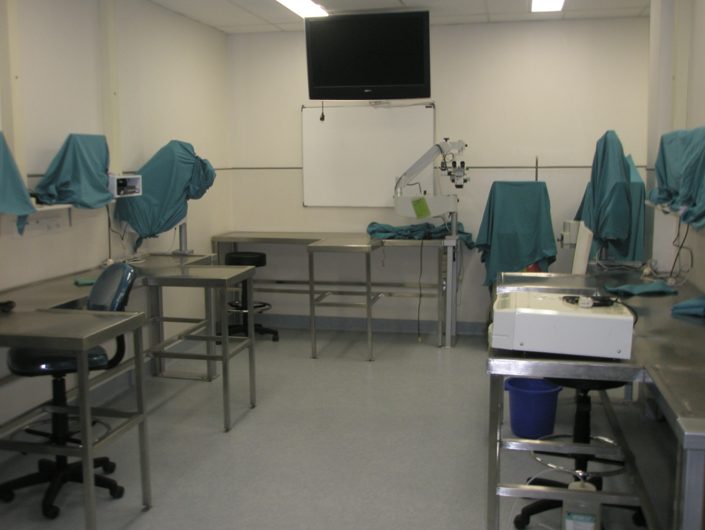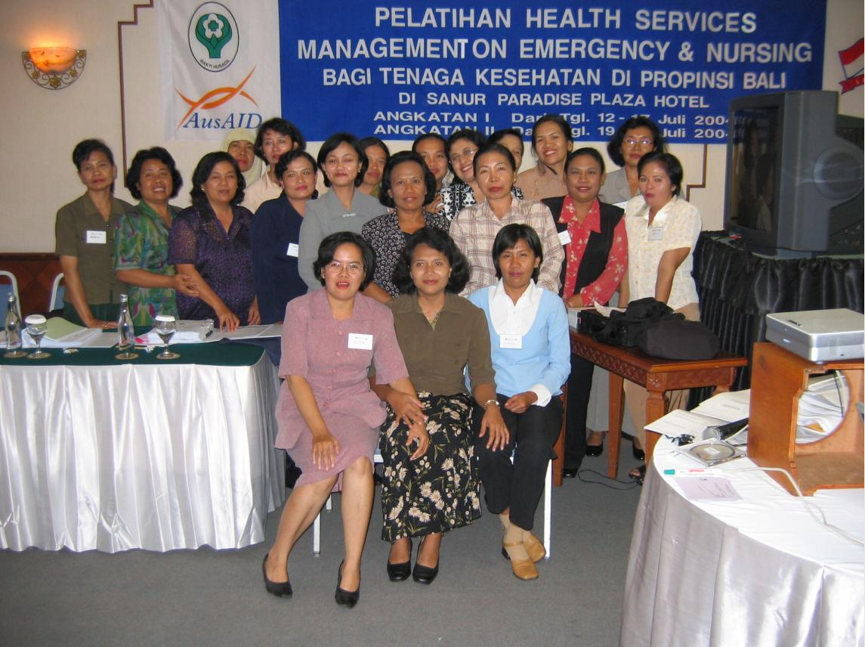

Bali Memorial Package

AidWorks Initiative Number INF 607

INDEPENDENT COMPLETION REPORT

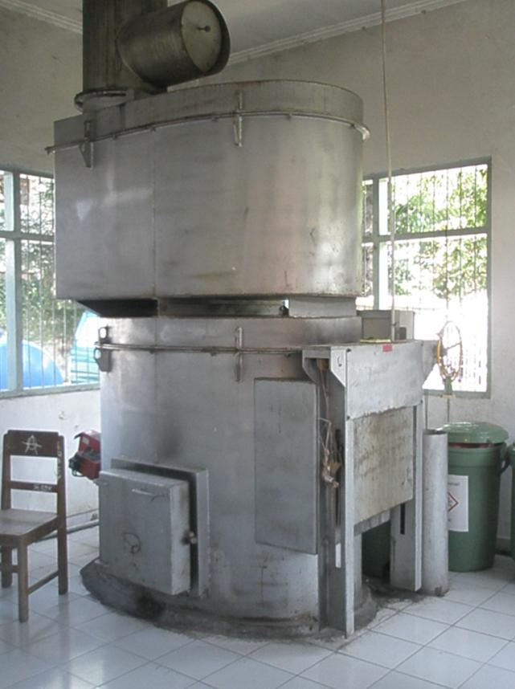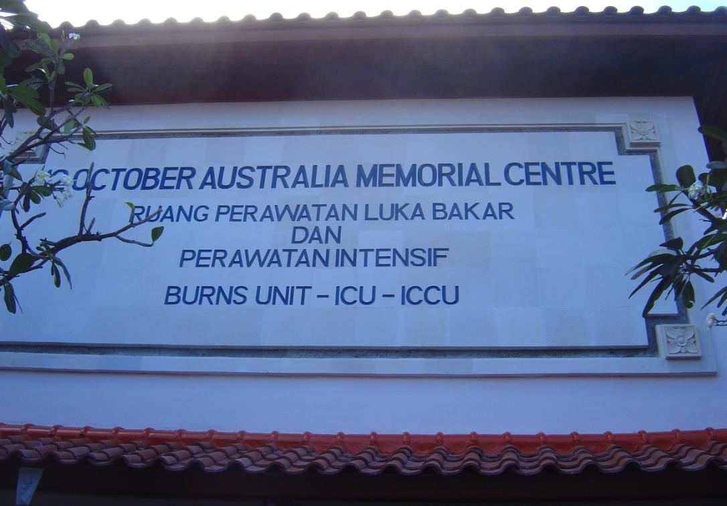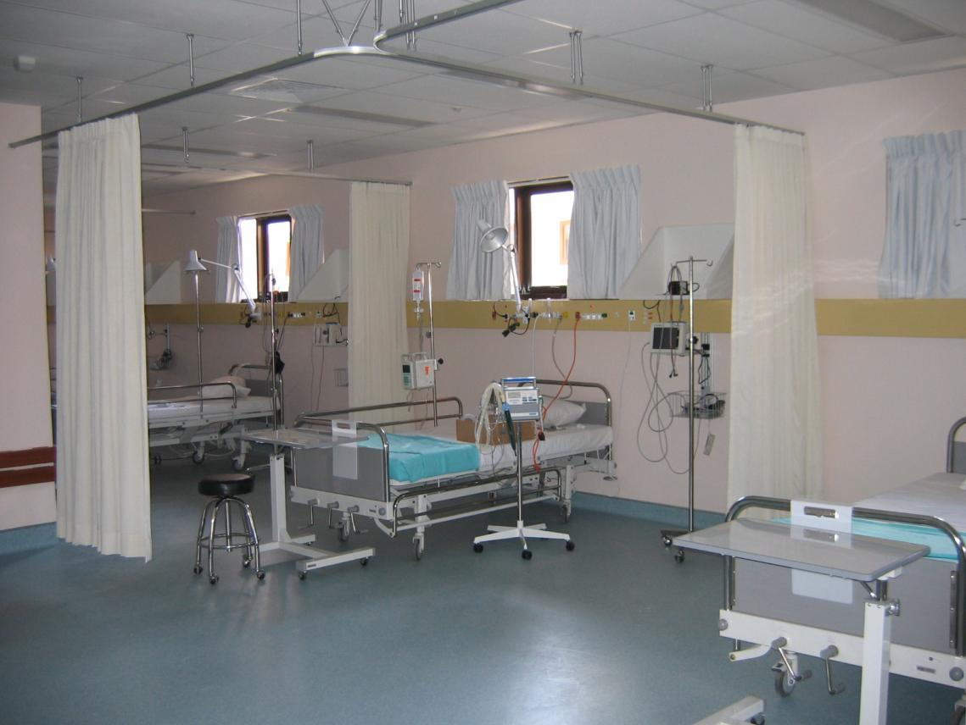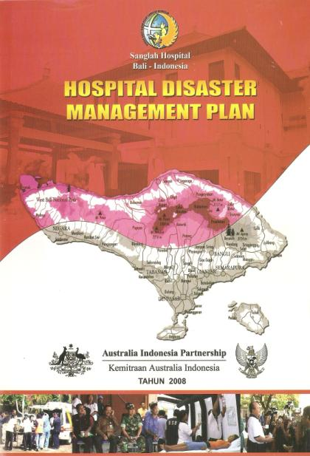

Prepared for AusAID by –
Dr John Menzies
Senior Medical and Hospital Advisor
JTA International

April 2009.

Aid Activity Summary
Aid Activity Name | Bali Memorial Package
AidWorks initiative number | INF607
Commencement date | 11 March 2003 | Completion date | 31 December 2009
Total Australian $ | $12,892,000.00
Total other $ | N/A
Delivery organisation(s) | TBA
Implementing Partner(s) | TBA
Country/Region | Bali, Indonesia
Primary Sector | Health / Disaster Management

Acknowledgments
Special acknowledgment is made of the efforts by AusAID staff members Prisca Seridanta and Fairlie Williams who helped with arranging the logistic details of the visit, and Anik Sandy who kindly gave of her time assisting with facilitation, provision of historical information and translation support in Bali.
Special thanks to all of the individuals who gave of their time to be interviewed, especially Drs. Susilia and Bintang who voluntarily travelled from Tabanan.

Author’s Details
Dr John Menzies is the Senior Medical and Hospital Advisor for JTA International. Dr Menzies has been involved with international health service assessment, planning and service delivery for six years. Prior to this, he held senior executive management positions in Australian Teaching Hospitals and Health Services.
Dr Menzies has spent a considerable amount of time in Indonesia over the last six years, with his first involvement in Bali occurring in early 2003 when he was engaged as a consultant for the WHO investigating the hospital and emergency service response following the 2002 Bali bombings. He was appointed by AusAID as the team leader of the review team that completed the situation analysis of the functioning and potential for the Australia Bali Memorial Eye Centre in November 2008.
Dr Menzies has not been directly involved with the management of any of the three main elements of the Bali Memorial Package viz., the construction of the Sanglah Hospital Project, the construction of the Australia Bali Memorial Eye Clinic, the Indonesia Australia Specialised Training Project or the Australian Development Scholarship program. He has participated as a presenter in some of the training programs that were organised by IASTP III.

Disclaimer
The views expressed in the evaluation are those of the author only, and do not represent the views of the Government of Indonesia or the Government of Australia.

Contents
Aid Activity Summary i
Acknowledgments i
Author’s Details i
Key Abbreviations iii
1. Executive Summary 1
2. Introduction 3
2.1 Activity Background 3
2.2 The November 2008 ABMEC Study and the BMP ICR Terms of Reference 5
3. Evaluation Objectives and Questions 5
4. Evaluation Scope and Methods 5
5. Evaluation Team 6
6. Evaluation Findings 7
6.1 Sanglah Hospital Initiatives. 7
6.2 Medical and Health Scholarship Initiatives 9
6.3 ABMEC Initiatives 11
6.4 The Bali Memorial Package as a single entity. 13
7. Evaluation Criteria Ratings 17
8. Conclusion and Recommendations 18
8.1 General BMP Conclusions 18
8.2 Specific Initiative Conclusions 19
Annex 1. 21
Terms of Reference 21
Annex 2. 24
Visit and Interview Schedule – March / April 2009. 24

Key Abbreviations

ABMEC | Australia Bali Memorial Eye Centre
AusAID | Australian Development Assistance Agency
AVI | Australian Volunteers International
BMP | Bali Memorial Package
DinKes | Dinas Kesehatan (Provincial Department of Health)
GOA | Government of Australia
GOI | Government of Indonesia
NGO | Non Government Organisation
PMI | Paling Merah Indonesia (Indonesian Red Cross)
RS | Rumah Sakit (Hospital)
RS Indera | Rumah Sakit Indera (Indera Hospital)
RS Sanglah | Rumah Sakit Sanglah (Sanglah Hospital)
YKI | Yayasan Kemanusiaan Indonesia

1. Executive Summary

The Bali Memorial Package (BMP) was a purpose designed Australian aid project consisting of three main elements. The BMP was developed in early 2003 following the bomb blasts that occurred in Bali on 12 October 2002, and was specifically for two main purposes. The first was a desire to improve the emergency response capability of Bali’s main hospital and emergency services and the second was a desire to provide the aid in such a way that it would be a memorial to those who lost their lives. The aid package was agreed between the Government of Australia and the Government of Indonesia.
The first of the three BMP elements was the provision of a number of activities at Bali’s main teaching Hospital - Rumah Sakit Sanglah. The package include the provision of a new two level building containing a 14 bed Intensive Care unit, a six bed Intensive Coronary Care Unit, a 15 bed Burns Unit, and a dedicated operating theatre. Substantial capacity building of staff was provided to assist with commissioning of the new equipment and to help with disaster preparedness activities. A number of other works were also approved at Sanglah to help the hospital manage during periods of disaster response and general operation.
The second element was suggested by Mr John Fawcett –the head of Yayasan Kemanusiaan Indonesia (YKI). This element involved the creation of ABMEC - a new two level stand-alone hospital building designed to provide international standard services to help treat patients with eye diseases and sight impairment. The building also included contemporary, international standard facilities to train Indonesian eye surgeons in cataract surgery and other intra ocular procedures. The package also provided two mobile clinics to allow surgeons to perform free operations for the poor in rural areas.
The third main element was a medical and health scholarship package that included the provision of several multi-year medical and health scholarships in Australia, and multiple short-term training / study courses predominantly provided in Indonesia.
As the Australian Government wanted to proceed swiftly with the initiatives, the planning for the three BMP elements involved a number of rapid planning, procurement and construction methodologies to ensure the works could be completed in a 5 year time frame. The BMP was formally announced in March 2003. The last of the major works (the construction of ABMEC) was completed in September 2007. A small amount of fully committed residual BMP funding currently remains for some minor initiatives at ABMEC, including some supplementary funding for an AVI volunteer position in hospital administration that will conclude in November 2009. The original estimated costing for the BMP was $10.5m but this was subsequently increased to $12.89m when the detailed costs were estimated. With the project essentially now completed, AusAID commissioned a completion report.
As a major situational analysis of the functioning and potential for ABMEC was undertaken in November 2008, AusAID decided that the final completion report study of the BMP should be undertaken by a consultant primarily focussing on the Sanglah Hospital and Medical and Health Scholarship elements and include the findings and recommendations of the ABMEC study.
This completion study occurred from March 30 to April 8, 2009. The study involved a review of all relevant historical documents, site inspections of the constructed facilities at Sanglah Hospital and ABMEC, and face to face interviews with all key stakeholders in Bali. As well as interviewing relevant senior local government and hospital officers, interviews were also held with clinicians and staff that were awarded scholarships, and staff who participated in Indonesian and Australian based short courses. Interviews were also held with two independent community representatives.
Each of the three main elements was assessed individually. The BMP as a whole was then assessed. The following table shows the results of the study for each element and the BMP as a whole. The assessment used the standard AusAID methodology.

Table 1.
Evaluation of the BMP and its constituent elements.

Evaluation Criteria | Sanglah Hospital Initiative Rating (1-6) | Med. & Health Scholar-ships. Rating (1-6) | ABMEC Initiatives Rating (1-6) | Overall Bali Memorial Package Rating (1-6)
Relevance | 6 | 6 | 3 | 5
Effectiveness | 6 | 5 | 4 | 5
Efficiency | 5 | 6 | 4 | 5
Impact | 6 | 6 | 5 | 5+
Sustainability | 5 | 6 | 4 | 5
Gender Equality | 5+ | 5+ | 5+ | 5+
Monitoring & Evaluation | N/A | N/A | N/A | N/A
Analysis & Learning | N/A | N/A | N/A | N/A
Rating scale: 6 = very high quality; 1 = very low quality. Below 4 is less than satisfactory.
The following are the main observations about each of the three main BMP elements.
The Sanglah Hospital initiatives were considered by all key stakeholders to have fully met their goals and objectives. Sanglah Hospital now has a new Critical care building and equipment that can offer high quality care to critically ill and injured patients, including patients with severe burns. The hospital has also been provided with important support services such as improved water storage and distribution. Assistance with disaster planning and emergency response has been of benefit both to Sanglah and other Bali Hospitals and emergency response services. Two important reasons why this element was very successful were i) the good, initial and ongoing, collaboration between all parties, and ii) the targeted capacity building that ensured that the new assets were used correctly.
The Medical and Health Scholarship initiatives, including all in-country training and capacity building, were highly praised by sponsors, and valued by all interviewed participants and key stakeholders. This element met its objectives and everyone that was interviewed enunciated multiple expected benefits they had achieved, as well as some unexpected benefits. The same comments were generally true about the capacity building support offered by all of the AVI volunteer inputs. It is believed that two key reasons why the Scholarship Package succeeded were, i) there was generally careful and targeted selection of the courses and training that was needed by the health facilities - matched with candidates who would gain best benefit, ii) the short courses contained practical skills demonstration as well as theory, and iii) generally, candidates were chosen who had better than basic understanding of English.
The ABMEC initiative has provided Bali with a new two level hospital facility that can offer very high quality in-patient and out-patient services for the treatment of specific eye diseases and sight impairment. The training facilities are of international standard and have the potential to train all local eye surgeons in modern intra-ocular surgical procedures. The provision of two purpose designed mobile clinics allows surgeons to perform free operations for the poor in rural areas. The ABMEC initiative was, however, the one package considered by all key stakeholders not to have met all of its original goals and objectives. In retrospect, many goals were ambitious and some could have been more realistic had wider consultation occurred during planning. Whilst everyone is pleased that Bali now has international standard hospital buildings and equipment for managing many eye conditions, ABMEC still requires some further assistance to achieve its full potential.
Although there has been some variation in scores between the three main package elements, overall, the BMP has been assessed as having achieved the majority of its initial broad goals and objectives. The BMP received assessment scores of at least 5 (high quality) for each of the measurable categories. In addition to achieving the planned objectives, many other benefits have occurred, particularly from the capacity building training. These have been ‘ripple’ effects with newly learnt procedures being applied elsewhere in Sanglah Hospital, ABMEC and Bali hospitals and health services in general.
A number of specific recommendations to help ABMEC achieve its full potential have already been made in the specific December 2008 ABMEC Report. Two new recommendations have been made in this completion report to help obtain better results in any future similar projects.

2. Introduction

2.1 Activity Background
Following the bomb blasts that occurred in Bali on 12 October, 2002 a total of 202 lives were lost, including 91 Australians. Hundreds of local citizens and foreign visitors were also seriously injured and required treatment for numerous injuries, including severe life threatening burns and shrapnel wounds. This tragic event received extensive international media coverage, and it became clear that the Balinese emergency response services, and the hospital and health services, were unable to cope effectively with such a disaster. The shock of this event was significant in Indonesia, Australia and many other countries around the world.
The Australian Government wanted to move quickly to try and assist Indonesia by offering aid to help strengthen the health services in Bali. It also wanted to provide the aid in such a way that it would be a memorial to those Australians who lost their lives. As a rapid response was required, AusAID officers in Indonesia set about developing a package of activities to meet the Australian Government requirements. As time was of the essence, AusAID officers were not always able to follow the usual detailed assistance planning methodology.
A number of specific activities were developed to help strengthen the critical care services at Bali’s largest teaching hospital – Rumah Sakit Umum Sanglah (Sanglah Hospital). A second program area centred on capacity building for health and emergency care workers in Bali. A third program area centred around the concept of developing a specialist eye clinic to help manage specific preventable blindness conditions for poor people and to train local eye surgeons in international standard cataract surgery techniques.
All program elements were developed expeditiously. The Sanglah Hospital enhancements were generally based upon fast track methods. The training and scholarship programs were generally able to integrate with the existing bilateral training program viz., the Indonesia Australia Specialised Training Project (IASTP) - Phases II and III, and the Australian Development Scholarship program. The eye clinic program was very much influenced by a local Indonesian Non Government Organisation – Yayasan Kemanusiaan Indonesia (YKI) and its head –Mr John Fawcett. Consequently, the eye clinic planning varied from the usual AusAID planning processes. This background information about planning is relevant, as the non traditional early planning ultimately impacted upon the way the two main building elements were implemented, and how they were able to achieve, or not achieve, their original goals and objectives.
The goals and objectives of the three elements of the Bali Memorial Package were as follows:-
A. Sanglah Hospital initiatives:
- Provision of a new intensive care centre comprising of a post-operative 14 bed Intensive Care Unit, a six bed Intensive Coronary Care Unit, a 15 bed Burns Unit, and a dedicated operating theatre.
- Refurbishment of the existing morgue and pathology department facilities comprising of an upgrade of the main dissection room involving replacement of wall and floor tiles, re-roofing of the existing building, other minor repairs, extensions and maintenance, and the procurement, installation and testing of specialised medical equipment.
- Other general hospital upgrades that would assist during times of disaster response and general operation including, an improved water supply storage and distribution system, and a new hospital incinerator.
- Provision of numerous education and capacity building activities including, training on all the new buildings’ plant and equipment, general clinical skills upgrading and emergency response training.
- In addition, some short term capacity building training was provided in Australia together with a limited number of 12 to 18 month Masters Degree scholarships.

B. The ABMEC initiative:
- Provision of a new two level stand-alone facility providing in-patient and out-patient international standard services for the treatment of eye diseases and sight impairment. Provision of modern education and training facilities for Indonesian doctors and nurses to receive instruction and practical experience in the latest international diagnostic and surgical techniques for many ophthalmic conditions. Specific facilities included; two operating theatres with three operating tables, clinical and diagnostic service departments, education and training facilities including live Closed Circuit TV images from operating microscopes and a training wet surgical laboratory. Specialist clinical services supported by a pharmacy department and limited diagnostic departments.
- Provision of two mobile clinics (purpose designed vans for cataract surgery), each with a trailer containing portable generators and associated equipment. These were provided to allow eye surgeons to perform free operations for the poor in rural areas.

C. Medical and Health Scholarships:
- Provision of several multi-year medical and health scholarships and study in Australia.
- Long-term scholarships provided for Masters level degrees for candidates from within the Balinese health system, in a broad range of health and medical disciplines including health information management and hospital accounting.
- Short-term training undertaken and delivered through the existing bilateral training program, the Indonesia Australia Specialised Training Project (IASTP)- Phases II and III and included:
  - Two courses in Hospital Services Management (general) in Bali for 41 participants from local hospitals comprising 205 participant days (August 2003);
  - Study Tour specializing in burns treatment in Australia for the Provincial Director of Health and four burns clinicians who visited three teaching hospitals with burns units and a number of community health centres (Oct-Nov 2003);
  - Study Tour for the Director of Sanglah Hospital to visit a number of teaching hospitals, observing emergency and intensive care units (May 2004);
  - Emergency training involving a range of emergency response personnel, as part of the Government’s Safe Community initiative: basic life support, advance trauma life support, basic trauma and cardiac, life support and advance cardiac life support (June-July 2004);
  - Hospital Services Management Training for doctors and paramedics from Emergency Departments – private, public, army and police hospitals- conducted in Bali (July 2004);
  - Hospital Services Management Training for heads of nursing and nursing sections in major public hospitals- conducted in Bali (July 2004); and
  - Campaign/Training of Trainers in Prevention of Burns Accident and Burns Patient Care (July 2006).

The original $10.5million figure, which was a “back-of-the envelope” calculation for the announcement of the Prime Minister’s package in early 2003, was not based upon detailed costing of the infrastructure elements of the assistance. The final cost of the whole program ultimately came to $12.89m. The first elements of the Bali Memorial Package (BMP) commenced in the first half of 2003. Specific components of the three main elements were progressively completed from July 2004 when the major construction work at Sanglah Hospital was commissioned. The main work at ABMEC was completed in September 2007. The program as a whole effectively concluded in the last quarter of 2008, although two minor elements are still progressing. The first continuing activity is the winding up of the residual outstanding work and contingency funding at ABMEC. The remaining funds have been allocated and will be fully consumed by 30 June 2009. The second is some minor financial support to Australian Volunteers International which is providing a volunteer to help with hospital administration support at ABMEC. This capacity building element will continue until November 2009.

2.2 The November 2008 ABMEC Study and the BMP ICR Terms of Reference
Two of the BMP elements proceeded generally according to the proposed plans, but one was beset by a number of issues. The program element that was not perceived as meeting all of its initial goals and objectives was the ABMEC initiative. In view of the issues surrounding this program element, AusAID commissioned a special study in October 2008 to undertake a situational analysis of the functioning and potential for the Australian Bali Memorial Eye Centre. This study occurred in November 2008 and involved a comprehensive review of the history of the project, its operation, and its potential to meet the initial goals and objectives. All key stakeholders were interviewed.
A team of four independent consultants completed the review from 13 to 20 November 2008. The team produced a detailed report which was publicly released in both English and Bahasa Indonesia versions in early April 2009. That report made a number of important recommendations and observations which are being considered as a separate exercise.
As the ABMEC package was the most complex issue, AusAID considered that the independent completion report of the combined three elements of the Bali Memorial Package could be undertaken by a single consultant, with the consultant taking into account the recent ABMEC report findings. AusAID subsequently engaged in March 2009, the original team leader of the ABMEC review to undertake the completion report study for the entire Bali Memorial Package of assistance.
The terms of reference for this Independent Completion Report are attached as Annex 1.

3. Evaluation Objectives and Questions
The objective of the completion evaluation study was to ascertain did the Bali Memorial Package as a whole, and its three key component elements meet their broad original objectives. To achieve this task each program element was individually reviewed.
The individual component elements were assessed as follows. For the Sanglah Hospital elements, a series of interviews and inspections were held at Sanglah Hospital. For the Medical and Health Scholarship program, a number of interviews were scheduled with recipients of the program and some of their employers. In the case of the ABMEC facility, the findings of the quite detailed November 2008 study were utilised.
After the analysis of each individual element was completed, an assessment of the BMP as a whole was undertaken.
No specific additional questions were asked for this Completion Study. Specific questions about the future potential at ABMEC had already been answered in the previously mentioned study.

4. Evaluation Scope and Methods
The evaluation occurred over a nine day period from Monday March 31 to Wednesday April 8, 2009. The evaluation consisted of three main elements. The first was a review of relevant historical documents including the following:
- Milestone Reports from AVI for Sanglah Hospital from 2005 to 2007
- Activity Completion Report for Sanglah Hospital by the Contractor in 2005
- Subsidiary Agreement for Sanglah Hospital
- ABMEC Progress Reports from AVI volunteer Hospital Administrator 2007-2008
In addition, the review included a study of many other supporting and related documents held at the AusAID Office in Jakarta.
The second review method was a series of interviews with key stakeholders. Each interviewee was asked a series of questions to assess their perception of the outcome and success of the relevant program initiative, as well as being given the opportunity to comment upon any suggestions for improvement should a similar program occur in the future.
The third review method involved a number of site inspections at both Sanglah and ABMEC to asses how the facilities were being utilised. (As the consultant had previously been at ABMEC in November 2008, it was possible to do a four month comparison of that facility to ascertain if any significant changes had occurred. The consultant had also previously inspected Sanglah Hospital facilities for an independent purpose in 2003 and again a comparison of the facility was possible over a six year period).
A copy of the inspection and interview program with key stakeholders is attached as Annex 2. It should be noted that the interviews at ABMEC were limited on this occasion as detailed interviews had occurred in November 2008. The key stakeholders that were interviewed were:
- Director of Provincial Health Department Bali (DinKes)
- Senior management, clinicians and general staff of Sanglah Hospital
- Senior management and the AVI volunteer hospital administrator at RS Indera/ABMEC
- Representative recipients of AusAID Scholarships and Short Course Education programs
- Director of Australian Volunteers International, Jakarta Office.
In addition, independent community opinions were sought from the PMI (Red Cross) Chapter Office Denpasar and the senior consultant medical officer at a private clinic in Bali (Bali International medical Clinic).
The consultant tried to asses each of the three package elements against the standard AusAID evaluation criteria, however, this was difficult for two of the assessment criteria for reasons described below. In particular, the Bali Memorial Package was not a traditional, carefully planned AusAID development project. It was a series of activities that were created in a short time frame to assist Bali in improving its health facilities. This meant that most program elements did not have clear performance and/or evaluation criteria. In addition, some required rapid procurement methodologies for planning and construction of facilities, and acquisition of plant and equipment. Finally, in the case of the ABMEC package, the design of the project was very much influenced by the YKI Foundation and its senior officers. There was limited consultation with the local DinKes (Provincial Health Department) about long term sustainability issues and limited consultation with other Balinese tertiary eye disease service providers about service integration and training for eye surgeons. Additional comments about this last point are included in the ABMEC Study¹.
It would have been advantageous to have also interviewed the Program Director for IASTP III but unfortunately, IASTP III concluded in late 2008. (IASTP III was the AusAID program that coordinated all of the short term Australian and in-country training programs offered to Indonesians under the Scholarship Package during the period 2003-08).
During the evaluation it was possible to gain sufficient information from early documentation about the broad goals and objectives of each of the BMP program elements. This allowed an assessment of the relevance, effectiveness, efficiency and sustainability of each element. An assessment of impact was possible and has been included. Although not originally included in the early documents, it was also possible to do an assessment of the gender equality impact of each program.
As the initial documents did not include detailed requirements for the criteria of ‘monitoring and evaluation’, nor for ‘analysis and learning’, it was not possible to do an evaluation of these criteria.
The results of each element’s assessment, and that of the BMP as a whole, are summated in the standard AusAID reporting table with the usual rating scale which ranges from 6 (indicating very high quality), through to 1 (indicating very low quality). A score of less than 4 indicates a less than satisfactory result.

5. Evaluation Team
As mentioned above, the evaluation team consisted of a sole consultant- Dr John Menzies. Dr Menzies is a very experienced hospital and health service administrator and planner with high level experience in Australia, Indonesia and many other countries. The earlier in depth study of the ABMEC facility was undertaken by a team of experienced health professionals led by Dr Menzies. The other members of that team included Prof. Frank Billson, Ms. Di Campbell and Dr. Stephanus Indrajaya.

6. Evaluation Findings
Each of the three main Bali Memorial Package elements were assessed individually before an overall assessment of the Package was undertaken.

6.1 Sanglah Hospital Initiatives.
General Comments:
The original agreement for the Sanglah initiatives was signed in May 2003. The agreement was subsequently extended in May 2005 to allow the project to conclude in December 2005. The new facility – known as the 12 October Australia Memorial Centre at Sanglah Hospital, was commissioned in July 2004. Capacity building and some other project works continued until October 2005 when the project was formally completed. Every single person that was interviewed at Sanglah Hospital, from the President/Director down to junior staff, were universally very happy with the assistance provided by AusAID not only for the buildings, plant and equipment, but also for the capacity building training. There were no major criticisms, just a few suggestions for improvement in the future should a similar project happen again. The comments from the independent community members who were interviewed and the Head of the Provincial Department of Health (DinKes) were also very complementary and indicated that the extra facilities and capacity building training provided at multiple sites in Bali, including Sanglah Hospital, were of value to all of the people of Bali.
Relevance
The project substantially met all of the objectives of the Australian Government and Sanglah Hospital requirements. The package elements have benefited the hospital and the people of Bali by providing better physical facilities for managing patients with critical illnesses and injuries – especially burns. The specific training about the new plant and equipment, as well as the general clinical training, significantly raised the knowledge and skill levels of local staff. As Sanglah Hospital is the main public referral hospital for Bali and parts of Eastern Indonesia, its enhanced services will be of benefit to a significant proportion of Indonesia. Rating 6.
Effectiveness
The new ward facilities and trained staff are providing substantially higher levels care for patients, particularly when compared to pre-2003 levels. This is especially true for patients with burns and critical conditions. The project has been assessed as being very effective in meeting the intended objectives. Depending upon the availability of additional recurrent resources, the new facilities have the potential to also offer other services for patients requiring critical care.
The new incinerator and water storage and distribution facilities solved pre-existing problems, and have given the hospital greater flexibility during normal and extraordinary operating periods. The refurbished and expanded mortuary facilities are regarded as a significant improvement. Assistance with disaster planning and emergency response has been effective as evidenced by Sanglah Hospital having implemented numerous improvements for disaster preparedness and response, including the creation of a comprehensive disaster preparedness manual in 2008. (This manual has since been suggested as a model for other Indonesian Hospitals to follow). Rating 6.
Efficiency
Generally there was evidence that the allocated resources had been used efficiently in developing and commissioning the new facilities. In most circumstances the facilities were also operating efficiently. However, there was some evidence that even greater efficiencies could have occurred if more traditional planning and construction methodologies had been used.
As noted in the May 2005 Completion Report of the Sanglah Constructions, fast track design, whilst ensuring projects can be completed faster, does not allow rigorous refinement of design, especially in terms of feedback from users who don’t often understand architectural drawings and specifications. It was noted that had additional time been spent on explaining the complexities and recurrent cost implications of some building items such as Australian standard air conditioning plant and fire detection panels, alternate products may have been chosen. However, given the urgent imperatives of responding fast to the Bali situation, the use of the fast track method was understandable. Rating 5.
Impact
The impact has been dramatic in many ways. Sanglah Hospital now has a very high standard critical care and burns care facility. In addition, there have been many other benefits that were not expected. For example, the training offered to staff in the critical care areas has had a ‘ripple’ effect on the whole hospital with improved clinical standards and infection control occurring throughout the whole hospital. Another example includes training offered to engineering staff in how to access information about equipment maintenance from the internet. This has meant that staff can now attempt to repair equipment that would previously have remained unrepaired.
Special mention must be made of the input of both the AusAID directly engaged training consultants, and the indirectly supported AVI volunteers. Their input was very highly regarded and lead to some quite significant clinical care improvements. Rating 6.
Sustainability
Whilst most of the benefits will be sustainable within Sanglah Hospital’s recurrent budget, some may prove a challenge in the future. Success will depend upon many local factors including ongoing support from hospital management to maintain the standards that have been introduced.
As mentioned under ‘efficiency’ above, had a more traditional planning approach been used, some improved efficiencies could have occurred during construction and some may have led to better operational efficiencies for Sanglah. One comment that was heard from several sources related to the very high standard of some plant and equipment. Some items are difficult to maintain either because of i) complexity, ii) local unavailability of spare parts or tradesmen to undertake repair work, and iii) the high cost of certain spare parts and consumables. It was believed that had Indonesian top level or best practice equipment been used, instead of Australian top level or best practice equipment, then some of the current maintenance and consumables costs could have been reduced without impacting on the overall quality and success of the project.
Some interviewees indicated that there were certain areas where they would like additional training support to help maintain the benefits that have been gained. Rating 5.
Gender Equality
Although gender equity was not a specific design component of the package, there was evidence that the principles of gender equity applied in this component element. Rating 5+.
Monitoring and Evaluation
Although monitoring and evaluation was not a specific design component of the package, there was evidence that all of objectives were achieved, however, if the traditional AusAID monitoring and evaluation had been included, greater benefits and efficiencies may have been achieved. Rating – N/A.
Analysis and Learning
This was difficult to asses as there were no relevant local projects or activities which could have been utilised. It was noted, however, that several of the recommendations from a June 2003, WHO workshop report on ‘Lessons Learned from the Bali Bomb Blast’, were followed and used in some package elements e.g. emergency response planning and pathology department activity. Rating – N/A.

Lessons learnt / Key Observations / Recommendations.
The Sanglah Package was considered by all key stakeholders to have met its objectives and everyone was very pleased with the final results. It is believed that the key reasons why the Sanglah Package succeeded were i) good, initial and ongoing, collaboration between all parties, and ii) targeted capacity building that ensured that the new assets were used correctly. If time had permitted and traditional monitoring and evaluation had been included, greater benefits could have arisen.
In retrospect, due to the fast track nature of the project design, some elements of the Burns Unit / ICU block were probably over-designed and/or the planners did not foresee certain problems associated with Australian standard plant and equipment that was not commonly available and/or used in Indonesia. In some cases, best practice Indonesian standard plant and equipment may have been more practical than best practice Australian standards. The result has meant that some items/services are not easy to maintain or to keep at the intended design standards.

6.2 Medical and Health Scholarship Initiatives
General Comments:
During the life of the BMP, a number of individuals and groups of staff members were selected for participation in AusAID funded training activities. Most activities were for groups, and took the form of capacity building training either at Sanglah Hospital, or ABMEC, or at a training venue in Bali. Some individuals and groups were selected for short course training and/or study visits in Australia.
A few individuals were selected to participate in a Masters Degree program in Australia relating to a health or medical discipline. The majority of the training and scholarships were organised by the then existing bilateral training program - the Indonesia Australia Specialised Training Project (IASTP) - Phase II initially, and later Phase III, or as part of the Australian Development Scholarships program. These training initiatives ran from early 2003 until late 2008.
In addition to the capacity building training organised by IASTP, AusAID also arranged for some capacity building to be provided by technically skilled volunteers organised by Australian Volunteers International (AVI). A total of seven AVI volunteers have participated since December 2005. Five have been in nursing related areas, one in hospital engineering and one in hospital administration. Five of the AVI volunteer positions received some supplementary funding from AusAID to help support the stay of the volunteers in Bali. This included the current hospital administrator volunteer at ABMEC whose current contract is until November 2009.
During the current evaluation period and during the ABMEC study in November 2008, over 20 individual scholarship or short term course participants were interviewed (including two clinicians from Tabanan Hospital), as well as 5 direct employers of participant candidates. In addition, over a dozen staff members who received capacity building training from AVI volunteers were also interviewed.
Without exception, every single person spoke very highly of the knowledge, skills, experience and benefits that were gained either by themself or their staff members. Every participant could describe at least one new initiative they had implemented in their workplace with the new knowledge they had gained. In particular, there were numerous complements about the clinical training provided by the AVI volunteers as they were able to teach and demonstrate in the local work environment. There were no major criticisms, just some suggestions as to how the benefits of the training could be enhanced. There was also a suggestion relating to improvements of input/feedback of AusAID involvement with the relevant AVI positions.
Relevance
This project element substantially met all of the objectives of the Australian Government and the individual participants and their local sponsors. The package elements benefited not only the participants but also their respective hospitals. Every course that was provided was considered to have delivered multiple benefits. In many cases, additional unexpected benefits had occurred. Rating 6.
Effectiveness
Every interviewee could elaborate the benefits gained by themself or their staff. The only reason why this program element did not score six was due to the fact that even greater effectiveness could have been achieved if there had been some additional support for participants following their return to the work place. See comments under Lessons / Key Observations / Recommendations below. Rating 5.
Efficiency
The majority of the short courses were designed to benefit multiple participants and included both theory and practical demonstrations elements. In a number of cases, teams of related staff members were assembled to participate – thus ensuring that when participants returned to their work place, there was more than one person to help implement the improvements that were needed.
Every interviewee believed that the course(s) they attended had been of benefit from both an efficient use of their time and the resources that were allocated. Many interviewees commented that there was a distinct advantage in having capacity building training in their own facility with other workers. This gave them confidence, and they could encourage one another to implement changes in work practice – especially clinical practice.
Again for reasons discussed below, even greater efficiencies could have been gained if some technical mentoring support could have been for some of the short course participants. Rating 6.
Impact
The impact of the training was always positive but did vary depending upon the enthusiasm of the participant and the support they received from their supervisor. The impact of some training programs was quite remarkable. Many participants had successfully implemented their Action Plans required under IASTP III training requirements and others has gone on to implement other initiatives with their newly acquired knowledge. What was also pleasing to note was the number of recipients of full time Australian Masters Degree programs that had remained in their previous job and were applying the lessons and skills they had learned. Rating 6.
Sustainability
Most interviewees believed that the changes they were able to implement, (resulting from the new knowledge or skills they acquired), should be sustainable. Some did, however, believe that there could be some slippage when certain AusAID supports were removed, or if local management support did not continue. Management support at Sanglah Hospital had been very supportive and most interviewees believed the changes could be sustained. Rating 6.
Gender Equality
Although gender equity was not a specific design component of the package, there was evidence that the principles of gender equity applied in this component element. Rating 5+.
Monitoring and Evaluation
Although monitoring and evaluation was not a specific design component of the package, there was evidence that most objectives were achieved. Improved monitoring and evaluation of some of the capacity building programs such as the AVI volunteer support could have delivered even higher benefits. Rating – N/A.
Analysis and Learning
This was difficult to asses as there were no relevant local projects or activities which could have been utilised. Rating – N/A.

Lessons learnt / Key Observations / Recommendations.
The Scholarship and training initiatives, including all in-country training and capacity building and Australian Development Scholarships, were highly praised by sponsors and valued by all interviewed participants and key stakeholders. The package met its objectives and everyone that was interviewed enunciated multiple expected benefits they had achieved, as well as some unexpected benefits. The same comments were generally true about the capacity building support offered by all of the AVI volunteer inputs.
It is believed that the key reasons why the Scholarship Package succeeded were i) there was generally careful and targeted selection of the courses and training that was needed by the health facilities - matched with candidates who would gain best benefit, ii) the short courses contained practical skills demonstration as well as theory, and iii) generally, candidates were chosen who had better than basic understanding of English.
Two points require some specific comment. Many interviewees believed that greater benefits could have been achieved if the IASTP III mentoring scheme was altered. The Indonesian ‘mentors’ who were allocated could only fulfil the role of administrative coordination. Many indicated that where mentorship (in the true sense of the word) was offered voluntarily by an Australian mentor (usually a course trainer), or where a candidate sought it themself from an Australian or Indonesian mentor, then greater benefits had accrued. This was due to the mentor being able to help with practical suggestions about Action Plan implementation or other initiatives the participant wanted to implement. This additional advice helped to positively reinforce their learning, and helped increase the chance of their project’s success. It is recommended that in future similar programs, consideration should be given to allocating a suitable technical mentor, preferably an Indonesian, who can offer genuine mentoring support. This would be in addition to the administrative Indonesian mentoring support.
The second point related to capacity building programs offered by the AVI volunteers. It was noted that in some cases the volunteers had not received technical feedback from AusAID about their performance. (They all received general AVI feedback). It was believed that if there had been better development of some terms of reference and subsequent technical monitoring, further benefits would have accrued and some local problems could have been avoided. It is recommended that if AVI volunteers are used in similar ways in future programs, AusAID should provide periodic technical assessment / feedback to help AVI provide more informative feedback for its volunteers.

6.3 ABMEC Initiatives
General Comments:
Limited detailed comments are made in this review about ABMEC, as a detailed analysis has been provided in the Independent Assessment Team Report of ABMEC. As noted in that report, this package was beset by a number of difficulties since its inception. The facility, which was to be given to the Indonesian Health System upon completion, was not planned either in the traditional Indonesian way, or in the traditional AusAID way. Most stakeholders believed that whilst it is a useful addition to Bali health services, and that it is offering good standards of care, additional work / support will be needed if it is to achieve its full potential.
The assessments in this section are primarily based upon the detailed observations made in the earlier ABMEC Study. A few minor updates have been made following the interviews and assessments made during this evaluation. Without repeating all of the detailed background information about ABMEC’s evolution, two important strategic events must be mentioned as they had a substantial impact upon the ability of ABMEC to meet its original goals and objectives. The first event was the withdrawal of support provided by YKI, one of the original initiating stakeholders. The second significant event was the introduction of Indonesia’s JAMKESMAS in 2007 which redefined how poor category patients could access treatment for elective eye surgery.
Relevance
The rating allocated in this section has tried to balance the goals and objectives of the original key stakeholders with the requirements of the current key stakeholders who have to manage the Centre. Whilst the initial objectives were satisfactory to most key stakeholders at the time of inception, it became evident during the construction and commissioning phases, that the initial planning and consultation had not been wide enough, and had not fully considered how the new facility would integrate into the Bali/Indonesian health system. This meant that the new facility would find it difficult to meet i) some of the existing and evolving clinical and management needs of the host hospital (RS Indera), ii) some of the requirements of the Balinese health services in general, and iii) the broader training requirements of new and experienced eye surgeons. Rating 3.
Effectiveness
The rating for effectiveness is an average of several components and influenced for the same reasons as described above. The new ABMEC building is of a very high standard and has met the original design criteria of being able to perform cataract and related surgery to international standards and has the capability of providing state of the art training for eye surgeons in cataract and intra ocular surgery. However, as ABMEC also has to fulfil other general eye disease management roles for the Balinese health system, there are some who believe it was ‘over designed’ for its broader role and its ability to integrate with the other Balinese elements of eye disease management and eye surgeon training. The withdrawal of support by one of the original key stakeholders (YKI) has also had an important impact. Consequently, the facility has not been assessed as being as effective as was initially planned. Some original goals were overly ambitious and it will be a challenge to meet some of them, including the eye surgeon teaching goals.
However, ABMEC with all its new facilities and equipment, has considerable potential to fulfil an important role in the management of eye disease in Bali and the training of doctors and nurses who manage eye disease. Rating 4.
Efficiency
Again for reasons enunciated in the Independent Assessment Team Report of ABMEC, the evolution and occurrence of certain events at ABMEC during planning, construction and commissioning have had an impact on efficiency. The project did not benefit from all of the efficiencies that could have occurred during construction and there are some issues of ongoing efficiency that are being addressed by the management team at ABMEC. If the project had the opportunity of wider consultation at the time of planning, more efficiencies could have been achieved. Rating 4.
Impact
Again this is an average score for several components. Even though ABMEC may not have fully achieved its original intended goals and objectives, there is no doubt that it has provided Bali with modern eye hospital buildings, equipment and training facilities that can offer international standard eye care and eye surgery training. The mobile eye clinics have also given ABMEC/RS Indera the opportunity to provide eye care around the island of Bali. This has been very beneficial in allowing the poor of Bali, who live in rural areas, the opportunity of having access to cataract surgery that may not have otherwise been possible.
At present, the eye training facilities are not being utilised and this element has not yet had its expected impact. Once the facilities are utilised, they have the potential to meet a substantial proportion of the technical training needs of eye surgeons for Bali and Eastern Indonesia. Rating 5.
Sustainability
Given the events that occurred, when measured against the broad original goals and objectives, ABMEC / RS Indera has found it a challenge to sustain the original expected quantity and quality of services at ABMEC. There are several reasons why some activities will be hard to sustain. The first reason relates to some targets being overly ambitious at the start. Second, some elements of the building have been over designed by Indonesian standards and there is a belief by some that had Indonesian top level or best practice equipment been used, instead of Australian top level or best practice equipment, then some of the current maintenance and consumables costs could have been reduced without impacting on the overall quality and success of the project. A third reason relates to evolving issues. A good example is the mobile clinics. Whilst they were initially designed to requested specifications, they now have a number of operational issues which require procedural and/or structural changes. Until structural changes occur, it will not be possible to run the units as efficiently as initially planned. A second example was the withdrawal of YKI’s maintenance support for the technical equipment. This has meant that alternate arrangements have had to be put in place and this has not always been an easy task.
Fortunately, new more relevant operational goals and objectives, and an enhanced recurrent budget provided by local management, should allow ABMEC to progressively increase the quantity and quality of eye services for the people of Bali. Rating 4.
Gender Equality
Although gender equity was not a specific design component of the package, there was evidence that the principles of gender equity applied reasonably well in this component element. Rating 5+.
Monitoring and Evaluation
Even though none of the three packages utilised the full complement of AusAID monitoring and evaluation mechanisms, this package had fewer than the other two from a ‘whole of project’ perspective. (It is acknowledged that this was due largely to the way the project was initiated). In retrospect, had more traditional AusAID monitoring and evaluation been used, it is possible that better efficiencies could have occurred during construction and there may have been better sustainability during operation. Rating– N/A.
Analysis and Learning
This was difficult to asses as there were no relevant local projects or activities which could have been utilised. Rating – N/A.
Lessons / Key Observations / Recommendations.
The ABMEC Package was the one package considered by all key stakeholders not to have met all of its original goals and objectives. In retrospect, many goals were ambitious and some could have been more realistic had wider consultation occurred during planning. Whilst everyone is pleased that Bali now has international standard hospital buildings and equipment for managing many eye conditions, ABMEC still requires some further assistance to achieve its full potential.
Fortunately, the management team at RS Indera/ABMEC, with support from the Provincial Department of Health, are looking at newer ways to meet the eye disease needs of the people of Bali and east Indonesia, whilst at the same time trying to achieve many of the original goals and objectives. Recommendations for consideration have been enunciated in the Independent Assessment Team Report of ABMEC. That report also provides additional information explaining why this package did not score higher in the relevance category.

6.4 The Bali Memorial Package as a single entity.
General Comments:
Whilst it is appropriate to have separately reviewed each of the three major BMP elements, the main purpose of this completion report is to look at the outcomes of the BMP as one complete package. A collective review is important for many reasons. Most importantly, it considers the broader overarching goals and objectives rather than the more specific goals and objectives which emerge during detailed planning. It is also important because there is overlap between the constituent elements e.g. general clinical capacity building courses, and it not always possible to attribute an outcome to a single activity. Finally, it is important as it has the effect of levelling out some of the peculiarities that occurred in any one element.
In allocating the collective scoring mark, an average of the scores for each of three BMP elements was utilised. An average score is reasonable given that all three BMP elements were of near equal significance in achieving the collective goals of the Bali Memorial Package.
Before reporting on the whole of package assessment, it is again appropriate to recall the important events that impacted upon the way the package was planned and implemented. Following the tragic events of October 2002 and the difficulties faced by the Balinese health services in dealing with a major disaster situation, the Australian Government wanted to act quickly to help the Government of Indonesia improve emergency response and critical care services in Bali. It also wanted its activities to be considered as a memorial to the people who lost their lives in the tragic event of October 2002.
Before the specific details of each program element were developed, there was agreement on the broad goals and objectives of the BMP by both the Government of Australia and the Government of Indonesia. As repeatedly mentioned, a significant factor that must be considered in undertaking this completion assessment is that the specific details of the three main component elements were planned after the broad details of the package were announced. The detailed planning was also faster than was usual for an AusAID assistance program. As a result the two construction elements were planned using fast track type methods. Initial goals and objectives were rapidly developed and often reflected the enthusiasm of the proposers and key stakeholders. Following approval of plans, the building projects were commenced, again using fast track type methods. In such circumstances it would not be surprising to expect that some initial goals and objectives would be somewhat ambitious and the construction activities could have caused some unexpected results, and in due course caused some sustainability issues.
In relation to budget, at the time of the announcement of the package in March 2003, preliminary estimates were $10.5m, however, after more detailed planning, a budget of $12.89m was approved. All of the project elements have been delivered within the approved final budget.
Relevance
Apart from some specific issues that arose within the ABMEC initiative, all of the BMP activities were relevant in achieving the initial goals and objectives agreed between the GOA and GOI in early 2003. At the end of the program, the following very positive outcomes have been achieved.
At Sanglah Hospital
- A new international standard intensive care centre building has been constructed containing a post-operative 14 bed Intensive Care Unit, a six bed Intensive Coronary Care Unit, a 15 bed Burns Unit, and a dedicated operating theatre. Refurbishment of the existing morgue and pathology department facilities comprising of an upgrade of the main dissection room involving replacement of wall and floor tiles, re-roofing of the existing building, other minor repairs, extensions and maintenance, and the procurement, installation and testing of specialised medical equipment for the morgue.
- Other general hospital upgrades have been provided to assist during times of disaster response and general operation including, an improved water supply storage and distribution system, and a new hospital incinerator.
- Provision of numerous education and capacity building activities including, training on all the new buildings’ plant and equipment, general clinical skills upgrading and emergency response training.

At ABMEC as part of RS Indera
- A new two level stand-alone facility eye clinic capable of providing in patient and out patient international standard services for the treatment of eye diseases and sight impairment has been provided. The facility includes an international standard wet laboratory complete with training operating microscopes.
- Two mobile clinics (purpose designed vans for cataract surgery) have been provided and are being used around Bali to provide free cataract operations for the poor in rural areas
- Provision of numerous education and capacity building activities including, training on all the new buildings’ plant and equipment, general clinical skills upgrading and emergency response training
Throughout Bali’s public hospitals and clinics over two hundred clinical and administrative staff benefited by:
- The awarding of long-term scholarships provided for Masters level degrees for candidates from within the Balinese health system, in a broad range of health and medical disciplines including health information management and hospital accounting.
- Participation in multiple short-term training courses delivered through the existing bilateral training program, the Indonesia Australia Specialised Training Project (IASTP)- Phases II and III
- Participation in in-house capacity building training provided either by IASTP initiatives or AVI volunteers in nursing, administration and engineering support.
From the very positive comments from interviewed key stakeholders and the inspection of all of the completed facilities, it is assessed that the BMP achieved an overall high rating as it meet the broad GOA and GOI objectives. Program Rating 5.
Effectiveness
As a whole, the BMP has been very effective in meeting most of the broad original goals and objectives that were established in 2003. The one exception has been the ABMEC program where some of the original goals were considered to be somewhat ambitious.
From the very positive comments from interviewed key stakeholders and the inspection of all of the completed facilities, it is assessed that the BMP achieved an overall high rating as it meet the broad GOA and GOI objectives and most of the specific objectives. Where objectives have not yet been reached, there was evidence that there is still potential to reach the objectives with additional local and donated support. Program Rating 5.
Efficiency
Generally most of the BMP activities were managed to get efficiency from the allocated resources. The exceptions related to some components of the two main building initiatives which had to use fast track methodologies. There was some evidence that greater efficiencies could have been achieved if the more traditional planning and construction methodologies had been used.
One suggestion that was raised at both Sanglah and ABMEC was that greater efficiency during construction, and sustainability during operation, could have occurred if more consideration was given to the selection of certain items of plant and equipment. In particular, it was suggested that had Indonesian top level or best practice equipment been used, instead of Australian top level or best practice equipment, then some of the current maintenance and consumable costs could have been reduced without impacting on the overall quality and success of the project. Engineering officers indicated that some items are difficult to maintain either because of i) complexity, ii) local unavailability of spare parts or tradesmen to undertake repair work, and iii) the high cost of certain spare parts and consumables.
Despite the previous concerns, it was assessed that the majority of the BMP activities were efficiently implemented. Program Rating 5.
Impact
Again, despite the few issues that have arisen, it was the view of all interviewees and consultant observation, both during this study and the November 2008 ABMEC study, that the impact of the BMP activities had been dramatic. The new facilities and equipment have provided Bali with exceptionally fine modern hospital buildings. The capacity building training has also been very instrumental in i) raising the standards of clinical care that can be offered to patients, and ii) helping improve the disaster and emergency preparedness of staff and hospital services. Program Rating 5.
Sustainability
With the exception of a couple of ABMEC facility activities / objectives, the majority of the BMP initiatives should be sustainable within locally allocated resources. (Specific project issues have been discussed above in each of the three program elements).
As was expected, a number of interviewees indicated that they have benefited greatly from the capacity building training and would like the training to continue to ensure the already improved services can continue to improve. Whilst it will not be possible to continue the training in all areas, there would be an advantage if some additional capacity building training could be provided at ABMEC to help that facility reach its full potential, especially in relation to eye surgeon training. Overall there were positive feelings about sustainability for the majority of the initiatives. Collective Rating 5.
Gender Equality
Although gender equity was not a specific design element of the BMP, it was very pleasing to note the significant number of female staff at both Sanglah and ABMEC that had directly, and indirectly, benefited from the capacity building and the new facilities that have been provided. There was also evidence that the broader principles of gender equity were applied in the component elements. Program Rating 5+.
Monitoring and Evaluation
As monitoring and evaluation was not a specific design component of the BMP it is not possible to offer any specific comments, other than those already described above in the three component elements. Program Rating– N/A.
Analysis and Learning
As analysis and learning was not a specific design component of the BMP it is not possible to offer any specific comments, other than those already described above in the three component elements. Program Rating– N/A.
Lessons / Key Observations / Recommendations.
All the relevant observations and recommendations from this study have been made above in the relevant three component element sections, and collectively summarised in Section 8 -Conclusions.

7. Evaluation Criteria Ratings

Evaluation Criteria | Sanglah Hospital Initiative Rating (1-6) | Med. & Health Scholar-ships. Rating (1-6) | ABMEC Initiatives Rating (1-6) | Overall Bali Memorial Package Rating (1-6)
Relevance | 6 | 6 | 3 | 5
Effectiveness | 6 | 5 | 4 | 5
Efficiency | 5 | 6 | 4 | 5
Impact | 6 | 6 | 5 | 5+
Sustainability | 5 | 6 | 4 | 5
Gender Equality | 5+ | 5+ | 5+ | 5+
Monitoring & Evaluation | N/A | N/A | N/A | N/A
Analysis & Learning | N/A | N/A | N/A | N/A

Rating scale:
Satisfactory |  | Less that satisfactory
6 | Very high quality | 3 | Less than adequate quality
5 | Good quality | 2 | Poor quality
4 | Adequate quality | 1 | Very poor quality
N/A= Not Assessed

8. Conclusion and Recommendations

8.1 General BMP Conclusions
The initial planning for the total Bali Memorial Package (BMP) was relatively fast and occurred at the end of 2002 and during the first few months of 2003. As time was of the essence in developing the package, the costings and the goals and objectives were initially broad in concept. They required refinement after the initial details were agreed between the GOA and the GOI and the formal announcement by the Prime Minister of Australia in March 2003. The initial work on two of the elements viz., the emergency care capacity building and Sanglah Hospital critical care enhancements, and the Medical and Health Scholarship initiatives was driven by local AusAID officers and involved consultative planning with key stake holders. The initial concept and work on the ABMEC project was very much influenced by Mr John Fawcett who initially proposed the specialist eye centre concept. The initial announced budget for the total package was $10.5m.
The project elements evolved with further planning after the official announcement of the BMP. To ensure the two main building projects were completed in a timely manner, various fast track methodologies were used to plan, and then construct and commission the facilities. The Scholarship initiatives were to occur over a five year period and include capacity building of local staff to ensure the new facilities and equipment were used appropriately. The eventual approved budget for the total package was increased to $12.89m.
Apart from some minor expenditure on residual work and some supplemental funding for an AVI hospital administration volunteer position at ABMEC, the Bali Memorial Package (BMP) has effectively concluded with the allocated $12.89m being fully utilised. The main expenditure occurred on the two main elements involving new building construction – Sanglah Hospital critical care services ($3.6m) and ABMEC services ($7m). The main critical care facilities at Sanglah Hospital were fully commissioned in July 2004 and those at ABMEC in September 2007. The remainder of the expenditure was allocated to the Medical and Health Scholarship initiative.
In retrospect, despite the relatively quick planning that was required, most of the broad goals and objectives of the BMP were very appropriate and deliverable. The exception was some of the ABMEC goals and objectives which were somewhat ambitious. As mentioned, ABMEC was not planned in a normal Indonesian way. It was very much driven by the ideals of John Fawcett and YKI who lobbied the Australian Government to build the facility. The principal intents of the project were reasonable i.e. i) to build a facility that allowed international standard, mass management of patients with cataract and related eye disease and ii) provision of modern training facilities for new and experienced eye surgeons. Unfortunately, some issues were inadequately considered such as the ultimate recurrent costs of running the facility, and how the training facilities would fit in with the entire education program for ophthalmologists. The project was also dependent upon the ongoing support of YKI in a number of areas, including technical equipment maintenance.
For many reasons, the local professional relationships with YKI broke down and they are now considered irreparable. In April 2008, YKI withdrew its support, which left ABMEC with several problems such as difficulties in maintaining biomedical equipment. These issues and others such as a limited recurrent budget, are now being addressed by the local management team at ABMEC / RS Indera and DinKes (the Provincial Department of Health). As well as the problems associated with initial planning and construction, one significant unexpected issue arose. In April 2008 a new national medical scheme for the poor (JAMKESMAS) was introduced throughout Indonesia. JAMKESMAS specifies which people in the population can be correctly classed as ‘poor’ and thus entitled to free health care. The consequence has meant that more people in the ‘near poor’ category now have to pay for services like all others in the community. This has had an impact on the number of ‘free’ in-house operations performed, and has caused unfair criticism to be directed towards ABMEC.
Now, six years after the BMP was announced, it has been assessed as having achieved the majority of its initial broad goals and objectives. The BMP has substantially enhanced the ability of Sanglah Hospital (Bali’s main public teaching hospital) to manage critically ill and injured patients. Its capacity to manage in a disaster situation has also been substantially improved. The facilities at ABMEC have also provided facilities and equipment that can deliver high standard care for many eye diseases including cataract surgery. The two new mobile clinics also allow this type of surgery to be provided throughout Bali for poor category patients who can not attend hospitals in large towns. The facilities at ABMEC for eye surgeon training are at an international standard and have the potential to train all new and existing eye surgeons in Bali and those from Eastern Indonesia.
As well as the benefits that have occurred in the two new hospital buildings, capacity building training of staff has helped improve general clinical care standards and emergency response preparedness in many hospitals around Bali. Without exception, every person that was interviewed indicated that they and their hospital had benefited greatly from the training that was offered. It was also obvious from observing the level of care that was provided in the new facilities at both Sanglah and ABMEC, that patients were receiving very high levels of care in first grade facilities. Having personally reviewed hospital critical care facilities in Bali immediately following the 2002 disaster, it can be said that the standard of ward care and facilities available for critically ill and injured patients at Sanglah Hospital have taken a quantum leap forward. The 2008 ABMEC study indicated that ABMEC was generally offering good standards of care (including microsurgical techniques) to the patients that present at both the fixed and mobile clinics. However, there was still room for improvement, especially with mobile clinic services and clinical auditing.
When the main component elements of the BMP were assessed using the AusAID evaluation criteria, there was some variation in scores between each element. Overall, the BMP scored very well with at least a score of 5 (Good Quality) in each criteria.
The most important observation about the BMP as a whole, relates to the planning methodology. Given the events that trigged the BMP initiation, and the desire of the Government of Australia to expeditiously provide a memorial aid program, it was not possible to always follow the normal GOA and GOI planning processes. Fast track type methods were used for planning and construction and procurement of equipment. Whist these methods delivered very good results, even better outcomes could have occurred if the more traditional methods of planning and construction had been used. In particular, the involvement of the NGO YKI and its principal Mr John Fawcett, with the ABMEC initiative, added an extra layer of complexity to the planning of the ABMEC element.

8.2 Specific Initiative Conclusions
The following are the specific observations and recommendations arising from the analysis of the three main component element of the Bali Memorial Package.
The Sanglah Initiatives.
Observations:
The Sanglah package of initiatives was considered by all key stakeholders to have fully met its goals and objectives. All of the provided service enhancements were being fully utilised. Two factors were seen as being major contributors to the success. The first reason related to the good, initial and ongoing collaboration between all parties. The second was the highly valued targeted capacity building that ensured that the new assets were used correctly.
Recommendations:
There were no specific recommendations.

The Medical and Health Scholarships Initiatives.
Observations:
The Scholarship and training initiatives, including all in-country training and capacity building and Australian Development Scholarships, were highly praised by sponsors and valued by all interviewed participants and considered to have met its objectives. It is believed that three factors were major contributors to the success. First, there was generally careful and targeted selection of the courses and training that was needed by the health facilities - matched with candidates who would gain best benefit. Second, the short courses contained practical skills demonstration as well as theory. Third, generally candidates were chosen who had better than basic understanding of English.
Recommendations:
1. In future similar programs, consideration should be given to allocating a suitable technical mentor, preferably an Indonesian, who can offer genuine mentoring support. This would be in addition to the administrative Indonesian mentoring support.
2. If AVI volunteers are used in similar ways in future programs, especially those receiving supplemental funding, AusAID should provide periodic technical assessment / feedback to help AVI provide more informative feedback for its volunteers.

The ABMEC Initiatives:
Observations:
ABMEC is now an important part of the specialist hospital RS Indera in Denpasar. It offers high standard eye care to the patients that attend its fixed and mobile clinics, and it is continuing to increase its throughput numbers. Even though ABMEC has been successful, it is the one initiative of the BMP that is yet to achieve its full potential and meet all of its initial goals and objectives. This is particularly true for its use of the speciality teaching facilities.
Two factors have been observed as being the main contributors for this element as not being as successful as the other two, in achieving its original goals and objectives. The first factor was the planning process. It did not commence in a traditional way and did not always follow the usual GOA and GOI planning procedures. Had the more traditional planning methodologies been utilised, it is likely that greater efficiencies and effectiveness would have resulted. The second factor was the withdrawal of YKI support. (Detailed comments about ABMEC are contained in the recently released ABMEC study).
Recommendations:
Several recommendations for consideration have been enunciated in the Independent Assessment Team Report of ABMEC.

Annex 1.

Terms of Reference

Bali Memorial Package – Independent Completion Report
29 March - 10 April 2009, Jakarta/Denpasar.

1. Background
1.1 Program Background
Following the terrorist attack in Bali on 12 October 2002 and subsequent pressure on the existing medical facilities to cope with the aftermath of the tragedy, the Prime Minister of Australia announced a $10.5 million package of assistance to the Bali health system. The assistance comprised an upgrade to Sanglah Hospital, focusing on a new intensive care unit, in conjunction with a program of emergency care capacity building ($4.5 million); the construction of a community eye treatment centre in Bali ($2.94 million); and the creation of a Bali memorial medical and health scholarship program ($3 million over five years).
The original $10.5million figure was a “back-of-the envelope” calculation for the announcement of the Prime Minister’s package and was not based on detailed costing of the infrastructure elements of the assistance. Total costs for the package ultimately came to $12.8 million.
Sanglah Hospital
Sanglah Hospital, the largest of the 33 hospitals in Bali, is a 738-bed government-owned enterprise that serves as a referral hospital for Bali, NTT and NTB. Sanglah was the main point of treatment for many victims of the bombings. Assistance included:
- New intensive care centre: including an Intensive Care Unit, Intensive Coronary Care Unit, Burns Unit, and dedicated operating theatre and training to the centre’s staff.
- Refurbishment of the existing morgue: including internal upgrades, re-roofing, minor repairs, and specialised medical equipment for the morgue.
- Other upgrades: improved water supply system, new hospital incinerator and the provision of training to hospital staff for any new specialised equipment.
Australia-Bali Memorial Eye Centre (ABMEC)
ABMEC originated as a proposal put by Mr John Fawcett to former Prime Minister Howard. The centre was opened in July 2007 and building and equipment were officially handed over to the Bali Provincial Government in September 2007. ABMEC commenced patient treatment in October 2007.
ABMEC was designed to be a stand-alone facility providing patients with international standard services for the treatment of sight impairment as well as education and training facilities for Indonesian doctors and nurses to receive instruction and practical experience in the latest international diagnostic and surgical techniques being applied to the treatment of ophthalmic conditions. ABMEC consists of two operating theatres, education and training facilities and two mobile clinics to provide free services to the rural poor.
The John Fawcett Foundation (in Indonesia called Yayasan Kemanusiaan Indonesia or YKI) was to provide support to ABMEC in the form of large numbers of free operations to the poor (YKI’s Blindness Rehabilitation Program) and the provision of surgical training using volunteer Ophthalmologists from Australia. For a number of reasons the relationship between YKI and the Government of Indonesia (GOI) broke down and YKI withdrew support from ABMEC in April 2008.
AusAID has provided $7 million in funding for the construction of and provision of equipment for ABMEC, the training of over 120 ABMEC personnel and the establishment of two mobile outreach eye clinics.
ABMEC aims to develop into the regional centre of excellence for eye treatment services in eastern Indonesia, thereby making a significant contribution to the Government of Indonesia’s Vision 2020 “Right to Sight” plan, which aims to reduce the rate of blindness in Indonesia by strengthening treatment and prevention programs for people at risk and those diagnosed with conditions causing blindness.
Bali Memorial Medical and Health Scholarships
This component of the package consisted of a multi-year medical and health scholarship program of long-term in-Australia study awards and short course training. Long-term scholarships were provided for Masters level degrees for candidates from within the Balinese health system, in a broad range of health and medical disciplines. Short-term training was undertaken and delivered through the bilateral training program, the Indonesia Australia Specialised Training Project (IASTP

2. Objectives
The primary objective of the Independent Completion Report (ICR) is t assess the quality, efficiency, effectiveness, impact and sustainability of the project. Specifically, the ICR will examine:
Relevance - assess whether the Bali Memorial Package contributed to higher level objectives of the aid program, as outlined in country and thematic strategies;
Effectiveness - assess whether the Bali Memorial Package achieved clearly stated objectives;
Efficiency - assess whether the Bali Memorial Package was managed to get value for money from our inputs of funds, staff and other resources;
Impact - assess whether the Bali Memorial Package produced positive or negative changes, either directly or indirectly, intended or unintended;
Sustainability - assess whether the Bali Memorial Package appropriately addressed sustainability so that the benefits of the activity will continue after funding has ceased, with due account of partner government systems, stakeholder ownership and the phase out strategy;
Monitoring & Evaluation - assess whether a monitoring and evaluation framework effectively measured progress towards meeting objectives;
Gender equality - assess whether the Bali Memorial Package advanced gender equality and promoted women (considering the four dimensions of gender equality: access decision-making, women’s rights, capacity-building);
Analysis & learning - assess whether the Bali Memorial Package was based on sound technical analysis and continuous learning.

3. Scope of the Independent Completion Report

The Independent Completion Report (ICR) will be expected to draw out lessons from the assessment of each of the evaluation criterion. The ICR should include overall ratings of the project based on a standard AusAID six-point scale of the quality of the project. Quality ratings in the ICR should be compared with ratings made earlier (QAI) by AusAID at different stages of its project cycle. The final ratings are intended to primarily measure the quality of project delivery against the objectives. The quality ratings are not designed to be a summary of the evaluation role of the completion report.
Key questions that may be considered during the review are at attachment A. These questions are provided as guidance and it is not necessary to respond to every question if not relevant.
4. Evaluation Process and Timeline
The ICR will be prepared by an independent consultant. The ICR consultant will:

- read and analyse relevant program and activity documentation provided by AusAID, including a desk review at AusAID Jakarta office ;
- conduct research as required for the completion of the report ;
- Prepare review itinerary and methodology.
- Participate in AusAID briefing sessions both prior to and at the conclusion of fieldwork;
- Undertake field work in Bali, including field investigations and consultations with activity staff, GOI officials, target beneficiaries and other agencies as appropriate.
- Prepare and present an Aide Memoire outlining initial findings of the ICR to AusAID Jakarta on the final day of the in-country mission.
- Prepare a draft and final ICR.
5. Team Composition

The ICR Team will comprise an independent consultant with particular expertise in the Indonesian health sector. The consultant will be supported by staff from AusAID Jakarta, as required.

6. Expected Deliverables and Reporting Requirements
The ICR consultant will provide AusAID with the following reports:
- Draft ICR – to be submitted to AusAID within two (2) weeks of completing the field visit. The report should follow the format of the attached independent completion report template.
- Final ICR – to be submitted within a week of receipt of AusAID’s comments on the draft ICR. AusAID will coordinate any comments from key stakeholders and provide these to the independent consultant.
Both the draft and final reports should be no more than 25 pages of text (excluding annexes) and should comply with AusAID guidelines.
7. Timetable
The ICR will take approximately 5 weeks and will commence on Sunday 29 March 2009 and be completed by end of April 2009.
8. Key documents
The key documents to be provided to the review team includes the following:
- Milestone Reports from AVI for Sanglah Hospital from 2005 to 2007
- Activity Completion Report for Sanglah Hospital by the Contractor in 2005
- Subsidiary Agreement for Sanglah Hospital
- ABMEC Progress Report from AVI Hospital Administrator 2007-2008

Annex 2.
Bali Memorial Package- Independent Completion Report

Visit and Interview Schedule – March / April 2009.

Date | Activity | Persons Involved | Location
Mon 30 March
 | Preliminary AusAID briefing and records review | Cilla Ballard, Fairlie Williams, Prisca Seridanta | AusAID Office Jakarta
Tue 31 March
 | Conclusion of records review & travel to Bali |  | Jakarta
Wed 1 April
 | Meeting with AVI hospital administrator volunteer and inspection of ABMEC | Peter Brophy | ABMEC Denpasar
Thur 2 April
 | Early morning briefing  Meeting with AVI hospital administrator volunteer  Meeting with Head DinKes  Meeting with Senior Management of RS Indera and ABMEC | Cilla Ballard, Prisca Seridanta  Peter Brophy  Dr N Sutedja  Dr Srijoni, Dr Yuniti and 4 senior staff | Sanur  ABMEC Denpasar  DinKES Denpasar  ABMEC Denpasar
Fri 3 April
 | Meeting with Senior Department Heads at Sanglah | Komang Ayu (Director of Nursing) and 10 senior staff | RS Sanglah Denpasar
 | Meeting with Dr Lanang President/Director Sanglah Hospital | Dr Lanang (Pres. Dir.) and Komang Ayu | RS Sanglah Denpasar
 | Preliminary inspection of Sanglah facilities | Discussions with various department heads | RS Sanglah Denpasar
 | Meeting with Head of Office PMI Bali Chapter | Pak I Putu Sastra Atmaja | Denpasar
 | Meeting with BIMC Senior Consultant | Dr D Tong | Kuta
Sat 4 April
 | Discussion with head of Pathology and senior staff of Sanglah Hospital and inspection of Pathology Facilities | Dr I Made Maker Dr I B Alit and 3 senior staff | RS Sanglah Denpasar
 | Inspection of Incinerator and Water Storage Facilities at Sanglah Hospital with senior engineering staff | Pak Hartono and staff | RS Sanglah Denpasar
 | Inspection of 12OAMC Burns Unit and Intensive Care Facilities Sanglah Hospital | Head of Anaes-thetics / ICU | RS Sanglah Denpasar
 | Meeting with 15 senior clinical staff Burns Unit, Coronary ICU and general Intensive Care Unit facilities Sanglah Hospital | Senior medical and nursing staff | RS Sanglah Denpasar
 | Meeting with 2 Sanglah Staff who received 18 month scholarships in Australia | Dr Asmarajaya, Dr Wirayana | RS Sanglah Denpasar
 | Inspection of new Disaster Control Room at Sanglah Hospital and meeting Disaster Coordinator | Dr K Wirasandhi & 3 senior emerg. dept. clinicians | RS Sanglah Denpasar
Mon 6 April
 | Meeting with 3 staff members at Sanglah Hospital who received short course training in Australia and/or Bali | Dr Sri Kandhiwati  Dr Ni W Milawati  Dr I Miswarihati | RS Sanglah Denpasar
 | Further inspection of emergency service supplies to 12OAMC | Pak Hartono | RS Sanglah, Denpasar
 | Meeting with 2 doctors from Tabanan Hospital who benefited from Short Course training in Australia and/or Bali | Dr I N Susila  Dr A Bintang | Denpasar
Tue 7 April
 | Meeting with head of AVI Jakarta office | Mr John Hunter | Jakarta
Wed 8 April
 | Debriefing with AusAID officers | Cilla Ballard, Fairlie Williams, Prisca Seridanta | AusAID Office Jakarta

Situation analysis of the functioning and potential for the Australia Bali Memorial Eye Centre. AusAID. April 2009.
Project Completion Report of Intensive Care Centre and Upgrading of Selected Hospital Facilities – James Cubitt Architects Pty Ltd. May 2005.
Technical Report. WHO Sponsored: Lessons learnt from the Bali bomb blast. Sanglah Hospital, Denpasar. Indonesia October 2003.

